Name:胡翔崳

Student ID: 7107056054

Basic

1. Tell me how to run your program

sudo ./test 140.120.13.1

1. Please describe the details about your program

宣告以及設定ICMP封包

傳封包道140.120.13.1

宣告IPheader並取得IP欄位

宣告ICMP並取得ICMP data

使用otime rtime ctime ttime 計算RTT

1. Show the execution result (snapshot)

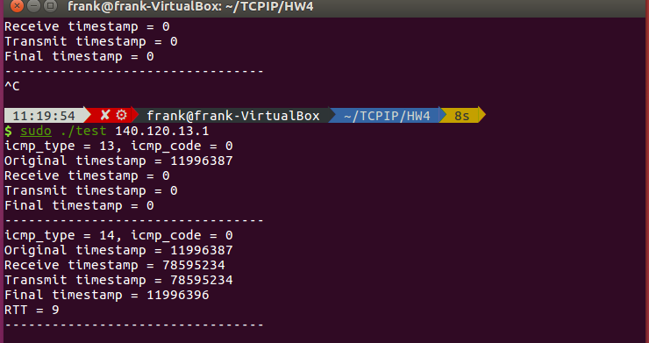

Advanced

1. Tell me how to run your program
2. Please describe the details about your program
3. Show the execution result (snapshot)