**Using Non-dominated Sorting Genetic Algorithm-II for Charging Station Deployment in Wireless Rechargeable Sensor Networks**

Shiang-Yu Hu1, Shang‐Juh Kao1, Fu-Min Chang2,[1]*

1Department of Computer Science and Engineering, National Chung-Hsing University, 145, Xingda Rd., South Dist., Taichung City, 402, Taiwan

2Department of Finance, Chaoyang University of Technology,   
168, Jifeng E. Rd., Wufeng District, Taichung City, 41349, Taiwan

**Abstract**

In WRSNs, wireless charging stations can recharge the batteries of sensor nodes so that they can operate sustainably. Since wireless charging stations are costly and have limited charging distances, how to deploy the minimal number of charging stations to cover all sensor nodes and satisfy the energy requirements of all sensor nodes are important and challenging issues. This paper proposes a new deploy strategy by taking the number of charging stations and the distance between sensor node and charging station into account simultaneously. We formulate the proposed strategy into a multi-objective problem and employ a non-dominated sorting genetic algorithm-II (NSGA-II) to solve this problem. We compare the proposed approach to the simulated annealing-based charging algorithm (SABC) and the layoff simulated annealing-based charging algorithm (LSABC) in terms of the number of charging stations and the overall charging power. The simulation results reveal that the overall charging power obtained using the proposed approach is 5% and 8% higher than that obtained using SABC and LSABC approaches. Moreover, the number of charging stations obtained using NSGA-II is 6% and 1% less than that obtained using SABC and LSABC approaches, respectively.

Keywords: wireless rechargeable sensor networks; wireless charging stations deployment; NSGA-II

**1 Introduction**

With the rapid development of Internet of Things (IoT) [1], all devices are gradually able to communicate via the Internet. In order to get more information, the technology of wireless sensor network (WSN), which is composed of wireless sensor nodes and relay nodes, is used extensively. WSN technology can be used in various applications because it has many advantages, such as lower cost, scalability, reliability, accuracy, flexibility, and ease of deployment. As wireless sensor nodes become smarter, smaller and cheaper, billions of wireless sensor nodes are deployed in many application scenarios. For example, sensor nodes can be used to detect, locate or track enemy movements. In addition, it can sense and detect the environment to predict disasters in advance. Moreover, sensor nodes can monitor a patient's health [2]. In the security, sensors can provide vigilant surveillance and increase alertness to potential terrorist attacks [3]. In the future, wireless sensor networks will eventually realize automatic monitoring of forest fires, avalanches, hurricanes, transportation, hospitals, etc. The wide ranges of potential applications for wireless sensor networks have made WSN becoming a fast-growing multi-purpose network [4].

Although the WSN allows users access information conveniently, there are some inherent problems. For example, in WSN, each sensor node senses various kinds of information and then transfer them to relay nodes. All actions consume energy, but the energy of sensor node is limited by battery capacity. When the energy of sensor node is exhausted, they may cause obstacles in the operation of WSN. To solve this network lifetime’s problem, wireless rechargeable sensor network (WRSN) [5-7], which is composed of charging stations, sensor nodes and relay nodes, is a promising approach.

Since wireless charging stations are costly and have limited charging distances, how to deploy the minimal number of charging stations to cover all sensor nodes and satisfy the energy requirements of all sensor nodes are important and challenging issues. Regarding these issues, most of the researches focus on reducing the number of charging stations. But they do not consider the charging efficiency of each sensor node under the same coverage of charging station. Actually, when the distance between sensor node and charging station decreases, the charging efficiency will be increased. Consequently, the charging stations do not need to replenish the sensor nodes’ power frequently. Therefore, this paper proposes a new deploy strategy by taking the number of charging stations and the distance between sensor node and charging station into account simultaneously. We formulate the proposed strategy into a multi-objective problem and employ a non-dominated sorting genetic algorithm-II (NSGA-II) [8] to solve this problem. Note that many approaches have proposed for searching the optimal solution of multi-objective problem, such as Vector Evaluated Genetic Algorithm (VEGA) [9], Weight-based Genetic Algorithm (WBGA) [10] and Multi-objective GA (MOGA) [11]. However, NSGA-II can find the optimal solution better because NSGA-II simultaneously optimize multiple assignment objective instead of searching for possible assignments based on a single composite values.

The remaining portion of this paper is organized as follows. Recent related studies are discussed in Section 2. Section 3 describes the system model and presents the problem formulation. The NSGA-II charging station deployment algorithm is introduced in Section 4. In Section 5, we conduct a simulation to verify the applicability of proposed approach and compare it with other prominent methods. Finally, the conclusions are provided in Section 6.

**2 System Related Work**

In this Section, we briefly introduce the concept of wireless rechargeable sensor networks and present various methods for the deployment of wireless charging station.

The environment of WRSN can be broadly divided into two categories: indoor and outdoor. A typical example of WRSN in outdoor environment is depicted in Figure 1. From the figure 1 we can see that a vehicle carries a wireless charging equipment (WCE) and travels along with the prior path planning to charge the power of sensor nodes. Because the distance of the vehicle’s movement and the lifecycle of sensor nodes are limited, how to plan the vehicle’s motion path is an important issue. The vehicle motion path planning needs to ensure that sensor nodes do not fail to deplete the WSN due to energy depletion, and charge as more sensor nodes as possible under the limited energy of WCE. In order to allow the WCE to travel further distance, Zhang *et al.* [12] proposed a Push-Wait mechanism, where WCEs are allowed to intentionally transfer energy between themselves. However, this approach needs too many WCEs. Liu *et al.* [13] proposed a Push-Shuttle-Back mechanism to allow that the WCE can go back to base station halfway for replenishing energy. With this mechanism, the energy loss in the movement and charging processes between WCEs can be reduced. In addition, the number of WCEs also can be reduced. In terms of path planning, Lyu *et al.* [14] proposed a periodic charging planning for a mobile WCE with limited traveling energy. This periodic charging planning ensures that the energy of the nodes in the WRSN varies periodically and that nodes perpetually fail to die. The authors proposed a Hybrid Particle Swarm Optimization Genetic Algorithm (HPSOGA) to solve this NP-hard problem.

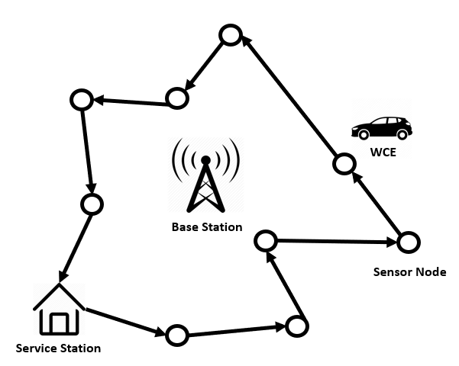

Figure 1. Typical example of WRSN in outdoor environment

A typical example of WRSN in indoor environment is shown in Figure 2. In indoor environment of WRSN, the charging station deployment needs to consider the sensor node position, radio frequency interference and charging efficiency. A good charging stations deployment intends to minimize the number of deployed charging station under the requirement of covering all sensor nodes. Jian *et al.* [15] proposed a movable-charger-based algorithm (MCBA), which is using overlapping area of charging antenna covered area, to ﬁnd out some candidate locations deploying of charging stations and then record them to a set. With the set of candidate locations, the authors employed a greedy algorithm to search the final deploying location of charging stations. It chooses the candidate position which cover the most sensor nodes. According to this rule, greedy algorithm is difficult to find better solution because it is easier to fall into local optimum. Similarly, based on the candidate set obtained from MCBA, Chien *et al.* [16] proposed a simulated anneal (SA) algorithm to find the final charging station locations. The main concept of SABC is that he can accept candidate nodes with a small number of sensor nodes. At the beginning of the process, a charging station is randomly selected from the candidate nodes, and the temperature is determined during each iteration to decide whether to add a charging station or replace the original charging station. This method has more directions for finding a solution, so there is a higher chance of finding a good solution. However, during the SABC iteration process, unnecessary solutions are often found repeatedly. If unnecessary solutions can be eliminated in the process, the convergence of the algorithm can be accelerated. Furthermore, Chien *et al.* [17] used the layoff algorithm to eliminate the unnecessary solutions during SA iterations. Different from SABC, LSABC initially treats all candidate nodes as all placements, and then randomly selects one candidate point for each iteration to eliminate. If the result is better, it replaces the original solution. If not, the candidate point is retrenched. Consequently, the computation time can be reduced.

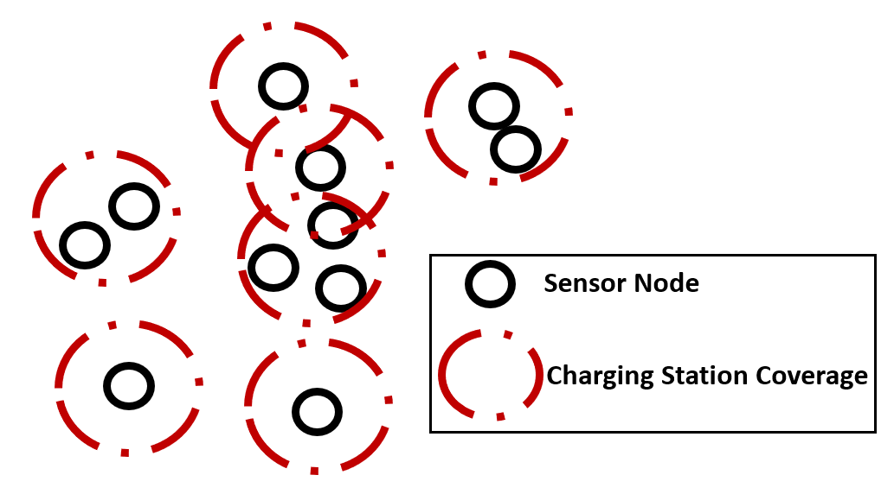

Figure 2. Typical example of WRSN in indoor environment

**3 System Model and Problem Formulation**

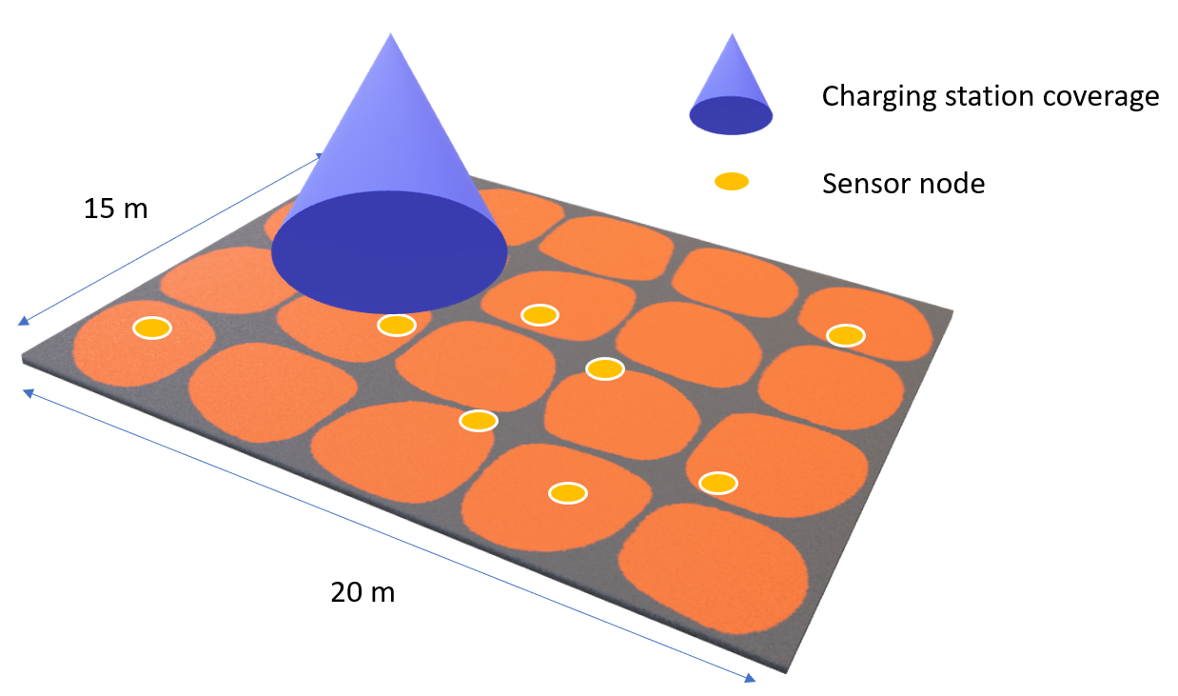

Figure 3. 20 x 15 indoor environment

In this study, we construct a 20 X 15 square meters indoor environment with *n* wireless rechargeable sensor nodes and *m* wireless directional charging stations which is shown in Figure 3. Let be the set of all the wireless rechargeable sensor nodes and be the set of all the charging stations. Those sensor nodes are randomly distributed in the three-dimensional region. Every directional charging station is identical and can charge a circular area with *R*-radius. Denote as the number of sensor nodes covered by charging station and *U* as the set of , where each is greater than equal to one. Because the efficiency of power transmission decreases as the distance of power transmission increases, the sensor nodes which are out of this *R*-radius circle cannot receive the effective power. A sensor node may be covered by multiple charging stations and receives power from multiple charging stations simultaneously. This paper aims to minimize the number of charging stations and maximize the overall charging capacity. To do that, we define the following problem.

(1)

.

Note that represents the sensor node which is covered by any charging station, represents the cover ratio of total charging stations. If sensor node is covered by any charging station, is equal to 1, otherwise, is equal to 0. For the sensor node , the total amount power received from multiple charging stations is denoted as . The sum of the sensor nodes received energy *P*. *E* denotes the effectual charging distance which is defined by charging equipment. denotes the distance between sensor node *i* and charging station *t*.

To measure , the following model which is provided by the company Powercast [18] is employed:

|  |  |
| --- | --- |
| , | (2) |

,where represents the power which transfer from charging station *t* to the sensor node *i*; denotes the value of antenna gains of charging station *t*; represents the value of antenna gains of sensor node *i;* denotes the wavelength of radio frequency (RF); denotes the distance between sensor node *i* and charging station *t*.

**4 NSGA-II based Charging Station Deployment**

In proposed method, all candidate deploying locations of charging station are discovered by applying MCBA [15] and then record them to a set. Based on this set, a modified NSGA-II scheme are performed to find a solution for the charging station deployment problem. Proposed by Deb *et al.* [8] on the basis of NSGA, NSGA-II improves the nondominated sorting algorithm and reduces the computational of parents and children with elitist strategy, introduces the crowded comparison operator to improve diversity of solutions, and avoids the use of niched operators. We encode all candidate locations of charging station into a set of genes, which is known as a chromosome or an individual. In our scheme, four primary phases are performed – initialization, crossover, mutation and selection. Individuals are created randomly in the initialization phase. In the crossover phase, genes are copied and are delivered to offspring. In the mutation phase, genes change their information content. Through the phases of crossover and mutation, different chromosomes are generated for maintaining the diversity of the next generation of solutions. In the selection phase, a modified non-dominated sorting scheme is used to preserve the diversity of different objectives. After many generations, the strongest genes are obtained. The chromosomes are updated continually in the main loop until the stopping criterion is met. The flowchart of the proposed NSGA-II approach is displayed in Figure 4.

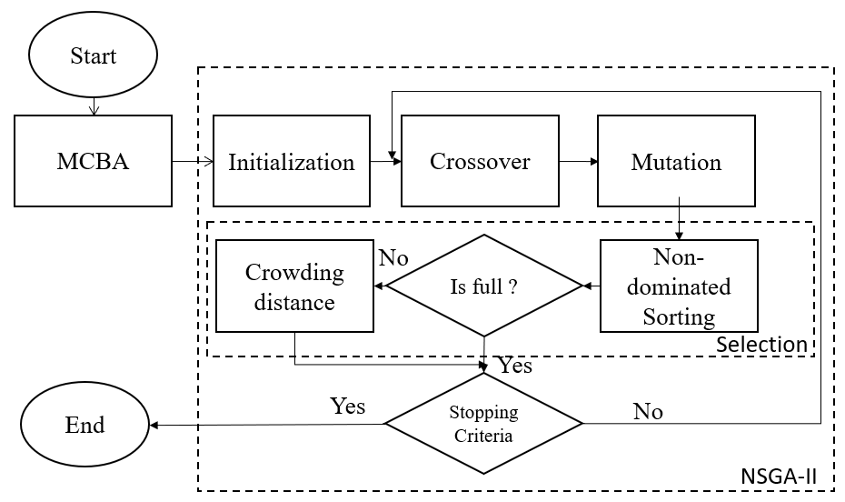

Figure 4. Flowchart of the proposed mechanism

**4.1 Representation and Initialization**

In the proposed approach, we assume that each sensor node can be covered by multiple charging stations and receives power from multiple charging stations simultaneously. The WRSN deployment space is regarded as a cuboid with the dimension (*L, E, H*), where *L* is the length of cuboid, *W* is width of cuboid and *H* is height of cuboid. In order to efficiently avoid the interference from obstacles and consider the actual situation, we deploy the charging station at ceiling as well as the sensor nodes are randomly distributed in the floor. On the basis of these assumptions, a sensor node is represented as a point with coordinates () and a charging station is denoted as a point with coordinates () in three-dimensional space. By applying the MCBA algorithm, we can get a set which includes all the places where the charging station may be deployed. Each candidate point is considered as a genetic cell.

A gene, which is a component of a chromosome, has two indicators, and . Note that stores the candidate position of charging station with (*x, y*) and represents this candidate point is deployed or not, where means this candidate point is deployed and represents the candidate point is not deployed. Figure 5 presents the process of transforming a candidate set into a chromosome. The coding example for a WRSN includes five sensor nodes and candidate locations

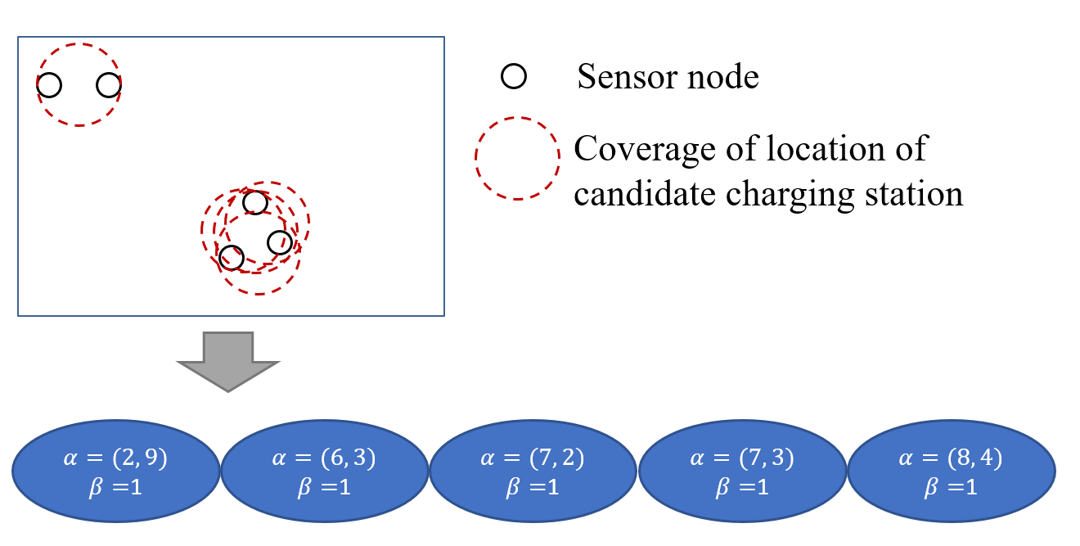

Figure 5. Example of a chromosome coding

In the initialization phase, individuals are created randomly. For example, in Figure 6, we randomly generate four chromosomes.

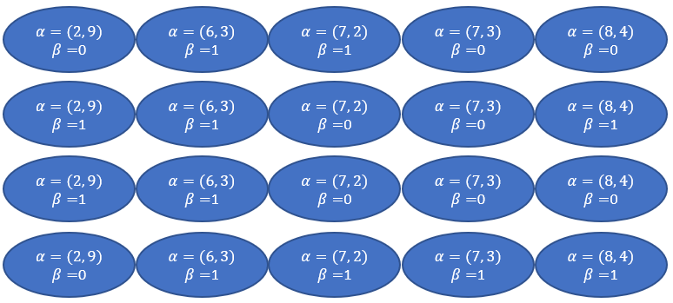

Figure 6. Four chromosomes are created in initialize phase

**4.2 Crossover**

In the crossover phase, switching point is randomly selected. At each iteration, parents selected after replication are exchanged for genetic, so that the new offspring can retain some of the characteristics of the parents. In order to avoid a large number of genetic changes caused by single-point mating, in this study, two-point mating was used. The process is determined by the crossover rate , which is a floating number between zero and one. If the generated random number is less then , two replicating parents are selected randomly. Two crossover point on this chromosome are also generated randomly and then exchange the genetic at the crossover point. An example of the crossover is presented in Figure 7.

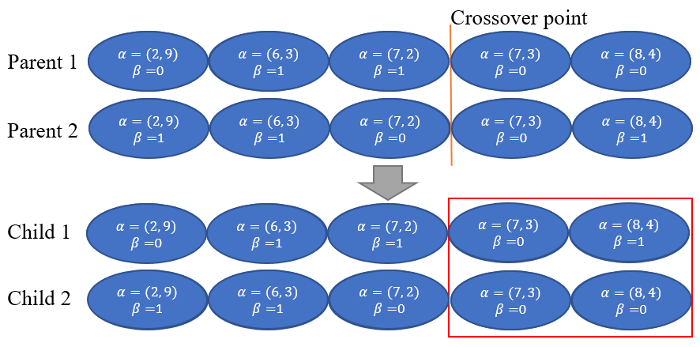

Figure 7. Example of a crossover

**4.3 Mutation**

The purpose of mutation is to generate the genetic that have not appeared in the parents, in order to prevent the best solution for falling into the local optimal solution. In this study, single-point mutation was used. Similar to the crossover phase, the mutation phase is determined by the mutation rate , which is a floating number between zero and one. If the generated random number is less then , then one gene of the chromosome is randomly selected for mutation. In this case, if the selected point is 0, it will become 1. The opposite if the selected point is 1, it will become 0. An example of mutation is presented in Figure 8.

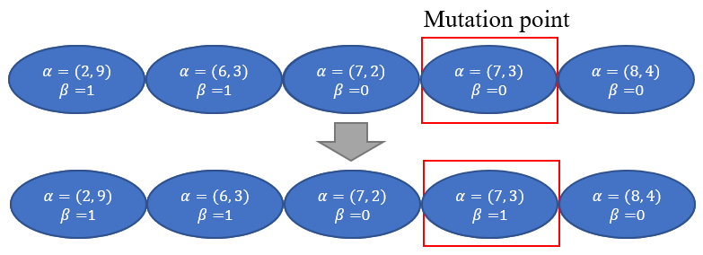

Figure 8. An example of mutation

**4.4 Selection**

In the selection phase, all chromosomes are decoded to obtain their information, such as the location of candidate nodes, the location is deployed or not. These parameters are used to calculate the fitness value through fitness function.

In fitness function, three metrics are considered, the number of charging stations for each chromosome *m*, the total coverage of charging stations and the sum of the sensor nodes received energy *P*. We can obtain *m*, and *P* by following equations:

|  |  |  |
| --- | --- | --- |
|  |  | (3) |

where is the number of genes in chromosome, equal to 1 or 0.

|  |  |  |
| --- | --- | --- |
|  |  | (4) |

where is the sensor node covered by any charging station.

|  |  |  |
| --- | --- | --- |
|  |  | (5) [19] |

where represents sensor node received the total amount power from multiple charging stations. We can obtain it value through Eq. (2).

From the initial population and the population obtained after the crossover and mutation phase, it becomes a population. In order to retain the first 50% of the population into the next generation, we must calculate the non-dominated sorting and the crowding distance. After non-dominated sorting, all chromosomes are classified into different levels and all levels rank by ascending order. If they are belonged to the same level, they will be ranked according to the crowding distance.

**4.4.1** **Non-dominated Sorting**

A non-dominated solution means that this solution cannot be dominated by other solutions. In other words, all objective function values of other solution can be greater than this solution. The main purpose of non-dominated ordering is to divide the initial population into several groups of non-dominated solution sets according to the objective function value of each chromosome. A pseudcode for non-dominated sorting is presented in Algorithm 1. To perform this algorithm, we need to input a set of population *P* with three parameters *N,* and *E,* where *N* represents the set of the number of charging station for each chromosome, denotes the set of the total coverage of charging stations for each chromosome and *E* represents the set of the sum of the received energy for each chromosome. For each solution we calculate two entities, , where represents the number of solutions which dominate the solution *p* and denotes the set of solutions that the solution *p* dominates. In Algorithm 1, we first calculate the number of chromosomes dominated by other chromosomes (lines 1-17). Note that *F* is the nondominated front. If is 0, which means that the chromosome is not dominated by other chromosomes, this chromosome is defined as level 1 and is removed from the population (lines 18-21). Next, we calculate the number of chromosomes dominated by other chromosomes from the remaining population. *Q* is used to store the members of next front. If the number of chromosomes dominated is 0, they are defined as level 2 (lines 23-33). Continuing the process until the entire population is sorted.

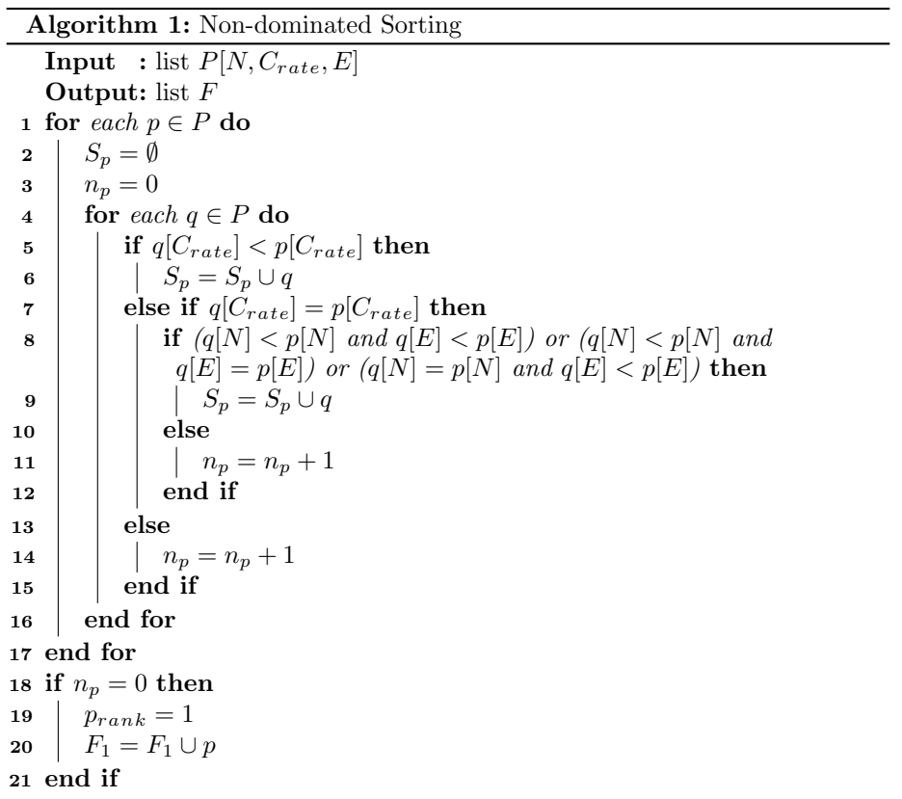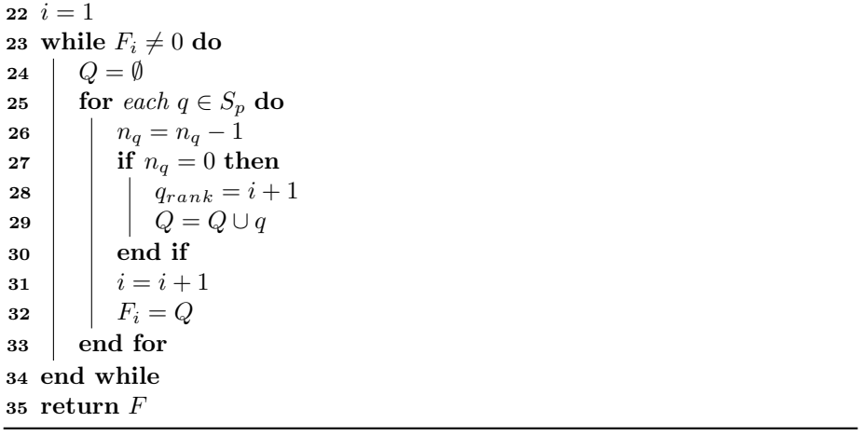

**4.4.2 Crowding Distance**

According to the ranks sorted in the previous step, the chromosomes of the same rank are taken out and the crowding distance is calculated. The concept of crowding distance is the denseness between the chromosome and its surrounding chromosomes. When the crowding distance is smaller, it means that the chromosome falls in a relatively crowded range. If the crowding distance is larger, it means that the chromosome falls in a relatively loose range. The formula for the crowding distance of the *i*th chromosome is as follows:

|  |  |  |
| --- | --- | --- |
|  |  | (6) |

is the number of target formulas, is the value of one of the objective functions, is the number of chromosomes, is the last chromosome in this level, and are the next chromosome objective function value and the previous chromosome objective function value of chromosome under the th target. In each level, when the chromosome distributes at the two ends, their crowding distance is set as infinity. A pseudcode for crowding distance calculation is presented in Algorithm 2.

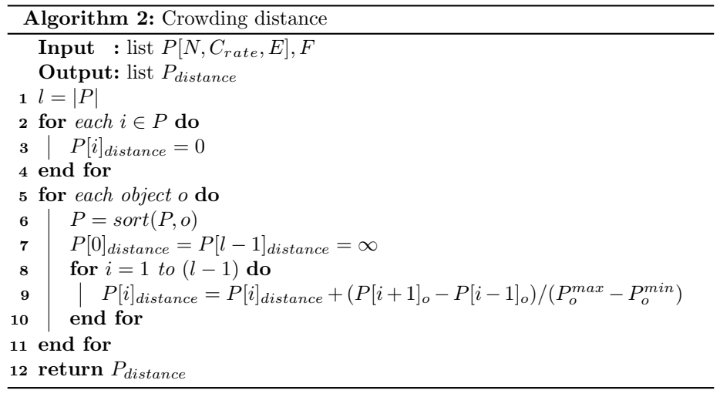

After the crossover and mutation phase, we get four new chromosomes and calculate the fitness value through the Eq. (3)(4)(5) together with the original chromosomes as shown in figure 9. Then we find the non-dominated set for all chromosomes and sort them according to the non-dominated set as shown in figure 10. Level 1 indicates that the chromosome is not dominated by any chromosome, level 2 indicates that the chromosome is dominated by a chromosome, and so on. In the next generation, we must pick out four new chromosomes, but we can see that there are 5 chromosomes in level 1, so we need to calculate the crowding distance of these five chromosomes.

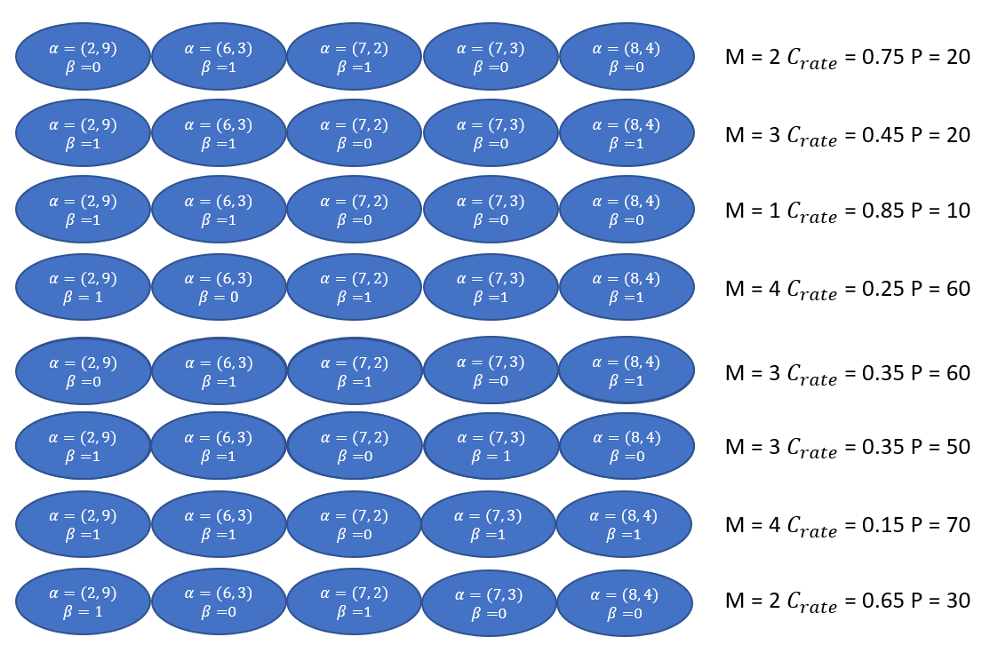

Figure 9. An example of fitness value

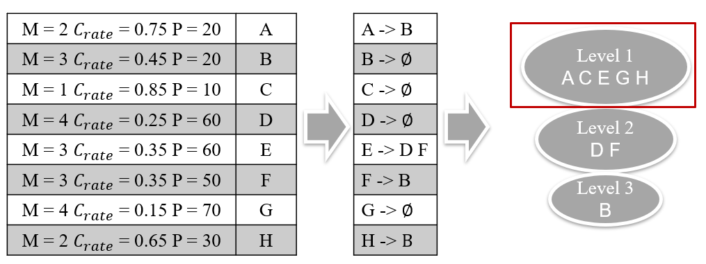

Figure 10. An example of non-dominated sorting

Before calculating the crowding distance, we must sort each target as shown in figure 11. After finishing the sorting, we can apply Eq. (6) to calculate the crowding distance. For example, chromosome . After the calculation, we take out the first four with large values. The larger the value of the chromosome, the lower the similarity of the chromosome with other chromosomes.

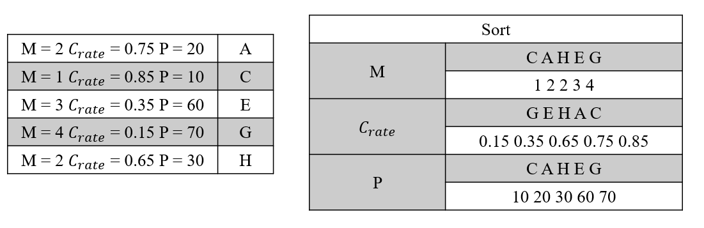

Figure 11. An example of crowding distance

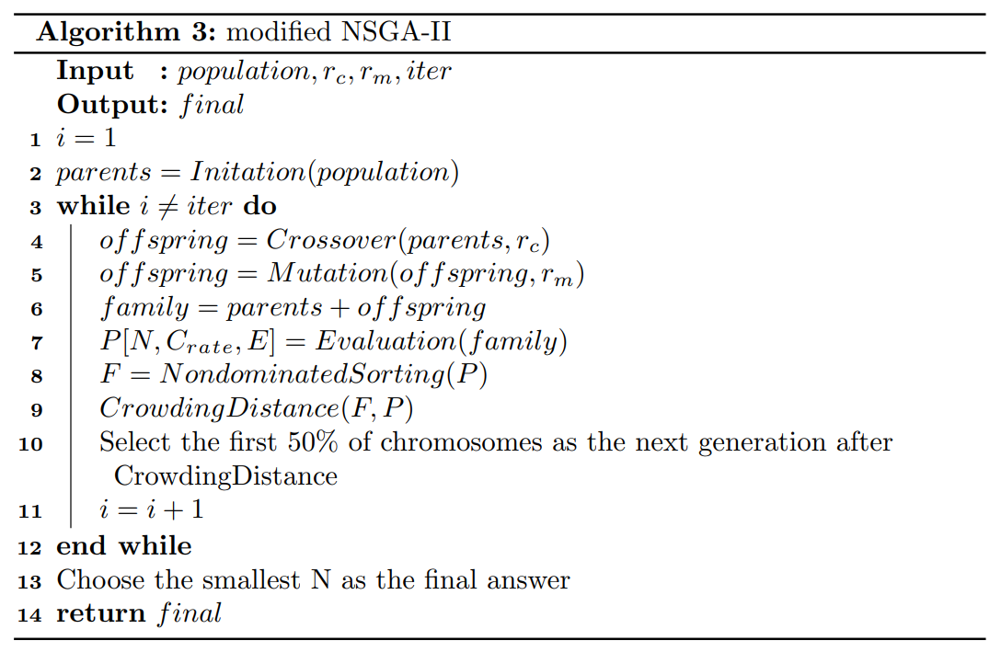

The process of proposed NSGA-II is shown in Algorithm 3. In the input parameters, *population* represents the amount of initial chromosome population; *iter* denotes a value for stopping criteria; and represent the rate of crossover and mutation, respectively; *final* is the output solution and represents the deployment positions of charging stations.

**5 Simulation and Performance Evaluation**

To verify the feasibility of proposed strategy, we simulate the proposed approach in a cubic indoor environment, 15 * 20 * 2.3 (), by using Python programming language. In section 5.1, we describe the experimental setting. NSGA-II convergence experiments are demonstrated in section 5.2 afterwards. Finally, we compare the proposed method with Jian *et al.*’s simulated annealing-based charging algorithm (SABC) approach and Jian *et al.*’s layoff simulated annealing-based charging algorithm (LSABC) approach in terms of the number of charging stations and the overall charging power in section 5.3.

**5.1 Experimental Settings**

In the simulation experiment, the sensor nodes are randomly deployed on the ground. For a charging station, the effectual charging distance is 3(m) and the angle is set to 30 [20]. We vary the number of sensor nodes from 25 to 125 with increment of 25. According to [18], frequency of charging station is set as 915 *MHz* , the transmission power is set as 3 *W EIPR* and receiver antenna gain is set as 6 *dBi* . Note that as the same with other researches, we assume that the charging efficiency is not affected by the number of sensor nodes. In other words, the time required to charge multiple power-depleted sensor nodes is the same as to charge a single one [21, 22] . The size of the population almost does not affect the result of experiment but the calculation time will increase. Therefore, we chose a population of 10 as the experimental setting. Before performing the comparisons between the proposed approach and other approaches, the crossover rate and mutation rate should be identified for the proposed NSGA-II approach. After experiments, it is found that the algorithm will reach a stable convergence after 1000, so we set iteration to 1000. The parameters details are shown in Table 1.

Table 1. Simulation parameters

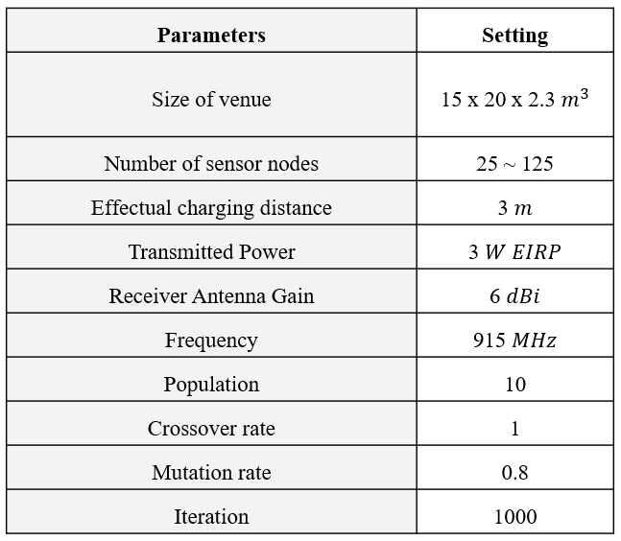

**5.2 NSGA-II Convergence Experiment**

We observe the convergence behavior of the number of charging stations under different crossover rate and mutation rate. In the experiment, the default values of are set as 1, 0.8 and 10, respectively. First, we vary the values of from 0.2 to 1 with increments of 0.2 to observe the effects on the NSGA-II convergence. The simulation result is presented in Figure 12. From the figure, we observe that the number of charging stations is smallest when is equal to 1. As a result, we set the crossover rate as 1. This means that every time you will go through the steps of crossover.

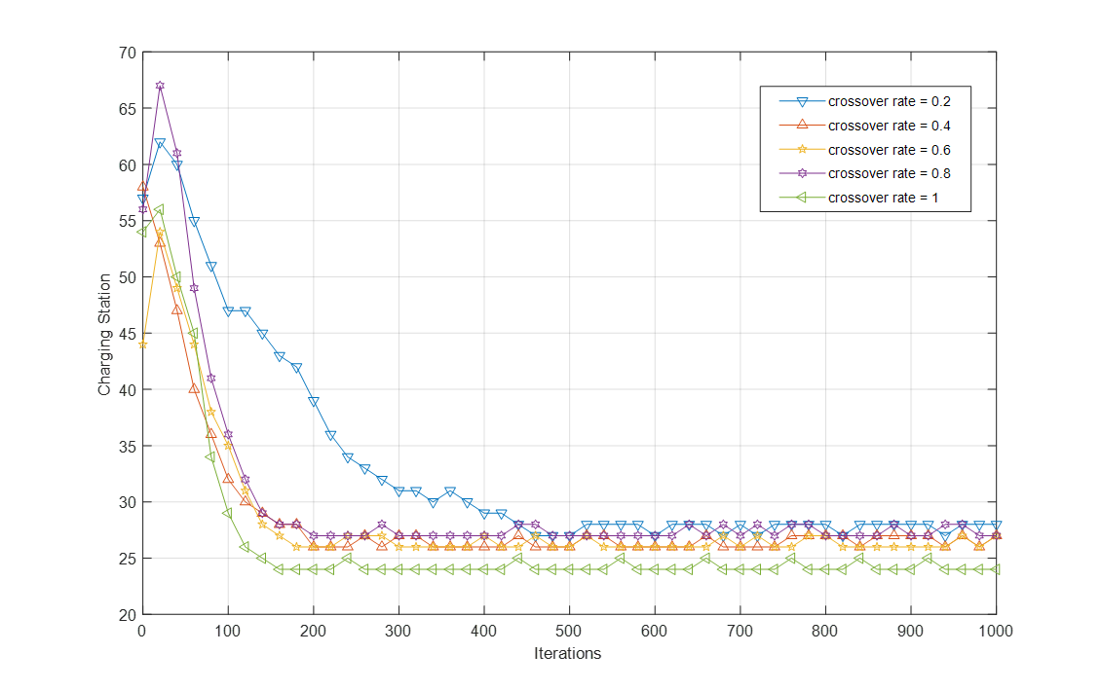

Figure 12. Effects of the crossover rate on NSGA-II convergence

Next, we vary the values of from 0.2 to 1 with increments of 0.2 to observe the effects on the NSGA-II convergence. The simulation result is presented in Figure 13. From the figure, we observe that the number of charging stations is smallest as is equal to 0.8. As a result, we set the mutation rate as 0.8.

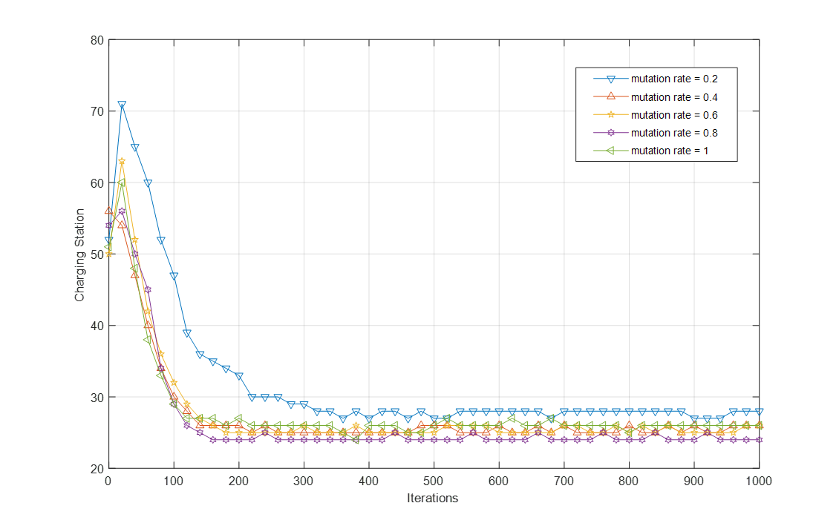

Figure 13. Effects of the mutation rate on NSGA-II convergence

**5.3 Simulation Results**

In our experiments, the simulations are executed 30 times. We measure the average number of charging stations and the average received energy of every sensor node. The Figure 14 shows the comparison of number of chargers with NSGA-II, LSABC and SABC. X-axis represents the number of sensor nodes, and Y-axis represents the number of charging stations. Obviously, the number of charging station of NSGA-II and LSABC is lower than SABC and this phenomenon become evident increasingly when the number of sensor nodes is increased. This is because NSGA-II uses the mechanisms of crossover and mutation and LSABC uses the layoff algorithm to avoid falling into local optimum. 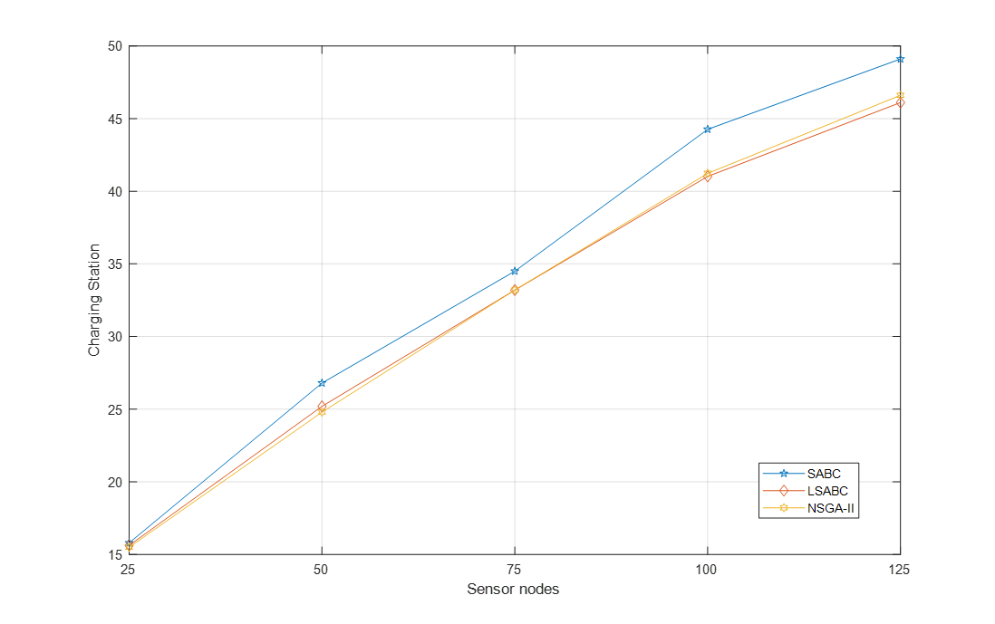

Figure 14. The number of charging station with sensor nodes increasing from 25 to 125

The Figure 15 shows the comparison of the average energy received of each sensor node. X-axis represents the number of sensor node, and Y-axis represents the average energy received of each sensor node (*mW*). The simulation results reveal that NSGA-II can receive more power than LSABC and SABC, because LSABC and SABC do not take the distance between the charging station and the sensor node into account. When the distance is closer, the sensor can receive more energy.

Figure 15. The average energy received of each sensor node with sensor nodes increasing from 25 to 125

We also compare the number of charging stations required by different methods under different sensor nodes and the overall sensor nodes energy received. The details are shown in Table 2. We can see that under the same number of charging stations, the overall energy received by the NSGA-II method is greater than that of other methods.

Table 2. Charging Station vs. Charging Efficiency in different number of sensor nodes

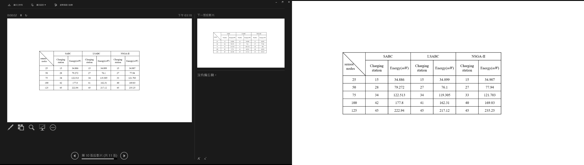

**6 Conclusions**

This paper proposed a new deploy strategy by taking the number of charging stations and the distance between sensor node and charging station into account simultaneously. We formulated the proposed strategy into a multi-objective problem and employed a NSGA-II to solve charging station deployment problem. We compared the proposed approach to the simulated annealing-based charging algorithm (SABC) and the layoff simulated annealing-based charging algorithm (LSABC) in terms of the number of charging stations and the overall charging power. The simulation results revealed that under the same number of charging stations, the overall charging power obtained using the proposed approach is 5% and 8% higher than that obtained using SABC and LSABC approaches. Moreover, the number of charging stations obtained using NSGA-II was 6% and 1% less than that obtained using SABC and LSABC approaches under the same number of sensor nodes, respectively. In future work, we can consider that there will be obstacles in the real environment, and these obstacles will interfere with the charging efficiency. Therefore, these conditions can also be added to the multi-objective problem.

**References**

[1] X. Liu, S. Zhao, A. Liu, N. Xiong, and A. V. Vasilakos, "Knowledge-aware proactive nodes selection approach for energy management in Internet of Things," *Future generation computer systems,* vol. 92, pp. 1142-1156, 2019.

[2] S. Rajba, P. Raif, T. Rajba, and M. Mahmud, "Wireless sensor networks in application to patients health monitoring," in *2013 IEEE Symposium on Computational Intelligence in Healthcare and e-health (CICARE)*, 2013, pp. 94-98.

[3] K. Huang, Q. Zhang, C. Zhou, N. Xiong, and Y. Qin, "An efficient intrusion detection approach for visual sensor networks based on traffic pattern learning," *IEEE Transactions on Systems, Man, and Cybernetics: Systems,* vol. 47, no. 10, pp. 2704-2713, 2017.

[4] I. F. Akyildiz, W. Su, Y. Sankarasubramaniam, and E. Cayirci, "Wireless sensor networks: a survey," *Computer networks,* vol. 38, no. 4, pp. 393-422, 2002.

[5] C. Lin, N. Xiong, J. H. Park, and T. h. Kim, "Dynamic power management in new architecture of wireless sensor networks," *International Journal of communication systems,* vol. 22, no. 6, pp. 671-693, 2009.

[6] Y. Zeng, C. J. Sreenan, N. Xiong, L. T. Yang, and J. H. Park, "Connectivity and coverage maintenance in wireless sensor networks," *The Journal of Supercomputing,* vol. 52, no. 1, pp. 23-46, 2010.

[7] P. Rawat, K. D. Singh, H. Chaouchi, and J. M. Bonnin, "Wireless Sensor Networks: recent developments and potential synergies," *Journal ofSuperComputing, www. researchgate. net/publication/25,* vol. 8165429.

[8] K. Deb, A. Pratap, S. Agarwal, and T. Meyarivan, "A fast and elitist multiobjective genetic algorithm: NSGA-II," *IEEE transactions on evolutionary computation,* vol. 6, no. 2, pp. 182-197, 2002.

[9] J. D. Schaffer, "SOME EXPERIMENTS IN MACHINE LEARNING USING VECTOR EVALUATED GENETIC ALGORITHMS (ARTIFICIAL INTELLIGENCE, OPTIMIZATION, ADAPTATION, PATTERN RECOGNITION)," 1986.

[10] T. Murata and H. Ishibuchi, "MOGA: multi-objective genetic algorithms," in *IEEE international conference on evolutionary computation*, 1995, vol. 1, pp. 289-294.

[11] C. M. Fonseca and P. J. Fleming, "Genetic Algorithms for Multiobjective Optimization: FormulationDiscussion and Generalization," in *Icga*, 1993, vol. 93, no. July: Citeseer, pp. 416-423.

[12] S. Zhang, J. Wu, and S. Lu, "Collaborative mobile charging," *IEEE Transactions on Computers,* vol. 64, no. 3, pp. 654-667, 2014.

[13] T. Liu, B. Wu, H. Wu, and J. Peng, "Low-cost collaborative mobile charging for large-scale wireless sensor networks," *IEEE Transactions on Mobile Computing,* vol. 16, no. 8, pp. 2213-2227, 2016.

[14] Z. Lyu, "Periodic charging planning for a mobile WCE in wireless rechargeable sensor networks based on hybrid PSO and GA algorithm," *Applied Soft Computing,* vol. 75, pp. 388-403, 2019.

[15] W.-J. Jian, H.-H. Cho, C.-Y. Chen, H.-C. Chao, and T. K. Shih, "Movable-charger-based planning scheme in wireless rechargeable sensor networks," in *2015 IEEE Conference on Computer Communications Workshops (INFOCOM WKSHPS)*, 2015, pp. 144-148.

[16] W.-C. Chien, H.-H. Cho, C.-Y. Chen, H.-C. Chao, and T. K. Shih, "An efficient charger planning mechanism of WRSN using simulated annealing algorithm," in *2015 IEEE International Conference on Systems, Man, and Cybernetics*, 2015, pp. 2585-2590.

[17] W.-C. Chien, H.-H. Cho, H.-C. Chao, and T. K. Shih, "Enhanced SA-based charging algorithm for WRSN," in *2016 International Wireless Communications and Mobile Computing Conference (IWCMC)*, 2016, pp. 1012-1017.

[18] Powercast Corporation, available from: http://www.powercastco.com/.

[19] S. He, J. Chen, F. Jiang, D. K. Yau, G. Xing, and Y. Sun, "Energy provisioning in wireless rechargeable sensor networks," *IEEE transactions on mobile computing,* vol. 12, no. 10, pp. 1931-1942, 2012.

[20] J.-R. Jiang, Y.-C. Chen, and T.-Y. Lin, "Particle swarm optimization for charger deployment in wireless rechargeable sensor networks," *International Journal of Parallel, Emergent and Distributed Systems,* pp. 1-16, 2018.

[21] Y. Ma, W. Liang, and W. Xu, "Charging utility maximization in wireless rechargeable sensor networks by charging multiple sensors simultaneously," *IEEE/ACM Transactions on Networking,* vol. 26, no. 4, pp. 1591-1604, 2018.

[22] W.-Y. Lai and T.-R. Hsiang, "Wireless Charging Deployment in Sensor Networks," *Sensors,* vol. 19, no. 1, p. 201, 2019.

1. * Corresponding Author: fmchang@cyut.edu.tw