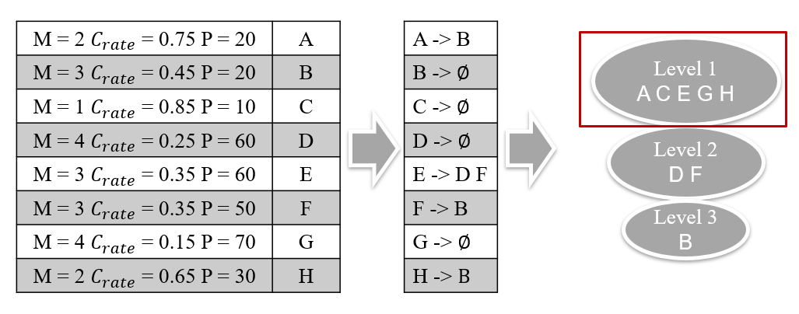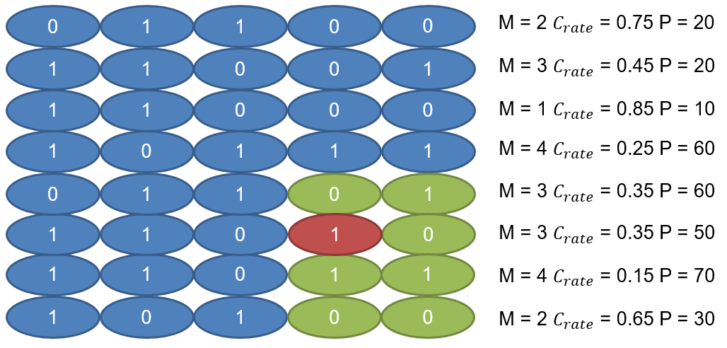After the crossover and mutation phase, we get four new chromosomes and calculate the fitness value through the Eq.(3)(4)(5) together with the original chromosomes as shown in figure 14. Then we find the non-dominated set for all chromosomes and sort them according to the non-dominated set as shown in figure 15. Level 1 indicates that the chromosome is not dominated by any chromosome, level 2 indicates that the chromosome is dominated by a chromosome, and so on. In the next generation, we must pick out four new chromosomes, but we can see that there are 5 chromosomes in level 1, so we need to calculate the crowding distance of these five chromosomes.

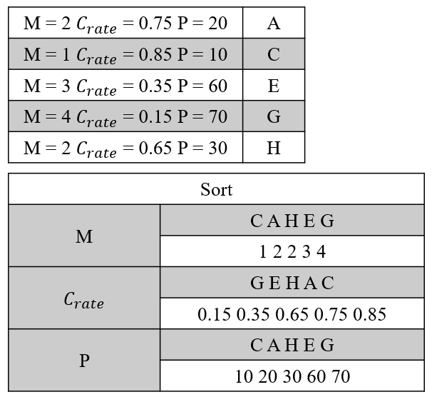Before calculating the crowding distance, we must sort each target as shown in figure 16. After finishing the sorting, we can apply Eq.(6) to calculate the crowding distance. For example, chromosome $A = {(2-1)}/{(4-1)}+{(0.85-0.65)}/{(0.85-0.15)}+{(30-10)}/{(70-10)}$. After the calculation, we take out the first four with large values. The larger the value of the chromosome, the lower the similarity of the chromosome with other chromosomes