//Important note:

//As I mentioned on an earlier assignment bash can’t return negative values so in my error messages I have the program return positive numbers. (example… -3 becomes 3)

Return 1

----------------------------

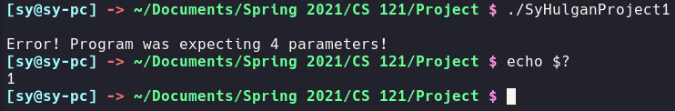

Return 2

----------------------------



Return 3

----------------------------

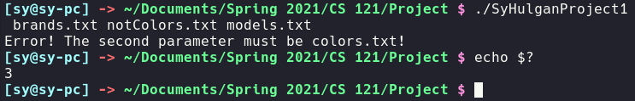

Return 4

----------------------------

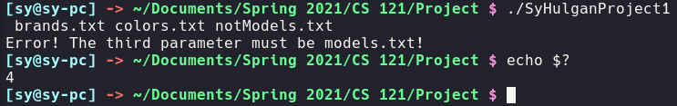

Return 5

----------------------------

