Group 8

Syed Khandker, Esko Reivari

Sandesh Hyoju, Timo Tammi & Henri Murtonen

1st, 2nd & 3rd phase of the ITKS452 Diary

1. Using CHAOS report’s findings (or similar), explain why requirements are important. Also explain how requirements help to increase the chances of having a successful project.

The Standish Group conducted four focus groups and numerous personal interviews to provide qualitative context for the survey results of software failures. For purposes of the study, projects were classified into three resolution types:

- Resolution Type 1, or project success: The project is completed on-time and on-budget, with all features and functions as initially specified.

- Resolution Type 2, or project challenged: The project is completed and operational but over-budget, over the time estimate, and offers fewer features and functions than originally specified.

- Resolution Type 3, or project impaired: The project is cancelled at some point during the development cycle.

Overall, the success rate was only 16.2%, while challenged projects accounted for 52.7%,

and impaired (cancelled) for 31.1%.
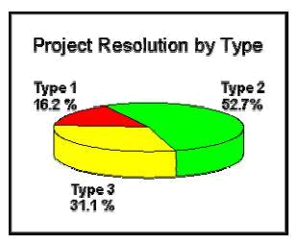

That's why requirements are important to finish project on time, on budget and with all features and function that are initially specified.

Requirements help to increase the chances of having a successful project as it is the process of establishing the services that the customer requires from a system and the constraints under which it operates and is developed. The major reasons that a project will succeed are user involvement, proper planning, executive management support and a clear vision and clear statement of requirements.

2. What beliefs are often hindering good requirements practices? Why they are actually

misbelieves?

The beliefs which are often hindering good requirements practices are:

- It is not worth discovering requirements directly from users: e.g:

- We have developed these kind of products for a long time and we know user needs.

O We developers also use our own product and therefore we can act as users.

- We are developing a new product and therefore users cannot have any requirements for it.

- It is difficult to discover requirements directly from users: e.g.:

O Users are unable to say what they need and want.

O There are so many users that we cannot interview them all.

- It is risky to discover requirements directly from users: e.g:

- We cannot show our customers that we do not know the basics of their business.

  - Product development personnel can spoil customer relationships by asking stupid questions.

- It is not worth documenting user requirements systematically: e.g:

  - Our customers are interested in documents presenting technical features of software, not in documents presenting what they know anyway.

O We do not have time for user requirements documentation.

They are actually misbelieves because:

- The more deeply user needs are understood, the more useful and usable systems can be developed.

- Users are experts in their tasks, and therefore they are the primary source of real user requirements (domain knowledge).

- For a new product, users hardly can say what they want; but they will quickly recognize something that they do not want.

- There are elicitation (esille saaminen) techniques like interviewing and observing that product development engineers can learn and use easily.

- By combining interview and observation techniques it is possible to get a comprehensive picture of user needs without requiring users to articulate their needs explicitly.

- Better to interview a small group of users than not to do this at all

- Well-prepared user visits can improve a company’s image among its customers and create competitive edge.

- When this lack of knowledge is discovered at a later stage, consequences will be worse

- Requirements document the agreement about the system, not just the content of customers’ heads.

- Well-documented user requirements are useful information for many groups: designers, testers, user manual writers, management and marketing personnel.

- Systematic user requirement documentation at the beginning of the product development saves time and decreases rework in later phases of the project.

Misconceptions about requirements engineering can strongly influence a company’s processes. Many companies and organizations have a solid understanding of requirements processes, but some do not. Some of the more common misconceptions are listed under the headings that follow.

- Misconception 1: Any Subject Matter Expert Can Become a Requirements Engineer after a Week or Two of Training Requirements engineers need strong communication and knowledge of engineering skills, the ability to organize and manage a data set of requirements, high-quality written and visual presentation skills, and the ability to extract and model business processes using both text and graphical (e.g., Integration DEFinition [IDEF], Unified Modeling Language [UML]) techniques. First and foremost, to elicit requirements from stakeholders requires the ability to interact with a variety of roles and skill levels, from subject matter experts (detailed product requirements) to corporate officers (elicitation of business goals). Moreover, people have to be trained to write good specifications.

- Misconception 2: Nonfunctional and Functional Requirements Can Be Elicited Using Separate Teams and Processes The subject domains for nonfunctional and functional requirements are related, may impact each other, and may result in iterative changes as work progresses. Team isolation may do more harm than good.

- Misconception 3: Processes That Work for a Small Number of Requirements Will Scale Requirements engineering processes do not scale well unless crafted carefully. For example, a trace matrix is an N × N matrix, where N is the number of requirements of interest. In each cell, a mark or arrow indicates that there is a trace

from requirement Ri(row i) to requirement Rj (column j). It is relatively easy to inspect, say, a 50-requirement matrix, but what happens when five to ten thousand requirements are needed to define a product? Filtering and prioritization become important in order to retrieve results that can be better understood, but the requirement annotations necessary to provide such filtering are often neglected up front because the database is initially small

3. Provide some definitions for and explain such concepts as “requirements”, “requirements engineering”, “requirements development”, “requirements management”, “stakeholders”.

Requirement

A requirement is a singular documented physical and functional need that a particular design, product or process must be able to perform. It is most commonly used in a formal sense in system engineering, software engineering or enterprise engineering. It is a statement that identifies a necessary attribute, capability, characteristic or quality of a system for it to have value and utility to a customer, organization, internal user, or other stakeholder.

It may range from a high-level abstract statement of a service or of a system constraint to a detailed mathematical functional specification. This is inevitable as requirements may serve a dual function

- May be the basis for a bid for a contract -therefore must be open to interpretation

- May be the basis for the contract itself - therefore must be defined in detail

- Both these statements may be called requirements
Requirement Engineering

Requirements engineering is a systematic way of developing requirements through an iterative process of analyzing a problem, documenting the resulting observations, and checking the accuracy of the understanding gained.

- Requirements engineering is comprised of two major tasks: analysis and modeling

- The requirements themselves are the descriptions of the system services and constraints that are generated during the requirements engineering process.

Requirement Development

Requirement development (RD) is the part of the project during which the needs of the customer are gathered and translated into a specification of what the system must do. RD can further subdivide requirements development into elicitation, analysis, specification and validation. These sub disciplines encompass all the activities involved with gathering, evaluating and documenting the requirements for a software including the following:

- Identifying the product's expected user classes

- Eliciting needs from individuals who represent each user class

- Understanding user tasks and goals and the business objective with which those tasks align.

- Analyzing the information received from users to distinguish their task goals from functional requirements, non functional requirements, business rules, suggested solutions and extraneous information.

- Understanding the relative importance of quality attributes

- Translating the collected user needs into written requirements specifications and models.

Requirement Management

Requirements management is the process of documenting, analyzing, tracing, prioritizing and agreeing on requirements and then controlling change and communicating to relevant stakeholders. It is a continuous process throughout a project.
Stakeholder

A stakeholder is a person or organization who influences a system's requirements or who is impacted by that system.

Stakeholders can affect or be affected by the organization's actions, objectives and policies. Some examples of key stakeholders :

  - Customers who fund a project or acquire a product to satisfy their organization's business objectives

  - Users who interact directly or indirectly with the product

  - Requirements analysts who write the requirements and communicate them to the development community

  - Developers who design, implement and maintain the produc

  - Tester who determine whether the product behaves as intended.

  - Documentation writers who produce user manuals, training materials and help systems.

  - Project managers who plan the project and guide the development team to a successful delivery

  - Sales, marketing, field support, help desk and other people who will have to work with the product and its customer

- Describe the machine-environment model (so called Jackson model).

Jackson system development model is a linear software development methodology developed by Michael A. Jackson.

Three basic principles of operation of Jackson model is that:

- Development must start with describing and modelling the real world, rather than specifying or structuring the function performed by the system. A system made using Jackson model method performs the simulation of the real world before any direct attention is paid to function or purpose of the system.

- An adequate model of a time-ordered world must itself be time-ordered. Main aim is to map progress in the real world on progress in the system that models it.

- The way of implementing the system is based on transformation of specification into efficient set of processes. These processes should be designed in such a manner that it would be possible to run them on available software and hardware
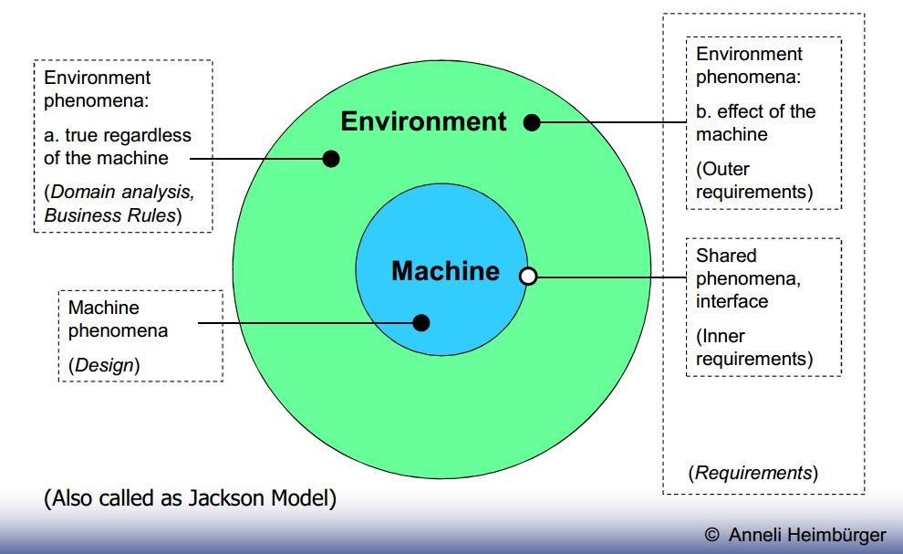

Fig: Machine Environment (Jackson) Model

Domain knowledge – description of environmental phenomena that occur regardless of the machine

- The average speed of manual spelling-check is about 5 pages per hour.

- Number of entries in Oxford English Dictionary is 252.200.

Outer requirements – described in terms of environmental phenomena, the desired

effects in the environment occurring due to the machine influence

- A text shall be able to be spelling-checked effectively and efficiently Inner requirements – description of shared phenomena, i.e. interaction of the machine and the environment at the machine-environment interface

- A computer-based system shall be developed able of checking spelling in electronic documents.

- If a word is found that is not in the system’s dictionary, the user shall be given a possibility to select among similar correct words.
Design information – described in terms of machine phenomena, the internal

structure and behavior of the machine

  - The binary search algorithm (a binary search is an algorithm for locating the position of an element in a sorted list) is to be used

- Starting with Jackson’s machine-environment model, explain why RE is in fact a problem solving process (in addition to being problem-stating).

RE is mainly a problem-solving process as It is about answering the question “what machine’s behavior on the boundary would achieve the desired effect on the environment”.

Jackson’s model is a method of system development that covers the software life cycle either directly or, by providing a framework into which more specialized techniques can fit. Jackson System Development can start from the stage in a project when there is only a general statement of requirements.

6. Describe all the different requirements engineering components.
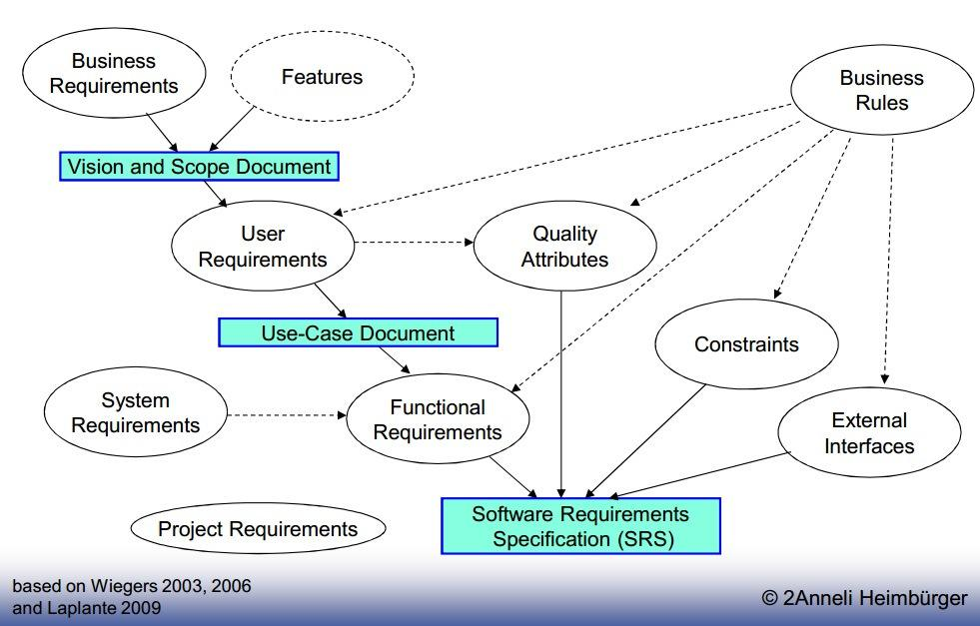

Fig: Requirement Engineering Component

- Business requirements: describe why the project is being undertaken.

- Features: the bulleted list on the product’s sale package.

- User requirements: describe the tasks the users must be able to perform with the system.

- Functional requirements: specify the functionality the developers must build into the product to enable users to accomplish their tasks, thereby satisfying the business requirements.

- Non-functional requirements i.e. Quality Attributes: augment the description of the product functionality by describing the product’s characteristics in various dimensions that are important to either users of developers

- Constraints: impose restrictions on the choices available to the developer for design and implementation of the system.

- External Interfaces: describe interfaces between the system and the external entities, with which the system must be able to communicate.

- Business Rules: include corporate policies, government regulations, industry standards, accounting practices, and computational algorithms.

O Are not requirements, but affect requirements development. A part of

domain knowledge.

- System Requirements: for software, the requirements for the whole computer-based system.

- Project Requirements: constraints placed on the development process of the system, e.g. budget, schedule, staff.

Requirements Engineering has two component requirements development and

requirements management.
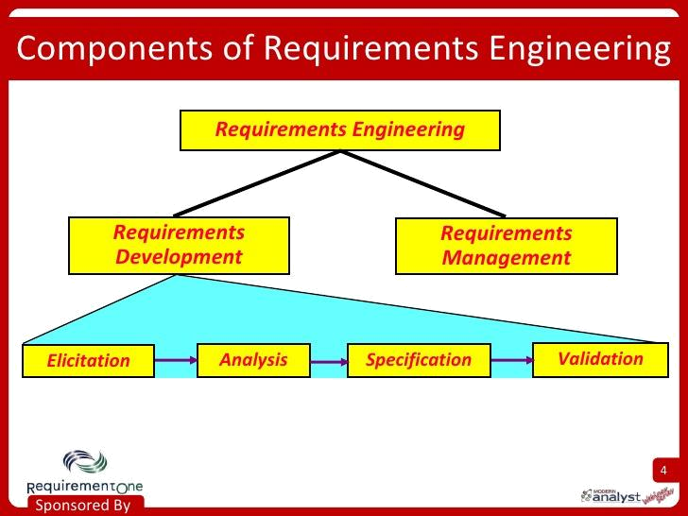

Requirement development is the part of the project during which the needs of the customer are gathered and translated into a specification of what the system must do. RD can further subdivide requirements development into elicitation, analysis, specification and validation.

- Elicitation: It is the process of gathering and documenting needs from stakeholders, identifying other requirements sources and applying techniques specified in the RMP to gather the information and document the needs

- Analysis: It is the process of analyzing the data gathered during elicitation, resolving conflicts, analyzing business rules, documenting assumptions, constraints and dependencies, and working with stakeholders to establish initial priorities.

- Specification: It is the process of defining functional and supplemental text based requirements and supporting them with various visualization techniques such as process models, UML diagrams, wireframes, white boarding etc

- Validation: It is the process of reviewing the requirement specifications and associated visualizations with the stakeholders for quality characteristics such as completeness, correctness, clarity, practicality, value etc.

Requirements management is the process of documenting, analyzing, tracing, prioritizing and agreeing on requirements and then controlling change and communicating to relevant stakeholders. It is a continuous process throughout a project.

7. What is system’s quality attributes? Describe some of them.

System quality attributes are non-functional requirements used to evaluate the performance of a system. Some of system’s qualities are:

- Availability: It is a measure of the planned up time during which the system is actually available for use and fully operational.

- Efficiency: It is a measure of how well the system utilizes processor capacity, disk space, memory or communication bandwidth.

- Flexibility: It measures how easy it is to add new capabilities to the product.

- Reliability: The probability of the software executing without failure for a specific period of time is known as reliability.

- Maintainability: It indicates how easy it is to correct a defect or modify the software. Maintainability depends on how easily the software can be understood, changed and tested.

- Portability: The effort required to migrate a piece of software from one operating environment to another is measure of portability.

- Testability: It is also known as verifiability, testability refers to the ease with which software components or the integrated product can be tested to look for defects
8. Discuss the place of requirements in the whole system engineering practice, according

to different models, compare them.

Systems engineering is an interdisciplinary field of engineering that focuses on how to design and manage complex engineering systems over their life cycles. Issues such as reliability, logistics, coordination of different teams (requirements management), evaluation measurements, and other disciplines become more difficult when dealing with large or complex projects. Systems engineering deals with work-processes, optimization methods, and risk management tools in such projects. It overlaps technical and human-centered disciplines such as control engineering, industrial engineering, organizational studies, and project management. Systems Engineering ensures that all likely aspects of a project or system are considered, and integrated into a whole.

9. What is the difference between RD and RM? What activities constitute both?
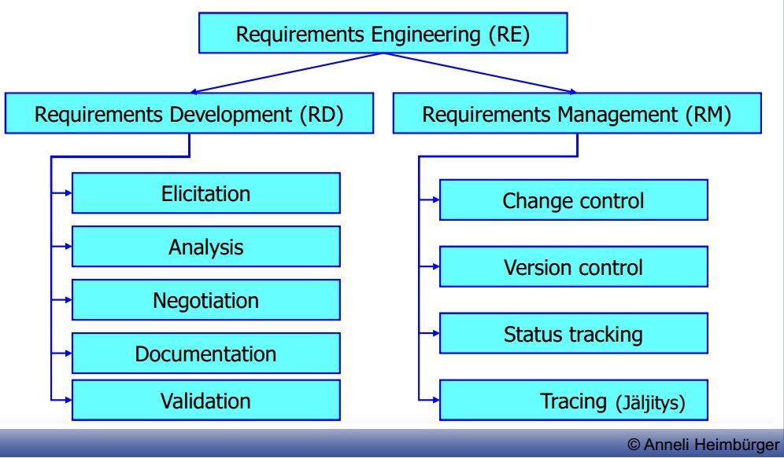

Fig: Requirements Engineering

Requirement Development establishes an agreement between the stakeholders (including the developing team) on the requirements of the system and it involves:

- Elicitation – the process of identifying system requirements from various sources through interviews, workshops, workflow and task analysis, document analysis, and other mechanisms.

- Validation (& verification) – the process of checking whether the requirements, as identified, do not contradict the expectations about the system of various stakeholders, and do not contradict each other.

- Analysis – the process of evaluating value/cost of different requirements, identifying dependencies between requirements, etc.

- Negotiation – the process of resolving conflicts between requirements, deciding which to accept, setting priorities.

- Documentation (specification) – the process of documenting requirements in a shareable and manageable form.

Whereas requirement management maintains the agreement and it Involves:

- Change control– managing changes to the requirements baseline, through reviewing proposed changes and evaluating the likely impact of each change before approving it, and incorporating approved changes into the project in a controlled way.

- Version control – managing document versions and requirements revisions.

- Requirements status tracking – defining a set of status values (Proposed, Approved, Implemented, Verified, Deleted, Rejected) for a requirement, and monitoring statuses throughout the project.

- Requirements tracing – managing dependency links between requirements, and tracing requirements up to their sources and down to corresponding design, source code, and test cases.

- The purpose of Requirement Development "RD" is to produce customer, product and product component requirements whereas Requirement Management "RM" is to manage the requirements of the project's products and product components.

- RD analyzes the customer, product and product component requirements whereas RM identifies inconsistencies between requirements and project's plans/work products.

  - RD deals with communication between PM, domain and functional architect, designer and his team whereas RM deals with communication between requirements analysts and customer.

  - RD is about the transformation of customer needs into requirements that can then evolve into design and/or code. This includes eliciting the customer needs(JAD sessions, interviews), transforming those needs into requirements, evolving them into product requirements, allocating the requirements across releases, teams, developers or modules, validating them, and ensuring that they fit within the customer constraints and assumptions whereas RM is all about maintaining the set of requirements that you have, and the process of accepting new ones.

- Who is the requirements analyst? What skills this person should have, what are the specifics of her/his job?

The requirement analyst is the individual who has the primary responsibility to elicit, analyze, validate, specify, verify, and manage the real needs of the project stakeholders, including customers and end users. The requirement analyst serves as the conduit between the customer community and the software development team through which requirements flow.

Skills of requirement analyst are:

- Interviewing skills: to talk with individuals and groups about their needs and ask the right questions to surface essential requirements information

- Listening skills: to understand what people say and to detect what they might to hesitant to say

- Analytical skills: to critically evaluate the information gathered from multiple sources, reconcile conflicts, decompose high-level information into details, abstract up from low-level information to a more general understanding, distinguish
presented user requests from the underlying true needs, and distinguish solution

ideas from requirements

- Facilitation skills: to lead requirements elicitation workshops

- Observational skills: to validate data obtained via other techniques and expose new areas from requirements

- Writing skills: to communicate information effectively to customers, marketing, managers and technical staff

- Organizational skills: to work with the vast array of information gathered during elicitation and analysis and to cope with rapidly changing information

- Interpersonal skills: to help negotiate priorities and to resolve conflicts among project stakeholders( such as customers, product management and engineering)

- Modelling skills: to represent requirements information in graphical forms that augment textual representations in natural language, including using modeling languages already established in the development organization

Job of requirement analyst are:

- Work with the project manager, product manager and project sponsor to document the product's vision and the project's scope.

- Identify project stakeholders and user classes. Document user class characteristics. Identify appropriate representatives for each user class and negotiate their responsibilities.

- Elicit requirements using interviews, document analysis, requirement workshop, storyboards, surveys, site visits.

- Write requirements specifications according to standard templates using natural language simply, clearly, unambiguously and concisely.

  - Decompose high-level business and user requirements into functional requirements and quality

  - Represent requirements using alternative views such as analysis models( diagrams), prototypes or scenarios where appropriate.

- What do we mean when speaking of “requirements’ quality”? What constitutes it? Explain some of important attributes of it.-

Requirements quality is constituted from different requirements attributes. These are classified as external and internal factors. External attributes are more important to users for example performance. Internal attributes indirectly contribute to customer satisfaction by making product easier to maintain e.g. Scalability .

12. What are the basic means of achieving the quality in general? How do they are used in

RE?

Different projects demand different set of quality attributes to success. Common practical

approach is to do following:

- Begin by choosing rich set of quality attributes

- Reduce attributes by thinking which attributes are likely to be important for project

- Prioritize attributes. Attribute importance depends on project. Thats why one needs to compare chosen quality attributes what is more important.

- Pin down concretely what these quality attributes mean and make sure customers understand what quality attributes mean

- Specify quality requirements well. Too vague explanations aren’t useful. Also make sure requirements are measurable. If requirement haven’t been specified well enough its not good enough
13. Explain why completeness of requirements is a risky factor. How can we deal with it?

In practice no one can document every single requirement for any system. You always have some assumed or implied requirement there. There isn’t any way to be certain that you have found all requirements of some system, but there are ways to find out that you have all requirements.

To elicit all requirements of system one can interview stakeholders, create workshops, observe users or do Questionnaires. These are only few way to ensure you have found all requirements. And no project team should expect to use only one technique

14. Explain the stakeholders’ classification framework.

Stakeholders are people, group or organizations that are actively involved in project are affected by its outcome or are able to influence its outcome. Framework is for identify, manage and classify these stakeholders. Then for each identified stakeholder we detect its major value or benefits they will receive from the product, their likely attitudes toward the product, major features and characteristics of interest and any known constraints that must be accommodated. If stakeholder has none of these, they cannot be counted as project stakeholder.

- Explain such concepts as “business requirements”, “vision”, “features”, and “scope”.

  - “business requirements” specify primary benefits system will give to its sponsors, users and buyers. Business requirements directly influences what user requirements to implement.

  - “vision” describes ultimate product that will achieve the business objectives. It describes what the product is about and what will it become.

  - “features” system capability that provide value to user and its defined by functional requirements.

  - “scope” the portion of the ultimate product vision that the current project will address. Draws boundary what is in and what is out for the current project.
16. Explain different levels and types of requirements.

Because there are so many different types of requirements information we need set of

adjectives to overload term “requirement”

Software requirements include three distinct levels:

  - Business requirement, a hig-level business objective of the organization that builds a product.

  - User requirement, a goal or a task that specific class of users must be able to perform.

  - Functional requirement, description of a behaviour that system wiill exhibit under specific conditions

- What are project’s scope management and scope creep? What techniques we may use when defining and managing the scope?

Scope management is controlling new requirements of project. When new requirements appear they need to be approved.

Scope creep means uncontrolled changes of features in project. This can happen if project scope is poorly defined, underestimating complexity or lack of change control.

18. What is requirements elicitation? What techniques are available for that?

It is a process of identifying needs and constraints of the various stakeholders for a software project. Elicitation does not mean same thing as gathering. It is analytical process that includes activities to collect, discover extract and define requirements.

There are several elicitation techniques like:

- Interviews are the most simple way to elicit requirements. Just ask users.

- Workshops encourage stakeholders to define requirements together. Workshops may be time consuming and has to be well planned.

  - Focus groups are representative group of users who gather to generate input and ideas on product functional and quality requirements.

  - Observation, may sometimes be easier way to understand users job details than to ask them if the job is complex or users are too familiar of the job.

  - Questionnaires are inexpensive way to survey large group of users to understand their needs across geographical boundaries

  - System Interface analysis independent elicitation to examine systems that you system connect. This may reveal functional requirements regarding to exchange of data and services between systems.

  - User Interface analysis studying existing UI systems to discover user and functional requirements.

  - Document analysis is examining any existing documentation for potential software requirements

- What did you learn?

Software requirements process is complicated ongoing process that requires constant managing and supervising. Requirements may easily grow too big and therefore ruin software project there are many practices to ensure requirement process succeeds.

20. Reflect your learning to your working experience/project experience or hobby related

to software engineering. How can you apply your learning?

In real life software projects people who interact with customer are sometimes solely responsible for defining requirements. These requirements should be discussed with whole project team and with stakeholders. Also project team and stakeholders usually change during project lifecycle and because of that requirement process may change.

21. Explain the use case approach. Explain the elements of a use case description.

A use case describes a sequence of interactions between a system and an external actor. An actor is a person, another software system, or a hardware device that interacts with the system to achieve a useful goal. Another name for actor is user role, because actors are roles that the members of one or more user classes can perform with respect to the system.
Use case approach is:
- The best-known and probably the best of known approaches to user requirements elicitation.
- Use cases are central in the Unified Process and UML.
- Is good because explicitly shifts the perspective from functional (what system must do) to user’s (what users must be able to do with the system).
- Functional requirements are then developed based on the use cases.
- A use case describes a sequence of interactions between a system and an external actor(s).
- An actor is a person, another software system, or a hardware device that interacts with the system to achieve a useful goal.
  - Type of actors do not correspond to user classes. They rather represent the roles, which a user can play.
- One of the actors is an end-user

Element of use case are:

- A unique identifier.
- A name that states the user task, e.g. “Place an Order”.
- A short description.
- A list of preconditions – conditions that must be satisfied or states in which the system must be in before the use case may begin.
- A list of post conditions – conditions describing the state of the system after the use case is successfully completed.
- A numbered list of steps that shows the sequence of dialog interactions between actors and the system that leads from the preconditions to the post conditions.
- A set of quality attributes attached to the use case, e.g. performance, usability, etc.
- A set of business rules applicable to the use case.

22. Explain the user story approach in agile SD (Laplante’s book).

User stories are one of the primary development artifacts for Scrum and Extreme Programming (XP) project teams. A user story is a very high-level definition of a requirement, containing just enough information so that the developers can produce a reasonable estimate of the effort to implement it.

User Stories provide a light-weight approach to managing requirements for a system. A short statement of function captured on an index card and/or in a tool. The details are figured out in future conversations between the team and the product owner or customers. This approach facilitates just in time requirements gathering, analysis and design by the following activities:

- Slicing user stories down in release planning

- Tasking user stories out in sprint planning

- Specifying acceptance test criteria for user stories early in development
User Stories are so good because it is:

- Understood equally well by everyone

- Useful for iteration planning

- Great for iterative development

- Encourage deferring of details

- Support opportunistic design

- Emphasize verbal communication

23.What are the potential problems and traps with the use case approach?

Potential problems with the use case approach:

- A set of Use Cases does not provide a system developer with all of the information that he needs about his client’s needs, in order to produce a system that meets those needs. Use Cases are nutritionally deficient.

- Use Cases are extremely attractive. Much of the attraction is probably due to their simplicity. One doesn’t have to work very hard to understand the basic Use Case concepts. With such a low-effort, no-sweat requirements-gathering technique available, it is tempting indeed to believe that all one has to do when gathering requirements is to create a list of Use Cases.

- The use of Use Cases, to the complete or virtual exclusion of other requirements-gathering techniques, has undesirable consequences, in the poor quality of the systems developed. But these consequences — the connection between requirements gathering and the eventual quality of the system as built — are largely invisible to both developers and developer management.

Traps with the use case approach

- Focusing on individual use cases and overlooking their interaction.

- CRUDL is a useful for quick analysis of correlation between use cases and various data entities.

- CRUDL stands for Create, Read, Update, Delete and List.

- A CRUDL matrix correlates system actions with data entities (individual data items or aggregates of data items) to make sure that you know where and how each data item is created, read, updated, deleted and listed.

24.What is requirements validation? How it is done?

Requirements validation is a feedback link. It communicates requirements, as constructed by the analysts, back to the stakeholders whose goals those requirements are supposed to meet, and to all those other stakeholders, with whose goals those requirements may conflict.

It is done by:

  - Checking the right product is being built

  - Ensuring that the software being developed (or changed) will satisfy its stakeholders

  - Checking the software requirements specification against stakeholders goals and requirements

- Explain what requirements review is. What is review reading technique and what other techniques we know?

Requirements review is a process in which a subset of the system stakeholders investigates the requirements represented in one or more of the available forms, using one or more of the available reading techniques, based on a subset of the quality criteria defined.

Requirement reading techniques provide very essential support to inspectors for filtration of ambiguous and doubted requirements from software requirements specifications (SRS). Inspectors use the reading techniques as a very effective strategy to simplify their workflow to purify the inconsistent requirements. There are many different reading techniques in literatures but practically ad-hoc reading and checklist-based are used in software industries.

Ad-hoc Reading Technique: This techniques works in ad-hoc mode it mean there is no proper mechanism in this technique as its name. All members in inspection team look for unwanted requirements from requirements specification without proper direction or guidelines. As such this technique is not so helpful for non experienced members. The defect correction is made on the bases of experience of inspectors.

Checklist based Reading: In this technique different questions based lists are provided to inspection team members and team members have to answer these questions which are related to consistency of requirements specifications. This reading technique is very helpful for inspectors to remove loop whole requirements specification by answering different question which they forgot during inspection process.

26. Explain why structured natural language stays the primary means of representing

requirements.

Because all stakeholders must understand the requirements and natural language is flexible enough to document any possible requirement. Other methods are considered to be too heavy to use. Also natural language acts as common language between stakeholders.

27. Explain why and how politics becomes a significant part of RE process.

In complex projects requirements engineering is a largely political process. What goals different stakeholders pursue and who has power to make decisions.

Changes in political ecology may affect in functional requirements and continuous changes in thse may affect problems. Also functional decisions may change the balance of political ecology.

There are two types of politics:

- Functional politics - which of poblems deserve attention, whose interests will be served - concerns about the functional intent of the system

- Resource politics - to solving which of problems to allocate the available resources - concerns about the flow of resources going into the system

28.What is requirements negotiation, what are its goals, and the role of the requirements

analyst?

Negotiation is the process of resolving conflicts between requirements, deciding which to accept, setting priorities. Its goals are to make conflicts explicit and to facilitate that right decisions are made. Right meaning that best solution is selected from group of solutions. Requirement analyst bridges communication between customer and developers.

29.What did you learn?

We learned that to succeed in requirement process, one needs to take account also political aspects. Communication between stakeholders is important and that is why we need common language. You can delegate negotiation to people whose job is to create bridge with stakeholders and developers which is important.

30. Reflect your learning to your working experience/project experience or hobby related

to software engineering. How can you apply your learning

In real life software projects, customer usually changes a some of functional requirements during project. You can affect these changes by negotiating about them and not just accepting them. Also if customer is about to have some political ecology change it may be good thing to take account before going forward in project. It is also important to use some structured natural language that everyone understands what needs to be done, misunderstandings are usually reason why projects fail that's why discussion is important.

31. What is the most common way to document software requirements and why?
Structured natural language is the most common way to document software requirement because it is flexible enough to document any possible requirement at any needed level of detail for any kind of system
32.Describe the main components of Software Requirements Specification.
The main components of SRS are:
- Requirements rationale
  - Requirements rationale indicates why a specific requirement is included. It includes reasons and assumptions. Examples:
    - Requirement: The library management system shall retrieve and display a user’s loan files in less than 20 seconds.
    - Reason: Surveys have shown that users become impatient if answers to their request of the library loan by telephone are delayed more than 20 seconds.
    - Assumption: The librarian will need to know the user’s identification before answering a request.
- Entity-Relationship diagram
  - Represents logical groups of information from the problem domain and their interconnections
- Data Flow diagram
  - Identifies the transformational processes of a system, the collections (stores) of data or material that the system manipulates, and the flows of data or material between processes, stores, and the outside world.
- State-Transition diagram
  - Represents a system (or a system element) as a finite state machine, involving a set of states and changes between them.
- Dialog Map
  - Presents the user interface as a finite-state machine.
- Decision Tree
  - Visualizes some complex logic.
33. Give some basic guidelines for preparing SRS document.
Some basic guidelines for preparing SRS documents are:
- to keep statements short and direct.
- to use terms consistently, and define them in glossary.
- to avoid vague requirements (more than one meaning)
- to state requirements in a consistent fashion, such as "The system shall", followed by an action verb, followed by the observable result.
- to avoid words such as "should", "may", "might".
- to emphasize the most important bits of information (italic, bold).

34. Describe briefly all 4 activities that constitute requirements management.
The four activities of requirement management are :
- Change control – managing changes to the requirements baseline, through reviewing proposed changes and evaluating the likely impact of each change before approving it, and incorporating approved changes into the project in a controlled way.
- Version control – managing document versions and requirements revisions.
- Requirements status tracking – defining a set of status values (Proposed, Approved, Implemented, Verified, Deleted, Rejected) for a requirement, and monitoring statuses throughout the project.
- Requirements tracing – managing dependency links between requirements, and tracing requirements up to their sources and down to corresponding design, source code, and test cases.

35. Explain the basic five (5) principles of the change control.
The basic five principles of the change control are:
- During the RD stage, changes to the draft of the requirements document can be made relatively freely.
- After the draft was approved:
  - Changes are to be made only by designated people
  - very change is to be documented
  - Changes are to be communicated to all the affected stakeholders and developers
- Requirements changes may also lead to overruns in project’s schedule, budget, negative impact on the product’s quality.
- Therefore, there is need for change impact analysis, and decision making whether to approve a change request at all.
- Change control is often seen as a barrier to change. However, it is not a barrier, it is structuring of change.

36.Describe the goals and principles of requirements tracing.
Requirements Tracing is defined as the ability to describe and follow the life of a requirement, in both a forward and backward direction, ideally through the whole systems life cycle. Requirements tracing should capture all levels of requirement engineering. These levels can be defined as the technical, cognitive, and social levels. The technical level can be described as taking the customer’s interests and needs and applying them to the product’s goals, constraints, and outcomes. The cognitive level is developing an understanding between the customer and the supplier on the functionality, non functionality, and possible side effects of the technical level. Finally, the social level is documenting the technical and cognitive levels in a comprehensive manger.
Goals of requirements tracing are:
- Change impact analysis – identify all system elements affected by a change request.
- Testing – when a test fails, helps to identify the likely part of the system that has a defect.
- Risk reduction – reduce the risk if a key team member with essential knowledge about the system leaves the project.
- Certification – certify that all the requirements were implemented.
- Project tracking – track the implementation status.
- Maintenance – make changes correctly and completely during maintenance.
- Reuse – facilitate reuse of the product components

37. What do you think of the future of RE support tools, can they eventually also (partially) automate some of requirements development activities?
The future of RE support tools is very bright. Some of the RE support tools with their feature are:
- Tool Name: Accept 360°, version 4.0
  - Company Name: Accept Software, Inc.
  - Contact Detail URL: http://www.acceptsoftware.com
  - Version 4.0 of Accept's industry-leading solution for enterprise product planning extends Accept 360°'s functionality into Design, as well as adding exciting new features in Strategic Planning, reports and analysis, and core platform capabilities. Major highlights include:
    - New module, Accept Design, for capturing and defining use cases
    - Comprehensive new reporting capabilities for defect tracking using the Accept Defects module
    - Support for a library of product lifecycle models with which to plan and execute product projects
    - New web support center providing case management and knowledge sharing capabilities to customers and partners

- Tool Name: Accompa
  - Company Name: Accompa, Inc.
  - Contact Detail URL: http://www.accompa.com/
  - Accompa is an affordable, on-demand (SaaS) requirements management tool. It simplifies the tasks of gathering, tracking, and managing requirements. Key features include:
    - Capture and define requirements, features and use cases
    - Customize the tool right from your web browser to fit your organization's needs
    - Easily create custom web forms to capture requirements from internal and external stakeholders over the web
    - Define and track relationships and dependencies; Automatically track complete change history
    - Add and track unlimited number of attachments
    - Collaborate with your team using built-in discussion threads, social tags and automatic alerts
    - Use systematic methodology to prioritize your requirements

- Tool Name: ARCWAY Cockpit
  - Company Name: ARCWAY AG
  - Contact Detail URL: http://www.arcway.com
  - ARCWAY Cockpit is a tool for managing requirements. It supports ARCWAY concept of Visual Requirements Engineering (VRE). In VRE requirements are linked to visual high-level models (called landscapes) of the system under design. Requirements specified in ARCWAY Cockpit can be imported from and exported to MS Excel. A fully customizable MS Word, HTML and Docbook report interface allows for ad hoc reports of specific requirements or complete specification documents.

- Tool Name: Avenqo PEP
  - Company Name: Avenqo GmbH
  - Contact Detail URL: http://www.avenqo.com/
  - Avenqo PEP is an Application Life Cycle Management tool that combines Requirements Management features with Test Management and Bug Tracking. Avenqo PEP provides a unique information repository for all stakeholders. This common approach guarantees full transparency and access to important project information for all team members - at any time and any place. Each stakeholder can get his own task-specific view onto these project information. Additionally, we have implemented some tools to support the communication between all stakeholders (e-mail based discussions, task management). The feature list of Avenqo PEP includes:
    - Full featured Requirements Management including baselining, history and offlining,
    - Flexibly configurable regarding attribute schemes (Status, Priority etc.) and user permissions
    - Providing project templates as a basis for further customizations supporting agile, iterative and waterfall processes
    - User definable workflow management for requirements, test cases, bugs etc.
    - Full top-down-traceability
    - Rich text editor (HTML-based)
    - integration of a comprehensive reporting tool (BIRT) and providing several templates for impact, progress and coverage analysis
    - Exporting/Importing documents (Word, Excel, PDF, HTML, ...)
    - Supporting test planning & execution including traceability

- Tool Name: codeBeamer ALM software
  - Company Name: Intland Software
  - Contact Detail URL: http://www.intland.com/
  - Product Detail URL: http://www.intland.com/
  - codeBeamer ALM software solution helps software development teams to manage the entire application lifecycle from requirements to delivery. The 3 core modules of codeBeamer ALM software solution are Requirements Management, Software Development and QA-Test Management. codeBeamer ALM software solution works integrated with different version control systems (Subversion, Git, Mercurial) and offers RESTful API based integration possibilities. Key Requirements Management features include:
    - Requirements’ Libraries and Re-use to copy single requirements or requirements’ folders from one project to another.
    - Import and export requirements from and to MS Word and Excel
    - Wiki authoring of requirements to create requirements
    - Requirements’ traceability to visualize the relationships of requirements
    - Release Management Agile Planning Board and Integrated Test Management

- XTie-RT (Cross Tie Requirements Tracer) Version 3.1.02
  - Company Name: Teledyne Brown Engineering
  - Contact Detail URL: http://www.tbe.com/
  - Product Detail URL: http://www.tbe.com/products/xtie/xtie.asp
  - XTie-RT is a client-server based application that manages requirements. Amongst other things like functional analysis, risk analysis, and testing it provides automatic parsing of requirements using the user-defined keywords that meet the keyword specification. XTie-RT is built on a proprietary database which supports a point and click query mechanism. Up to 128 simultaneous users operating on multiple projects are allowed. It can be configured to support a functional or OO project based methodology. Traceability functions include support for normal parent/child links to manage requirements and support for peer links between items in the database and general documents to provide an audit trail showing compliance to quality standards or contractual conditions.

38. Explain the challenges in global multicultural software development.
There are many issues in multicultural software development:
- Team building issues, agility is important issue in software development nowadays, but not all people from different cultures are not equally disposed towards change and innovation. If team is built correctly taking all these cultural factors in mind, it may give positive contribution to team.
- Meetings, purpose of meeting is usually determined where one is coming from e.g. Americans and britons see meeting as opportunity for decision-making and getting things done. French sees it as covering aspects of an problem. Cultures are divided to different types of classes, keeping meeting with different type of classes may prove to be difficult task.
- Motivating people from different cultures may be challenging task. Motivation factors may vary even with close neighbours. Some people may be motivated by achievement, some with words and some people with common goals.

39. Explain Hofstede’s culture model and Lewis’s culture model. Give examples in software development context (report by Heimbürger et al)
- Hofstede’s cultural model shows difference of different cultures by values. Values are generalization and inviduals may differ from these values. Hofstede’s chart present values like:
  - Power distancr(PDI), How people think about equality and relationships with superiors and subordinates.
  - Uncertainty avoidance(UAI), degree to which people feel either uncomfortable or comfotable in ambigious situations.
  - Masculinity, “toughness” needed in taking care of business versus softer values of taking care of people being concerned with quality of life.
  - Long-term/short-term orientation(LTO/STO) , This dimension indicates the difference between western and East Asian cultures.
  - Invidualism/Collectivism(IND), indicates how a persons sees himself as an invidual rather than a member of a group.

40. Explain the main components of the “Ontology-based Information Security Requirements Engineering Framework” (according to Chikh et al. article)?
Main components of Ontology based framework are
- Domain ontologies, contains domain-related concepts and relationships in structured and machine-interpretable format.
- Knowledge resources, correspond to three domains: SR resources, IS resources and application domain resources. These resources represent every document or reference useful in the corresponding domain.
- semantic annotator, Annotation is a process that associates names, attributes, comments or descriptions or a document or to a selected part in it. Provides metadata about existing data speeding up searching.
- Semantic query processor, makes the framework capable to process users queries over annotated knowledge resources. helps users to formulate queries using ontological concepts at different levels of specificities.
- Requirement authoring, takes the retrieved knowledge resources by semantic query processor as input and analyze them to build new requirements for future use.

41. What are the challenges for requirements engineering in the development process of
computer/mobile games (according to Alves et al. article)?
There has been little study of requirements engineering in game industry, because usually requirements engineering gives little support to a highly creative work like game development. Games have to be designed to be fun and fun can be perceived differently with different people in different cultures. New product development is difficult because new game must present new features and attract users. Also limited time is allocated to gather User requirement during design phase.
Requirement elicitation is usually for finding user needs and desired while games tend to attract users. It's still open issue to understand enjoyment and fun attributes.
42. Study the sample documents (Cafeteria Ordering System) in Optima
a. What is the vision and scope of the COS?
Vision is to process and trigger meals orders ,so that they are delivered to customer(s) so that they don’t have to go and eat restaurants.
Scope:
FE-1: Order meals from the cafeteria menu to be picked up or delivered -> partially implemented
FE-2: Order meals from local restaurants to be delivered -> implemented
FE-3: Create, view, modify, and delete meal service subscriptions -> implemented
FE-4: Register for meal payment options -> partially implemented
FE-5: Request meal delivery -> partially implemented
FE-6: Create, view, modify, and delete cafeteria menus -> implemented
FE-7: Order custom meals that aren’t on the cafeteria menu -> implemented
FE-8: Produce recipes and ingredient lists for custom meals from cafeteria -> implemented
FE-9: Provide system access through corporate Intranet or through outside Internet access by
authorized employees -> implemented

b. Which are the major features?
- Order Meals
- Create, View, Modify and Deleted Meal Subscriptions
- Register for Meal Payment options
- Request for meal payment options
- Request meal delivery
- Create, view, modify and deleted cafeteria menus

c. What is the business context?
Many employees have requested system that would permit a cafeteria user to order meals online to be delivered to designated company. Knowing what food items customers want would reduce wastage in cafeteria and would improve the efficiency of cafeteria staff. And ability to order meals for delivery from local restaurant would make wider range of choice available to employees and provides possibility of cost savings through volume purchase
d. Who are the primary actors and related use cases?
- Patron
1.Order Meal
2. Change Meal Order
3. Cancel Meal Order
4. View Menu
5. Register for Payroll Deduction
6. Unregister for Payroll Deduction
7. Subscribe to Standard Meal
8. Modify Meal Subscription
9. Override Meal Subscription

- Menu manager
10. Create Menu
11. Modify Menu
12. Define Meal Special
- Cafeteria Staff

13. Prepare Meal
14. Generate Payment Request
15. Request Delivery
16. Generate System Usage Reports
- Meal deliverer
17. Deliver Meal
18. Record Meal Delivery
19. Print Delivery Instructions
e. In “order meal” use case analysis there are alternative flows. Why not in Use Case
ID 5 and Use Case ID 11?
Because system isn’t required to do alternative flows in ID 5 and ID 11 cases.
f. Which business rules are dynamic?
BR-2,BR-8 ,BR-11 ,BR-12,BR-88
g. What is context diagram?
Diagram that defines the boundary between the system or part of a system and its environment showing the entities that interact with it.
h. Which functional requirements have been derived from “order meal” use case?
Order.Place: Order.Place.Register: Order.Place.Register.Order.Place.Date: Order.Place.Date.Cutoff: Order.Deliver.Select: Order.Deliver.Location:Order.Deliver.Notimes: Order.Deliver.Times: Order.Menu.Date:Order.Menu.Available: Order.Units.Food: Order.Units.Multiple: Order.Units.TooMany:Order.Units.Change: Order.Confirm.Display: Order.Confirm.Prompt: Order.Confirm.NotOrder.Confirm.More: Order.Pay.Method: Order.Pay.Deliver:Order.Pay.Pickup:Order.Pay.DetailsOrder.Pay.Confirm: Order.Pay.Confirm.Deduct Order.Pay.Confirm.OK:Order.Pay.Confirm.NG:Order.Done: Order.Done.Store,Order.Done.Inventory
Order.Done.MenuOrder.Done.Times:Order.Done.Patron:Order.Done.CafeteriaOrder.Done.Failure, Order.Previous.Period:Order.Previous.Reorder:
i. What kind of external requirements there are in COS?
performance requirements, security requirements and software quality attributes.
Diary Questions ITKS452 Anneli Heimbürger JYU/MIT
43.During an elicitation interview, the following input (Example 1 and Example 2) was
provided by a customer. What type of requirement (list given below) each of the
numbered expressions is?
Example 1:
(1) We need a software system to manage information about our products: create
descriptions, delete, edit and so on. (2) I think it can be done with Oracle and those Java
packages for accessing it. (3) Anyway, the system should be created with Java, (4) because
we want it to be portable. (5) And the system will need to send an email to all our registered
customers, when a new product is added. (6) We want to increase our exposure to potential
buyers, you know. (7) And this is a reason also why we need that system operational already
a month before Christmas. (8) Yeah, of course all those junk-mail regulations must be taken
into account. (9) The system should be quite easy-to-use, because our sales department
people are not computer experts.. (10) And yeah, only people from the sales department are allowed to add, delete or edit products, others can only see the information. (11) What else. Part of data will come from our Helsinki office, they use some XML-based format, so the system will need to understand that format, (12) and load the data automatically into the database.
Types of requirements:
a) Business requirement
1
b) Business rule
6, 10
c) Design constraint
3
d) Design idea (not a requirement)
2
e) External interface requirement
11
f) Functional requirement
5, 12
g) Project requirement (budget)
h) Project requirement (schedule)
7
i) Quality attribute (performance)
j) Quality attribute (portability)
4
k) Quality attribute (security)
8
l) Quality attribute (usability)
9
m) User requirement
10
44.What did you learn?
Software project between different cultures may prove to be difficult if cultures are totally different from each others. Requirements engineering tries to solve these issues by different techniques. There is charts to predict cultural factors in software project but inviduals may always differ from these charts and different behaviour may occur.
Tracing of requirements is ongoing task during software project, requirements engineering gives few tools to trace these hidden requirements. Following steps
Requirement engineering in game development has not been studied closely and still needs studied to be taken to use. Requirement engineering studies needs, but in game development fun and attraction is main focus.
45. Reflect your learning to your working experience/project experience or hobby related
to software engineering. How can you apply your learning?
It's hard to reflect multicultural software project because i mainly work with people from 1 culture. But there have been few times that person from another culture has been neglected with bad results. Usually cultural things are not taken in consideration because software people tend to be professionals that leave emotions out of the picture, but emotions drive people to act differently in meetings and in social situations. In my opinion big software project should take multicultural factor in mind but smaller projects with less diversity should just forget it.
It is true that in game development its hard to do requirements because the high creativity needed to make the game fun. Requirements like “game has to be fun” is hard to make because you don't know who is going to play your game. People may see fun differently.

