JAWABAN

POST TEST

PEMOGRAMAN BERBASIS OBYEK



Nama : Rosyiidah Hasnaa

Kelas: 2 D4 Teknik Informatika A

NRP: 2110191004

POST TEST

1. Post test 1
2. Listing

public class Today{

private int tanggal;

private int bulan;

private int tahun;

public today(int dd, int bb, int tt){

tanggal=dd;

bulan=bb;

tahun=tt;

}

public int getTahun(){

return this.tahun;

}

public int getBulan(){

return this.bulan;

}

public int getTanggal(){

return this.tanggal;

}

}

public class Yesterday extends Today{

public int tgl_yesterday;

public int bln_yesterday;

public int tahun_yesterday;

public Yesterday(int tgl, int bulan, int tahun){

super(tgl,bln,tahun);

}

if(getTanggal()==1){

if(getBulan()==3){

if(getTahun()%400==0 || getTahun()% 4== 0){

//tahun kabisat

System.out.println("Tahun Kabisat");

tgl_yesterday=29;

}else{

//bukan kabisat

System.out.println("Bukan kabisat");

tgl_yesterday=28;

}

bln_yesterday=2;

tahun_yesterday=getTahun();

}else if(getBulan()==1){

tgl_yesterday=31;

bln_yesterday=12;

tahun_yesterday=getTahun()-1;

}else if(getBulan()==2 || getBulan()==4 || getBulan()==6 || getBulan()==8 || getBulan()==9 || getBulan()==11){

tgl_yesterday=31;

bln_yesterday=getBulan()-1;

tahun_yesterday=getTahun();

}else{

tgl_yesterday=30;

bln_yesterday=getBulan()-1;

tahun_yesterday=getTahun();

}

}else{

tgl_yesterday=getTanggal()-1;

bln_yesterday=getBulan();

tahun_yesterday=getTahun();

}

public String getYesterday(){

return tgl_yesterday+" : "+bln_yesterday+" : "+tahun_yesterday;

}

}

public class Main1 {

public static void main(String Args[]) {

Yesetrday tanggal = new Yesterday(1,3,2004);

System.out.println(getYesterday());

}

}

1. Output

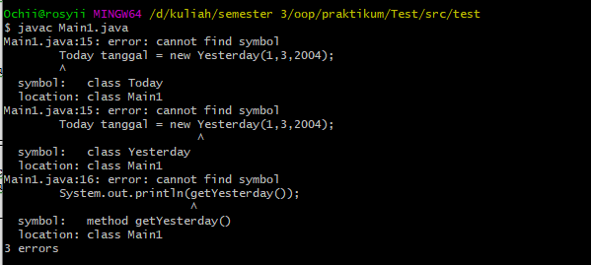

1. Postest 2
2. Listing

public abstract class BangunDatar{

public abstract double Luas();

public abstract double Keliling();

}

public class Persegi extends BangunDatar{

public double sisi;

public Persegi(int sisi){

this.sisi=sisi;

}

public double Luas(){

return this.sisi * this.sisi;

}

public double Keliling(){

return 4*this.sisi;

}

}

public class PersegiPanjang extends BangunDatar{

public double panjang;

public double lebar;

public PersegiPanjang(double pjg, double lbr){

this.panjang=pjg;

this.lebar=lbr;

}

public double Luas(){

return this.panjang * this.lebar;

}

public double Keliling(){

return 2*(this.panjang+this.lebar);

}

}

public class Segitiga extends BangunDatar{

public double s;

public double a;

public double b;

public double c;

public Segitiga(double a, double b, double c){

this.a=a;

this.b=b;

this.c=c;

this.s=(a+b+c)/2;

}

public double Luas(){

return Math.sqrt(this.s * (this.s-this.a)*(this.s -this.b)*(this.s - this.c));

}

public double Keliling(){

return this.a+this.b+this.c;

}

}

public class Tes{

public static void main(String Args[]) {

BangunDatar bangun1 = new Persegi(4);

BangunDatar bangun2 = new PersegiPanjang(4,10);

BangunDatar bangun3 = new Segitiga(4,5,6);

System.out.println("Persegi");

System.out.println("Luas : "+bangun1.Luas());

System.out.println("Keliling : "+bangun1.Keliling());

System.out.println("Persegi Pnajang");

System.out.println("Luas : "+bangun2.Luas());

System.out.println("Keliling : "+bangun2.Keliling());

System.out.println("Segitiga");

System.out.println("Luas : "+bangun3.Luas());

System.out.println("Keliling : "+bangun3.Keliling());

}

}

1. Ouput

