HELP University

Muslimah Fashion Shopping Website

Nursyahimah binti Jalil (B1301811)

Maisha Nawaz (B1601269)

**Introduction**

**Background**

Nowadays, women also playing a big role in their career while handling responsibilities towards family. This situation will lead to insufficient time for women to keep updated with current fashion trends. This is because they do not have much time to go to physical boutique and spending money on travel cost.

Not only that, they have to face the crowds and waiting for a long time to use the fitting room or even to make payment in famous boutique. This will lead to frustration.

In order to get the best deals, women usually will go to the different boutique to make comparison on the price and quality. This is tiresome to shop from one location and transfer to another location. What is worse is that there are no available stocks for the item they want to buy.

We want to focus on developing for Muslim women shopping website is because it is quite hard nowadays to find a physical boutique selling for clothing that follow the syariah compliance.

Therefore, we personally think that web-based solution is one of the best way to develop our Muslimah Fashion Shopping platform to fulfilled the needs of Muslim women. This is because they can keep following the latest trends while dressing up according to syariah compliance conveniently.

**Objectives**

The main objective of this shopping online web page are :

1. To provide an effective online shopping platform for Muslimah.
2. To give satisfaction for user experience in online shopping.
3. To provide variety of choices for Muslim Women to shop.
4. To allow the Muslim Women to shop anywhere and anytime.

**Requirements definition**

**Functional Requirements**

1. The Muslimah Shopping online website shall be allow for the customer create an account /sign in by their on personal information such as name,address,email,username,password confirm-password ,contact number.
2. The Muslimah Shopping online website shall be log in by their username and password.
3. The system shall allow customer to create report issues for the any problem for product.
4. The system shall allow customer check the track order number for this product whether delivered or not.
5. The system shall allow Customer to buy variety muslimah dress with maintain their religion.
6. This system shall allow admin to edit, delete and update this website anytime .

**Non-functional. Requirements**

1) Interoperability

* 1. The Muslimah Shopping online website shall be accessible by using different web browser such as Google Chrome, Safari and Internet Explorer.

2) Data integrity

1. All the details of the customer in their profile such as name, address and contact number must be enclosed to protect their privacy.
   1. User cannot view other user’s profile.

3) Availability

1. The Muslimah Shopping online website should be available anytime and anywhere regardless of their access time and place (24 hours per day/7days per week).

4) Performance

1. The user/customer should be able to view the whole page during the first visit less than 10 seconds.
2. The user/customer should be able to get response from the website once click any button or navigation less than 1 second. Faster response time to increase the efficiency of the website so that the customer will not get upset or frustrated with the service.

5) Security

1. Only administrator has authority to make changes or update on the web page.
2. Only registered user can make purchase and track their order.
3. Every user have their own unique password to protect their account.

6) Usability

1. The language used throughout the webpage shall be English since it is universal and can be understandable by many people.]
2. The design of the webpage should be simple and not complicated for the user to experience a user friendly website.

7) Recoverability

1. If there is any error or failure on the system, it should be automatically recovered by backup system within less than 1 hour.

**Requirements specification**

**Use Case Diagram**

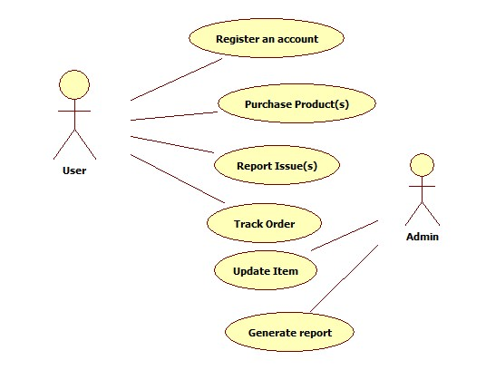

**Use Cases**

|  |  |
| --- | --- |
| **Use Case** | Register an account |
| **Actors** | User |
| **Description** | This use case begins when the user wants create a profile account in the Muslimah Shopping Website. Details such as username, email,password,confirm password,contact number, gender, date of birth and address need to be enter in the system before clicking the “Sign Up” button to register |

|  |  |
| --- | --- |
| **Use Case** | Purchase Products |
| **Actors** | User |
| **Description** | This use case begins when the user interested to buy any products from the Muslimah Shopping Website after browsing the catalog.The user have to select the quantity,size and click “Add to Cart” to save the products they want. The user have to make payment after confirm the order. |

|  |  |
| --- | --- |
| **Use Case** | Report issues |
| **Actors** | User |
| **Description** | This use case begins when the user wants to make any report of the product they had purchase .If the product have any problem or issues, they can directly click the “Report Issue(s) button and fill in the form. Not only that , they also can give recommendations regarding our system. |

|  |  |
| --- | --- |
| **Use Case** | Track order |
| **Actors** | User |
| **Description** | This use case begins when the user want to track the parcel of their purchase item whether it is already delivered or not. The user also can get their tracking number from here. |

|  |  |
| --- | --- |
| **Use Case** | Update Item |
| **Actors** | Admin |
| **Description** | This use case begins when the admin of this system wants to update any item or products from the catalog. They can edit the product name, quantity, color or status of the item. |

|  |  |
| --- | --- |
| **Use Case** | Generate report |
| **Actors** | Admin |
| **Description** | This use case begins when the admin want to generate report based on certain condition. The admin can choose to generate report of the sales by week,months or year. Not only that the admin can also generate report of the sales by different kinds of product. |

**Expanded Use Cases**

|  |  |
| --- | --- |
| **Use Case 1** | Register an account |
| **Goal in Context** | To allow the users to sign-up for the Muslimah Shopping Website and having personal account. |
| **Primary Actor**  **Secondary Actor** | User  - |
| **Trigger** | The user open the website and sign up to register. |
| **Related Use Cases** | - |
| **Actor Action** | **System Response** |
| 1. This use case begins when the user wants to create a profile account in the Muslimah Shopping Website and clicking on sign up button. | 2. The system will display a form. Details such as userName, password, confirmPassword, email, address,contactNo, gender, dateOfBirth is needed to fill in. |
| 3. User input all the details need such as userName, password, confirmPassword, email, address,contactNo, gender, dateOfBirth before clicking the sign up button. | 4. The system will process the data before generate the userID automatically and store all the user information. |
|  | 5. The system will notify the user for success registration. |
| 6. The user can started to use the website with their personal account. |  |
| **Alternative course of events** | |
| Line 3 : The system will prompt the user to re-enter the data if the user fails to fill the data correctly.  Line 4: If the userName or email already existed, the system will give the notification to directly login into the system. | |

|  |  |
| --- | --- |
| **Use Case 2** | Purchase Products |
| **Goal in Context** | To allow the user to make purchase of our products from the website. |
| **Primary Actor**  **Secondary Actor** | User  - |
| **Trigger** | The user browse the catalog and select the chosen item. |
| **Related Use Cases** | - |
| **Actor Action** | **System Response** |
| 1. This use case begins when the user interested to buy any products from the Muslimah Shopping Website after browsing the catalog. | 2. The system will display the details of the product and allow user to change the quantity and size. |
| 3. User input the quantity and size of the product they want and click “Add to Cart” button to save the item. | 4. The system will store the information and update the cart. Notification is display once the item is added successfully to the shopping cart. |
| 5. The user have to click “View Cart” button to view the chosen item before confirm the order. | 6. The system will display all the chosen item of the customer and calculate the total. |
| 7. The user has to confirm the order. | 8.The system will prompt the user to fill the payment information. |
| 9. The user fill in the payment information and submit it. | 10. The system will process and verify the payment. Order confirmation receipt will be display. |
| **Alternative course of events** | |
| Line 3 : Line 3 is repeated if user want to buy more than one item.  Line 7 : The user can edit the item before confirm the order.  Line 4: If the user fails to enter the payment information correctly ,the system will prompt user to re-enter the information. | |

|  |  |
| --- | --- |
| **Use Case 3** | Generate report |
| **Goal in Context** | To allow the admin to generate report based on certain condition. |
| **Primary Actor**  **Secondary Actor** | Admin  - |
| **Trigger** | The admin need to track the sales by prompting the system to generate sales report |
| **Related Use Cases** | - |
| **Actor Action** | **System Response** |
| 1. This use case begins when the admin want to generate report based on certain condition. |  |
| 2. The admin can choose to generate report of the sales according to time or product. |  |
| 3. The admin can choose the report according to time by daily, weekly, monthly or annually. |  |
| 4.. The admin can choose the report according to listed products. |  |
| 5.. The admin have to click on “Generate Report” to get the information needed | 6. The system will process and display the report. |
| **Alternative course of events** | |
| Line 3 and Line 4 : The admin can choose to select both or either one type of report.  Line 5 : The admin can click “Cancel” to cancel the use case. | |

|  |  |  |
| --- | --- | --- |
| **Use Case 4** | Track Order | |
| **Goal in Context** | To track the status of the parcel. | |
| **Primary Actor**  **Secondary Actor** | Customer | |
| **Trigger** | When the customer wants to know whether their purchase item already delivered or not. | |
| **Related Use Case** | - | |
| **Actor Action** | | **System Response** |
| 1. This use case begins when the user want to track the parcel of their purchase item whether it is already delivered or not. | |  |
| 2. The user have to log in first to view their personal account and click to “Track order”tab navigation | | 3. The system will display the status,deliveryDate, of the parcel according to the tracking number. |
| Alternative Course of Events | | |
| Line 3: “No item ordered” will be display if the user do not make any purchase. | | |

|  |  |  |
| --- | --- | --- |
| **Use Case 5** | Update Item | |
| **Goal in Context** | To allow the Admin to make update on the catalog of the products. | |
| **Primary Actor**  **Secondary Actor** | Admin | |
| **Trigger** | When Admin want to update information. | |
| **Typical Course of Events** | | |
| **Actor Action** | | **System Response** |
| 1. This use case begins when the admin of this system wants to update any item or products from the catalog. | |  |
| 2. The admin can edit the product name, quantity, color or stockStatus of the item. | |  |
| 3. The admin also can upload new picture of the product. | |  |
| 4. The admin click “Save update” to save the changes | | 5. The system will automatically save the changes made |
| Alternative Course of Events | | |
| Line 3: The admin can click “Cancel” to cancel the use case. | | |

|  |  |  |
| --- | --- | --- |
| **Use Case 6** | Report issues | |
| **Goal in Context** | To allow the user to make any report or issues arise in experiencing the Muslimah Shopping website. | |
| **Primary Actor**  **Secondary Actor** | User | |
| **Trigger** | When the user wants to make any report to the system. | |
| **Typical Course of Events** | | |
| **Actor Action** | | **System Response** |
| 1. This use case begins when the user wants to make any report of the product they had purchase . | |  |
| 2. The user have to login first before making any report. | |  |
| 3. If the product have any problem or issues, they can directly click the “Report Issue(s) button and fill in the form. | |  |
| 4. The user have to submit the form after fill in. | | 5. The system receive the report and take actions within 24hour. |
| **Alternative Course of Events** | | |
| Line 2 : If user do not want to make any report, cancel the use case. | | |

**Analysis Class Diagram**

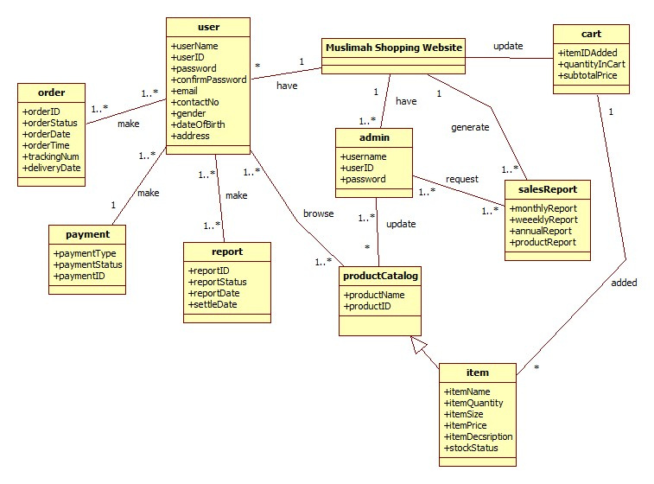

Bibliography

 Bjork,R.(2002).*Analysis Classes*. Retrieved from http://www.math-cs.gordon.edu/courses/cs211/ATMExample/AnalysisClasses.html

Maciaszek, L.A. (2007). *Requirements Analysis and System Design*. Retrieved from http://www.dcs.bbk.ac.uk/~roman/isc/slides/OnlineShoppingBackground.pdf