Merging directions: (see Handbook Page 18):

1. Accident data: accident + vehicle + occupant;
2. Accident <-> Roadlog:
   1. (RD_INV, MILEPOST) <-> (ROAD_INV, BEGMP, ENDMP)
3. With other files:
   1. _INV variables <-> _INV variables
   2. MILEPOST <-> (BEGMP, ENDMP)

CURVE and GRADE file (see Handbook Page 14):

1. CURVE file:

Note that when the curve file is merged with the Roadlog File to put curvature variables on the roadway sections, 70 to 80 percent of the roadway sections will show missing degree of curve and other variables. These "missing sections" actually denote tangent sections where the degree of curve is zero. This should be anticipated and handled by the analyst;

1. GRADE file:

The Grade File contains approximately 34,200 records. In addition to beginning and ending milepoint, the Grade File contains information on the percent grade, direction ("+" or ""), and length. In addition, the file contains information concerning "Grade Type," which denotes whether the downstream end of the grade is an angle point (i.e., a minor change in grade without a vertical curve) or is connected to the succeeding grade with a vertical curve.

|  |  |  |  |
| --- | --- | --- | --- |
| **Variable Name** | **Description** | **File** | **Format** |
|  |  |  |  |
| FORM_REPT_NO | TRAFFIC COLLISION REPORT FORM NUMBER | Accident | CHA(7) |
| State_Plane_X | X COORDS IN WA PLANE | Accident |  |
| State_Plane_Y | Y COORDS IN WA PLANE | Accident |  |
| rd_inv | ROADWAY INVENTORY | Accident | CHA(11) |
| milepost | ACCUM ROUTE MILEPOST (ARM) | Accident | NUM |
| CASENO | CASE NUMBER | Accident | CHA(10) |
| ACCYR | ACCIDENT YEAR | Accident | CHA(4) |
| RTE_NBR | STATE ROUTE NUMBER | Accident | CHA(3) |
| COUNTY | COUNTY NUMBER | Accident | CHA(2) |
| CITY | CITY NUM | Accident | CHA(2) |
| rur_urb | RURAL URBAN INDICATOR | Accident | CHA(1) |
| FUNC_CLS | FUNCTIONAL CLASS | Accident | CHA(2) |
| MONTH | ACC MONTH | Accident | CHA(2) |
| DAYMTH | ACC DAY OF MONTH | Accident | CHA(2) |
| WEEKDAY | DAY OF WEEK | Accident | CHA(1) |
| ACCTYPE | ACC TYPE | Accident | CHA(4) |
| REPORT | ACC SEVERITY | Accident | CHA(1) |
| SEVERITY | MOST SEVERE INJURY | Accident | CHA(1) |
| loc_type | ACC LOCATION TYPE | Accident | CHA(1) |
| RD_CHAR1 | ROADWAY CHARACTERISTICS | Accident | CHA(1) |
| RDSURF | ROADWAY SURFACE | Accident | CHA(1) |
| RD_REL | ON/OFF ROAD | Accident | CHA(1) |
| LIGHT | LIGHT CONDITION | Accident | CHA(1) |
| intent | INTENTIONAL ACTION | Accident | CHA(1) |
| loc_char | LOCATION CHARACTERISTICS | Accident | CHA(1) |
| weather | WEATHER CONDITION | Accident | CHA(1) |
|  |  |  |  |
| curv_inv | STATE RTE TYPE ID | Curve | CHA(11) |
| DIR_CURV | HORIZ CURVE DIRN | Curve | CHA(1) |
| rte_nbr | ROUTE NUMBER | Curve | CHA(3) |
| begmp | HORIZ CURVE BEGIN MLPOST | Curve | NUM |
| endmp | HORIZ CURVE END MLPOST | Curve | NUM |
| deg_curv | DEGREE OF CURVATURE | Curve | NUM |
|  |  |  |  |
| rte_nbr | ROUTE NUMBER | Grade | CHA(3) |
| grad_inv | STATE RTE TYPE ID | Grade | CHA(11) |
| dir_grad | DIRECTION OF GRADE | Grade | CHA(1) |
| pct_grad | PERCENT GRADE | Grade | NUM |
| begmp | GRADE BEGIN MILEPOST | Grade | NUM |
| endmp | GRADE END MILEPOST | Grade | NUM |
|  |  |  |  |
| CASENO | ACC RPT NUMBER | Occupant | CHA(6) |
| SEATPOS | DRV/OCC SEAT POSITION | Occupant | CHA(1) |
| VEHNO | VEHICLE NUMBER | Occupant | NUM |
|  |  |  |  |
| CASENO | ACC REPORT NUMBER | Vehicle | CHAR(10) |
| DRV_SEX | DRV SEX | Vehicle | CHA(1) |
| DRV_AGE | DRV AGE | Vehicle | CHA(2) |
| drassess | DRUG RECOG EXPERT ASSESS | Vehicle | CHA(1) |
| spdlimit | VEH POSTED SPEED | Vehicle | CHA(2) |
| surf_typ | ROADWAY SURFACE TYPE | Vehicle | CHA(2) |
| contrib1 | DRV CONTRIB CIRCUMS 1 | Vehicle | CHA(2) |
| contrib2 | DRV CONTRIB CIRCUMS 2 | Vehicle | CHA(2) |
| Intox | DRV SOBRIETY | Vehicle | CHA(1) |
| Stolen | VEH STOLEN | Vehicle | CHA(1) |
| vehcond1 | VEH DEFECT 1 | Vehicle | CHA(2) |
| vehcond2 | VEH DEFECT 2 | Vehicle | CHA(2) |
| vehcond3 | VEH DEFECT 3 | Vehicle | CHA(2) |
| com_body | COMM CARRIER CARGO BODY | Vehicle | CHA(1) |
| cdplaccd | COMM CARRIER PLACARD | Vehicle | CHA(1) |
| vehno | VEH NUMBER | Vehicle | NUM |
|  |  |  |  |
| LSHL_TYP | LEFT SHOULDER TYPE RD1 | Roadlog | CHA(1) |
| MED_TYPE | MEDIAN TYPE | Roadlog | CHA(1) |
| RD_LIGHT | INTERSECTION ILLUM-ND | Roadlog | CHA(1) |
| RSHL_TYP | RIGHT SHOULDER TYPE RD1 | Roadlog | CHA(1) |
| RURURB | RURAL URBAN | Roadlog | CHA(1) |
| SURF_TYP | SURFACE TYPE RD1 | Roadlog | CHA(1) |
| EW_IND | EAST WEST IND | Roadlog | CHA(1) |
| COUNTY | COUNTY NUMBER | Roadlog | CHA(2) |
| FUNC_CLS | FEDERAL FUNC CLASS | Roadlog | CHA(2) |
| RTE_NBR | ROUTE NUMBER | Roadlog | CHA(3) |
| CITY | CITY NUMBER | Roadlog | CHA(4) |
| ROAD_INV | ROUTE TYPE ID | Roadlog | CHA(11) |
| SPD_LIMT | LEGAL SPEED LIMIT | Roadlog | NUM |
| BEGMP | BEGIN MILEPOST | Roadlog | NUM |
| ENDMP | CALCULATED ENDING MILEPOST | Roadlog | NUM |
| ACSEQ_NB | ACC SEQ NUM | Roadlog | NUM |
| LSHLDWID | LEFT SHOULDER WIDTH RD1 | Roadlog | NUM |
| MEDWID | MEDIAN WIDTH | Roadlog | NUM |
| NO_LANES | TOTAL NUMBER OF LANES | Roadlog | NUM |
| RSHLDWID | RIGHT RD1  SHOULDER WIDTH | Roadlog | NUM |
| Lanewid | CALCULATED LANE WIDTH | Roadlog | NUM |
| rdwy_wid | TOTAL ROADWAY WIDTH | Roadlog | NUM |
| AADT | AVER ANNUAL DAILY TRAFFIC | Roadlog | NUM |
| mvmt | MILLION VEH MILES TRAVELLED | Roadlog | NUM |

Accident variables:

1. Weather

1. LightA screenshot of a cell phone

   Description automatically generated
2. SEVERITY

1. REPORT

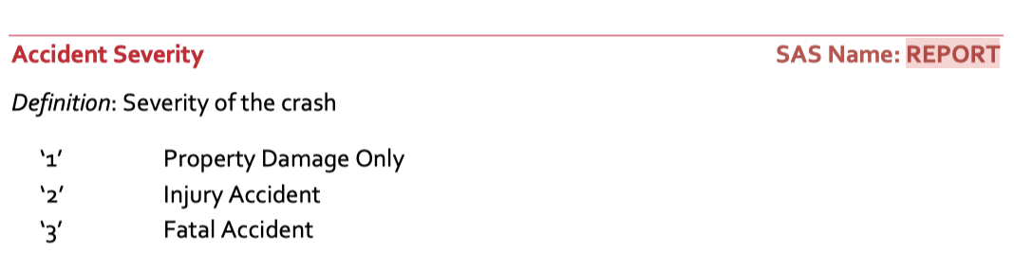

1. LOC_CHAR

1. MILEPOST



1. RUR_URB

1. RTE_NBR

1. RDSURF

CURV variables:

1. CURV_INV

1. RTE_NBR

1. DEG_CURV

GRADE variables:

1. RTE_NBR

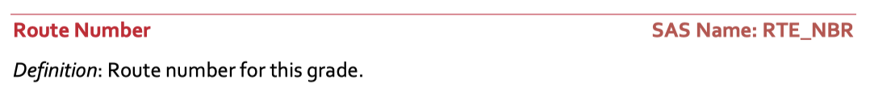

1. GRAD_INV

1. DIR_GRAD

1. PCT_GRAD

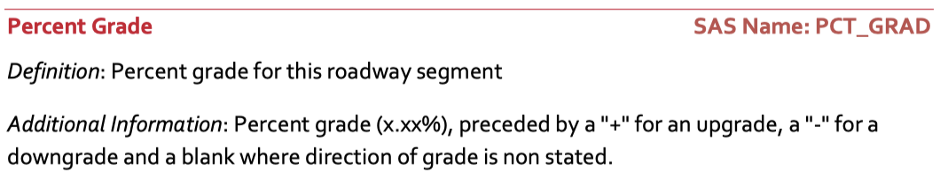

OCCUPANT variables:

1. SEATPOS

ROAD variables:

1. LSHL_TYP

1. MED_TYPE

1. RSHL_TYP

1. RURURB

1. FUNC_CLS

1. RTE_NBR

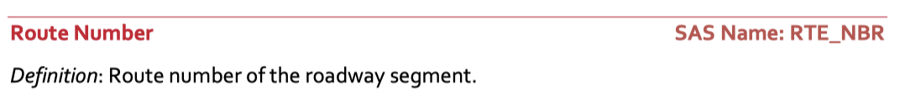

1. ROAD_INV



1. LSHLDWID

1. NO_LANES

1. LANEWID

1. RDWY_WID

1. AADT

1. MVMT



VEHICLE variables:

1. DRV_SEX:

1. DRV_AGE:

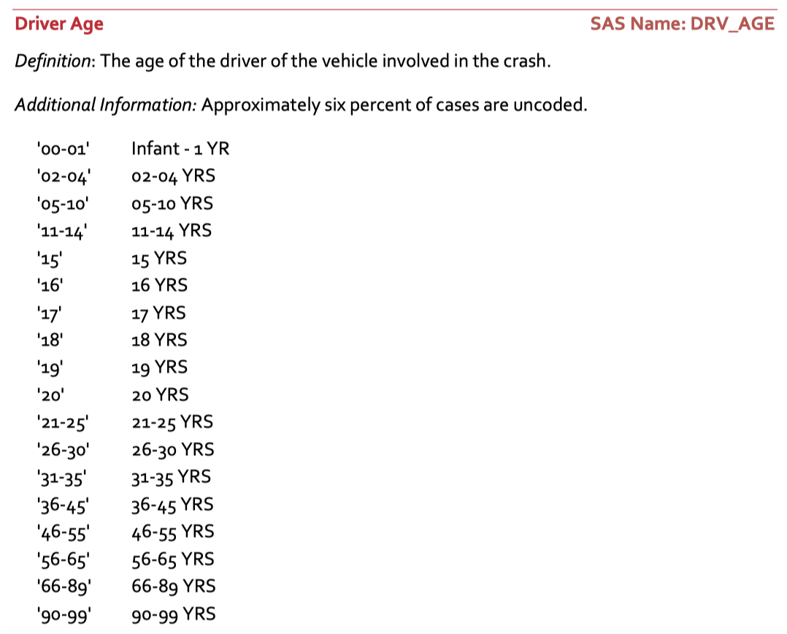

1. DRASSES

1. INTOX:

1. VEHCOND1

