# Petri Nets

# Task 1

For each of the following Petri Nets determine, if the net is safe, live,

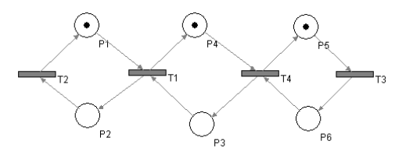

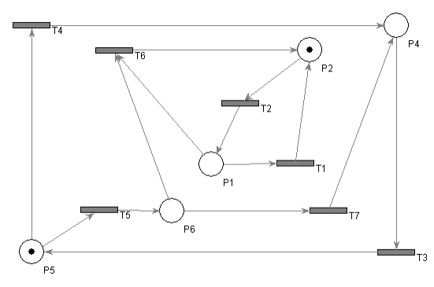

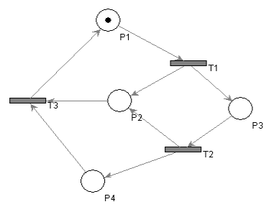

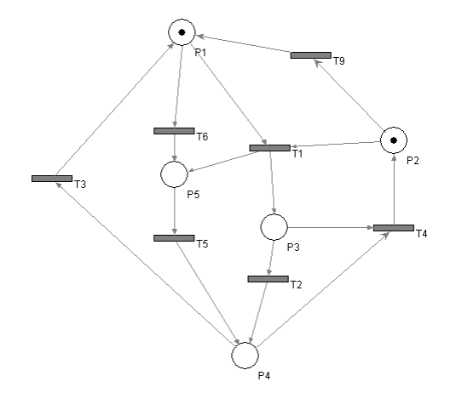

# Task 2

Model the following process as a Petri Net. Use http://pipe2.sourceforge.net/

Change management process starts with the customer registering a change request. The change requests is then reviewed in parallel by the analyst and designer - they will specify the scope of the change and amount of work required to introduce it. The lead programmer will then estimate the cost of introducing the change based on their inputs. The customer will be notified about the estimate and will have to decide, whether the change will be introduced or not. If he decides not to introduce it, the process ends now. If agrees to the price, the programming team develops the change. Then it has to be tested and accepted by the customer, and the process ends.