Practical No:10
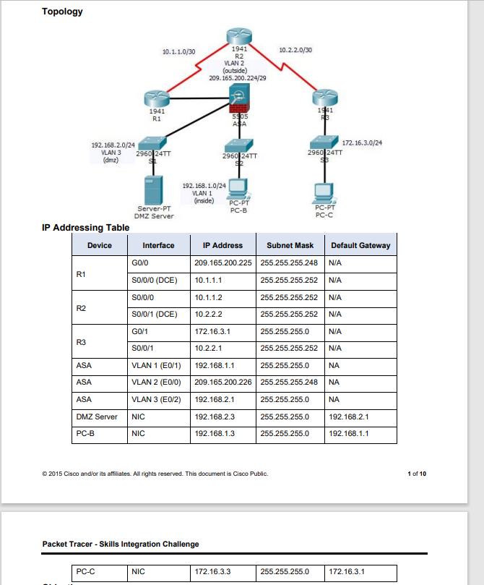

VLAN
on ASA
enable
configure terminal
interface vlan 1
nameif inside
ip address 192.168.1.1 255.255.255.0
security-level 100
no shutdown
exit
interface ethernet0/1
switchport access vlan 1
no shutdown

conf t
route outside 0.0.0.0 0.0.0.0 209.165.200.225
object network inside-net
subnet 192.168.1.0 255.255.255.0
nat (inside,outside) dynamic interface
end

conf t
class-map inspection_default
match default-inspection-traffic
exit
policy-map global_policy
class inspection_default
inspect icmp
service-policy global_policy global
exit

- Configuring DHCP, AAA, SSH
DHCP
dhcpd address 192.168.1.5-192.168.1.36 inside
dhcpd dns 209.165.201.2 interface inside
dhcpd enable inside

SSH
username admin password admin1
aaa authentication ssh console LOCAL
crypto key generate rsa module 1024
crypto key generate rsa modulus 1024
ssh 192.168.1.0 255.255.255.0 inside
ssh 172.16.3.3 255.255.255.255 outside
ssh timeout 10

- Creating DMZ VLAN
interface vlan 3
ip address 192.168.2.1 255.255.255.0
no forward interface vlan 1
nameif dmz
security-level 70
exit
interface ethernet 0/2
switchport access vlan 3
exit
show interface ip brief

- Creating object for dmz-server (nat)
conf t
object network dmz-server
host 192.168.2.3
nat (dmz,outside) static 209.165.200.227
exit

access-list OUTSIDE-DMZ permit icmp any host 192.168.2.3
access-list OUTSIDE-DMZ permit tcp any host 192.168.2.3 eq 80
access-group OUTSIDE-DMZ in interface outside

pcb to pcc allowed
pcb to server allwed
pcc to pcb not allowed
sever to pcb not allowed

