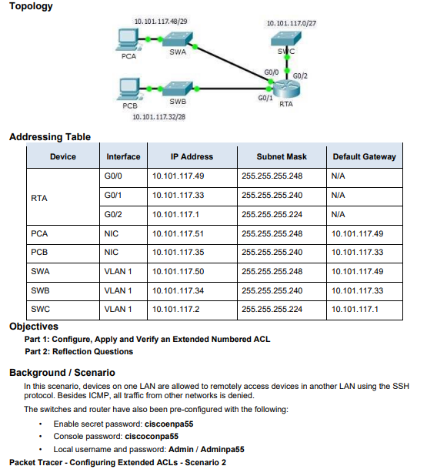

Router>en
Router#conf t
Enter configuration commands, one per line. End with CNTL/Z.
Router(config)#interface g0/0
Router(config-if)#ip address 10.101.117.49 255.255.255.248
Router(config-if)#no shutdown

Router(config-if)#exit
Router(config)#
Router(config)#interface g0/1
Router(config-if)#ip address 10.101.117.33 255.255.255.240
Router(config-if)#no shutdown
Router(config-if)#exit
Router(config)#
Router(config)#interface g0/2
Router(config-if)#ip address 10.101.117.1 255.255.255.224
Router(config-if)#no shutdown
Router(config-if)#exit

Access-list:
Router(config)#access-list 199 permit tcp 10.101.117.32 0.0.0.15 10.101.117.0 0.0.0.31 eq 22
Router(config)#access-list 199 permit icmp any any
Router(config)#interface g0/2
Router(config-if)#ip access-group 199 out
Router(config-if)#exit
Router(config)#end
Router#write memory
Router#write memory

Swa
Switch>en
Switch#conf t
Switch(config)#hostname SWA
SWA(config)#
SWA(config)#interface vlan 1
SWA(config-if)#ip address 10.101.117.50 255.255.255.248
SWA(config-if)#no shutdown
SWA(config-if)#exit
SWA(config)#
SWA(config)#ip default-gateway 10.101.117.49
SWA(config)#
SWA(config)#enable secret ciscoenpa55
SWA(config)#line console 0
SWA(config-line)#password ciscoconpa55
SWA(config-line)#login
SWA(config-line)#end
SWA#write memory

Swb
Switch>enable
Switch#configure terminal
Enter configuration commands, one per line. End with CNTL/Z.
Switch(config)#hostname SWB
SWB(config)#
SWB(config)#interface vlan 1
SWB(config-if)#ip address 10.101.117.34 255.255.255.240
SWB(config-if)#no shutdown

SWB(config-if)#exit
SWB(config)#
SWB(config)#ip default-gateway 10.101.117.33
SWB(config)#
SWB(config)#ip domain-name network.com
SWB(config)#username Admin secret Adminpa55
SWB(config)#
SWB(config)#crypto key generate rsa
How many bits in the modulus [512]: 1024

SWB(config)#
SWB(config)#line vty 0 4
SWB(config-line)#login local
SWB(config-line)#transport input ssh
SWB(config-line)#
SWB(config-line)#enable secret ciscoenpa55
SWB(config)#line console 0
SWB(config-line)#password ciscoconpa55
SWB(config-line)#login
SWB(config-line)#end
SWB#write memory

Swc
Switch>enable
Switch#configure terminal
Enter configuration commands, one per line. End with CNTL/Z.
Switch(config)#hostname SWC
SWC(config)#
SWC(config)#interface vlan 1
SWC(config-if)#ip address 10.101.117.2 255.255.255.224
SWC(config-if)#no shutdown

SWC(config-if)#exit
SWC(config)#
SWC(config)#ip default-gateway 10.101.117.1
SWC(config)#
SWC(config)#ip domain-name network.com
SWC(config)#username Admin secret Adminpa55
SWC(config)#
SWC(config)#crypto key generate rsa

How many bits in the modulus [512]: 1024

SWC(config)#
*Mar 1 0:9:25.918: %SSH-5-ENABLED: SSH 1.99 has been enabled
SWC(config)#line vty 0 4
SWC(config-line)#login local
SWC(config-line)#transport input ssh
SWC(config-line)#
SWC(config-line)#enable secret ciscoenpa55
SWC(config)#line console 0
SWC(config-line)#password ciscoconpa55
SWC(config-line)#login
SWC(config-line)#end
SWC#write memory

pcb
ping 10.101.117.2
ssh -l Admin 10.101.117.2 pass: Adminpa55
allowed

pca
ping 10.101.117.2
allowed
ssh -l Admin 10.101.117.2
not allowed

