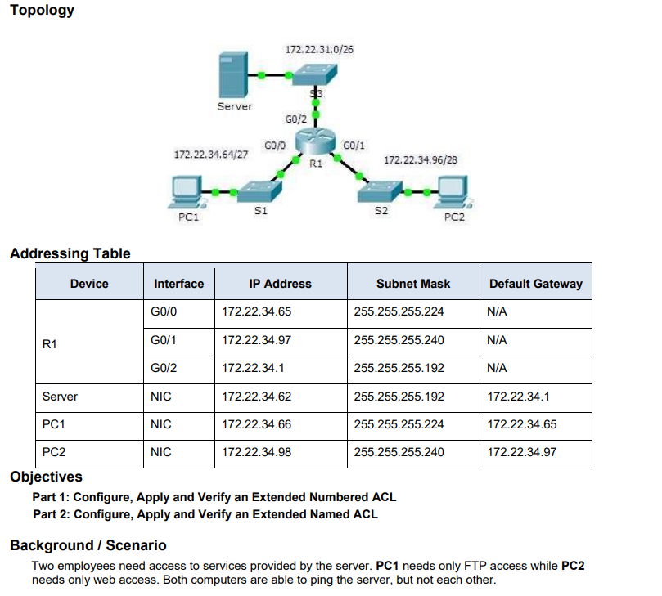

Router>en
Router#conf t
Enter configuration commands, one per line. End with CNTL/Z.
Router(config)#enable
% Incomplete command.
Router(config)#configure terminal
^
% Invalid input detected at '^' marker.
Router(config)#
Router(config)#interface gigabitEthernet0/0
Router(config-if)#ip address 172.22.34.65 255.255.255.224
Router(config-if)#no shutdown

Router(config-if)#exit
Router(config)#
Router(config)#interface gigabitEthernet0/1
Router(config-if)#ip address 172.22.34.97 255.255.255.240
Router(config-if)#no shutdown

Router(config-if)#exit
Router(config)#
Router(config)#interface gigabitEthernet0/2
Router(config-if)#ip address 172.22.34.1 255.255.255.192
Router(config-if)#no shutdown

Router(config-if)#exit
Router(config)#
Router(config)#end
Router#write memory
%LINK-5-CHANGED: Interface GigabitEthernet0/0, changed state to up

%LINEPROTO-5-UPDOWN: Line protocol on Interface GigabitEthernet0/0, changed state to up

%LINK-5-CHANGED: Interface GigabitEthernet0/1, changed state to up

%LINEPROTO-5-UPDOWN: Line protocol on Interface GigabitEthernet0/1, changed state to up

%LINK-5-CHANGED: Interface GigabitEthernet0/2, changed state to up

%LINEPROTO-5-UPDOWN: Line protocol on Interface GigabitEthernet0/2, changed state to up

%SYS-5-CONFIG_I: Configured from console by console

Building configuration...
[OK]
Router#
Router#conf t
Enter configuration commands, one per line. End with CNTL/Z.
Router(config)#access-list 101 permit tcp host 172.22.34.66 host 172.22.34.62 eq ftp
Router(config)#access-list 101 permit icmp host 172.22.34.66 host 172.22.34.62
Router(config)#access-list 101 permit tcp host 172.22.34.98 host 172.22.34.62 eq www
Router(config)#access-list 101 permit icmp host 172.22.34.98 host 172.22.34.62
Router(config)#access-list 101 deny icmp host 172.22.34.66 host 172.22.34.98
Router(config)#access-list 101 deny icmp host 172.22.34.98 host 172.22.34.66
Router(config)#access-list 101 permit ip any any
Router(config)#interface g0/0
Router(config-if)#ip access-group 101 in
Router(config-if)#exit
Router(config)#interface g0/1
Router(config-if)#ip access-group 101 in
Router(config-if)#exit
Router(config)#

