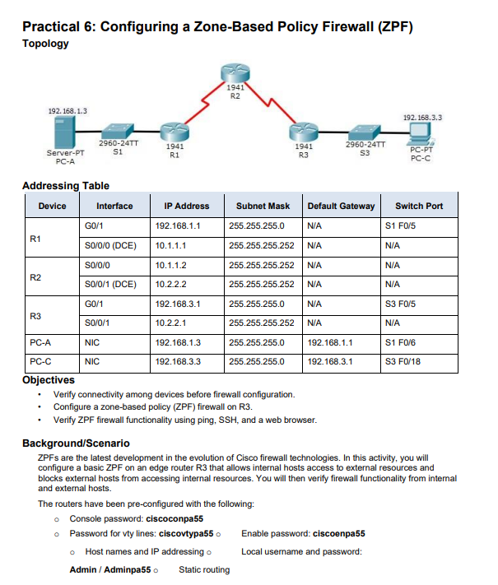

R1
Router>enable
Router#configure terminal
Router(config)#hostname R1
R1(config)#
R1(config)#interface g0/1
R1(config-if)#ip address 192.168.1.1 255.255.255.0
R1(config-if)#no shutdown
R1(config-if)#exit
R1(config)#interface s0/0/0
R1(config-if)#ip address 10.1.1.1 255.255.255.252
R1(config-if)#clock rate 64000
R1(config-if)#no shutdown
R1(config-if)#exit
R1(config)#
R1(config)#ip route 192.168.3.0 255.255.255.0 10.1.1.2
R1(config)#
R1(config)#end
R1#write memory

R2
Router>enable
Router#configure terminal
Router(config)#hostname R2
R2(config)#
R2(config)#interface s0/0/0
R2(config-if)#ip address 10.1.1.2 255.255.255.252
R2(config-if)#no shutdown
R2(config-if)#exit
R2(config)#
R2(config)#interface s0/0/1
R2(config-if)#ip address 10.2.2.2 255.255.255.252
R2(config-if)#clock rate 64000
R2(config-if)#no shutdown
R2(config-if)#exit
R2(config)#
R2(config)#ip route 192.168.1.0 255.255.255.0 10.1.1.1
R2(config)#ip route 192.168.3.0 255.255.255.0 10.2.2.1
R2(config)#
R2(config)#end
R2#write memory

R3
Router>enable
Router#configure terminal
Router(config)#hostname R3
R3(config)#
R3(config)#interface g0/1
R3(config-if)#ip address 192.168.3.1 255.255.255.0
R3(config-if)#no shutdown
R3(config-if)#exit
R3(config)#
R3(config)#interface s0/0/1
R3(config-if)#ip address 10.2.2.1 255.255.255.252
R3(config-if)#no shutdown

R3(config-if)#exit
R3(config)#
R3(config)#ip route 192.168.1.0 255.255.255.0 10.2.2.2
R3(config)#
R3(config)#end
R3#write memory

Ospf:
R1
R1>enable
R1#configure terminal
Enter configuration commands, one per line. End with CNTL/Z.
R1(config)#
R1(config)#router ospf 1
R1(config-router)#network 192.168.1.0 0.0.0.255 area 0
R1(config-router)#network 10.1.1.0 0.0.0.3 area 0
R1(config-router)#exit
R1(config)#
R1(config)#end

R2
R2>enable
R2#configure terminal
Enter configuration commands, one per line. End with CNTL/Z.
R2(config)#
R2(config)#router ospf 1
R2(config-router)#network 10.1.1.0 0.0.0.3 area 0
R2(config-router)#network 10.2.2.0 0.0.0.3 area 0
R2(config-router)#exit
R2(config)#
R2(config)#end
R2#

R3
enable
configure terminal
router ospf 1
network 192.168.3.0 0.0.0.255 area 0
network 10.2.2.0 0.0.0.3 area 0
exit
end

firewall
R3>enable
R3#configure terminal
Enter configuration commands, one per line. End with CNTL/Z.
R3(config)#zone security INSIDE
R3(config-sec-zone)#exit
R3(config)#zone security OUTSIDE
R3(config-sec-zone)#exit
R3(config)#class-map type inspect match-any ALLOWED-PROTOCOLS
R3(config-cmap)#match protocol icmp
R3(config-cmap)#match protocol http
R3(config-cmap)#match protocol https
R3(config-cmap)#match protocol ssh
R3(config-cmap)#exit
R3(config)#policy-map type inspect INSIDE-POLICY
R3(config-pmap)#class type inspect ALLOWED-PROTOCOLS
R3(config-pmap-c)#inspect
R3(config-pmap-c)#exit
R3(config-pmap)#exit
R3(config)#zone-pair security INSIDE-OUTSIDE source INSIDE destination OUTSIDE
R3(config-sec-zone-pair)#service-policy type inspect INSIDE-POLICY
R3(config-sec-zone-pair)#exit
R3(config)#interface g0/1
R3(config-if)#zone-member security INSIDE
R3(config-if)#exit
R3(config)#
R3(config)#interface s0/0/1
R3(config-if)#zone-member security OUTSIDE
R3(config-if)#exit
R3(config)#

