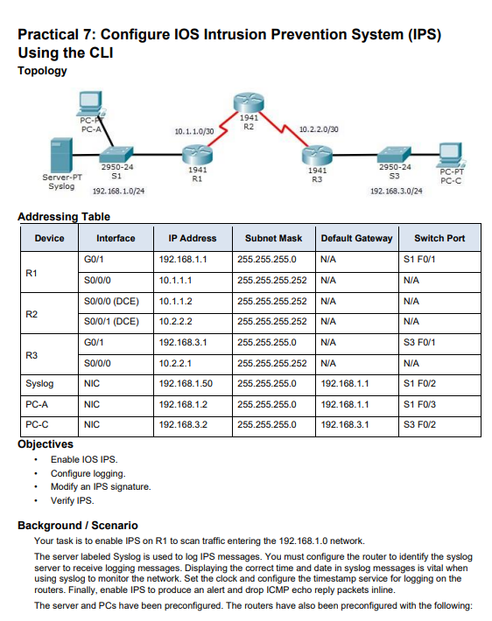

Do rip
Command on r1

Router#mkdir ips
Router#conf t
Router(config)#ip ips config location flash:ips
Router(config)#ip ips name iosips
Router(config)#ip ips notify log
Router(config)#service timestamps log datetime msec
Router(config)#logging host 192.168.1.50
Router(config)#ip ips signature-category
Router(config-ips-category)#category all
Router(config-ips-category-action)#retired true
Router(config-ips-category-action)#ex
Router(config-ips-category)#category ios_ips basic
Router(config-ips-category-action)#retired false
Router(config-ips-category-action)#ex
Router(config-ips-category)#exit
Router(config)#interface gig0/1
Router(config-if)#ip ips iosips out
Router(config-if)#ex
Router(config)#ip ips signature-definition
Router(config-sigdef)#signature 2004 0
Router(config-sigdef-sig)#status
Router(config-sigdef-sig-status)#retired false
Router(config-sigdef-sig-status)#enable true
Router(config-sigdef-sig-status)#ex
Router(config-sigdef-sig)#engine
Router(config-sigdef-sig-engine)#event-action produce-alert
Router(config-sigdef-sig-engine)#event-action deny-packet-inline
Router(config-sigdef-sig-engine)#ex
Router(config-sigdef-sig)#ex
Router(config-sigdef)#ex

