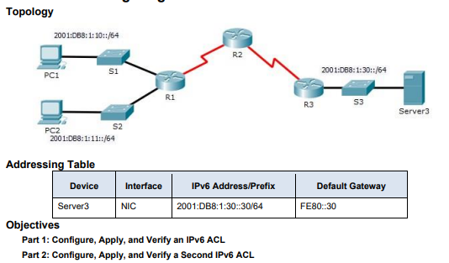
R1
Router>enable
Router#configure terminal
Enter configuration commands, one per line. End with CNTL/Z.
Router(config)#ipv6 unicast-routing
Router(config)#
Router(config)#interface g0/0
Router(config-if)#ipv6 address 2001:DB8:1:10::1/64
Router(config-if)#no shutdown

Router(config-if)#
Router(config-if)#interface g0/1
Router(config-if)#ipv6 address 2001:DB8:1:11::1/64
Router(config-if)#no shutdown

Router(config-if)#
Router(config-if)#interface s0/0/0
Router(config-if)#ipv6 address 2001:DB8:1:12::1/64
Router(config-if)#no shutdown

R2
Router>enable
Router#configure terminal
Enter configuration commands, one per line. End with CNTL/Z.
Router(config)#ipv6 unicast-routing
Router(config)#
Router(config)#interface s0/0/0
Router(config-if)#ipv6 address 2001:DB8:1:12::2/64
Router(config-if)#no shutdown

Router(config-if)#
Router(config-if)#interface s0/0/1
Router(config-if)#ipv6 address 2001:DB8:1:23::1/64
Router(config-if)#no shutdown

Router>enable
Router#configure terminal
Enter configuration commands, one per line. End with CNTL/Z.
Router(config)#ipv6 unicast-routing
Router(config)#
Router(config)#interface s0/0/1
Router(config-if)#ipv6 address 2001:DB8:1:23::2/64
Router(config-if)#no shutdown

Router(config-if)#
Router(config-if)#interface g0/0
Router(config-if)#ipv6 address 2001:DB8:1:30::1/64
Router(config-if)#no shutdown

Ospf
R1
Router>enable
Router#configure terminal
Enter configuration commands, one per line. End with CNTL/Z.
Router(config)#ipv6 unicast-routing
Router(config)#
Router(config)#ipv6 router ospf 10
Router(config-rtr)#router-id 1.1.1.1
Router(config-rtr)#exit
Router(config)#
Router(config)#interface g0/0
Router(config-if)#ipv6 ospf 10 area 0
Router(config-if)#exit
Router(config)#
Router(config)#interface g0/1
Router(config-if)#ipv6 ospf 10 area 0
Router(config-if)#exit
Router(config)#
Router(config)#interface s0/0/0
Router(config-if)#ipv6 ospf 10 area 0
Router(config-if)#exit
Router(config)#
Router(config)#end
Router#
%SYS-5-CONFIG_I: C

R2
Router>enable
Router#configure terminal
Enter configuration commands, one per line. End with CNTL/Z.
Router(config)#ipv6 unicast-routing
Router(config)#
Router(config)#ipv6 router ospf 10
Router(config-rtr)#router-id 2.2.2.2
Router(config-rtr)#exit
Router(config)#
Router(config)#interface s0/0/0
Router(config-if)#ipv6 ospf 10 area 0
Router(config-if)#exit
Router(config)#
Router(config)#interface s0/0/1
Router(config-if)#ipv6 ospf 10 area 0
Router(config-if)#exit
Router(config)#
Router(config)#end
00:53:20: %OSPFv3-5-ADJCHG: Process 10, Nbr 1.1.1.1 on Serial0/0/0 from LOADING to FULL, Loading Done

Router#
%SYS-5-CONFIG_I: Configured from console by console

R3
Router>enable
Router#configure terminal
Enter configuration commands, one per line. End with CNTL/Z.
Router(config)#ipv6 unicast-routing
Router(config)#
Router(config)#ipv6 router ospf 10
Router(config-rtr)#router-id 3.3.3.3
Router(config-rtr)#exit
Router(config)#
Router(config)#interface s0/0/1
Router(config-if)#ipv6 ospf 10 area 0
Router(config-if)#exit
Router(config)#
Router(config)#interface g0/0
Router(config-if)#ipv6 ospf 10 area 0
Router(config-if)#exit
Router(config)#
Router(config)#end
Router#
%SYS-5-CONFIG_I: Configured from console by console

Acl
Router>enable
Router#configure terminal
Enter configuration commands, one per line. End with CNTL/Z.
Router(config)#ipv6 access-list BLOCK_PC1
Router(config-ipv6-acl)#deny ipv6 2001:DB8:1:10::/64 2001:DB8:1:30::/64
Router(config-ipv6-acl)#permit ipv6 any any
Router(config-ipv6-acl)#exit
Router(config)#interface g0/0
Router(config-if)#ipv6 traffic-filter BLOCK_PC1 out
Router(config-if)#exit
Router(config)#end
Router#
%SYS-5-CONFIG_I: Configured

