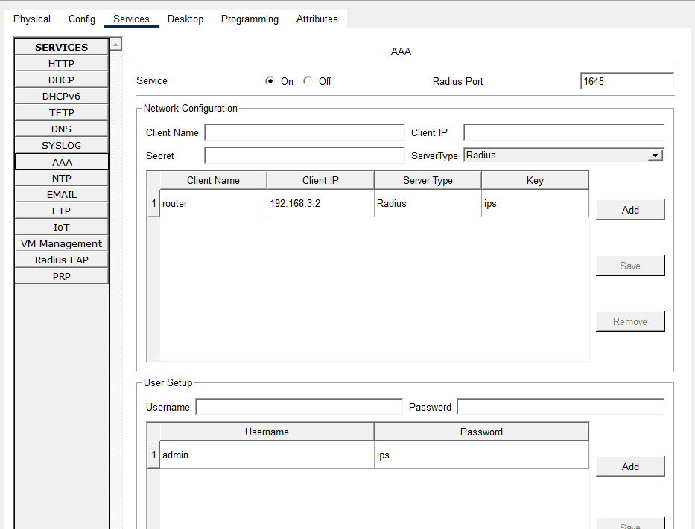
RADIUS Server: 192.168.3.1
Router: 192.168.3.2
Key: ips

enable
configure terminal
aaa new-model
radius-server host 192.168.3.1 key ips
aaa authentication login default group radius local
username admin privilege 15 secret ips
interface gigabitEthernet0/0
ip address 192.168.3.2 255.255.255.0
no shutdown
exit
hostname Router
ip domain-name example.com
crypto key generate rsa
1024
line vty 0 4
login authentication default
transport input ssh
exit
end
write memory
from pc
ssh -l admin 192.168.3.2
pass:ips

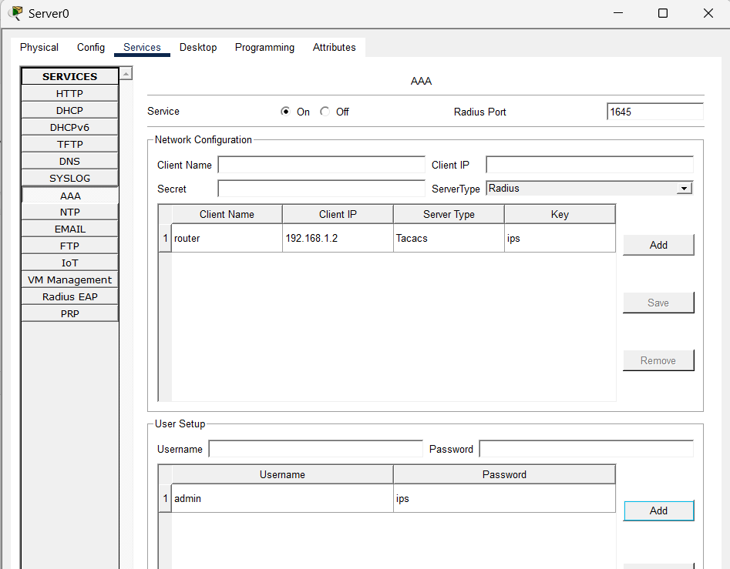

TACACS Server: 192.168.1.1
Router: 192.168.1.2
Key: ips
enable
configure terminal
aaa new-model
tacacs-server host 192.168.1.1 key ips
aaa authentication login default group tacacs+ local
username admin privilege 15 secret ips
interface gigabitEthernet0/0
ip address 192.168.1.2 255.255.255.0
no shutdown
exit
hostname Router
ip domain-name example.com
crypto key generate rsa
1024
line vty 0 4
login authentication default
transport input ssh
exit
end
write memory

from pc
ssh -l admin 192.168.3.2
pass:ips

