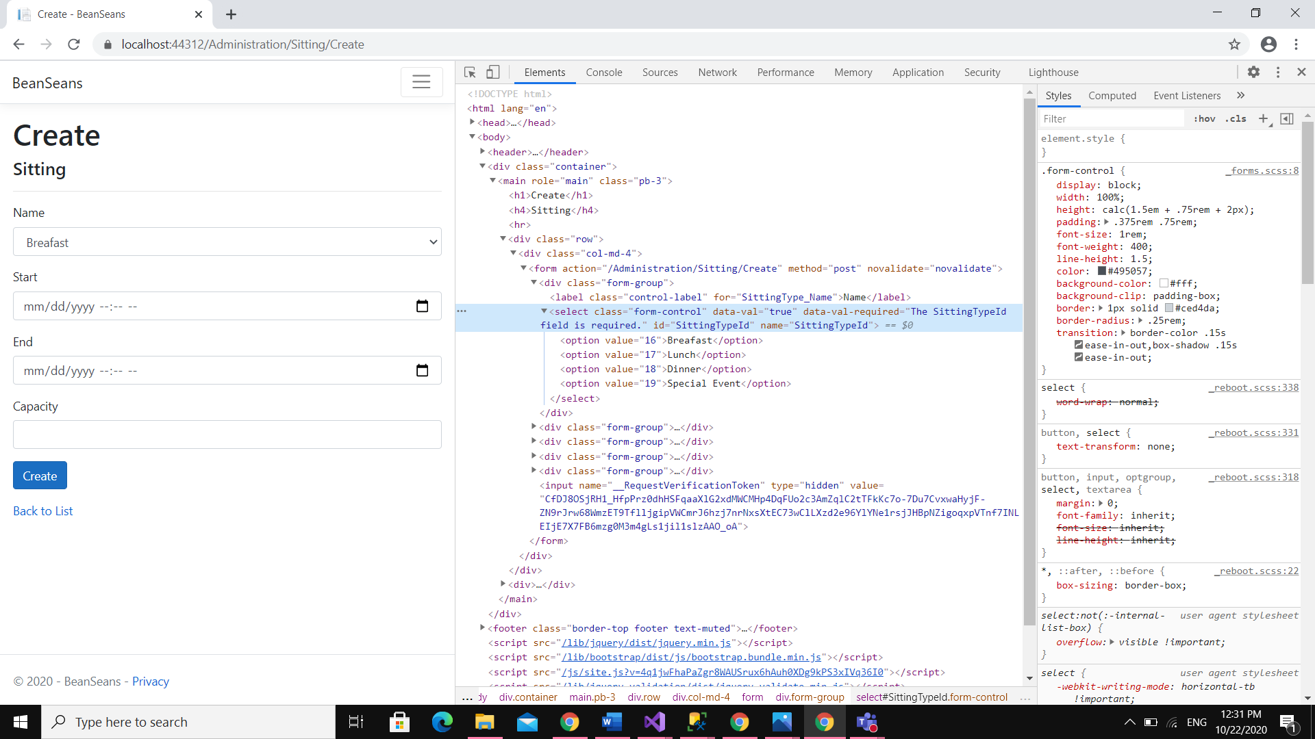

Value==Id, Name==Displayed

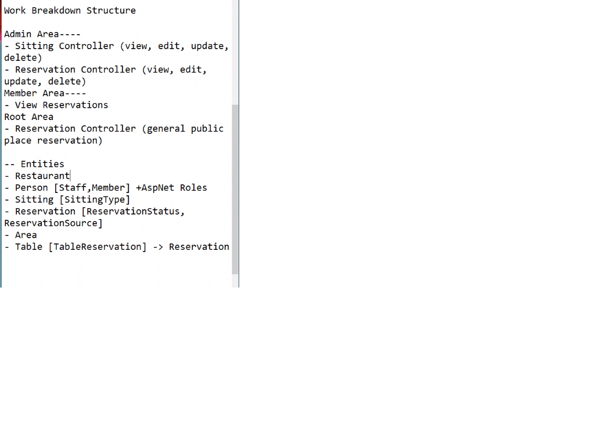Admin-Reservation: all Resevation crud

Member-Reservation: Crud for the reservation

Root-Reservation: crud for own reservation