Test

cz

4/16/2021

Report starts here

## some title

thii heading

include a figure

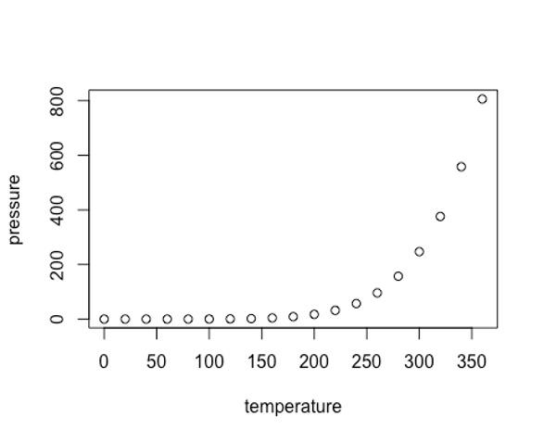

plot