Version 1.0 2025-11-27
Syke

The purpose of this document is to describe the output of the “Compute areas of CORINE classes within shapefile polygons” tool available in Galaxy and AquaINFRA Interaction Platform (AIP, https://aquainfra.ogc.igb-berlin.de/pygeoapi/processes/syke-corine-stats-real-areas).

The output is composed of CSV-files (one for each separate area included in the input shapefile) that contain values in ASCII. An example is available here:

corine_stats_real_areas_Vantaa_testing.xlsx

When opened with Excel, the file looks like this:

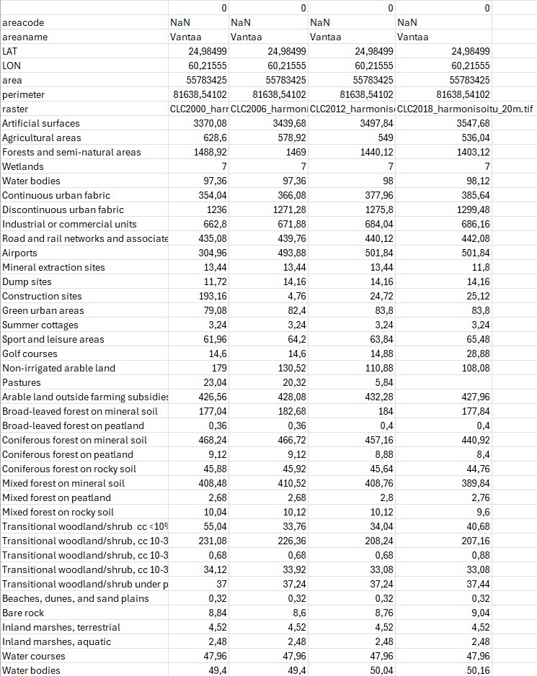

Each CSV currently has 5 columns: 1st a "name column" that describes what the values represent and then 4 "value columns" (one for each of the 4 rasters in the Corine dataset). The number of columns will increase when more Corine datasets become available (reference year 2024 will be completed during 2026).

The value columns of the 1st six rows (areacode, areaname, ..., area, perimeter) are identical since they are the same for each raster.

The "raster" row has different values since that shows the names of the raster files (currently Corine datasets from 2000, 2006, 2012 and 2018).

After that come the 39 Corine classes (Artificial surfaces, Agricultural areas, ... Water Bodies) and their values (area in ha), which often change between years (the land cover changes). For example, the areas of Artificial surfaces are 3370.08 ha in 2000, 3439.68 ha in 2006 and 3497.84 ha in 2012 (an increasing trend is visible in the data).

