ASIC Lab Handbook
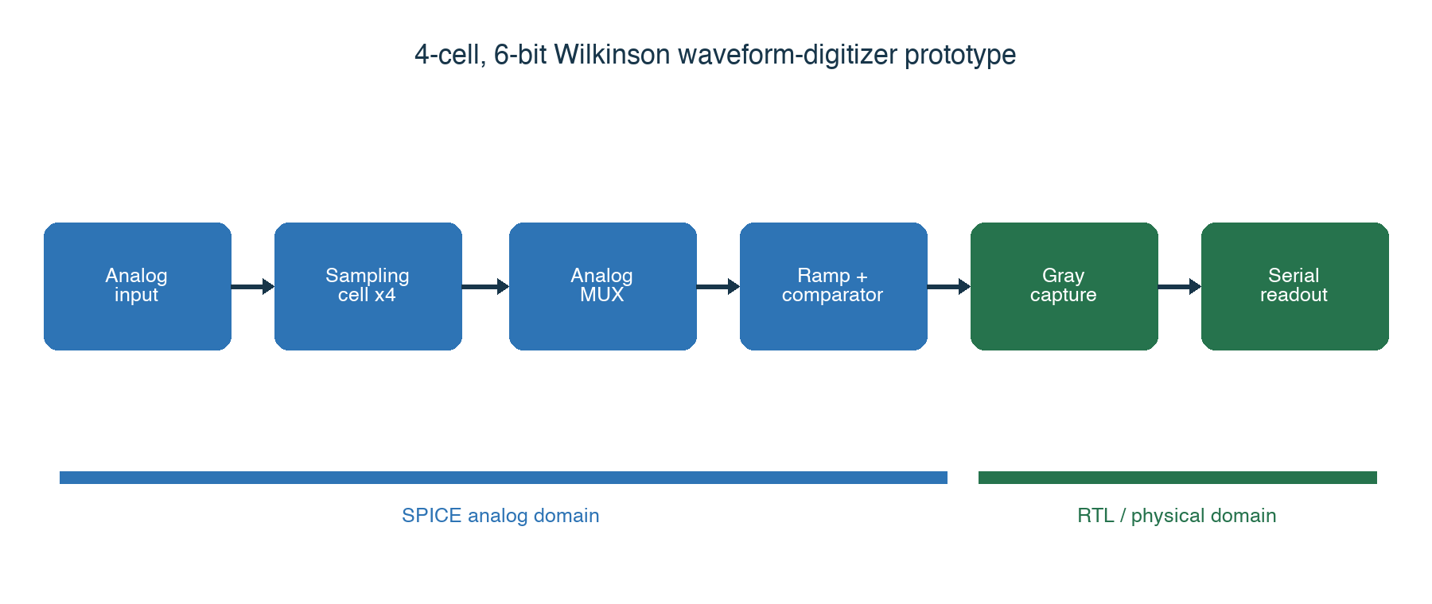
Tape-out 1 signal path
Figure 1. Tape-out 1 signal path. Blue blocks are analog; green blocks are digital.
Version 1.1 | 2026-08-14
Repository: https://github.com/sykeisuke/asic_rd

Purpose of this handbook
This handbook is the primary working guide for the Tape-out 1 prototype. Its goal is not to obtain the highest possible performance on the first attempt. The goal is to demonstrate a complete, reproducible ASIC flow: specification, schematic capture, SPICE simulation, RTL, mixed-signal verification, physical design, signoff, fabrication, packaging, and measurement.
The reader should be able to inspect the design files, reproduce the recorded results with the documented commands, and explain the engineering decision that follows from each result. A screenshot alone is not evidence. Always keep the input file, command, generated artifact, and pass/fail criterion together.

Learning outcomes
After completing the handbook, the reader should be able to:
- explain MOS behavior and basic analog design using the GF180MCU PDK;
- explain Wilkinson conversion from sample-and-hold through digital capture;
- distinguish schematic, netlist, RTL, layout, and extracted views;
- reproduce the block-level and integrated verification results;
- explain the SPICE-to-RTL boundary and Gray-code CDC strategy;
- identify the outputs and limitations of synthesis, STA, DRC, LVS, and PEX;
- distinguish a flow prototype from a tape-out-ready full-chip design.

Recommended sequence
Stage | Labs | Outcome
Foundations | 0-2 | Environment, PDK, MOS, sampling
Conversion | 3-5 | Comparator, ramp, one-cell and four-cell Wilkinson conversion
Digital | 6-8 | Controller, co-verification, CDC, serial readout
Physical design | 9 | Netlist-to-GDS flow and analog-layout planning
Design review | 10-16 | Evidence, blockers, specification, and tape-out readiness

0. How to read an ASIC project
ASIC development combines circuit theory, software, semiconductor process rules, packaging, and measurement. Do not try to memorize every term first. For each task, identify three things: the input, the tool that processes it, and the output artifact.

Four representations to keep separate
Representation | Meaning | Example in this repository
Schematic | Human-readable components and connectivity | nmos_dc.sch, sampling_cell.sch
Netlist | Simulator-readable devices and connections | *.spice, Xschem-generated netlist
RTL | Clock-by-clock digital behavior | *.v, synthesizable Verilog
Layout | Geometric layers fabricated on silicon | DEF, GDSII
Models are not silicon. A nominal SPICE result is not a production guarantee; an RTL simulation does not include transistor behavior; and GDSII alone does not include package, bond wire, PCB, or laboratory equipment.

Units used throughout the project
Prefix | Scale | Example
m | 10^-3 | 1 mV = 0.001 V
u | 10^-6 | 1 us = 0.000001 s
n | 10^-9 | 1 ns
p | 10^-12 | 1 pF, 1 ps
For every lab, record the Git commit, command, start and finish time, PASS/FAIL, main artifact, and any observation that affects the next design decision.

1. Toolchain
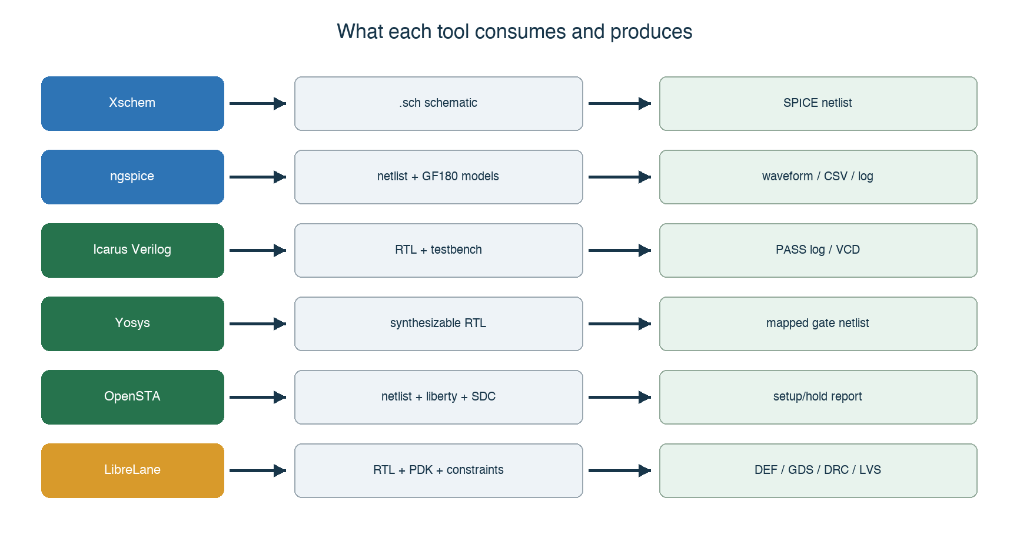
Toolchain inputs and outputs
Figure 2. Tool inputs and outputs. The Makefile provides stable entry points.
Tool | Role | What the designer does
Docker Desktop | Runs the pinned Linux environment on macOS | Start Docker; check container and disk state
Make | Maps a target name to a repeatable command sequence | Run targets such as make nmos-dc
Xschem | Analog schematic editor and SPICE netlister | Place symbols, wire nets, edit properties, inspect netlists
ngspice | Transistor-level circuit simulator | Inspect logs, measurements, RAW and CSV waveforms
AWK/shell | Extracts results and applies automated checks | Read what each script treats as PASS
Icarus Verilog | RTL compiler and simulator | Compile, run testbenches, inspect VCD files
Yosys | RTL synthesis | Inspect mapped netlists and cell statistics
OpenSTA | Static timing analysis | Inspect SDC constraints and setup/hold reports
LibreLane/OpenROAD | Digital RTL-to-GDS flow | Review configuration, metrics, reports, DEF, and GDS
KLayout/Magic/Netgen | Layout viewing, DRC, and LVS | Inspect layers, pins, markers, and mismatches
KLayout, Magic, and Netgen become central during analog layout. In the current digital demonstration, LibreLane coordinates several backend tools.

2. What the Makefile does
make is not a simulator. It selects a target in the Makefile, which invokes one or more scripts and tools. For example, make nmos-dc runs the Xschem and ngspice path and then checks the generated data.
When a target fails:
- open the corresponding scripts/run-*.sh file;
- find the last successful command;
- identify the first failing command and its inputs;
- inspect the generated log before changing the design;
- rerun the smallest failing step, then rerun the Make target.
Target | Internal tools | Main artifacts
make nmos-dc | Xschem, ngspice | Netlist, RAW, CSV
make four-cell-cosim | ngspice, shell/AWK, Icarus Verilog | Analog stimulus, co-simulation log
make digital-top | Icarus Verilog, Yosys, OpenSTA | VCD, mapped netlist, timing report
make digital-physical | LibreLane/OpenROAD | GDS, DEF, metrics, reports

3. Analog-design foundations
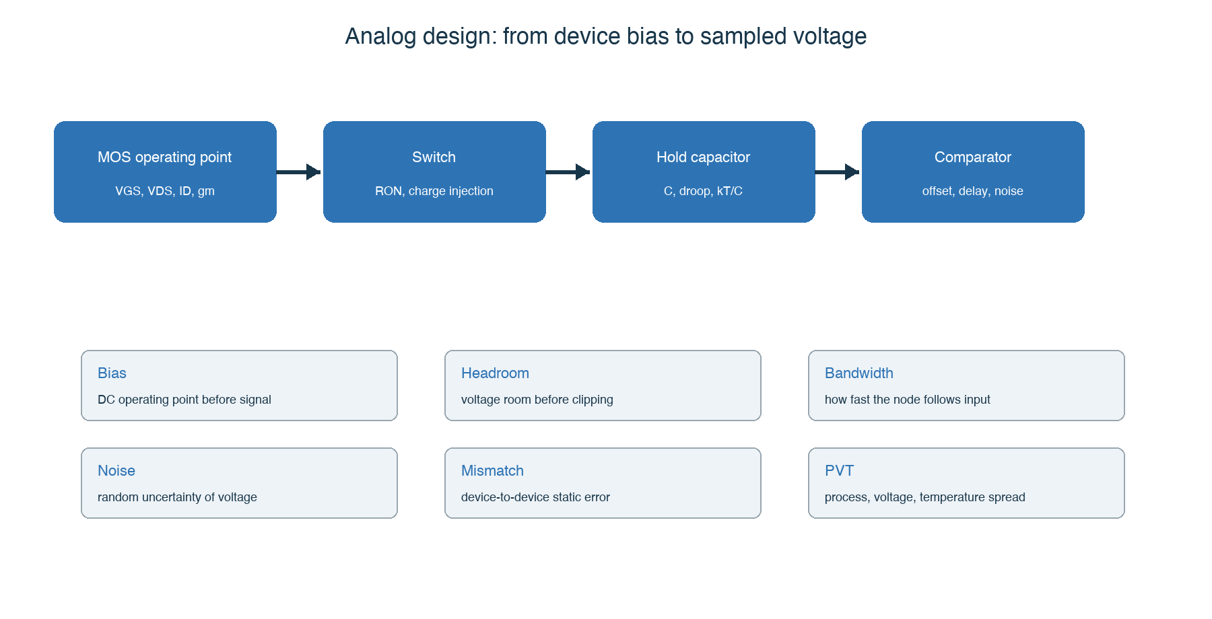
Analog design reasoning chain
Figure 3. Device bias, transient behavior, sampling error, and verification are connected.
An analog node has continuous voltage, current, and time. Check the DC operating point first, small-signal behavior second, and large transient, noise, mismatch, and PVT behavior after the nominal circuit is understood.

3.1 MOS transistor essentials
Quantity | Meaning | Typical check
VGS | Gate-to-source voltage controlling channel formation | DC sweep
VDS | Drain-to-source voltage affecting region and headroom | I-V curve
ID | Drain current determining bias, power, and speed | Operating point
gm | Conversion strength from gate voltage to drain current | Operating point or derivative
ro | Finite output resistance in saturation | Slope of Id-Vds curve
W/L | Device geometry affecting current, capacitance, and mismatch | Schematic property
A MOS device has four terminals. Always review body/bulk connections, body effect, and parasitic junction diodes.

3.2 Bias, headroom, gain, and bandwidth
Bias is the no-signal operating state. Verify that each transistor is in the intended region and every node remains within the rail limits. Headroom is the voltage margin that allows the signal to move without forcing a device out of its required operating region.
- DC operating point: Are node voltages and branch currents plausible?
- Gain: Does the required input change produce the required output change?
- Bandwidth: Is the response fast enough at the required frequency?
- Slew rate: Can large signals move at the required speed?
- Settling: Does the node enter the allowed error band before capture?

3.3 RC acquisition and hold
During tracking, the switch on-resistance and hold capacitance form an RC time constant:
tau = RON * CHOLD
error after time t = exp(-t/tau)
With RON = 2 kohm and CHOLD = 1 pF, tau = 2 ns; approximately 14 ns is required for seven time constants. A real switch is signal-dependent, and the source, wiring, pad, and MUX add resistance and capacitance.

3.4 Error, noise, PVT, and Monte Carlo
Category | Examples | Verification
Systematic | Comparator offset, ramp slope error | Corners and parameter sweeps
Random noise | Thermal noise, kTC noise | Noise/transient-noise analysis
Mismatch | Threshold and device-ratio variation | Monte Carlo mismatch
PVT | Process, supply, temperature | Corner matrix
Parasitic | Layout RC and coupling | PEX simulation
For a new waveform, first check ground reference, rails, expected input range, floating nodes, transition order, and the simulator time step. Only then judge the detailed circuit behavior.

4. Module connectivity
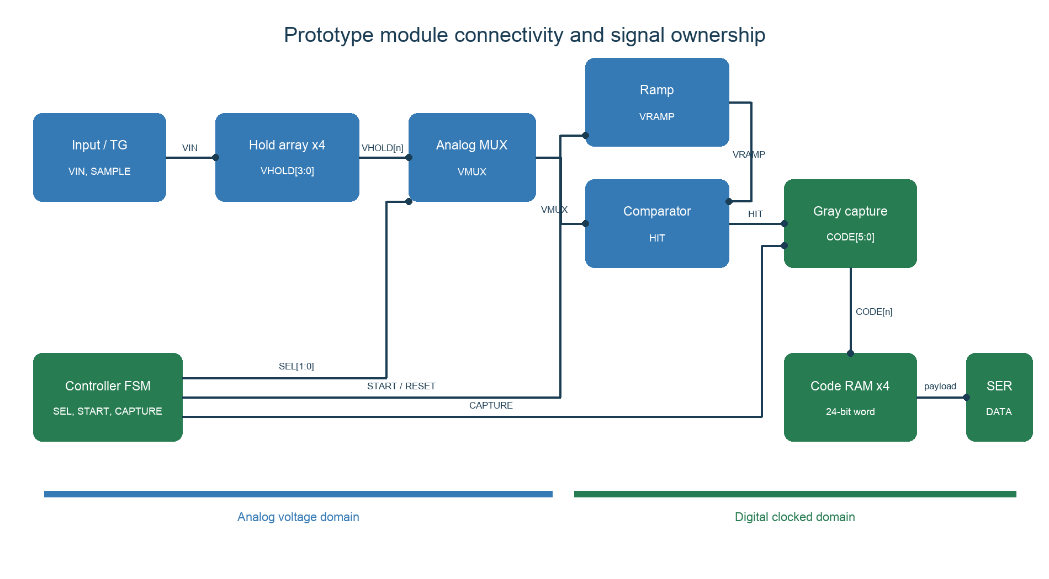
Module connectivity and ownership
Figure 4. Signal ownership and the analog-to-digital boundary.
Signal | Producer | Consumer | Meaning
VIN | Signal source/pad | Sampling transmission gate | Analog input
SAMPLE[i:0] | Controller/clock generation | Sampling cell | Digital track/hold control
VHOLD[i] | Hold capacitor | Analog MUX | Stored sampled voltage
SEL[i:0] | Controller | Analog MUX | One-hot cell selection
VMUX | Analog MUX | Comparator | Selected hold voltage
VRAMP | Ramp generator | Comparator | Wilkinson reference ramp
HIT | Comparator | Gray capture/controller | Asynchronous crossing event
CODE[i] | Gray capture | Code registers | One-cell result
DATA | Serializer | FPGA | 24-bit payload

4.1 One conversion in time order
- SAMPLE[i] turns on the transmission gate and VHOLD[i] follows VIN.
- SAMPLE[i] turns off; CHOLD[i] stores the sampled voltage.
- SEL[i] connects one VHOLD[i] to VMUX.
- The MUX bus settles and is optionally reset between cells.
- VRAMP starts while the Gray counter runs.
- The comparator changes HIT when VRAMP crosses VMUX.
- The capture circuit stores the Gray counter value.
- The controller advances to the next cell and repeats the conversion.
- Four 6-bit codes are assembled into one 24-bit word.
- The serializer sends the word to the FPGA.
The controller-to-analog interface must define active polarity, pulse width, one-hot constraints, settling time, reset state, and safe illegal states. The comparator-to-capture interface must define edge polarity, synchronization, maximum delay, and the invalid/missing-edge response.

5. Complete design flow
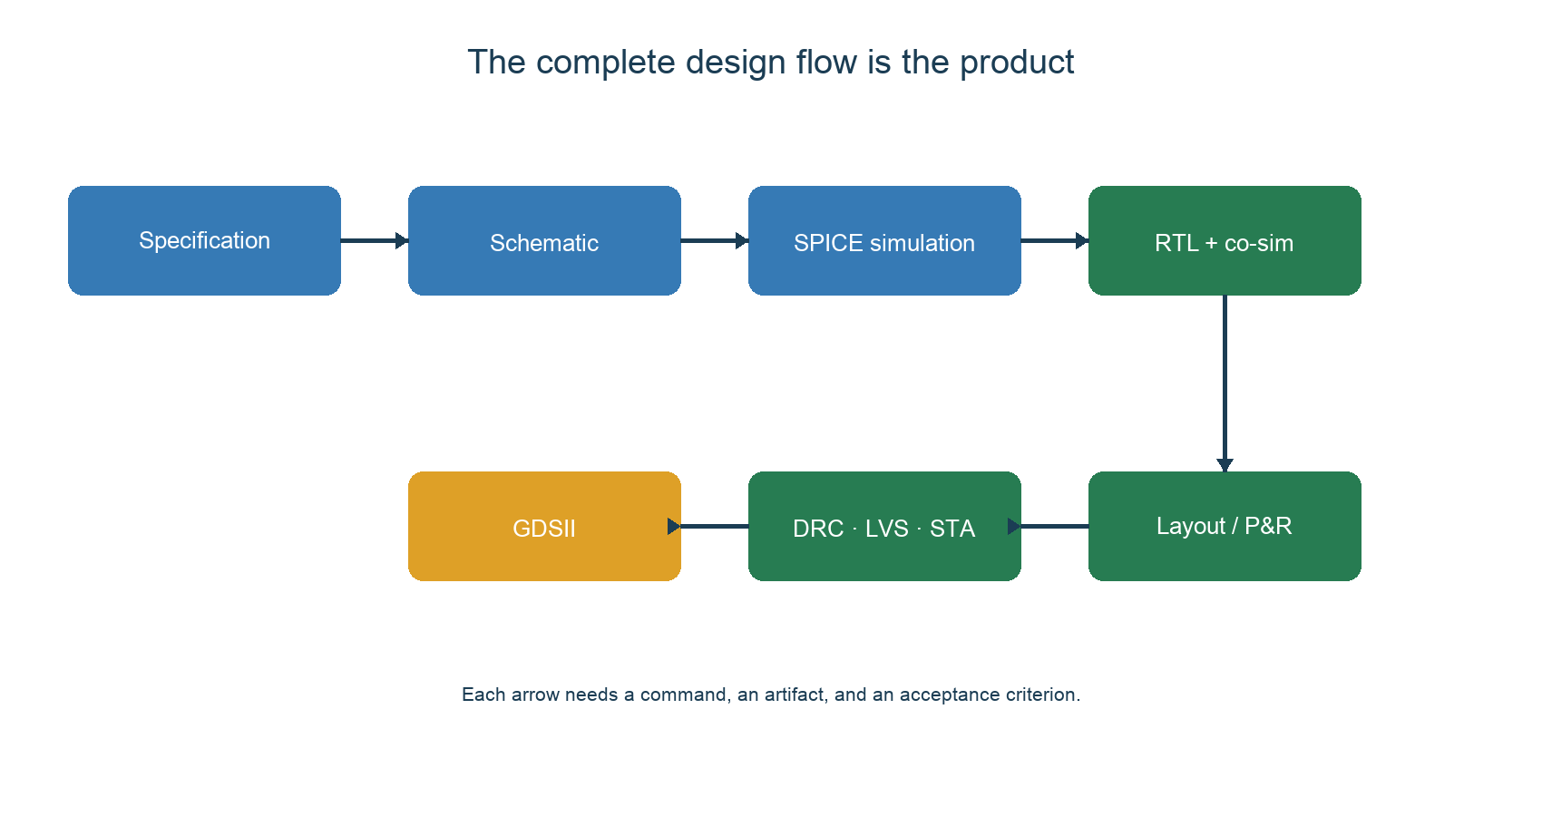
Complete design flow
Figure 5. Tape-out requires evidence from specification through GDSII and signoff.
Block | Input and output | Tape-out 1 evidence
Sampling cell | VIN + SAMPLE -> VHOLD | Four distinct values are stored in order
Analog MUX | VHOLD[i] + SEL -> VMUX | Only the selected cell drives the bus
Ramp | START -> VRAMP | Slope, reset, range, and repeatability
Comparator | VMUX, VRAMP -> HIT | Correct edge over required range
Gray capture | CLK, HIT -> CODE | Stable code near asynchronous crossing
Serializer | CODE -> DATA | Correct 24-bit frame and bit order

Lab 0. Read the repository
Run:
git clone https://github.com/sykeisuke/asic_rd.git
cd asic_rd
git status
make check
Read these files first:
- README.md - entry point and quick start;
- docs/PROTOTYPE_SPECIFICATION.md - controlled Tape-out 1 requirements;
- docs/TOP_LEVEL_INTERFACE.md - current interface ownership;
- docs/VERIFICATION_MATRIX.md - requirement-to-evidence mapping;
- docs/TAPEOUT_BLOCKERS.md - unresolved release blockers.
Directory ownership:
- simulations/: Xschem/ngspice circuits and testbenches;
- digital/: synthesizable RTL, testbenches, and physical design;
- mixed_signal/: SPICE-to-RTL verification bridges;
- docs/: specifications, decisions, procedures, and evidence ownership;
- work/ and runs/: generated artifacts, never the source of truth.
Acceptance: make check passes, the current commit is recorded, and the reader can identify one source file and one generated artifact for each domain.

6. macOS, Docker, VNC, and /foss
The Mac is the host. Docker Desktop runs the pinned Linux image. Xschem and other GUI tools run inside that Linux container and are displayed through a browser-based VNC session.
cp .env.example .env
# Edit .env and set ASIC_RD_VNC_PASSWORD before the first start.
make vnc
Open http://localhost:8080/ and enter the locally configured VNC password. The repository is mounted as /foss/designs; PDKs and tools are provided by the container under /foss/pdks and /foss/tools.
A Docker Hub account is normally unnecessary for public images unless a rate limit, private image, or organization policy requires authentication.

Troubleshooting checklist
Symptom | Check
localhost:8080 does not open | Docker state, make vnc log, port conflict
Xschem cannot find PDK symbols | PDK, PDK_ROOT, and /foss/pdks mount
/foss/designs is empty | Host repository path and volume mount
A file is missing after editing | Host/container path ownership and current directory
macOS blocks a Docker helper | Docker version, signature, and approved installation source

7. First use of Xschem
- Run make vnc from the repository root.
- Open the browser desktop.
- In File Manager, open /foss/designs/simulations/gf180_nmos_dc/nmos_dc.sch.
- Confirm the MOS symbol, voltage sources, ground, model include, and analysis command before running the simulator.
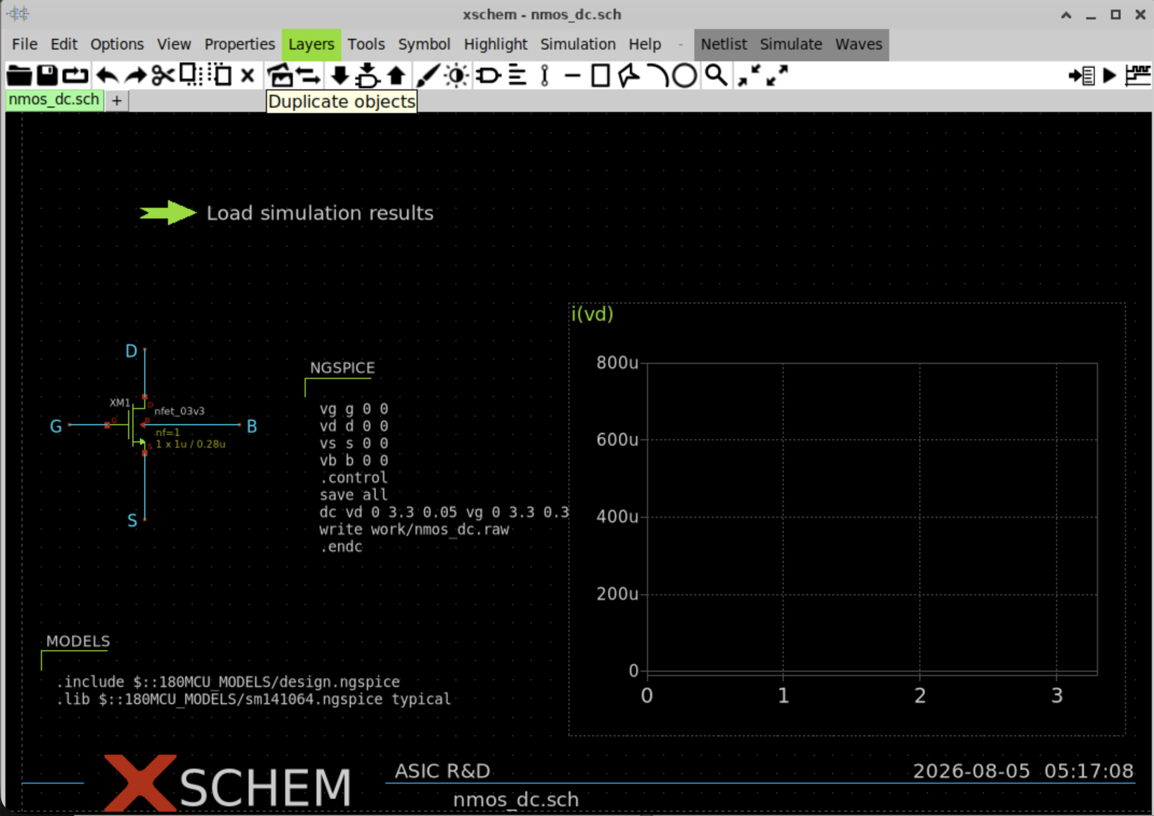
Xschem NMOS schematic before results
Figure 6. NMOS DC schematic. An empty graph is expected before loading the RAW data.

7.1 Display the first waveform
From the Mac terminal:
make nmos-dc
Confirm that simulations/gf180_nmos_dc/work/nmos_dc.raw exists and is not empty. In Xschem, use Ctrl + left click on the green Load simulation results launcher. A normal click selects the launcher; a double-click opens its properties.
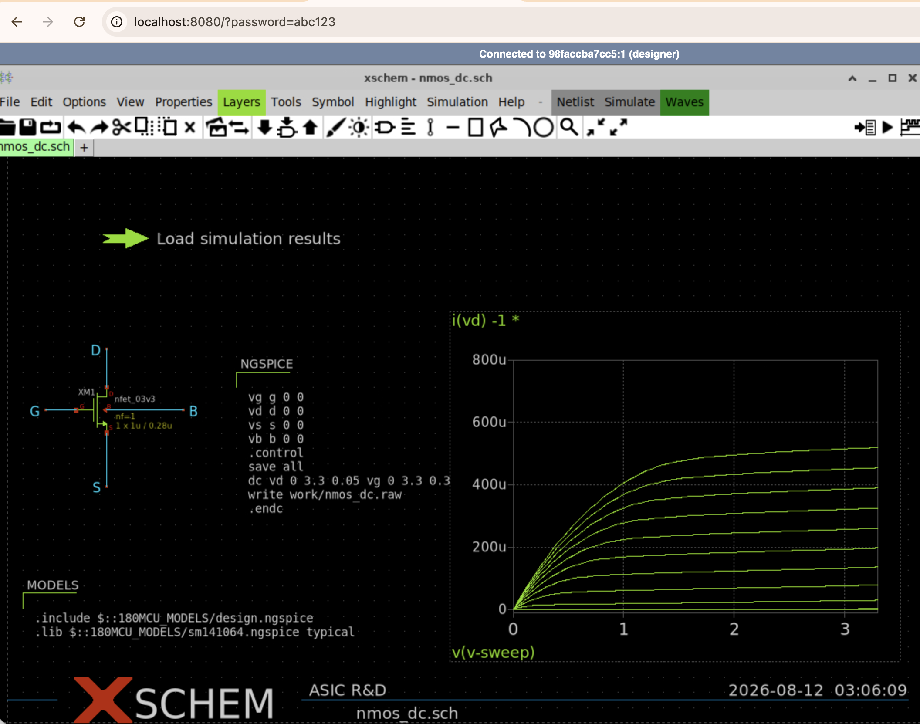
Xschem NMOS Id-Vds result
Figure 7. Id-Vds curves for multiple VGS values.
The horizontal axis is VDS, the vertical axis is drain current, and each curve corresponds to a different VGS. Check the linear region, saturation behavior, current magnitude, and monotonic ordering.

7.2 Trace Xschem to ngspice
The path is:
nmos_dc.sch -> generated SPICE netlist -> ngspice -> RAW/CSV -> graph/check
Inspect the device instance, model include, source definitions, .dc command, and output path. If Xschem reports a missing RAW file, verify the working directory and the exact path written by the simulation control block.

8. Digital tools
Purpose | Command/tool | Evidence
Compile | iverilog -g2012 ... | Syntax and supported constructs
Simulate | vvp work/testbench | PASS/FAIL, events, VCD
Inspect waves | GTKWave or another VCD viewer | Clock, reset, state, code, serial data
Synthesize | Yosys | Mapped netlist and cell use
Analyze timing | OpenSTA | Constraints, setup/hold slack
Place and route | LibreLane/OpenROAD | DEF, GDS, metrics, signoff reports
A VCD confirms event ordering, not analog voltage behavior. Synthesis also removes many simulation conveniences: real-number behavior, arbitrary delays, unsupported constructs, and non-synthesizable testbench code.

Lab 1. Measure a GF180 MOS device
Run:
make nmos-dc
Tasks:
- identify the GF180 device model, W, L, body, and supply;
- explain the VGS and VDS sweep;
- locate the CSV and RAW artifacts;
- change device width in a separate experiment and predict the current change;
- rerun the simulation and compare prediction with the result.
Acceptance: ngspice exits without error, the expected CSV exists, drain current increases with width under the same bias, and the change is committed only after the schematic, generated netlist, and result agree.

Lab 2. Sampling cell
Run:
make sampling-cell
make four-cell-mux
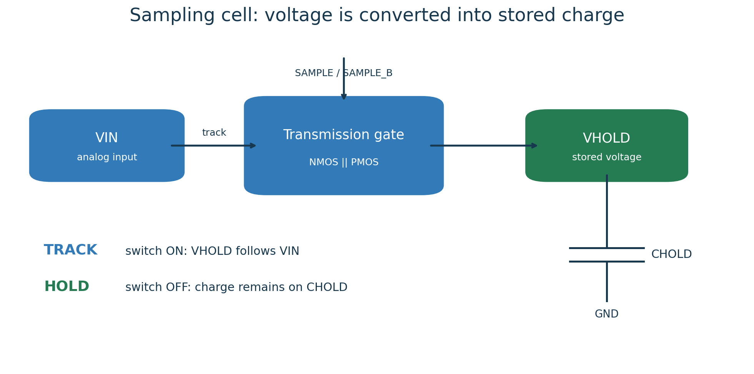
Sampling switch and hold capacitor
Figure 8. During TRACK, VHOLD follows VIN. During HOLD, charge remains on CHOLD.
The ideal-switch model isolates timing logic from transistor limitations. The GF180 NMOS-only and transmission-gate versions reveal on-resistance, signal range, acquisition error, and charge injection.
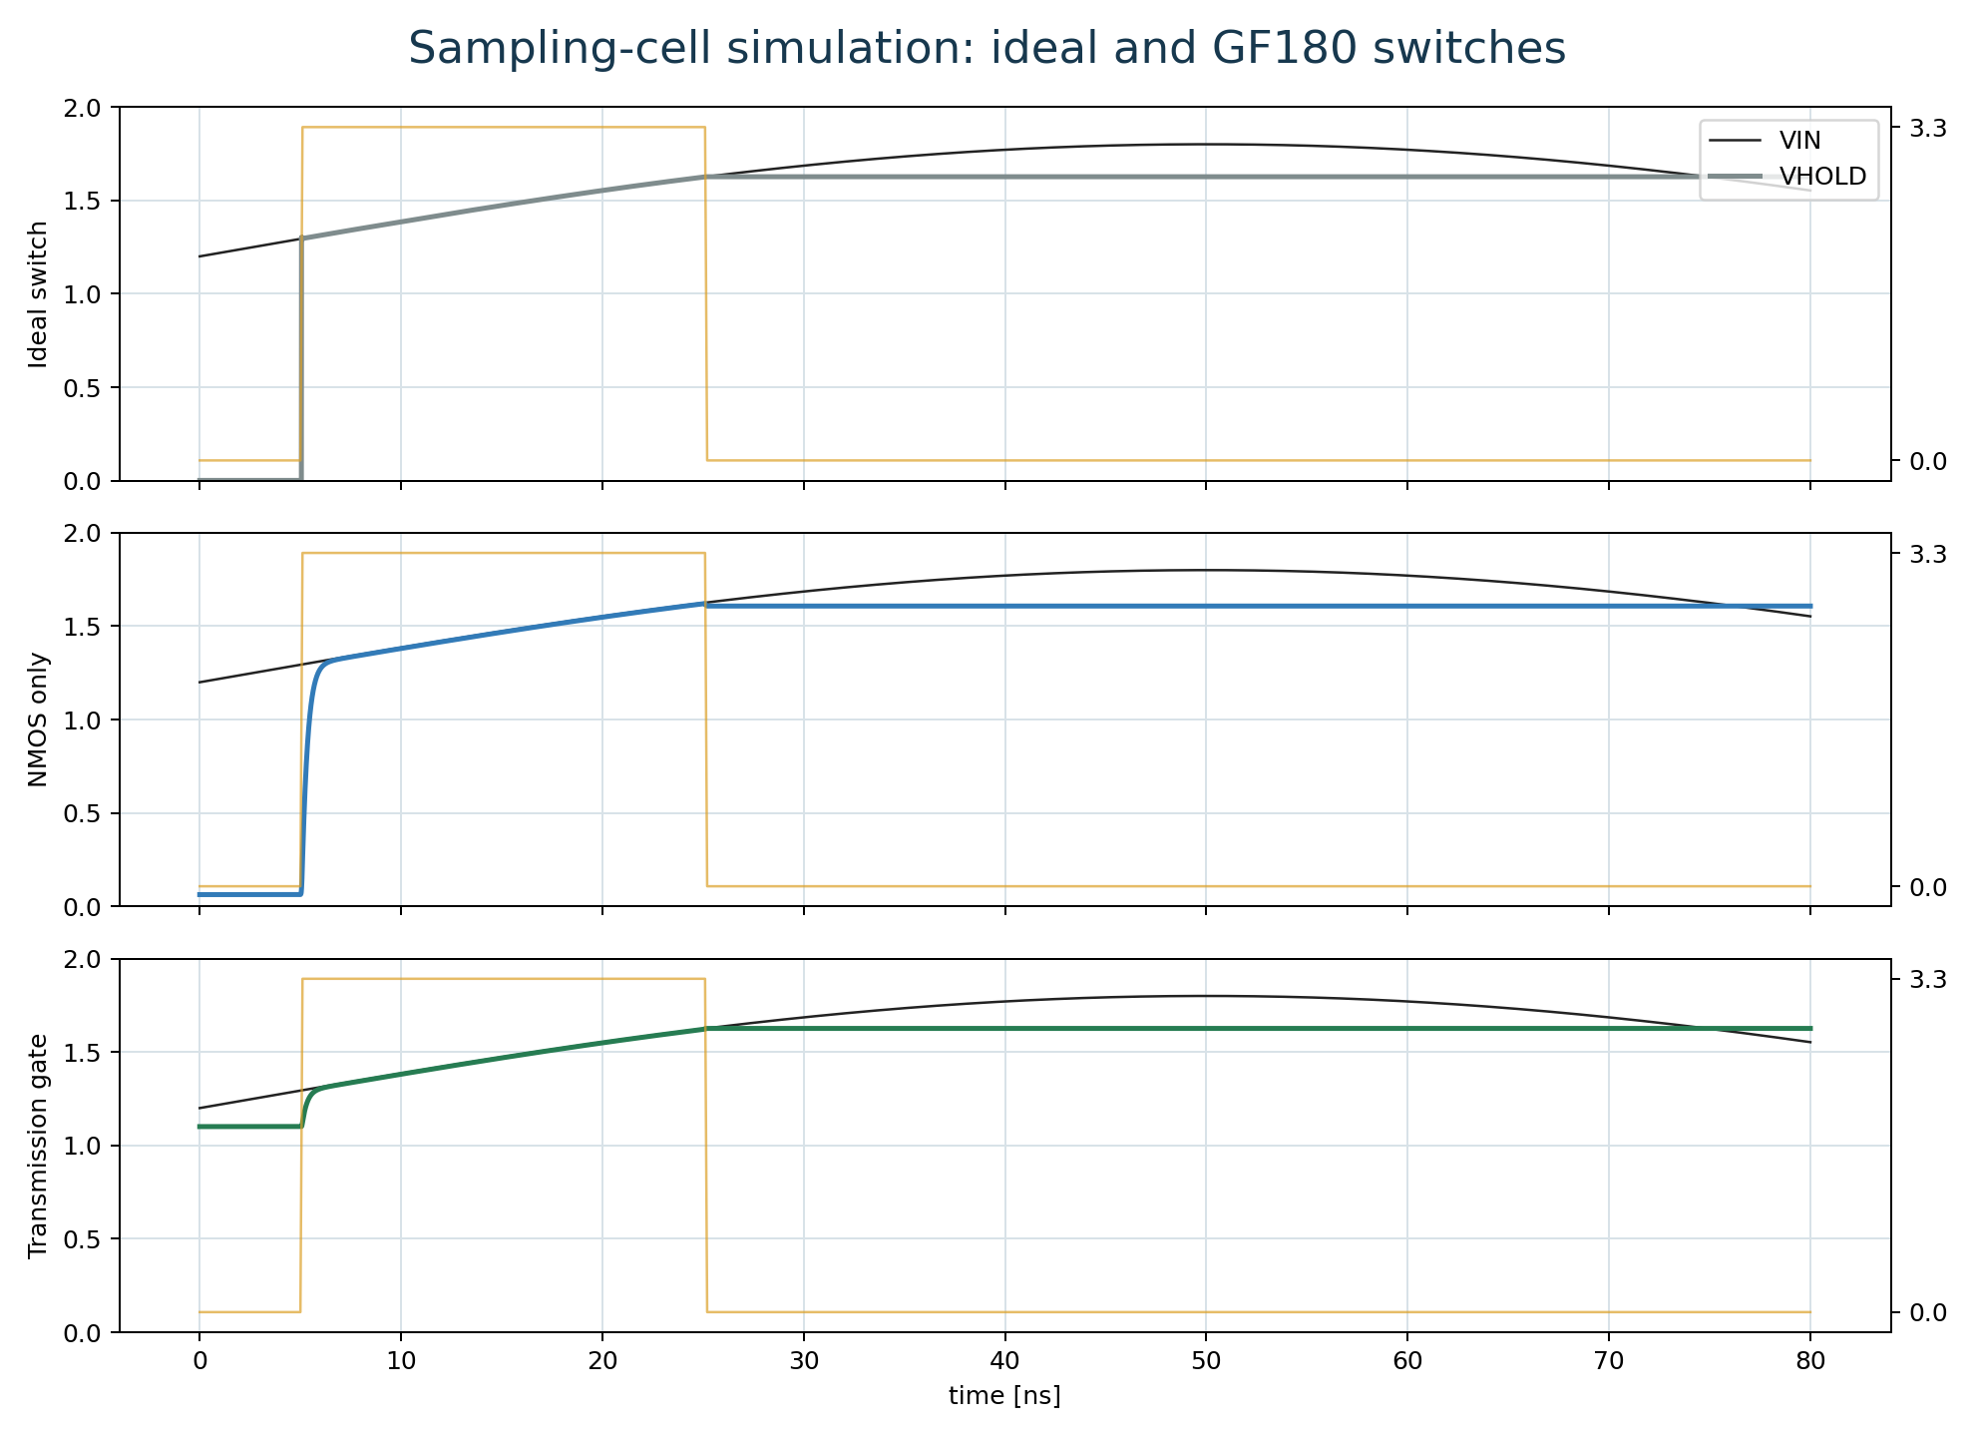
Sampling-cell simulation
Figure 9. Ideal and transistor-level sampling-cell waveforms.
Inspect in this order:
- verify that SAMPLE is high during the acquisition window;
- verify that VHOLD follows VIN while tracking;
- measure acquisition error immediately before the falling edge;
- inspect the edge disturbance after the switch opens;
- measure hold droop over the defined interval;
- confirm that only the selected cell changes in the four-cell test.
Acceptance: four cells store the intended sequence; unselected cells are not overwritten; acquisition error, edge disturbance, and droop are measured; and the transmission-gate control is complementary and non-overlapping.

Lab 3. Comparator and ramp
Run:
make comparator
make comparator-range
make comparator-offset
make ramp-generator
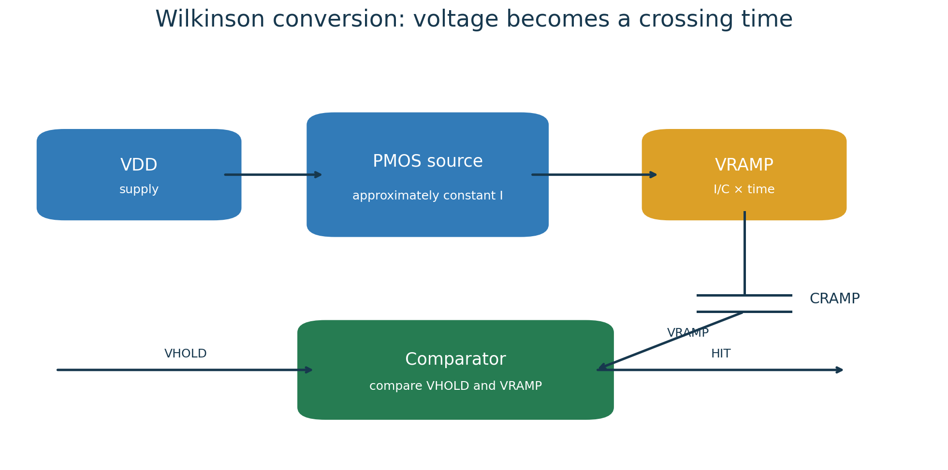
Ramp and comparator
Figure 10. The comparator converts a voltage crossing into an event time.
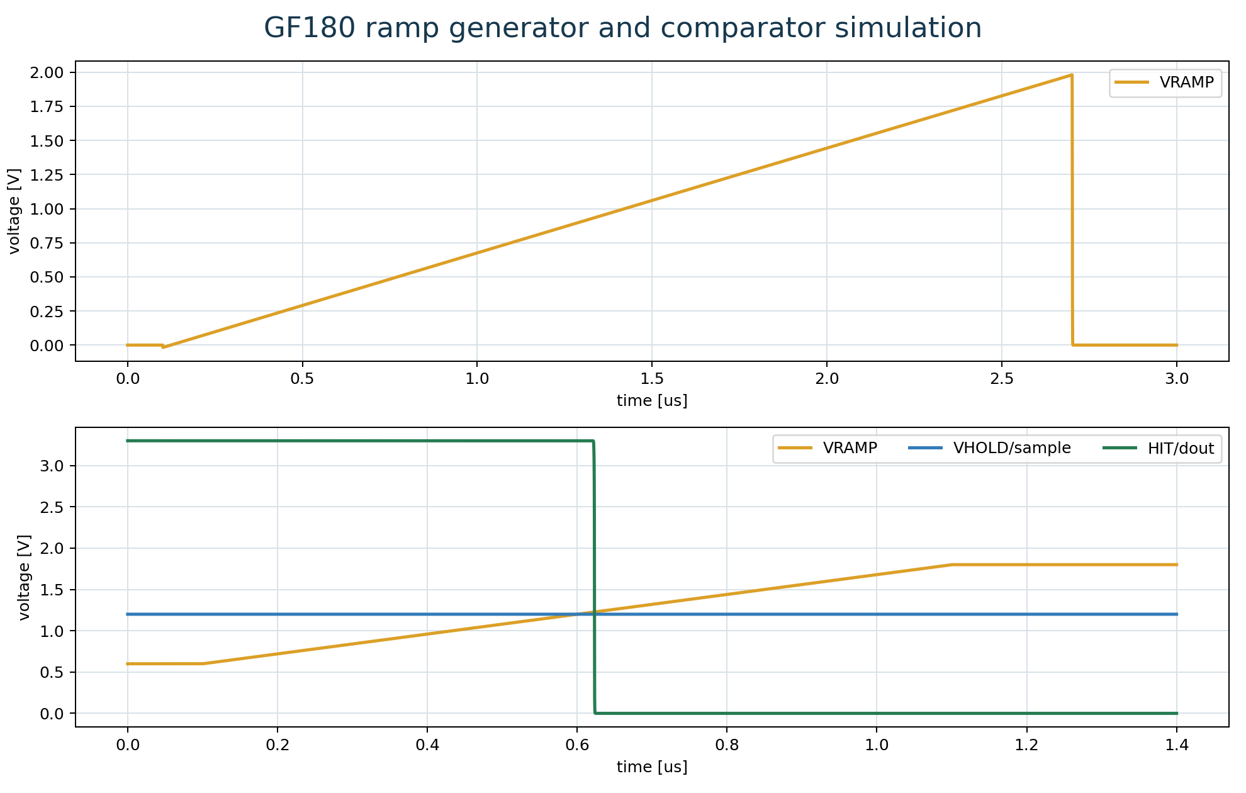
Ramp/comparator simulation
Figure 11. Ramp reset, linear rise, sampled voltage, and comparator output.
Measure logic swing, propagation delay, common-mode/input range, trip-point offset, ramp slope, linearity, reset level, and cycle-to-cycle repeatability. The nominal 6-bit reference uses a 1.6 V conversion range and approximately 25 mV/LSB. These values are a prototype target, not a silicon guarantee.

Lab 4. One-cell Wilkinson slice
Run:
make wilkinson-slice
make transfer
The one-cell slice combines a sampled input, hold capacitor, ramp, comparator, counter, and capture event. The expected code is approximately:
code = (VHOLD - ramp_start) / ramp_slope / counter_period
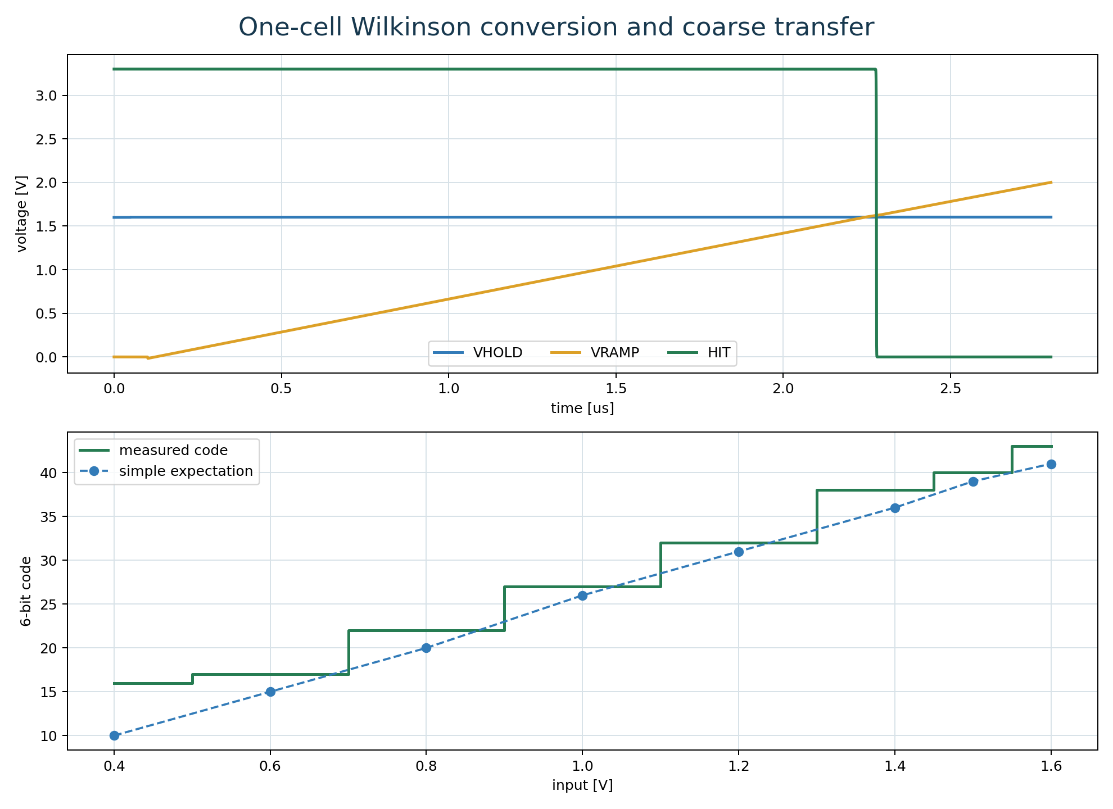
One-cell Wilkinson result
Figure 12. Crossing waveform and coarse 6-bit transfer characteristic.
Acceptance: code increases monotonically with input; codes remain in 0..63; measured values agree with the expected slope within the documented tolerance; and dead regions or saturation are reported rather than hidden.

Lab 5. Four-cell shared conversion
Run:
make four-cell-wilkinson
To inspect the integrated RAW waveform in GAW:
cd /foss/designs/simulations/gf180_four_cell_wilkinson
gaw work/four_cell_wilkinson.raw
Add v(vin), v(hold0) through v(hold3), v(mux_bus), v(ramp), v(reset), and v(compare_out) to separate panels. Use zoom-out first, then zoom into one cell-conversion interval.
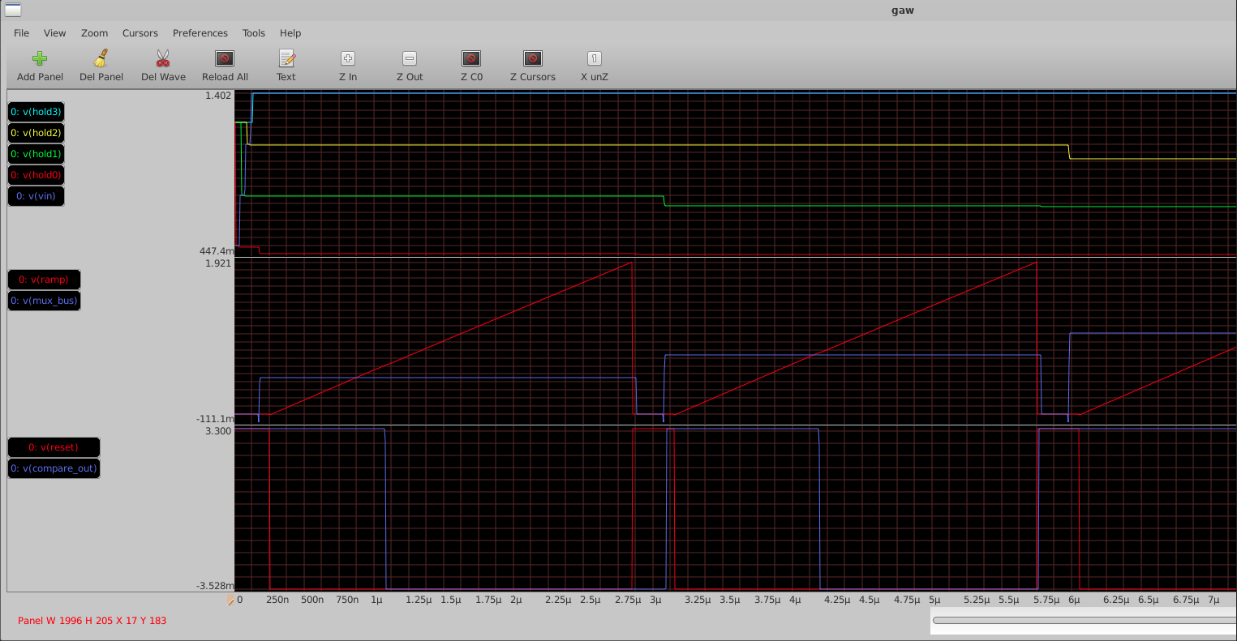
Four-cell integrated waveform
Figure 13. Stored levels, MUX bus, ramp, reset, and comparator crossing.
Verify that the MUX bus matches the selected hold node, bus reset occurs between cells, the comparator toggles once per conversion, and the crossing time increases with held voltage.
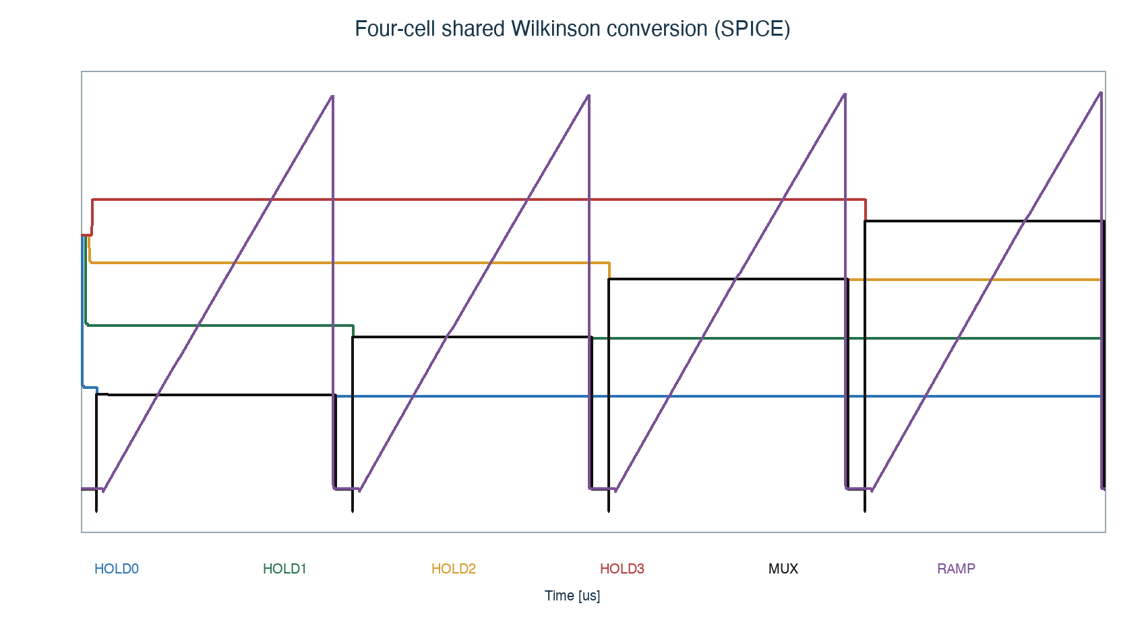
Four-cell shared conversion summary
Figure 14. Shared ramp/comparator sequence and resulting cell codes.
Acceptance: all four cells complete sequential conversion, no cell is skipped, the selected voltage is stable before ramp start, and measured codes match the expected order and tolerance.

Lab 6. Controller RTL
Run:
make counter
make gray-counter
make controller
make digital-top
The controller sequence is:
- IDLE: wait for a valid trigger;
- RESET_RAMP: clear ramp and counter;
- SELECT: assert exactly one cell select;
- CONVERT: start the counter and wait for comparator hit or timeout;
- CAPTURE: store the captured code;
- NEXT/DONE: advance to the next cell or start serialization.
Inspect reset behavior, one-hot selection, capture pulse width, code stability, timeout handling, and serialized payload. The analog blocks are represented by testbench behavior here; this is not transistor-level mixed-signal simulation.

Lab 7. SPICE-to-RTL co-verification
Run:
make four-cell-cosim
This flow extracts crossing events from SPICE, converts them into deterministic RTL testbench stimulus, and checks end-to-end code ordering.
The interface contract must define time unit, edge polarity, sampling rule, code format, timeout, and invalid cases. Debug in this order: SPICE CSV, extracted event list, testbench pulse, capture enable, captured code, then the expected-code comparison.

Lab 8. Gray capture and CDC
Run:
make phase-sweep
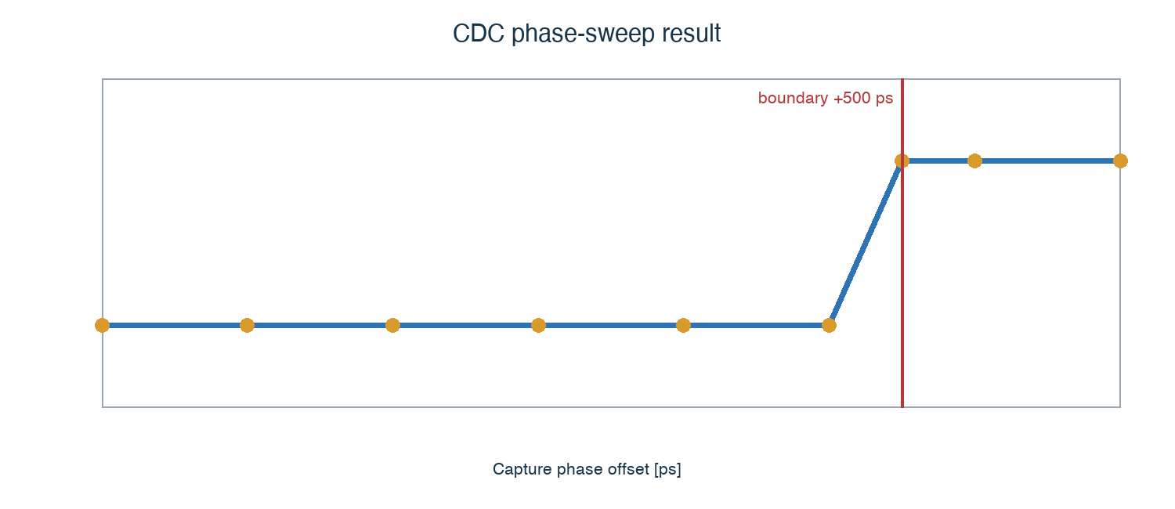
Gray capture phase sweep
Figure 15. Captured code around a clock-boundary phase sweep.
An asynchronous comparator edge may arrive close to a counter transition. Binary counters can change multiple bits at once; Gray code changes one bit at a time and limits the ambiguity at the capture boundary.
Acceptance: captures away from the boundary match the expected code; a boundary event differs by at most the documented adjacent-code ambiguity; and no unstable multi-bit failure appears in the phase sweep.

9. 24-bit serial readout
Four 6-bit cell results form one 24-bit word. Define and verify bit order, frame start, serial clock phase/polarity, valid/ready behavior, reset state, idle level, and timeout behavior.
Logic-analyzer acceptance procedure:
- release reset;
- apply known codes such as 16, 20, 27, and 35;
- start serialization;
- capture 24 clock edges;
- reconstruct the word with the documented bit order;
- confirm frame length, payload, and idle recovery.

Lab 9. RTL-to-GDS
Run:
make digital-physical
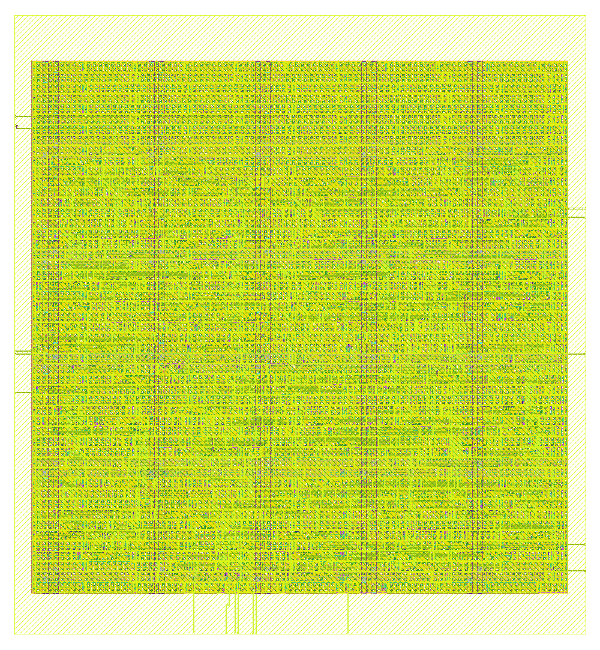
Digital physical result
Figure 16. GF180 standard-cell digital physical-design result.
Review die/core dimensions, utilization, standard-cell count, total wire length, estimated power, clock constraints, setup slack, hold slack, DRC, LVS, antenna, and generated GDS/DEF/netlist views.

9.1 Analog layout is a separate design task
Digital place-and-route does not create a production analog layout. The sampling switch, MUX, ramp, and comparator require analog layout decisions:
- device matching and orientation;
- short, shielded high-impedance nodes;
- symmetric differential paths;
- guard rings and well ties;
- quiet analog supplies and return paths;
- controlled input-bus and pad parasitics;
- extraction and post-layout re-simulation.

9.2 DRC, LVS, and PEX order
schematic simulation
-> layout
-> DRC
-> extraction
-> LVS
-> PEX simulation
DRC checks geometric rules. LVS checks schematic-to-layout connectivity and device correspondence. PEX adds extracted resistance and capacitance so that sampling error, ramp slope, comparator delay, and settling can be reevaluated.

10. Reading signoff results
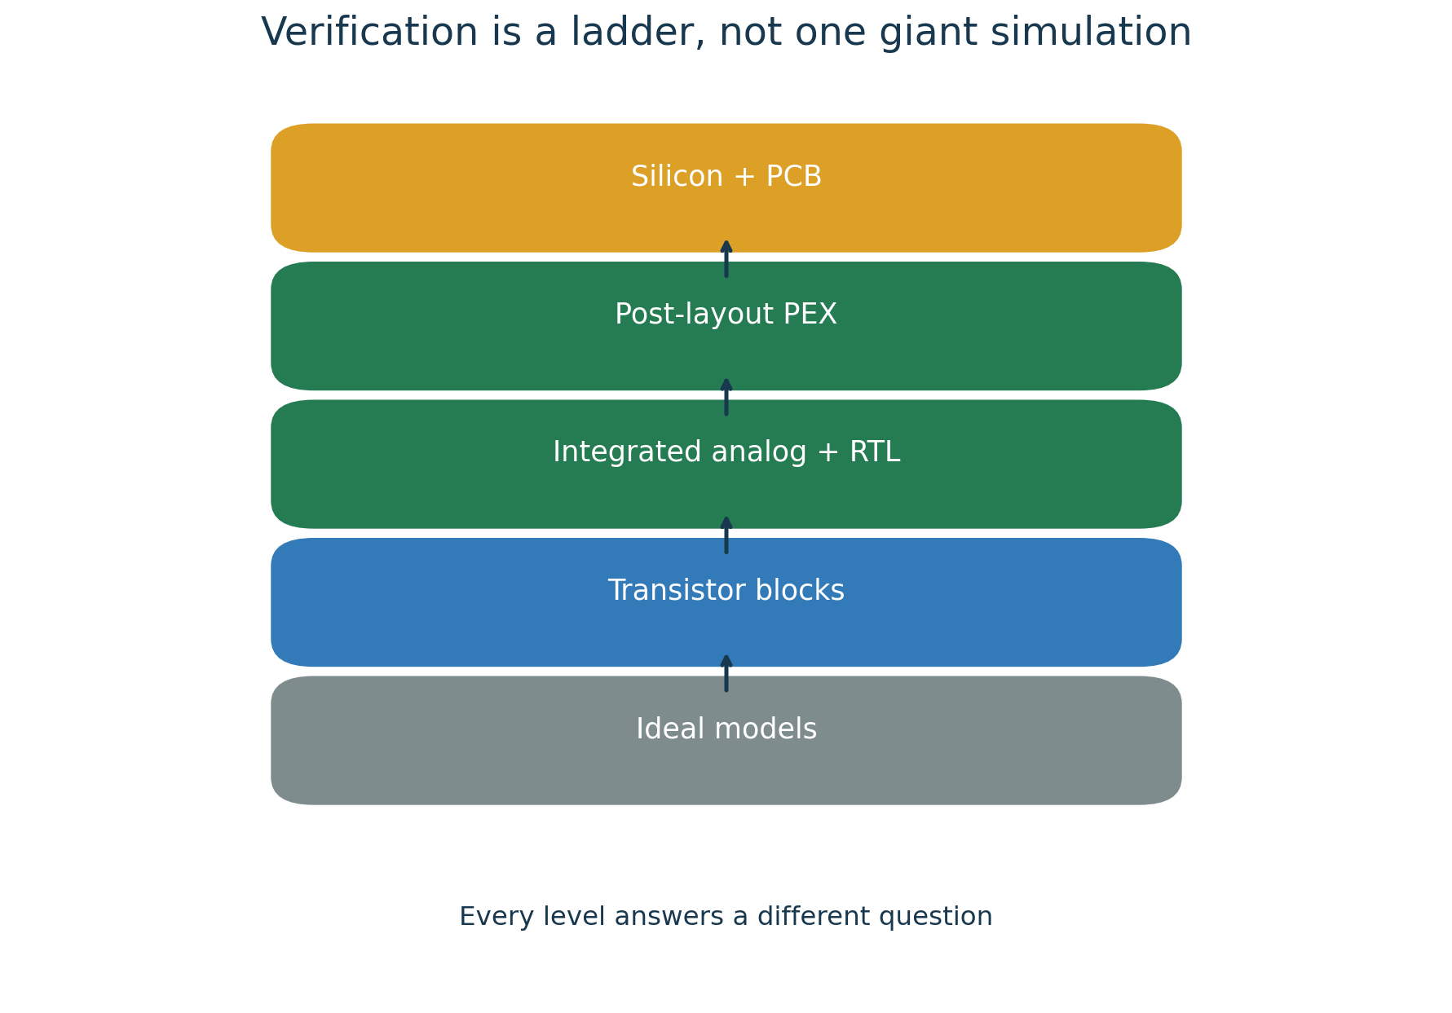
Verification ladder
Figure 17. Verification proceeds from ideal models to silicon and PCB measurements.
Check | Required result | Meaning
DRC | Zero unwaived violations | Geometry satisfies the selected rule deck
Antenna | Zero unresolved violations | Process charging risk is controlled
LVS | Match | Layout connectivity/devices agree with schematic/netlist
Setup | Non-negative slack | Data arrives before the capture requirement
Hold | Non-negative slack | Data remains stable after the capture edge
Confirm that each report belongs to the current commit, PDK/library version, netlist, constraints, and final GDS. A zero in an old or unrelated report is not signoff evidence.

11. Reproducible debugging
Use this loop:
- rerun the smallest failing command;
- minimize the failing case to one cell or event;
- record input, initial state, output, and time base;
- change one variable at a time;
- convert the failure into a regression test;
- rerun the local test, then the complete regression;
- record the decision and commit the source and test together.
Common categories include SPICE convergence, floating nodes, time-step error, wrong edge polarity, CDC ambiguity, RTL timeout, incorrect reset, DRC/LVS mismatch, missing constraints, and pad/package assumptions.

12. Practical exercises

Exercise A: Reproduction report
- Run make check and make four-cell-wilkinson.
- Record commit, command, runtime, PASS/FAIL, and two key artifacts.
- Explain why the evidence is reproducible.

Exercise B: ADC design change
- Change ramp slope, conversion time, or code scale in a branch.
- Predict the expected code change before simulation.
- Update the verification criterion and compare prediction with measurement.

Exercise C: CDC boundary
- Run the phase sweep.
- Explain why binary capture can fail and why Gray capture limits ambiguity.
- Identify what remains an implementation assumption.

Exercise D: Physical experiment
- Change clock constraint, utilization, or one synthesis option.
- Compare area, slack, wire length, runtime, and cell count.
- Record the tradeoff in the repository.

13. From prototype to tape-out
The repository demonstrates important parts of the flow, but foundry release requires additional controlled evidence.
Area | Required before release
MPW/provider | Exact run, PDK release, submission checklist, area, schedule
Analog layout | Sampling/MUX/ramp/comparator layout and PEX verification
PVT/Monte Carlo | Corners, mismatch, offset, ramp, settling, calibration plan
Top integration | Pad ring, I/O cells, ESD, level shifting, supply domains
Package/PCB | Bond map, package/COB constraints, evaluation PCB, FPGA interface
Full-chip signoff | Top DRC/LVS, antenna, ERC, density, timing, deliverable audit

Tape-out readiness review
- ☐ Exact PDK and provider template revision are frozen.
- ☐ Every requirement maps to current test evidence.
- ☐ No waiver is undocumented or ownerless.
- ☐ Pad ring, seal ring, density fill, and top-level GDS are complete.
- ☐ Package, PCB, pin map, and power-up sequence agree.
- ☐ First-silicon measurements and expected limits are defined.
Higher sample rate increases clock-skew, aperture, switch-settling, bus-loading, feedthrough, and calibration difficulty. Higher resolution increases the importance of comparator offset/noise, ramp linearity, supply noise, leakage, and cell-to-cell pedestal variation. A 12-bit, 1 GSa/s target is therefore a different verification and calibration problem, not a parameter-only change.

14. Tape-out 1 specification snapshot
The controlled source is docs/PROTOTYPE_SPECIFICATION.md; this table is only a quick reference.
Item | Tape-out 1 baseline
Process | GF180MCU open-PDK baseline, exact provider revision controlled separately
Channels | One analog channel
Storage depth | Four cells
ADC | Shared 6-bit Wilkinson conversion
Readout | 24-bit serial payload
Control | Synthesizable RTL finite-state machine
Primary objective | Demonstrate the complete reproducible design flow
Not yet claimed | Final bandwidth, precision, radiation tolerance, yield

Glossary
Term | Meaning
PDK | Process models, devices, layers, rules, and libraries
MPW | Multi-project wafer sharing fabrication cost
SCA | Switched-capacitor array for analog sample storage
Wilkinson ADC | Converts voltage to crossing time, then time to a code
CDC | Clock-domain crossing
DRC | Design-rule check
LVS | Layout-versus-schematic comparison
STA | Static timing analysis
PEX | Parasitic extraction
GDSII | Final mask-layout exchange format

15. Command quick reference
Command | Purpose
make check | Environment and repository sanity
make nmos-dc | GF180 NMOS DC sweep
make sampling-cell | Single sampling-cell simulation
make four-cell-mux | Four-cell sampling and analog selection
make comparator | Comparator nominal test
make comparator-range | Comparator input/common-mode range
make comparator-offset | Offset sensitivity
make ramp-generator | Ramp generation and reset
make wilkinson-slice | One-cell Wilkinson conversion
make transfer | ADC transfer characteristic
make four-cell-wilkinson | Shared four-cell analog conversion
make gray-counter | Gray counter RTL
make controller | Conversion controller RTL
make four-cell-cosim | SPICE-to-RTL co-verification
make phase-sweep | CDC boundary sweep
make digital-top | Digital regression, synthesis, and STA
make digital-physical | RTL-to-GDS demonstration
make vnc | Browser-based analog design desktop
make stop | Stop the design container

16. Final review sheet
The prototype complete-flow claim is justified only when all applicable items below have current, reproducible evidence.
- ☐ Four-cell, 6-bit behavior is reproduced.
- ☐ Sampling error and ADC-code error are measured.
- ☐ Ramp, comparator, and counter behavior are consistent.
- ☐ Gray capture passes the phase-sweep criterion.
- ☐ The SPICE-to-RTL contract is documented and tested.
- ☐ DRC/LVS/STA reports correspond to the current source and constraints.
- ☐ Every result identifies source, command, generated artifact, and criterion.
- ☐ Remaining tape-out blockers have an owner and closure condition.
Primary references:
- README.md
- docs/PROTOTYPE_SPECIFICATION.md
- docs/PDK_PAD_SUPPLY_FREEZE.md
- docs/TOP_LEVEL_INTERFACE.md
- docs/VERIFICATION_MATRIX.md
- docs/TAPEOUT_BLOCKERS.md
- docs/decisions/

