|  |
| --- |
| **Homework 1** |
| **11-791 Design and Engineering of Intelligent Information System Fall 2012** |
| **UML Design and Named Entity Recognition Implementation with UIMA SDK** |

|  |
| --- |
| **Suyoun Kim**  **Andrew id: suyoung1**  **Language Technologies Institute**  **School of Computer Science**  **Carnegie Mellon University**  [**suyoun@cs.cmu.edu**](mailto:suyoun@cs.cmu.edu) |

1. UML Design
   1. Domain diagram for IntelligentInformationSystem

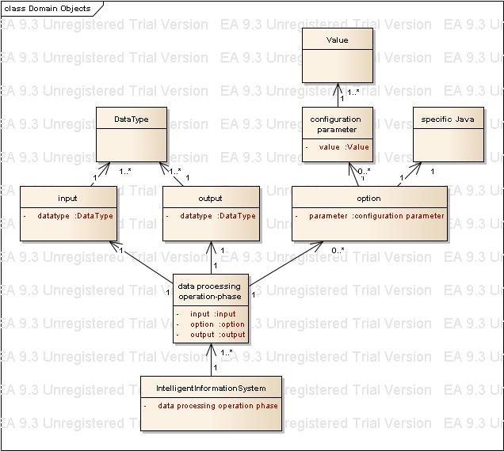

* 1. Domain diagram for AnalysisEngine

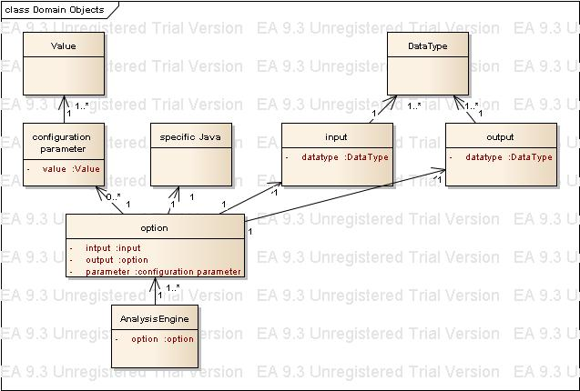

* 1. Sequence Diagram

