**SYNOPSIS**

**Title: Virtual Campus Management System**

The implementation of this project is create a virtual reality platform of interaction between the College Staffs and Students. The organogram of college operation system becomes more efficient, accurate & less complex. My project comes under the category of web application programs in which I tries to reduce the human efforts in “**College Campus**” and creating smooth flow of work anytime anywhere using proper authentication. Using the constructs of MS-SQLserver and all the user interfaces have been designed using the **asp.net** technologies.

The key concepts of my project is to connect student & college anytime, anywhere all 24/7 and 365 days a year, this is the network of connections only between the administrators, accounts department, students of the institution.

**AIM**

* To create virtual presence of college anytime anywhere.
* The aim of this project is to create separate network and environment for the particular institutions to build the connection between the student and the college by making separate user authentications to access the Network and to enjoy the features given to the student anytime anywhere 24/7 online.
* To computerize the scholarship management system.
* To computerize document collections of students by admin.
* To computerize manual leave letters.
* To computerize administrative tasks.

**Modules:**

1. College Administration.
2. Student Administration.
3. Accounts Administration.
4. Scholarship Management.
5. Payroll Management.
6. Login Trackers.
7. Reports.
8. Authentication.

SYSTEM REQUIREMENTS

* Software Requirements:
* **Operating System :**
* Windows 10
* **Front End Tool :**
* Microsoft Visual Studio 2010(Service Pack 1)
* Microsoft Visual Web Developer 2010 Express
* HTML 5
* CSS 3.0
* **Back End Tool :**
* Microsoft SQL Server 2012 R2(Database)
* IIS Express 8.0
* Hardware Tools Used :
* CPU : Processor Intel(R) Core(TM) i3-4010U CPU @ 1.70GHz, 1701 Mhz, 2 Core(s), 4 Logical Processor(s)
* Memory : 4GB
* Hard Disk : 1TB

**DATABASE DESIGN**

* dbo.AdminLogin

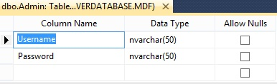

* dbo.StudentUserAccounts

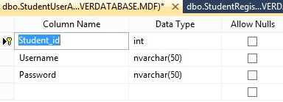

* dbo.AccountsLogin

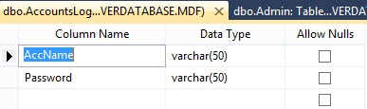

**ER-DIAGRAM**

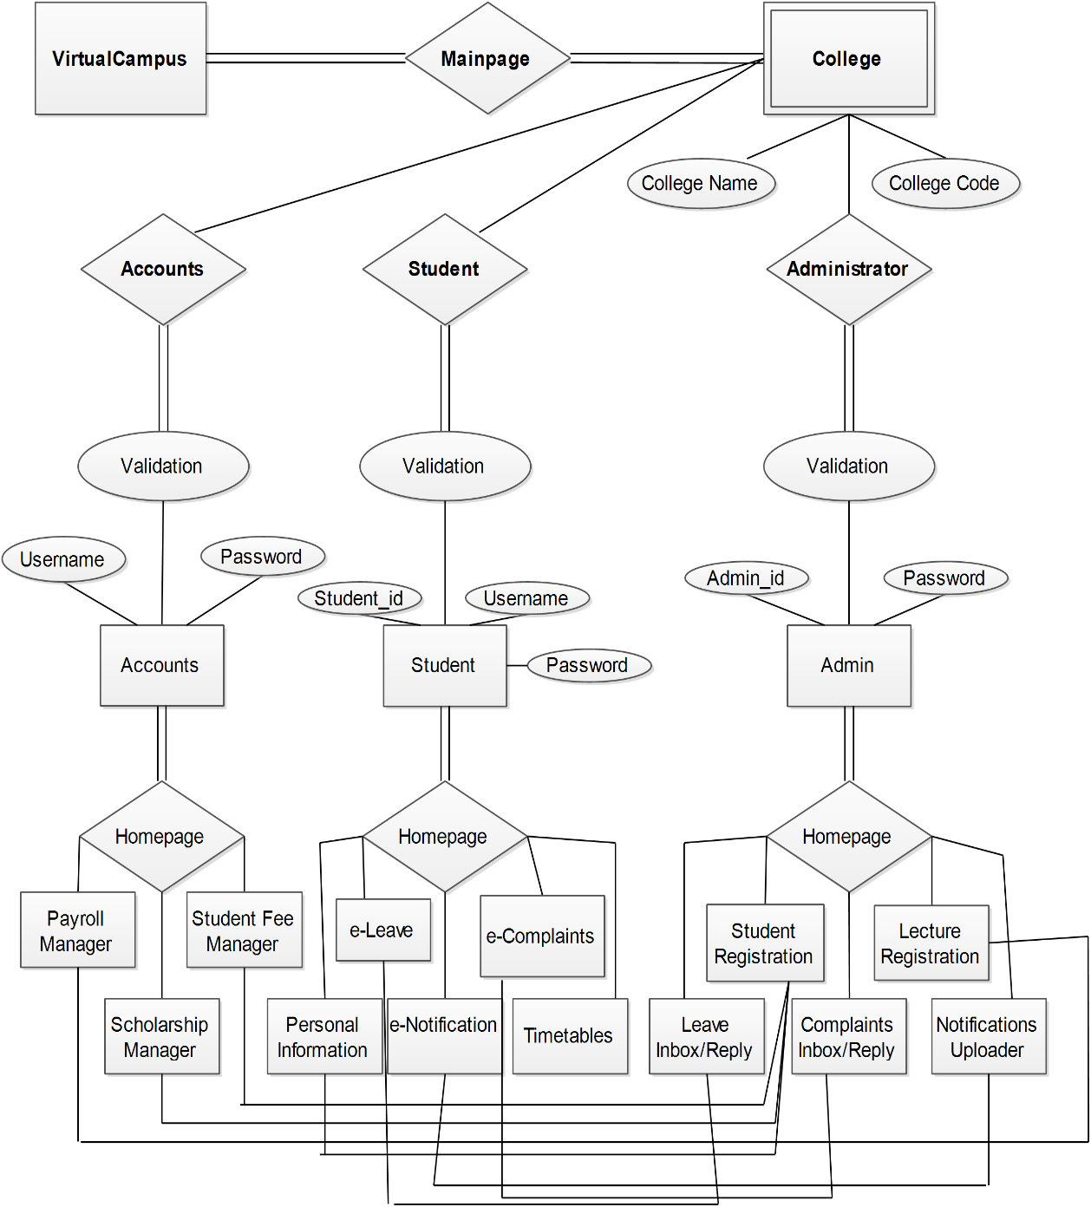

Submitted By:

**SYLVESTER ABRAHAM REG NO. (144KSB7048**)