
PROJECT REPORT

CiteLock
A Self-Correcting RAG System and Hallucination Auditor
Submitted by
N025 | Yug Dhaigude
N027 | Sylborn Furtado
N043 | Goon Jain
Under the guidance of
Faculty Mentor | Dr. Sofia Francis
SVKM's NMIMS, Deemed-to-be University
November 2026

Abstract
Large language models write fluent answers, but they sometimes state facts that no source supports. This behaviour, called hallucination, is a serious problem when answers are used for studying, research or business decisions. CiteLock is a retrieval-augmented generation (RAG) platform that audits its own answers. A user uploads documents and asks a question. CiteLock retrieves the relevant passages, drafts an answer from them, splits the answer into small factual claims, checks every claim against the documents, and repairs or removes any claim that is not supported. The result is an answer in which each statement links to a source passage, together with a complete audit trail.
The system is built as a web application. The backend runs the whole process as a LangGraph state graph with conditional routing, a bounded self-correction loop and abstention. The frontend shows this graph executing live, node by node, and lets users inspect and later reopen any past run. This report describes the problem, design, implementation, testing and deployment of the project.

1. Introduction
Retrieval-augmented generation improves language model answers by supplying them with passages from a trusted document set. Standard RAG still has a weakness: nothing checks that the final answer actually follows from the retrieved text. A model can add outside knowledge, misstate a number, or contradict the source, and the user has no easy way to notice.
CiteLock adds the missing check. Instead of trusting the draft answer, it treats the answer as a set of claims and verifies each one. The project combines retrieval, generation, claim decomposition, evidence-based verification and self-correction in one auditable pipeline.

2. Problem Statement
- Unsupported statements. Language models present guesses as facts with the same confidence as real answers.
- No traceability. Ordinary RAG shows sources, but does not prove that each sentence is backed by them.
- No audit record. Teams that rely on AI answers need evidence of what was checked, what failed and what was corrected.

3. Objectives
- Build a RAG system that answers questions only from the user's own documents.
- Break every answer into atomic claims and verify each one against the retrieved evidence.
- Automatically correct or remove unsupported claims, with a strict limit on retries, and abstain when the evidence is insufficient.
- Keep each user's data isolated and protect the system against misuse.
- Make the process transparent by showing the live execution and storing a full audit trail.
- Deploy the system as a reliable web application.

4. Background and Concepts

4.1 Retrieval-Augmented Generation
Documents are split into small chunks, and each chunk is converted into a numeric vector (an embedding) that captures its meaning. At question time, the question is embedded too, and the most similar chunks are retrieved and given to the language model as context.

4.2 Hybrid Retrieval
CiteLock searches in two ways: by meaning (vector similarity) and by keywords (full-text search). The two ranked lists are merged using Reciprocal Rank Fusion, which rewards passages that rank well in both.

4.3 Hallucination and Claim Verification
A hallucination is a statement not supported by the source. To detect it, the answer is decomposed into atomic claims, which are single factual statements that can each be judged. Every claim receives a verdict: supported, partially supported, contradicted, unsupported or insufficient evidence.

4.4 LangGraph
LangGraph models a program as a graph of nodes that share a typed state, connected by edges that can branch depending on that state. This suits CiteLock because its flow is not a straight line: results decide whether to finalize, correct, abstain or stop with an error, and the correction step loops.

5. System Architecture
CiteLock has a web frontend, an API backend and external services. The browser talks to the backend, which owns the pipeline and uses a database, a file store, an embedding service and a language model service.
Layer | Technology
Frontend | Next.js and TypeScript with Tailwind CSS, hosted on Vercel
Backend | FastAPI (Python), SQLAlchemy and Alembic, running in Docker on Render
Database | Neon PostgreSQL with the pgvector extension and full-text search
Authentication | Firebase Authentication (ID tokens verified by the backend)
File storage | Firebase Cloud Storage (private bucket)
Embeddings | Google Gemini embedding model (768 dimensions)
Answers and judging | Pluggable provider: Groq, Gemini, OpenAI or a mock for testing
Orchestration | LangGraph state graph

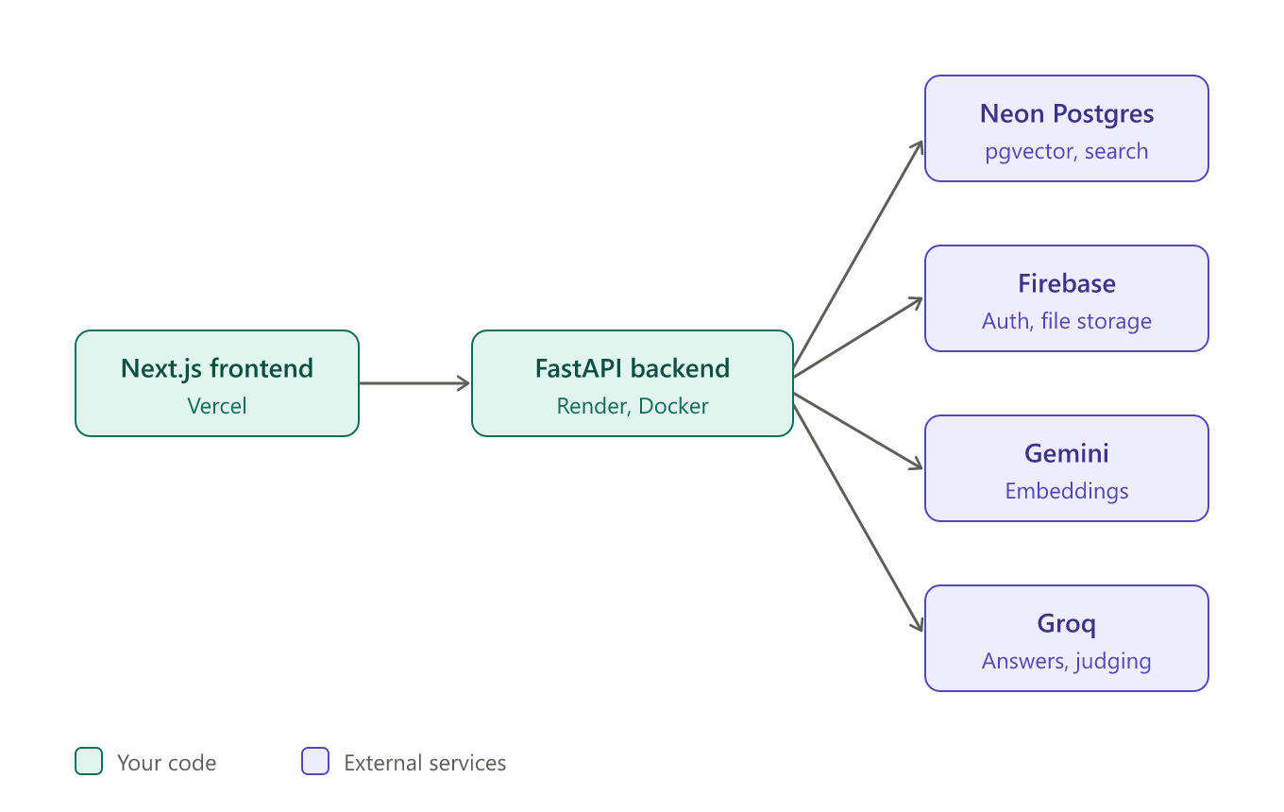
Figure 1. System architecture
Model providers sit behind a common interface, so the language model or embedding service can be changed through configuration without changing the pipeline code.

6. Methodology: How a Question Is Answered

6.1 Document ingestion
A user uploads a PDF, DOCX or TXT file. The backend validates the file, stores the original in a private bucket, extracts the text, splits it into overlapping chunks, creates an embedding for each chunk and saves everything in PostgreSQL. Documents move through the states uploaded, processing and indexed, or failed with a readable reason and a Retry option.
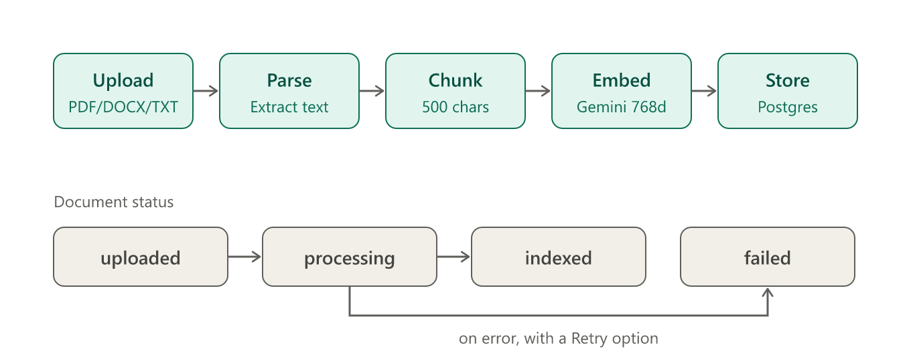
Figure 2. Document ingestion flow

6.2 The audited query pipeline
- Query input: the question is screened by a prompt-injection guard and workspace settings are read.
- Evidence retrieval: hybrid search finds the most relevant passages in the user's workspace only.
- Answer generation: the model drafts an answer using only those passages and cites them.
- Claim decomposition: the draft is split into atomic claims.
- Claim verification: each claim is checked by an LLM judge, a numeric checker and provenance tracing.
- Conditional router: verdicts and workspace policy decide the next step.
- Self-correction and re-verification: failed claims are revised using extra evidence and checked again, up to a fixed number of rounds.
- Abstention: if claims still cannot be grounded, the system says the documents do not contain enough evidence.
- Final answer and persistence: the answer, claims, evidence links and full execution trace are saved in one database transaction.
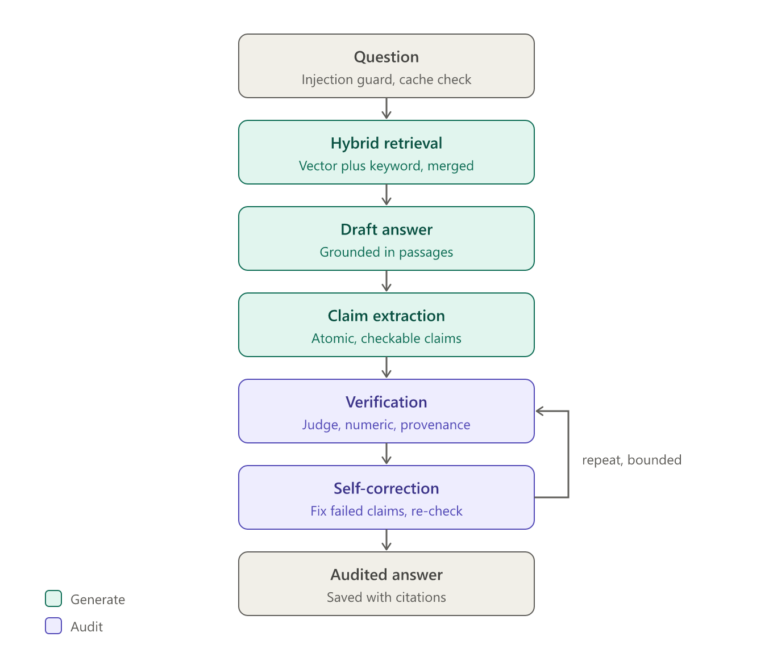
Figure 3. Query pipeline
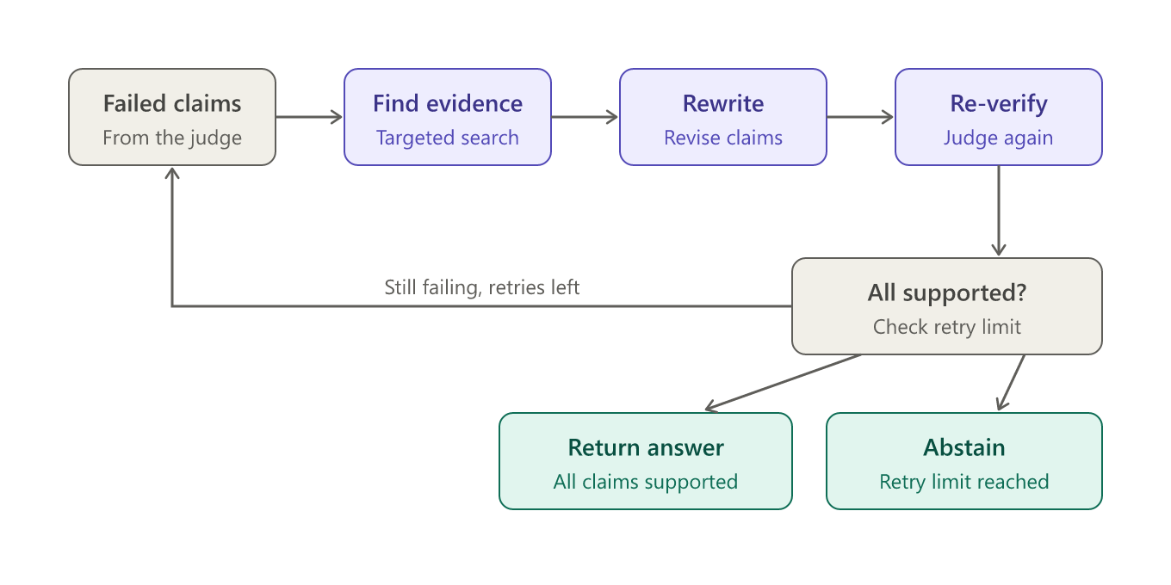
Figure 4. Self-correction loop and its two exits

6.3 Claim verdicts
Verdict | Meaning
supported | The evidence directly affirms the claim.
partially_supported | The evidence confirms part of the claim.
contradicted | The evidence explicitly refutes the claim.
unsupported | The evidence mentions the topic but not the specific assertion.
insufficient_evidence | The evidence does not address the claim.
verification_error | The check itself failed, so the run stops instead of guessing.

7. Implementation

7.1 Backend
- FastAPI routes for workspaces, documents, queries, audits, analytics and evaluation.
- A LangGraph graph with 12 nodes and conditional edges. Every node can also branch to an error handler.
- Services for ingestion, retrieval, generation, claim extraction, verification, correction, caching and audit logging.
- Database models for users, workspaces, documents, chunks, queries, answers, claims, evidence links, verification runs and audit events, with Alembic migrations.

7.2 Frontend
- Pages for dashboard, documents, grounded chat, audits, evaluation and settings.
- A live execution graph built with React Flow, showing every node as pending, running, completed, failed or skipped, with animated edges only where a transition really happened.
- A node inspector that shows retrieved passages, draft answers, claim verdicts with confidence and rationale, and before-and-after metrics for each correction round.
- A final answer card with citations and a verification summary: status, grounding rate, hallucination rate, claim counts, correction rounds and latency.
- A Previous queries menu and an audit page that restore an old answer and its recorded graph.

7.3 Live streaming
The backend streams progress to the browser using Server-Sent Events. Each graph event carries a sequence number so duplicates are dropped, heartbeats keep the connection alive, and a malformed or interrupted stream is reported as an error and never shown as a finished answer. A Stop button lets a user cancel a running query, and the backend abandons the remaining work.

8. Security and Reliability
- Authentication and isolation. Every request carries a Firebase token, and each workspace is accessible only to its owner.
- Prompt-injection guard. Hostile instructions in questions are blocked, and retrieved passages are treated strictly as data.
- Private storage and file validation. Uploads are checked and stored in a private bucket.
- Rate limiting. Each user is limited per minute and per hour, because every query spends model quota.
- Bounded behaviour. Correction rounds have a hard cap, the pipeline has an overall time limit, and slow model calls are retried a limited number of times.
- Failure handling. Provider outages, retrieval failures, database failures and timeouts produce clear messages, and failed runs are recorded with their trace. Documents stuck during a server restart are marked failed so they can be retried.

9. Testing and Results
Area | Result
Backend automated tests | 255 passed, 1 skipped (unit, integration and security tests)
Frontend automated tests | 99 passed, 3 live tests skipped unless a server is running
Static checks | ESLint clean, TypeScript type check clean, production build succeeds
Live end-to-end test | Real HTTP run against the real server: upload, query, live graph, final answer, history restore and cache hit all passed
Continuous integration | A GitHub Actions workflow runs the backend tests, migrations check, lint, type check, tests and build on every push

The tests cover normal runs, correction loops across several rounds, abstention, provider outages, retrieval and database failures, timeouts, malformed model output, interrupted streams, duplicate events, restoring past runs, large claim sets, and several identical queries arriving at once (executed only once). Automated tests use mock model providers. During development the deployed system was also run with live model providers on the hosting platform.

10. Deployment
The frontend is deployed on Vercel and the backend as a Docker service on Render. The database is a Neon PostgreSQL instance with pgvector, and authentication and file storage use Firebase. The backend applies database migrations automatically at startup. A deployment guide in the repository lists every environment variable and the exact steps for Render and Vercel.

11. Limitations
- CiteLock verifies answers only against the uploaded documents. A statement that is true in the real world but absent from them is reported as unsupported.
- Scanned PDFs without a text layer are rejected, because OCR is not supported.
- Claim extraction relies on a language model, so very long or compound sentences can produce overlapping claims.
- Free-tier model limits can make multi-step verification slow. A lighter verifier model can be configured for this.
- Rate limits are kept in memory, so they are exact for a single backend instance only.

12. Future Scope
- A reranking step after hybrid retrieval to improve answer quality.
- Conversation threads so follow-up questions keep context.
- OCR support for scanned documents.
- Shared workspaces with member roles for teams.
- Deeper monitoring, tracing and a tamper-evident audit trail.

13. Conclusion
CiteLock shows that an AI answering system can be made accountable. By decomposing answers into claims, verifying each claim against source documents, correcting failures within strict limits and abstaining when evidence is missing, it reduces the risk of unsupported statements and gives users the evidence behind every answer. Running the pipeline as a LangGraph state graph made the flow explicit and testable, and the live execution view makes the verification process visible to the user. The project was implemented end to end, tested at several levels and deployed as a web application.

References and Technologies Used
- LangGraph, a framework for stateful, graph-based language model workflows.
- FastAPI, SQLAlchemy and Alembic for the backend, API and migrations.
- PostgreSQL with the pgvector extension, hosted on Neon.
- Next.js, React, Tailwind CSS and React Flow for the frontend.
- Firebase Authentication and Cloud Storage.
- Google Gemini, Groq and OpenAI model APIs.
- Render and Vercel for hosting; GitHub Actions for continuous integration.

