CiteLock
Self-Correcting RAG and Hallucination Auditor
Project overview and technical guide

1. What CiteLock is
CiteLock is a retrieval-augmented generation (RAG) platform that audits AI-generated answers against trusted source documents. A typical RAG application retrieves text, asks a language model to answer, and trusts the result. CiteLock does not: it splits each answer into small factual claims, checks every claim against the documents, and rewrites or removes the claims the documents do not support.
The result is an answer in which every statement is traceable to a source passage, together with an audit record that shows how each claim was verified.

2. The problem it solves
- Hallucination. Language models state plausible but unsupported facts with confidence.
- No traceability. Ordinary RAG shows sources but does not prove that each statement is backed by them.
- No audit trail. Teams that rely on AI answers need a record of what was checked, what failed, and what was corrected.

3. How a question flows through the system
- Ingestion. A user uploads a PDF, DOCX or TXT file. The backend parses it, splits it into chunks (500 characters with a 50-character overlap), creates a vector embedding for each chunk, and stores everything in Postgres. The document moves through the states uploaded, processing, and indexed (or failed).
- Hybrid retrieval. The question is searched two ways: by vector similarity and by keyword (full-text search). The two ranked lists are merged with Reciprocal Rank Fusion, always within the user's own workspace.
- Draft answer. The language model writes an answer using only the retrieved passages, with citation markers.
- Claim decomposition. The draft is broken into atomic claims, each a single checkable statement, such as "tokens are signed with Ed25519".
- Verification. Each claim is checked three ways: a structured LLM judge returns a verdict, a numeric checker validates numbers, dates and percentages, and provenance tracing finds the exact source text behind the claim.
- Self-correction. Claims that are unsupported, contradicted or only partly supported are revised using targeted evidence and re-verified, for a bounded number of rounds. If a claim still cannot be grounded, the system abstains instead of guessing.
- Persistence and audit. The query, answer, claims, evidence links and verification runs are saved, so every answer has a complete audit history that can be viewed and exported.

Workflow diagrams
The three diagrams below show the same flow visually: first the one-time ingestion of a document, then the path every question takes, then the self-correction loop in detail.
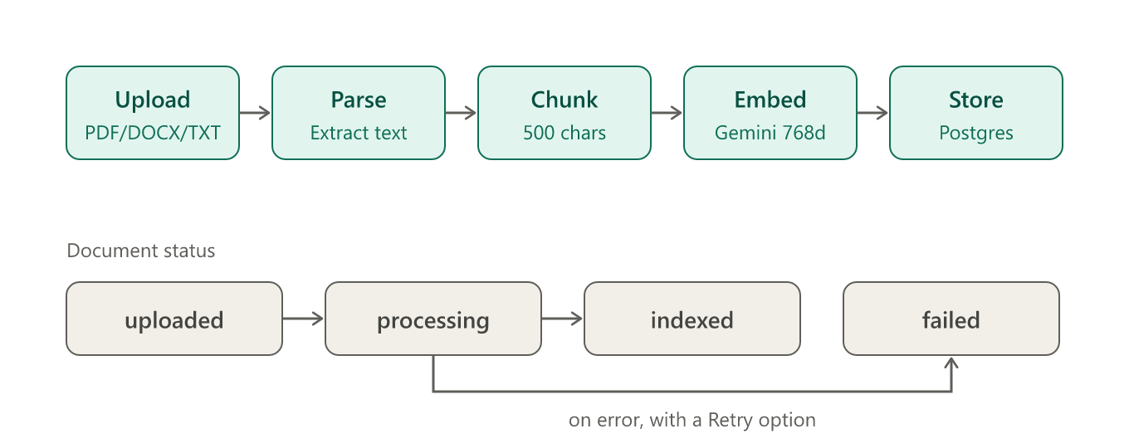
Figure 1. Document ingestion and status states
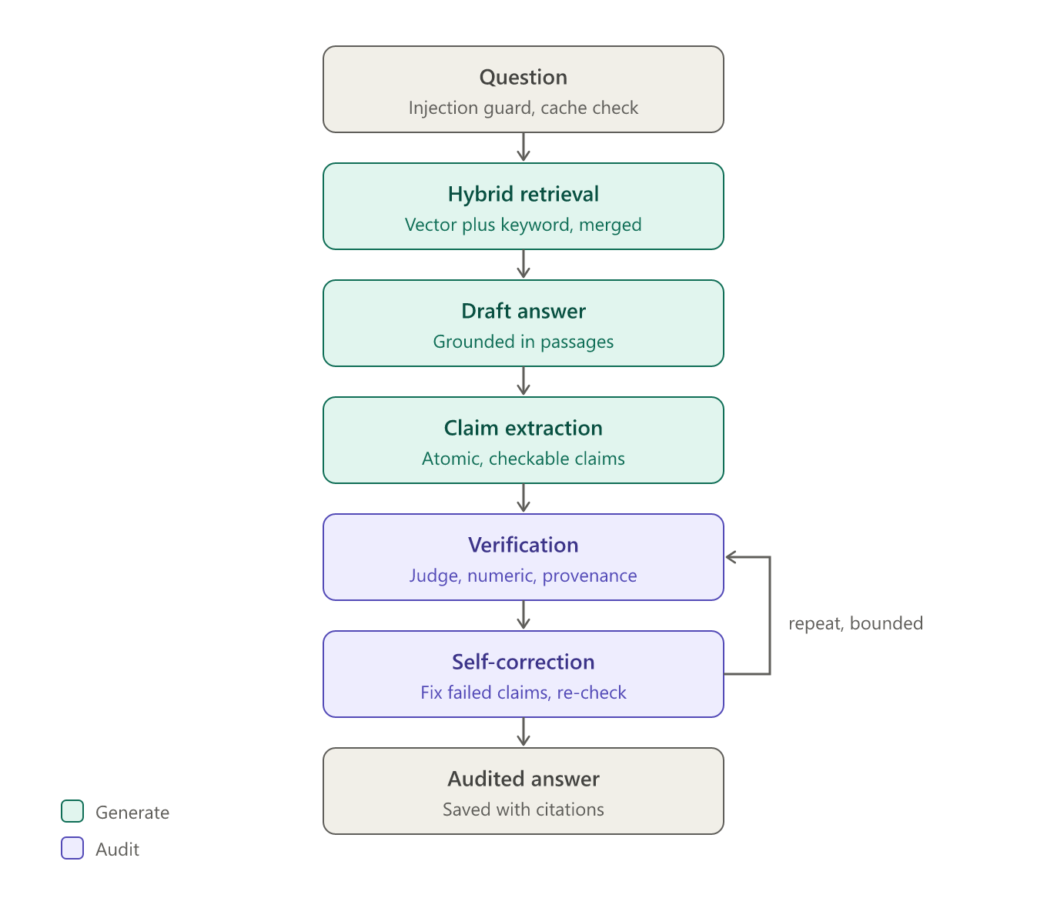
Figure 2. Query pipeline from question to audited answer
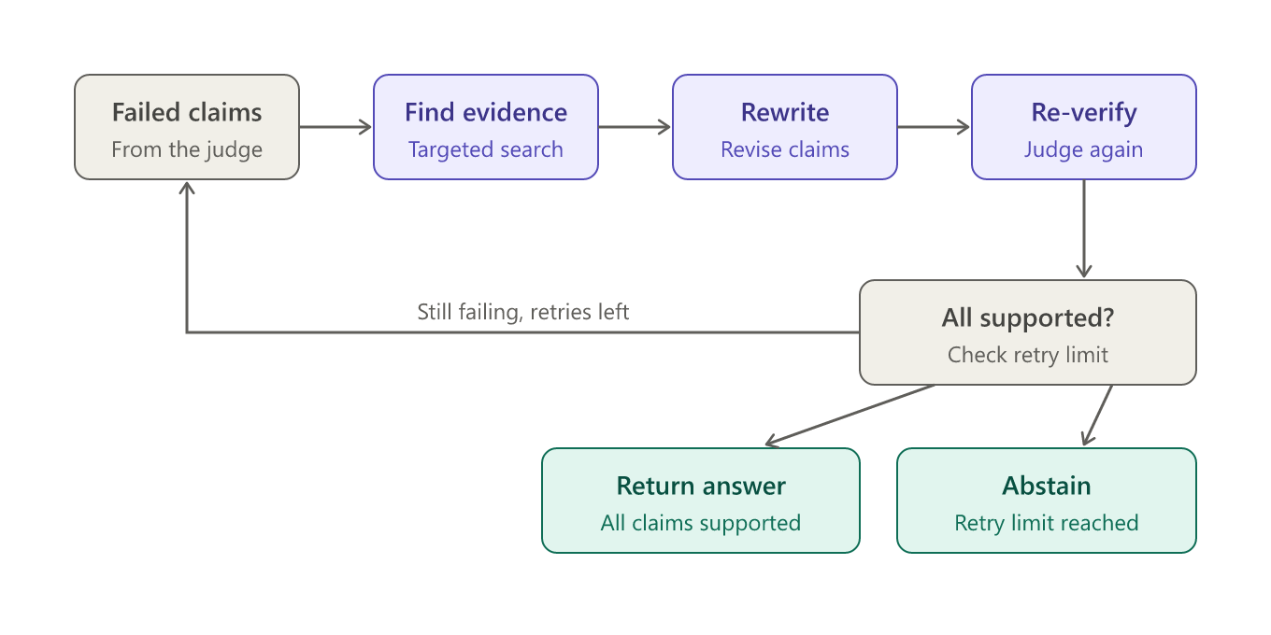
Figure 3. Self-correction loop and its two exits

Claim verdicts
Verdict | Meaning
supported | The evidence directly affirms the claim.
partially_supported | The evidence confirms part of the claim.
contradicted | The evidence explicitly refutes the claim.
unsupported | The evidence mentions the topic but not the specific assertion.
insufficient_evidence | The evidence is empty or does not address the claim.
verification_error | The check itself failed (for example a provider outage). The pipeline stops rather than guess.

4. Architecture
Layer | Technology
Frontend | Next.js and TypeScript with Tailwind CSS, hosted on Vercel.
Backend | FastAPI (Python 3.11), SQLAlchemy 2.0 and Alembic migrations, running in Docker on Render.
Database | Neon Postgres with the pgvector extension for vectors, plus full-text search for keywords.
Authentication | Firebase Authentication. The backend verifies Firebase ID tokens.
File storage | Firebase Cloud Storage (private bucket, accessed only through the backend).
Embeddings | Google Gemini (gemini-embedding-001), 768 dimensions.
Answers and judging | Pluggable provider: OpenAI, Gemini, Groq, or a mock for offline development.

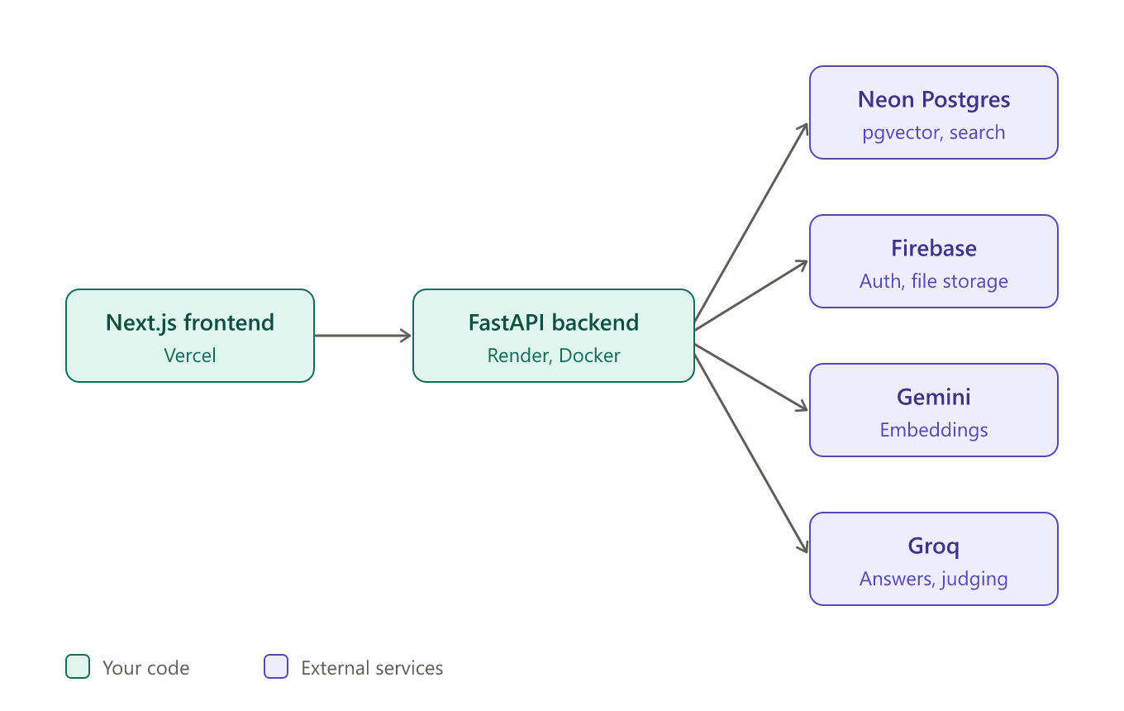
Figure 4. System architecture
Model providers sit behind a common interface (backend/app/providers/base.py). Switching the language model or the embedding service requires only changing environment variables, not code.

5. Key features
- Evidence-grounded generation that states honestly when the context is missing.
- Atomic claim extraction with a sentence-level fallback if structured output fails.
- Type-aware numeric checking that separates currency, percentages, years and counts to avoid false contradictions.
- Bounded self-correction with abstention when claims cannot be resolved.
- Workspace isolation: documents, history and settings are separate for each workspace.
- Audit history and analytics, with export of any answer's audit.
- Result caching so repeated questions over unchanged documents reuse earlier results.
- Evaluation suite that scores the pipeline against a benchmark set of cases.

6. Security
- Prompt-injection guard rejects queries that try to override the model's instructions, and untrusted passages are sanitized.
- File validation checks uploads before they are processed.
- Token-verified access: each request is tied to a Firebase user and to a workspace they belong to.
- Server-side secrets: model keys, database credentials and the Firebase service account stay on the backend and are never sent to the browser.

7. Data model
Table | Purpose
users, workspaces | Accounts and the isolated tenants they work in. Workspaces also hold per-workspace settings.
documents, chunks | Uploaded files and their text chunks with embeddings and full-text indexes.
queries, answers | Each question and the final audited answer.
claims | Atomic claims extracted from each answer, with verdicts and confidence.
evidence_links | Links from each claim to the exact chunk and text span that supports or refutes it.
verification_runs | Records of each verification pass, including correction rounds.
audit_events | Security and system events, such as blocked prompt injections.

8. Main API endpoints
All routes are under /api/v1/workspaces/{workspace_id}.
Endpoint | Purpose
POST /documents/upload | Upload a document for ingestion.
GET /documents | List documents and their processing status.
POST /documents/{id}/reprocess | Retry a failed document.
POST /queries?stream=true | Run the audited pipeline, streaming progress events.
GET /audits and /audits/{id} | Browse and open answer audits; /export downloads one.
GET /analytics | Aggregate results over a time range.
POST /evaluation/run | Run the benchmark suite.
GET and PUT /settings | Read and change workspace policy, such as retrieval depth.

9. Configuration
The backend is configured through environment variables. The key ones are listed below; values are secrets and must never be committed or shared.
Variable | Purpose
LLM_PROVIDER, LLM_API_KEY | Which service writes and judges answers (openai, gemini, groq or mock), and its key.
EMBEDDING_PROVIDER, EMBEDDING_API_KEY | Which service creates embeddings, and its key.
GEMINI_LLM_MODEL, GROQ_LLM_MODEL | Optional model overrides for each provider.
DATABASE_URL | Postgres connection string.
FIREBASE_SERVICE_ACCOUNT_JSON, FIREBASE_STORAGE_BUCKET | Firebase credentials and bucket.
ENVIRONMENT, CORS_ORIGINS | Deployment mode and allowed frontend origins.
MAX_CORRECTION_RETRIES | Upper limit on self-correction rounds.

10. Deployment
- The frontend is deployed on Vercel and calls the backend over HTTPS.
- The backend is a Docker service on Render. On each start it runs the Alembic migrations, then launches the FastAPI server.
- The database is a hosted Neon Postgres instance with pgvector enabled.
- Changes pushed to the main branch on GitHub redeploy the services automatically.

11. Running it locally
- Copy backend/.env.example to backend/.env and frontend/.env.example to frontend/.env.local, then fill in your own keys.
- Start Postgres with pgvector: docker compose up -d postgres.
- In backend: create a virtual environment, run pip install -e ., then alembic upgrade head, then uvicorn app.main:app --reload --port 8000.
- Run the backend tests with pytest -v.
- In frontend: install dependencies and run the dev server on port 3000.

12. Limits and next steps
- Free-tier rate limits. The free Groq tier caps tokens per minute, so claim checks run one at a time and answers can be slow. A paid tier or a smaller model removes the bottleneck.
- Model availability changes. Providers retire models without notice. The Groq adapter now picks an available model automatically; the Gemini adapter still needs a valid model name.
- Development login in production. ALLOW_DEV_AUTH should be off in the deployed environment.
- Small polish items: blank page numbers on text files, and the README should mention Groq.

