CiteLock
Self-Correcting RAG and Hallucination Auditor
Project overview and technical guide

1. What CiteLock is
CiteLock is a retrieval-augmented generation (RAG) platform that audits AI-generated answers against trusted source documents. A typical RAG application retrieves text, asks a language model to answer, and trusts the result. CiteLock does not: it splits each answer into small factual claims, checks every claim against the documents, and rewrites or removes the claims the documents do not support.
The result is an answer in which every statement is traceable to a source passage, together with an audit record that shows how each claim was verified.

2. The problem it solves
- Hallucination. Language models state plausible but unsupported facts with confidence.
- No traceability. Ordinary RAG shows sources but does not prove that each statement is backed by them.
- No audit trail. Teams that rely on AI answers need a record of what was checked, what failed, and what was corrected.

3. How a question flows through the system
- Ingestion. A user uploads a PDF, DOCX or TXT file. The backend parses it, splits it into chunks (500 characters with a 50-character overlap), creates a vector embedding for each chunk, and stores everything in Postgres. The document moves through the states uploaded, processing, and indexed (or failed).
- Hybrid retrieval. The question is searched two ways: by vector similarity and by keyword (full-text search). The two ranked lists are merged with Reciprocal Rank Fusion, always within the user's own workspace.
- Draft answer. The language model writes an answer using only the retrieved passages, with citation markers.
- Claim decomposition. The draft is broken into atomic claims, each a single checkable statement, such as "tokens are signed with Ed25519".
- Verification. Each claim is checked three ways: a structured LLM judge returns a verdict, a numeric checker validates numbers, dates and percentages, and provenance tracing finds the exact source text behind the claim.
- Self-correction. Claims that are unsupported, contradicted or only partly supported are revised using targeted evidence and re-verified, for a bounded number of rounds. If a claim still cannot be grounded, the system abstains instead of guessing.
- Persistence and audit. The query, answer, claims, evidence links and verification runs are saved, so every answer has a complete audit history that can be viewed and exported.

Workflow diagrams
The three diagrams below show the same flow visually: first the one-time ingestion of a document, then the path every question takes, then the self-correction loop in detail.
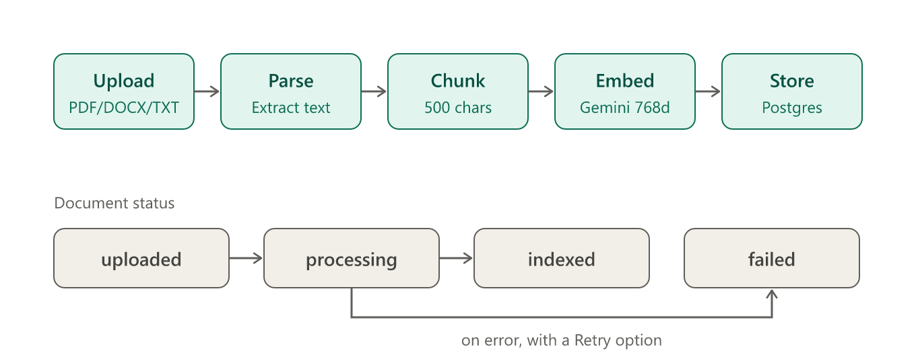
Figure 1. Document ingestion and status states
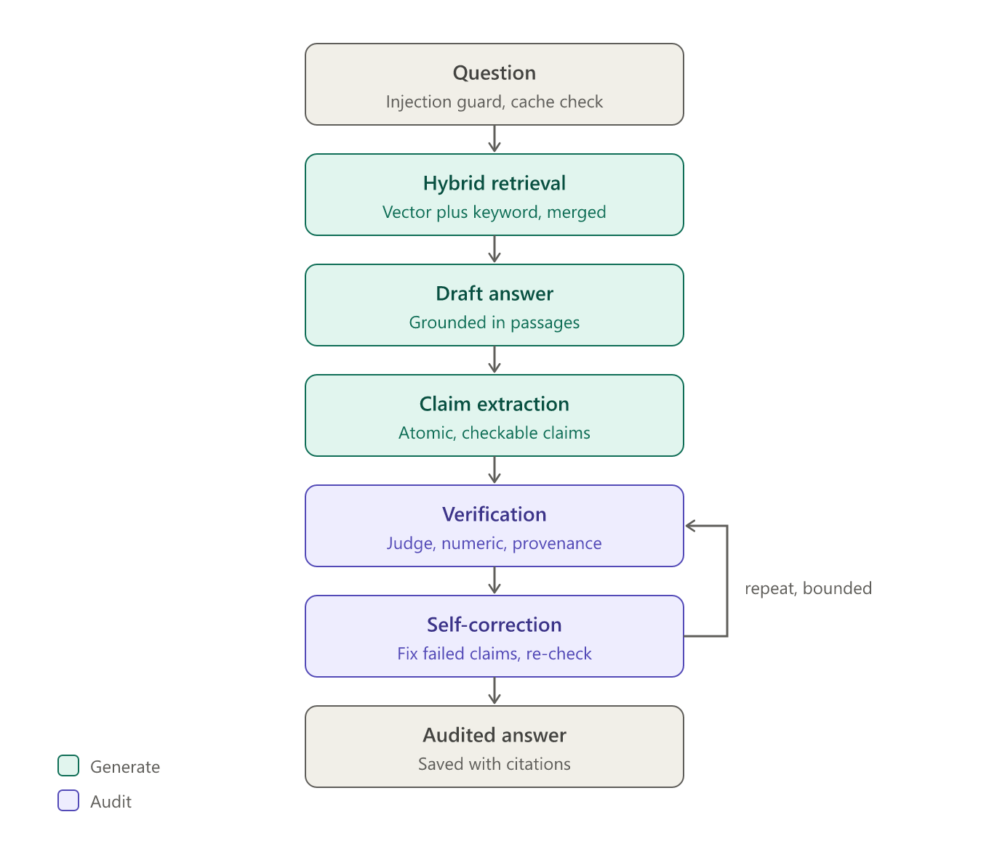
Figure 2. Query pipeline from question to audited answer
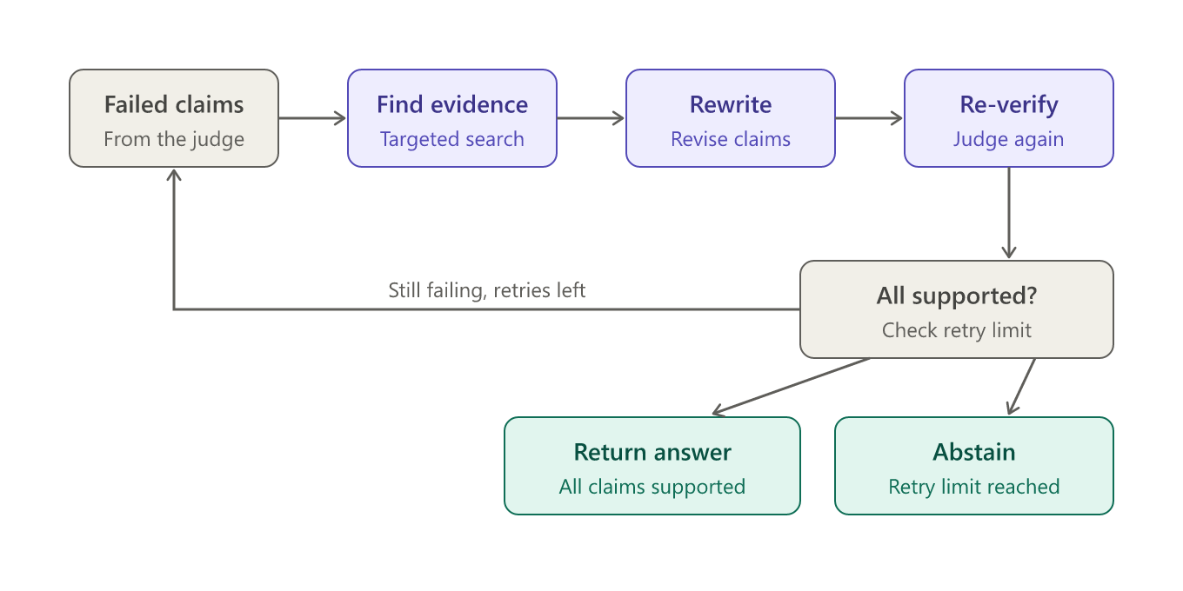
Figure 3. Self-correction loop and its two exits

Claim verdicts
Verdict | Meaning
supported | The evidence directly affirms the claim.
partially_supported | The evidence confirms part of the claim.
contradicted | The evidence explicitly refutes the claim.
unsupported | The evidence mentions the topic but not the specific assertion.
insufficient_evidence | The evidence is empty or does not address the claim.
verification_error | The check itself failed (for example a provider outage). The pipeline stops rather than guess.

4. End-to-end walkthrough
This section follows one real session from sign-in to audited answer, using the Project Titan example: a document called Project_Titan_Architecture.txt and the question "How do the components of Project Titan communicate?".

Step 1: Sign in and get a workspace
- The frontend signs you in with Firebase Authentication and receives a short-lived ID token.
- Every API call carries that token in an Authorization header. The backend verifies it with the Firebase Admin SDK and, on your first request, creates your user row automatically.
- All data lives inside a workspace (for example "Project Titan"). A route only works if the workspace's owner is the signed-in user, so one user can never read another user's documents.

Step 2: Upload and index a document
- The upload endpoint receives the file, cleans the file name, checks the type and contents, and computes a checksum.
- The original file is stored in a private Firebase bucket at workspaces/<workspace>/documents/<id>/<name>. A database row is created with status uploaded, and an audit event is recorded.
- A background task then does the heavy work so the upload returns immediately: status moves to processing, the text is extracted, split into overlapping chunks, and each chunk is embedded by Gemini into a 768-number vector.
- Chunks and vectors are written to Postgres in one transaction, and the status becomes indexed. If anything fails (for example an API-key or billing error), the status becomes failed with a readable message and a Retry button.

Step 3: Ask a question
- In Grounded Chat, the frontend sends the question to the streaming query endpoint and keeps the connection open, so progress appears live.
- First, the prompt-injection guard screens the question. Blocked attempts are logged as security events.
- Next, the cache is checked using a fingerprint of the workspace, documents, question and settings. A repeat question on unchanged documents returns the earlier verified result immediately.
- On a cache miss, a worker thread runs the pipeline and reports each stage to the browser as it finishes.

Step 4: Retrieve evidence
- The question is embedded and compared with every chunk's vector (dense search), and also matched against the text by keyword (full-text search).
- The two ranked lists are merged with Reciprocal Rank Fusion, and the top passages are kept (five by default, adjustable per workspace).
- Only chunks from the current workspace are searched.

Step 5: Write a draft answer
- The language model receives the passages, each labelled with its document and chunk ID, and is told to answer only from them, cite the passage after each statement, and say so when the documents do not cover something.
- Passages are sanitized and treated strictly as data, so instructions hidden inside a document are not followed.
- If nothing relevant was retrieved, the system returns a clear "no reference evidence was found" message rather than inventing an answer.

Step 6: Break the draft into claims
- A second model call splits the draft into atomic claims, for example "inter-node communication requires TLS 1.3" and "tokens are signed with Ed25519".
- Headings, questions and filler are dropped, and pronouns are resolved to real names. If the model's output is not valid JSON, a sentence-based fallback is used.

Step 7: Verify every claim
- The LLM judge compares the claim with the evidence and returns a verdict, a confidence score, a rationale and supporting quotes.
- The numeric checker separately validates numbers, percentages and dates, so "99.9%" is never confused with "99%".
- Provenance tracing finds the exact chunk and text span behind the claim, and only real chunk IDs are accepted.
- If the judge itself fails (for example a rate limit), the claim is marked verification_error and the run stops instead of guessing.

Step 8: Self-correct
- Claims that are unsupported, contradicted, partially supported or lacking evidence are sent back for repair.
- The controller fetches targeted evidence for each failed claim, rewrites it, extracts the claims again and re-verifies everything. It will not repeat an identical attempt.
- This loop runs up to the configured number of rounds (three on your deployment). If a claim still cannot be grounded, the answer is trimmed or the system abstains. In your Project Titan test, two correction passes were needed.

Step 9: Save and show the result
- In one transaction the system saves the query, the final answer, each claim with its verdict, the evidence links to exact chunks, the verification runs and an audit event. A failure rolls everything back, so no half-saved answers exist.
- A cache entry is written if the result is safe to reuse.
- The browser receives a final event and renders the answer with its verified citations (seven in your example), the number of correction passes and the number of claims evaluated.

Step 10: Review and improve
- The Audits page lists every answer with its claims and evidence, and can export an audit.
- Analytics summarizes verdicts over time, and the Evaluation page runs the benchmark suite to measure accuracy.
- Workspace settings let you tune retrieval depth, retry limits, abstention policy and the preferred model provider.

5. Architecture
Layer | Technology
Frontend | Next.js and TypeScript with Tailwind CSS, hosted on Vercel.
Backend | FastAPI (Python 3.11), SQLAlchemy 2.0 and Alembic migrations, running in Docker on Render.
Database | Neon Postgres with the pgvector extension for vectors, plus full-text search for keywords.
Authentication | Firebase Authentication. The backend verifies Firebase ID tokens.
File storage | Firebase Cloud Storage (private bucket, accessed only through the backend).
Embeddings | Google Gemini (gemini-embedding-001), 768 dimensions.
Answers and judging | Pluggable provider: OpenAI, Gemini, Groq, or a mock for offline development.

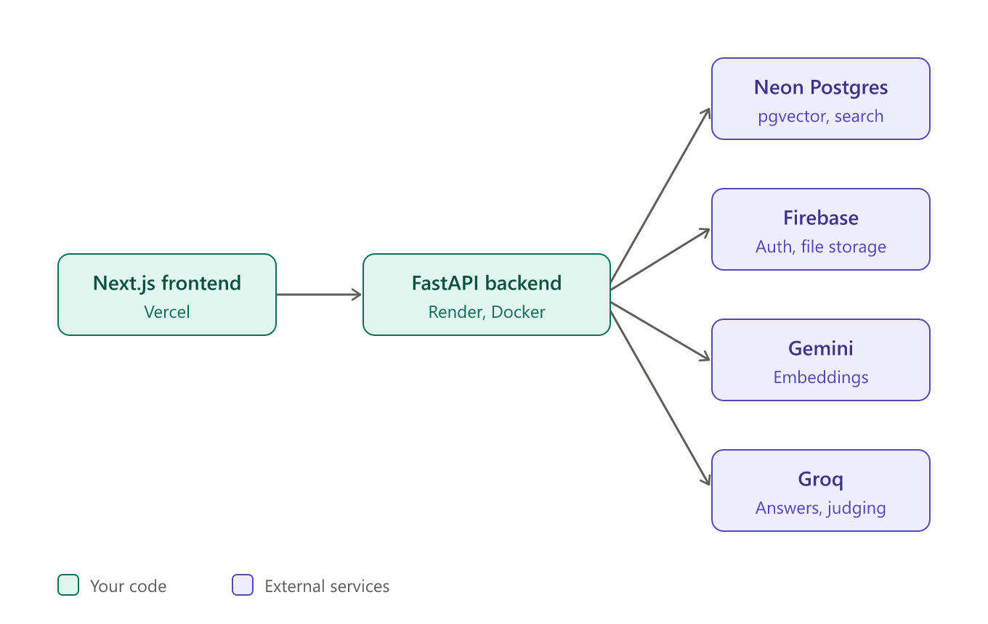
Figure 4. System architecture
Model providers sit behind a common interface (backend/app/providers/base.py). Switching the language model or the embedding service requires only changing environment variables, not code.

6. Key features
- Evidence-grounded generation that states honestly when the context is missing.
- Atomic claim extraction with a sentence-level fallback if structured output fails.
- Type-aware numeric checking that separates currency, percentages, years and counts to avoid false contradictions.
- Bounded self-correction with abstention when claims cannot be resolved.
- Workspace isolation: documents, history and settings are separate for each workspace.
- Audit history and analytics, with export of any answer's audit.
- Result caching so repeated questions over unchanged documents reuse earlier results.
- Evaluation suite that scores the pipeline against a benchmark set of cases.

7. Security
- Prompt-injection guard rejects queries that try to override the model's instructions, and untrusted passages are sanitized.
- File validation checks uploads before they are processed.
- Token-verified access: each request is tied to a Firebase user and to a workspace they belong to.
- Server-side secrets: model keys, database credentials and the Firebase service account stay on the backend and are never sent to the browser.

8. Data model
Table | Purpose
users, workspaces | Accounts and the isolated tenants they work in. Workspaces also hold per-workspace settings.
documents, chunks | Uploaded files and their text chunks with embeddings and full-text indexes.
queries, answers | Each question and the final audited answer.
claims | Atomic claims extracted from each answer, with verdicts and confidence.
evidence_links | Links from each claim to the exact chunk and text span that supports or refutes it.
verification_runs | Records of each verification pass, including correction rounds.
audit_events | Security and system events, such as blocked prompt injections.

9. Main API endpoints
All routes are under /api/v1/workspaces/{workspace_id}.
Endpoint | Purpose
POST /documents/upload | Upload a document for ingestion.
GET /documents | List documents and their processing status.
POST /documents/{id}/reprocess | Retry a failed document.
POST /queries?stream=true | Run the audited pipeline, streaming progress events.
GET /audits and /audits/{id} | Browse and open answer audits; /export downloads one.
GET /analytics | Aggregate results over a time range.
POST /evaluation/run | Run the benchmark suite.
GET and PUT /settings | Read and change workspace policy, such as retrieval depth.

10. Configuration
The backend is configured through environment variables. The key ones are listed below; values are secrets and must never be committed or shared.
Variable | Purpose
LLM_PROVIDER, LLM_API_KEY | Which service writes and judges answers (openai, gemini, groq or mock), and its key.
EMBEDDING_PROVIDER, EMBEDDING_API_KEY | Which service creates embeddings, and its key.
GEMINI_LLM_MODEL, GROQ_LLM_MODEL | Optional model overrides for each provider.
DATABASE_URL | Postgres connection string.
FIREBASE_SERVICE_ACCOUNT_JSON, FIREBASE_STORAGE_BUCKET | Firebase credentials and bucket.
ENVIRONMENT, CORS_ORIGINS | Deployment mode and allowed frontend origins.
MAX_CORRECTION_RETRIES | Upper limit on self-correction rounds.

11. Deployment
- The frontend is deployed on Vercel and calls the backend over HTTPS.
- The backend is a Docker service on Render. On each start it runs the Alembic migrations, then launches the FastAPI server.
- The database is a hosted Neon Postgres instance with pgvector enabled.
- Changes pushed to the main branch on GitHub redeploy the services automatically.

12. Running it locally
- Copy backend/.env.example to backend/.env and frontend/.env.example to frontend/.env.local, then fill in your own keys.
- Start Postgres with pgvector: docker compose up -d postgres.
- In backend: create a virtual environment, run pip install -e ., then alembic upgrade head, then uvicorn app.main:app --reload --port 8000.
- Run the backend tests with pytest -v.
- In frontend: install dependencies and run the dev server on port 3000.

13. Limits and next steps
- Free-tier rate limits. The free Groq tier caps tokens per minute, so claim checks run one at a time and answers can be slow. A paid tier or a smaller model removes the bottleneck.
- Model availability changes. Providers retire models without notice. The Groq adapter now picks an available model automatically; the Gemini adapter still needs a valid model name.
- Development login in production. ALLOW_DEV_AUTH should be off in the deployed environment.
- Small polish items: blank page numbers on text files, and the README should mention Groq.

