|  |  |  |  |  |  |
| --- | --- | --- | --- | --- | --- |
| Class Assignment 2 | | | | | |
| 학번 | 2018023390 | **이름** | 이서연 | **제출일** | 2021.05.09 |

1. Which requirements you implemented

|  |  |
| --- | --- |
| A. Camera manipulation | 모두 구현 |
| B. Single mesh rendering mode | 모두 구현 |
| C. hierarchical mode | 모두 구현 |
| D. Lighting | 모두 구현 |
| Extra credits | 모두 구현. |

1. A hyperlink to the video uploaded to Internet video streaming services by capturing the animating hierarchical model as a video

실행 시 사진

|  |  |  |  |  |  |
| --- | --- | --- | --- | --- | --- |
| level 1 | 몸통 | | | | |
| level 2 | 오른발 | 왼발 | 팔 | 머리 | |
| level 3 |  |  |  | 윗부리 | 아랫부리 |

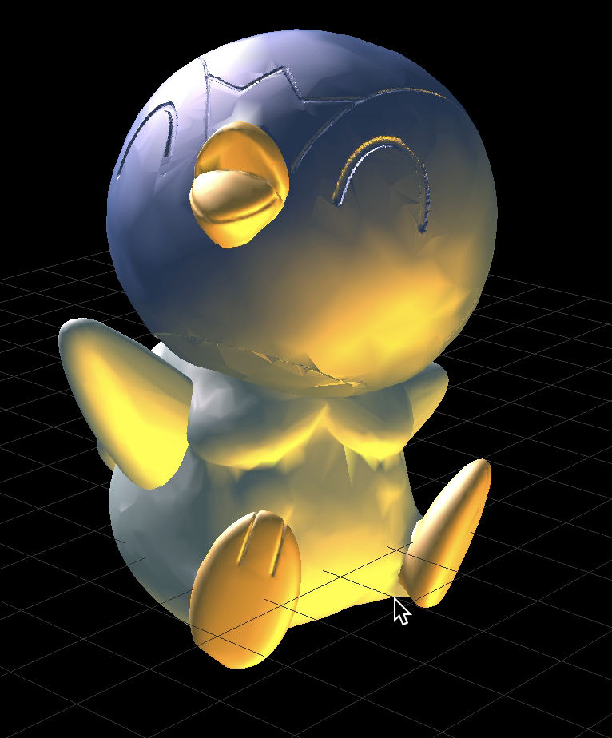

유튜브 링크 : <https://youtu.be/AfaPUdOYmWg>

1. Light configuration
   1. How many light sources ? Light source 2개 사용
   2. Where do you put the light sources ? source 1 = (.0,2.,2.,1.), source 2 = (.0,-2.,-2.,1.)
   3. What is the type of each light source? light source 1, 2 모두 Point light이다.