Northwind Traders Ltd – Active Directory Project

1 -(Information)

- The aim for this project is to showcase my current Active Directory skills and planning, with the goal to create and maintain a structured and functional Active Directory setup for Northwind Traders Ltd.

- Throughout this project, I will be demonstrating my abilities, including:

- Creating a New Organisational Unit
- Delegate OU Control
- Delete or Rename an OU
- Search inside an OU
- Export an OU List
- Remove OU Deletion Protection
- Creating a User Account
- Finding Objects & Assets in Active Directory
- View a File Path of an Object
- Find & Move a Computer to a New OU
- Reseting User Passwords
- Unlock a User's Account (with no password change)
- Creating a New Security Group/Group
- Adding a User to a Group
- Adding a Group as a Member of Another Group
- Removing a User or Group from a Group
- Deleting a Group
- Disable a User Account
- Delete an Account

2 -(Briefing)

Northwind Traders Ltd is a growing company with multiple departments. The IT team has been tasked with designing and managing an Active Directory (AD) environment to improve organization, security, and access control.
The company structure includes:
- HR Department
- Finance Department
- IT Department
- Sales Department
I have endured the role of a Junior System Administrator, who is responsible for implementing and maintaining AD.

My goals for this Project are:

- Design and manage Organisational Units (OUs)
- Create and manage user accounts
- Implement group-based access control
- Apply and troubleshoot Group Policy Objects (GPOs)
- Maintain and secure AD objects

3 -(Part 1 – Creating the Organisational Structure)

The Top-Level OU
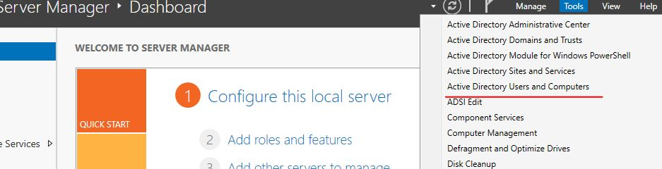
- First I must go into Active Directory Users and Computers to commence the creation
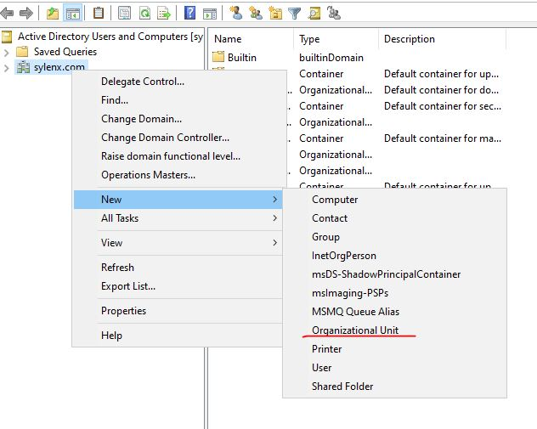

- I right-click on my Domain, “New” then select “Organisational Unit”
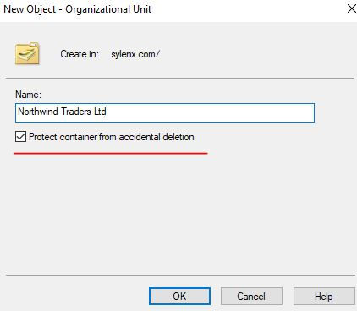

- I can now name my Top-Level Organisational Unit and Protect it from Accidental Deletion

The Sub-OUs
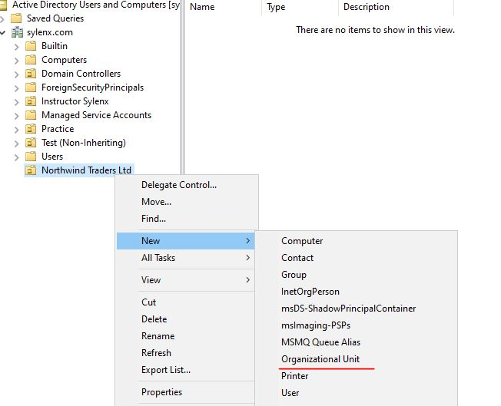

- To Create the Sub-Ous, right-click Top-Level OU, “New”, “Organisational Unit”
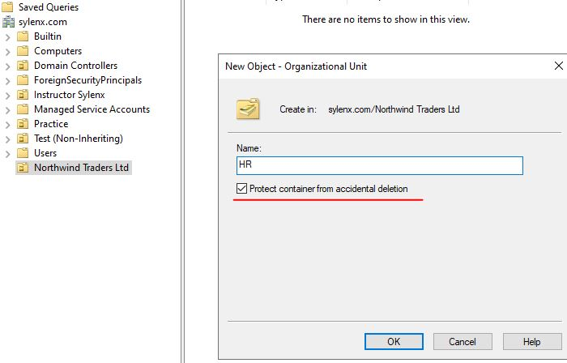

- Similarly to the Top-Level OU, we name the OU and Protect from Accidental Deletion
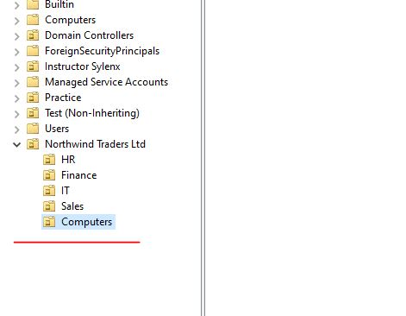

- The five Sub-Organisational Units have been added

4 -(Part 2 – Delegating OU Control and Adding Users)

Delegating Control
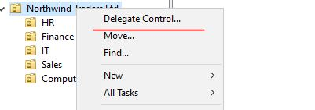

- To begin Delegating Control I Right-Click the OU and select “Delegate Control”
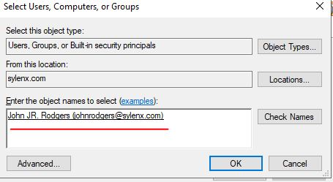

- I search for the user who will be granted control. In this case it is John Rodgers – the primary IT Manager
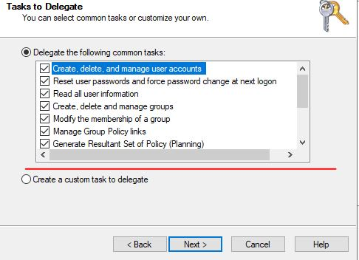

- I then grant him the permissions that he can use
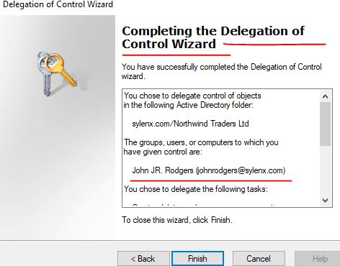

- Delegation of Control is completed

Adding Users
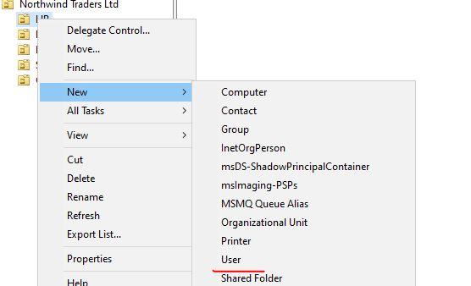
- To create a new User, I Right-Click the Target OU (in this case HR) and select “New” → “User”
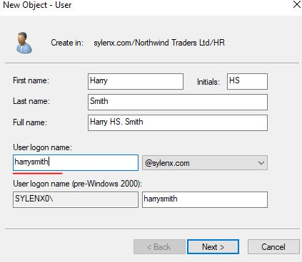

- I then assign the basic details for the user
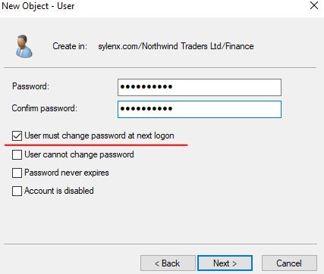

- I then assign them a password that they can change at their next logon
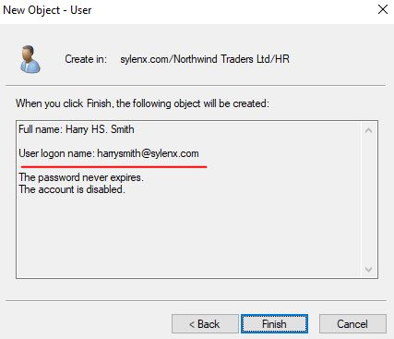

- The User account is now completed and is on the domain

4 -(Part 2 – Every day Active Directory Tasks)

Reseting a Password
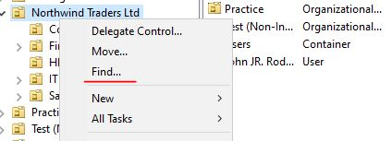

- We must first find the target user who has requested a password change
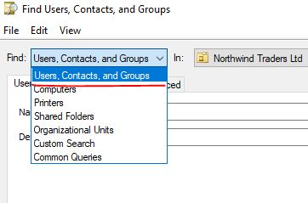
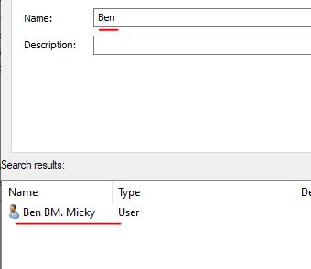

- We adjust our search filters and then input their name to show results

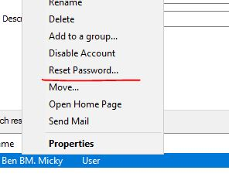

- We Right-Click then Reset Password
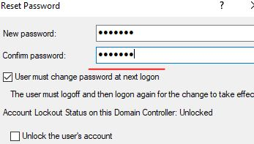

- We choose a temporary password for them to type in at their login screen. They can then change this to a personal password when prompted

Unlock an Account

- We must first find the target user who has a locked account

- We adjust our search filters and then input their name to show results
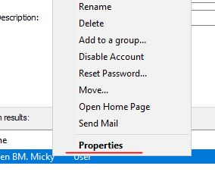

- We go to properties
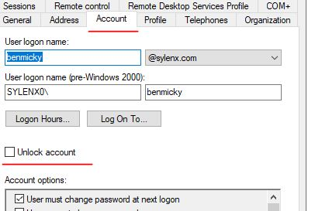

- Account Tab then Unlock Account

Disable an Account

- We must first find the target user who needs to be disabled

- We adjust our search filters and then input their name to show results

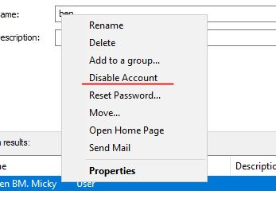

- We click on Disable Account
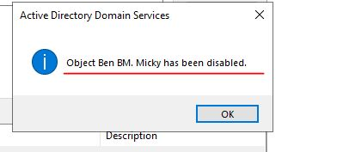

- Account has been disabled

Delete an Account

- We must first find the target user who must be deleted

- We adjust our search filters and then input their name to show results

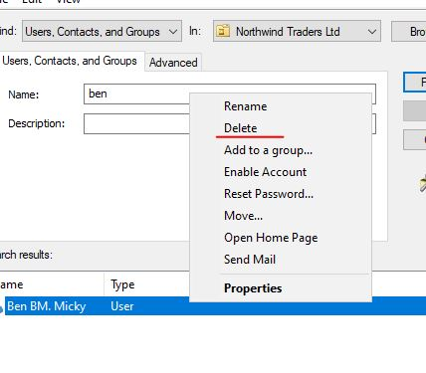

- We Right-Click the user and select Delete

Deleting and Renaming an Organisational Unit

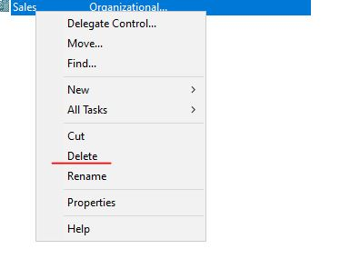
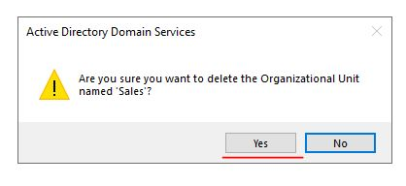

- Select and Right-Click the chosen OU and then select Delete

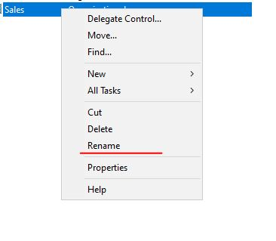
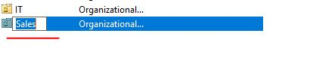

- Select and Right-Click the chosen OU and select Rename

Search Inside an Organisational Unit

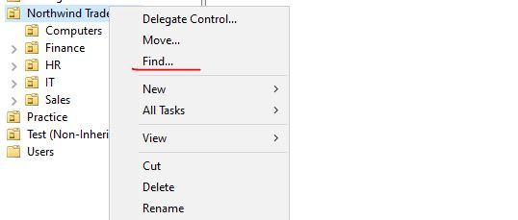
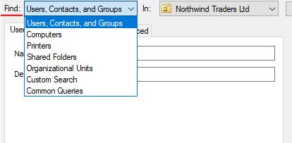

- Right-Click and select Find and then adjust the Search Filter to commence a Search inside the organisational unit

Export an Organisational Unit as a List

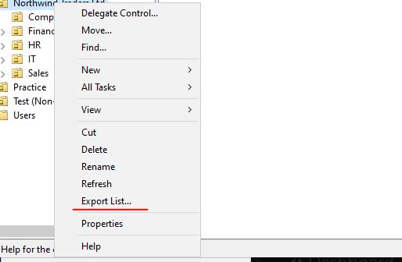

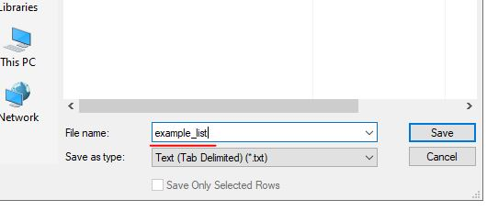

- Select and Right-Click your target Organisational Unit and select Export List. Then Name and Save.

Remove Organisational Unit Deletion Protection

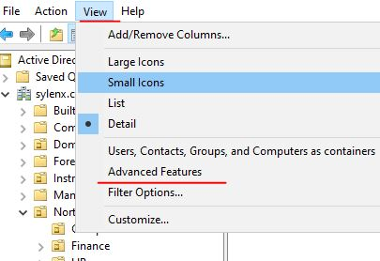

- Go to the View Tab and then select Advanced Features
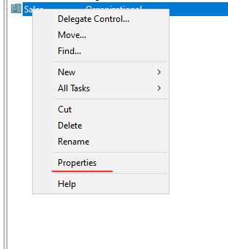

- Right-Click target Organisational Unit and select Properties
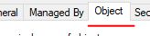

- Go to the Object Tab
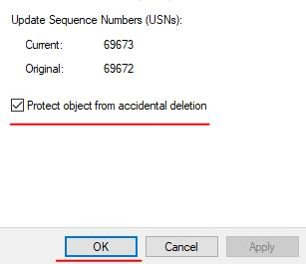

- Uncheck Protect Object from accidental deletion
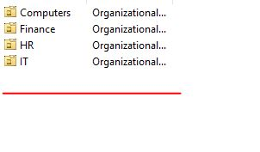

- The Organisational Unit can now be, and is now deleted

View the File Path of an Object

- Go to the View Tab and then select Advanced Features

- Right-Click target Organisational Unit and select Properties
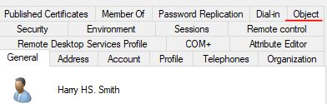

- Select the Object Tab
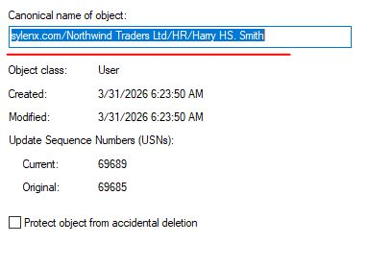

- The File Path for the object is now viewable

An Incorrectly Added Computer/Move a Computer to a New Organisational Unit

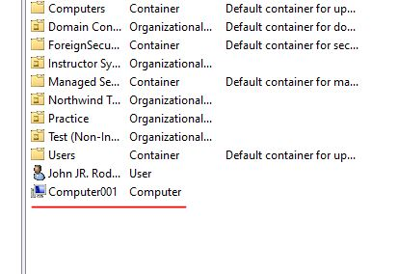

- First locate the computer that needs to be moved/incorrectly added

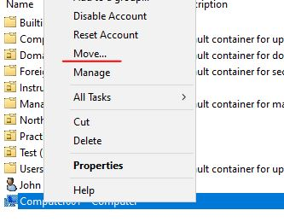

- Right-Click the computer and select Move
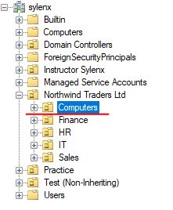

- Select the Organisational Unit to added the computer too. In this case it will be the Computers Organisational Unit.
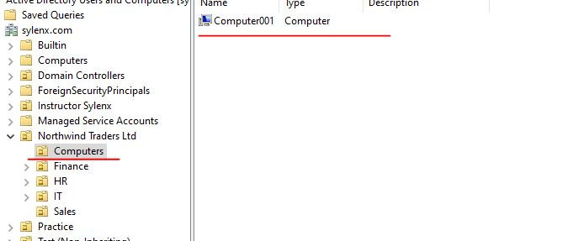
- The computer is now in the Computers Organisational Unit

Creating a New Security Group

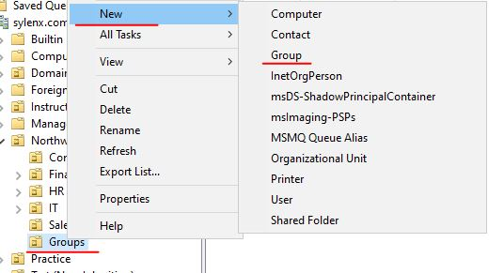
- Right-Click on the target Organisational Unit, select New and select Group
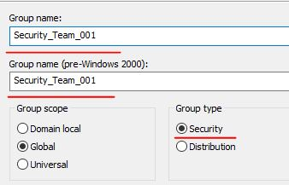

- Complete the Group Details
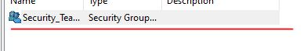

- The Security Group is now created

Adding a User to a Group

- We must first find the target user who we want to add to a Group

- We adjust our search filters and then input their name to show results
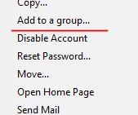

- We select Add to a Group
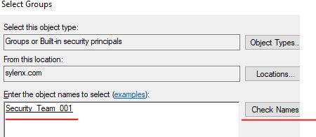

- We then type in the name of our desired Group and Check Names to verify the Group exists
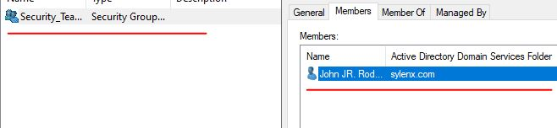

- We then add the user to the Group and verify it by checking the Group

Adding a Group as a Member of Another Group

- We must first find the target Group who we want to add to another Group
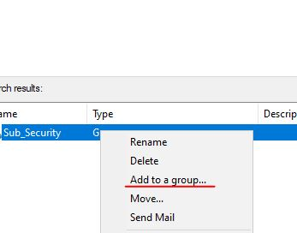

- Once the target Group is found, we Add to a Group
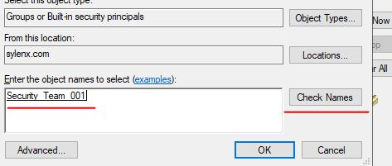

- We search for the Target Group and Check Names to verify it exists
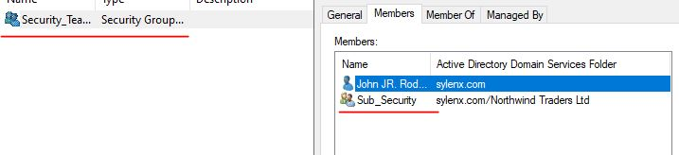
- We have successfully added the Group to the Main Security Group

Removing a User or Group from a Group

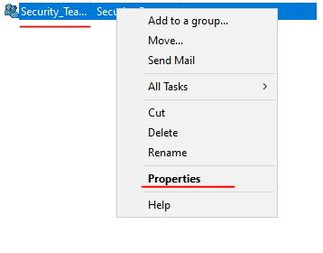

- Select the Main Group and Right-Click and select Properties
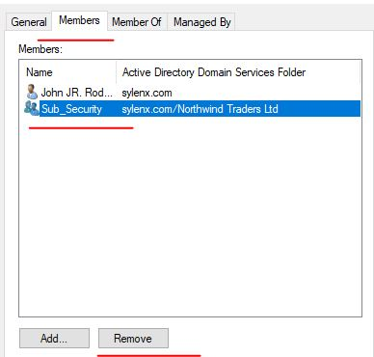

- Go to the Members Tab, select the Group and select Remove

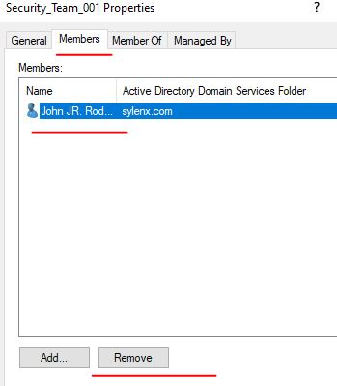

- Repeat process to Remove a User
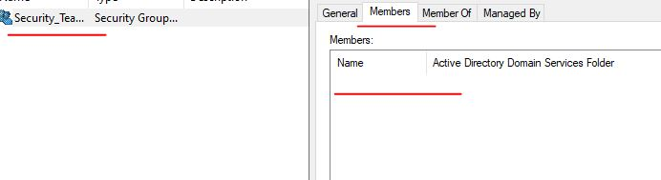
- Our Main Group does not have any Members

Deleting a Group

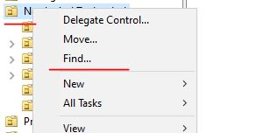

- Right-Click on Main Organisation Unit and select Find
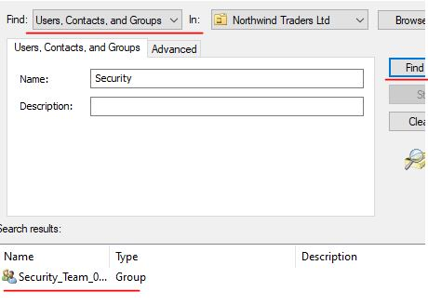

- Adjust Search Filtering, type in target Group name and select Find
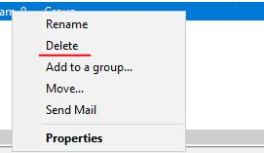

- Once the Target Group is Found, Right-Click and select Delete
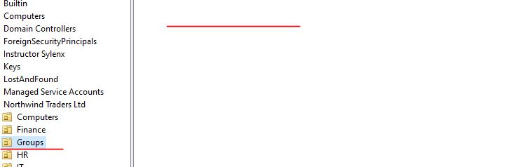

- The Group has now been deleted from the Group Organisational Unit

5 -(Part 3 – Summery)
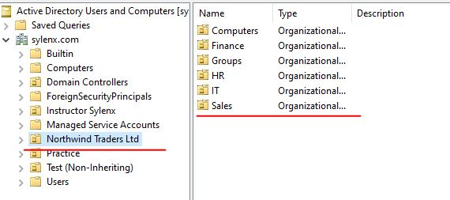
- The Northwind structural Overview
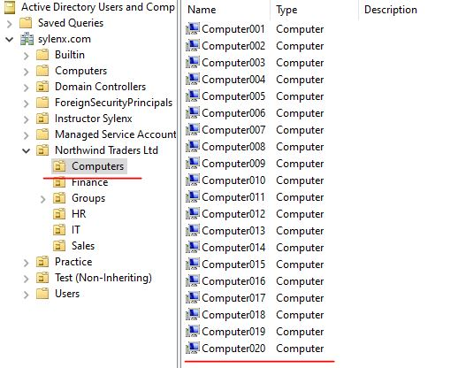
- A list of the Northwind User’s Computers in the Computers OU
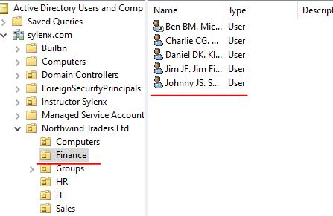

- The Northwind Finance Department OU
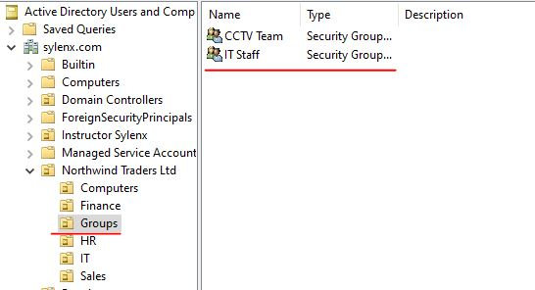
- The Northwind Groups OU
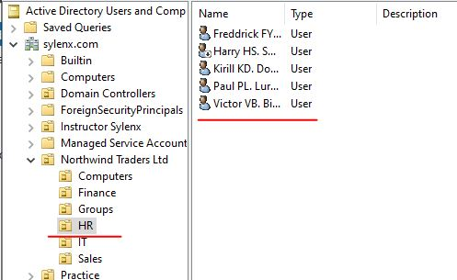
- The Northwind HR Department OU
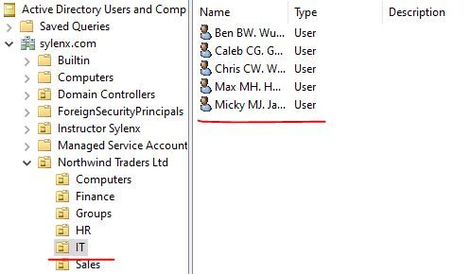
- The Northwind IT Department OU
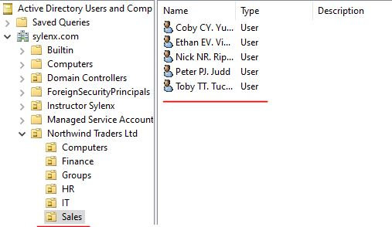
- The Northwind Sales Department OU

