Wazuh-SOC-Lab-Environment
Network Topology(Kali----attacker, Metasploitable2---------target, Ubuntu Server ----------SIEM(Wazuh SOC)
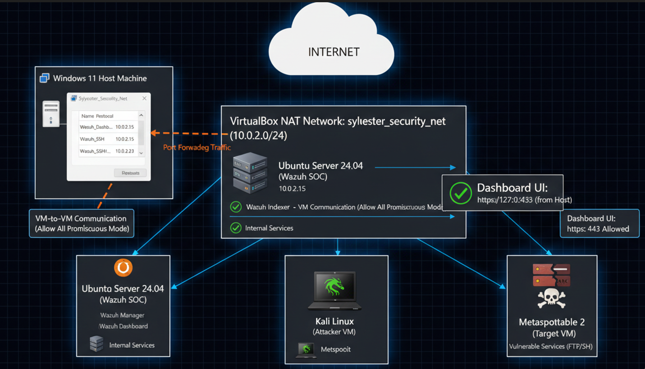

Metasploitable2 credentials:
Username:msfadmin
Password:msfadmin
Base Network for the three machines hosted in the Virtual Box
1: Create infrastructure to ensure all machines can communicate with each other while maintaining internet access.
In the virtual box manager navigate to File ,Network manager, NAT Networks Tab
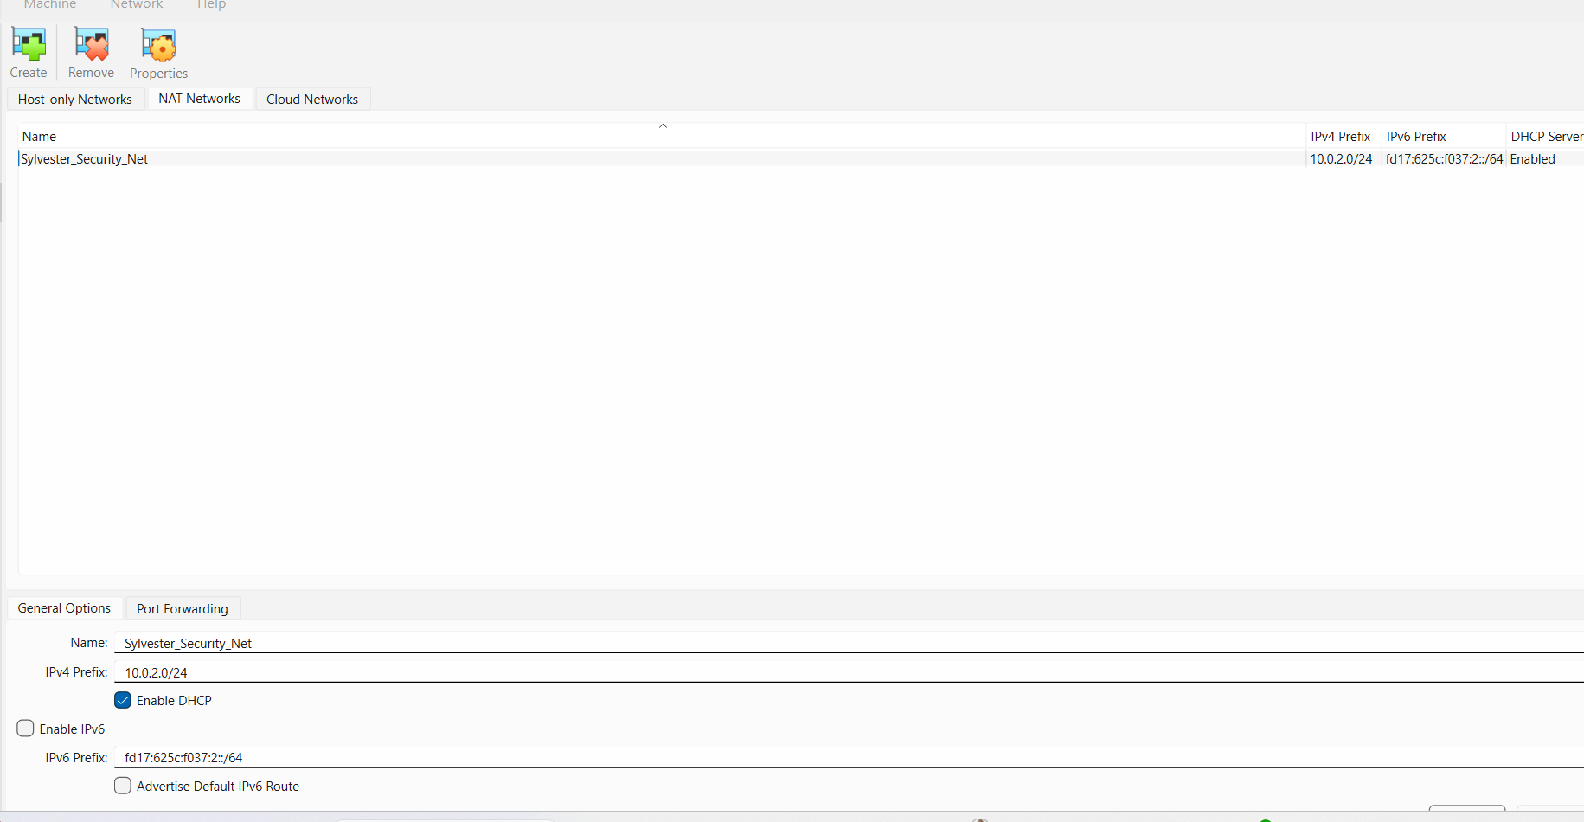
Enable DHCP
For each of the machines, plug them into the new virtual switch to Sylvester_Security_Net attached to the NAT Network
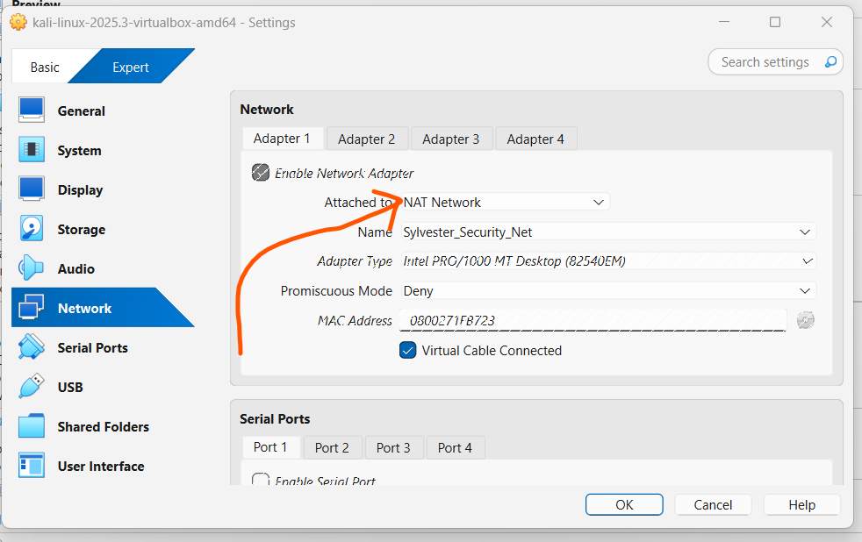

Accessing the Dashboard from Windows
1: In your VirtualBox Manager (not the VM window), right-click your VM and go to Settings -> Network.
2: Select Adapter 1 (the NAT Network one).
3: Click Advanced -> Port Forwarding
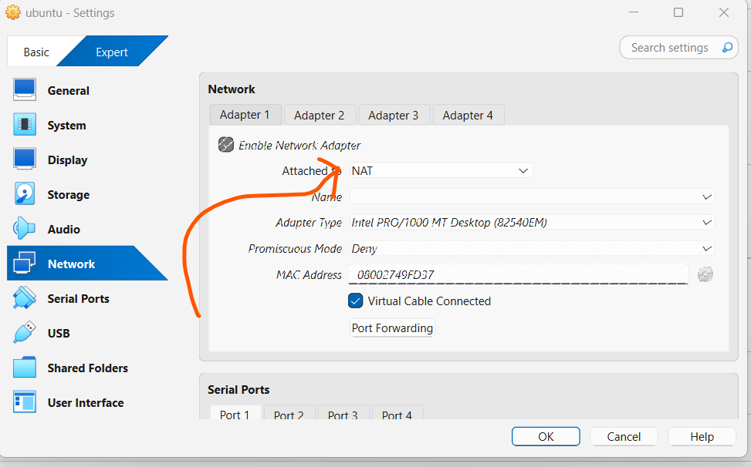
Infrastructure Layer Finalized: Successfully provisioned the Ubuntu 22.04 LTS instance ('tarus') with a dual-NIC architecture. Initialized the Wazuh v4.x automated deployment script to initialize the SIEM's indexing and management planes.
Add a new rule:
Rule 1 (Dashboard): Allows you to type https://localhost:4433 in your Windows browser to see the Wazuh UI.
Rule 2 (SSH): Allows you to use PowerShell to connect via ssh sylkip3@127.0.0.1 -p 5555 so you can copy and paste the installation commands.
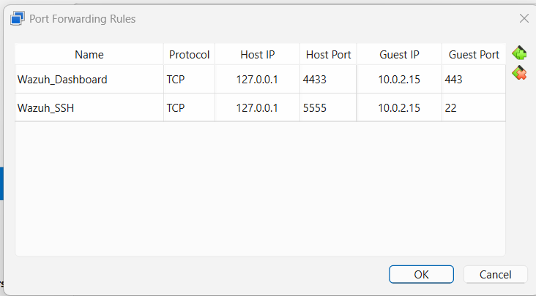
Network Abstraction: Implemented Port Address Translation (PAT) to bridge the host loopback interface with the guest service ports. Mapped Host:4433 to Guest:443 for web-tier management and Host:5555 to Guest:22 for administrative SSH access, bypassing NAT-induced isolation.
Connecting to Ubuntu server through the host machine: Windows
Open Windows Command Prompt elevated privileges
- Connect via SSH (The easy way to copy-paste) Open PowerShell/CMD on your Windows host and type: ssh sylkip3@127.0.0.1 -p 5555
Username:sylkip3
Password:****
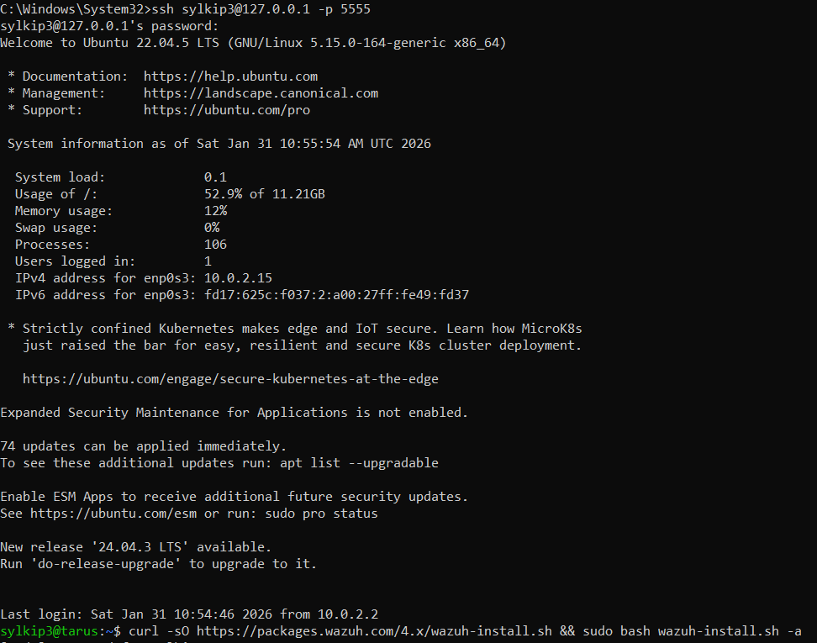
- Run the Wazuh Installation Once you are logged into the Ubuntu prompt via PowerShell/CMD
Copy and paste this command:
curl -sO https://packages.wazuh.com/4.x/wazuh-install.sh && sudo bash wazuh-install.sh -a

Open the Required Ports
- Allow Agent Enrollment: sudo ufw allow 1515/tcp
- Allow Agent Connection: sudo ufw allow 1514/tcp
- Allow SSH through the firewall: sudo ufw allow 22/tcp
- Allow the Wazuh Dashboard port: sudo ufw allow 443/tcp
- Verify Rules: sudo ufw status
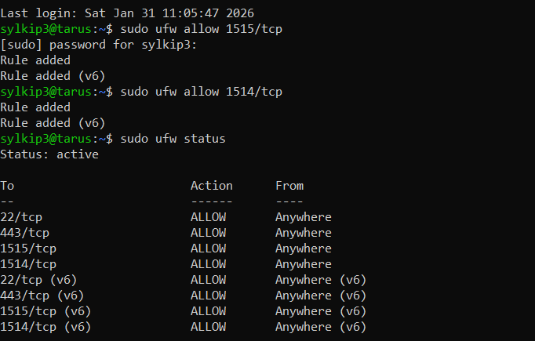
- Enable the firewall: sudo ufw enable (Press y when prompted).

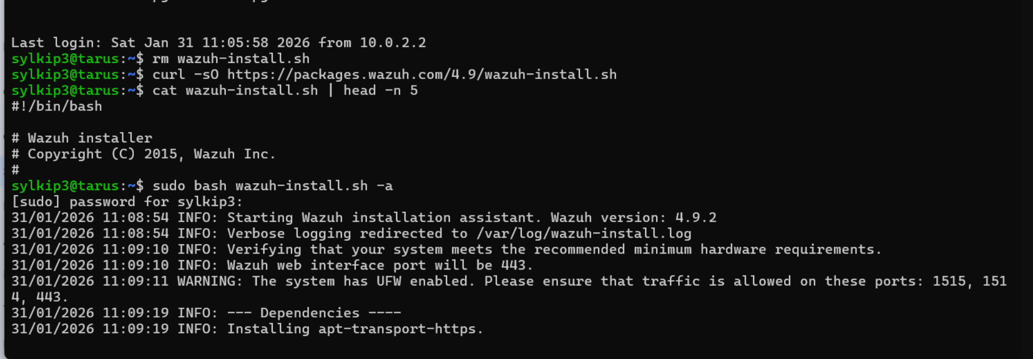

Network Engineering: Successfully implemented Port Address Translation (PAT) rules. Established a management tunnel (Host:5555 -> Guest:22) for remote command-line interface (CLI) operations and a web-tier tunnel (Host:4434 -> Guest:443) to expose the Wazuh Dashboard to the host OS while maintaining NAT network isolation.
- Accessing the Dashboard
Once the script finishes, you can open your Windows web browser (Chrome or Edge) and go to: https://127.0.0.1:4433/

User: admin
Password: S02KdqgNQ*7qdRQyciA8uUo*stqLctjT
Wazuh Dashboard
