1. Uploaded Cloud Formation template on the AWS console.

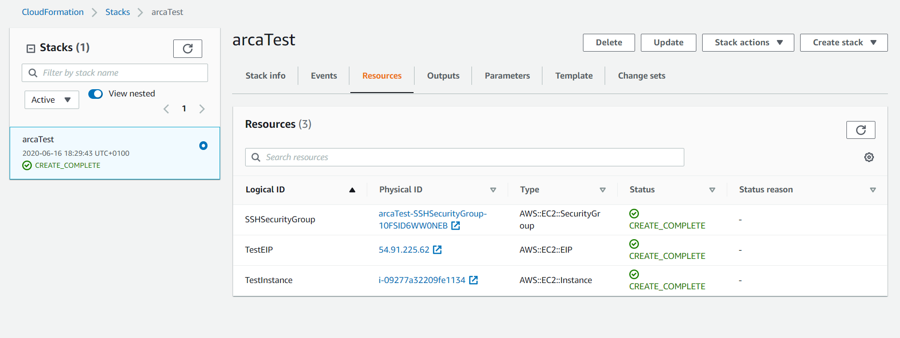

1. Create an IAM Policy with the Json policy Editor that allows EC2 stop and start actions

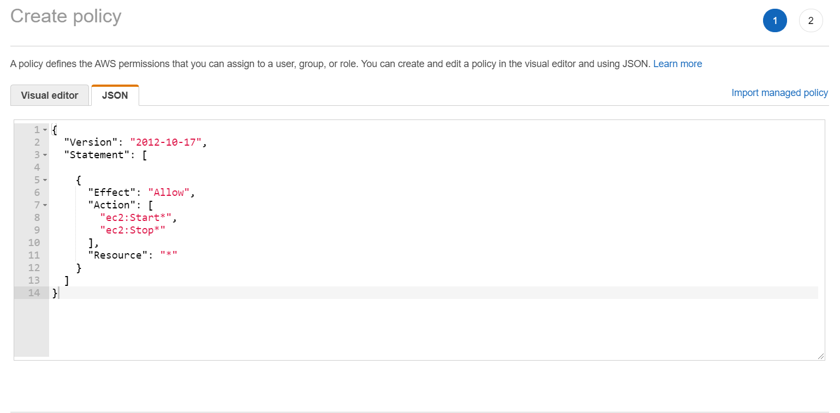

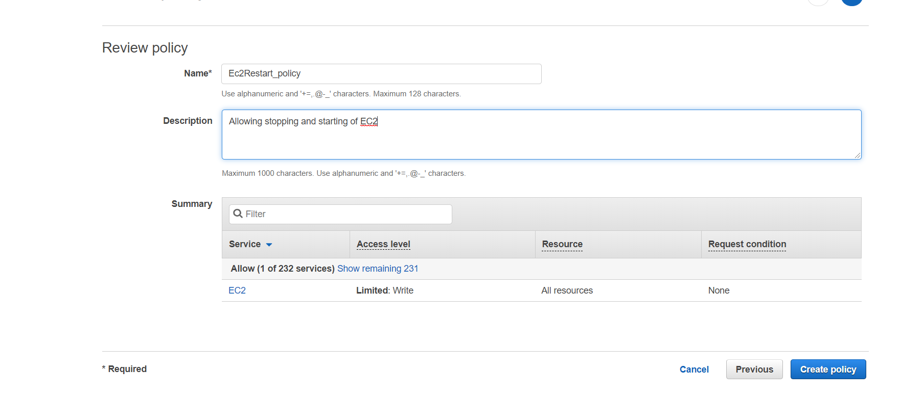

1. Create an IAM Role for Lambda and attach the created policy in Step 1 above

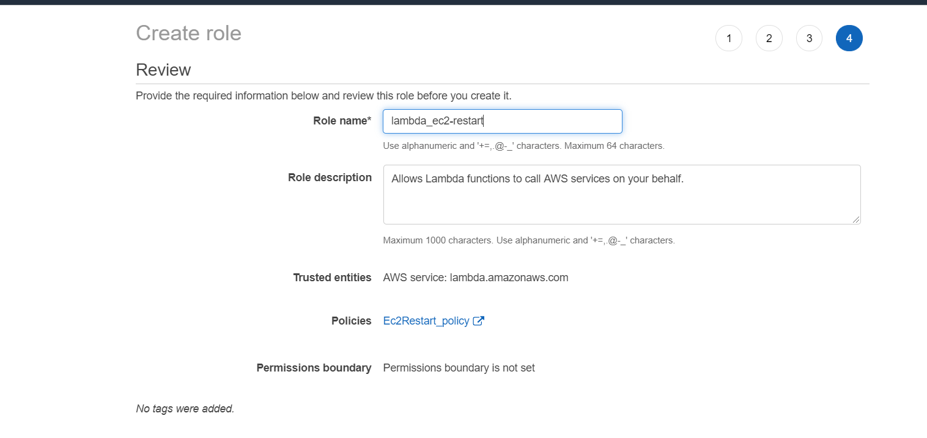

1. Create a Lambda function to stop the EC2 instance with a python script. See attached script
2. Create a Lambda function to start the EC2 instance with python script. See attached script

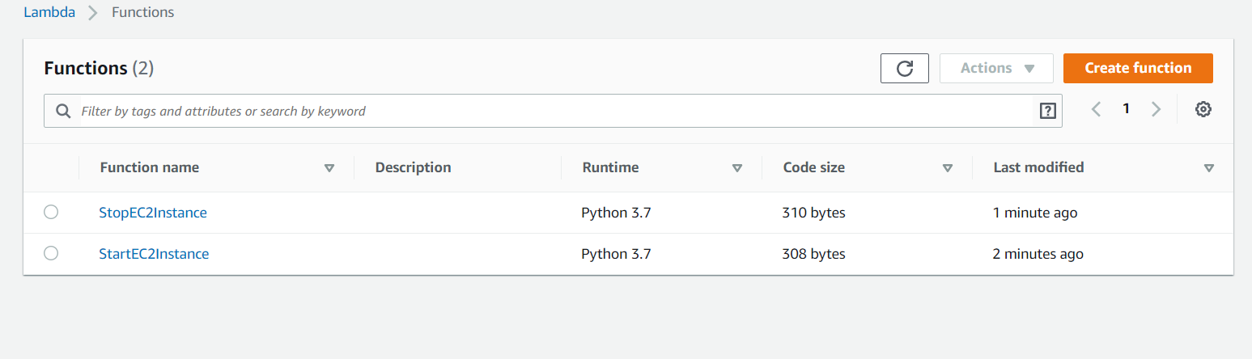

1. Create a test event for the two functions. Ec2 instance is stopped and started as expected. See output in the screenshot below.

