**MA155**

**Project 3:** General Probability and Discrete Probability Distribution Applications

**Submission Instructions:**

* Once you are done with the task, submit your project using this MS Word file on canvas.
* Use your first and last name to name the file.

**Scenario**:

A health insurance policy covers visits to a doctor's office. Each visit costs $230. The annual deductible on the policy is $300. For a policy, the number of visits per year has the following probability distribution.

|  |  |  |  |  |  |  |  |
| --- | --- | --- | --- | --- | --- | --- | --- |
| Number of Visits | 0 | 1 | 2 | 3 | 4 | 5 | 6 |
| Probability | 0.6 | 0.15 | 0.1 | 0.08 | 0.04 | 0.02 | 0.01 |

1. Use Microsoft Excel to create a table with the following column headings: Visit, Probability, Annual Deductible, Cost, and Payment.

**Note:** Cost = Visits x Cost per Visit; Payment = MAX(0, Cost – Annual Deductible)

|  |  |  |  |  |
| --- | --- | --- | --- | --- |
| **Visits** | **Probability** | **Annual Deductible** | **Cost** | **Payment** |
| 0 | 0.60 | 300.00 | 0 | 0.00 |
| 1 | 0.15 | 300.00 | 230 | 0.00 |
| 2 | 0.10 | 300.00 | 460 | 160.00 |
| 3 | 0.08 | 300.00 | 690 | 390.00 |
| 4 | 0.04 | 300.00 | 920 | 620.00 |
| 5 | 0.02 | 300.00 | 1150 | 850.00 |
| 6 | 0.01 | 300.00 | 1380 | 1080.00 |

1. A policy is selected at random from those where costs exceed the deductible.

i. Calculate the probability that this policyholder had exactly 3 office visits (Round your answer to three decimal places).

0.08 8

= = = 0.320 = 32%

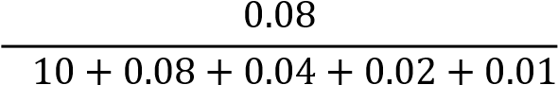 0. 0.25 25

ii. Calculate the probability that this policyholder had exactly 5 office visits (Round your answer to three decimal places).

0.02 2

= = = 0.08 = 8%

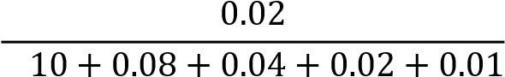 0. 0.25 25

iii. Briefly comment (no more than two sentences) on your results from parts 2.i) and 2.ii).

Given that a policy is randomly selected from those where costs exceed deductible, the policyholder is more likely to have exactly 3 visits to a doctor’s office compared to exactly 5 visits.

3. Use the Table in part 1 to answer respond to the following questions:

1. Find the expected payment for visits to a doctor on this policy.

𝐸𝑥𝑝𝑒𝑐𝑡𝑒𝑑 𝑃𝑎𝑦𝑚𝑒𝑛𝑡 = ∑ 𝑃𝑎𝑦𝑚𝑒𝑛𝑡 × 𝑃𝑟𝑜𝑏𝑎𝑏𝑖𝑙𝑖𝑡𝑦 = $99.80.

1. **(10 points)** Find the standard deviation of payments for visits to a doctor on this policy.

𝑆𝑡𝑎𝑛𝑑𝑎𝑟𝑑 𝐷𝑒𝑣𝑖𝑎𝑡𝑖𝑜𝑛 

1. Briefly comment (no more than two sentences) on your results from parts 3.i) and 3.ii).

The expected payment for visits to a doctor’s office under this health insurance policy is $99.08 and the variability or standard deviation corresponding to this estimate (expected payment) is $215.08. It is obvious that the standard deviation is larger than the expected payment by more than two folds.