🚀 Deploy Apache on EC2
Using Terraform & EC2 User Data
Lab Exercise — VS Code · Terraform · AWS · PuTTY · GitHub

Item | Value
Cloud Provider | AWS
IaC Tool | Terraform ≥ 1.3.0
Operating System | Amazon Linux 2
Web Server | Apache (httpd)
Instance Type | t2.micro (Free Tier eligible)
Server Hostname | Myfirstwebserver
Webpage Message | Hello from Myfirstwebserver
SSH Client (Windows) | PuTTY

Lab Objectives
- Launch an Amazon EC2 instance via Terraform
- Use EC2 User Data to configure Apache automatically at boot
- Set the server hostname to Myfirstwebserver
- Display a custom webpage: "Hello from Myfirstwebserver"
- Connect to the instance via PuTTY
- Verify the webpage from a web browser
- Push the project to GitHub

Prerequisites

Required Software
Tool | Purpose | Where to Get It
VS Code | IDE — edit & run Terraform | code.visualstudio.com
Terraform ≥ 1.3.0 | Infrastructure as Code CLI | developer.hashicorp.com/terraform
AWS CLI | Authenticate Terraform with AWS | aws.amazon.com/cli
PuTTY | SSH client for Windows | putty.org
Git | Version control / push to GitHub | git-scm.com

Recommended VS Code Extensions
- HashiCorp Terraform — syntax highlighting & autocompletion
- AWS Toolkit — AWS resource browser inside VS Code
Install via Extensions panel: Ctrl+Shift+X

AWS Account Requirements
- An active AWS account
- IAM user/role with EC2FullAccess and VPCFullAccess permissions
- An existing EC2 Key Pair (.ppk) in your target region

Project Structure
apache-ec2-terraform/
├── terraform/
│ ├── main.tf # EC2, Security Group, User Data
│ ├── variables.tf # Input variable definitions
│ ├── outputs.tf # Public IP, URL, SSH command
│ └── terraform.tfvars # ⚠ Your values (excluded from Git)
├── .gitignore # Excludes state, keys, tfvars
└── README.md # Full documentation

Setup: AWS Credentials in VS Code
Terraform reads credentials from the AWS CLI. Configure them from the VS Code integrated terminal (Ctrl+`):

Step 1 — Run aws configure
aws configure

Step 2 — Enter Your Credentials
AWS Access Key ID: <your-access-key-id>
AWS Secret Access Key: <your-secret-access-key>
Default region name: us-east-1
Default output format: json
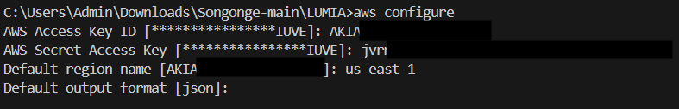

Tip: Credentials are saved to ~/.aws/credentials and automatically picked up by Terraform.
For better security, consider AWS IAM Identity Center (SSO) instead of long-lived access keys.

Setup: Key Pair for PuTTY

Step 1 — Create a Key Pair in AWS Console
- Open AWS Console → EC2 → Key Pairs
- Click Create key pair
- Name it (e.g., my-keypair)
- Select RSA type
- Select format: .ppk (required for PuTTY on Windows)
- Click Create — the .ppk file downloads automatically

⚠ Save the .ppk file securely. AWS will not allow you to download it again.
⚠ Do NOT commit .ppk or .pem files to GitHub — they are already excluded by .gitignore.

Step 2 — Update terraform.tfvars
Open terraform/terraform.tfvars and enter your key pair name:
key_pair_name = "my-keypair" # Must match name in AWS Console exactly

Deployment Steps
All commands run in the VS Code integrated terminal from the terraform/ directory.

Step 1 — Clone the Repository
git clone https://github.com/<your-username>/apache-ec2-terraform.git
cd apache-ec2-terraform/terraform

Step 2 — Initialize Terraform
Downloads the AWS provider plugin. Run once per workspace.
terraform init
Expected: Terraform has been successfully initialized!

Step 3 — Validate Configuration
Checks syntax without contacting AWS.
terraform validate
Expected: Success! The configuration is valid.

Step 4 — Preview the Plan
Shows exactly what will be created — no changes are made yet.
terraform plan
You should see 3 resources to add: AMI data source, security group, EC2 instance.

Step 5 — Apply (Deploy)
terraform apply
Type yes when prompted. Terraform will output:
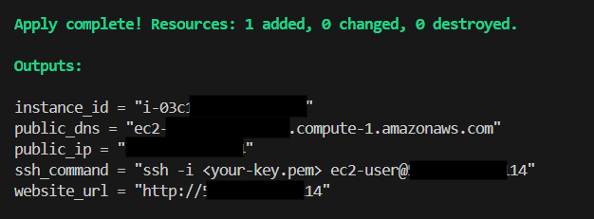
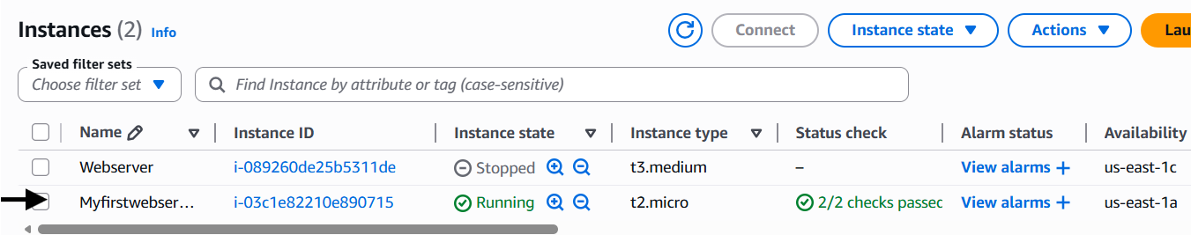
Wait 60–90 seconds after apply for User Data to finish installing and starting Apache
before opening the website URL in your browser.

Connect via PuTTY

Step 1 — Get the Public IP
terraform output public_ip

Step 2 — Open PuTTY
- Launch PuTTY
- In Host Name, enter: ec2-user@<public-ip>
- Port: 22, Connection type: SSH

Step 3 — Load Your Private Key
- In the left panel, go to Connection → SSH → Auth → Credentials
- Click Browse next to Private key file for authentication
- Select your .ppk file

Step 4 — Save the Session (Optional)
- Return to Session in the left panel
- Enter a name (e.g., Myfirstwebserver) under Saved Sessions
- Click Save

Step 5 — Connect
Click Open. Accept the host key fingerprint if prompted.
You should see the Amazon Linux 2 shell prompt:
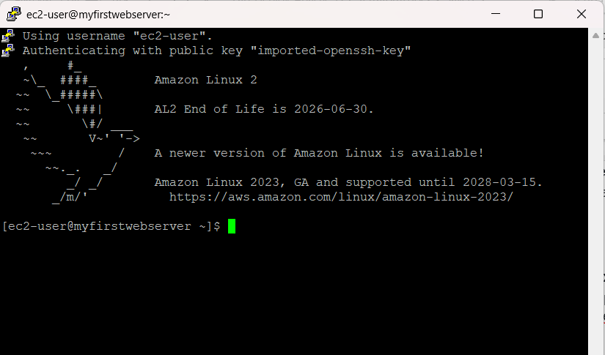
The prompt shows Myfirstwebserver — confirming the hostname was set correctly by User Data.

Verify the Webpage
- Copy the website_url output from Terraform
- Open any web browser
- Navigate to http://<public-ip>
You should see the custom webpage displaying:

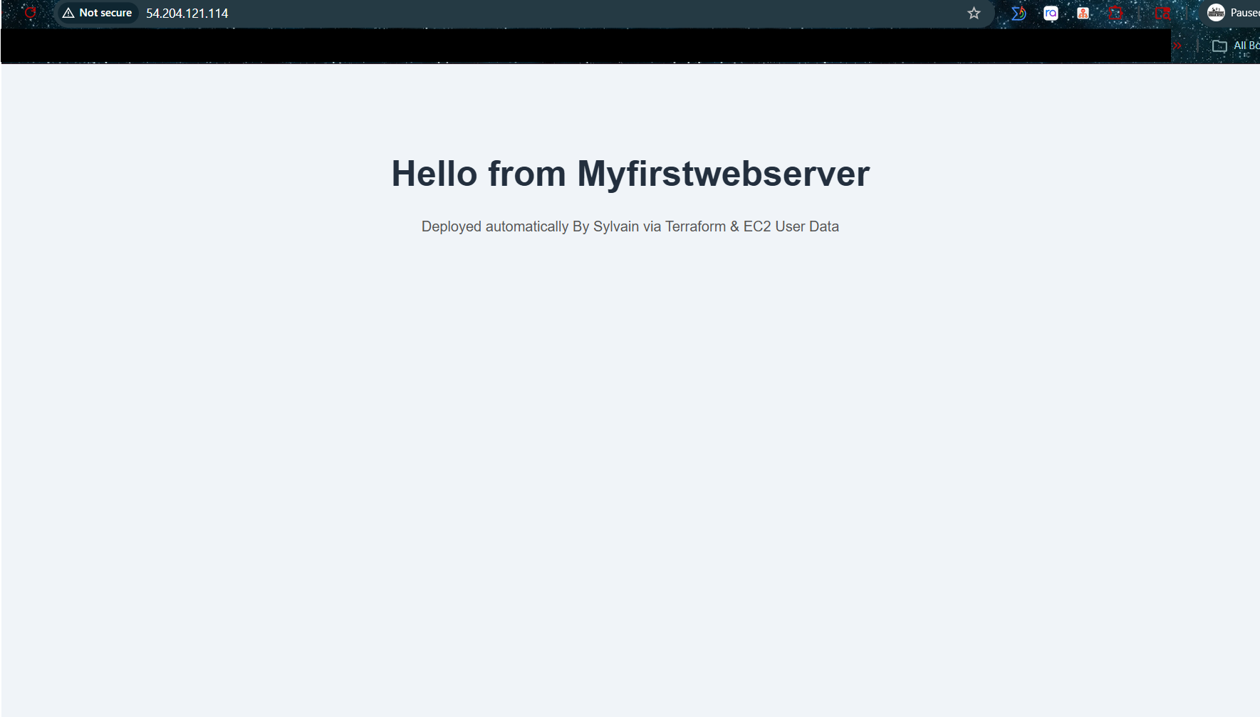

Verify Inside the Instance
After connecting via PuTTY, run these commands:

Confirm the Hostname
hostname
Expected output: Myfirstwebserver
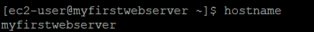

Check Apache Status
sudo systemctl status httpd
Expected: active (running)
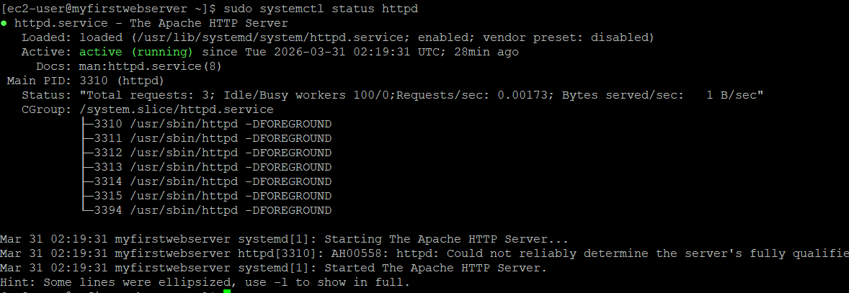

View the User Data Log
sudo cat /var/log/cloud-init-output.log | tail -20
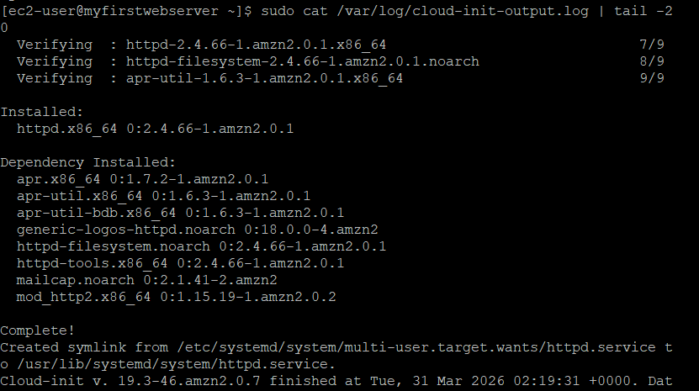

Test the Web Server Locally
curl http://localhost
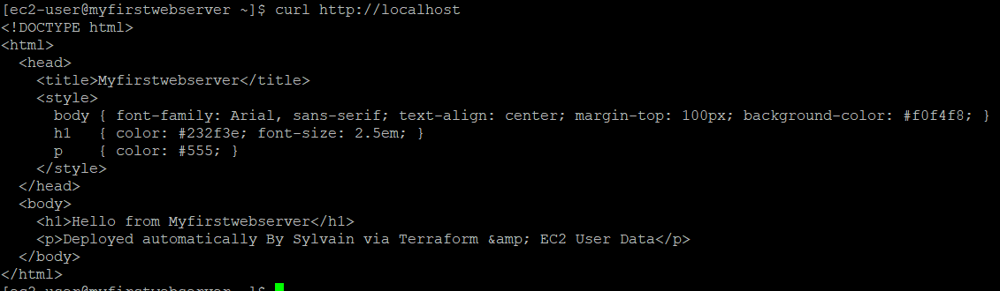

Push to GitHub

First-Time Setup
git init
git add .
git commit -m "Initial commit: Apache EC2 Terraform lab"
git branch -M main
git remote add origin https://github.com/<your-username>/apache-ec2-terraform.git
git push -u origin main

Subsequent Pushes
git add .
git commit -m "describe your change"
git push

⚠ terraform.tfvars, *.tfstate, *.pem, and *.ppk files are in .gitignore.
⚠ They will NOT be pushed to GitHub. Never commit credentials or state files.

Terraform Outputs Reference
Output | Description | Example
instance_id | AWS EC2 Instance ID | i-0abc123def456789
public_ip | Public IP address | 54.123.45.67
public_dns | Public DNS hostname | ec2-54-123-45-67.compute-1.amazonaws.com
website_url | Full URL to the webpage | http://54.123.45.67
ssh_command | SSH command (Linux/macOS) | ssh -i key.pem ec2-user@54.123.45.67

Retrieve outputs at any time:
terraform output # All outputs
terraform output public_ip # Single value

Teardown
To avoid ongoing AWS charges, destroy all resources when the lab is complete:
terraform destroy
Type yes to confirm. All created resources (EC2 instance and security group) will be permanently deleted.

Troubleshooting
Problem | Likely Cause | Solution
terraform init fails | No internet / wrong provider version | Check connection; verify required_providers block
No valid credential sources | AWS CLI not configured | Run aws configure
InvalidKeyPair.NotFound | Wrong key pair name in tfvars | Verify name matches EC2 → Key Pairs exactly
Page doesn't load after apply | User Data still running | Wait 90 seconds and refresh
PuTTY: No supported auth methods | Wrong .ppk or wrong username | Use ec2-user; verify .ppk matches the key pair
Apache not running | User Data script error | SSH in, run: sudo systemctl status httpd
Port 80 refused | Security group missing HTTP rule | Verify inbound TCP 80 from 0.0.0.0/0

Lab Objectives Checklist
- Launch an Amazon EC2 instance via Terraform
- Use EC2 User Data to install and start Apache automatically
- Set the server hostname to Myfirstwebserver
- Display custom webpage: "Hello from Myfirstwebserver"
- Connect to the instance via PuTTY
- Verify the webpage from a web browser
- Push project to GitHub (excluding sensitive files)
- Destroy resources after the lab

