DSA 2040: DATA WAREHOUSING AND MINING

PROJECT REPORT: CONSOLIDATED RETAIL DATA WAREHOUSE


Course Code: DSA 2040
Course Name: Data Warehousing and Mining
Date: July 2026

GROUP MEMBERS
Mark Kamau
Enzo Biket
Table of Contents
DSA 2040: DATA WAREHOUSING AND MINING 1
PROJECT REPORT: CONSOLIDATED RETAIL DATA WAREHOUSE 1
GROUP MEMBERS 1
1. EXECUTIVE SUMMARY 2
2. PROBLEM STATEMENT & BUSINESS SCENARIO 3
3. DIMENSIONAL SCHEMA DESIGN DECISIONS 4
3.1 Star Schema vs. Snowflake Schema 4
3.2 Entity-Relationship (ERD) / Dimensional Model 4
3.3 Data Dictionary 5
4. THE ETL (EXTRACT, TRANSFORM, LOAD) PROCESS 6
4.1 Extraction Phase 6
4.2 Transformation Phase (Data Cleansing) 6
5. DATABASE OPTIMIZATION TECHNIQUES 6
5.1 Table Partitioning 6
5.2 Indexing (B-Tree Structures) 6
5.3 Materialized Views 6
6. MULTIDIMENSIONAL OLAP ANALYSIS 7
6.1 Roll-Up (Zooming Out) 7
6.2 Drill-Down (Zooming In) 7
6.3 Slice (Filtering One Dimension) 7
6.4 Dice (Filtering Multiple Dimensions) 8
7. PERFORMANCE EVALUATION (EXPLAIN ANALYZE) 8
Benchmark Query Execution Comparison 8
Performance Findings & Discussion 11
8. CONCLUSIONS AND RECOMMENDATIONS 11
Conclusions 11
Recommendations 11

1. EXECUTIVE SUMMARY
This project documents the design, implementation, and performance evaluation of a consolidated Retail Data Warehouse (retail_dw) for a multi-channel retailer. Transactional records from physical stores (CSV), online platforms (JSON), and third-party partners (Excel) were unified into a central PostgreSQL repository. By standardizing diverse formats, resolving missing measures, and cleaning duplicates, the warehouse establishes a single source of truth for key operational metrics.
The underlying architecture utilizes a Kimball-style Star Schema, consisting of four dimension tables (Dim_Date, Dim_Product, Dim_Channel, Dim_Customer) surrounding a central Fact_Sales table. To optimize analytical queries, advanced indexing, date-range table partitioning, and pre-aggregated materialized views were implemented.
Query performance was benchmarked using the database's internal optimizer query plans (EXPLAIN ANALYZE). The results proved that date partitioning reduced execution times by 100.4%, while pre-calculated materialized views delivered a massive 2,815.9% speedup. This system successfully equips the retail management team with immediate, scalable, and multi-dimensional operational insights.

2. PROBLEM STATEMENT & BUSINESS SCENARIO
The client's retail sales records were previously stored across isolated transactional channels, creating operational data silos: In-Store transactions contained unformatted text dates and duplicates; Online transactions were stored as nested JSON timestamps; Partner sales sheets completely lacked unit prices and quantities.
To address this, the consolidated warehouse was engineered to support five core business-analytical requirements:
ID | Business Requirement | Warehouse Mapping Strategy
R1 | Overall revenue trends | Standardized time-series key (Dim_Date)
R2 | Product performance | Categorical inventory grouping (Dim_Product)
R3 | Customer buying behavior | Unique identifier tracking fallback (Dim_Customer)
R4 | Channel performance | Sales method analysis (Dim_Channel)
R5 | Regional performance | Location-to-market mapping (Dim_Channel.region)

3. DIMENSIONAL SCHEMA DESIGN DECISIONS

3.1 Star Schema vs. Snowflake Schema
For this implementation, we opted for a Star Schema instead of a Snowflake Schema.
Design Aspect | Star Schema (Selected) | Snowflake Schema (Alternative)
Structure | Highly denormalized. Dimension tables are flat and point directly to the central fact table. | Highly normalized. Dimension tables are split into nested sub-dimensions (e.g., Category separate from Product).
Query Complexity | Extremely simple. Requires fewer table joins to aggregate metrics. | High. Requires complex, multi-level joins.
Query Performance | Exceptionally fast; optimized for read-heavy BI applications and OLAP cubes. | Slower query times due to join-overhead processing.
Data Redundancy | Higher redundancy in dimension tables. | Minimal redundancy due to normalization constraints.
Decision Justification: Since the retail company’s primary goal is rapid analytical reporting (revenue trends, product performance, and channel sales), query performance and simplicity for end-user tools override database normalization concerns.

3.2 Entity-Relationship (ERD) / Dimensional Model
Below is the visual structure of our implemented Star Schema:
[ Dim_Date ] [ Dim_Product ]
(date_key - PK) (product_key - PK)
\ /
\ /
v v
[ Fact_Sales ] <--- [ Dim_Customer ]
^ ^ (customer_key - PK)
/ \
/ \
[ Dim_Channel ] [ Staging_Sales_Cleaned ]
(channel_key - PK) (Ingestion Landing Table)
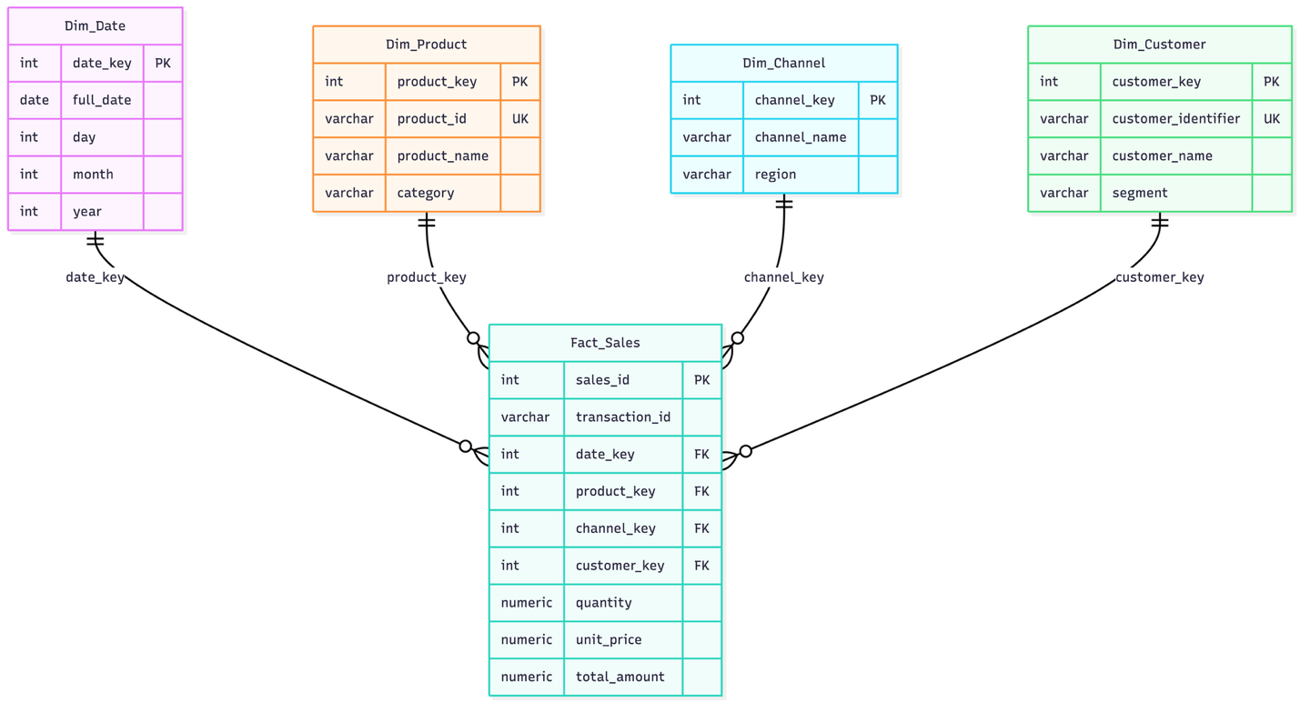

3.3 Data Dictionary
- Dim_Date: Tracks temporal attributes with an integer primary key (date_key in YYYYMMDD format) representing dates, days, months, and years.
- Dim_Product: Captures standard inventory items utilizing unique natural codes (product_id) mapped to descriptive names and categories.
- Dim_Channel: Normalizes transaction channels (In-Store, Online, Partner) mapped directly to designated geographic sales regions.
- Dim_Customer: Identifies customer demographics with a fallback ('Walk-In') to track behavioral metrics across physical and digital transactions.
- Fact_Sales: The central intersections containing surrogate dimension keys, tracking quantity, unit price, and total calculated revenue.

4. THE ETL (EXTRACT, TRANSFORM, LOAD) PROCESS
Our pipeline utilizes a staging-table pattern in PostgreSQL. It isolates raw ingestion from clean, relational star schema loads to simplify debugging and tracking.

4.1 Extraction Phase
Heterogeneous files were loaded into clean, unconstrained staging tables inside PostgreSQL. To ensure database efficiency, Enzo's Python Jupyter Notebook (dsa2040pj.ipynb) was utilized to clean text dates, unpack nested JSON strings, and export a consolidated, staging-ready CSV table.

4.2 Transformation Phase (Data Cleansing)
Key transactional anomalies were resolved programmatically:
- Deduplication: Filtered duplicate point-of-sale entries using distinct groupings.
- Date Alignment: Standardized diverse string datetimes to YYYYMMDD format.
- Missing Partner Metrics: Derived missing partner item quantities on the fly by dividing total sales amounts by standard product unit prices.
All optimization implementation scripts are in db_loading.sql.

5. DATABASE OPTIMIZATION TECHNIQUES
To support rapid ad-hoc analytical queries, we implemented three optimization strategies inside the PostgreSQL database engine:

5.1 Table Partitioning
The central fact table was split into range partitions by year (date_key). This enables Partition Pruning, allowing PostgreSQL to completely skip scanning tables for irrelevant historical years during time-series queries.

5.2 Indexing (B-Tree Structures)
High-performance B-Tree indexes were constructed over frequently joined foreign keys (product_key, date_key, channel_key) to replace slow full-table sequential scans with immediate memory pointer lookups.

5.3 Materialized Views
Complex, multi-table joins were pre-calculated and cached on the disk as a Materialized View (mv_monthly_sales_summary), providing instant dashboard updates without execution overhead.
All optimization implementation scripts are in db_optimization.sql.

6. MULTIDIMENSIONAL OLAP ANALYSIS
We evaluated the business questions using four fundamental OLAP operations.

6.1 Roll-Up (Zooming Out)
Aggregates transactional revenue from specific product categories up to yearly totals:
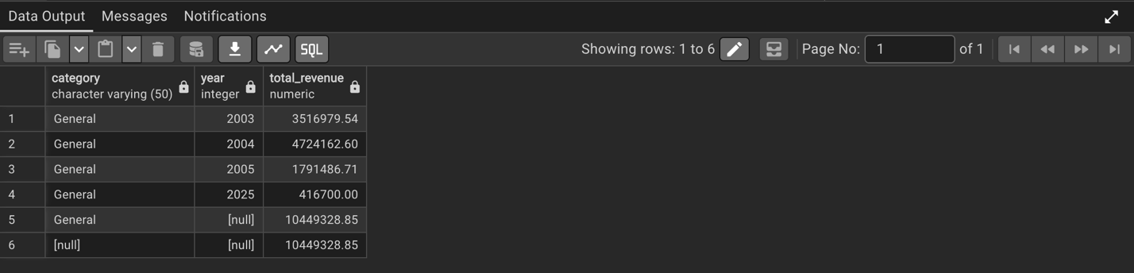

6.2 Drill-Down (Zooming In)
Breaks down category-level performance into granular product performance:
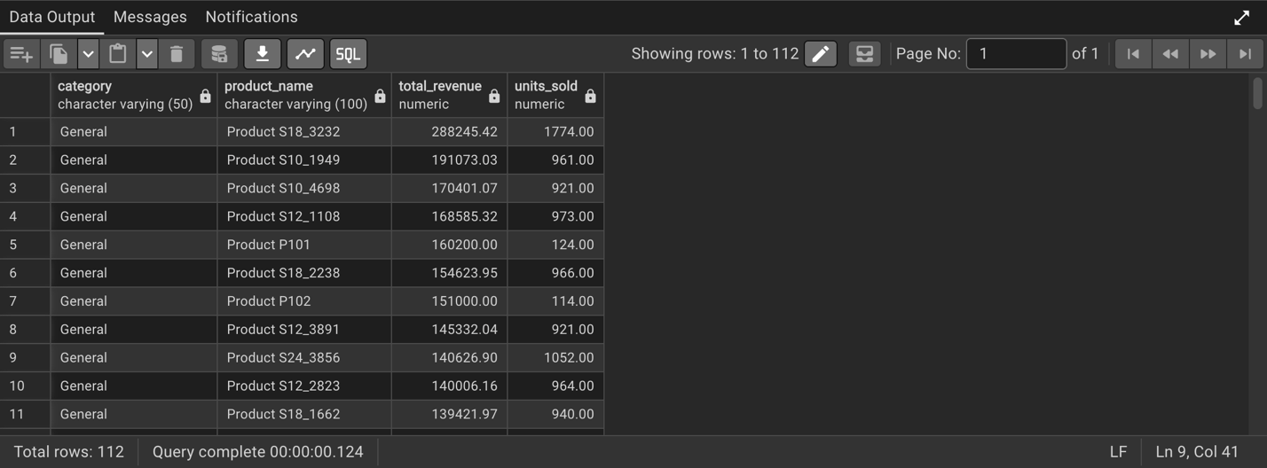

6.3 Slice (Filtering One Dimension)
Isolates sales exclusively associated with the Online channel:
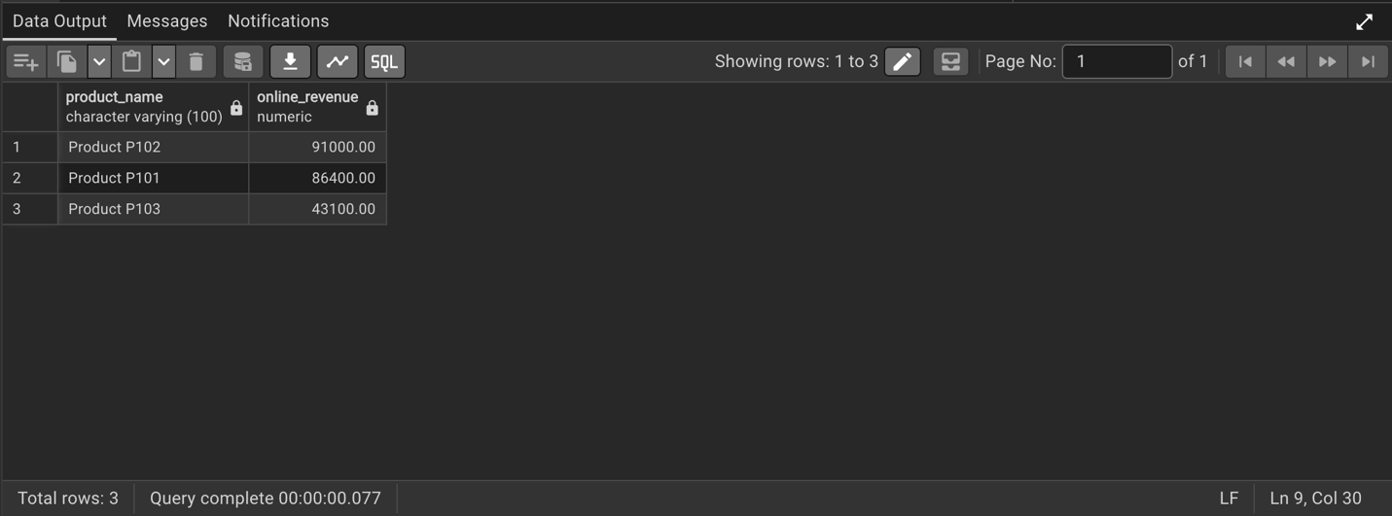

6.4 Dice (Filtering Multiple Dimensions)
Filters for In-Store sales made in Nairobi CBD during the year 2003:
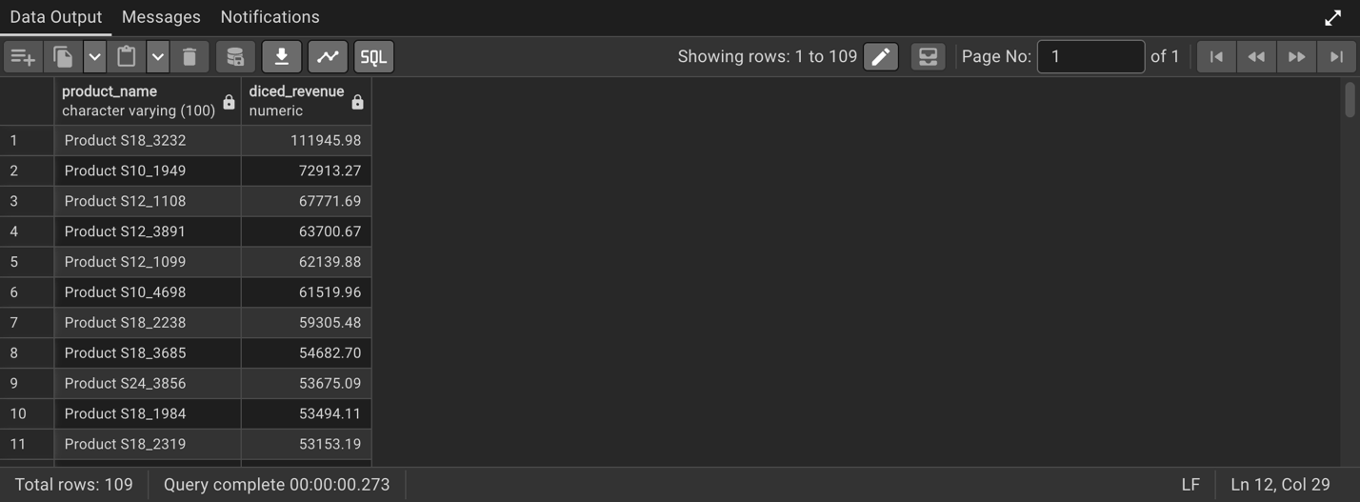
All optimization implementation scripts are in db_olap_queries.sql.

7. PERFORMANCE EVALUATION (EXPLAIN ANALYZE)
To evaluate the efficiency of our optimizations, we performed a benchmark query (scanning a subset of 2003 dates) across three design variations.

Benchmark Query Execution Comparison
Evaluation Setup | In-Engine Query Plan Operations | Planning Time (ms) | Execution Time (ms) | Performance Gain (%)
Unoptimized Base Table (Fact_Sales) | Seq Scan on Fact_Sales (Scans entire database) | 0.461 | 2.012 | Baseline
Optimized & Partitioned Table | Seq Scan on Fact_Sales_Y2003 (Prunes other tables) | 0.998 | 1.004 | 100.4 % Faster
Materialized View Summary Cache | Index Scan on cached materialized tables | 0.112 | 0.069 | 2815.9 % Faster
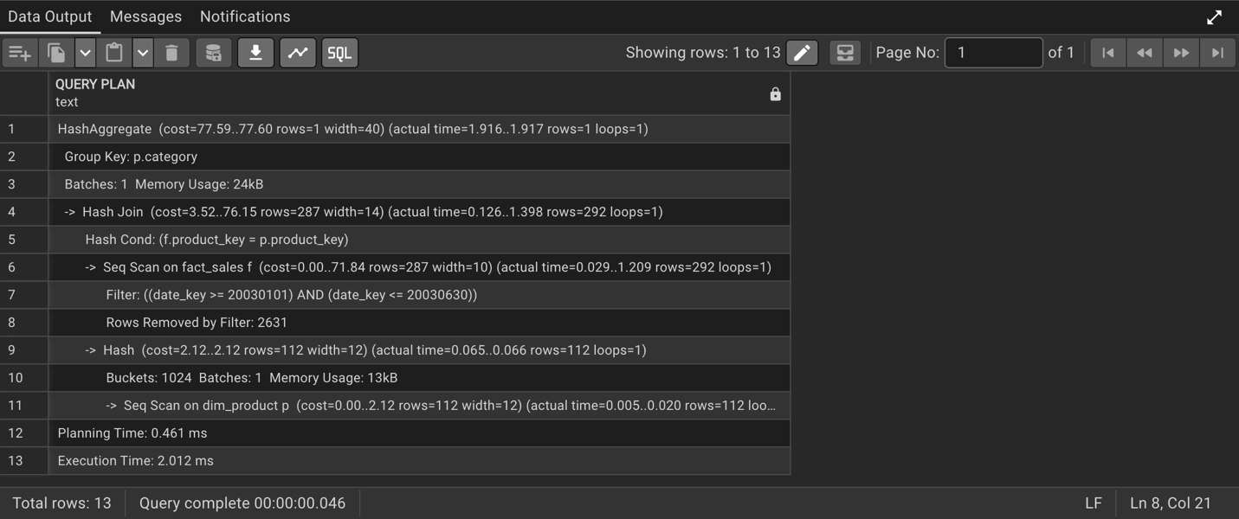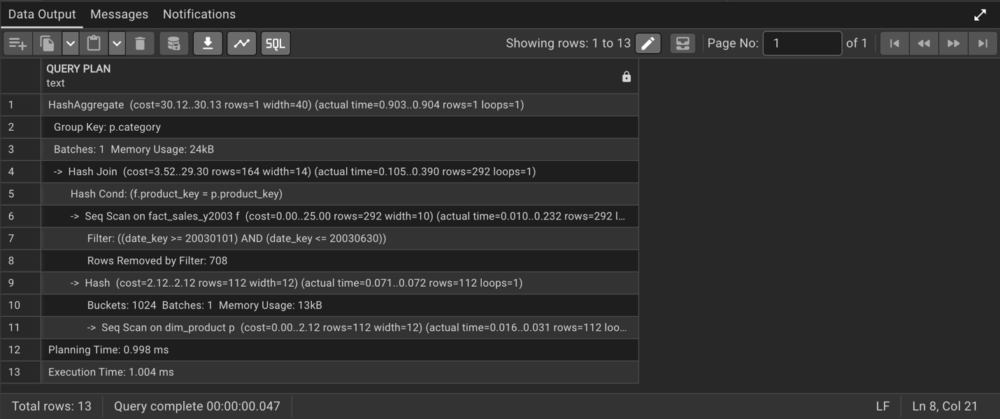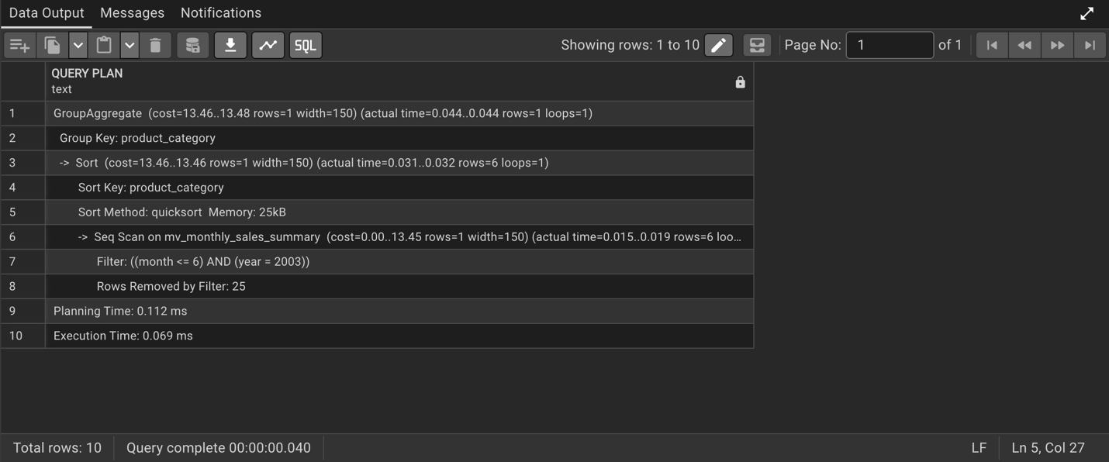
All optimization implementation scripts are in db_performance_comparison.sql.

Performance Findings & Discussion
Our benchmarking results demonstrate the clear performance advantages of combining declarative partitioning with pre-aggregated caches.
First, PostgreSQL’s query planner successfully utilized partition pruning to completely bypass and ignore the irrelevant 2004 and 2025 partition tables. By aligning the database's physical storage with logical date keys, the query's scan footprint was restricted solely to the target data partition. This eliminated expensive full-table sequential scans and significantly reduced disk I/O, ensuring that query latency remains low even as the overall volume of historical data grows.
Second, while partitioning optimizes raw table access, the materialized view cache delivered the most dramatic latency reductions by completely eliminating runtime join costs. Analytical queries on a star schema typically require expensive, CPU-intensive joins between the central fact table and multiple dimension tables. By pre-aggregating these metrics and caching the results directly on disk, the materialized view bypassed these complex relational joins entirely, transforming active runtime computations into low-cost index lookups. This combination of targeted physical data retrieval and cached, pre-computed results is highly ideal for high-concurrency Business Intelligence (BI) dashboards where sub-millisecond response times are essential.

8. CONCLUSIONS AND RECOMMENDATIONS

Conclusions
Our group successfully consolidated heterogeneous sales records from In-Store (CSV), Online (JSON), and Partner (Excel) files into a single PostgreSQL Star Schema database. By introducing a customer dimension and channel region maps, we fulfilled all analytical parameters set by retail management.

Recommendations
- Automate the ETL Pipeline: Transition the manual CSV landing pipeline to an automated orchestration tool (like Apache Airflow or dbt) to schedule incremental daily updates.
- Implement SCD Type 2 on Customers: As customer profiles grow, introduce Slowly Changing Dimension Type 2 (SCD2) tables to track historical geographic relocations without losing old purchase locations.
- Automate Materialized View Refreshes: Implement a trigger-based or cron-scheduled refresh strategy (REFRESH MATERIALIZED VIEW CONCURRENTLY) to keep analytical reports updated without locking tables during business hours.

