**CST-256 Design Report Template**

|  |  |  |
| --- | --- | --- |
| **Topic:** | *Topic 1 – Laravel Introduction* | |
| **Date:** | *01-18-2019* | |
| **Revision:** | *1.0* | |
| **Team:** | 1. *Jake McDermitt* | |
| 1. *Sylvanus Edi* | |
|  | |
|  | |
| **Weekly Team Status Summary:** | |  |  |  |  | | --- | --- | --- | --- | | **User Story** | **Team**  **Member** | **Hours**  **Worked** | **Hours Remaining** | |  |  |  |  | |  |  |  |  | |  |  |  |  | |  |  |  |  | |  |  |  |  | |  |  |  |  | |  |  |  |  | |  |  |  |  | |  |  |  |  | |  |  |  |  | |  |  |  |  | |  |  |  |  | |  |  |  |  | | |
| **GIT URL:** | *The GIT Bitbucket URL that I can use to clone your code.* | |
| **Hosting URL:** | *The Hosting URL that I can use to access your application.* | |
| **Peer Review:** | *Y* | We acknowledge that our team has reviewed this report and we agree to the approach we are all taking. |

**Design Documentation**

**Install Instructions:**

*Copy all included folders to your htdocs folder. NOTE: some extra folders were added to the root and some configuration files changed.*

**General Technical Approach:**

*Users will go to the login page, register an account, then log in.*

**Key Technical Design Decisions:**

*N/A*

**ER Diagram:**

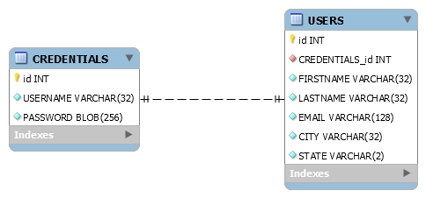

**DDL Scripts:**

-- MySQL Workbench Synchronization

-- Generated: 2020-01-18 17:19

-- Version: 1.0

SET @OLD_UNIQUE_CHECKS=@@UNIQUE_CHECKS, UNIQUE_CHECKS=0;

SET @OLD_FOREIGN_KEY_CHECKS=@@FOREIGN_KEY_CHECKS, FOREIGN_KEY_CHECKS=0;

SET @OLD_SQL_MODE=@@SQL_MODE, SQL_MODE='ONLY_FULL_GROUP_BY,STRICT_TRANS_TABLES,NO_ZERO_IN_DATE,NO_ZERO_DATE,ERROR_FOR_DIVISION_BY_ZERO,NO_ENGINE_SUBSTITUTION';

CREATE SCHEMA IF NOT EXISTS `LinkMe` DEFAULT CHARACTER SET utf8 ;

CREATE TABLE IF NOT EXISTS `LinkMe`.`CREDENTIALS` (

`id` INT(11) NOT NULL AUTO_INCREMENT,

`USERNAME` VARCHAR(32) NOT NULL,

`PASSWORD` BLOB(256) NOT NULL,

PRIMARY KEY (`id`))

ENGINE = InnoDB

DEFAULT CHARACTER SET = utf8;

CREATE TABLE IF NOT EXISTS `LinkMe`.`USERS` (

`id` INT(11) NOT NULL AUTO_INCREMENT,

`CREDENTIALS_id` INT(11) NOT NULL,

`FIRSTNAME` VARCHAR(32) NOT NULL,

`LASTNAME` VARCHAR(32) NOT NULL,

`EMAIL` VARCHAR(128) NOT NULL,

`CITY` VARCHAR(32) NOT NULL,

`STATE` VARCHAR(2) NOT NULL,

PRIMARY KEY (`id`),

INDEX `fk_USERS_CREDENTIALS_idx` (`CREDENTIALS_id` ASC),

CONSTRAINT `fk_USERS_CREDENTIALS`

FOREIGN KEY (`CREDENTIALS_id`)

REFERENCES `LinkMe`.`CREDENTIALS` (`id`)

ON DELETE NO ACTION

ON UPDATE NO ACTION)

ENGINE = InnoDB

DEFAULT CHARACTER SET = utf8;

SET SQL_MODE=@OLD_SQL_MODE;

SET FOREIGN_KEY_CHECKS=@OLD_FOREIGN_KEY_CHECKS;

SET UNIQUE_CHECKS=@OLD_UNIQUE_CHECKS;

**Sitemap Diagram:**

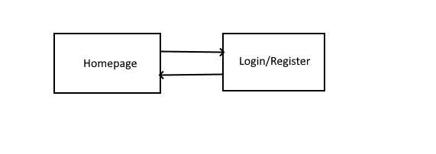

**Security Design:**

*N/A*

**Third Party Interface Design:**

*N/A*

**Flowcharts:**

*N/A*

**User Interface Diagrams:**

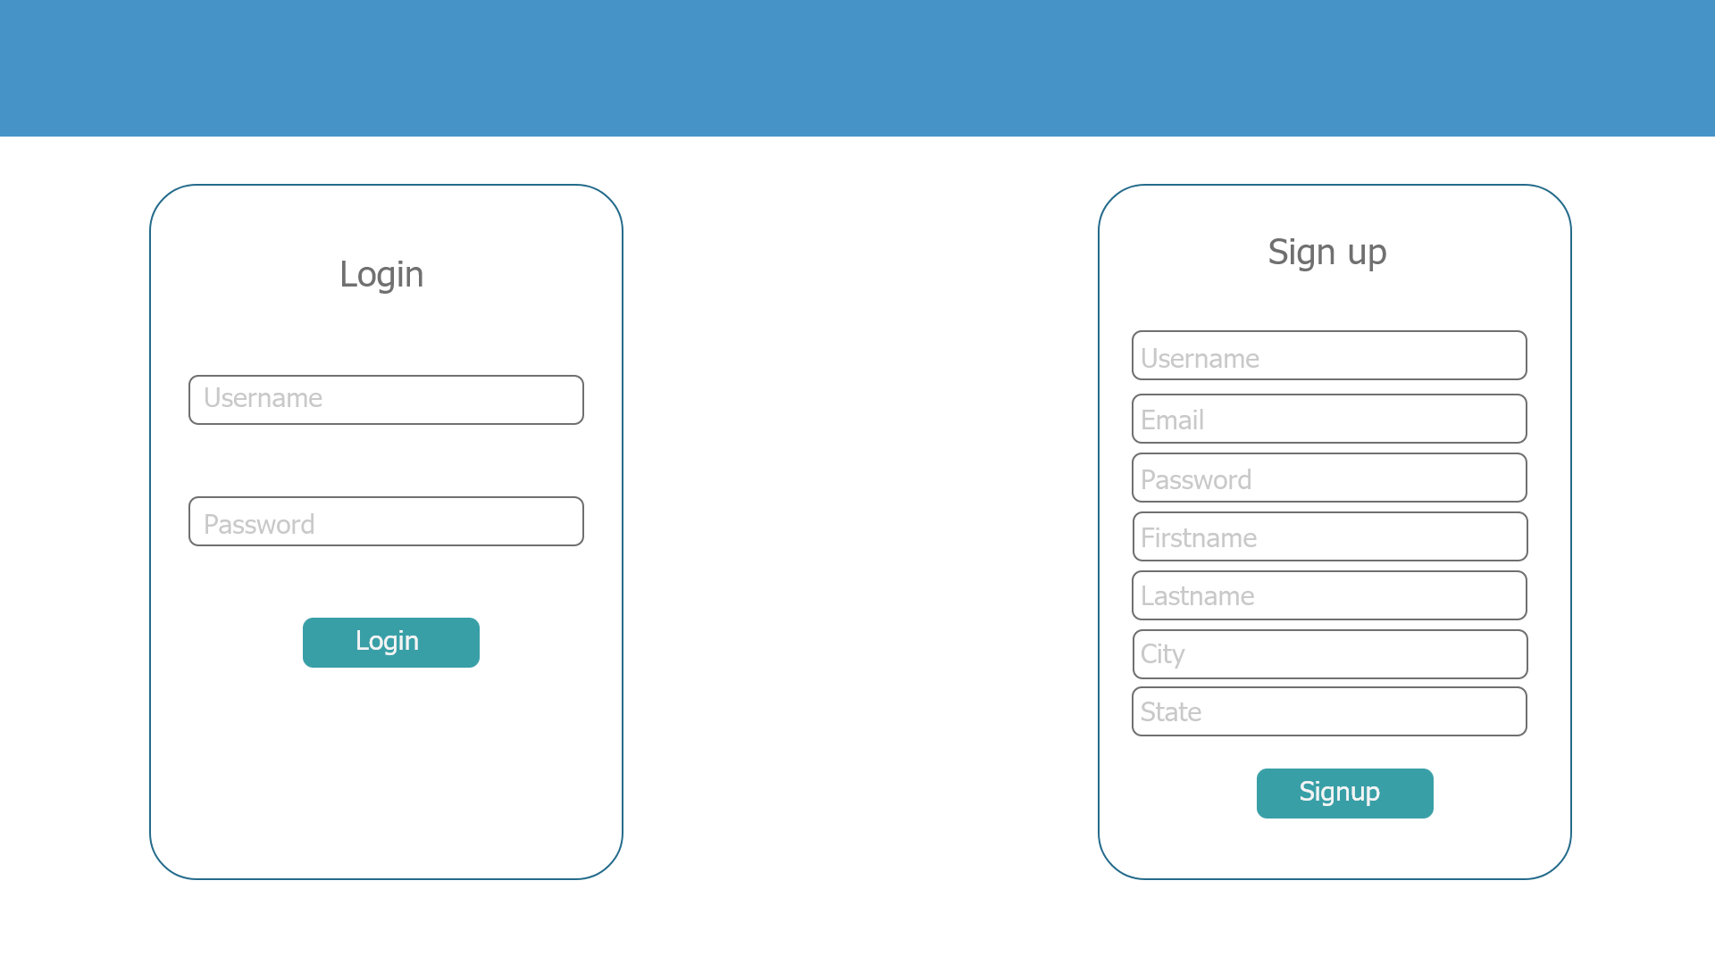

**Class Diagrams:**

*N/A*

**Pseudo Code:**

*N/A*

**Other Documentation:**

*N/A*