PROJECT: OS mini project : System Report Generator (bash script)
Name: Ritika Rajpal
Sandeep Sahani
Class: D12A
CODE:

#!/bin/bash

#configuration
#set path for dir to create and update index.html and style.css
#use proper path ending with /

path=/home/sylveryte/public_html/report/

#code init file checkings
_index=index.html
_style=style.css
indexfile=$path$_index
stylefile=$path$_style

#CSS CODE HANDLE
#if css exists and has code
if [ -s "$stylefile" ]; then
author=sylveryte
else
touch $stylefile
tee $stylefile << _EOFC_
body{
background-color: black;
}
.body{
background-color: #282828;
color: white;
margin: 0% 15%;
padding: 5px 30px;
border-radius: 5px;
}
h1,h2,h3{
background-color:grey;
border-radius: 10px;
padding: 10px;
}
.container{
background-color:#323232;
padding:25px;
border-radius: 5px;
margin: 10px;
}
article,pre{
color: #d3d3d3;
padding-left: 20px;
/*background-color: #484848;*/
background-color: #282828;
margin: 5px 0px 0px 15px;
padding: 20px;
border-radius: 10px;
}
.pback{
background-color: #447f61;
border-radius: 5px;
}
.pfore{
background-color: #874343;
padding: 2px;
border-radius: 5px;
}

_EOFC_
fi

#code

title="System Report of <strong>$HOSTNAME</strong>"
current_time=$(date +"%x %r %Z")
timestamp="Generated on <strong>$current_time</strong> by <strong>$USER</strong>"

report_uptime(){
cat <<- _EOF_
<h3>
Uptime
</h3>
<pre>
$(uptime)
</pre>
_EOF_
return
}

report_ram_space(){
echo "<h3>Memory Info</h3><article>"

total=$(free | grep -i mem | awk '{print $2}')
used=$(free | grep -i mem | awk '{print $3}')
per=$((100*$used/$total))%

while read line; do
echo "<div style=\"padding:7px 0px\">"
echo "<strong>"
echo $line | awk '{print $1}'
echo "</strong><br>total<strong>:"
echo $line | awk '{print $2}'
echo "</strong><br>available<strong>:"
echo $line | awk '{print $4}'
echo "</strong><br>used<strong>:"
echo $line | awk '{print $3}'
echo "</strong><div style=\"margin:10px 3px\"><div class=\"pback\"><div class=\"pfore\" style=\"width:$per\">$per</div></div></div>"
echo "</div>"
done < <(free -h | grep -i mem)
echo "</article>"
}

report_disk_space(){
echo "<h3>Disk Size Info</h3><article>"
#read output of df -h line by line
while read line; do
echo "<div style=\"padding:7px 0px\">"
echo "<strong>"
echo $line | awk '{print $1}'
echo "</strong><br>size<strong>:"
echo $line | awk '{print $2}'
echo "</strong><br>available<strong>:"
echo $line | awk '{print $4}'
echo "</strong><br>used<strong>:"
echo $line | awk '{print $3}'
echo "</strong><div style=\"margin:10px 3px\"><div class=\"pback\"><div class=\"pfore\" style=\"width:"
echo $line | awk '{print $5}'
echo "\">"
echo $line | awk '{print $5}'
echo "</div></div></div>"
echo "</div>"
done < <(df -h | grep -vi filesystem)
echo "</article>"
}

report_usb(){
cat <<- _EOF_
<h2>
Connected USB devices
</h2>

<pre>
$(lsusb)
</pre>
_EOF_
return
}
report_pci(){
echo "<h2>PCI devices</h2>
<h4>
Block Devices
</h4><pre>"
while read line; do
if [[ $line == b* ]]; then
echo $line
fi
done < <(ls -l /dev | grep -vi total )
echo "</pre>
<h4>
Character Devices
</h4><pre>"
while read line; do
if [[ $line == c* ]]; then
echo $line
fi
done < <(ls -l /dev | grep -vi total )
echo "</pre>"
return
}
report_users(){
cat <<- _EOF_
<h2>
User login Activities
</h2>

<pre>
$(last -a | head )
</pre>
_EOF_
return
}

tee $indexfile <<- _EOF_
<html>
<head>
<title>$title</title>
<link rel="stylesheet" type="text/css" href="style.css">
</head>
<body>
<div class="body">
<h1>$title</h1>
<div class="container">$timestamp</div>
<div class="container">
$(report_uptime)
$(report_users)
$(report_ram_space)
$(report_usb)
$(report_disk_space)
$(report_pci)
</div>
</div>
</body>
</html>
_EOF_

OUTPUT:
index.html
<html>
<head>
<title>System Report of <strong>archabbit</strong></title>
<link rel="stylesheet" type="text/css" href="style.css">
</head>
<body>
<div class="body">
<h1>System Report of <strong>archabbit</strong></h1>
<div class="container">Generated on <strong>10/22/2017 12:47:38 PM IST</strong> by <strong>sylveryte</strong></div>
<div class="container">
<h3>
Uptime
</h3>
<pre>
12:47:38 up 19 min, 1 user, load average: 0.89, 0.87, 0.70
</pre>
<h2>
User login Activities
</h2>

<pre>
sylveryt tty1 Sun Oct 22 12:28 still logged in /dev/tty1
.
.
.
reboot system boot Fri Oct 20 00:38 - 01:00 (00:21) 4.13.3-1-ARCH
</pre>
<h3>Memory Info</h3><article>
<div style="padding:7px 0px">
<strong>
Mem:
</strong><br>total<strong>:
7.8G
</strong><br>available<strong>:
5.4G
</strong><br>used<strong>:
1.5G
</strong><div style="margin:10px 3px"><div class="pback"><div class="pfore" style="width:18%">18%</div></div></div>
</div>
</article>
<h2>
Connected USB devices
</h2>

<pre>
Bus 002 Device 001: ID 1d6b:0003 Linux Foundation 3.0 root hub
Bus 001 Device 004: ID 0bda:b006 Realtek Semiconductor Corp.
Bus 001 Device 003: ID 04f2:b50d Chicony Electronics Co., Ltd
Bus 001 Device 005: ID 3938:1031
Bus 001 Device 001: ID 1d6b:0002 Linux Foundation 2.0 root hub
</pre>
<h3>Disk Size Info</h3><article>
<div style="padding:7px 0px">
<strong>
dev
</strong><br>size<strong>:
3.9G
</strong><br>available<strong>:
3.9G
</strong><br>used<strong>:
0
</strong><div style="margin:10px 3px"><div class="pback"><div class="pfore" style="width:
0%
">
0%
</div></div></div>
</div>
<div style="padding:7px 0px">
<strong>
run
</strong><br>size<strong>:
3.9G
</strong><br>available<strong>:
3.9G
</strong><br>used<strong>:
1.3M
</strong><div style="margin:10px 3px"><div class="pback"><div class="pfore" style="width:
1%
">
1%
</div></div></div>
</div>
<div style="padding:7px 0px">
<strong>
/dev/sda5
</strong><br>size<strong>:
79G
</strong><br>available<strong>:
62G
</strong><br>used<strong>:
13G
</strong><div style="margin:10px 3px"><div class="pback"><div class="pfore" style="width:
18%
">
18%
</div></div></div>
</div>
<div style="padding:7px 0px">
<strong>
tmpfs
</strong><br>size<strong>:
3.9G
</strong><br>available<strong>:
3.9G
</strong><br>used<strong>:
51M
</strong><div style="margin:10px 3px"><div class="pback"><div class="pfore" style="width:
2%
">
2%
</div></div></div>
</div>
<div style="padding:7px 0px">
<strong>
tmpfs
</strong><br>size<strong>:
3.9G
</strong><br>available<strong>:
3.9G
</strong><br>used<strong>:
0
</strong><div style="margin:10px 3px"><div class="pback"><div class="pfore" style="width:
0%
">
0%
</div></div></div>
</div>
<div style="padding:7px 0px">
<strong>
tmpfs
</strong><br>size<strong>:
3.9G
</strong><br>available<strong>:
3.9G
</strong><br>used<strong>:
632K
</strong><div style="margin:10px 3px"><div class="pback"><div class="pfore" style="width:
1%
">
1%
</div></div></div>
</div>
<div style="padding:7px 0px">
<strong>
/dev/sda7
</strong><br>size<strong>:
210G
</strong><br>available<strong>:
186G
</strong><br>used<strong>:
14G
</strong><div style="margin:10px 3px"><div class="pback"><div class="pfore" style="width:
7%">7%
</div></div></div>
</div>
<div style="padding:7px 0px">
<strong>
/dev/sda8
</strong><br>size<strong>:
232G
</strong><br>available<strong>:
220G
</strong><br>used<strong>:
61M
</strong><div style="margin:10px 3px"><div class="pback"><div class="pfore" style="width:
1%">1%
</div></div></div>
</div>
<div style="padding:7px 0px">
<strong>
/dev/sda6
</strong><br>size<strong>:
477M
</strong><br>available<strong>:
398M
</strong><br>used<strong>:
50M
</strong><div style="margin:10px 3px"><div class="pback"><div class="pfore" style="width:
12%">12%
</div></div></div>
</div>
<div style="padding:7px 0px">
<strong>
tmpfs
</strong><br>size<strong>:
799M
</strong><br>available<strong>:
794M
</strong><br>used<strong>:
4.6M
</strong><div style="margin:10px 3px"><div class="pback"><div class="pfore" style="width:
1%
">
1%
</div></div></div>
</div>
</article>
<h2>PCI devices</h2>
<h4>
Block Devices
</h4><pre>
brw-rw---- 1 root disk 8, 0 Oct 22 12:27 sda
.
.
.
brw-rw----+ 1 root optical 11, 0 Oct 22 12:27 sr0
</pre>
<h4>
Character Devices
</h4><pre>
crw------- 1 root root 10, 58 Oct 22 12:27 acpi_thermal_rel
crw------- 1 root root 10, 235 Oct 22 12:27 autofs
.
.
.
.
crw--w---- 1 root tty 4, 18 Oct 22 12:27 tty18
crw--w---- 1 root tty 4, 19 Oct 22 12:27 tty19
crw--w---- 1 root tty 4, 2 Oct 22 12:27 tty2
crw-rw-rw- 1 root root 1, 5 Oct 22 12:27 zero
</pre>
</div>
</div>
</body>
</html>
style.css
body{
background-color: black;
}
.body{
background-color: #282828;
color: white;
margin: 0% 15%;
padding: 5px 30px;
border-radius: 5px;
}
h1,h2,h3{
background-color:grey;
border-radius: 10px;
padding: 10px;
}
.container{
background-color:#323232;
padding:25px;
border-radius: 5px;
margin: 10px;
}
article,pre{
color: #d3d3d3;
padding-left: 20px;
/*background-color: #484848;*/
background-color: #282828;
margin: 5px 0px 0px 15px;
padding: 20px;
border-radius: 10px;
}
.pback{
background-color: #447f61;
border-radius: 5px;
}
.pfore{
background-color: #874343;
padding: 2px;
border-radius: 5px;
}
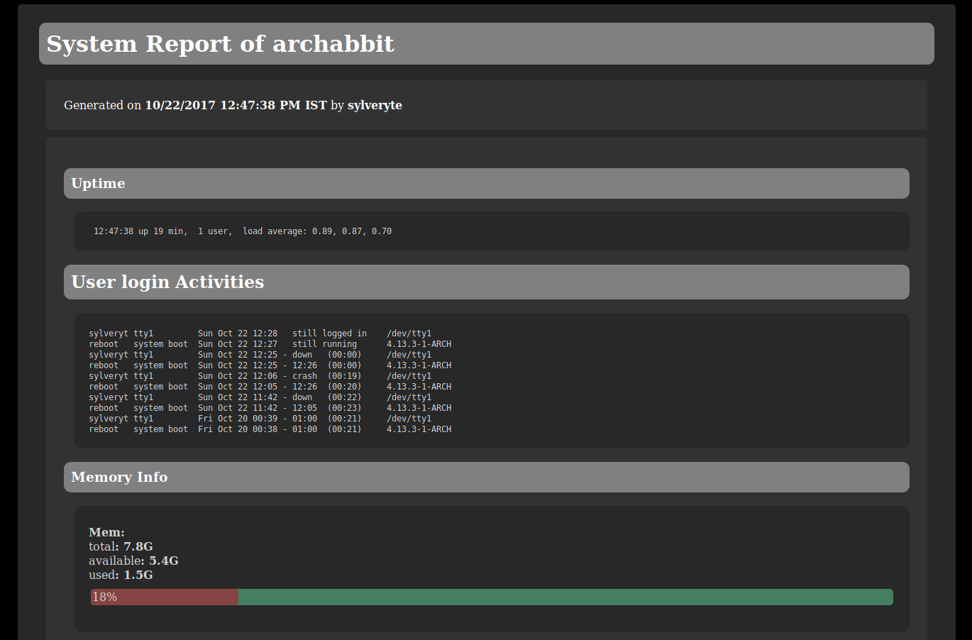
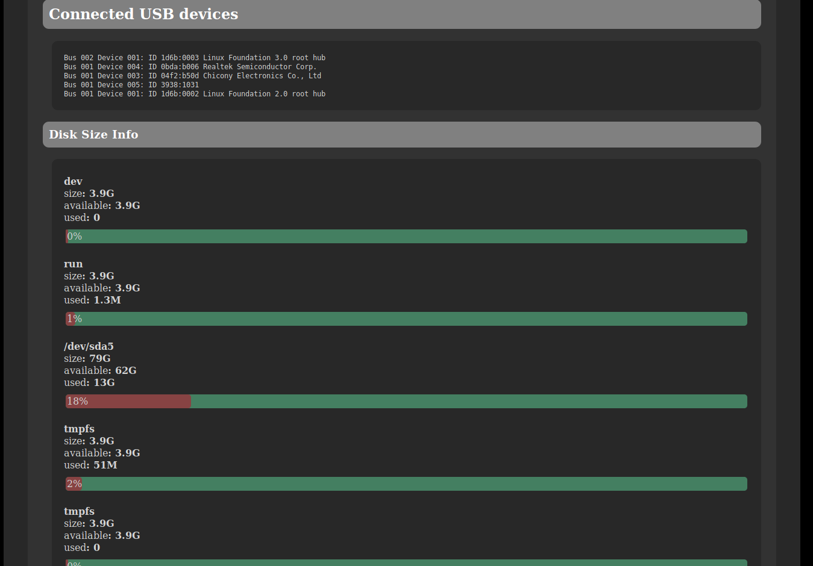
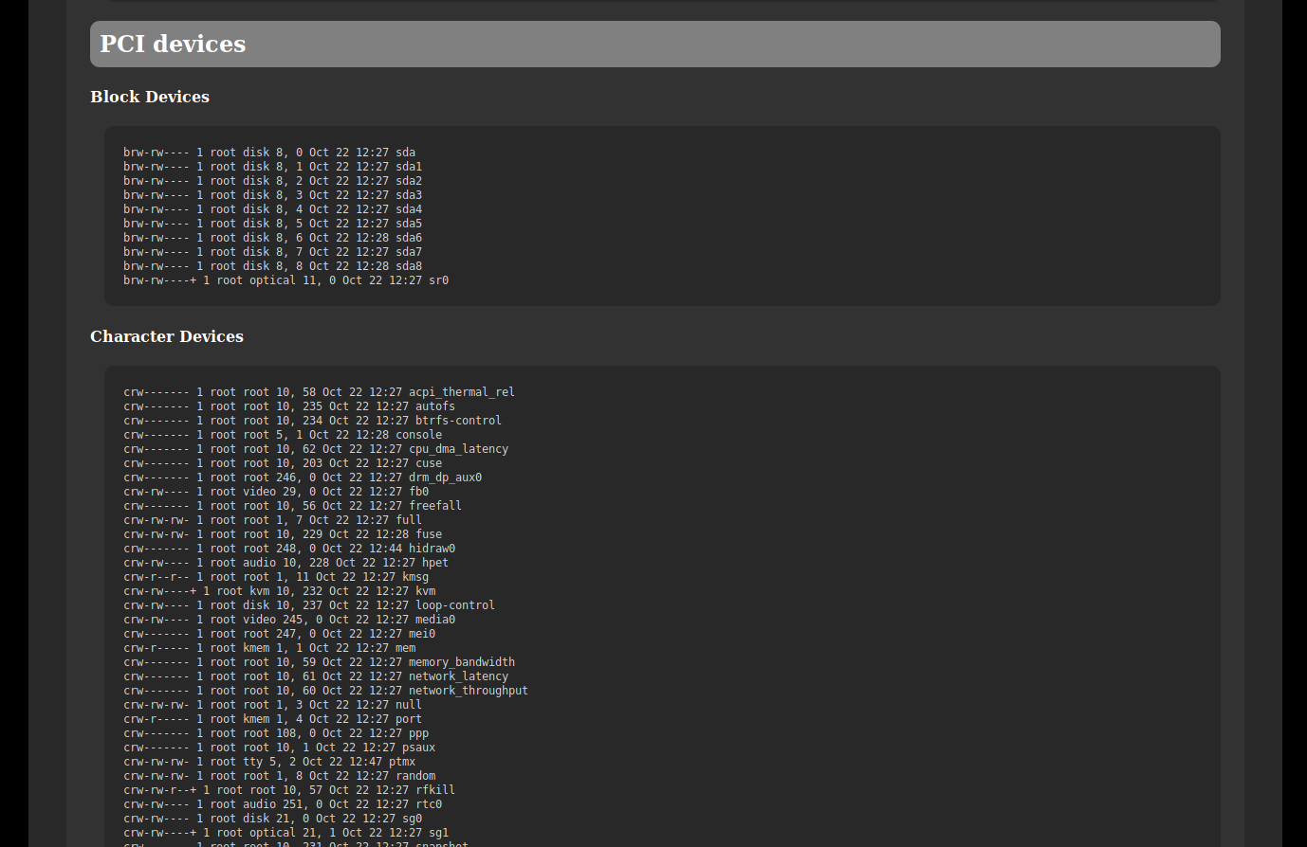
OUTPUT(OF OUTPUT):

