RestoAI
Quick-Start Guide
The nine things you will do most, in ten minutes
Version 1.0, 25 September 2026. Screenshots are real captures of the working app (24 September 2026).
For every other feature, see the RestoAI User Manual.

What's inside
# | Task
1 | Log in
2 | Add a menu item (with a photo)
3 | See today's orders
4 | Update an order's status (e.g. mark it ready)
5 | Connect your WhatsApp number
6 | Check what needs your attention today
7 | Add a staff member
8 | Create a simple coupon
9 | See how a customer places an order

1. Log in
- Open the RestoAI sign-in page.
- Enter your email and password and click Sign In. You land on the Dashboard.

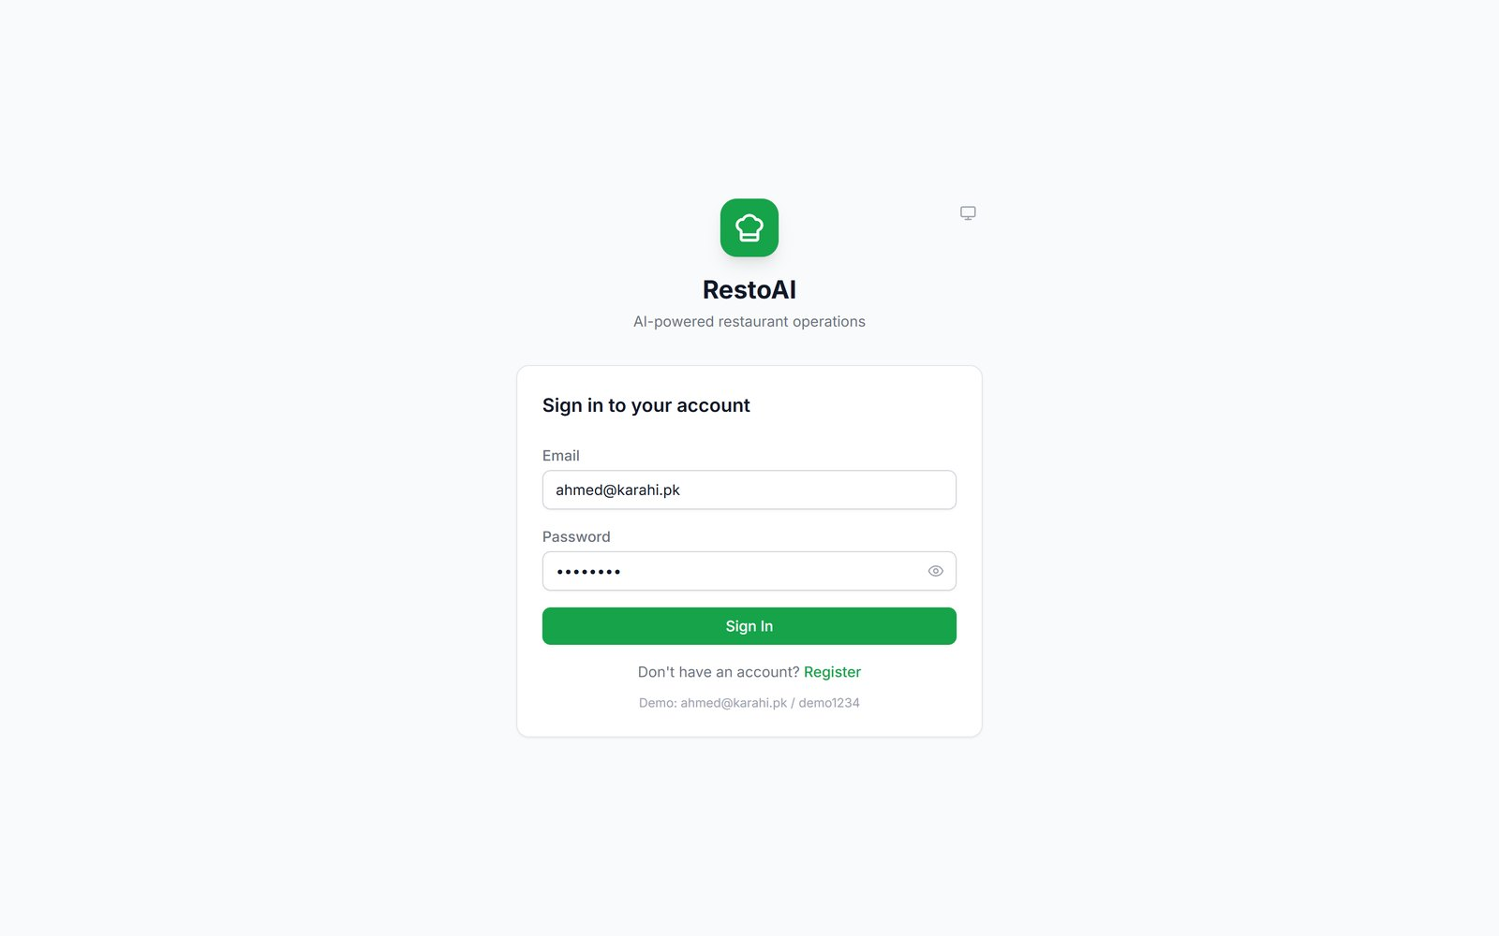
Figure 1. Owners, managers and staff all sign in here.

2. Add a menu item (with a photo)
- Menu → Add Item. Enter name, price and category (Urdu name, description and tags are optional) → Save.
- Click the pencil icon on the new dish → Upload photo → Save.

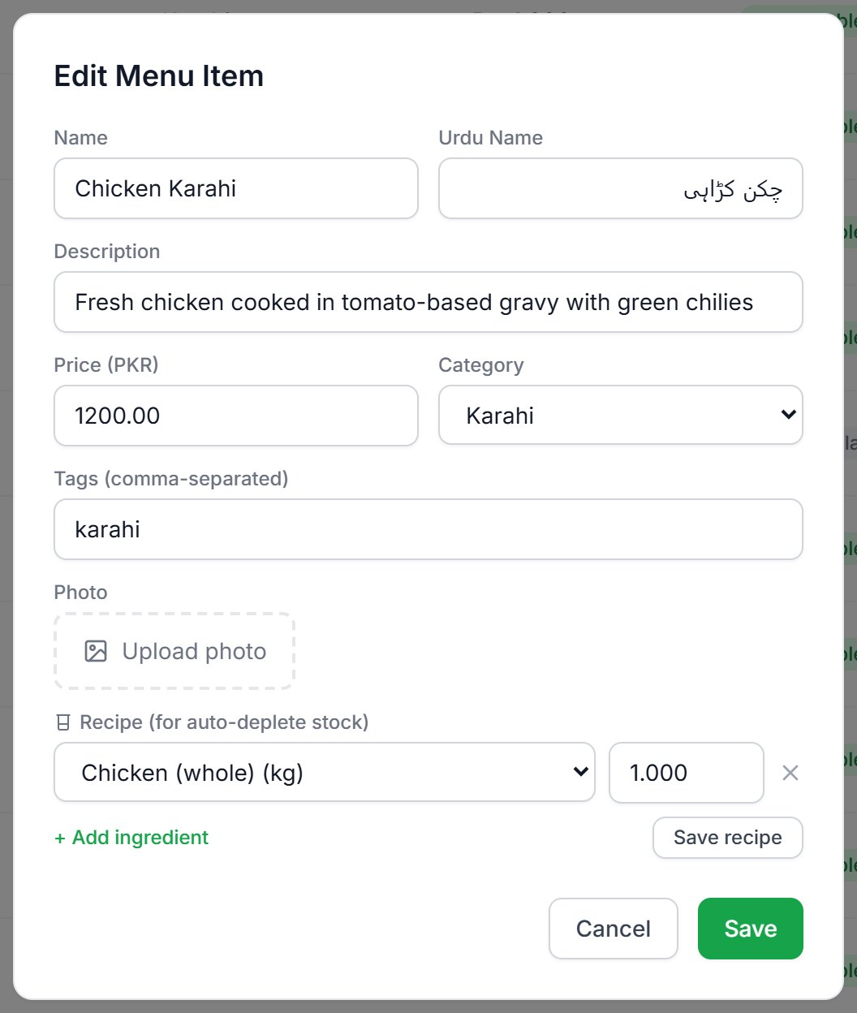
Figure 2. The photo box appears when you edit a dish. The recipe box below it makes stock go down automatically.
Important: Photos can only be added when editing, not in the first Add Item form. Photo upload could not be confirmed working when this guide was made; check the photo appears.

3. See today's orders
Click Orders. Every order from WhatsApp, your website, the POS and dine-in tables is here, newest first. Tap a filter pill (New, Preparing, Ready…) to narrow the list, and click an order to see its items, address and customer note.
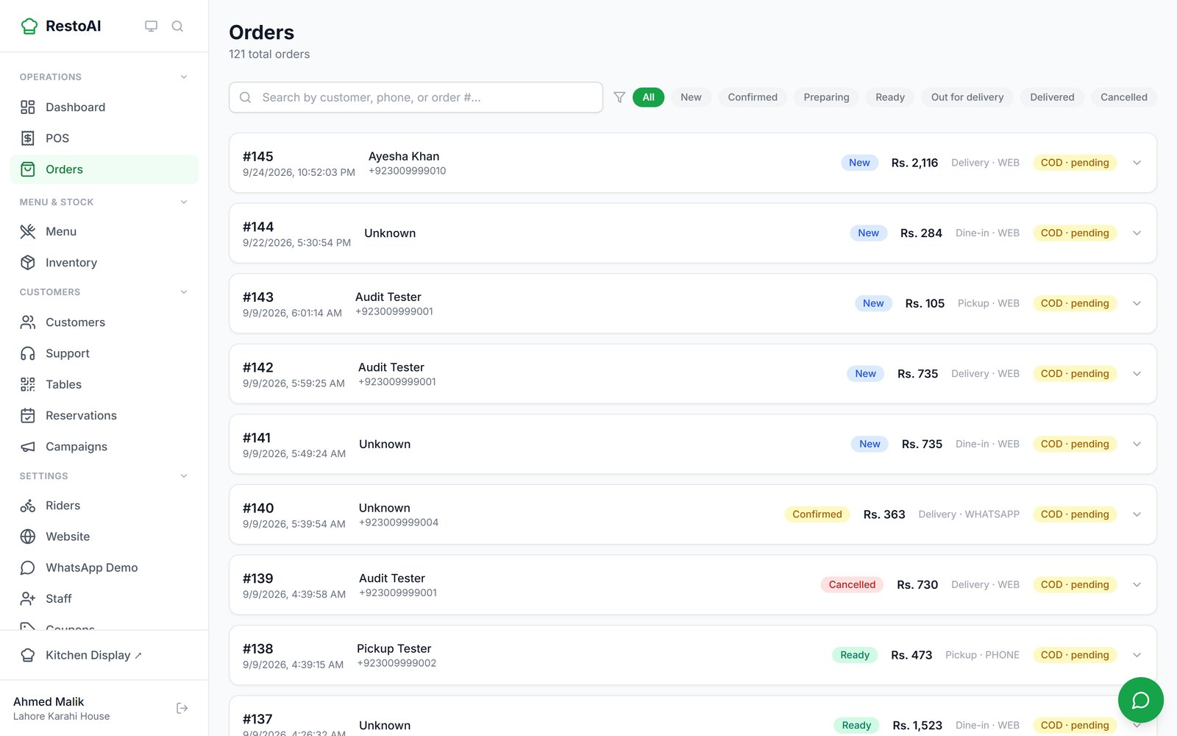
Figure 3. The Orders page.

4. Update an order's status
Open Kitchen Display ↗ from the bottom of the menu. Each order card has one button for the next step: Confirm order, Start preparing, Mark ready. The customer gets a WhatsApp message and their tracking page updates each time. (You can do the same from an order on the Orders page.)
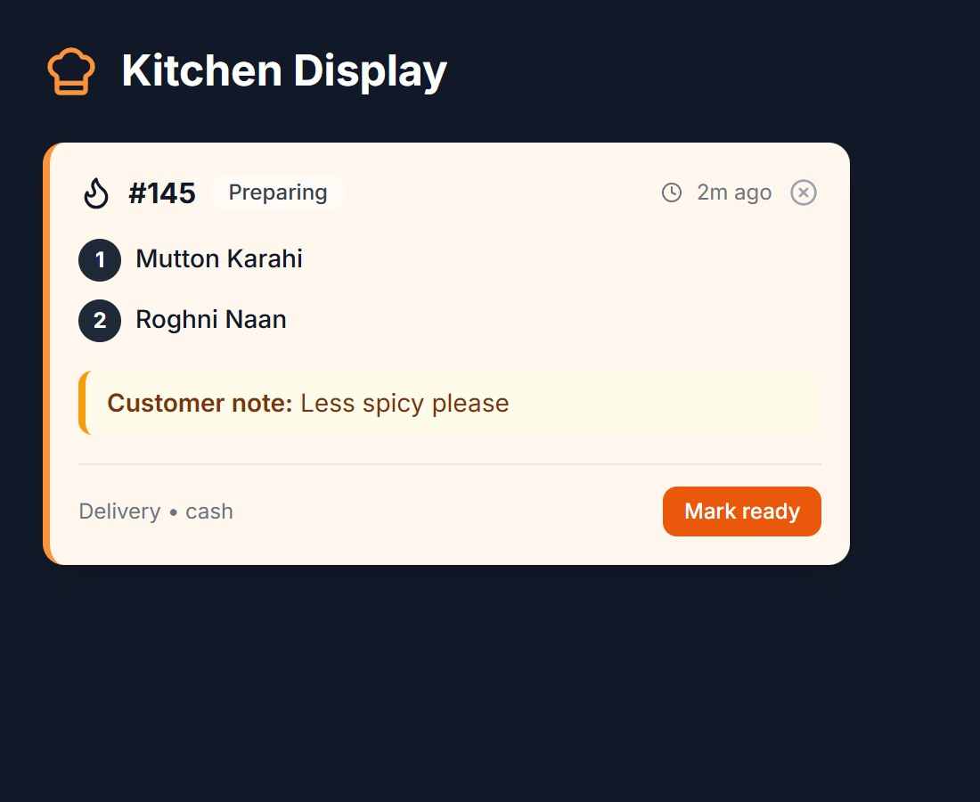
Figure 4. An order being prepared on the Kitchen Display. One tap on Mark ready and it moves on (cropped).

5. Connect your WhatsApp number
- WhatsApp Connect → Connect WhatsApp.
- Answer Do you already use this number on WhatsApp? A new number goes straight to Meta's sign-up. A number already on the WhatsApp app must have that account deleted from the phone first; a number on another provider (Wati, Gupshup…) needs an assisted move via support@restoai.app. RestoAI explains each case on screen.
- Finish Meta's sign-up (verify by SMS or call). The status changes from "Not connected".

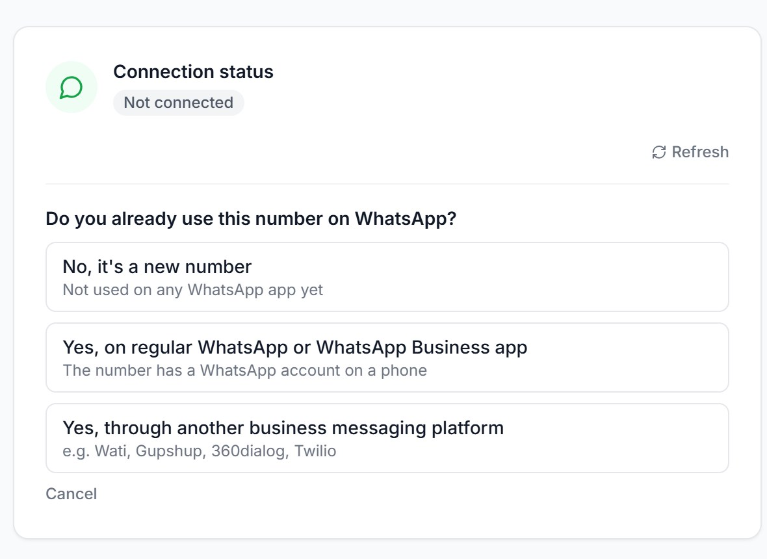
Figure 5. The question RestoAI asks before Meta's sign-up starts (cropped).

6. Check what needs your attention today
Open the Dashboard. The coloured cards at the top are your to-do list: cash or payment mismatches, suspicious activity, low stock and menu suggestions found by the AI helpers. Below them are today's orders, revenue and top dish. Review and resolve the items on the AI Agents page. If WhatsApp is connected, you also get a morning summary on WhatsApp.
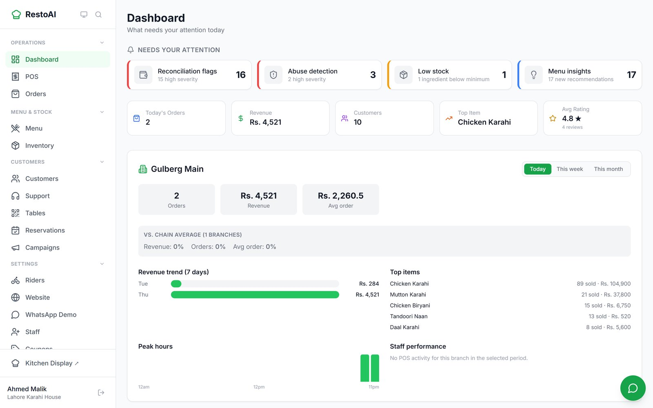
Figure 6. The Dashboard.

7. Add a staff member
- Staff → Invite Staff.
- Enter their email (and phone, to send the invite by WhatsApp too), pick Staff or Manager → Send Invite.
- Copy the link and send it to them. They open it, set a password, and sign in on the normal sign-in page.

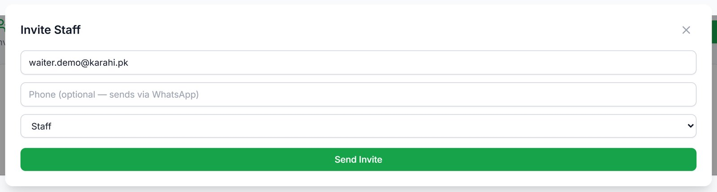
Figure 7. The Invite Staff form.
Owners control what staff can do on the Permissions page. By default staff cannot give discounts, refund, or change settings.

8. Create a simple coupon
- Coupons → New Coupon.
- Type a code (e.g. FRIDAY15), choose Percent off and enter 15. Optionally set a minimum order, a usage limit or an expiry date.
- Create Coupon. Customers enter the code at checkout.

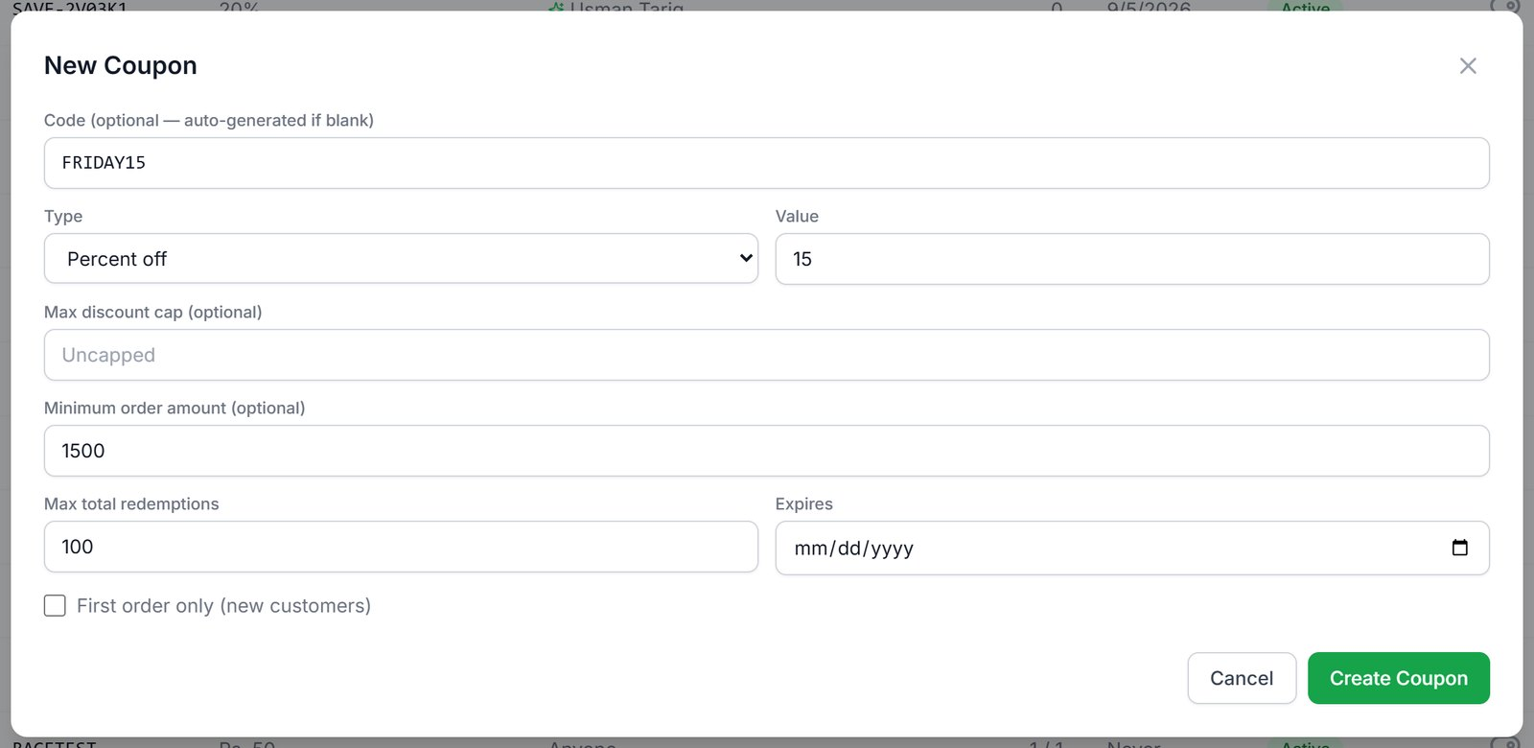
Figure 8. Creating FRIDAY15: 15% off orders over Rs. 1,500.

9. How a customer places an order
Your customers need no app and no account. On your online menu they tap Add on dishes, check out with their name, phone and address, and land on a tracking page that updates as the kitchen works, with a WhatsApp message at each step. On WhatsApp they simply type their order ("1 malai boti aur 2 roghni naan") and reply "yes" to the summary. At a table, they scan the QR code and order from the same menu.
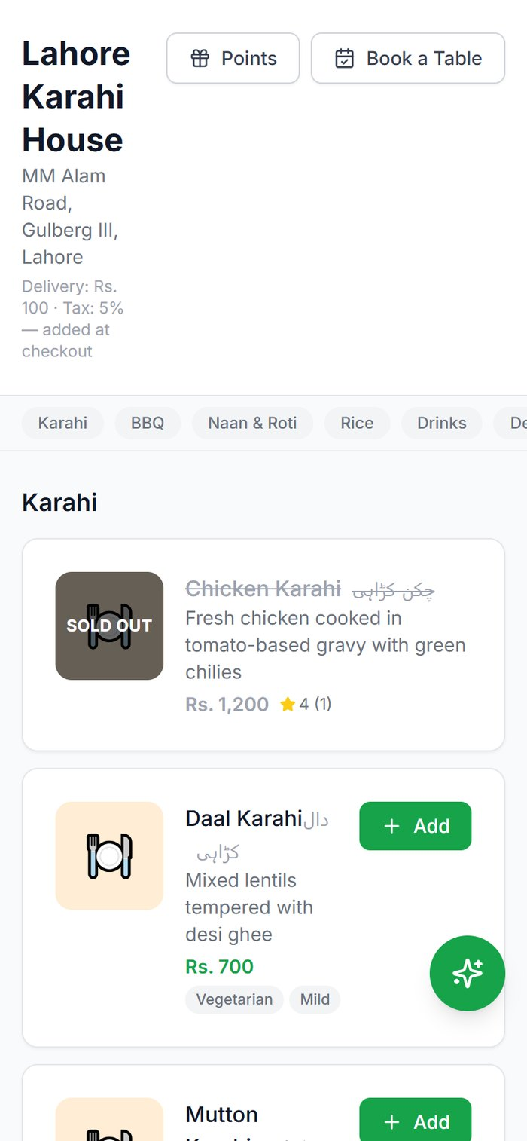  Menu | 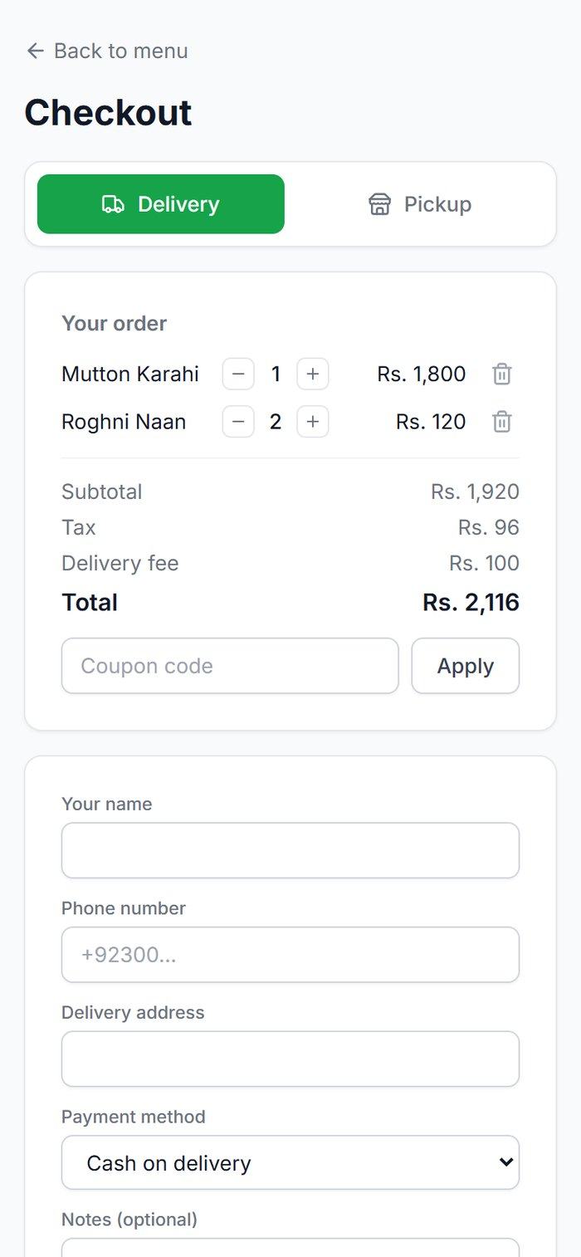  Checkout | 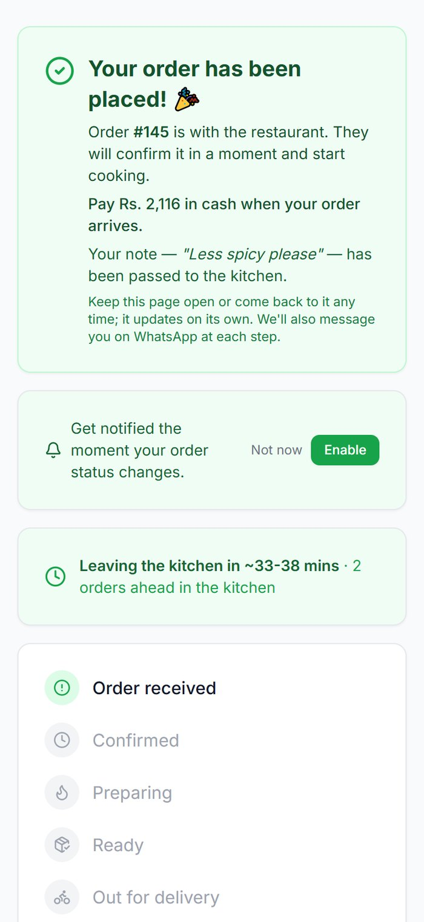  Order placed
Figure 9. A customer ordering from the online menu on a phone.
Note: The published restaurant website (the page with the "Order Now" button) currently shows an error, so share your online menu link directly for now. See the User Manual, 3.16.

