RestoAI
User Manual
For restaurant owners, managers, staff and riders
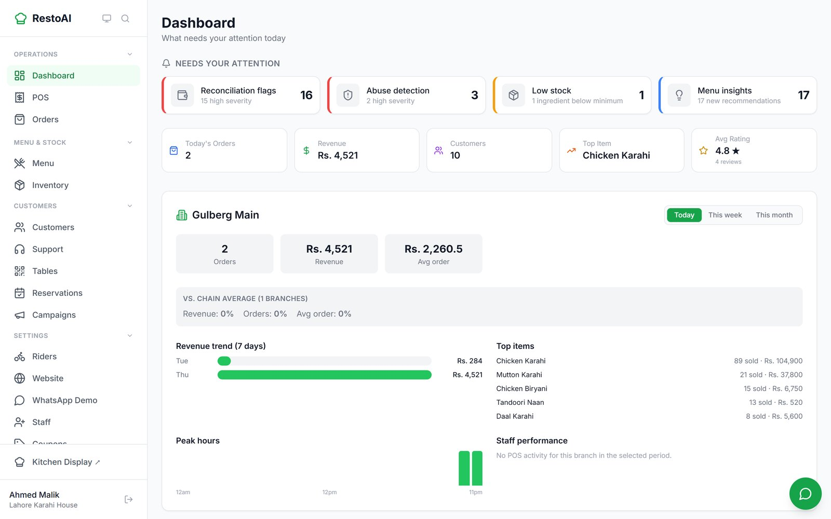
Version 1.0, 25 September 2026
Every screenshot in this manual is a real capture of the working app, taken on 24 September 2026
with the demo restaurant "Lahore Karahi House" (branch: Gulberg Main).
Contents
1. Introduction 4
1.1 Who this manual is for 4
1.2 How to read the screenshots 4
2. Getting started 5
2.1 The five roles 5
2.2 Signing in as owner, manager or staff 5
2.3 Signing in as a rider 7
2.4 Customers 7
3. Owner and manager guide 8
3.1 Dashboard: what needs your attention today 8
3.2 Menu 10
3.3 Orders 13
3.4 Kitchen Display 14
3.5 POS (point of sale) 16
3.6 Tables and dine-in QR codes 20
3.7 Riders and delivery 21
3.8 Inventory: ingredients, recipes, suppliers, purchase orders 24
3.9 Customers (CRM) 25
3.10 Coupons and referral codes 27
3.11 Campaigns (WhatsApp broadcasts) 28
3.12 Reservations 29
3.13 Support tickets 30
3.14 Insights: ask your data 32
3.15 AI Agents page 32
3.16 Your restaurant website 33
3.17 Connecting your WhatsApp number 35
3.18 Staff and permissions 36
3.19 In-store display boards 40
3.20 Subscription and account status 41
4. Staff guide 42
4.1 Managers 43
5. Rider guide 44
5.1 Sign in 44
5.2 Your deliveries 44
5.3 Picking up and delivering 44
6. Customer guide 47
6.1 Ordering on the website 47
6.2 Tracking an order 48
6.3 Leaving a review 50
6.4 Ordering at the table (dine-in QR) 50
6.5 Booking a table 51
6.6 Loyalty points 52
6.7 The Menu Assistant 53
7. The WhatsApp AI assistants 55
7.1 Customer ordering assistant 55
7.2 Owner business assistant 58
8. The agent system: your AI team 59
8.1 Daily Briefing 59
8.2 Win-Back 59
8.3 Rider Dispatch 59
8.4 ETA 59
8.5 Reconciliation 60
8.6 Abuse Detection 60
8.7 Replenishment 60
8.8 Menu Insight 60
8.9 Customer Support 60
8.10 Business Assistant 60
9. Troubleshooting and FAQ 61
9.1 WhatsApp 61
9.2 Account and access 61
9.3 Everyday questions 61
9.4 What is not available yet 62
10. Glossary 63
Appendix: platform administration 64

1. Introduction
RestoAI runs a restaurant's daily operations from one place: orders from WhatsApp, your own website and dine-in QR codes land in the same kitchen queue, next to a point-of-sale till, stock control, delivery riders, customer lists, promotions and a set of AI helpers that watch the business in the background.
It is built for Pakistani restaurants. Prices are in rupees, menus can carry Urdu names, and customers can talk to the WhatsApp assistant in English, Urdu or Roman Urdu. There is no commission on orders.

1.1 Who this manual is for
The manual is split by role so you can go straight to the part that concerns you:
If you are… | Read
The owner or a manager | Chapter 2 (sign-in), Chapter 3 (everything in the admin app), Chapters 7–9
Kitchen, counter or floor staff | Chapter 2, then Chapter 4 (what staff can do)
A delivery rider | Chapter 2.3 and Chapter 5 (the rider app). Two pages in total.
Curious how customers order | Chapter 6 (website, dine-in QR, tracking, reviews, loyalty) and Chapter 7 (WhatsApp)

1.2 How to read the screenshots
Screenshots of the admin app were taken on a laptop-sized screen. Screenshots of what customers and riders see were taken on a phone-sized screen, because that is how they use it. The Kitchen Display and the in-store display boards have a dark background by design.
Names, phone numbers and orders you see belong to the demo restaurant. Some are obviously test entries (for example "Audit Tester" or "Race Test") left from earlier testing; your own account starts empty.
Note: Where a feature exists but could not be shown working, this manual says so plainly instead of describing it. A summary of those gaps is in Chapter 9.4.

2. Getting started

2.1 The five roles
Role | Who | How they sign in | What they see
Owner | The person who registered the restaurant | Email + password at the RestoAI sign-in page | Everything, including Staff Permissions
Manager | Invited by the owner | Same sign-in page | Almost everything; exactly what the owner allows in Staff Permissions. Branch figures are limited to the branches they are assigned to.
Staff | Invited by the owner or a manager | Same sign-in page | Day-to-day screens: orders, kitchen, POS, menu. Settings pages are hidden. See Chapter 4.
Rider | Added by the owner or a manager on the Riders page | Phone number + PIN on the rider login page | Only the rider app: their own deliveries and cash collected
Customer | Anyone ordering | No account or password | Your website, online menu, order tracking, table booking, loyalty points, WhatsApp

Owners, managers and staff share one sign-in system. Riders use a separate, simpler login with a PIN, because they only need to see their deliveries and should never be able to reach the admin app. Customers never need to sign in.

2.2 Signing in as owner, manager or staff
- Open the RestoAI sign-in page and enter your email and password.
- Click Sign In. You land on the Dashboard.
- Your name and restaurant appear at the bottom of the left-hand menu. Click the arrow icon next to them to sign out.

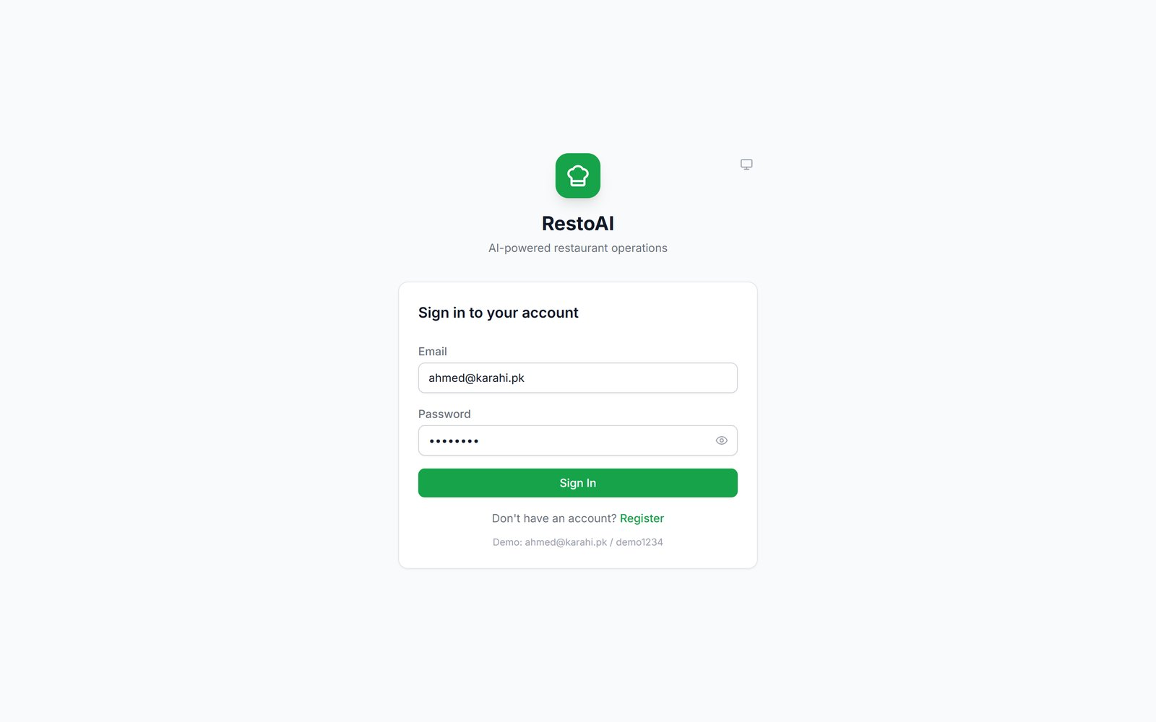
Figure 1. The sign-in page. Owners, managers and staff all use this page.
New owners create an account with the Register link on the same page. Staff and managers do not register themselves; they receive an invite link from the owner (see 3.18) and set their password there.
The left-hand menu is grouped into Operations, Menu & Stock, Customers, Settings and Intelligence. Click a group heading to collapse it. Press Ctrl+K anywhere to open a quick "Jump to a page" search.
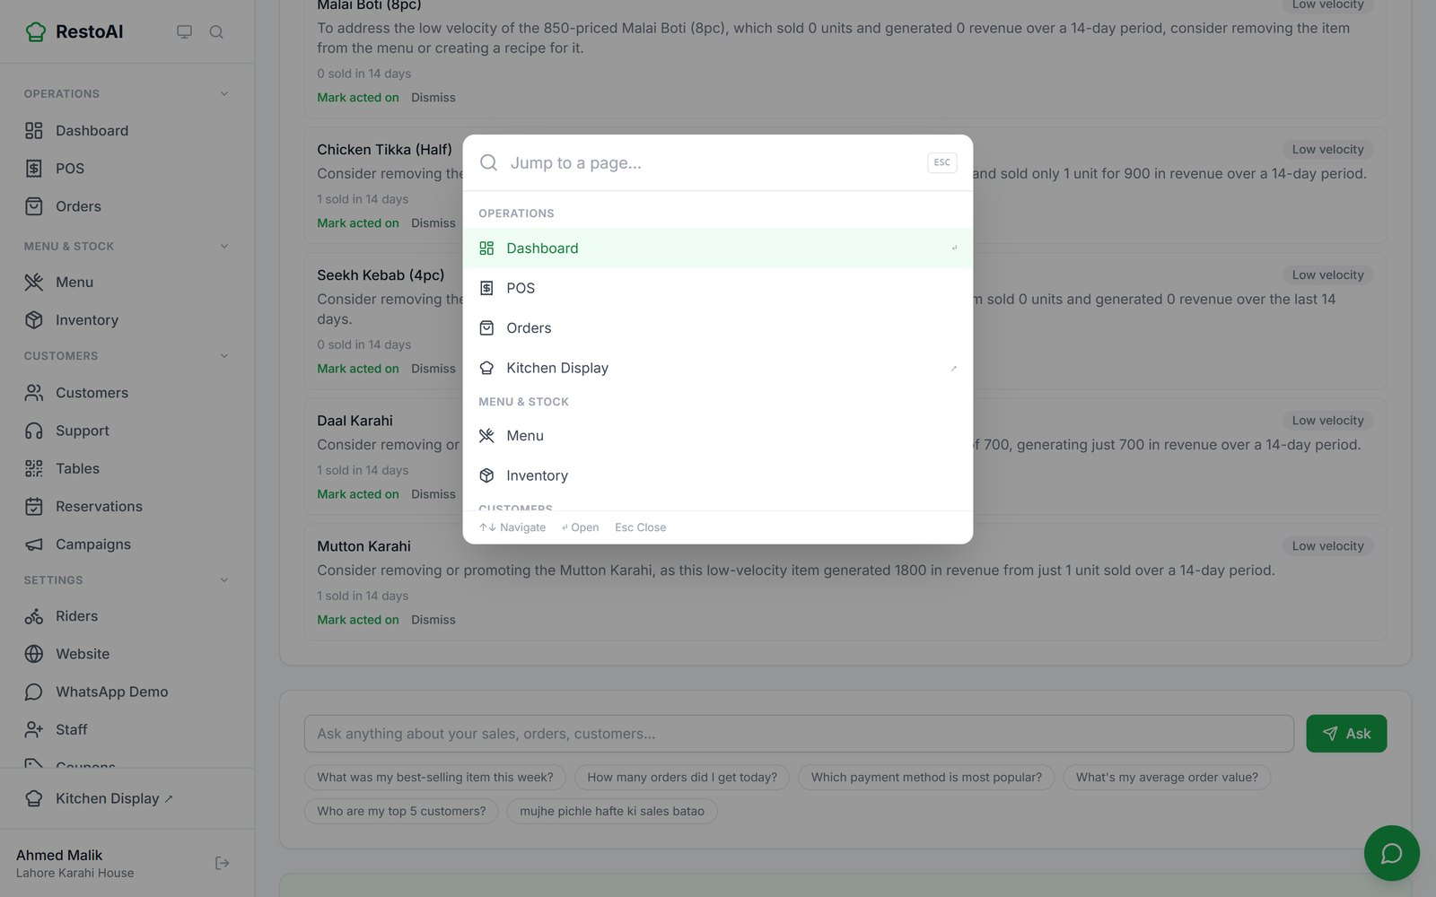
Figure 2. Quick navigation (Ctrl+K) lets you jump to any page by typing its name.
The small monitor icon next to the RestoAI logo switches between light, dark and system colour themes.

2.3 Signing in as a rider
Each rider signs in on their phone with three things: the restaurant code (for the demo restaurant this is lahore-karahi), their phone number, and a PIN the owner gave them. The owner can share a link that already contains the restaurant code. See Chapter 5.

2.4 Customers
Customers do not sign in. They are recognised by their phone number when they order, book a table or check loyalty points.

3. Owner and manager guide
This chapter walks through every page of the admin app in the order it appears in the menu. Managers can use everything here unless the owner has switched a permission off (3.18), except the Staff Permissions page itself, which only the owner sees.

3.1 Dashboard: what needs your attention today
The Dashboard is the first page after sign-in. It is designed to answer one question quickly: is anything wrong today?
- Needs your attention: four cards fed by the AI helpers: reconciliation flags (cash or payment mismatches), abuse detection (suspicious coupon or cancellation patterns), low stock, and menu insights. The full lists are on the AI Agents page (3.15).
- Today at a glance: today's orders, revenue, customer count, top item and average rating.
- Branch panel (here "Gulberg Main"): orders, revenue and average order value for Today, This week or This month, compared against the chain average, plus a 7-day revenue trend, top items, peak hours and staff performance.
- Further down: top-selling items for 30 days, today's order status, food-cost margins and recent customers.

Figure 3. The Dashboard. The coloured cards at the top are the day's to-do list.
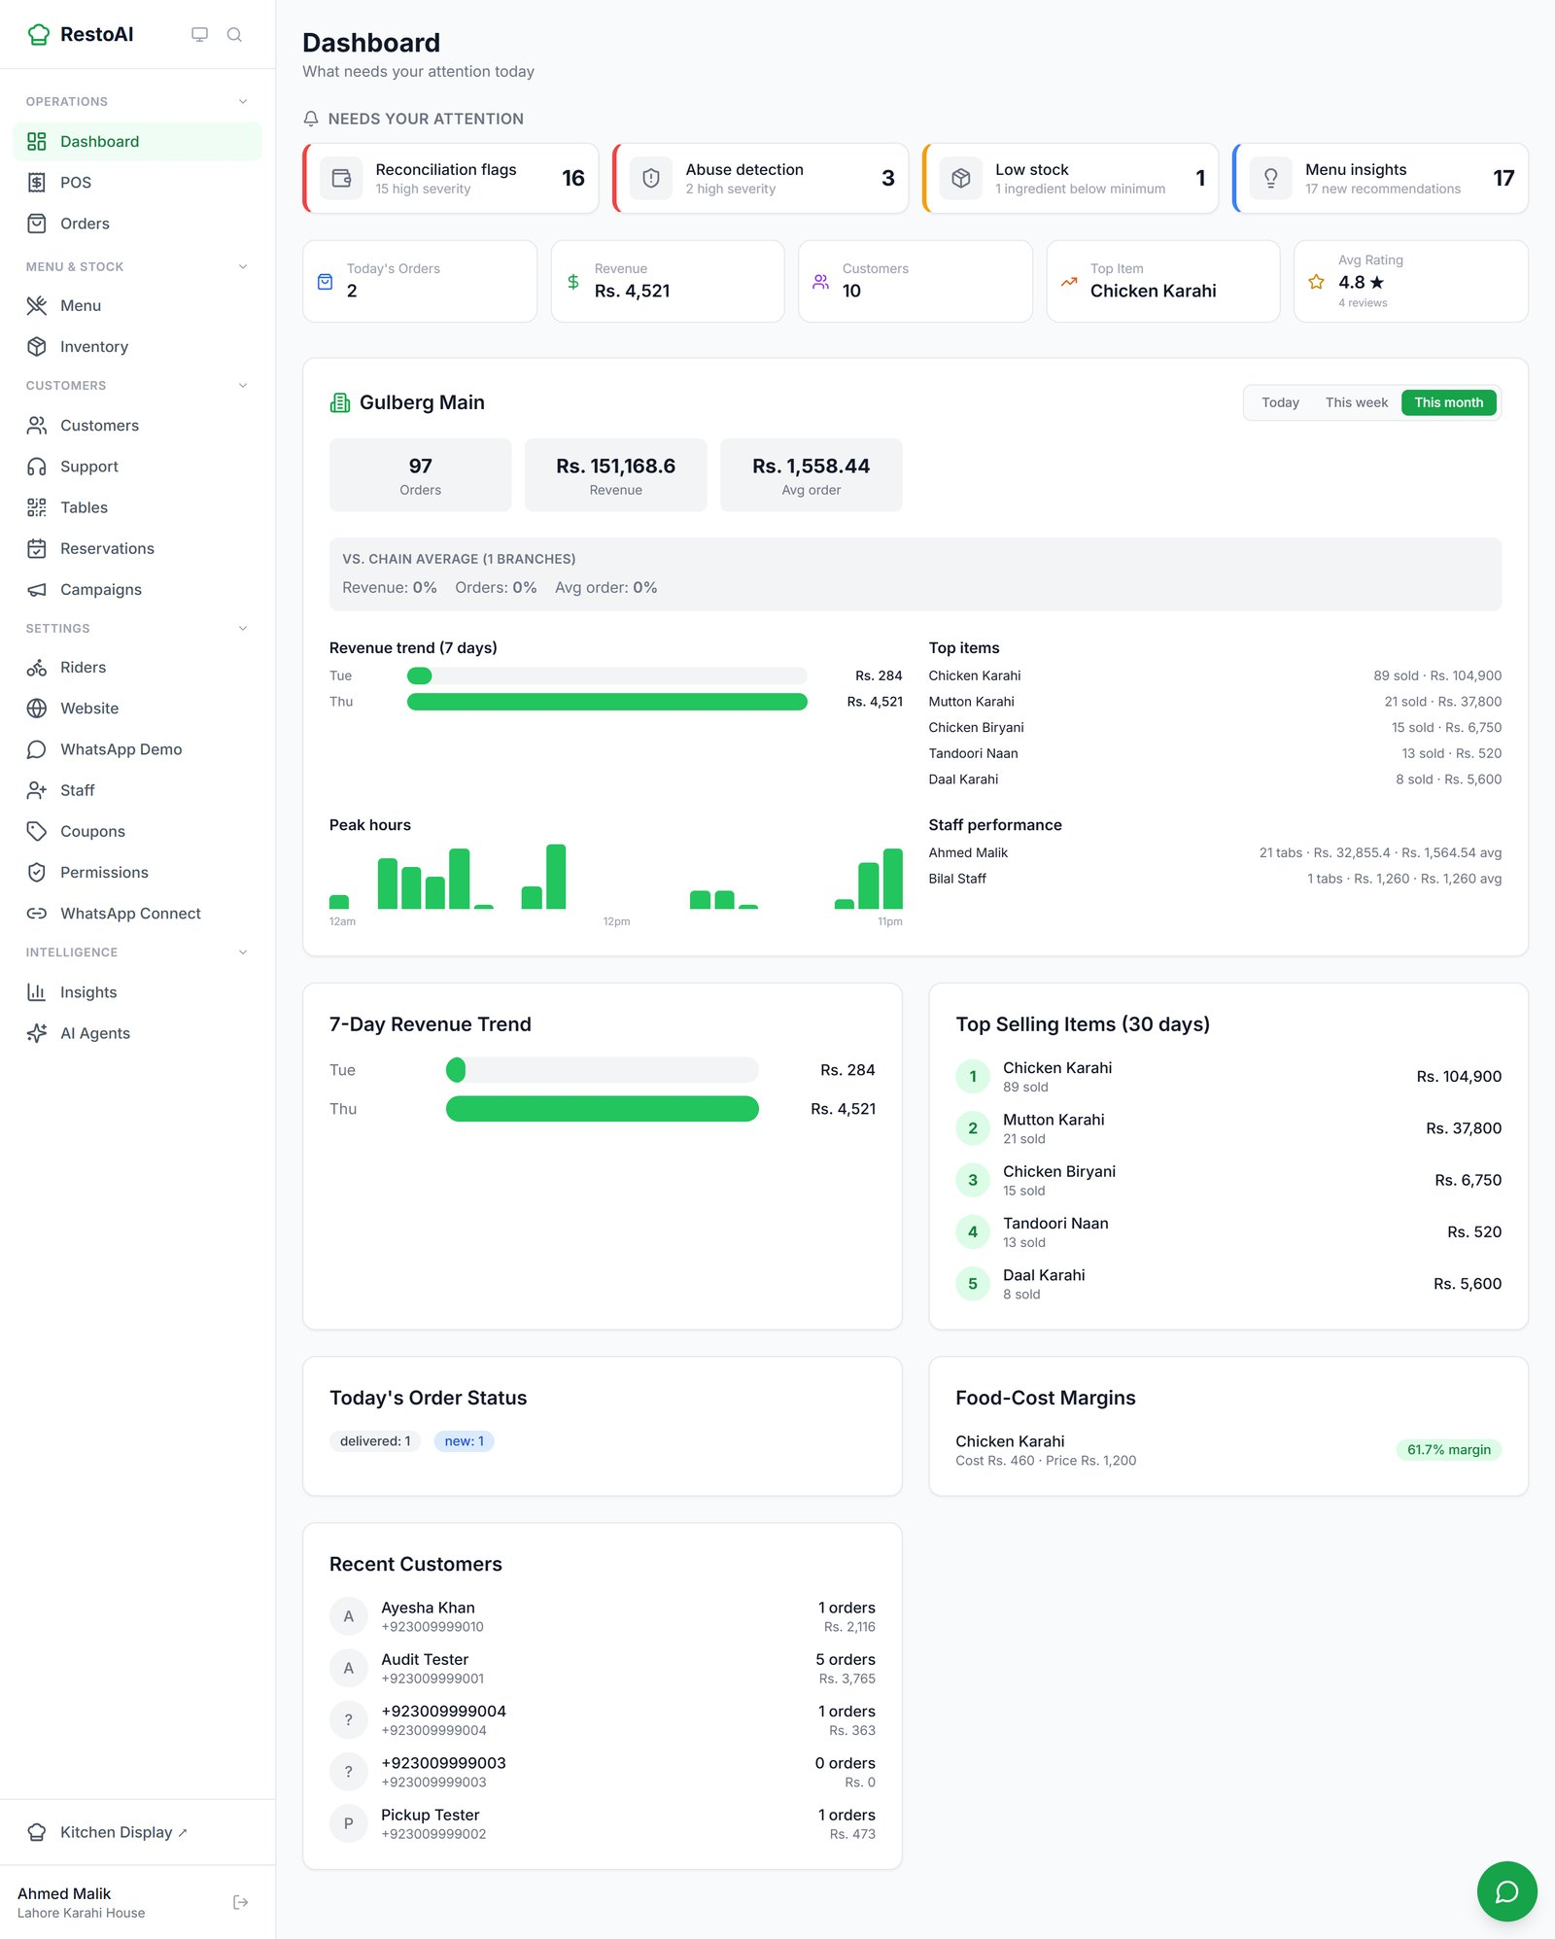
Figure 4. The branch panel switched to "This month": 97 orders and Rs. 151,168.6 revenue for the demo branch.
Note: An owner with two or more branches sees a side-by-side branch comparison first and clicks a branch to drill down. The demo restaurant has only one branch, so it opens straight on that branch's drill-down; the comparison view could not be captured. A manager assigned to a single branch also goes straight to that branch.

The AI Assistant (bottom-right chat bubble)
The green chat bubble in the bottom-right corner of every admin page opens the AI Assistant. Ask about sales, orders, customers or the menu in English or Urdu. It suggests starter questions such as "How were sales today?" and "Any ingredients running low?". The keyboard shortcut is Ctrl+J.
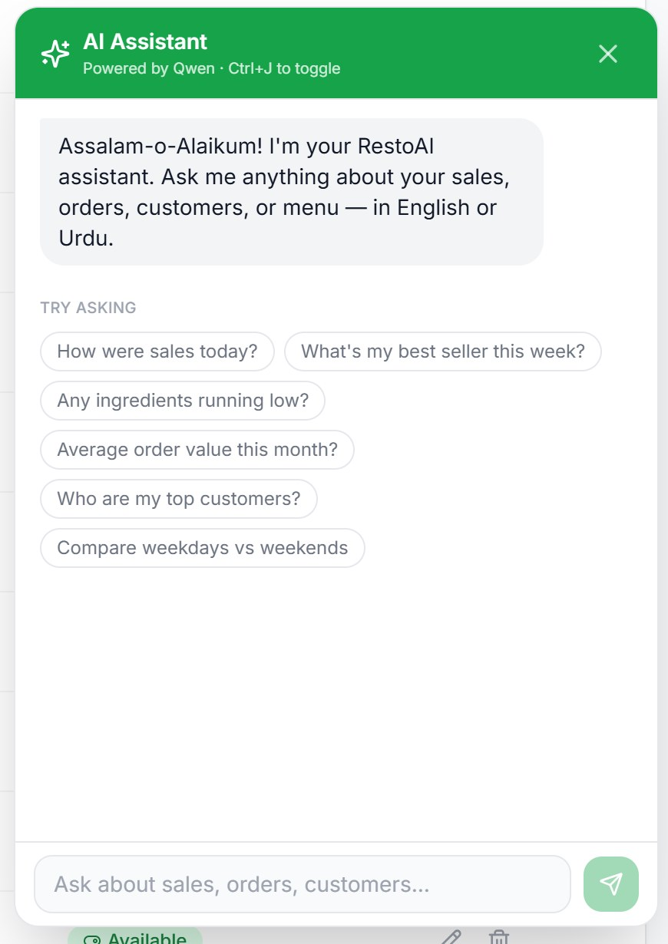  Suggested questions | 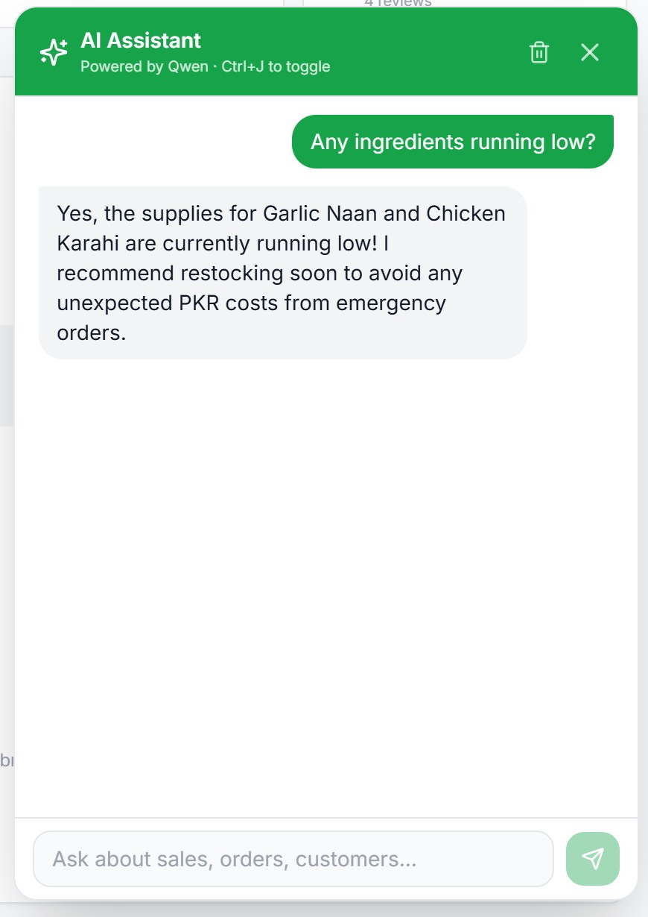  An answer
Figure 5. The AI Assistant panel (cropped).

3.2 Menu
The Menu page lists every dish with its Urdu name, category, price and availability. Use the search box to find a dish.
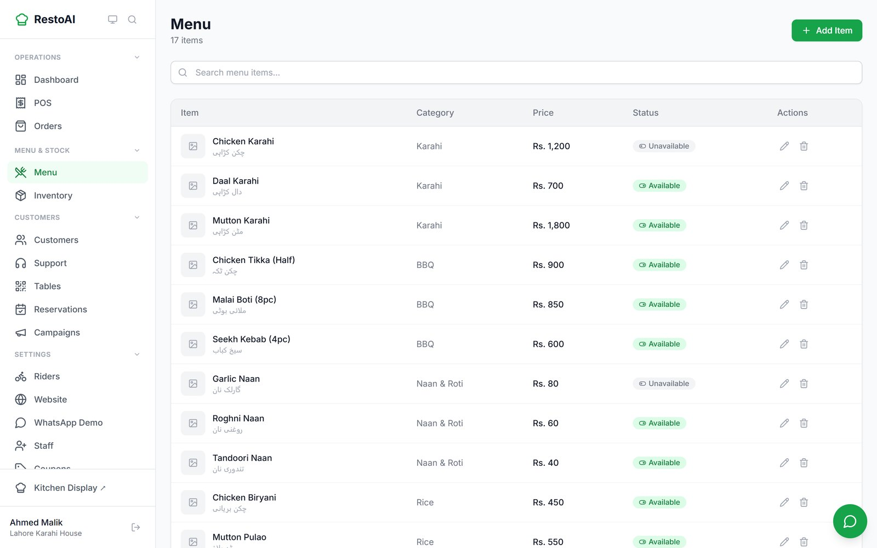
Figure 6. The menu list. The status pill shows whether a dish can currently be ordered.

Add a dish
- Click Add Item (top right).
- Fill in Name, Urdu Name (optional), Description, Price (PKR), Category and Tags (comma-separated, e.g. "creamy, mild"). Tags appear as little labels on your online menu and help the WhatsApp assistant answer questions like "something mild".
- Click Save.

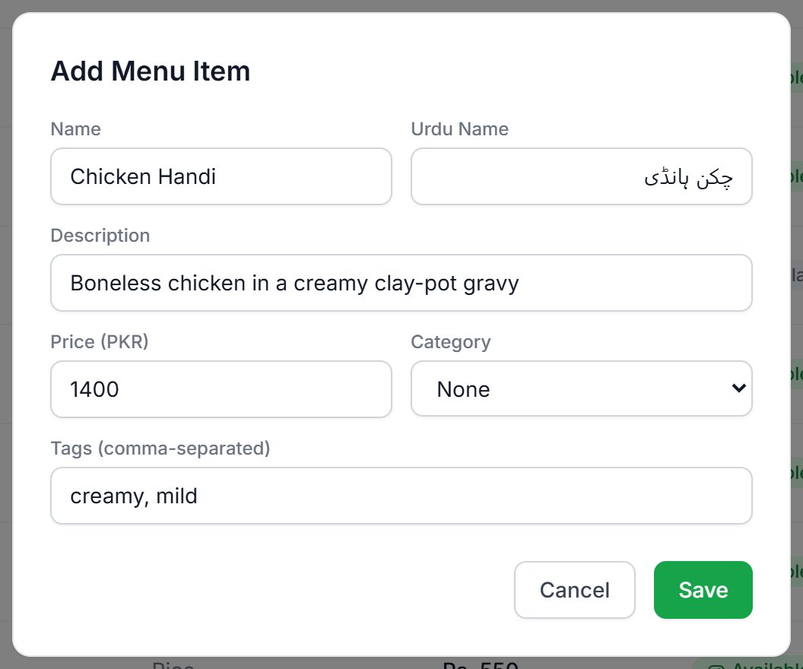
Figure 7. The Add Menu Item form.

Edit a dish, add a photo and set its recipe
- Click the pencil icon on the dish's row.
- To add a photo, click Upload photo in the Photo section.
- To make stock go down automatically when the dish sells, add its Recipe: click + Add ingredient, choose an ingredient and enter how much one portion uses, then click Save recipe.
- Click Save to save the other fields.

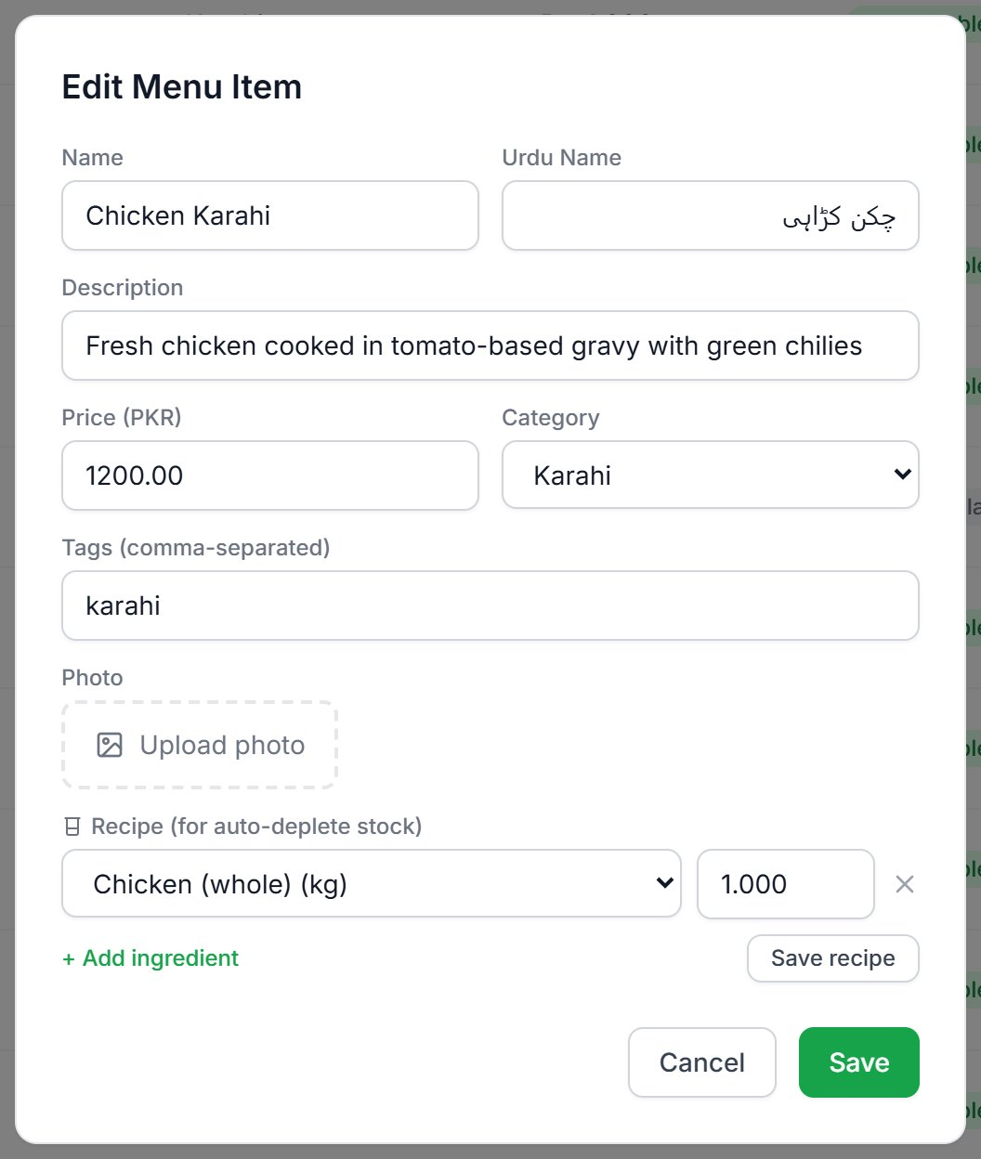
Figure 8. Editing Chicken Karahi: photo upload and a recipe line (1 kg of Chicken (whole) per portion).
Important: The Photo section only appears when editing an existing dish, not in the Add Item form. Add the dish first, then open it again to add a photo.
Photo upload could not be confirmed working for this manual: in the test environment the upload was rejected by the server (the photo storage service was not configured there) and no error message was shown. Check that a photo actually appears after uploading.

Mark a dish unavailable
Click the Available / Unavailable pill on a dish's row to switch it. Unavailable dishes show as "SOLD OUT" on your online menu and cannot be ordered. A dish can also become unavailable on its own when its recipe ingredients run out (for example Chicken Karahi in the screenshots).
Note: RestoAI can read a photo of a paper menu with AI ("menu digitisation") on the server, but there is currently no button in the app to use it. It is listed as a gap in Chapter 9.4.

3.3 Orders
The Orders page lists every order from every channel: website (WEB), WhatsApp, phone/counter (POS) and dine-in. Each row shows the order number, customer, status, total, type (Delivery, Pickup or Dine-in), channel and payment status.
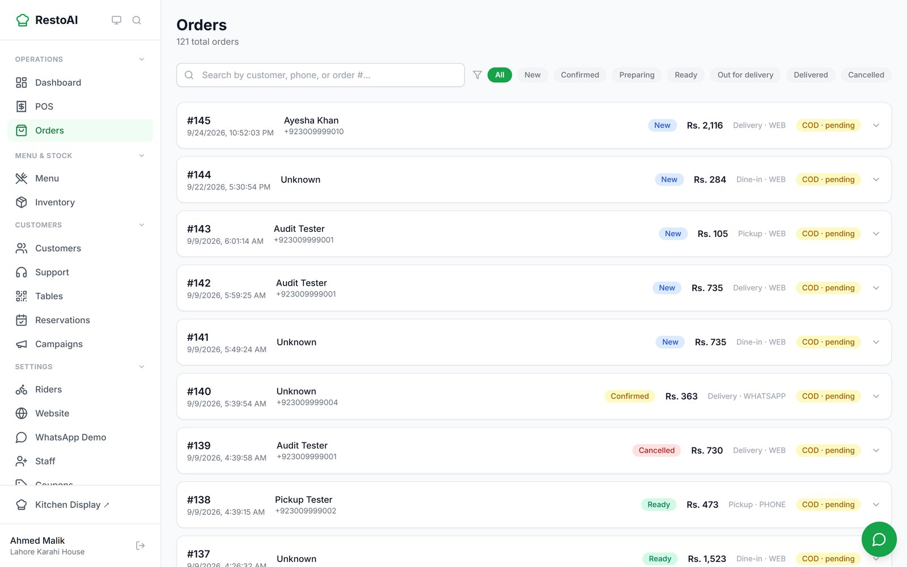
Figure 9. The Orders list. Use the filter pills to show only New, Confirmed, Preparing, Ready, Out for delivery, Delivered or Cancelled orders.

See an order's details and move it forward
- Click an order to expand it. You see the delivery address, payment method, the bill breakdown (subtotal, tax, delivery), the items, the assigned rider and any customer note.
- Click the green button (for example Move to confirmed) to advance the order one step.
- To cancel, click Cancel order and choose or type a reason. The reason is sent to the customer and shown on their tracking page.

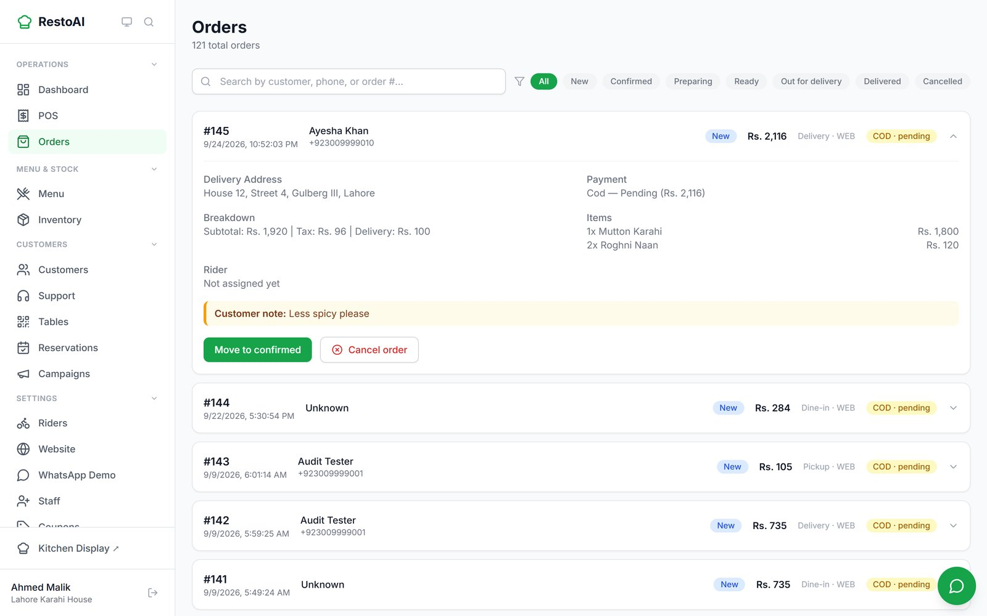
Figure 10. Order #145 expanded, with the customer's note "Less spicy please" highlighted.
An order moves through these steps. The customer receives a WhatsApp message and sees their tracking page update at each one:
Status | Meaning | Who usually sets it
New | Just placed, not yet accepted | Automatic
Confirmed | The restaurant accepted it | Kitchen / staff
Preparing | Being cooked | Kitchen
Ready | Cooked and packed | Kitchen
Out for delivery | Rider has picked it up (delivery orders only) | Rider app
Delivered | Handed over / served / collected | Rider app or staff
Cancelled | Stopped, with a reason | Staff

3.4 Kitchen Display
Open it from Kitchen Display ↗ at the bottom of the menu (it opens in its own full-screen page, ideal for a tablet or TV in the kitchen). New orders appear automatically; the green "Live" dot shows it is updating.
Each card shows the order number, how long ago it arrived, the items, any customer note, the order type and payment. The big button always shows the next step: Confirm order, then Start preparing, then Mark ready. Once ready, the card leaves the kitchen screen.
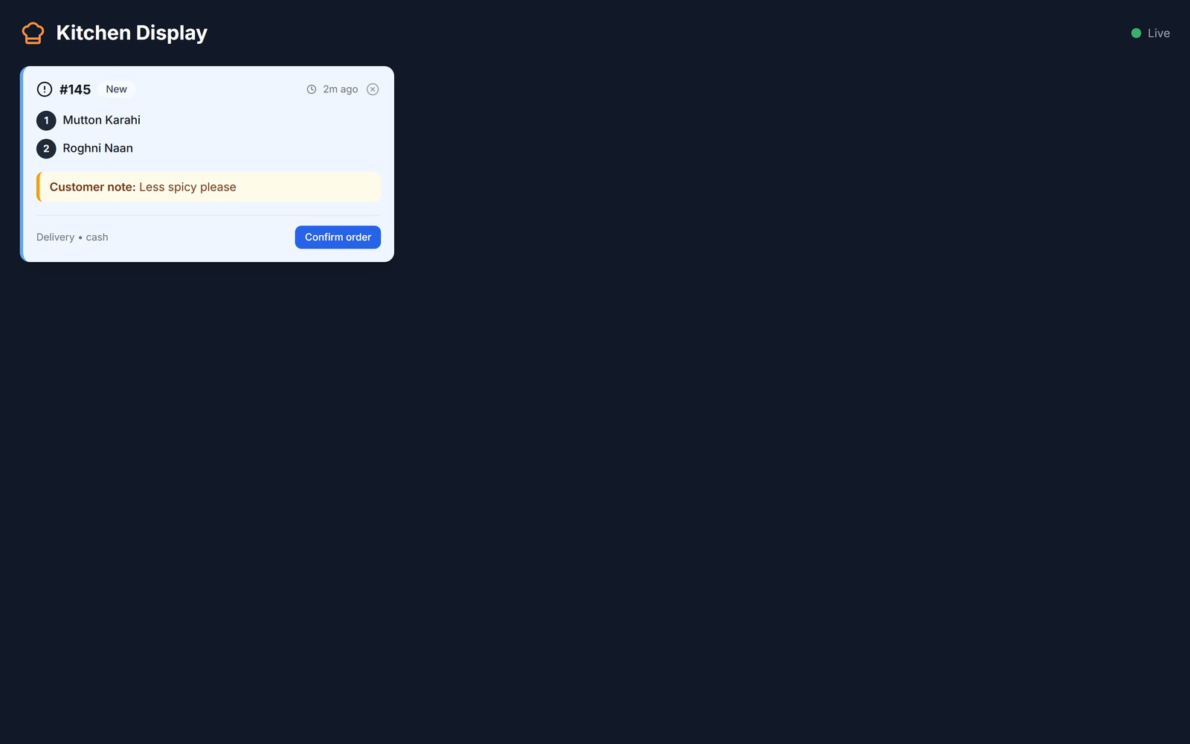
Figure 11. A new web order on the Kitchen Display, with the customer's note.
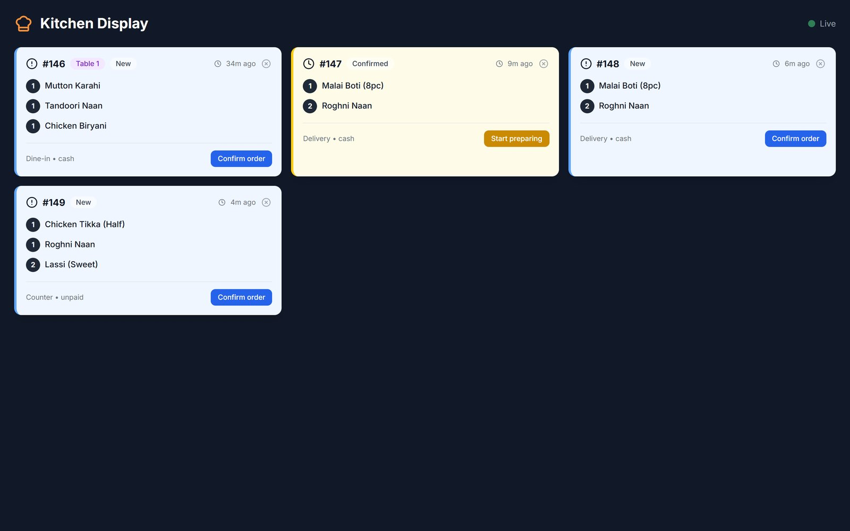
Figure 12. Several orders at once: a dine-in round from Table 1, two WhatsApp orders and a counter (POS) order.
Tip: Orders older than a day are hidden from the kitchen screen to keep it clean. You can still find them on the Orders page.

3.5 POS (point of sale)
The POS is the till for walk-in, counter, phone and table-service orders. Work happens in tabs: open a tab, add items, send them to the kitchen in rounds, then settle the bill.

Open a shift
- Go to POS and click Open shift.
- Enter the opening cash float (the cash already in the drawer) and click Open Shift.

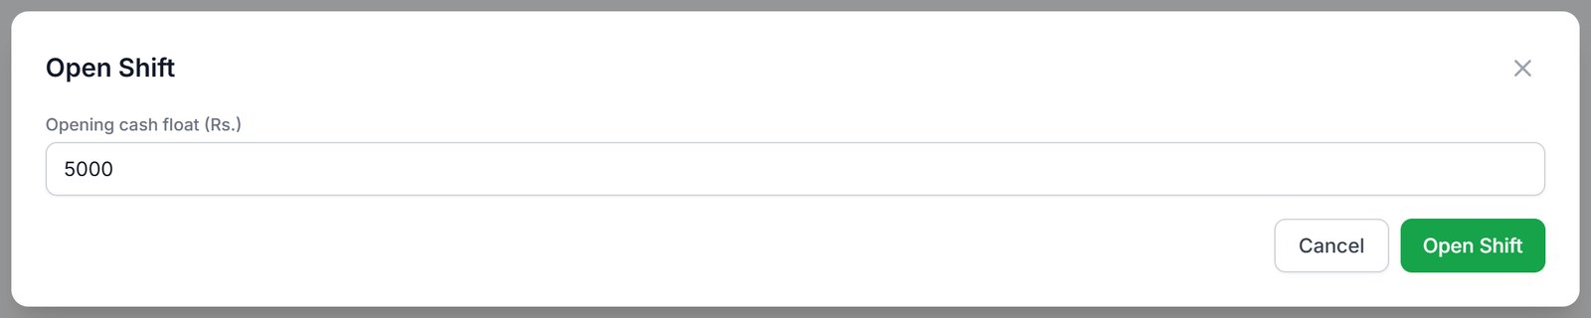
Figure 13. Opening a shift with a Rs. 5,000 float.

Take an order
- Click New Tab and pick Counter, Dine-in (then choose the table) or Phone. Customer name and phone are optional.
- Click Open Tab, then click dishes in Add Items to add them. Use − / + to change quantities.
- Click Send Round to send those items to the kitchen. You can add more rounds to the same tab later.

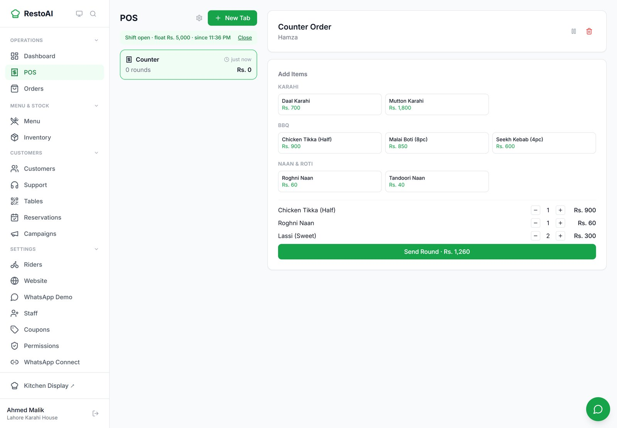
Figure 14. A counter tab for "Hamza" with items added, ready to send.
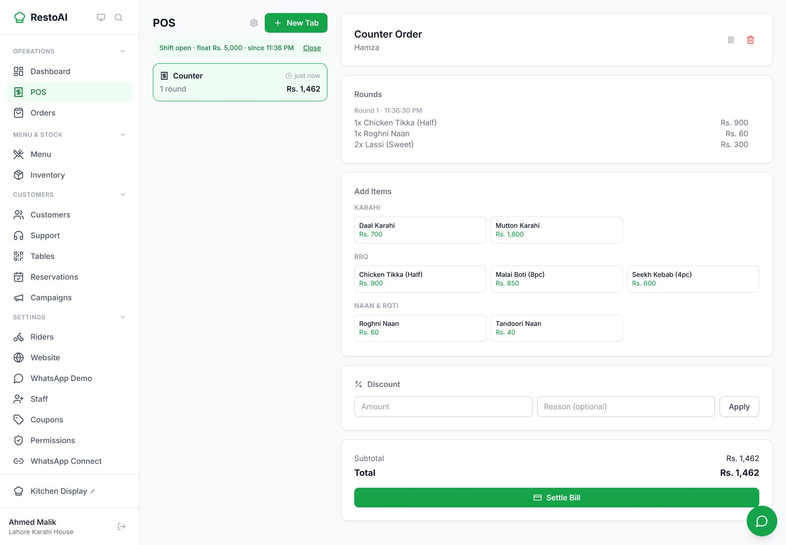
Figure 15. After sending, the round is listed on the tab. The Discount box and Settle Bill are below it.

Discounts, voids, transfers
- Discount: enter an amount and optional reason, then Apply. Needs the "Apply a discount" permission (owners and managers by default).
- Void an item: hover over a line on the tab and click its remove icon, then give a reason. Needs the "Void a line item" permission.
- Icons at the top of the tab let you transfer a dine-in tab to another table, park it, or void the whole tab.

Settle the bill, including split payments
- Click Settle Bill. The total is filled in against Cash.
- To split, change the first amount, click + Split across another method, and choose Card, JazzCash or EasyPaisa for the rest. The form shows "Fully covered" when the amounts add up.
- Click Confirm & Close Tab. The receipt opens with Print, Refund and Done.

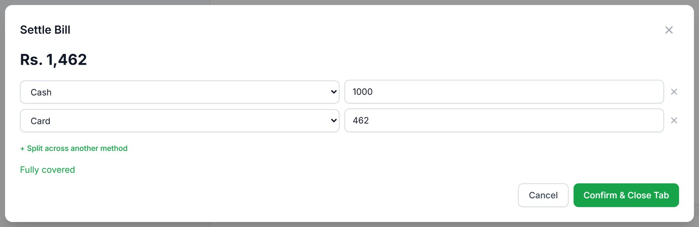
Figure 16. Settling a bill split across Rs. 1,000 cash and Rs. 462 card; "Fully covered" confirms the amounts add up (cropped).
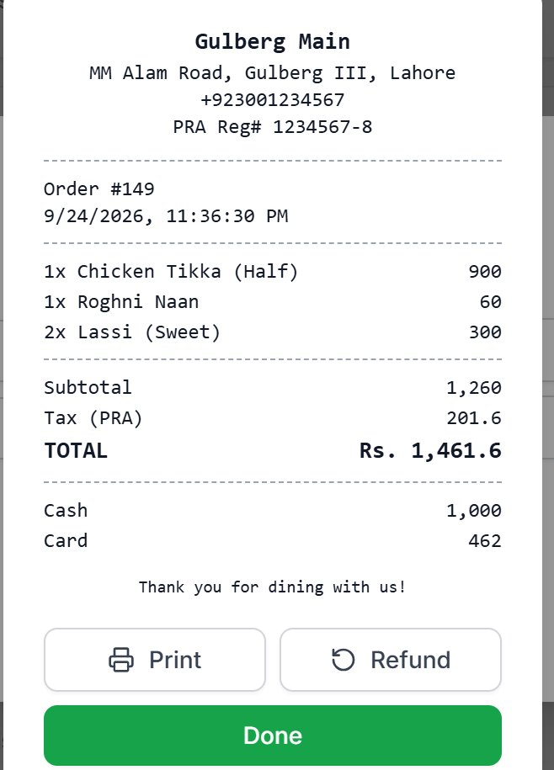
Figure 17. The receipt, showing the tax authority line, your registration number and both payment methods.
Important: Refunds are started from the receipt and need the same permission as discounts, so by default only owners and managers can refund.
The POS uses its own tax setting (the gear icon on the POS page: tax authority, rate and registration number). In the demo this is 16% PRA. Online and WhatsApp orders currently use a fixed 5% tax. Make sure both match your actual obligations.
Known issue: after Confirm & Close Tab, the Settle Bill window stays open behind the receipt. Click Done and close it.

Close the shift (Z-Report)
- Click Close in the green shift bar at the top of the POS.
- Count the cash in the drawer, enter it and click Close & View Z-Report.
- The Z-Report shows takings by payment method and by category, discounts, voids and refunds, the opening float, expected cash, counted cash and the variance (shortage or excess).

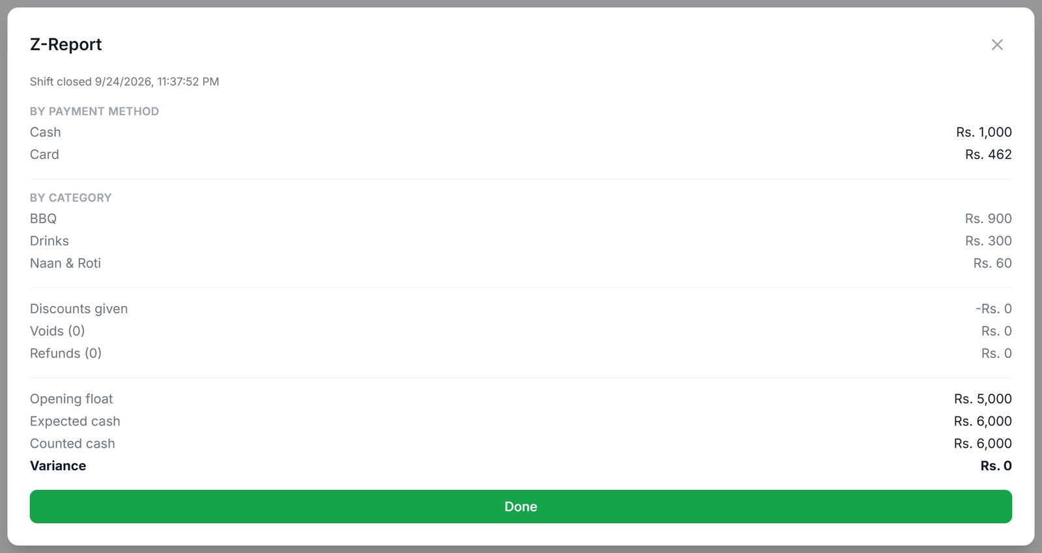
Figure 18. The Z-Report. Here expected and counted cash match (variance Rs. 0) (cropped).

3.6 Tables and dine-in QR codes
Every table gets its own QR code. Guests scan it with their phone camera, order from the menu and see a running bill, without waiting for a waiter (see 6.3 for the guest's side).
- Go to Tables, type a table number and click Add Table.
- Click Show QR on a table card to display its QR code. Print it and stick it on the table.
- When guests order, the card shows Occupied; when they ask for the bill it shows Bill requested and a notice pops up for staff.
- After the bill is paid, click Close session, then Confirm. The next guests who scan start a fresh bill.

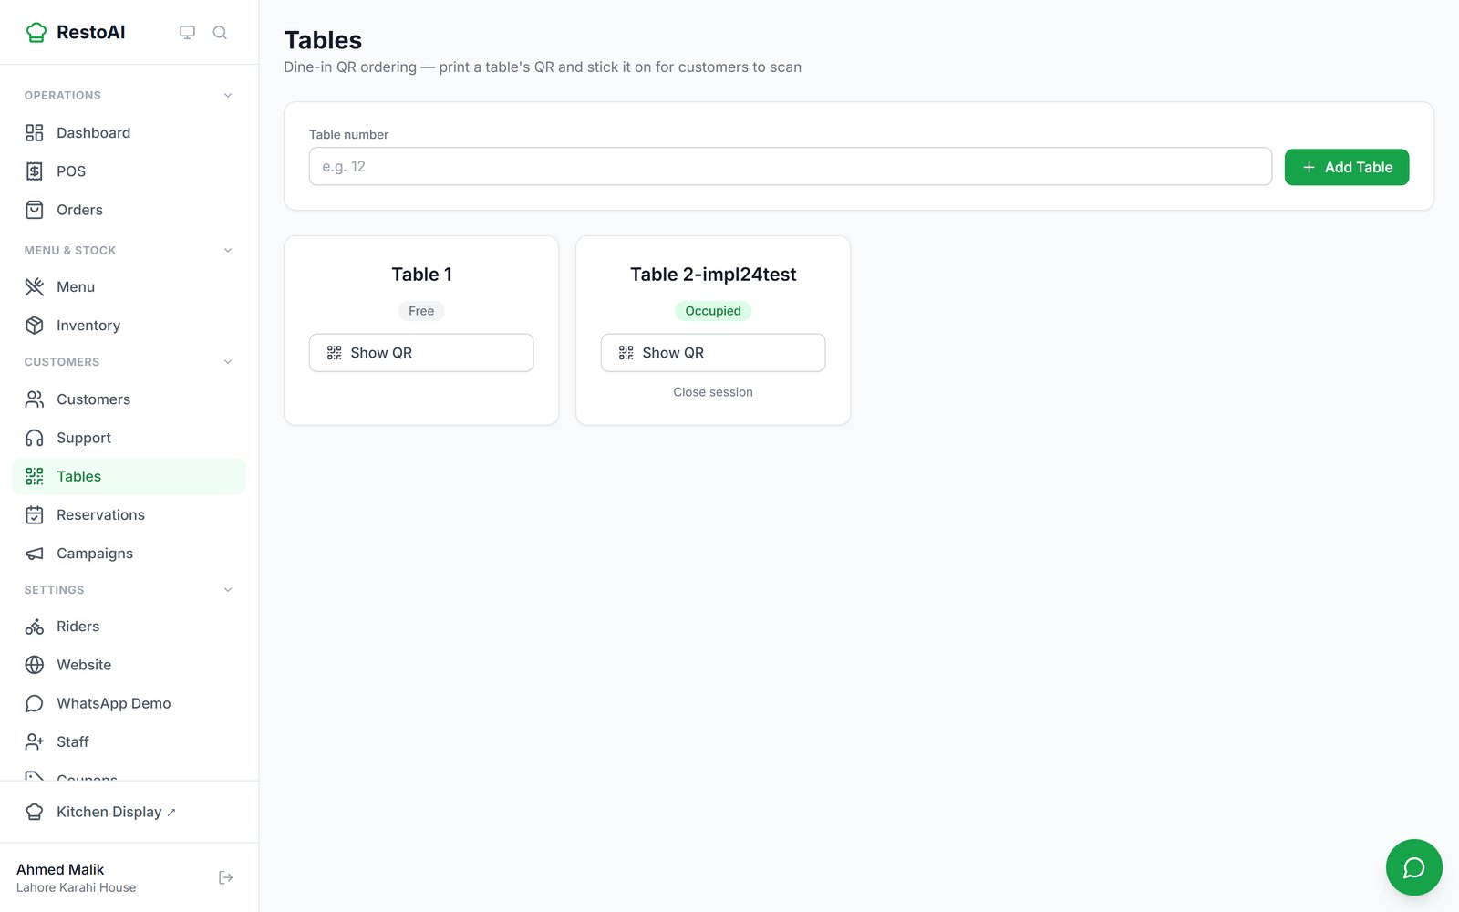
Figure 19. The Tables page.
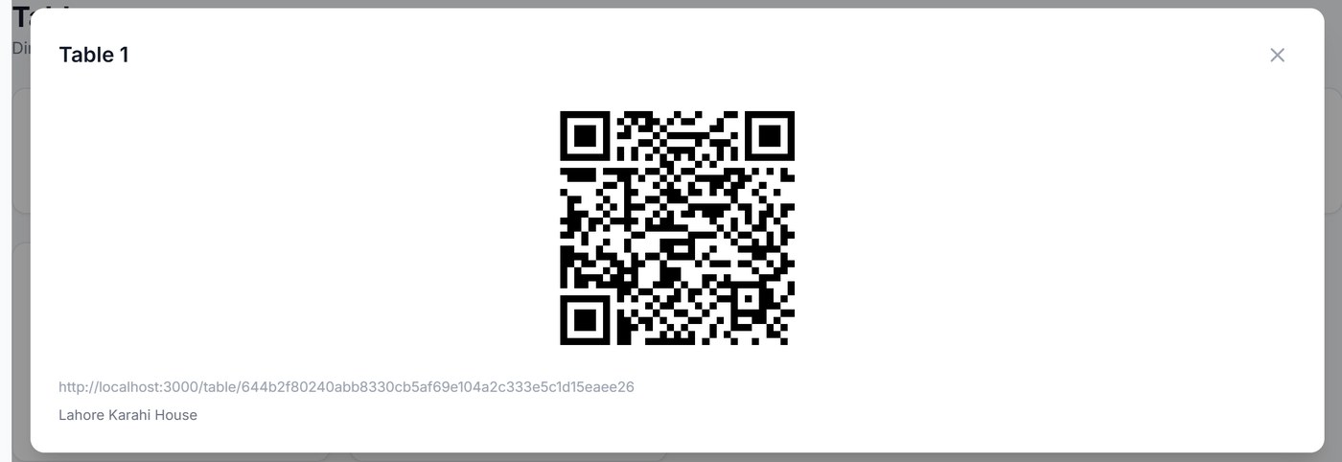
Figure 20. A table's QR code, ready to print (cropped).
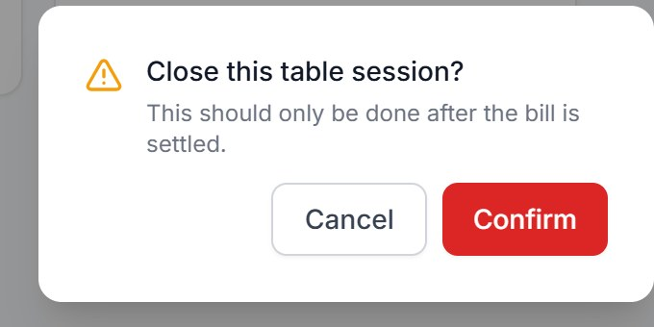
Figure 21. Confirming Close session after the bill is paid (cropped).
Note: The QR in the screenshot points at a test web address because it was captured on a test setup. On your live account the QR points at your restaurant's real address.

3.7 Riders and delivery
The Riders & Delivery page has four panels: the Roster of riders, Unassigned Deliveries, Active Deliveries, and Reconciliation History of cash.
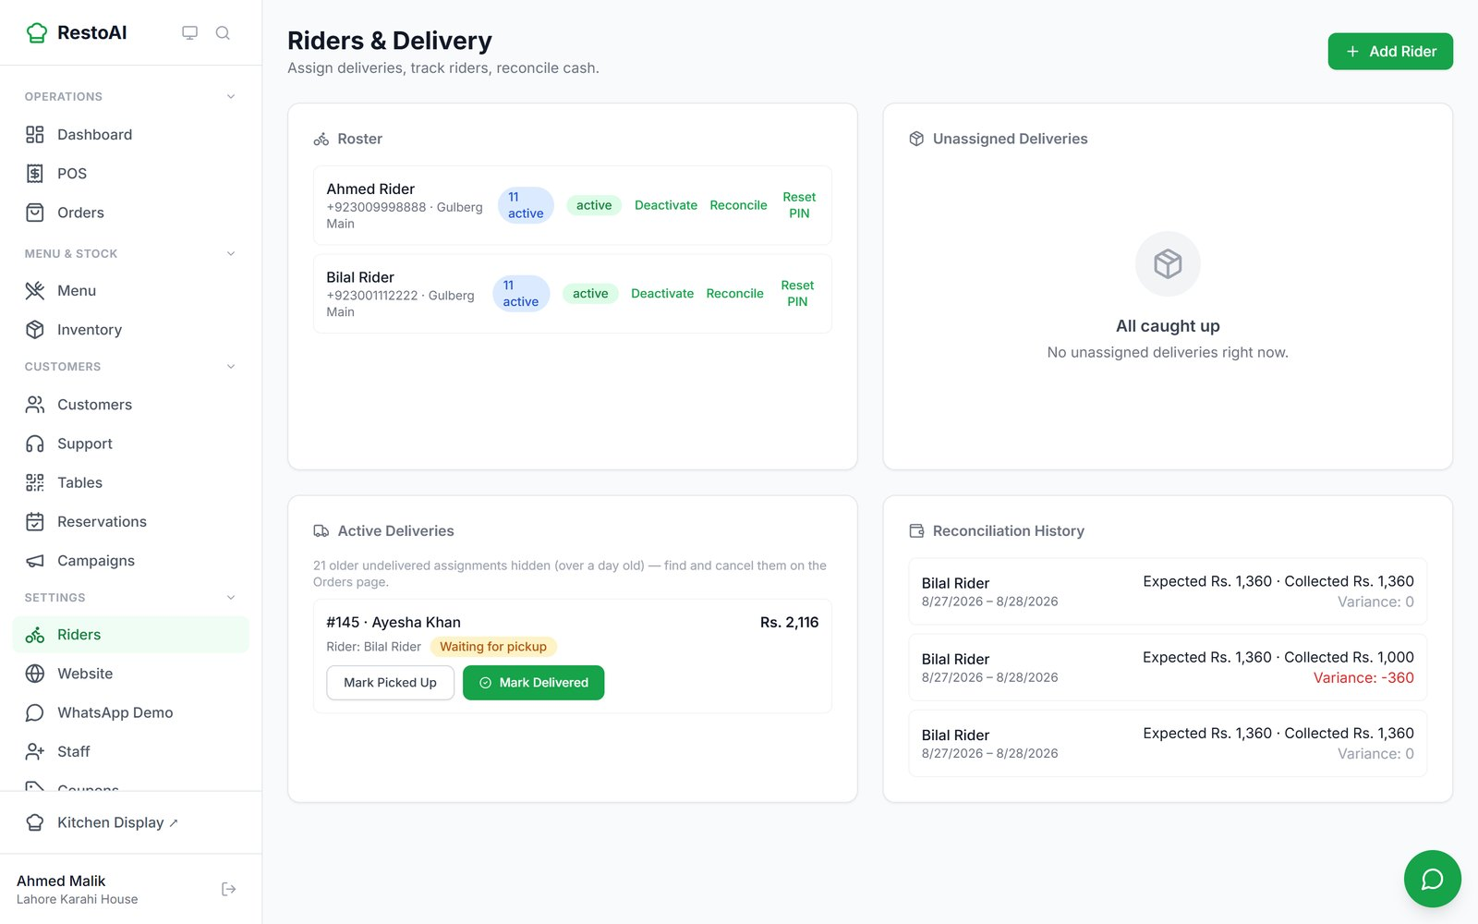
Figure 22. Riders & Delivery. Order #145 was assigned to Bilal Rider automatically as soon as it was ready.

Add a rider and give them a PIN
- Click Add Rider, enter their name and phone number, and save.
- A PIN is generated and shown once. Give it to the rider in person or by phone. It will not be shown again.
- If a rider forgets their PIN, click Reset PIN on their row to generate a new one.

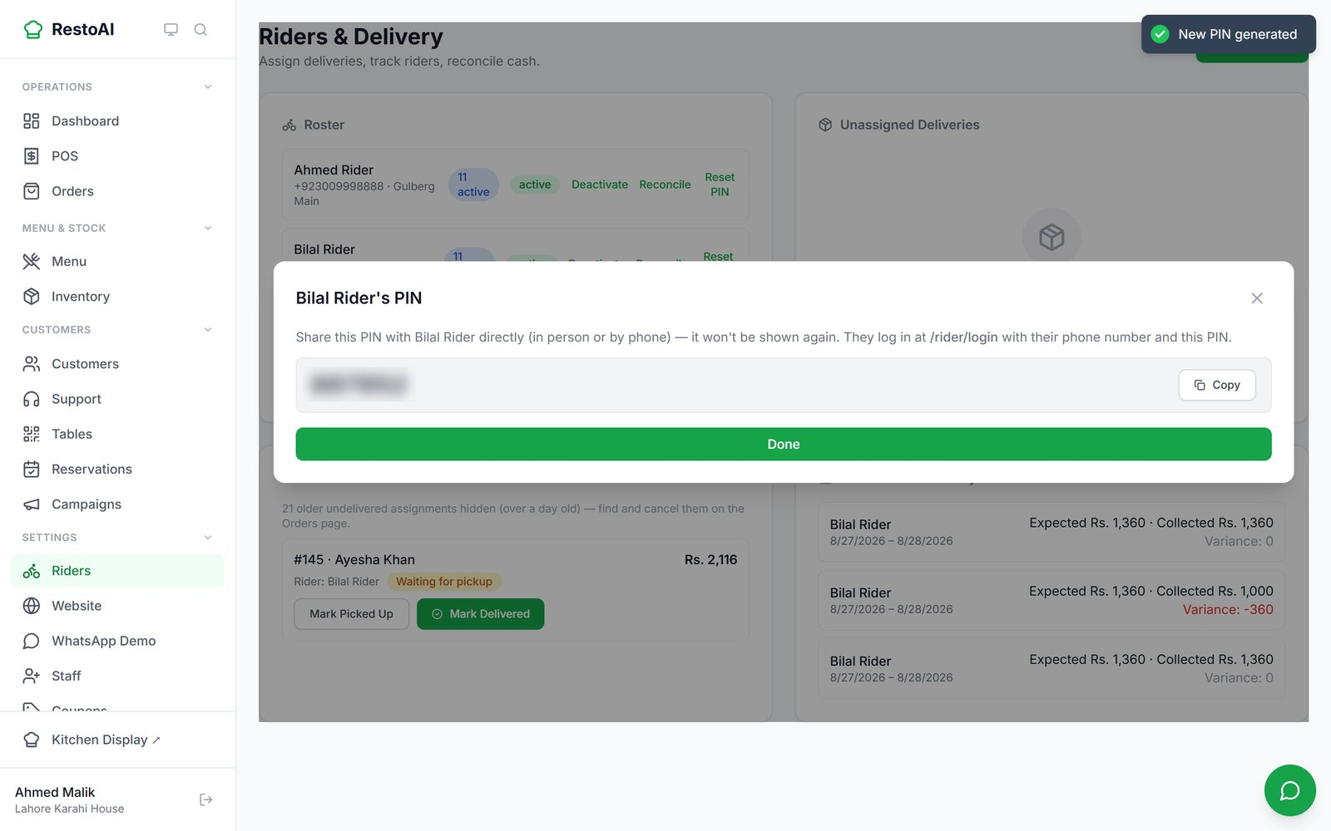
Figure 23. A new PIN shown once (blurred here on purpose).

Assigning deliveries
How deliveries are assigned depends on the Rider dispatch setting on the AI Agents page (3.15). With Full auto-assign (as in the demo), each ready delivery is given to the least busy rider automatically. With Suggest only, ready deliveries wait in Unassigned Deliveries where you pick a rider from the list or click Auto-assign.
The rider marks the order picked up and delivered in their app (Chapter 5). You can also do it from Active Deliveries with Mark Picked Up and Mark Delivered.
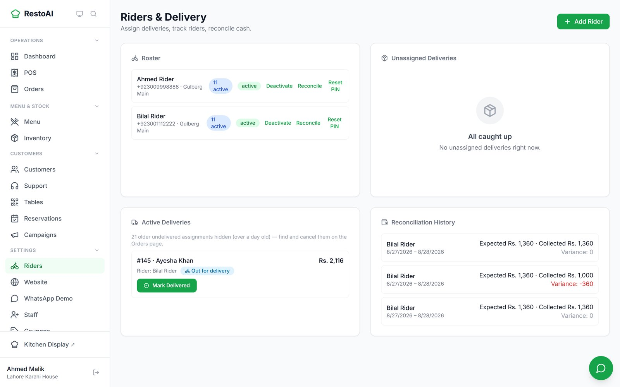
Figure 24. Active Deliveries after the rider picked up order #145: status "Out for delivery".

Cash reconciliation
- Click Reconcile on a rider's row.
- Choose the From and To dates and click Run Reconciliation.
- The result is added to Reconciliation History: expected cash, collected cash and the variance. A negative variance (in red) means the rider handed in less than expected.

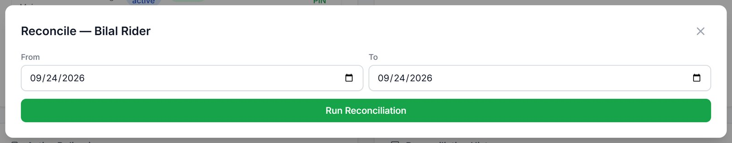
Figure 25. Starting a cash reconciliation for Bilal Rider.
Tip: Deactivate a rider who has left with Deactivate; their history is kept.

3.8 Inventory: ingredients, recipes, suppliers, purchase orders
Inventory tracks ingredients, not dishes. Each ingredient has current stock, a low-stock threshold, cost per unit and an optional preferred supplier. When a dish with a recipe (3.2) is sold, its ingredients are deducted automatically. Stock can never go below zero: an order that would need more than you have is refused.
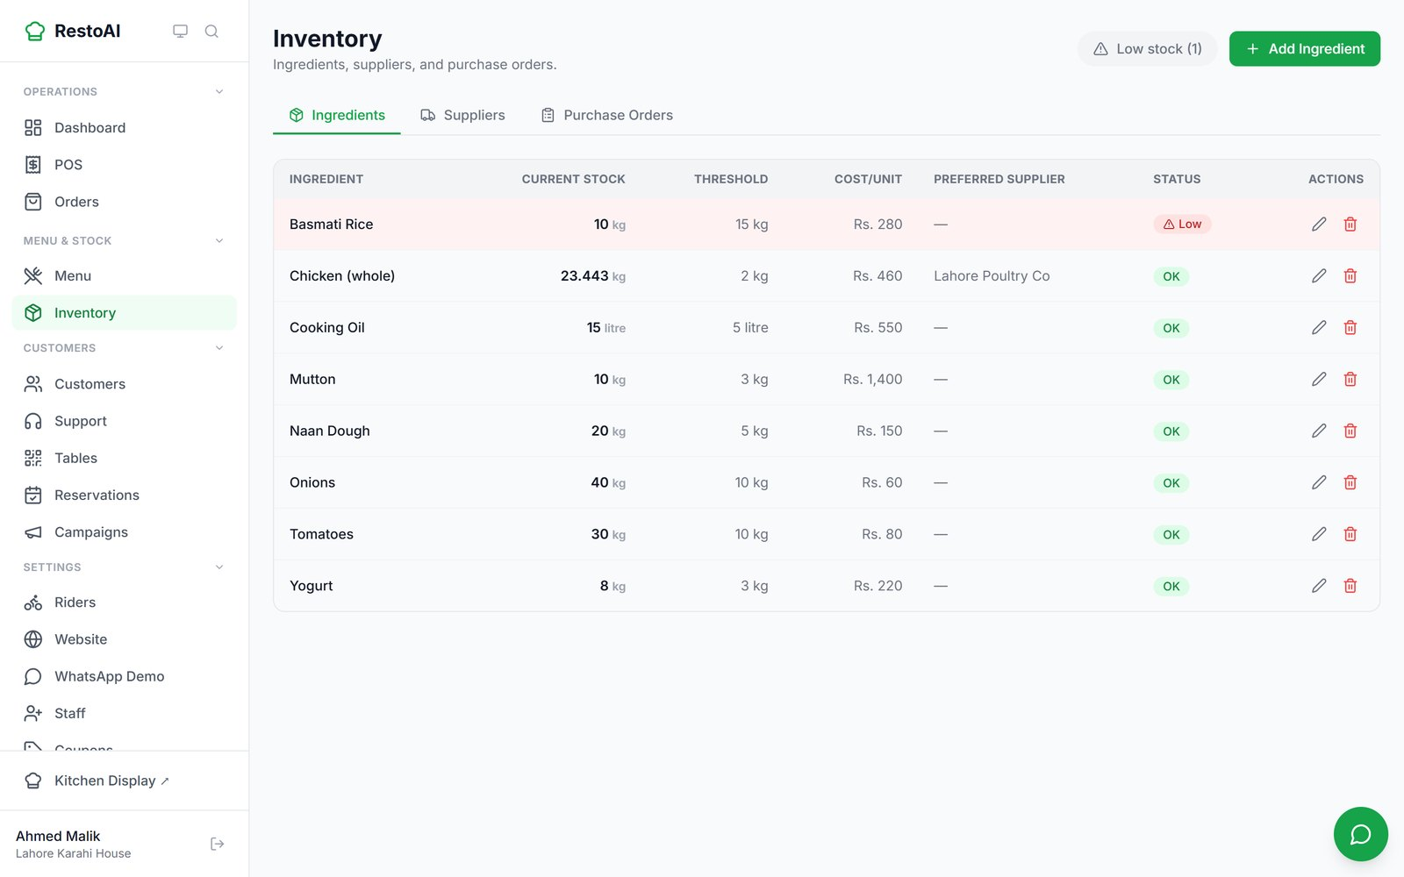
Figure 26. Ingredients. Basmati Rice is below its 15 kg threshold and marked Low.
- Add Ingredient: name, unit, current stock, threshold, cost per unit, preferred supplier.
- Low stock (n) button: show only ingredients below their threshold.
- Pencil icon on a row: edit or restock (staff can restock by default; only owners and managers can add or delete ingredients).
- Suppliers tab: keep supplier names and phone numbers.
- Purchase Orders tab: create an order to a supplier; when the goods arrive click Mark Received and the stock is added automatically.

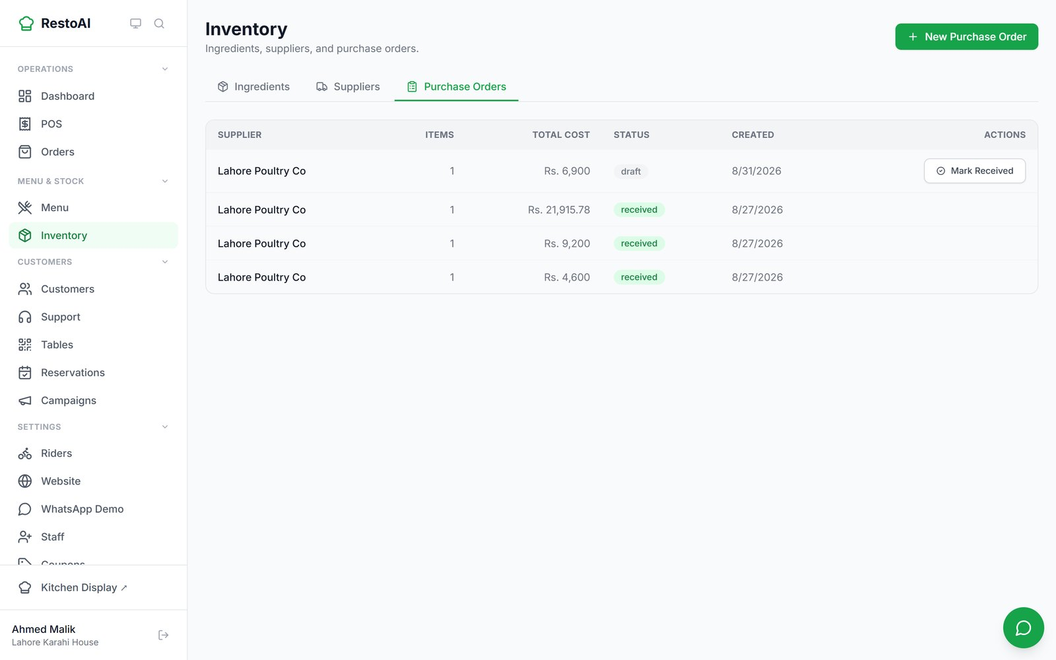
Figure 27. The Purchase Orders tab. Draft orders have a Mark Received button.
The Replenishment helper (3.15) watches stock against sales and suggests purchase orders before you run out; it never orders anything without your approval.

3.9 Customers (CRM)
Every customer who orders is saved automatically with their phone number. The Customers page lets you search them, tag them and see their history.
- Go to Customers and search by name or phone.
- Click a customer to open their profile: number of orders, total spent, loyalty points, tags and full order history.
- Type a tag (for example "vip") in the tag box and press Enter to add it; click the × on a tag to remove it.

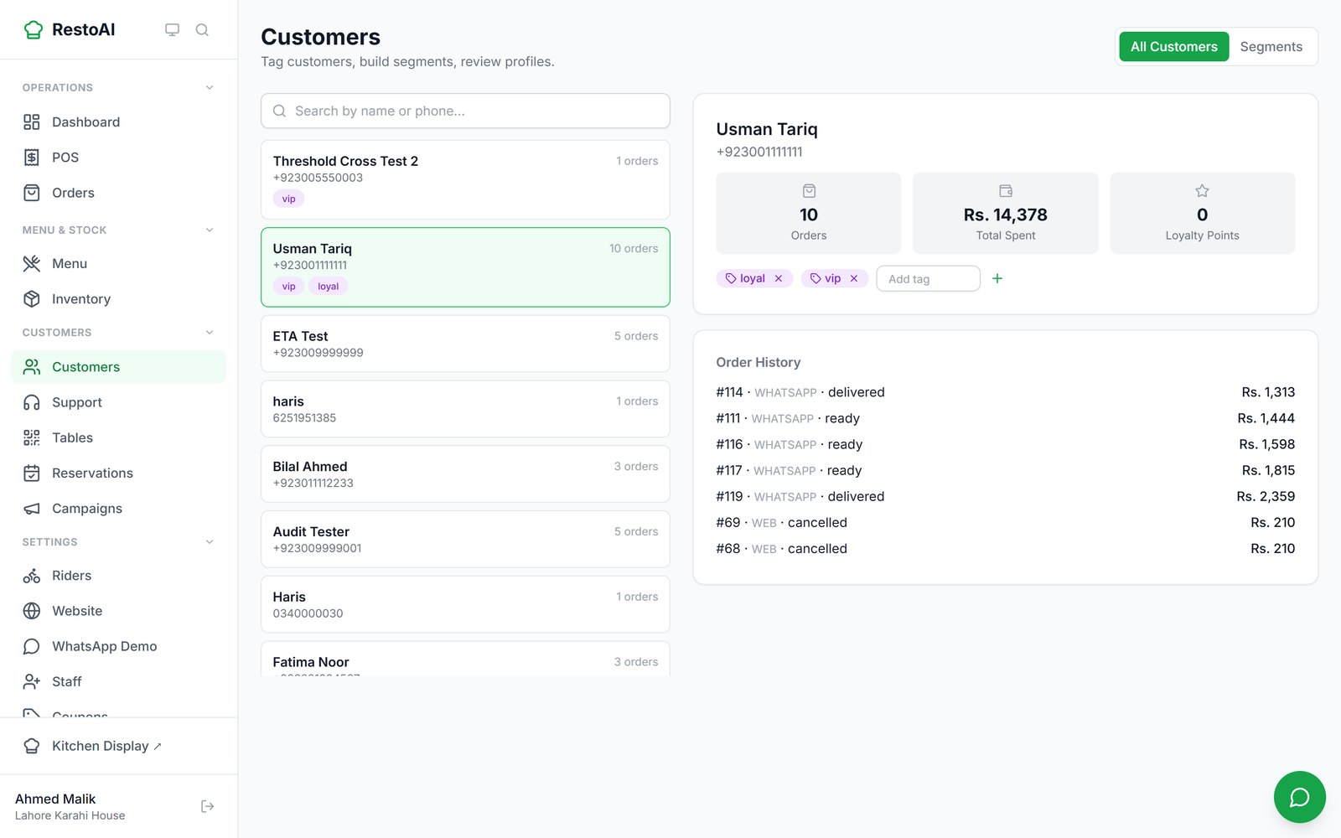
Figure 28. A customer profile: 10 orders, Rs. 14,378 spent, tagged "loyal" and "vip".

Segments and RFM
The Segments tab groups customers automatically by RFM (how Recently they ordered, how Frequently, and how much Money they spend) into groups such as Champions, Loyal customers, Recent/promising, Needs attention, About to sleep, Cannot lose them and Lost. You can also build your own saved segments (for example "Frequent (5+ orders)" or "VIP tag") with New Segment, and check who is in them with Preview Matches.
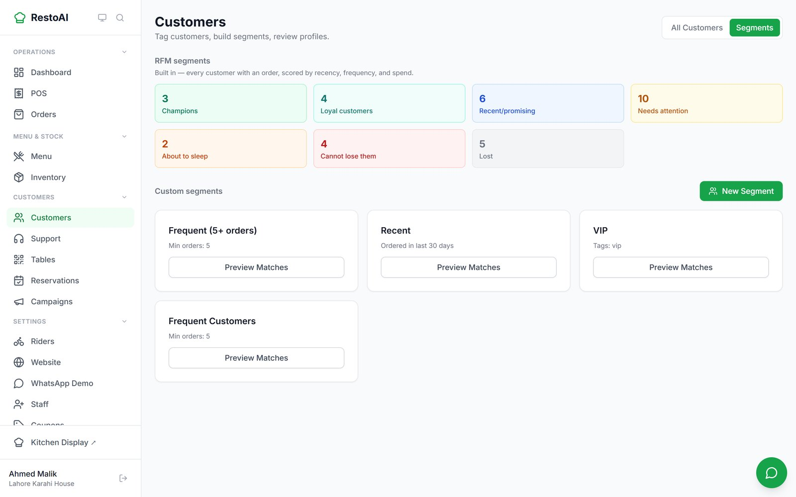
Figure 29. RFM segments and custom segments. These groups can be used as campaign recipients (3.11).

3.10 Coupons and referral codes
The Coupons page lists every discount code: the ones you create, plus codes created automatically by the Win-Back helper (starting SAVE- or THANKS-) and referral codes (starting REFER-).

Create a coupon
- Click New Coupon.
- Enter a Code (or leave it blank to generate one) and choose the Type: Percent off, Fixed amount (PKR), Free delivery, or Buy one get one.
- Set the Value, and optionally a Max discount cap, Minimum order amount, Max total redemptions, an Expires date, and First order only.
- Click Create Coupon. Customers type the code in the coupon box at checkout (6.1), or mention it on WhatsApp.

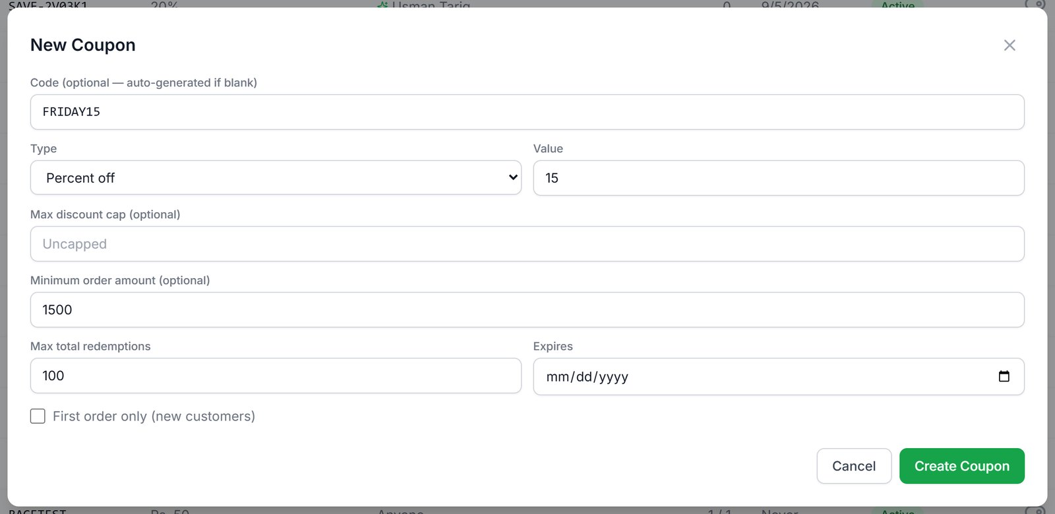
Figure 30. Creating FRIDAY15: 15% off orders over Rs. 1,500, up to 100 uses.
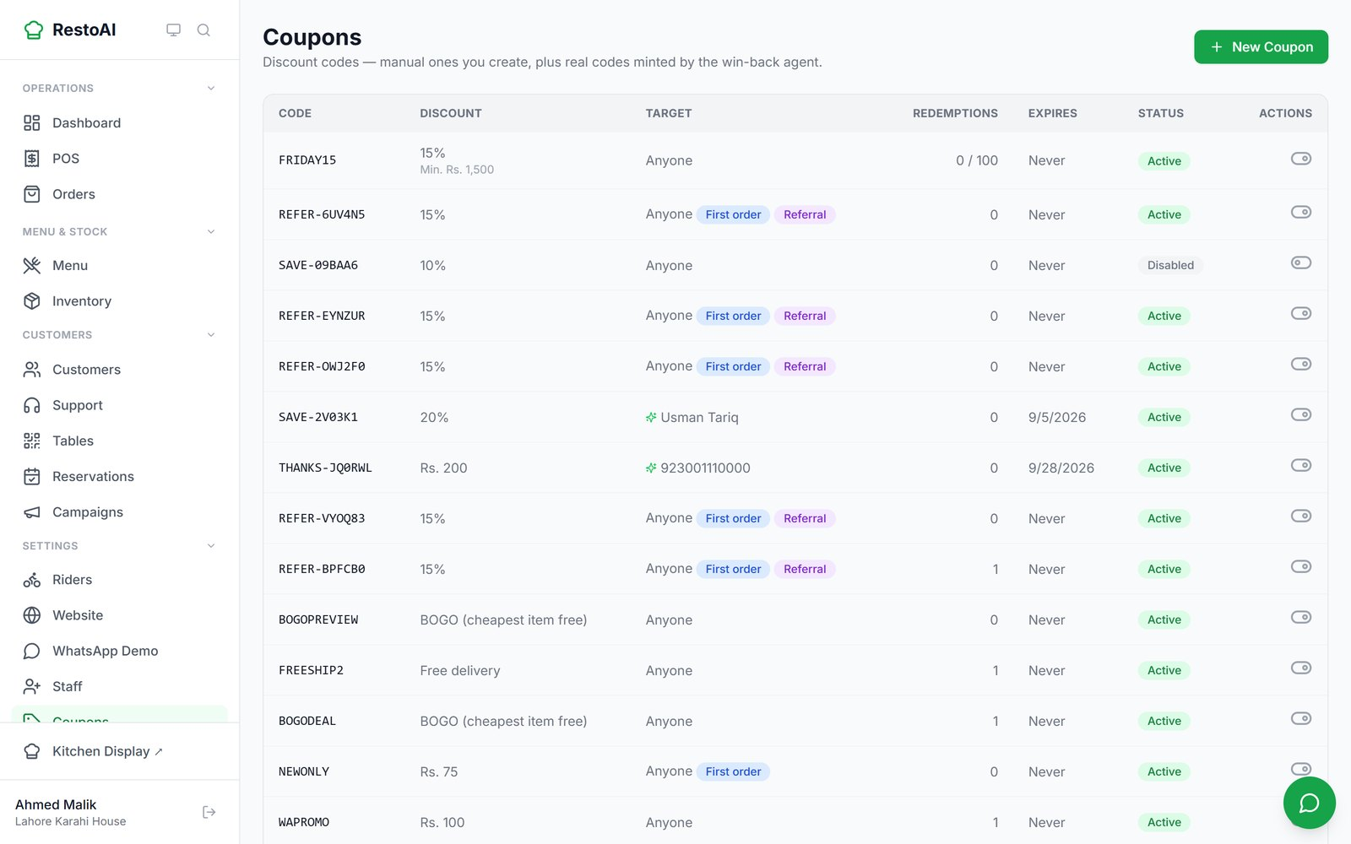
Figure 31. The new coupon at the top of the list. The switch on the right turns a coupon on or off.

Referral programme
Each customer gets a personal referral code on their order tracking page (see 6.1). A friend who uses it gets a discount on their first order, and the customer earns a reward once the friend's order is delivered. Referral codes appear in the Coupons list with First order and Referral labels. There is no separate referral settings page.

3.11 Campaigns (WhatsApp broadcasts)
Campaigns send one WhatsApp message to many customers, for example a weekend offer.
- Click New Campaign, give it a name and write the message. Use {{name}} to insert each customer's name; the preview shows how it will look.
- Click Create Campaign. It is saved as a draft.
- Click Add Recipients on the draft and choose All customers, A saved segment, or An RFM segment (3.9).
- Click Send. The campaign card shows how many were sent.
- Click the eye icon on a sent campaign to see total recipients, sent, failed and pending.

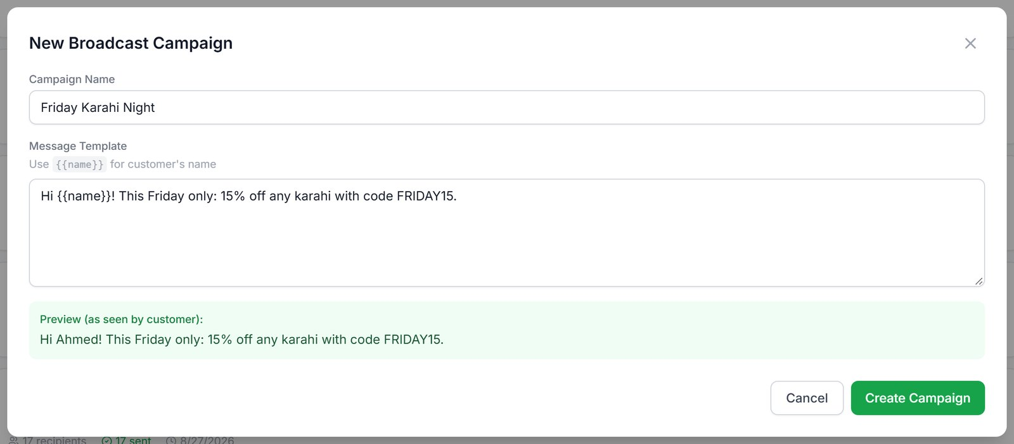
Figure 32. Writing a campaign with a live preview.
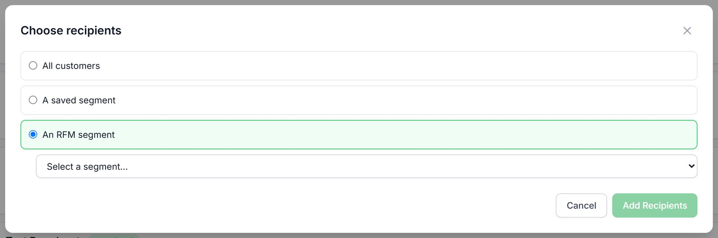
Figure 33. Choosing recipients: all customers, a saved segment, or an RFM segment (cropped).
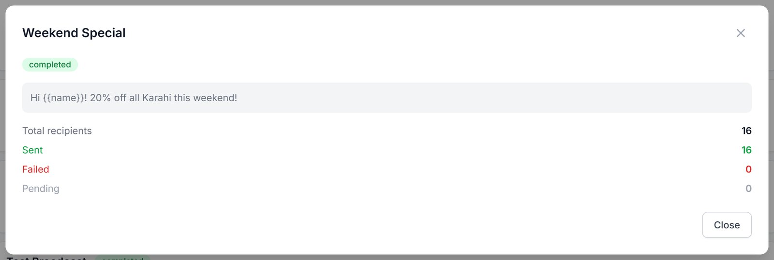
Figure 34. Results of a sent campaign (cropped).
Important: Messages are only delivered to customers' phones once your WhatsApp number is connected (3.17). Only send offers to customers who expect to hear from you.

3.12 Reservations
Table bookings made on your website (6.4) or over WhatsApp appear here, one day at a time. Use the arrows or the date box to change the day.
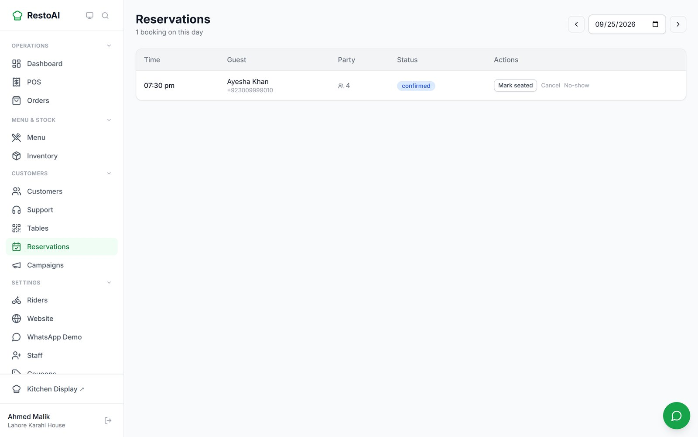
Figure 35. The reservations for 25 September: Ayesha Khan, party of 4 at 7:30 pm, confirmed.
For each booking choose Mark seated when the guests arrive, No show if they do not come, or Cancel. Cancelling sends the guest a WhatsApp message with the date and time.

3.13 Support tickets
When a customer on WhatsApp raises a problem rather than an order, the Customer Support helper (8.9) handles it. Routine questions are answered from your real data; complaints and upset customers are always escalated to a person. This page is where your team picks those up.
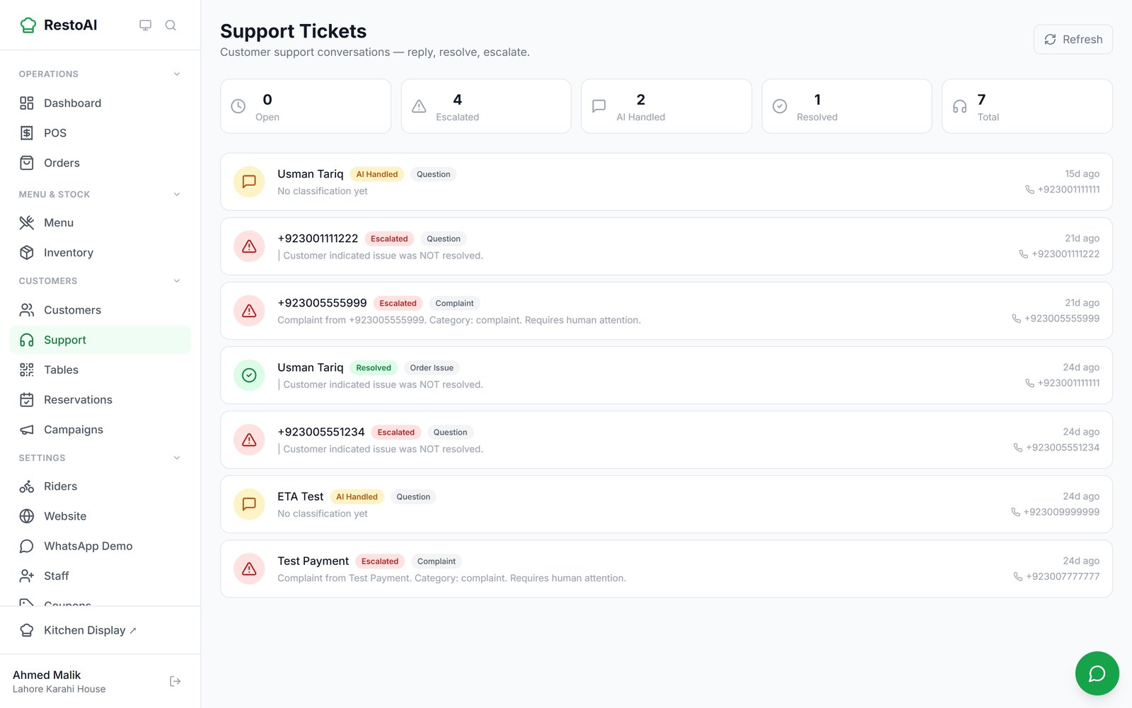
Figure 36. Support tickets, with counts of open, escalated, AI-handled and resolved tickets.
- Click a ticket to see the whole conversation, the AI's classification and a suggested resolution.
- Type in Type a reply to send via WhatsApp… and send; the customer gets it on WhatsApp.
- Click Resolve when the issue is sorted. A ticket is never closed silently.

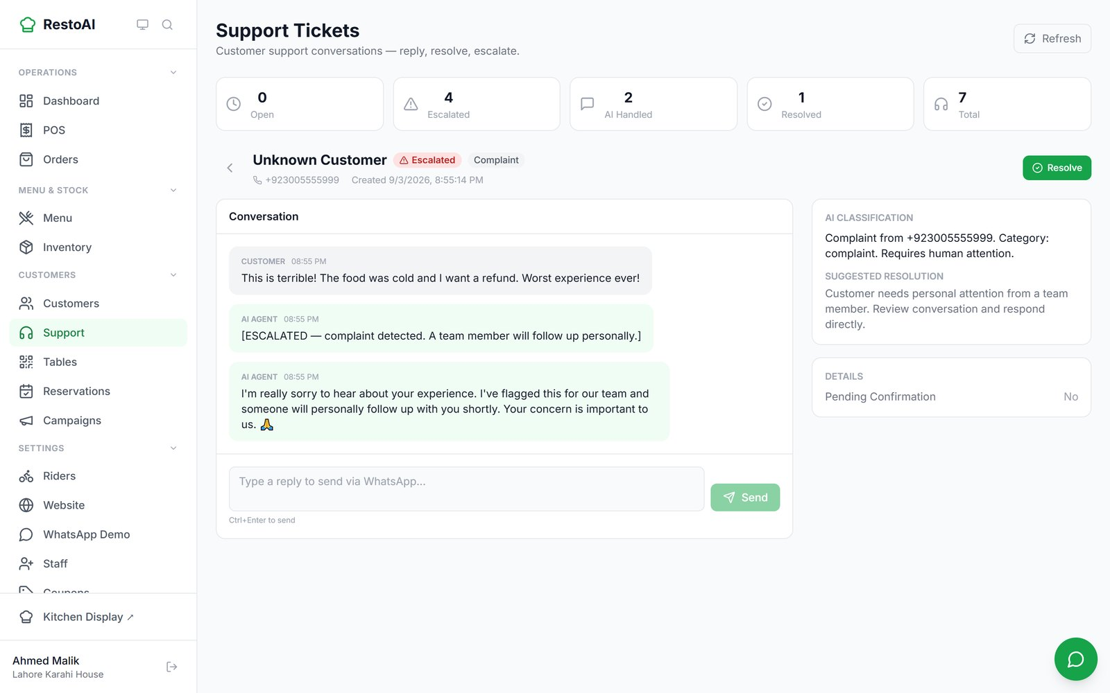
Figure 37. An escalated complaint: the AI apologised, promised a person would follow up, and flagged it for staff.
Known issue: While a customer has an open support ticket, every new WhatsApp message from them, including a normal order, is added to that ticket instead of being treated as an order. Resolve tickets promptly so customers can order again.

3.14 Insights: ask your data
The Insights page has two parts: Menu Insights (recommendations from the Menu Insight helper, 8.7) and a question box where you ask about sales, orders and customers in plain English or Roman Urdu ("mujhe pichle hafte ki sales batao").
- Type a question, or click one of the suggestions.
- Click Ask. The AI Answer appears below, and the question is saved under Recent Queries.
- For each menu insight, click Mark acted on once you have made the change, or Dismiss.

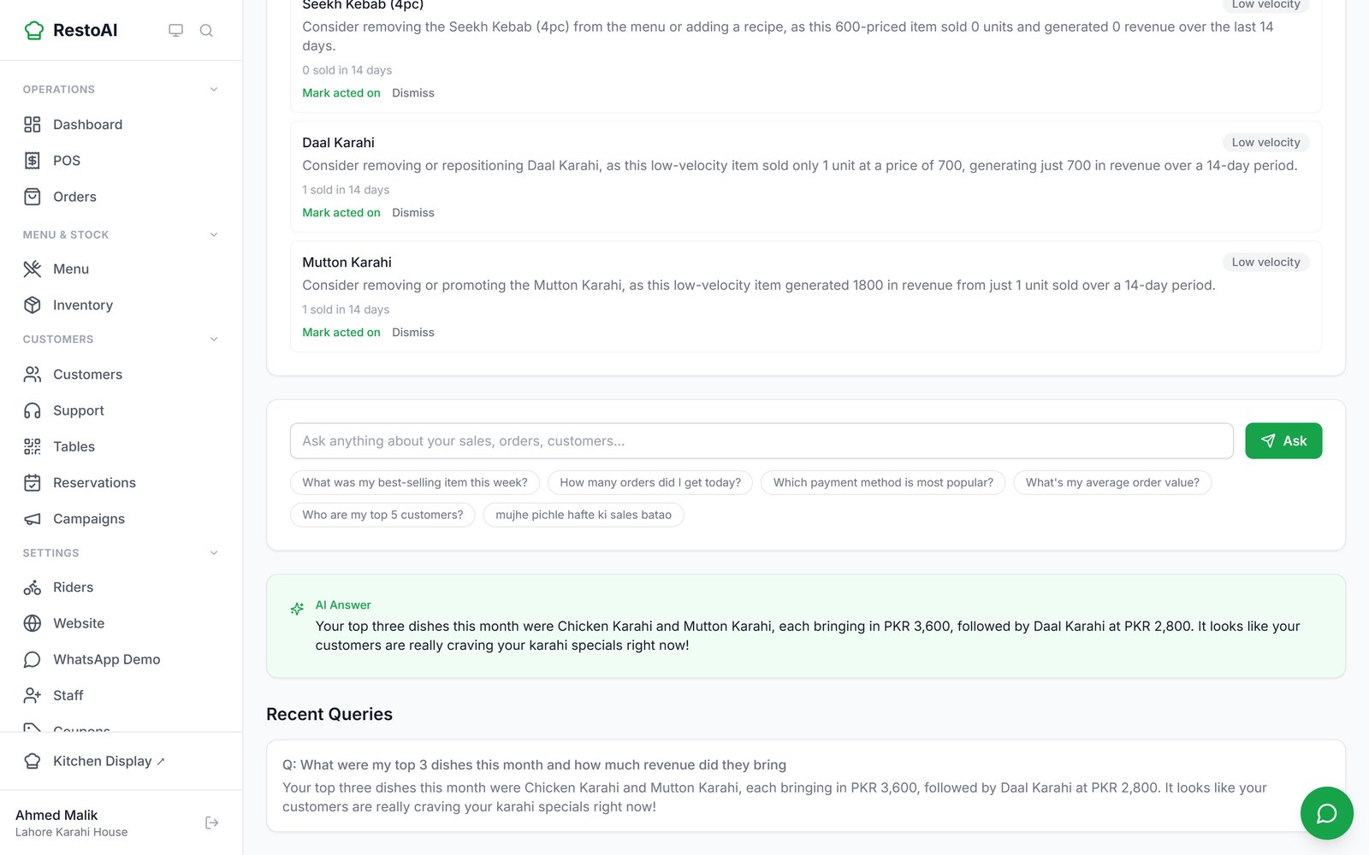
Figure 38. An answer to "What were my top 3 dishes this month and how much revenue did they bring".
Important: Treat AI answers as a quick guide and check important numbers on the Dashboard. In testing, the answer above did not match the Dashboard's own "This month" top-item figures.
Known issue: typing a question mark (?) in this box opens the quick-navigation window instead. Leave the "?" off your question for now.

3.15 AI Agents page
The AI Agents page is the control room for the helpers that run in the background (Chapter 8 explains each one). The tiles at the top show each helper's status and how many items it has found.
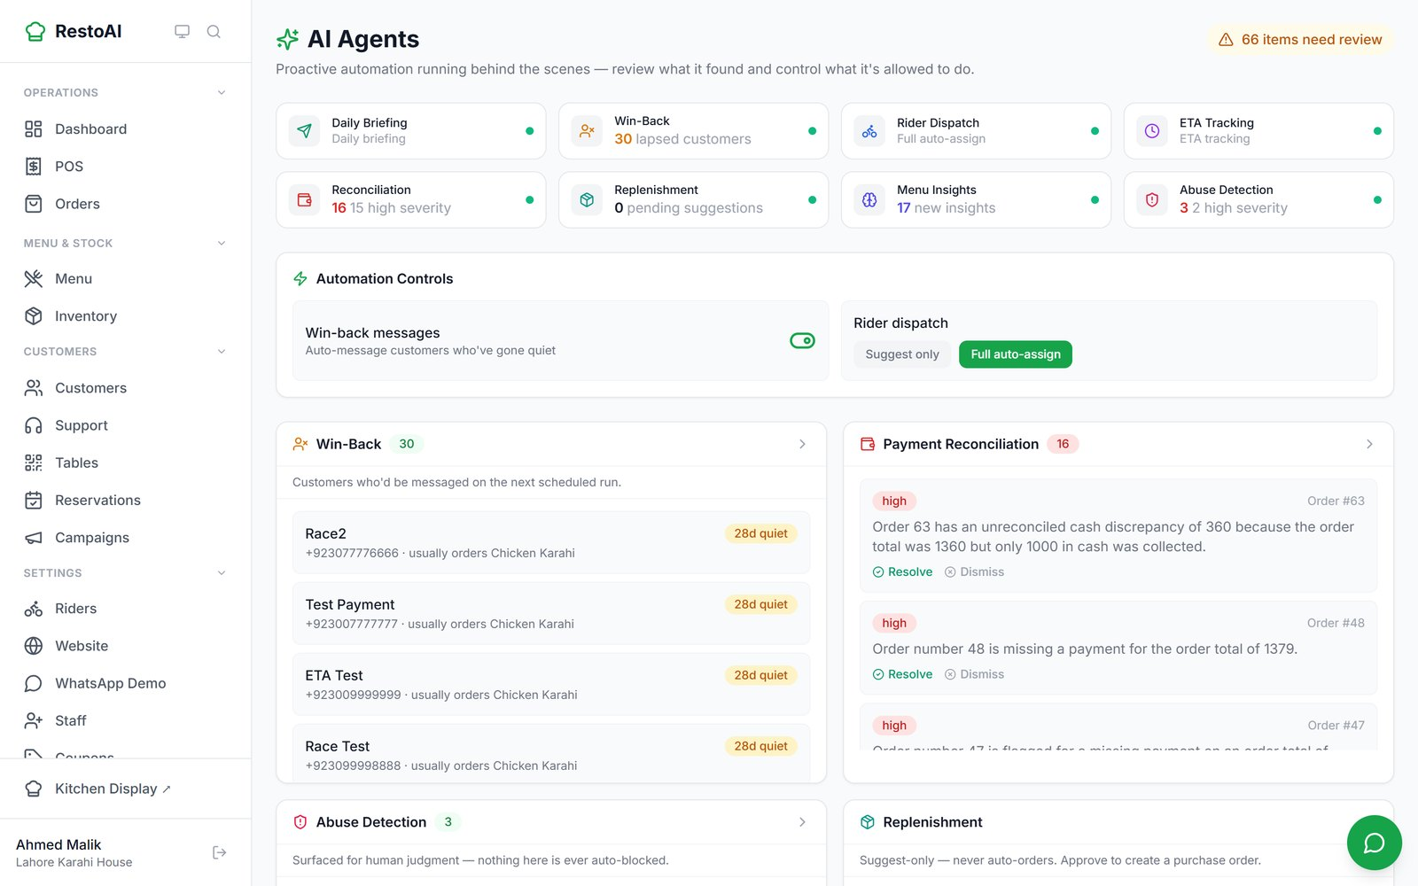
Figure 39. AI Agents: status tiles, automation controls, and lists of findings to review.
- Automation Controls: switch Win-back messages on or off, and choose Rider dispatch: Suggest only or Full auto-assign.
- Win-Back: customers who will be messaged on the next scheduled run.
- Payment Reconciliation: orders where payment or cash does not add up. Click Resolve or Dismiss.
- Abuse Detection: suspicious patterns for a person to judge. Click Confirm or False positive. Nothing is blocked automatically.
- Replenishment: purchase-order suggestions. Nothing is ordered until you Approve.
- Menu Insights: pricing and menu recommendations.

Note: The helpers run on a schedule (see Chapter 8). There is no "run now" button on this page.

3.16 Your restaurant website
RestoAI builds a simple website for your restaurant with an Order Now button that leads to your online menu, and a Book a Table button.
- Go to Website and pick one of five templates: Classic Warm, Modern Minimal, Family & Casual, Fine Dining, Fast & Casual. The Live Preview on the right updates immediately.
- Choose your Subdomain (your address), and an Accent Color.
- Fill in the sections: Hero (headline, subheadline, image), Our Story, Gallery, Hours & Location, Testimonials (write your own or show real customer reviews) and Contact.
- Click Save draft to save without publishing, or publish it. View live opens the public site; Unpublish takes it offline.

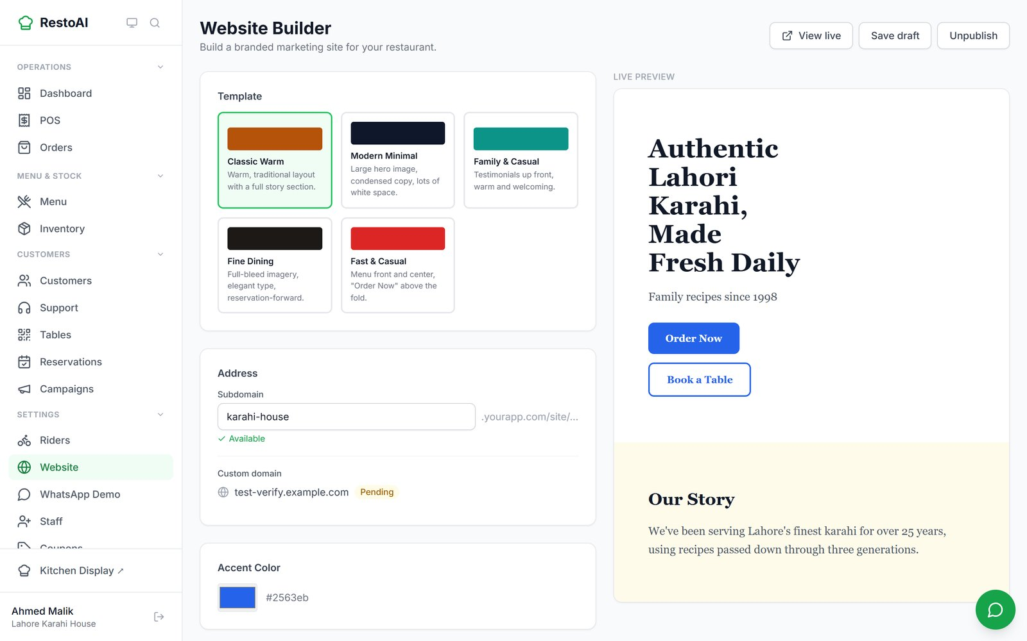
Figure 40. The Website Builder with the Classic Warm template selected.
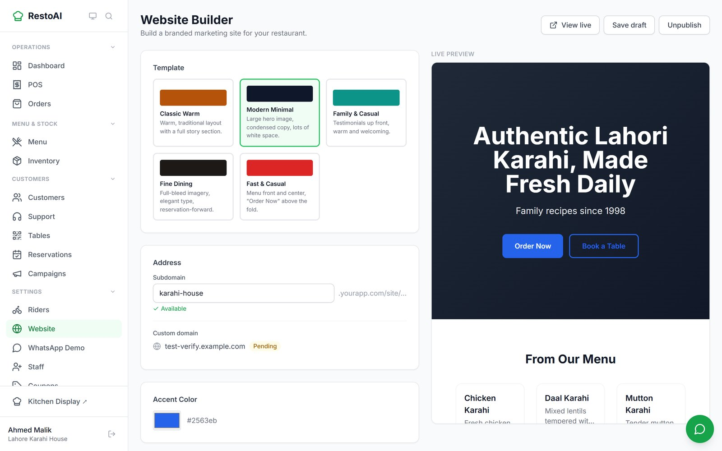
Figure 41. Previewing the Modern Minimal template before saving.
Known issue: At the time of writing, the published website crashes for visitors with "Something went wrong" (checked on 24 September 2026, on both the test setup and the live service). The Website Builder's Live Preview above shows the same design correctly. Until this is fixed, send customers your online menu link instead of the website link.

Note: A custom domain (your own .com or .pk) can be entered but shows "Pending"; connecting custom domains is not available yet. Use the RestoAI subdomain.

3.17 Connecting your WhatsApp number
To let customers order on your own WhatsApp number, and to send order updates and campaigns from it, connect the number on the WhatsApp Connect page (owners and managers).
- Go to WhatsApp Connect and click Connect WhatsApp.
- Answer Do you already use this number on WhatsApp? RestoAI shows what you need to do before continuing.
- For a new number, continue into Meta's own sign-up window and follow its steps (choose your business, verify the number by SMS or call).
- When it finishes, the connection status changes from "Not connected". Click Refresh if it does not update.

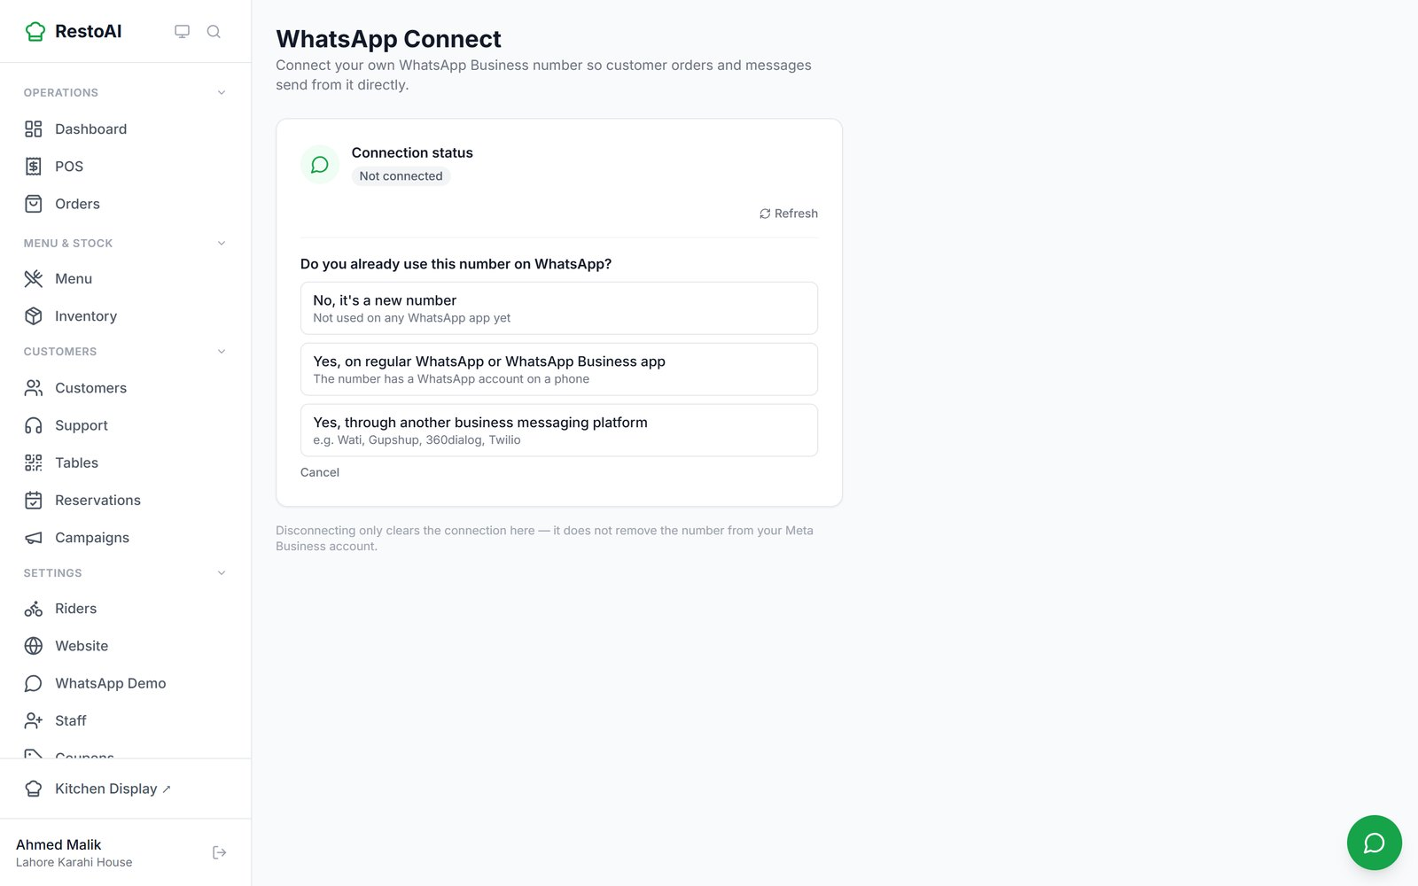
Figure 42. The pre-check question shown before Meta's sign-up starts.
Your answer | What RestoAI tells you
No, it's a new number | Continue straight to Meta's sign-up.
Yes, on regular WhatsApp or WhatsApp Business app | Meta only accepts a number that no longer has a WhatsApp account on a phone. First (optionally) back up chats, then delete the WhatsApp account on that phone (Settings → Account → Delete my account). Keep the SIM active for the verification code. Your number and customers' saved contact stay the same; chat history does not move over. Then click I've deleted it, continue.
Yes, through another business messaging platform (e.g. Wati, Gupshup, 360dialog, Twilio) | This needs an assisted migration; the Connect button cannot do it. Email support@restoai.app to plan the move. Do not cancel your current provider until it is finished. You keep your templates, quality rating and limits.

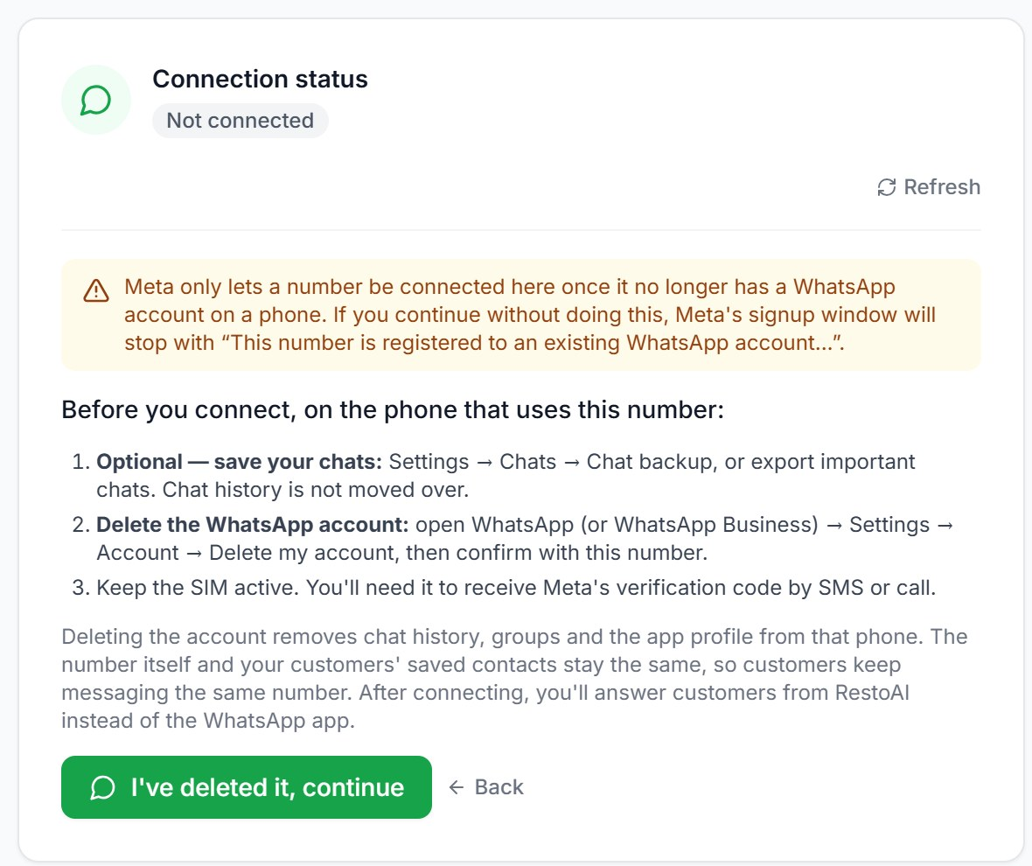  Number already on WhatsApp | 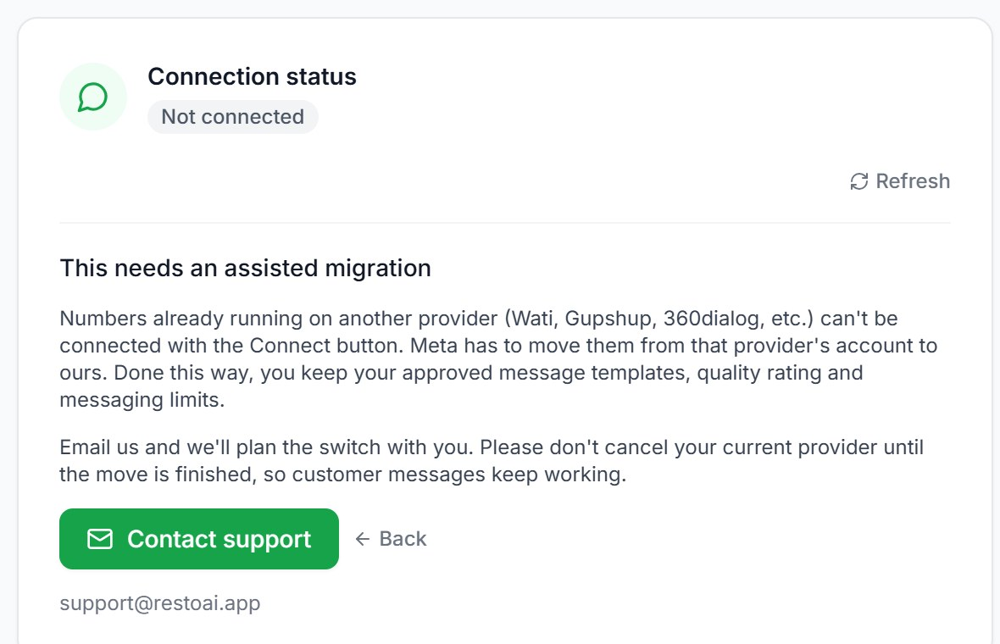  Number on another provider
Figure 43. The guidance shown for each "yes" answer (cropped).
Note: Meta's sign-up window and the "Connected" status could not be captured for this manual because the demo restaurant has no number connected.

3.18 Staff and permissions

Invite a manager or staff member
- Go to Staff and click Invite Staff.
- Enter their email address, optionally their phone (the invite is then also sent on WhatsApp), the role (Staff or Manager) and, if needed, a branch.
- Click Send Invite. A link appears; click Copy and send it to them. The invite is listed as pending.
- They open the link, enter their name and choose a password (Create account), then sign in on the normal sign-in page.

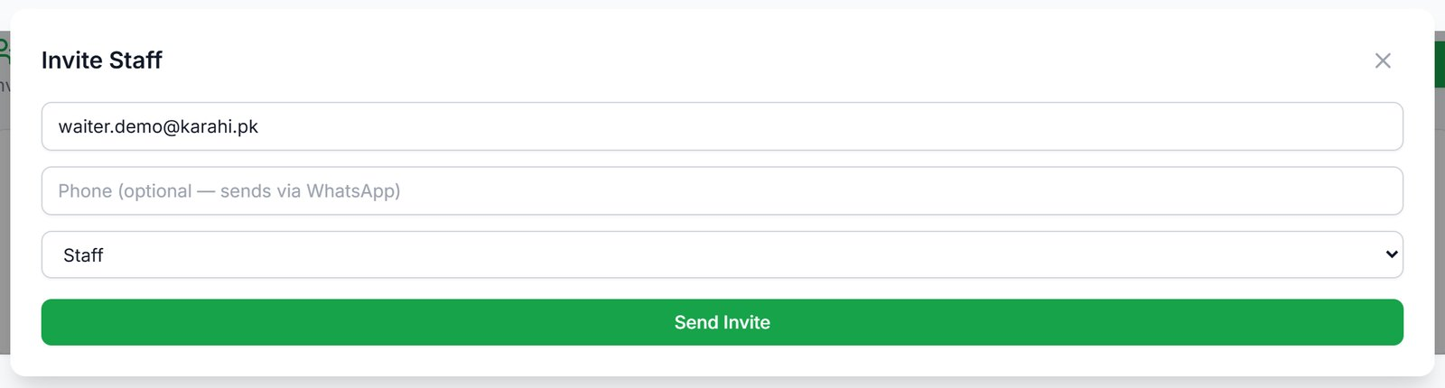
Figure 44. The Invite Staff form.
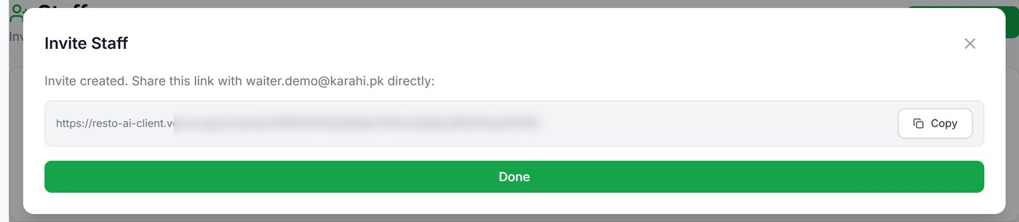
Figure 45. The invite link to copy and send (blurred on purpose; cropped).
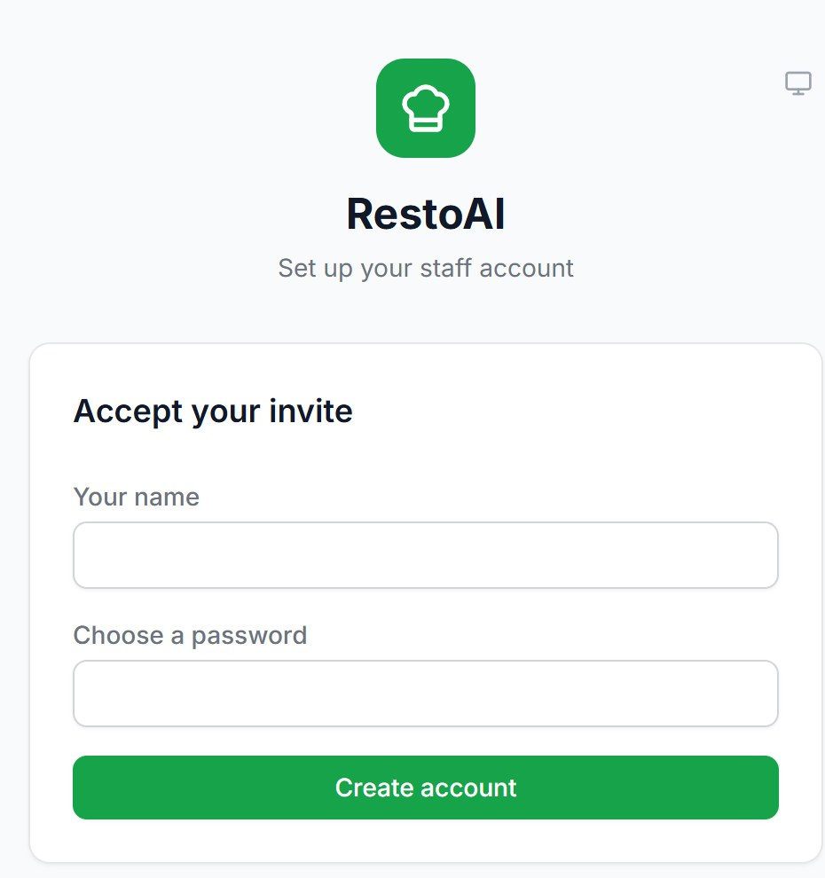
Figure 46. What the invitee sees when they open the link (cropped).
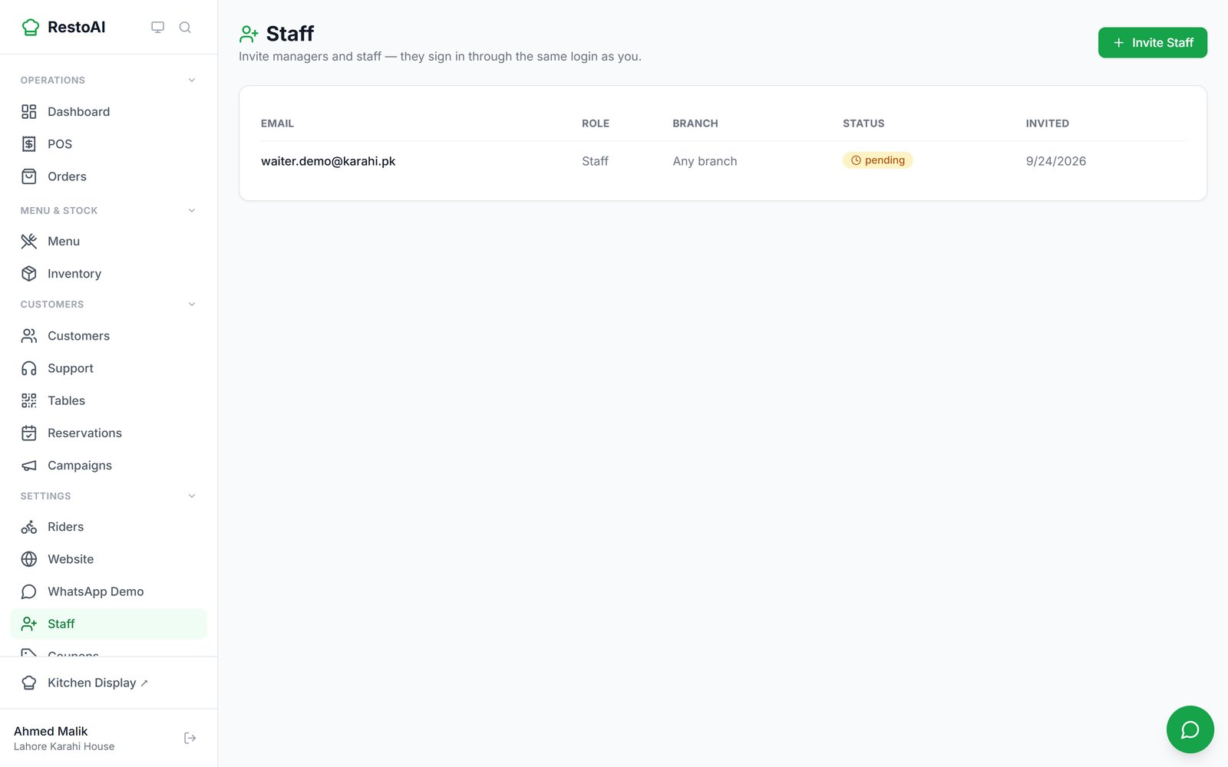
Figure 47. The pending invite on the Staff page.
Important: The Staff page lists invites, not staff accounts. Accounts created any other way (for example the demo restaurant's existing staff and managers) do not appear anywhere in the app, and there is no screen to remove a staff account. Keep a note of who has access.

Staff Permissions (owner only)
The Permissions page decides what Managers and Staff can do. The owner always has full access. Tick or untick a box and click Save Changes.
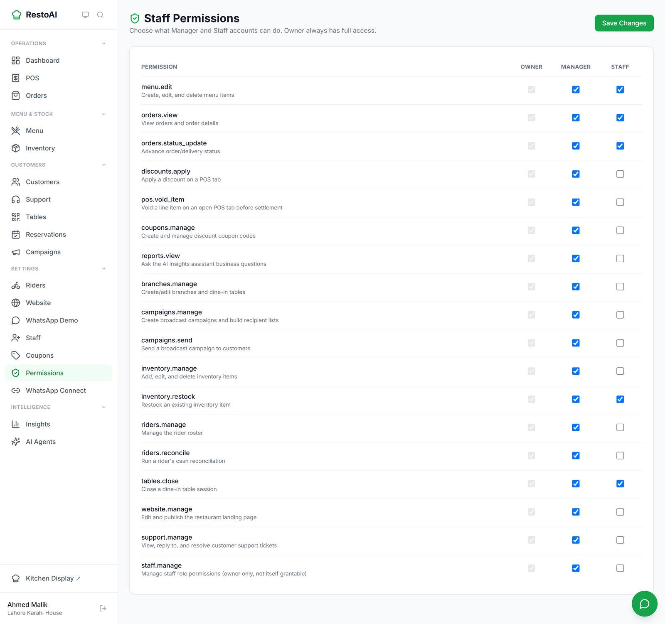
Figure 48. The permission matrix.
Permission | What it allows | Manager | Staff
menu.edit | Create, edit and delete menu items | Yes | Yes
orders.view | View orders and order details | Yes | Yes
orders.status_update | Advance order/delivery status | Yes | Yes
discounts.apply | Apply a discount on a POS tab (also needed for refunds) | Yes | No
pos.void_item | Void a line item on an open POS tab | Yes | No
coupons.manage | Create and manage coupons | Yes | No
reports.view | Ask the AI insights assistant business questions | Yes | No
branches.manage | Create/edit branches and dine-in tables | Yes | No
campaigns.manage / campaigns.send | Create and send broadcast campaigns | Yes | No
inventory.manage | Add, edit and delete inventory items | Yes | No
inventory.restock | Restock an existing item | Yes | Yes
riders.manage / riders.reconcile | Manage riders; run cash reconciliation | Yes | No
tables.close | Close a dine-in table session | Yes | Yes
website.manage | Edit and publish the website | Yes | No
support.manage | View, reply to and resolve support tickets | Yes | No

The table shows the settings of the demo restaurant, which are the defaults.

3.19 In-store display boards
Two full-screen pages are meant for a TV in the restaurant: a token board that lists pickup and dine-in order numbers that are ready ("Ready for Pickup"), and a digital menu board with prices and sold-out items. Open them in a browser on the TV; each branch has its own address.
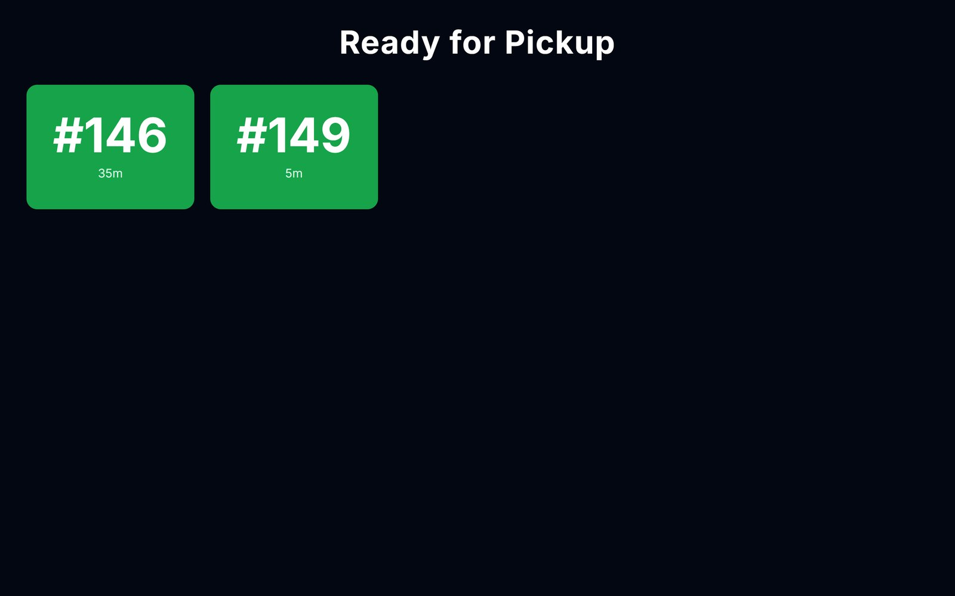
Figure 49. The token board with two orders ready.
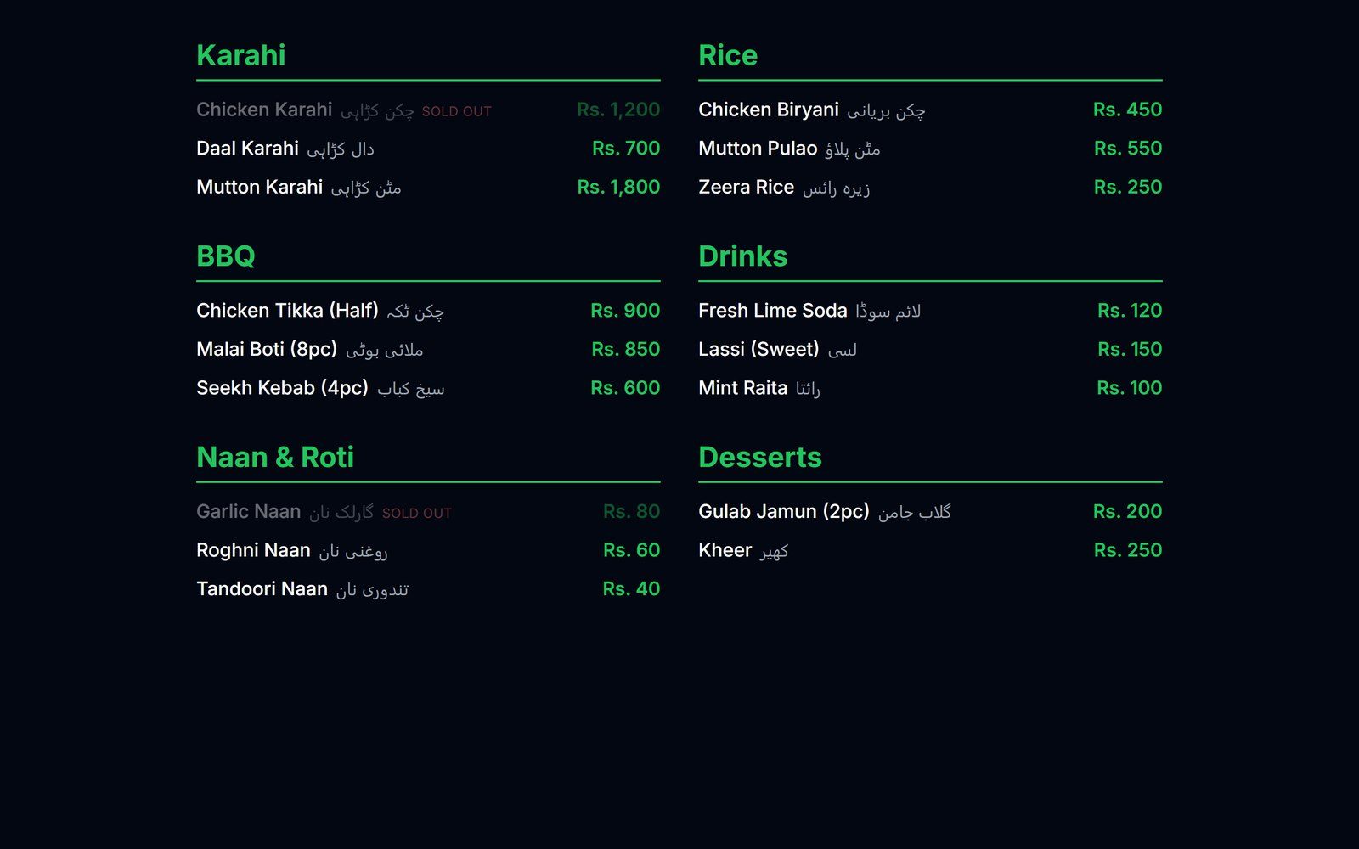
Figure 50. The digital menu board, including Urdu names and sold-out dishes.

3.20 Subscription and account status
There is currently no page in the admin app to view or change your RestoAI plan; this is handled by the RestoAI team. If your subscription lapses and the account is suspended, every sign-in (including riders) shows: "This account has been suspended. Please contact support." Access returns within about a minute of the account being reactivated.

4. Staff guide
Staff sign in on the same page as the owner (2.2) with the email and password they chose from their invite. The menu is shorter: pages the owner has not allowed are hidden. With the default permissions, staff can:
- See all orders and move them forward: Orders (3.3) and the Kitchen Display (3.4).
- Take orders and settle bills at the POS (3.5), but not give discounts, void items or refund; ask a manager.
- Edit the Menu, including marking a dish sold out (3.2).
- Restock ingredients in Inventory (3.8), but not add or delete them.
- Close a table's session after the bill is paid (3.6).

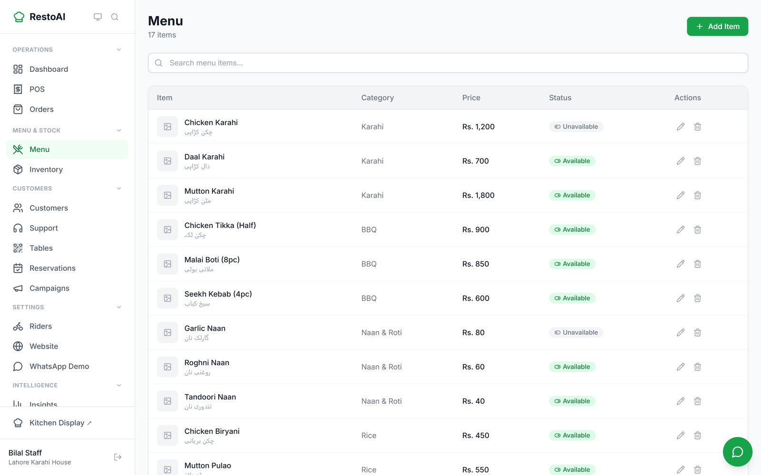
Figure 51. A staff member's view of the Menu page. Settings pages such as Staff, Coupons, Permissions and AI Agents are not in the menu.
Known issue: With default permissions the staff Dashboard shows "Failed to load dashboard", because the dashboard figures need the "reports" permission. This is expected to be replaced by a proper message; staff can go straight to Orders, POS or the Kitchen Display.
If a staff member opens a page they are not allowed to use by typing its address, most pages say "Insufficient permissions". The Coupons page instead shows "No coupons yet", which is misleading: coupons do exist, staff just cannot see them.

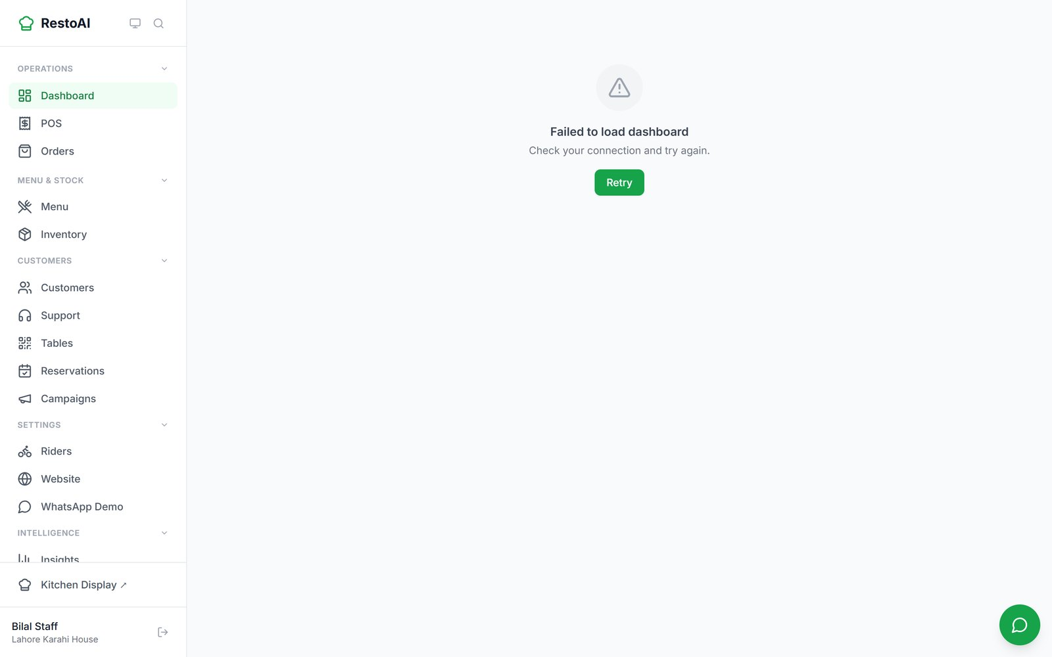
Figure 52. A staff account's Dashboard with default permissions.

4.1 Managers
Managers see the same menu as the owner except Permissions. Their Dashboard shows only the branches the owner assigned to them.
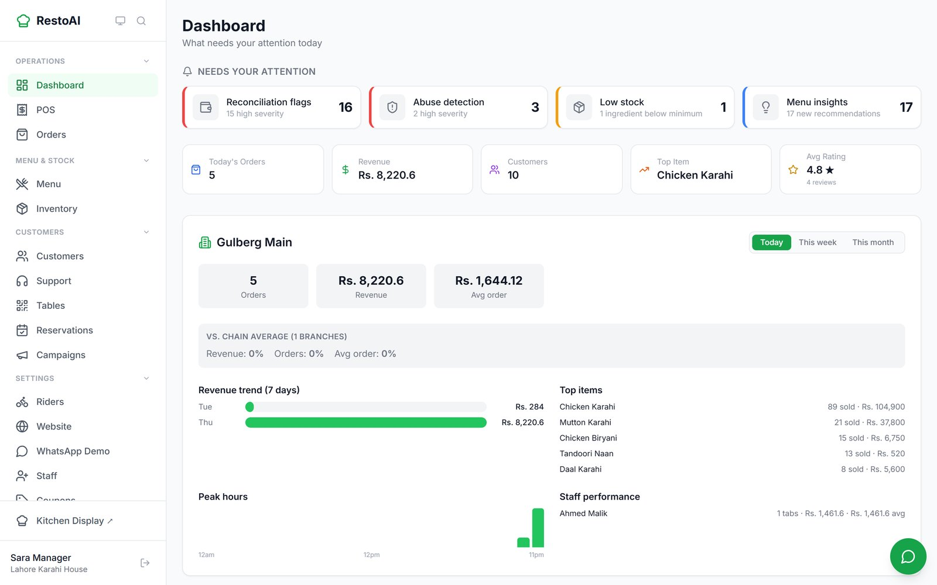
Figure 53. A manager's Dashboard. The name at the bottom left shows who is signed in.

5. Rider guide
The rider app works in the phone's web browser. There is nothing to install.

5.1 Sign in
- Open the link your restaurant gave you. (Or open the rider login page and type the Restaurant code yourself; ask your manager for it.)
- Enter your Phone number and the PIN your manager gave you, and sign in.
- Five wrong PINs lock the login for a few minutes. Ask your manager to Reset PIN if you forgot it.

5.2 Your deliveries
After signing in you see today's Cash collected and number Delivered, and Your deliveries: each order with the customer's name, phone (tap to call), address, payment method, and whether you have picked it up.

5.3 Picking up and delivering
- When you collect the food, tap Mark picked up. The customer is told their order is on its way, with your name.
- At the door, tap Mark delivered. For cash orders, check the amount collected and tap Confirm Delivered.
- The delivery moves to "Delivered today" and your cash total goes up. Hand the cash in at the end of the shift; your manager reconciles it (3.7).

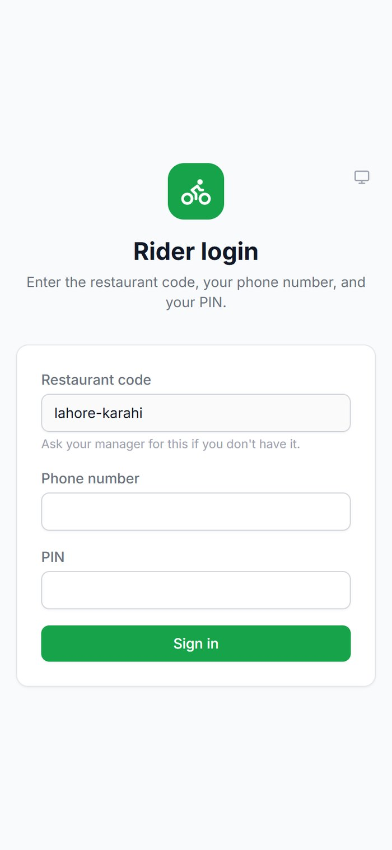  1. Sign in | 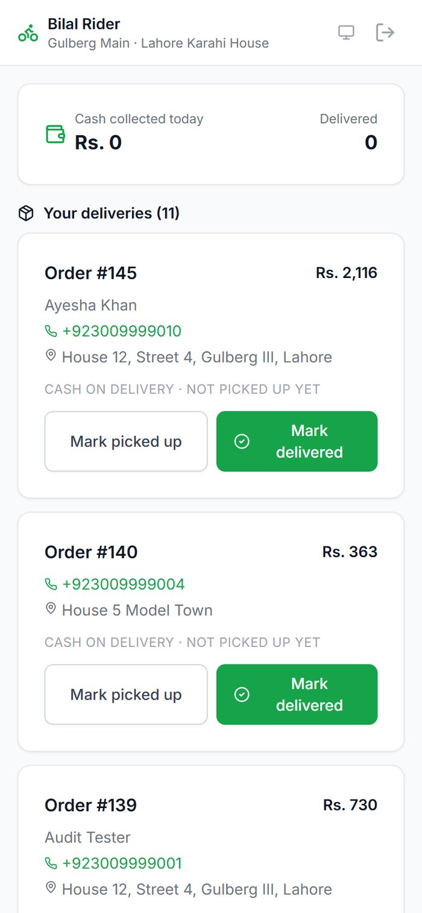  2. Your deliveries | 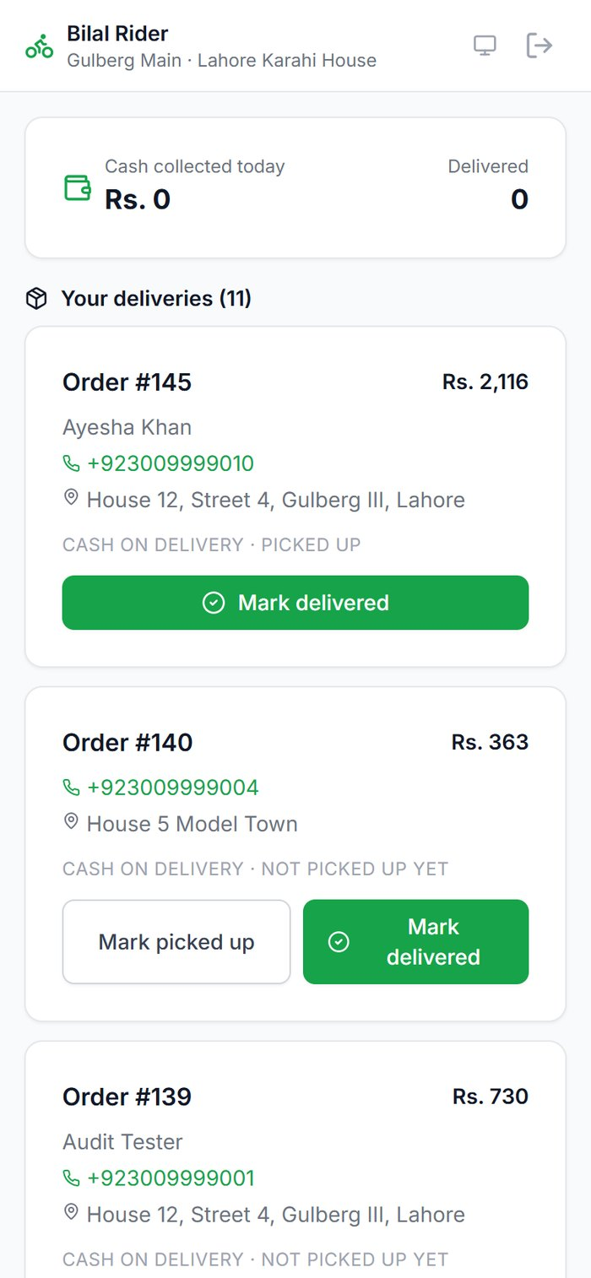  3. Picked up
Figure 54. Signing in and picking up an order.
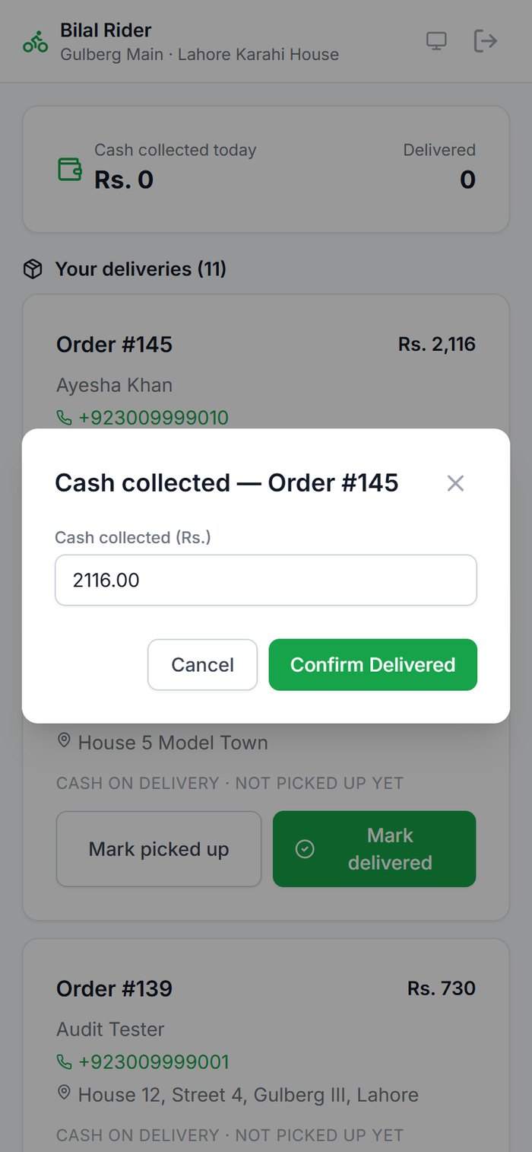  4. Confirm cash collected | 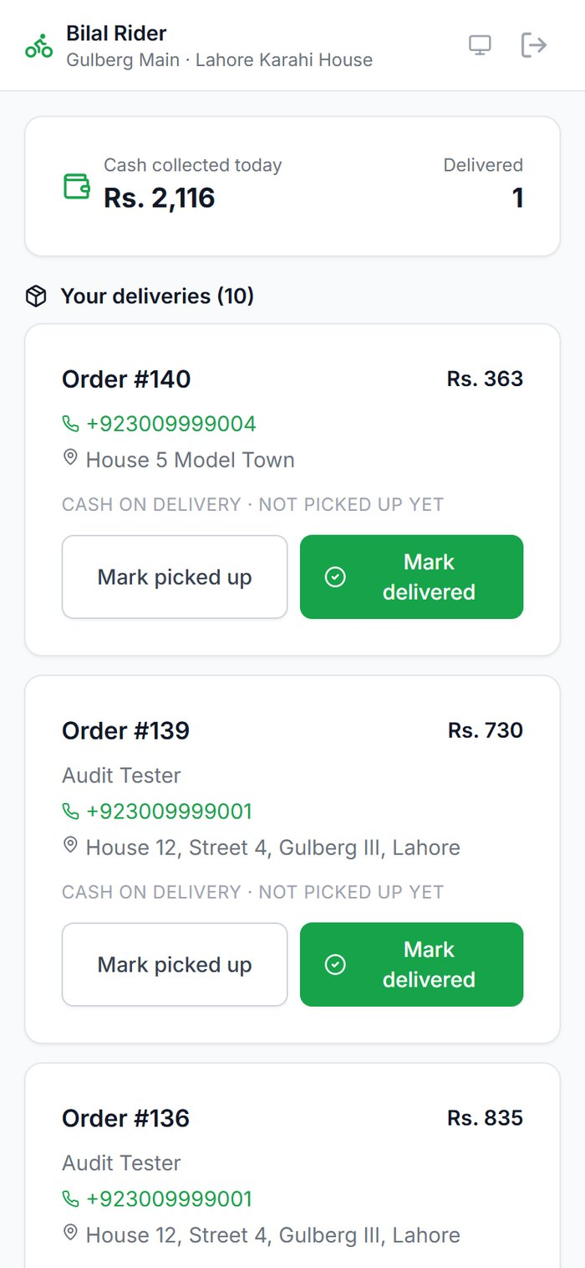  5. Delivered: cash updated
Figure 55. Delivering a cash-on-delivery order.
Note: The rider app cannot be installed like a normal app yet; keep it as a browser bookmark or a shortcut on the home screen.

6. Customer guide
This chapter shows exactly what your customers see, so you can explain it to them. Customers order in three ways: your website and online menu, the QR code on a table, or WhatsApp (Chapter 7).

6.1 Ordering on the website
- The customer opens your online menu link (or taps Order Now on your website; see the known issue in 3.16).
- They browse by category (Karahi, BBQ, Naan & Roti…) and tap Add on dishes. Sold-out dishes are greyed out. The cart total appears at the bottom.
- At Checkout they choose Delivery or Pickup, check the order (they can change quantities or remove items), and may enter a coupon code.
- They enter their name, phone number, delivery address and payment method (cash on delivery), plus an optional note for the kitchen, and place the order.

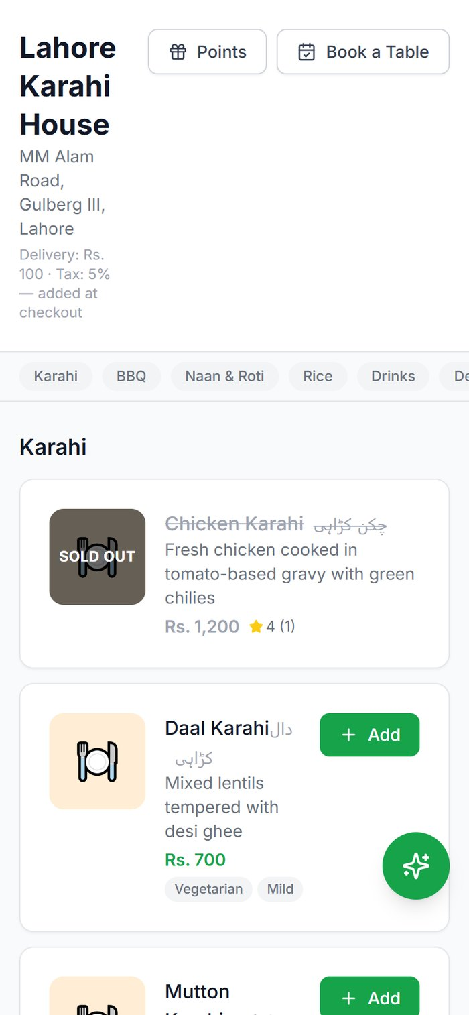  Online menu | 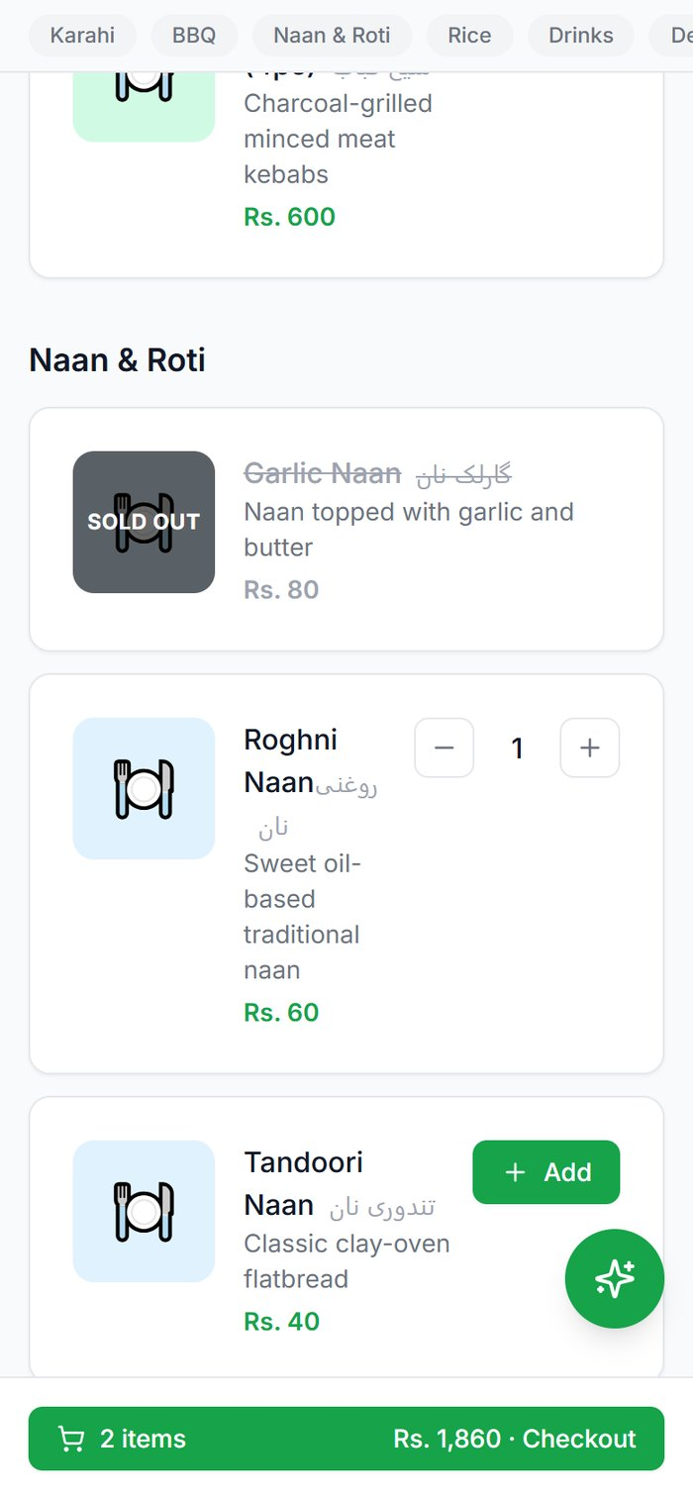  Adding dishes
Figure 56. The online menu on a phone.
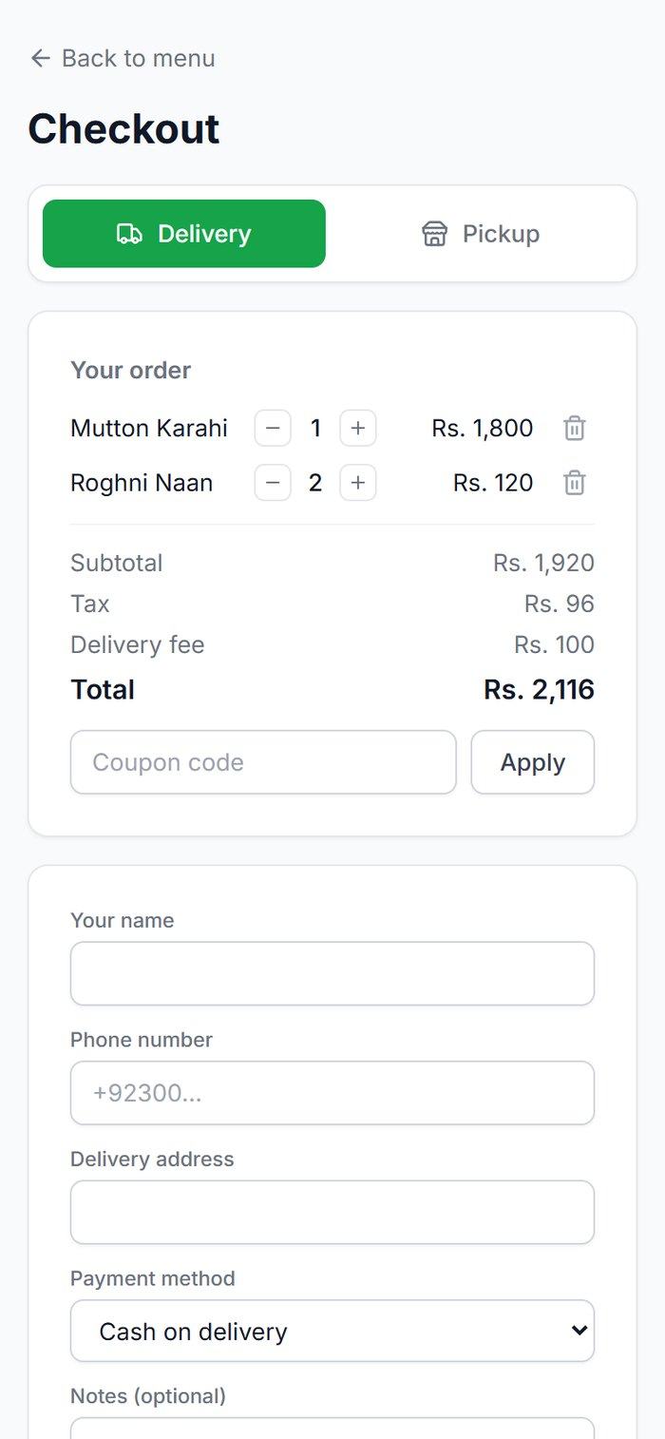  Checkout | 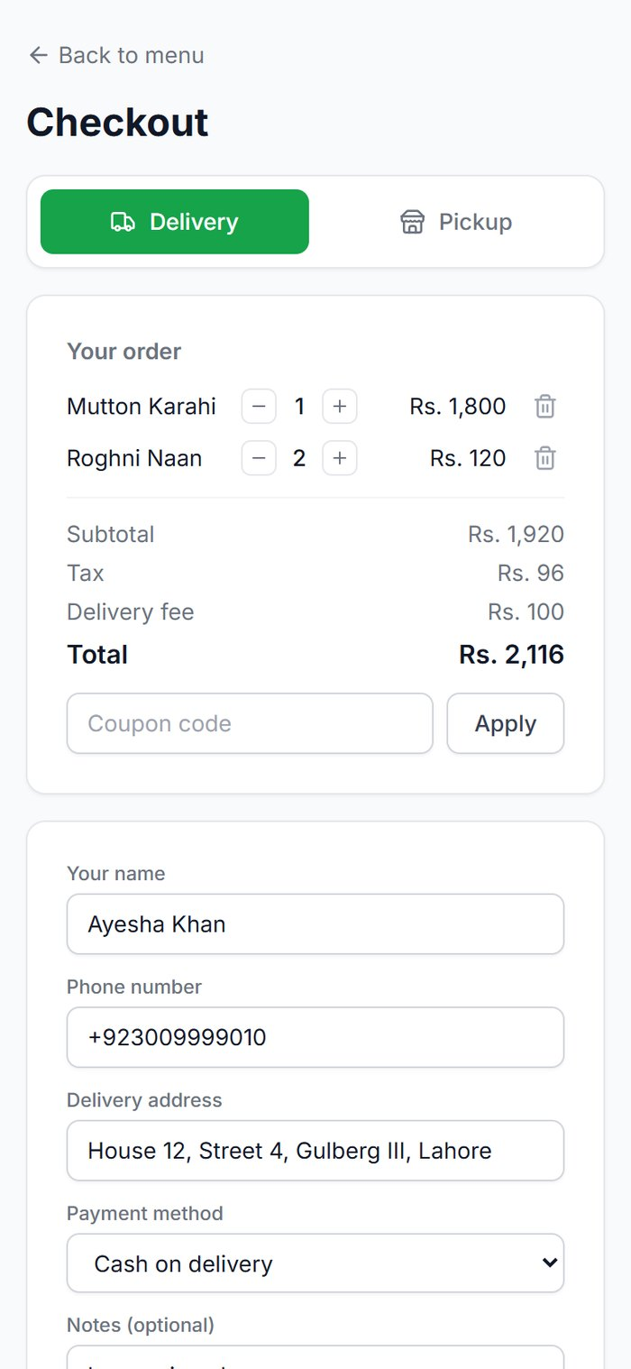  Details filled in | 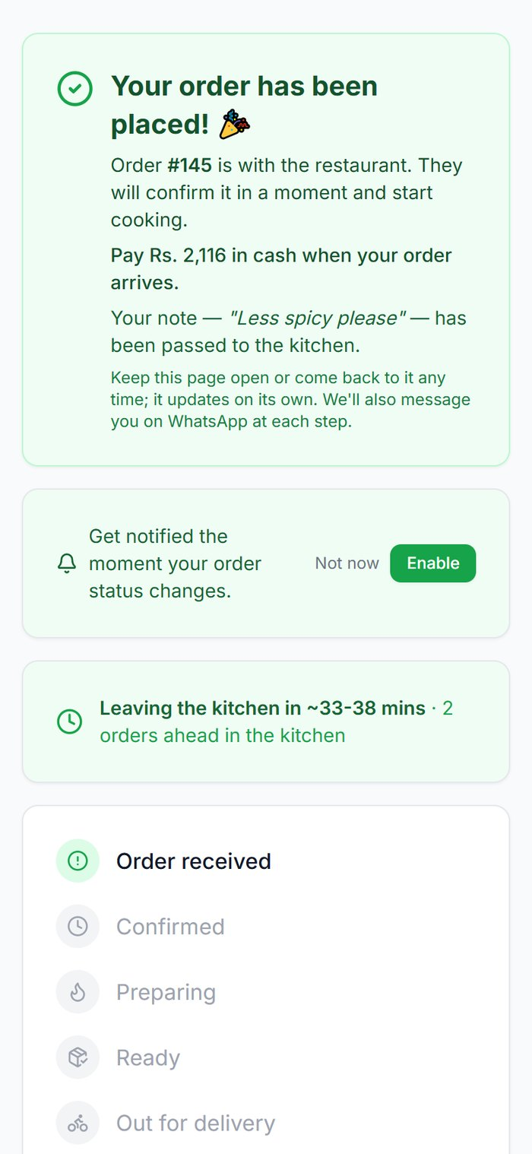  Order placed
Figure 57. Checking out: delivery fee (Rs. 100) and tax (5%) are added at checkout.
If the customer has loyalty points, checkout offers to redeem them.

6.2 Tracking an order
After ordering, the customer lands on a tracking page that updates by itself. It shows the current status, an estimated time based on how busy the kitchen is, the items, and the delivery address and note. They can tap Enable to get phone notifications, and they also receive a WhatsApp message at each step.
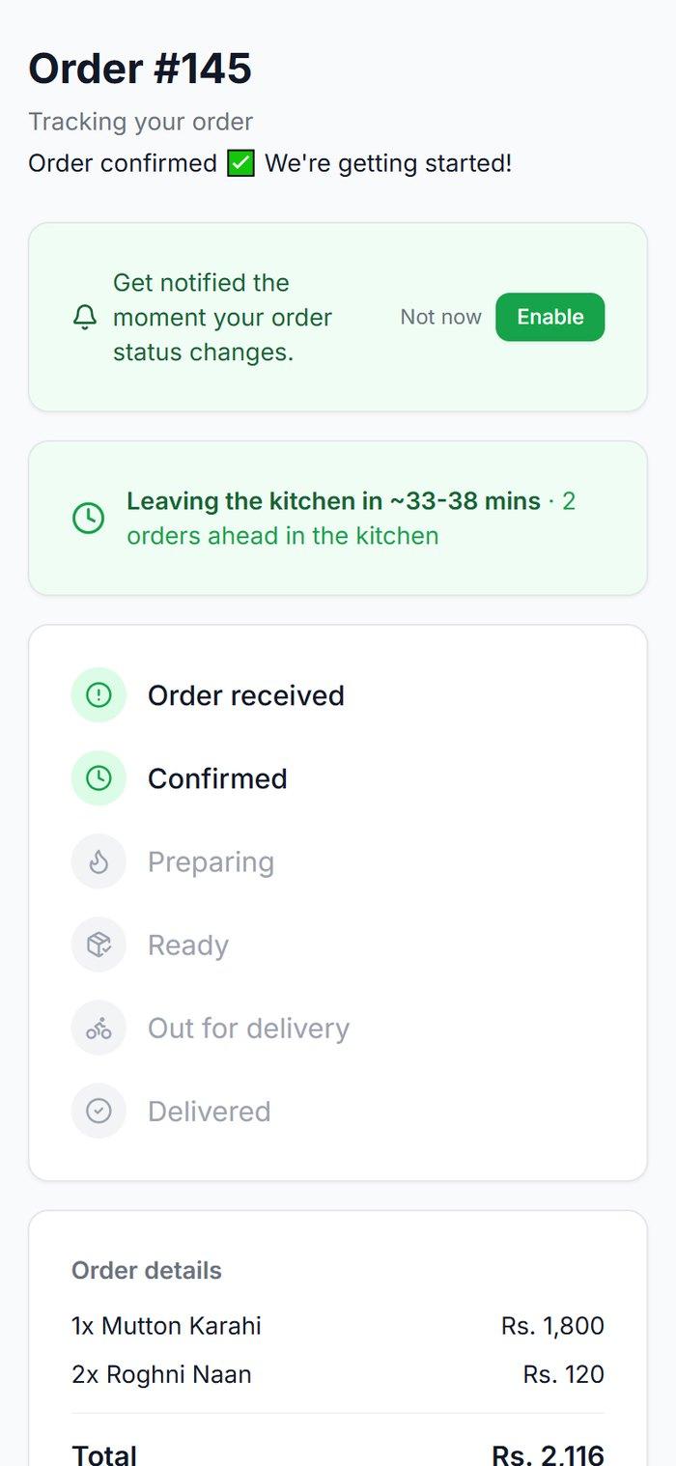  Confirmed | 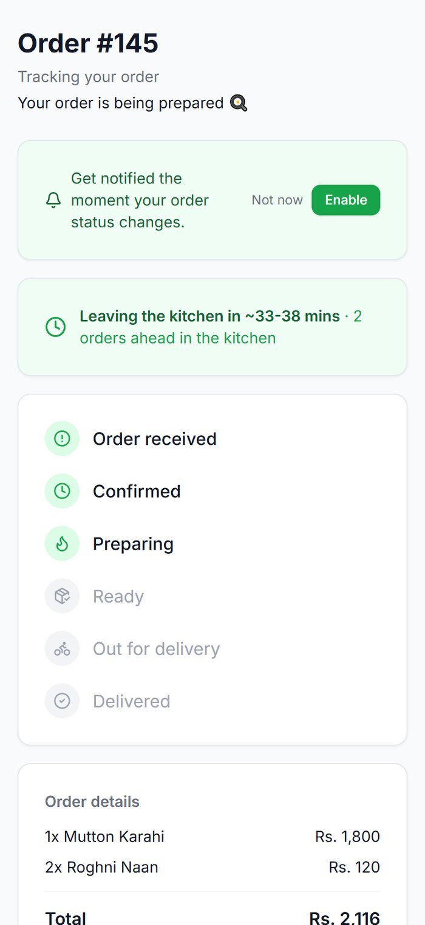  Preparing | 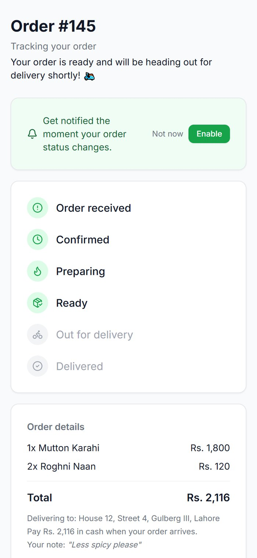  Ready
Figure 58. The tracking page as order #145 moved through the kitchen.
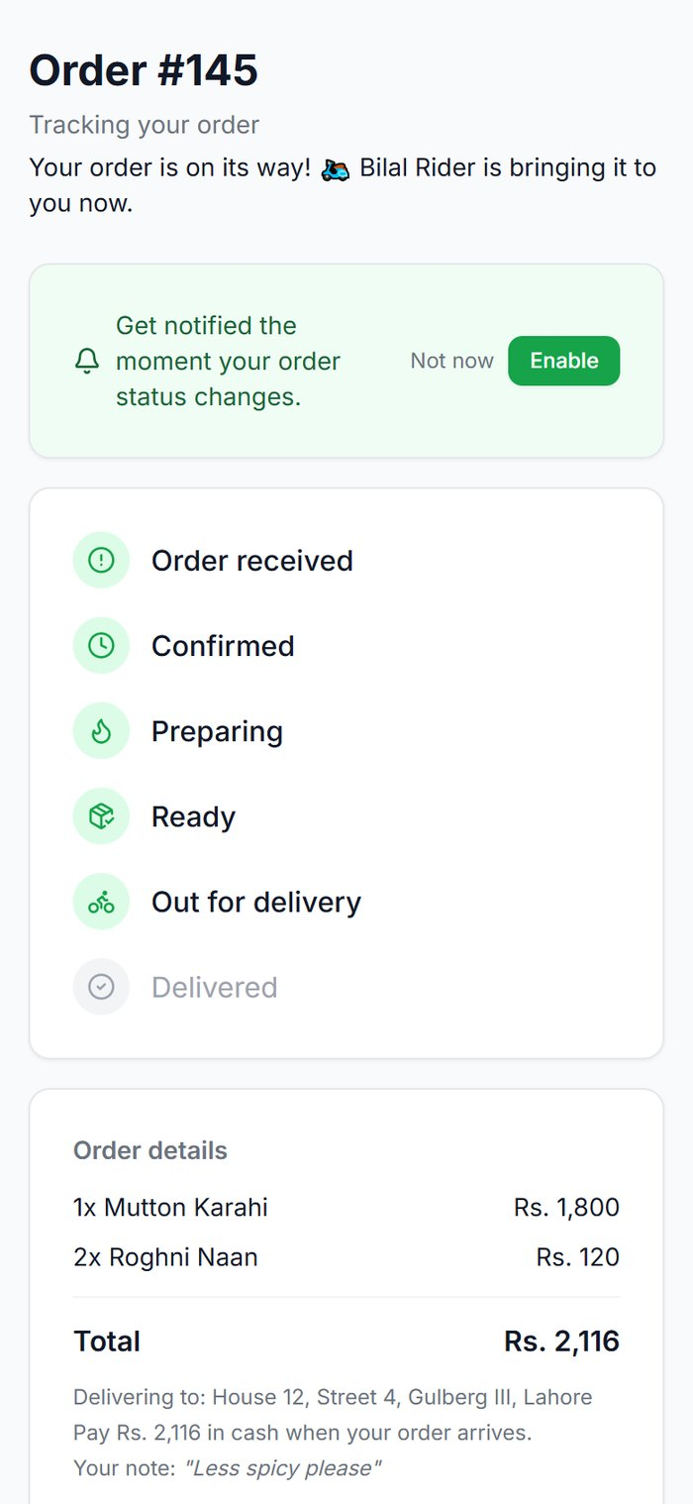  Out for delivery | 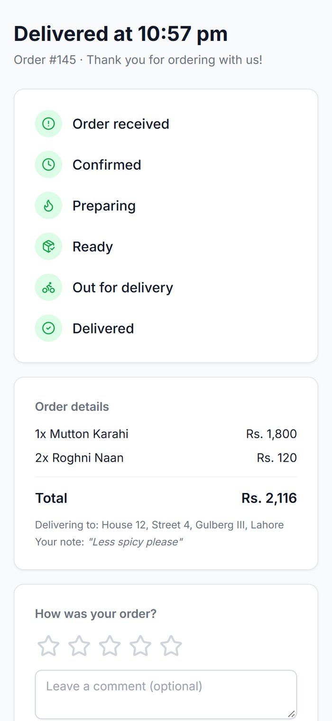  Delivered | 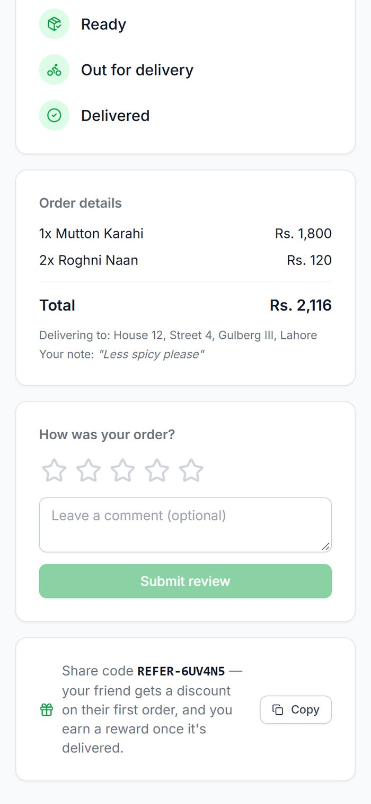  Referral code
Figure 59. Out for delivery with the rider's name, delivered, and the customer's referral code.

6.3 Leaving a review
Once the order is delivered, the tracking page asks How was your order? The customer taps 1–5 stars, optionally writes a comment, and taps Submit review. A "Thanks for your feedback!" message confirms it. Reviews feed the average rating on your Dashboard and can be shown on your website.
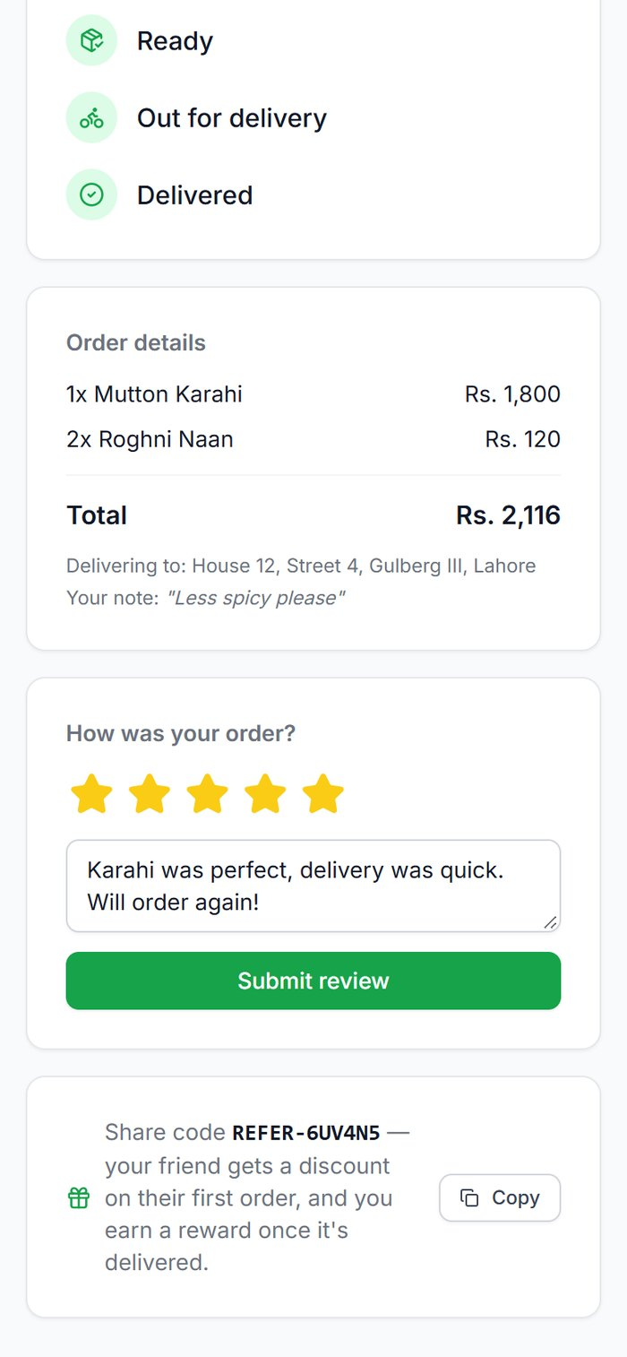
Figure 60. Leaving a 5-star review.
Known issue: If the customer reloads the page, the review form appears again and a second review can be submitted for the same order.

6.4 Ordering at the table (dine-in QR)
- The guest scans the QR code on the table. The menu opens with the table number at the top. No app or sign-in is needed.
- They add dishes and tap Send to Kitchen. Each send is a "round"; they can order more later.
- The Bill tab shows every round with its status, subtotal, tax and grand total, and a Split evenly calculator.
- When finished, they tap Request Bill from Staff. Staff see a notice and the table shows "Bill requested".

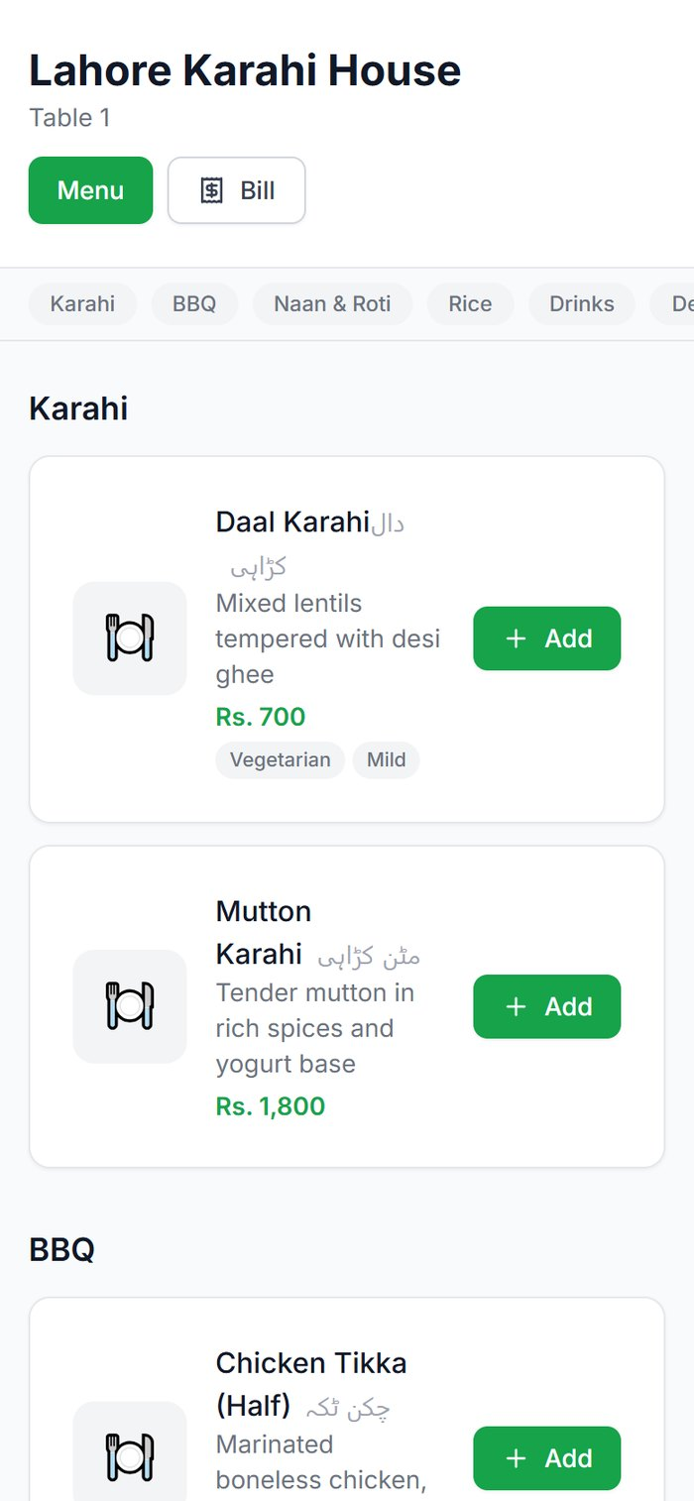  After scanning | 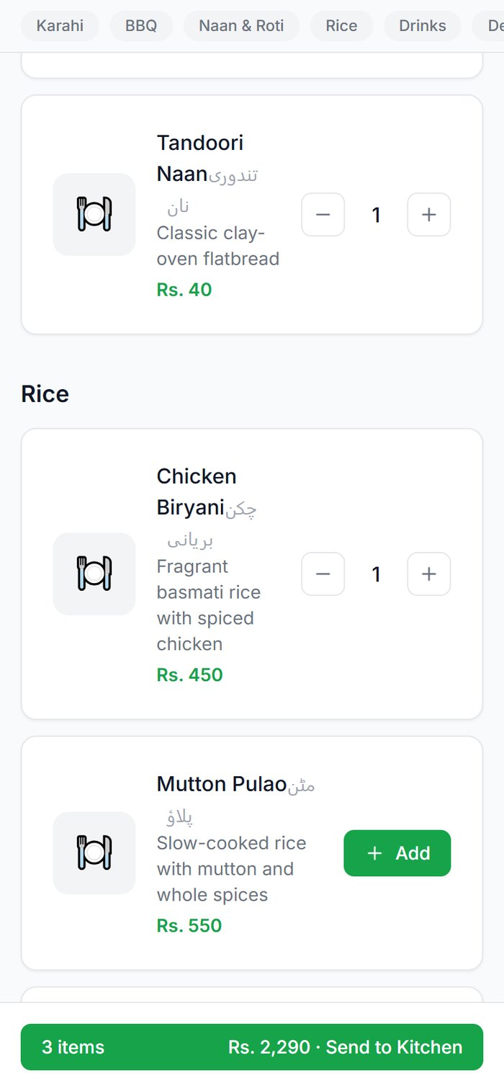  Adding dishes | 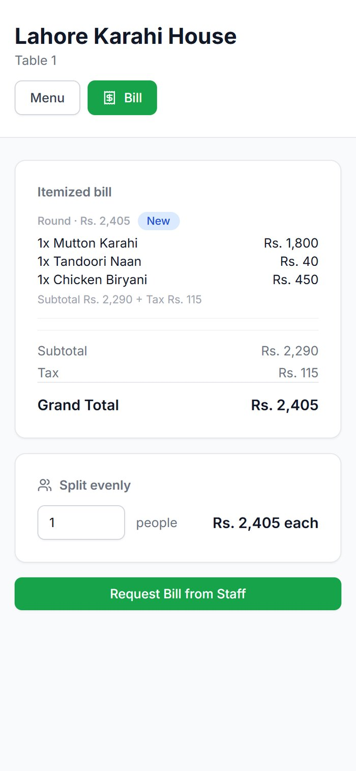  Itemised bill
Figure 61. Dine-in ordering from Table 1.

6.5 Booking a table
From the website or online menu, Book a Table asks for name, phone, party size, date, time and an optional note. The customer sees "Table booked!" and receives a WhatsApp confirmation. The booking appears on your Reservations page (3.12).
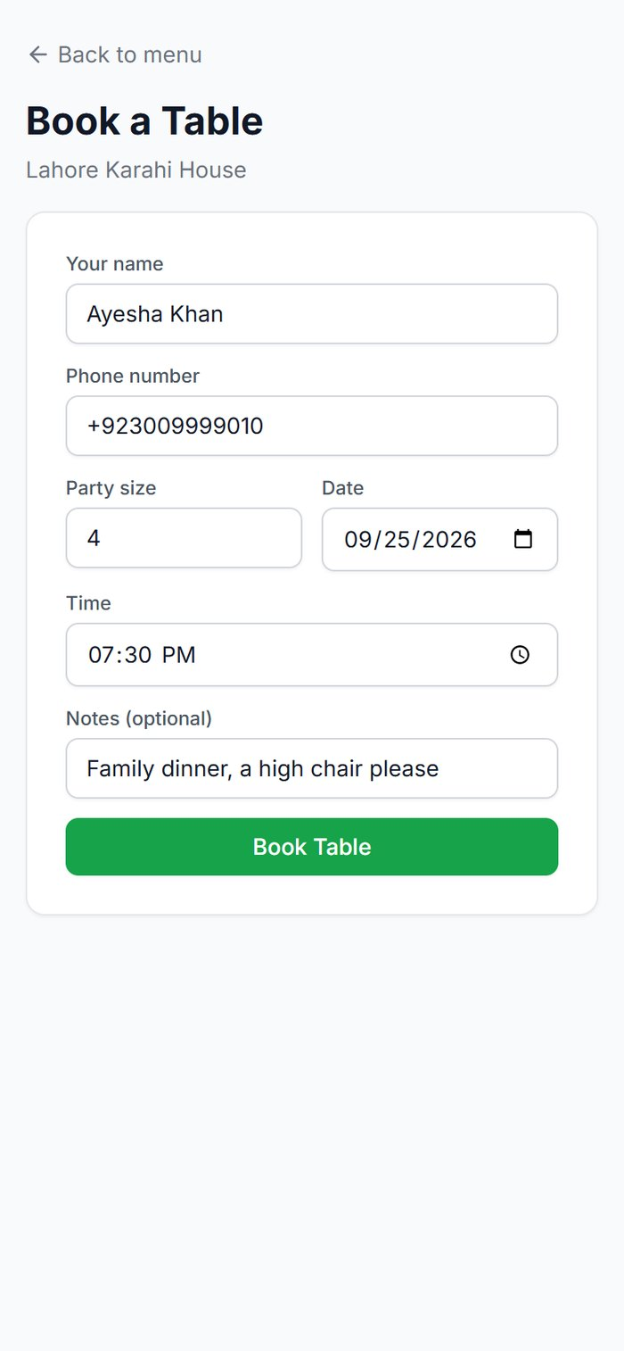  Booking form | 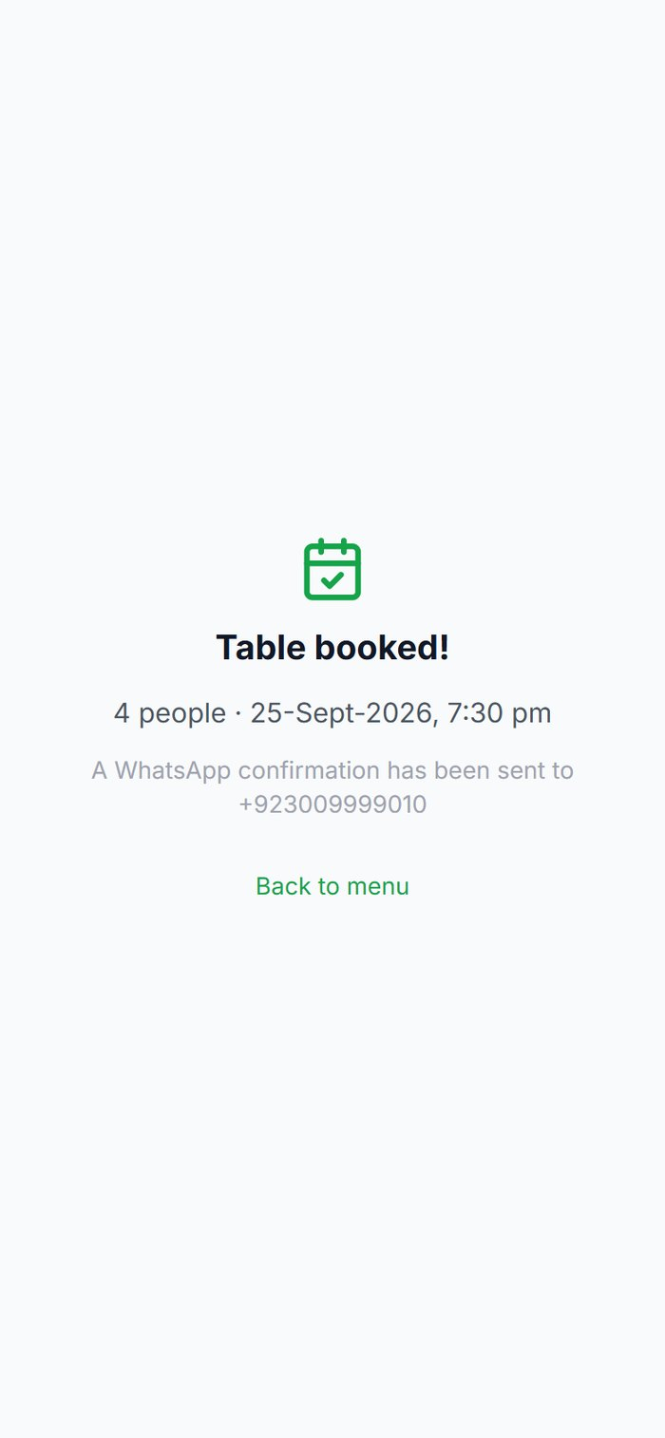  Confirmed
Figure 62. Booking a table for four.

6.6 Loyalty points
Customers earn points on delivered orders. Points on the online menu shows their balance using their phone number, and what it is worth. In the demo restaurant, 1 point is earned per rupee and 100 points are worth Rs. 1.
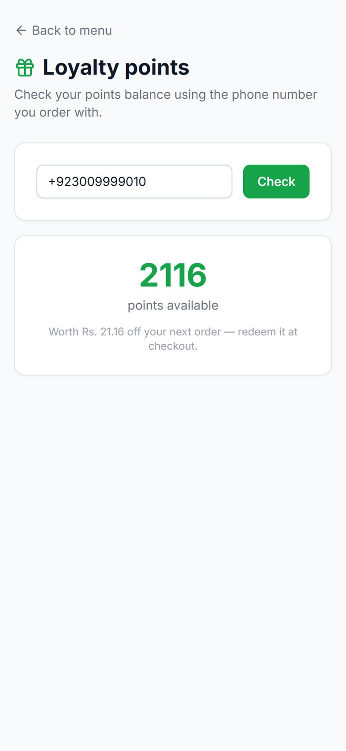
Figure 63. Checking the balance: 2,116 points, worth Rs. 21.16.

6.7 The Menu Assistant
The sparkle button on the online menu opens a Menu Assistant. Customers can ask for suggestions ("something spicy under Rs. 500") and get an answer based on your real menu. It can take up to about 20 seconds to reply.
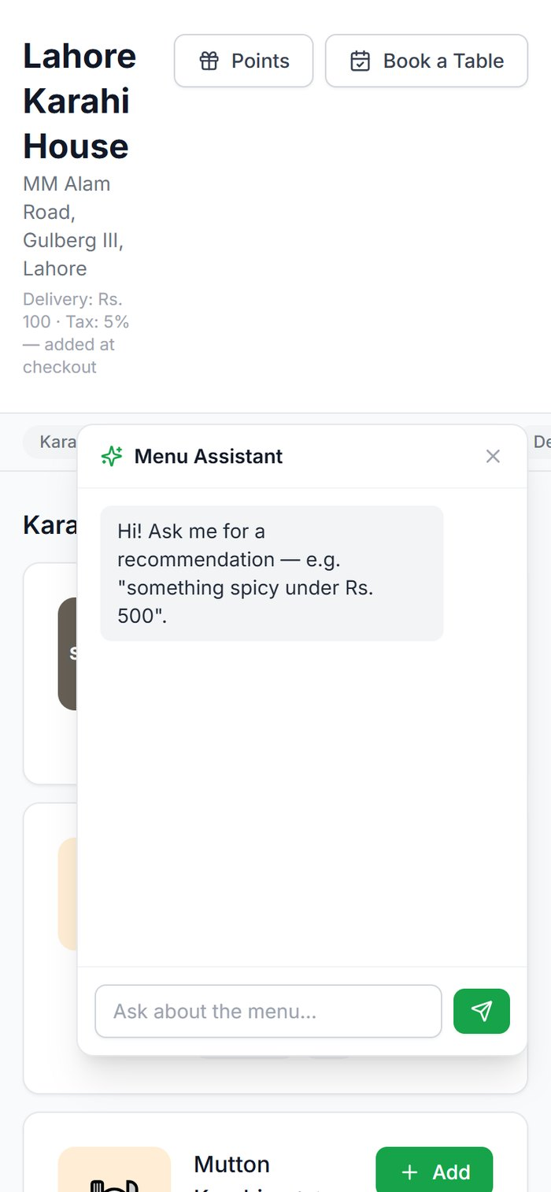  Opening the assistant | 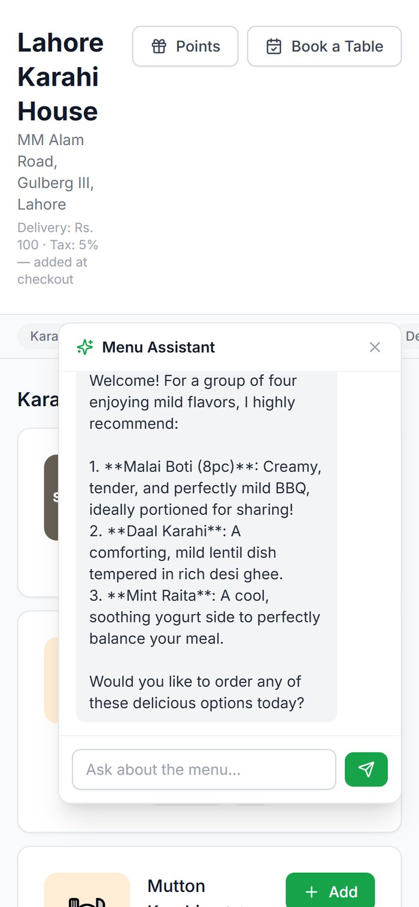  A recommendation
Figure 64. The Menu Assistant on the online menu.
Known issue: The assistant's replies show formatting symbols literally, for example Malai Boti appears with the asterisks.

7. The WhatsApp AI assistants
RestoAI has two assistants on WhatsApp. Customers talk to the ordering assistant. The owner and managers, messaging from their own registered phone numbers, reach the business assistant. RestoAI tells them apart by the sender's phone number before anything else happens, so a customer can never see business figures.
Note: The conversations below were run through the WhatsApp Demo page in the admin app (Settings → WhatsApp Demo), which sends a message through exactly the same AI as a real WhatsApp message, without needing a phone. Screenshots of a real phone could not be taken for this manual.

7.1 Customer ordering assistant
Customers write naturally, in English, Urdu or Roman Urdu. The assistant understands dishes, quantities, address and payment method, matches them to your menu and prices, and always asks for a "yes" before placing the order.
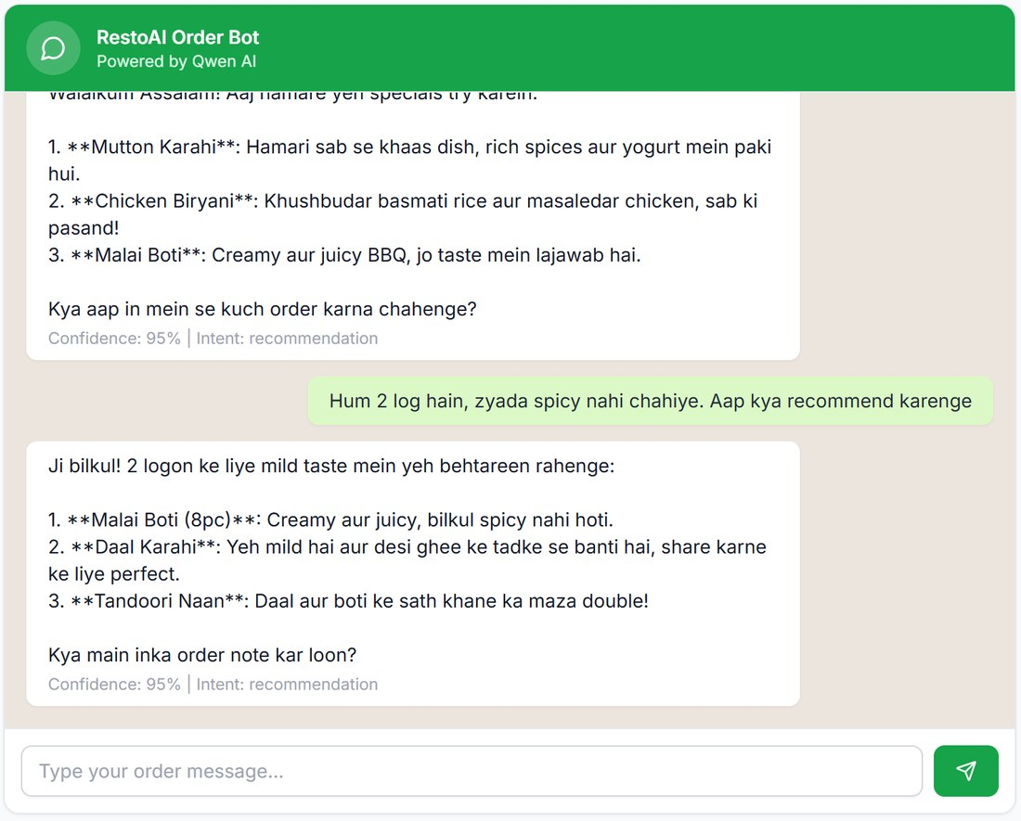
Figure 65. A greeting and a request for mild dishes for two people. The assistant recommends from the real menu. (cropped)
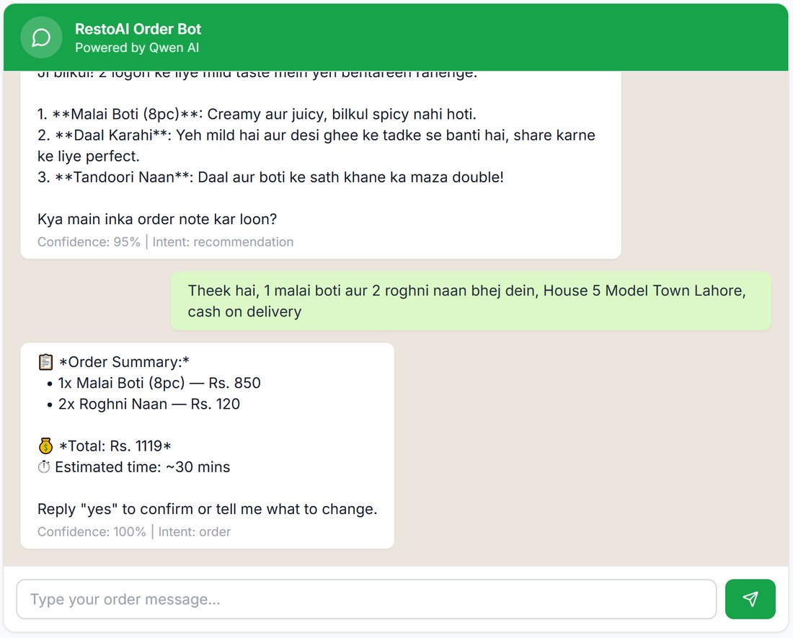
Figure 66. The customer orders in Roman Urdu with their address; the assistant replies with an order summary and total, and asks for "yes". (cropped)
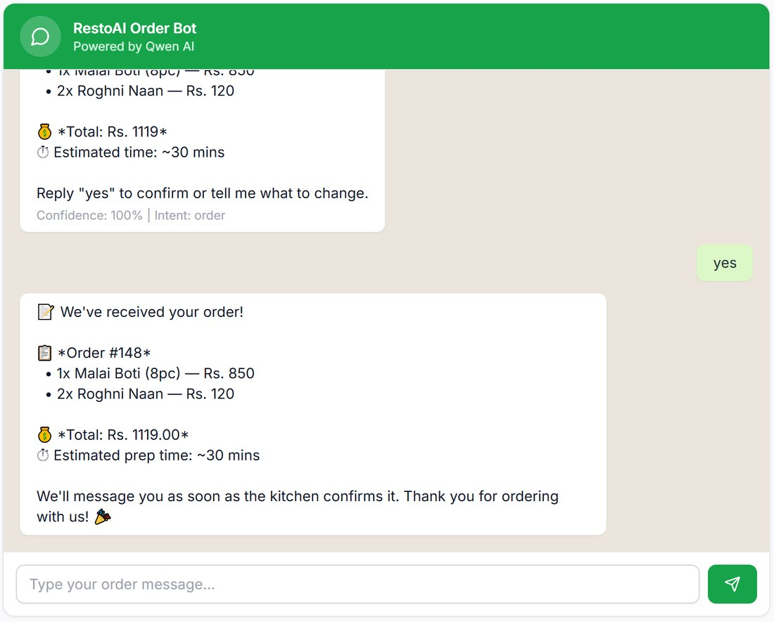
Figure 67. After "yes", the order is placed (#148) and goes straight to the Kitchen Display. (cropped)
After that, the customer receives a WhatsApp message each time the order moves on. These are the actual messages sent for web order #145 during testing:
When | Message the customer receives
Order placed | 📝 We've received your order #145 at Lahore Karahi House. (followed by the items)
Confirmed | Order confirmed ✅ We're getting started!
Preparing | Your order is being prepared 🍳 Estimated ready in ~38 mins.
Ready | Your order is ready and will be heading out for delivery shortly! 🛵
Picked up | Your order is on its way! 🛵 Bilal Rider is bringing it to you now.
Delivered | Delivered! Enjoy your meal 🍽️
Table booked | ✅ Table booked at Lahore Karahi House for 4 on 25-Sept-2026, 7:30 pm. See you then!

The same sentence is shown on the customer's tracking page (6.2), so the two never disagree.
Customers can also ask for the menu, book a table, or raise a problem; problems go to the support flow (3.13).

7.2 Owner business assistant
Owners and managers whose phone number is saved on their RestoAI account can message the restaurant's WhatsApp number to ask about the business: "What needs my attention today", "How were sales yesterday", or in Roman Urdu. Answers use real figures. A manager only gets figures for their own branches.
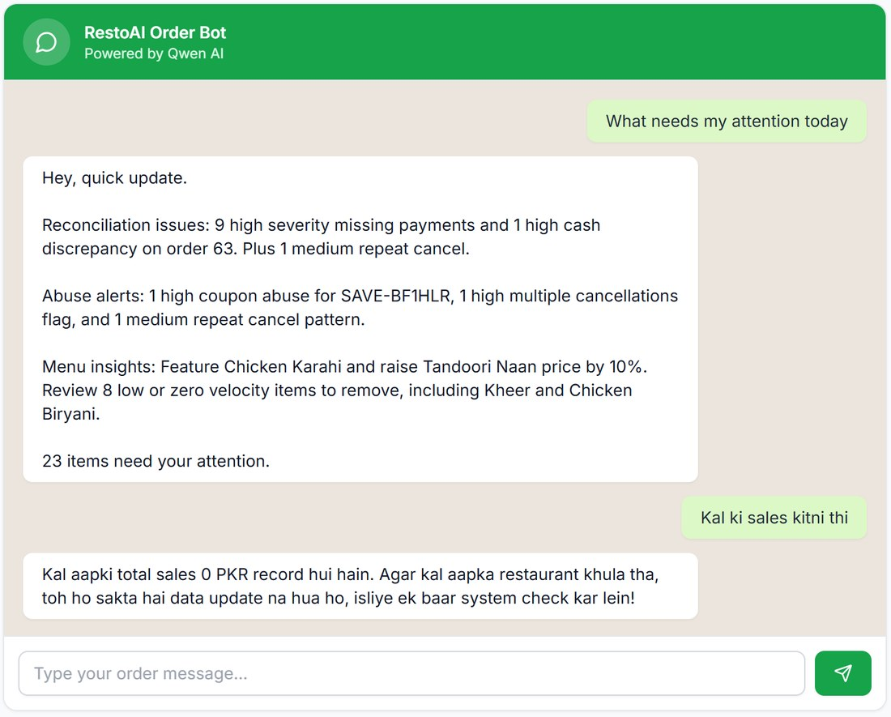
Figure 68. The owner asks what needs attention, then asks in Roman Urdu for yesterday's sales (the demo restaurant genuinely had no sales that day) (cropped).
The same kind of question can be asked in the admin app with the AI Assistant bubble (3.1) or on the Insights page (3.14).
Tip: Every morning the Daily Briefing helper (8.1) sends the owner a summary of yesterday on WhatsApp without being asked, once WhatsApp is connected.

8. The agent system: your AI team
RestoAI runs ten AI helpers ("agents"). Eight work quietly in the background on a schedule or when something happens; two are assistants people talk to. Two rules apply to all of them: they only use your real data, and anything that costs money or could upset a customer needs a person's approval.
Helper | When it runs | What you notice
8.1 Daily Briefing | Every morning, 8:00 am | A WhatsApp summary of yesterday
8.2 Win-Back | Mondays, 8:30 am | Quiet customers get a personal offer
8.3 Rider Dispatch | When a delivery is ready | Deliveries assigned or suggested
8.4 ETA | Every time a customer looks | Realistic "ready in" times
8.5 Reconciliation | Every morning, 9:00 am | Payment and cash mismatches flagged
8.6 Abuse Detection | Every morning, 9:30 am | Suspicious patterns flagged for you
8.7 Replenishment | Every morning, 10:00 am | Purchase-order suggestions
8.8 Menu Insight | Mondays, 10:30 am | Pricing and menu recommendations
8.9 Customer Support | When a customer raises a problem | Tickets, with complaints escalated
8.10 Business Assistant | When you message it | Answers about your business

Times are Pakistan time.

8.1 Daily Briefing
Every morning it looks at yesterday's orders and revenue and sends the owner a short WhatsApp summary, so you know how the day went before you open the app.

8.2 Win-Back
Finds customers who used to order but have gone quiet, and sends each a personal WhatsApp message with a real one-time coupon (valid for 7 days) based on the dish they usually order. You can see who is next on the AI Agents page and switch the messages off entirely with Win-back messages. The coupons it creates appear on the Coupons page (SAVE- and THANKS- codes).

8.3 Rider Dispatch
When a delivery is ready it picks the rider with the fewest active deliveries. In Full auto-assign it assigns directly; in Suggest only it waits for you. It does not use GPS or distance.

8.4 ETA
Instead of a fixed "30 minutes", it estimates when each order will leave the kitchen from how many orders are ahead of it, and shows that to the customer ("Leaving the kitchen in ~33–38 mins · 2 orders ahead").

8.5 Reconciliation
Checks delivered orders against payments and the cash riders collected. Anything that does not add up, such as a missing payment or a rider short by Rs. 360, becomes a flag on the Dashboard and the AI Agents page for you to Resolve or Dismiss.

8.6 Abuse Detection
Looks for patterns such as one coupon being used by many accounts, repeated cancellations, or suspicious reviews. It only flags them; it never blocks a customer or cancels anything. You decide: Confirm or False positive.

8.7 Replenishment
Compares each ingredient's stock with how fast it is being used, and suggests a purchase order before you run out. Nothing is ordered until you click Approve.

8.8 Menu Insight
Once a week it sorts dishes by how well they sell and how much margin they make, and suggests actions: feature a best-seller, raise a price, or reconsider a dish that has not sold. Suggestions appear on the Insights and AI Agents pages.

8.9 Customer Support
Handles non-order WhatsApp messages. It answers routine questions from your real data, sends complaints and upset customers straight to a person, and only closes a ticket when the customer confirms or staff resolve it. See 3.13.

8.10 Business Assistant
Answers the owner's and managers' questions over WhatsApp using real figures, including "what needs my attention", which gathers the findings of the other helpers into one reply. See 7.2.

9. Troubleshooting and FAQ

9.1 WhatsApp

Why can't I connect the WhatsApp number I already use?
Meta only allows a number to be connected to a business platform once it no longer has a WhatsApp account on a phone. If you continue without deleting that account, Meta's sign-up stops with "This number is registered to an existing WhatsApp account". On the WhatsApp Connect page, answer "Yes, on regular WhatsApp or WhatsApp Business app" and follow the steps (3.17): back up chats if you want them, delete the WhatsApp account on the phone, keep the SIM active for the code, then continue. Your number and your customers' saved contact stay the same.

My number is on Wati / Gupshup / 360dialog / Twilio. Can I move it?
Yes, but not with the Connect button. It needs an assisted migration arranged with support@restoai.app. Keep your current provider running until the move is complete.

A customer's WhatsApp order was not placed. Their messages only get "added to your case".
That customer has an open support ticket. Open Support, deal with it and click Resolve; their next message will be treated normally.

9.2 Account and access

What does "This account has been suspended" mean?
Your RestoAI subscription has been paused, so owners, staff and riders cannot sign in. Your data is kept. Contact RestoAI support; access returns within about a minute of reactivation.

A staff member sees "Failed to load dashboard".
Expected with default staff permissions (see Chapter 4). They can use Orders, POS and the Kitchen Display normally.

A rider forgot their PIN.
Riders page → Reset PIN on their row. The new PIN is shown once.

How do I remove a staff member?
There is currently no screen for this. Contact RestoAI support.

9.3 Everyday questions

Why is a dish showing "Sold out" when I didn't switch it off?
Its recipe uses an ingredient that has run out. Restock the ingredient in Inventory and the dish becomes available again.

My published website shows "Something went wrong".
This is a known fault in the current version (3.16), not something in your settings. Share your online menu link with customers until it is fixed; ordering, checkout and tracking work normally.

Why doesn't my online tax match my POS receipts?
Online and WhatsApp orders use 5% tax; the POS uses the rate set with its gear icon. See 3.5.

I uploaded a photo but nothing appeared.
Photo upload could not be confirmed during testing (3.2). Try again, and contact support if it still does not appear.

The Insights box jumped to "Jump to a page…" while I was typing.
Typing "?" opens quick navigation. Press Esc and ask the question without the question mark.

9.4 What is not available yet
These were checked while preparing this manual and could not be shown working:
- AI menu digitisation (reading a photo of a paper menu): exists on the server, no button in the app.
- Menu photo upload: failed in the test environment without an error message; not confirmed working.
- Multi-branch comparison: needs two or more branches; the demo restaurant has one, and there is no page to add branches.
- Subscription/plan page for restaurants: not in the app.
- WhatsApp "Connected" state and Meta's sign-up window: not captured (no number connected on the demo account).
- A list of current staff accounts, and removing staff: not in the app (only invites are listed).
- A "run now" button for the AI helpers: not in the app; they run on schedule.
- Installing the rider app like a normal app: not available; use a browser bookmark.
- Custom domain for your website: can be entered, but shows "Pending".
- The published restaurant website itself: crashes with "Something went wrong" (3.16).

10. Glossary
Term | Meaning
Branch | One physical location of your restaurant. Reports, tables, riders and stock belong to a branch.
Channel | Where an order came from: WEB (website), WHATSAPP, PHONE/counter (POS) or dine-in (table QR).
COD | Cash on delivery.
Float | The cash already in the till when a POS shift opens.
KDS | Kitchen Display System, the kitchen screen (3.4).
Meta | The company that runs WhatsApp. Connecting your number goes through Meta's sign-up.
PRA | Punjab Revenue Authority, the tax authority shown on the demo receipts. Set yours in POS tax settings.
Reconciliation | Checking that the money collected matches what was expected.
RFM | Recency, Frequency, Monetary: grouping customers by how recently, how often and how much they order.
Round | One batch of items sent to the kitchen from a POS tab or a dine-in table.
Segment | A saved group of customers, used as campaign recipients.
Tab | An open bill on the POS.
Tenant | Your restaurant's account in RestoAI. Your data is kept separate from every other restaurant.
Token board | A TV screen showing ready order numbers for pickup and dine-in.
Variance | The difference between expected and actual cash.
WABA | WhatsApp Business Account: the business account at Meta that your number belongs to once connected.
Z-Report | The end-of-shift summary printed when you close a POS shift.

Appendix: platform administration
RestoAI's own operators manage restaurant accounts from a separate Super Admin area with its own sign-in, which always requires a code from an authenticator app (two-factor authentication). Restaurant owners do not use this area.
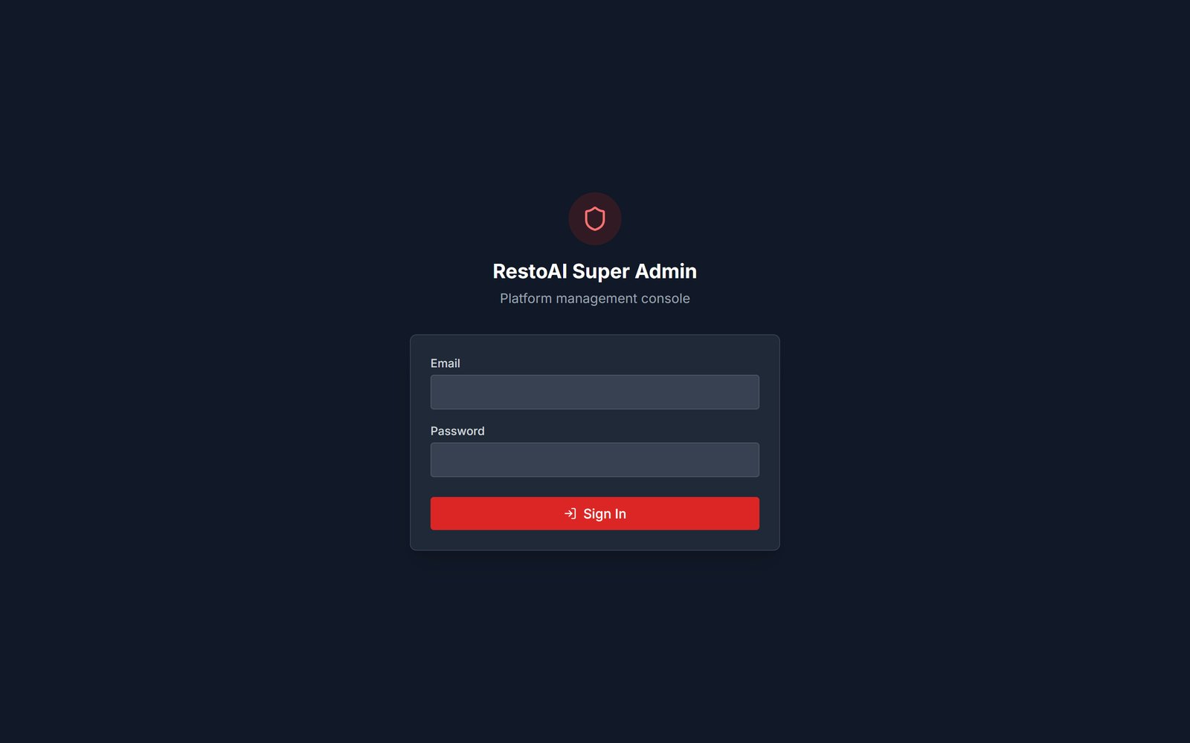
Figure 69. The Super Admin sign-in page.
Note: Only the sign-in page is shown. The tenant list, expiring-subscriptions view, tenant detail and audit log require the operator's authenticator code and were not captured for this manual.

