**Private Cloud Storage Using Raspberry Pi**

|  |
| --- |
| Project Workbook |
|  |

|  |
| --- |
| By |
| Manasi Deshpande  Sylvestor George  Anup Kher  Kalyan Vallamsetla |
| 06/24/2015 |
| **Advisor:** Si Thu Aung |

# Literature Search, State of the Art

## Literature Search

The Internet of Things (IoT) has been defined in Recommendation ITU-T Y.2060 (06/2012) as a global infrastructure for the information society, enabling advanced services by interconnecting (physical and virtual) things based on existing and evolving interoperable information and communication technologies. [1]

According to Gartner’s Hype Cycle of Emerging Technologies 2014 [2], Internet of Things is predicted to reach its maturity or the “Plateau of Productivity” in the next 5 to 10 years. This is a considerable improvement over Gartner’s 2012 prediction of 10 to 20 years. This clearly implies that IoT is soon going to reach mainstream success and now is the perfect time for innovation.

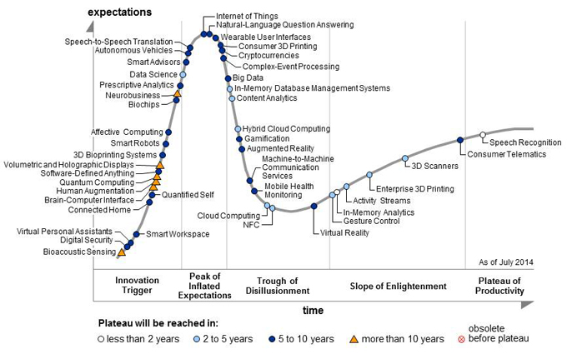

Figure 1. Gartner’s Hype Cycle for Emerging Technologies

Internet of Things in its most basic form is communicating with everyday objects with the help of the internet. The typical components of an IoT are *things,* which can be objects such as thermostats, light-switches, water-sprinklers, blenders, stovetops, etc.; *internet,* which wirelessly connects these objects to the internet and an *application,* which can be a web application, mobile application or simply a computer which can be used to manage the data transmitted by these objects. The main purpose of IoT is collecting data from these devices. This data collection is enabled by RFID tags or sensors embedded in the devices.

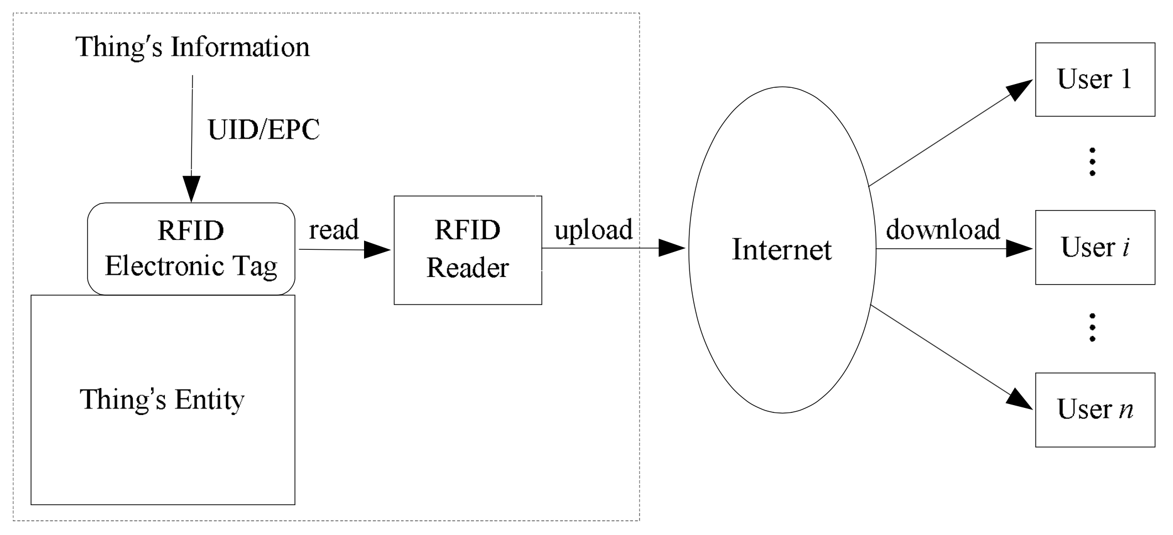

Figure 2. Architecture of IoT [3]

Smart homes are at the center of the IoT revolution because a large number of devices that can be connected to the Internet are available at our homes. Currently, the following IoT products are the most popular for smart homes:

Belkin WeMo

Canary

Our project lies under the smart home category. There are two parts to it: (1) An auto-backup feature and (2) a smart home-camera solution.

**The auto-backup feature:**

The purpose of the auto-backup feature is to trigger a backup from any of the connected smartphones to our Raspberry-Pi controller on a press of a single button. The idea is to create a mobile/web application that aims at backing up the entire phone data to our controller with minimal user input.

**The smart home-camera solution:**

This feature will keep a track of all the visitors visiting the user’s home when he/she is away by clicking their picture from the home security camera and maintain a database. The user can then refer this database to look for any suspicious person who may have visited their property.

**State-of-the-Art Summary**

Following are the cutting-edge technologies that can be implemented in our project:

**Sensors**

Sensors are at the heart of IoT devices. For IoT applications various types of sensors that can be used are as follows:

Proximity sensors: They measure how close an object is to the sensor

Accelerometer: They measure the lateral movement of the sensor

Gyroscope: They measure the radial movement of the sensor

Temperature sensors, humidity sensors: Measures the ambient temperature and humidity

Light sensors: Measure the intensity of the ambient light

Pedometer: Measures the number of steps the user has taken

**Communication Media**

For the sensors to transmit their data they need a reliable medium, following are the latest developments: [4]

RFID: Radio Frequency Identification is one of the strongest contenders in implementation of IoT. Primarily because of its low power requirements and it does not need an additional power source. RFID has evolved to a very small size that is ideal for IoT applications. [5] The recent advancements in RFID technology have been implementation of Wireless Power Transfer (WPT) and Energy Harvesting (EH)

IEEE 802.11: This communication standard commonly known as WiFi is used to send and receive wireless signals, data, etc. over a fixed short range. WiFi usually operates in 2.4GHz – 60GHz frequency band and supports data speeds upto 6Gbps. This is a strong candidate as a communication medium for IoT because of it’s widespread use and ease of installation.

Bluetooth Low Energy: The latest Bluetooth core specification 4.2 brings improvements targeted specifically at IoT. It helps connect to IoT devices in a better and efficient way. The most important improvement is lower power IP connectivity that is essential in such small low-powered devices. It also implements a flexible version of Bluetooth Smart’s GATT architecture. [6]

**References**

1. Y. Huang, G. L. (2010). Descriptive models for internet of things.*August 13-15,*
2. STAMFORD. (2014). **Gartner's 2014 hype cycle for emerging technologies maps the journey to digital business**. Retrieved from [http://www.gartner.com/newsroom/id/2819918](http://www.gartner.com/newsroom/id/2819918" \t "_blank)
3. Special Interest Group. (2015). Bluetooth 4.2. Retrieved from [http://www.bluetooth.com/SiteCollectionDocuments/4-2/bluetooth4-2.aspx#control](http://www.bluetooth.com/SiteCollectionDocuments/4-2/bluetooth4-2.aspx" \l "control" \t "_blank)
4. Recommendation ITU-T Y.2060. (2012). Overview of the internet of things. Retrieved from [http://www.itu.int/ITU-T/recommendations/rec.aspx?rec=y.2060](http://www.itu.int/ITU-T/recommendations/rec.aspx?rec=y.2060" \t "_blank)
5. P. Suresh, J. Vijay Daniel, V.Parthasarathy, R.H. Aswathy. (2014). A state of the art review on the internet of things (IoT) history, technology and fields of deployment
6. L. Roselli, C. Mariotti, P. Mezzanotte, F. Alimenti, G. Orecchini, M. Virili, N.B. Carvalho. (2015). Review of the present technologies concurrently contributing to the implementation of the internet of things (IoT) paradigm: RFID, green electronics, WPT and energy harvesting.

# Project Justification

In the current age of technological advancement where everything is “online” and connected to the internet, there are a lot of IoT products available for home automation. Most of them deal with automating the home devices making it possible for the user to control them remotely with help of a smartphone.

Our ideology behind this project is (1) to free the user of any device storage capacity dependency and to automate the backup process from his smartphone to the cloud and (2) make a controller communicate with an external smart camera device placed outside the house which records images of the people visiting the user’s house while the user is away. Security of the house is one of the reasons that we are trying to address.

We are expecting to minimize a user’s interaction with the storage applications and to relieve the user from the daily hassle of backing up the data in order to keep the smartphone from running out of storage space. Additionally, the second feature of the system will be to provide a home monitoring solution that logs the visitors chronologically and provide the user with the data to help him follow-up accordingly.

Our controller (Raspberry Pi 2) will be programmed to collect the data from the home security camera and help the user track any suspicious visitors or get in touch with the visitors whom the user missed.

Recent improvements in chip design and communication technology is helping IoT reach mainstream adoption. This has been rightly predicted by Gartner’s 2014 report on Emerging technologies.

# Project Requirements

## Use Cases

**Use case 1: Auto-backup of Smartphone data**

When the user’s smartphone is detected on the home network, he/she will be provided with a prompt to go ahead with a backup of the smartphone’s data. This data will be first stored on our controller i.e. Raspberry Pi and later could be moved to the cloud.

To perform this backup, a mobile app will be developed through which the user can schedule/approve backups.

**Use case 2: Capturing images of visitors and storing them chronologically**

The home security camera will take pictures of visitors ringing the door bell and store them in a database on the Raspberry Pi. These pictures will be presented to the user with the help of a dashboard on a web application. The user can go through the pictures to review security of the house and monitor any unknown persons.

**Requirements**

**Functional Requirements:**

**Essential**

Auto-backup: The controller should store the data from the mobile phone automatically

Visitor capture: The home security camera should capture the picture of every visitor

**Desired**

Intelligent photo backup: Specifically backup pictures from the mobile phone

Facial recognition: Recognize the faces of visitors using previous visiting history

**Optional**

Send auto messages to the visitors: All the known visitors will be sent a message which says “I’ll back by 8 PM”

**Non-functional Requirements:**

The auto backup should be seamless with minimal user interaction

The backup should not take a very long time to complete. The user should be provided with a progress report with an estimated completion time.

The home security camera should be placed outside the home in a way that it can capture the entire face of the visitor.

The controller (Raspberry Pi) should be configured to notify the user if and when it is running out of storage space.

# Dependencies and Deliverables

## Dependencies

1. Different set of sensors such as heat sensor, motion sensor etc. to test our system: This project is a prototype of IOT, built for a home to setup a private cloud for the home with a few extended features such as home security, temperature alerts etc. In order to test this system we require so sensors such as motion sensors which signal the camera to click pictures when something suspicious is sensed. As some of these sensors are not readily available and  some of them are expensive, obtaining these sensors right in time might be a dependency for this project
2. Integration of the hardware sensors with the Raspberry Pi: The sensors have there own way of communicating their results with the controller, usually in the binary form 0’s and 1’s. Apart from the results they also send a garbage data which needs to be cleared before getting the actual values that are output by the sensor. Hence it is necessary to integrate the Raspberry Pi with the sensors so that it reads the actual values and discard the garbage values. In addition to this different sensors use different API’s hence, integrating these sensors could be a dependency for this project.
3. Different set of home appliances such as printer, mobile phones and other wireless devices with wifi connectivity to test our system.

# Project Architecture

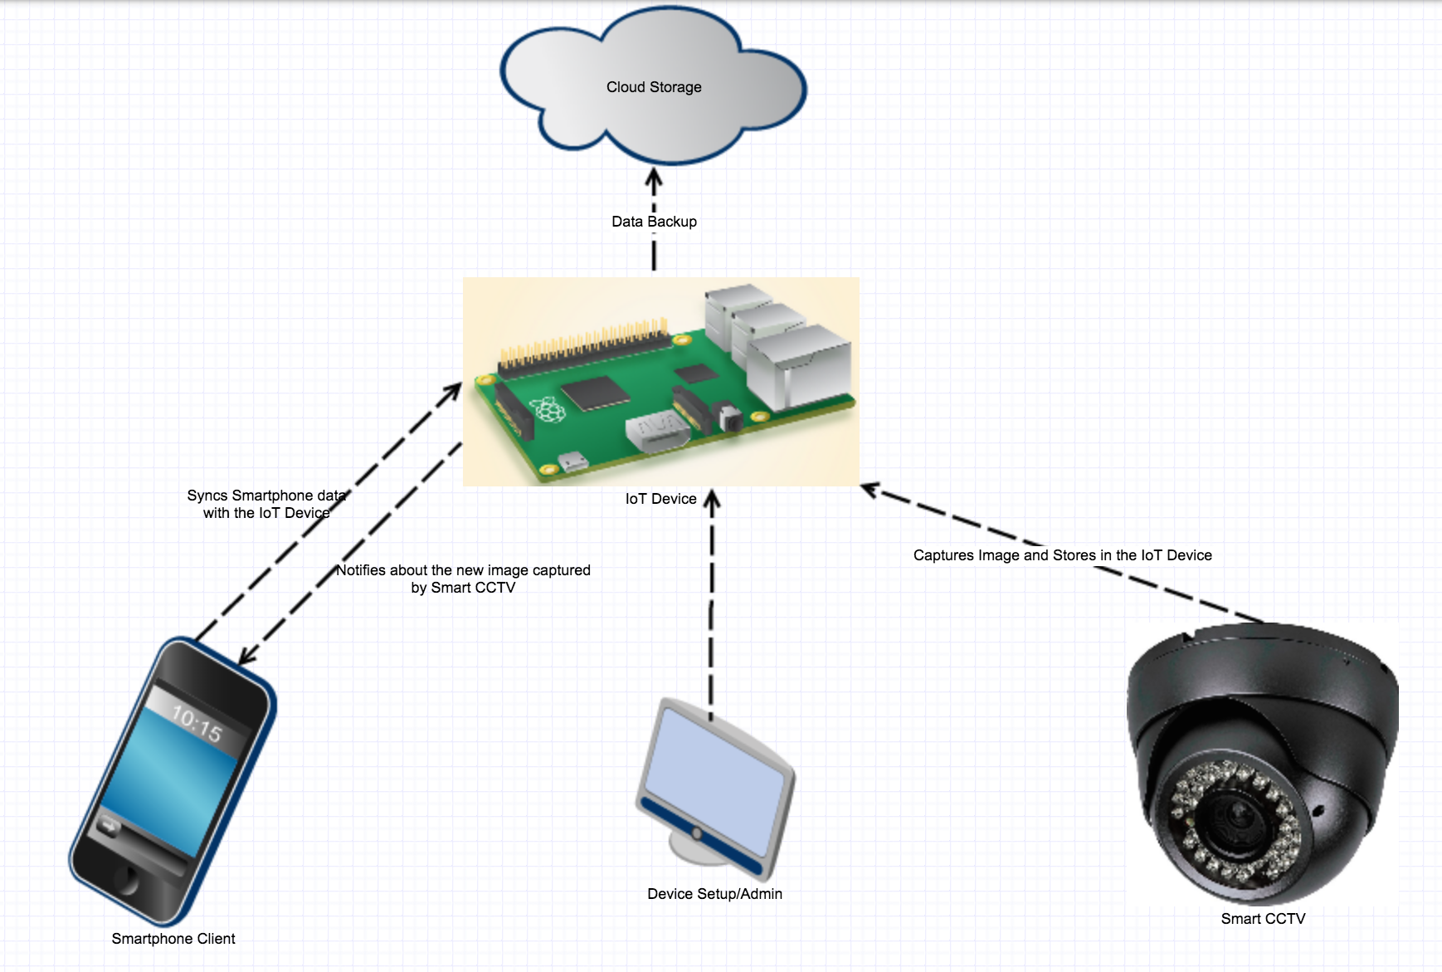

# Project Architecture

**IoT Device:** The IoT device could either be a Raspberry Pi or a Spark Photon. These devices entail all server related tasks such as syncing/storing data from the Smartphone, pictures taken by the CCTV and running application that notifies the client whenever the CCTV takes a new picture. The IoT device can either keep the data stored in its storage or can transfer data to the cloud for backup based on user preference. As an alternative user may have to delete old data from the IoT device once the storage is full in order to sync more data from their smartphone or store new images from the CCTV. Users can also connect to the IoT device to change default settings such as frequency of deleting old data, backing up data to the cloud, etc. of the device based on their own needs.

**Smartphone Client:** Client can be either an Android/iPhone smartphone, which directly interacts with the IoT Device over the local network. Once the smartphone is in the vicinity of the same network, authorized users can sync all their stored data from their smartphone client to the IoT device with a single click. This will allow the users to delete data from their smartphone without making an extra effort on filtering important data. The client receives a notification with attached picture that the CCTV camera takes and stores it in the IoT device. Thus, keeping the users updated about who all have been at their doorstep in their absence.

**Smart CCTV:** A motion sensor camera can be installed at the doorstep, which detects any movement and captures an image of the people who are at the doorstep. The CCTV is on the same network as that of the IoT device and sends the clicked picture to the IoT device over the network, which stores that picture.

**Cloud Backup:** The IoT device can connect to a public cloud storage, which allows the users to maintain backup of their data and delete the old data from the IoT device. This is an optional choice for the users based on their needs and preference. As an alternative user may have to delete old data from the IoT device once the storage is full in order to sync more data from their smartphone or store new images from the CCTV.

# Project Design

[

Describe your project design. Types of design artifacts that you provide might include:

* UML diagrams (class diagrams, sequence diagrams, etc.)
* UI Mockups
* Database Entity diagrams
* Hardware block diagrams
* Other artifacts you deem necessary to describe your project in detail.
* CMPE Students may want to consider the following alternatives:
* Hardware Block Diagram
* System Block Diagram (Detailed block diagram for each block)
* Circuit Diagram (as applicable)

Evaluated: Workbook Assignment 2

]

# QA, Performance, Deployment Plan

[

Describe the testing, performance evaluation, and deployment plan for your project

CMPE students may want to consider the following alternatives

* Testing: Different tests done or to be done on the project and their outcomes
* Algorithms
* Bill of materials
* Evaluated: Workbook Assignment 2

]

# Implementation Plan and Progress

Setting up a programming and execution environment.

Acquiring development tools.

Obtaining a hardware prototyping and simulation environment.

Understanding/executing example programs or hardware simulations.

Implementing a vertical slice (for example, from UI to database) of your project so the use of all technologies is understood.

Implementing the Essential feature set.

Implementing the Desired and Optional Features

# Project Schedule

|  |  |  |  |  |  |
| --- | --- | --- | --- | --- | --- |
| **Task Name** | **Start Date** | **End Date** | **Duration** | **% Complete** | **Assigned To** |
| **Abstract** | **06/03/15** | **06/04/15** | **2** | **100%** | **Team** |
| Brainstorming | 06/03/15 | 06/03/15 | 1 | 100% | Team |
| Abstract Preperation | 06/04/15 | 06/04/15 | 1 | 100% | Team |
| Abstract Presentation |  |  | 1 | 100% | Team |
| **Project Workbook Assignment 1** | **06/15/15** | **06/25/15** | **9** | **100%** |  |
| Literature Search | 06/15/15 | 06/17/15 | 3 | 100% | Manasi Deshpande |
| State-of-the-Art, References | 06/17/15 | 06/19/15 | 3 | 100% | Manasi Deshpande |
| Justification | 06/15/15 | 06/19/15 | 5 | 100% | Anup Kher |
| Requirements | 06/20/15 | 06/25/15 | 5 | 100% | Anup Kher |
| Dependencies and Deliverables | 06/20/15 | 06/25/15 | 5 | 100% | Kalyan Vallamsetla |
| Project Architecture | 06/16/15 | 06/25/15 | 8 | 100% | Sylvestor George |
| Implementation Plan | 06/20/15 | 06/25/15 | 5 | 100% | Manasi Deshpande |
| Project Schedule | 06/15/15 | 06/19/15 | 5 | 100% | Kalyan Vallamsetla |
| **Project Workbook Assignment 2** | **07/01/15** | **07/31/15** | **23** |  |  |
| Project Design | 07/01/15 | 07/31/15 | 23 |  | Kalyan Vallamsetla,Sylvestor George |
| QA, Performance, Deployment Plan | 07/01/15 | 07/31/15 | 23 |  | Manasi Deshpande, Anup Kher |

**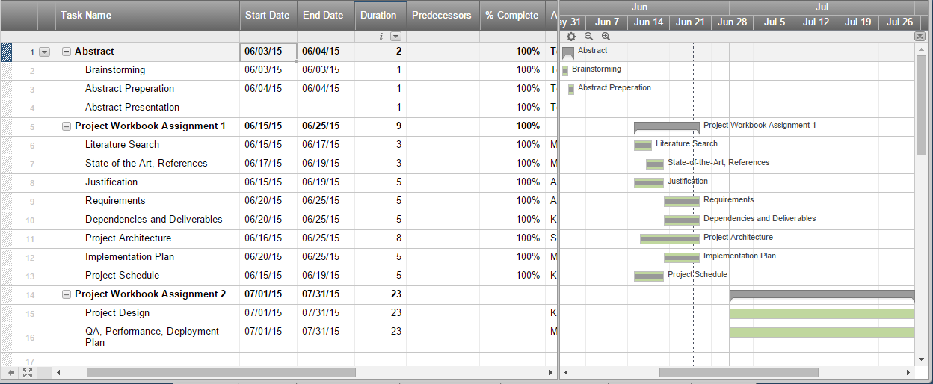**

Pert Chart:

