|  |  |  |  |
| --- | --- | --- | --- |
| Student Name | Sylvia Siu Wei Wan | Date: | 22 Oct 2018 |
| Student ID | C15423602 | Supervisor: | Tanya Thompson |

CHALLENGES:

<Describe the challenges you faced this week in your FYP, and/or describe any challenges that you have overcome from last week, and explain how you solved the problem.>

ACTION ITEMS:

<insert a bullet point list of your action items for this week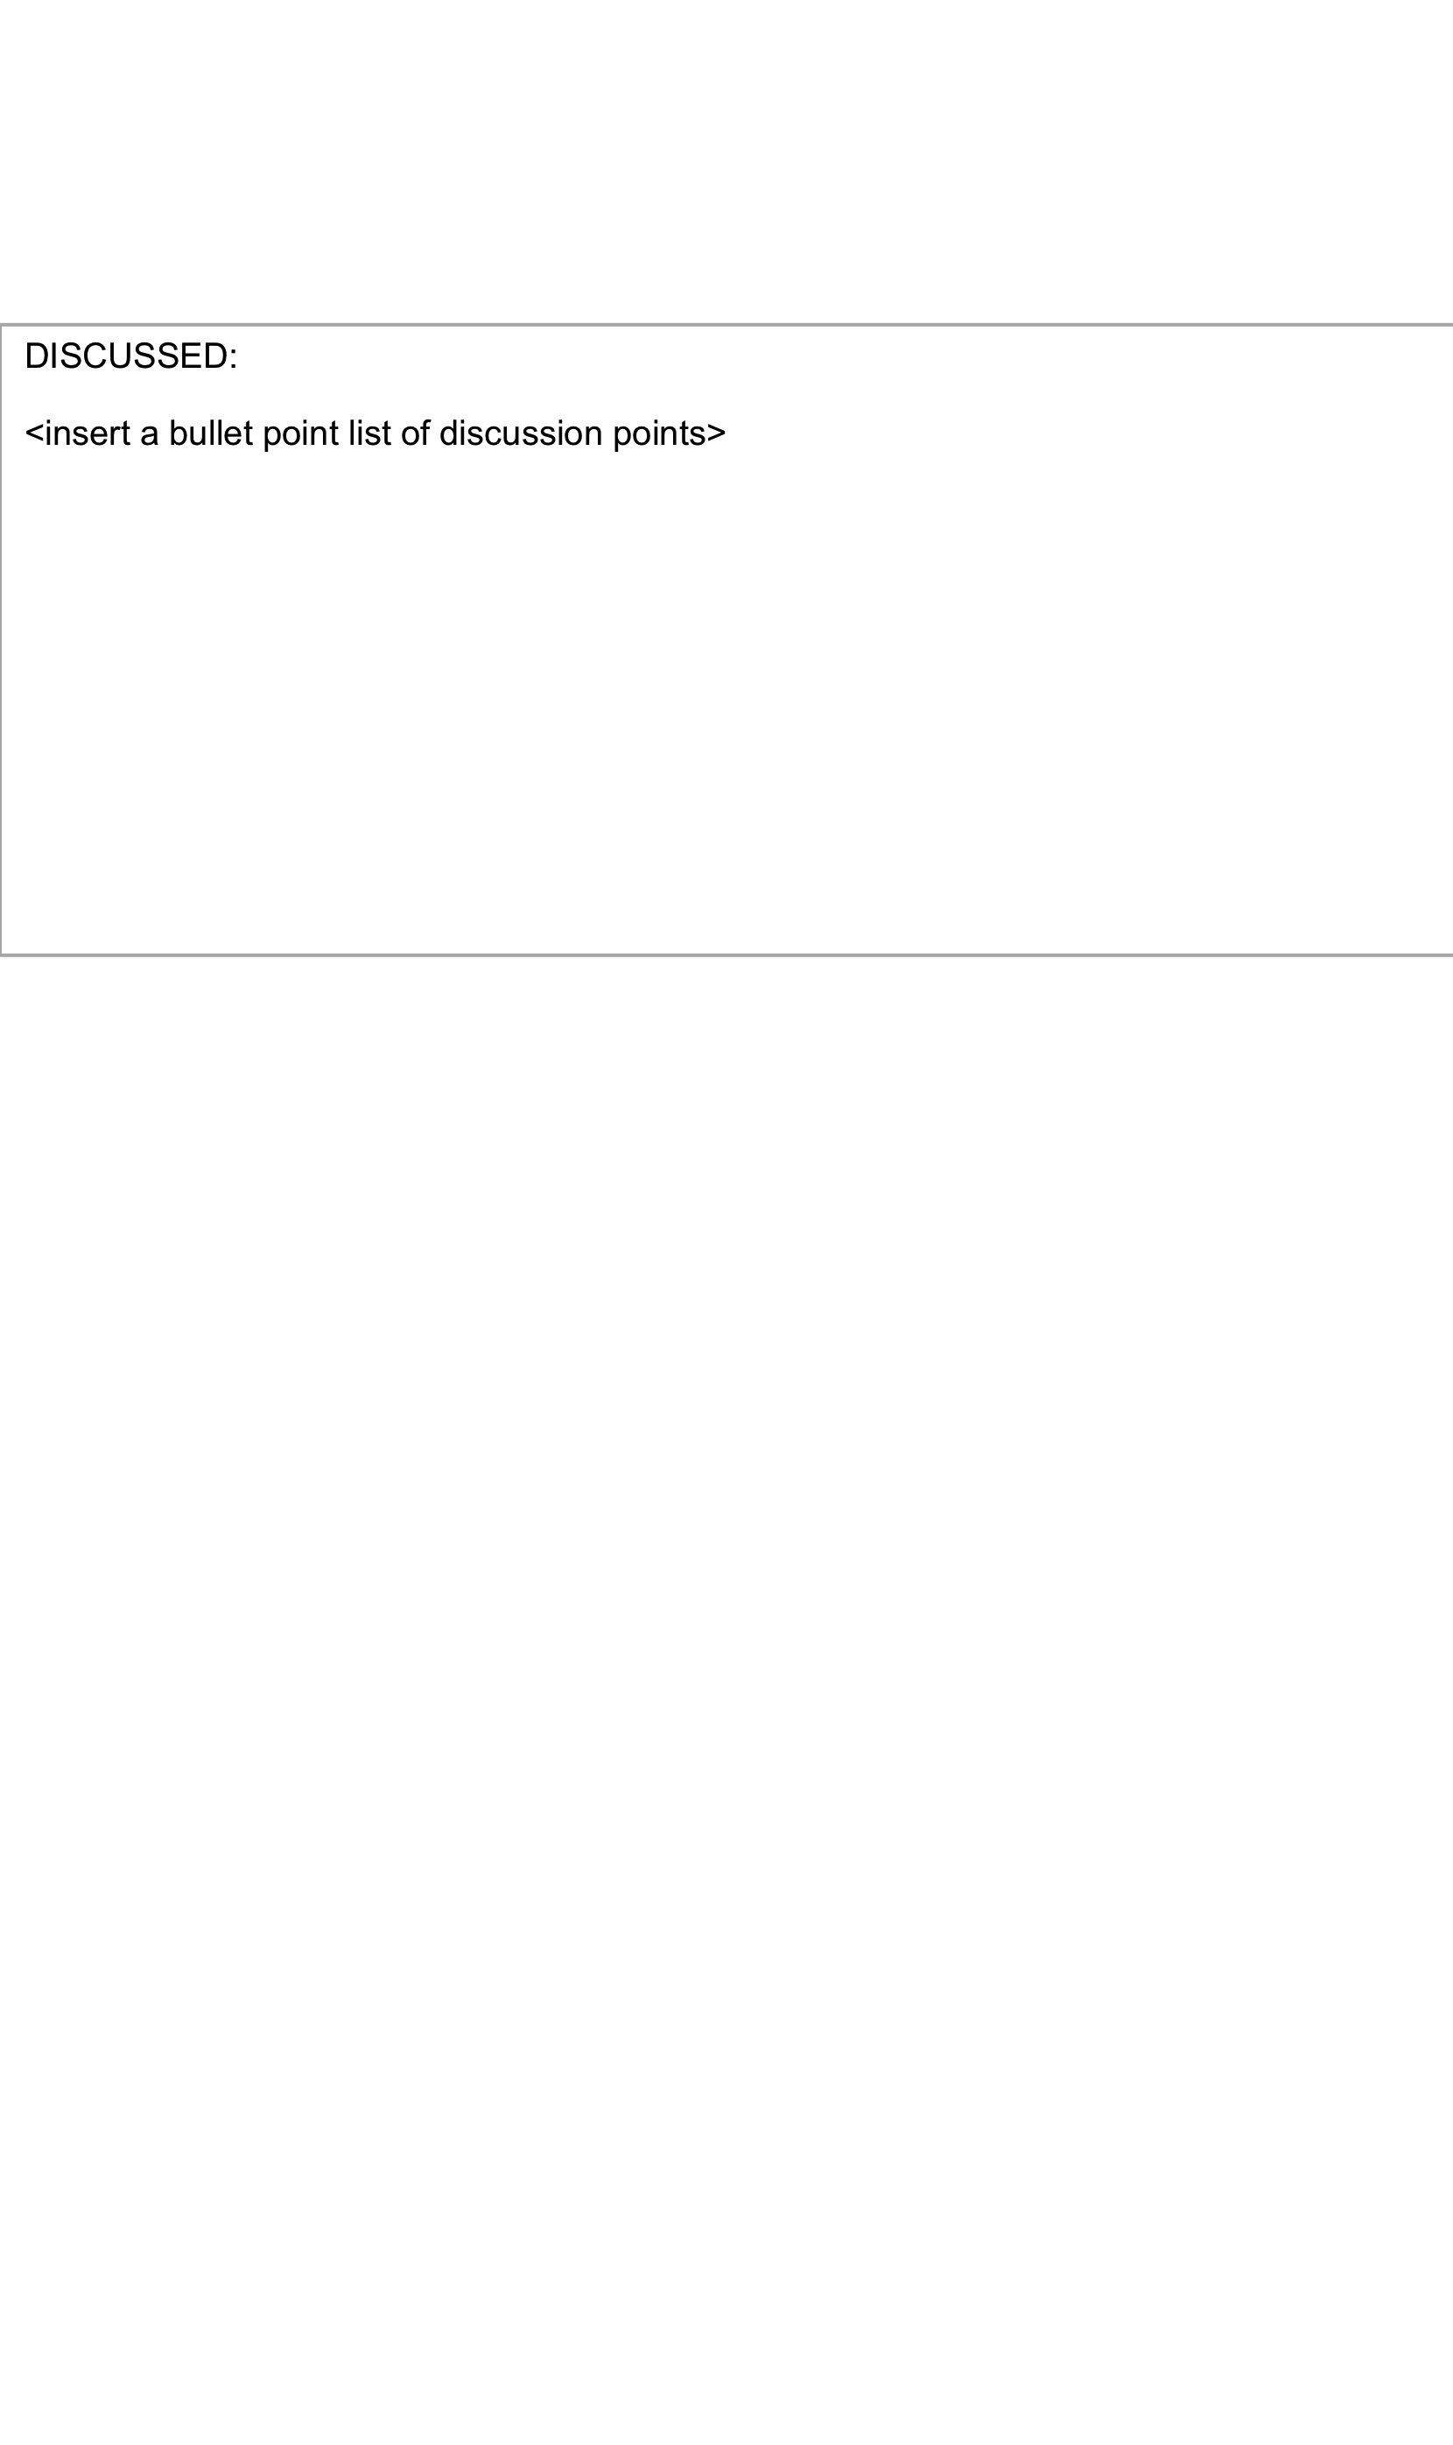>

DISCUSSED:

* Writing up interim report, take into account how much time there is into the report.
* What sort of research is to be done – recommender algorithm.
* What types of apps are similar to my project idea and how I can integrate some features, what are the differences.
* Document everything, take everything into consideration – pros and cons.
* What issues can be identified.
* Project plan – Gantt chart.
* Working prototypes.
* Do more this semester.
* Have a good scope of requirements.