|  |  |  |  |
| --- | --- | --- | --- |
| Student Name | Sylvia Siu Wei Wan | Date: | 23 Nov 18 |
| Student ID | C15423602 | Supervisor: | Tanya Thompson |

CHALLENGES:

Getting the report done in time.

ACTION ITEMS:

* Send a draft report
* Write up report
* Make necessary changes
* Explain diagrams within report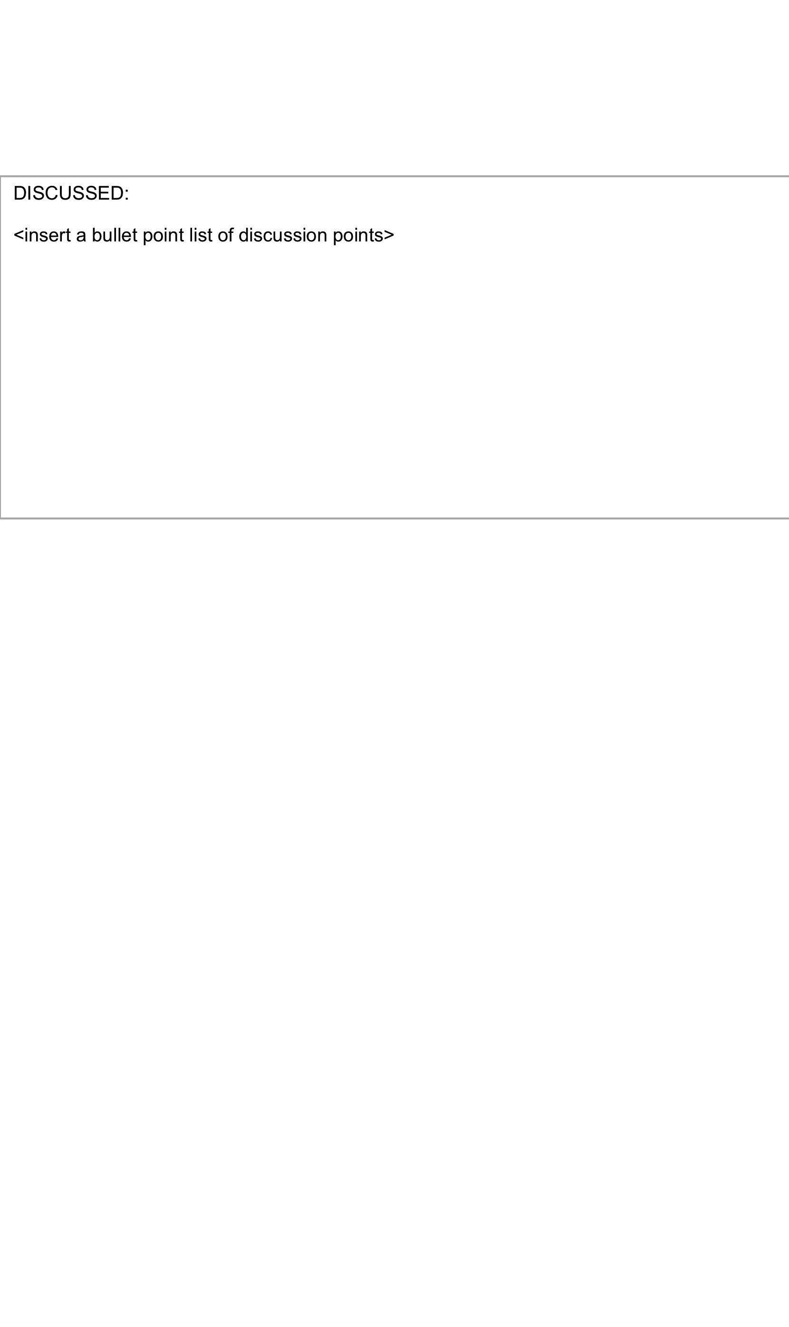inin>

DISCUSSED:

* Machine Learning complexity
* Firebase database
* What selection you choose and why?
* Criticality thinking – clearly outline the challenge
* Don’t write report in first person
* Connect database in prototype
* Architecture must be sound
* What are your objectives? Are they highly innovative?
* Critiquing and questioning yourself
* Referencing