Jack Sims
Game 3a Design Document

Design elements. Your design document must describe the following elements:
- Game name/level name. What is the name of your game, and the name of the level?
  - Game Name: Bitty
  - Level Name: Bitty’s First Steps
- Player movement. Desired player movement. After going through the Platformer Toolkit, give the desired values for your player avatar for acceleration, max speed, and deceleration on the Running tab, jump height, down gravity, and duration on the Jumping tab.
  - Acceleration: 79
  - Max Speed: 12
  - Deceleration: 76
  - Jump Height: 3.8
  - Down Gravity: 3.2
  - Duration: 2.5
- Visual asset packs. Which asset packs will you be using for (a) platform elements, (b) for the player avatar, and (c) for particle effects? Do you plan on creating any custom tiles (max. 10?)
  - a: Kenney 1-bit Platformer Pack will be used for platform elements
  - b: Kenney 1-bit Platformer Pack will be used for the player
  - c: Kenney Particle Pack will be used for all particle effects
  - I do not plan on creating any custom tiles.
- Audio. Which assets will you be using for audio for jumping and collecting actions? Will you be creating custom audio assets for any of these? What other actions will have associated audio?
  - I will not be using any pre-made assets for the audio in this game. I plan on creating all of the audio in the game using my synthesizer for jumping, collecting the goal key and coins, using the UI, and foley-like sounds for running.
- Collectibles. What kind of collectible item will be in your level? Does it have an associated score?
  - The game will have collectible coins that affect your overall score, as well as the key, which when collected ends the level.
- End of level condition. What does the player need to do to end the level?
  - The player needs to reach the key at the end of the level in order to pass on into the next level through the door next to the key.
- Camera. Please describe the kind of camera behavior your game will implement.
  - I plan on implementing a camera with no damping but a fair amount of “lookahead” so players can make accurate jumps.
If you plan on implementing any optional elements, please describe those as well.
- Nothing comes to mind, I am fine with what I have!

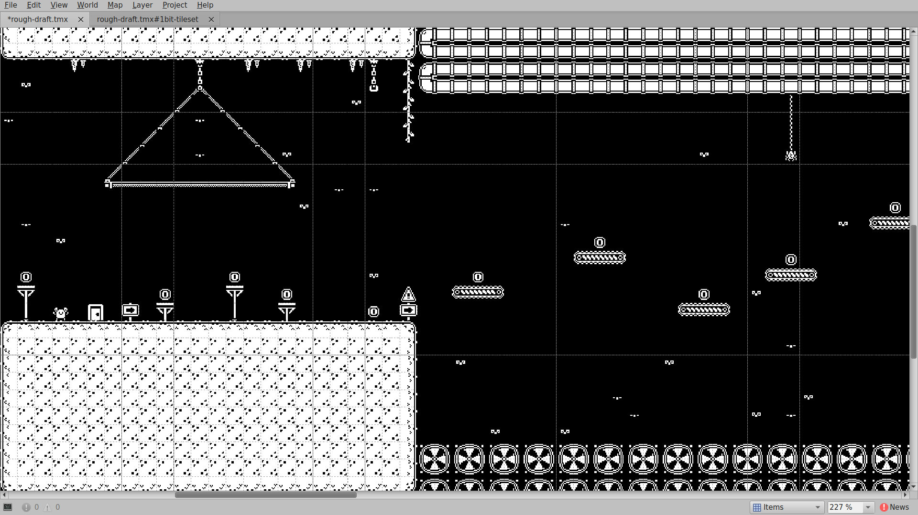
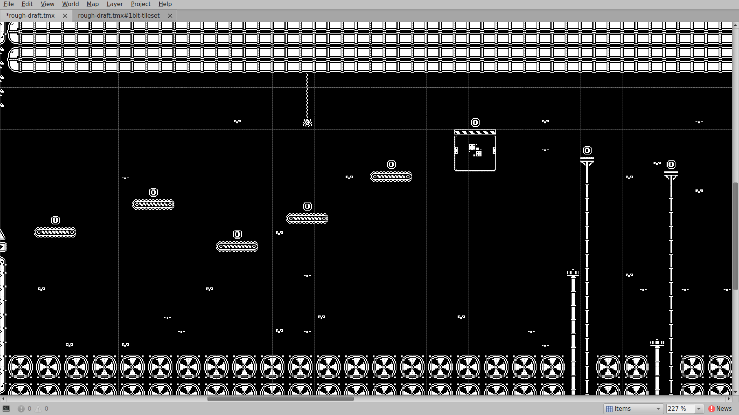
Draft level design. Using the Tiled editor, create a level which is at least three screens wide, and which includes both ground and platforms.
