STAT5810 Project2 Group A

Final Report
You Jinsheng, Tong Yin, Ekaterina Saraeva, Guy Serbin, Mingyo Chung, Vasile Turcu

Introduction

The data set we worked on is the South America Climate data - there are 76 sampling stations which are located below the 200 meters above sea level. We first examined the data using Arcview-Xgobi and Splus, the spatial classification of the data and the spatial dependence of two major variables were explored. Then we used three methods to model the mean annual temperature and annual precipitation data. The predictions at new locations that have no data were made. To evaluate the performance of each model, the fitted values were calculated at known locations, and the residuals were calculated and plotted against the fitted values. The three methods we used were:
- Trend Surface Model ;
- Ordinary Kriging;
- Universal Kriging.

Part I. Visualization and Exploration of the Data

Using Arcview_Xgobi to explore the data
1) Classification of the mean annual temperature
Spatial distribution of the mean annual temperature is shown below. South America is located in the southern semisphere of the Earth. So, the general rule for temperature is the temperature is lower given further in the south direction. No significant outliers were detected in the data set. From the figure below it is easy to see that the mean annual temperatures higher than 25°C are located to the north of 10 degree (northing, relative coordinate) while low temperatures (lower than 10 °C) lie to the south of 5 degree (northing, relative coordinate). Besides this, we found that the temperatures in the coastal areas are lower than those in the continental areas at the same latitude.
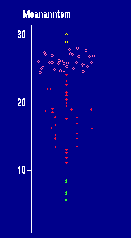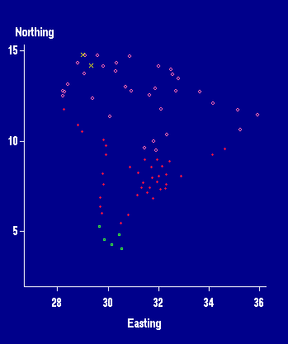

2) Classification of annual precipitation
The outliers in the precipitation data are significant. The highest annual precipitation with a value of about 7000 mm is located in the tropical rainfall forest region (north-west part of the continent). The second highest value is located in the coastal area in the south.
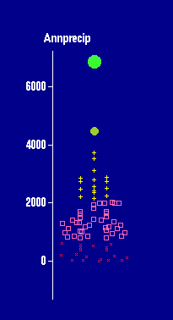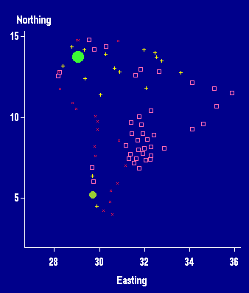

3) Contour Maps of mean annual temperature (left) and annual precipitation (right)
Here we show two maps which are interpolated from the original dataset with 12-point idw method in Arcview GIS. The temperature map (left) shows strong spatial trend (north to south direction), while the precipitation shows more rainfall in the coastal zone than within the continent.
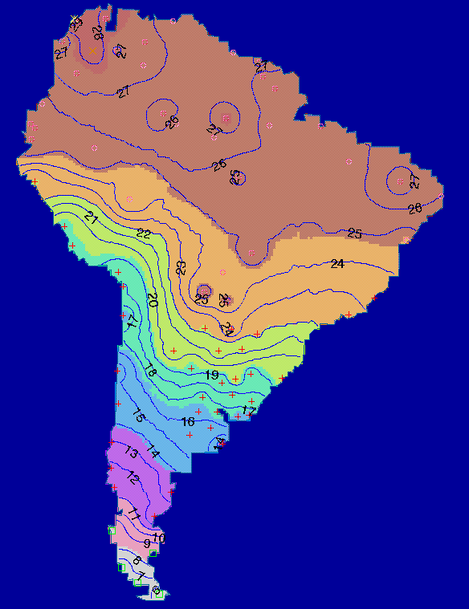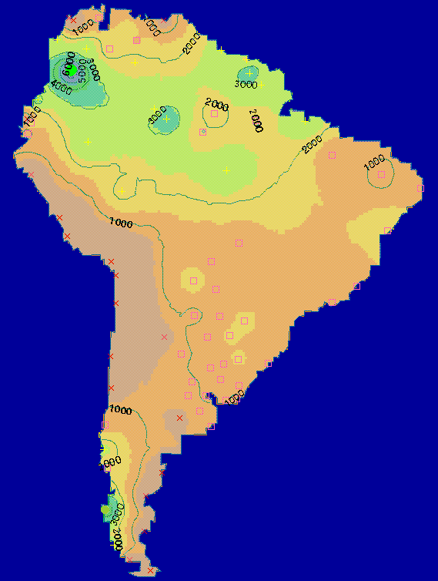

4) Variogram Cloud Link Analysis
We linked the Arcview and Xgobi using the variogram cloud link with a cutoff distance of 1307. Then the g33 (temperature) and g44 (precipitation) were analyzed. Large temperature differences were noticed in the middle part of the continent and the smallest temperature differences are in the coastal zones. For the precipitation, the highest differences are in the northwest part of the continent.
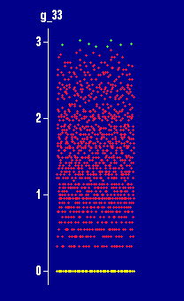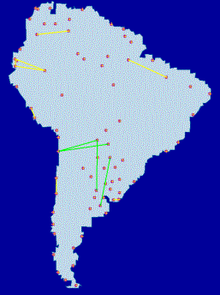

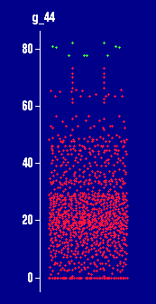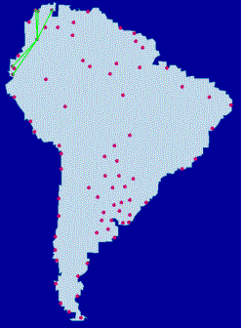

5) Grand tour to determine the clusters
We tried to find clusters using the grand tour. We brushed the points close together using different colors and glyphs; we then examined the GIS map to see if this classification makes sense. At first we used all the variables except the PCA scores to find the clusters. Then by disabling some of the variables which are highly correlated (i.e. some temperature variables that have strong correlations with the mean annual temperature, Jan and July temperatures that have strong correlations with annual precipitation), we repeated the process. The clustering grand tour plot and the Arcview map are shown below:

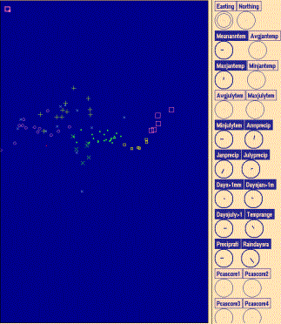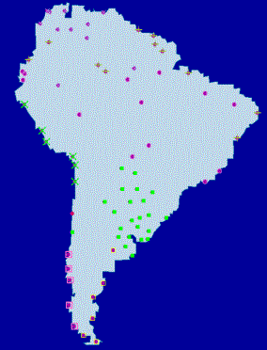
It is obvious, that the resulting clusters are very similar to those shown on page 236, Bailey & Gatrell, for the six-class solution.

We also explored the data using S-Plus. The analysis is shown in Appendix A.0, p.20.

Part II. Modeling Temperature and Precipitation

TREND SURFACE MODEL

### Temperature
As it was noted in the "Exploration of the Data" section of our project there is strong non-stationarity or trend in the Annual Temperature Data (more precisely, linear trend in North-South direction as can be seen on the contour map), so we started the analysis by removing the trend. As the first step, we tried to use Linear Trend Surface Model for removing the trend. We calculated the trend using linear and quadratic surfaces first, then removed it from the original data and found the residuals; found the main parameters necessary to construct the covariance matrix (sill, range and nugget) by fitting theoretical variogram and used Generalized Least Squares Method to make predictions. It appeared that the model did not work well enough on the given set of data: it did not effectively remove the trend (Appendix A.1, p.23).
So, we decided to take a closer look at the data and study it using directional variograms. We also tried to use another function: loess to remove the trend.
("climate" was the original data set for locations and the main parameters: temperature and precipitation (Appendix A.1, p.23))
Directional variogram for the original data (first plot):
temp.dvar1 _ variogram (Meananntemp~loc(climate$Easting, climate$Northing), data = climate, azimuth = c(0, 45, 90, 135), tol.azimuth = 11.25)
plot (temp.dvar1)
Modeling the trend using loess function:
loess.temp _ loess (Meananntemp ~ Easting*Northing, data = climate, normalize = F, span = .25)
Residuals (second plot):
temp.res _ climate$Meananntemp - predict(loess.temp)
temp.dvar2 _ variogram (temp.res~loc(climate$Easting, climate$Northing), azimuth = c(0, 45, 90, 135), tol.azimuth = 11.25, method = "robust")
plot (temp.dvar2)
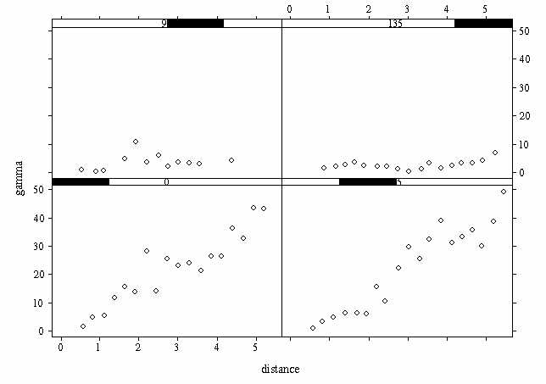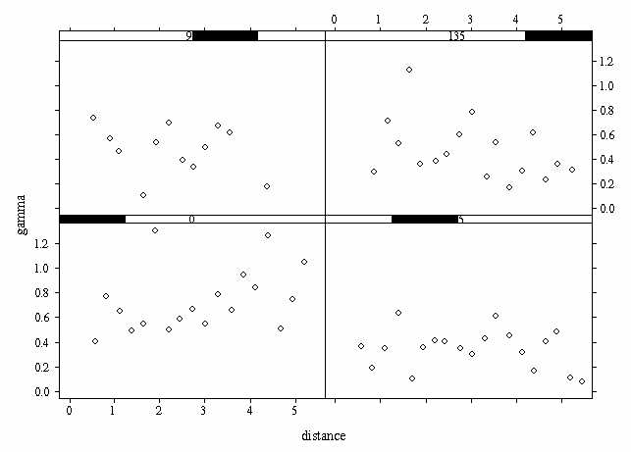
temp _ matrix (c(Easting, Northing, temp.res), 76,3)
temp _ data.frame (temp)
dimnames (temp)[[2]] _ name2
There is obvious anisotropy in North-South direction and South-West direction in the original data.
Residuals: Some non-stationarity can still be present in North-South direction. The rest of variograms do not show any spatial correlation. Correction for spatial anisotropy and subsequent determination of the variogram parameters for the residuals are shown in Appendix A.3, p.34 . The final parameters are:
range - 1.5;
sill - 0.35;
nugget - 0.25.
We used Generalised Least Squares Model to make predictions using linear and quadratic models.
For Generalised Least Squares Model predicted values are calculated according to the following formulas:
Y(s) = X(s) * betta
betta = ( t(X) * C^-1 * X) ^-1 * t(X) * C^-1 * y
where X(s) - (p x 1) vector of p functions of the spatial coordinates;
C - (n x n) matrix of covariances;
y - vector of observed values at the sample sites s;
U(s) - zero mean errors;
betta - (p x 1) vector of parameters to be estimated when the model fitted to the observed data.
The S-Plus codes used to construct the C and X matrixes (for linear and quadratic surfaces) are presented in Appendix A.2, p.32.
The linear model did not work very well (Appendix A.4, p.37); predictions made using quadratic model are shown below.
Ct _ covmat (76, Easting, Northing, 0.35, 1.5, 0.25)
Xq _ quadxmake (76, Easting, Northing)
bettaqt _ (solve(t(Xq) %*% (solve (Ct)) %*% (Xq))) %*% t(Xq) %*% (solve (Ct)) %*% y
Yqt _ Xq %*% bettaqt
Exploration of residuals:
temp.res2 _ climate$Meananntemp - Yqt
temp2 _ matrix (c(Easting, Northing, temp.res2), 76,3)
temp2 _ data.frame (temp2)
dimnames (temp2)[[2]] _ name2
temp2.varmom _ variogram (temp2$Residual~loc (Easting, Northing), data = temp2)
temp2.var _ variogram (temp2$Residual~loc (Easting, Northing), data = temp2, method ="robust")
par (mfrow=c(1,2))
par (pty = "s")
plot (temp2.varmom)
title ("MOM")
plot (temp2.var)
title ("Robust")
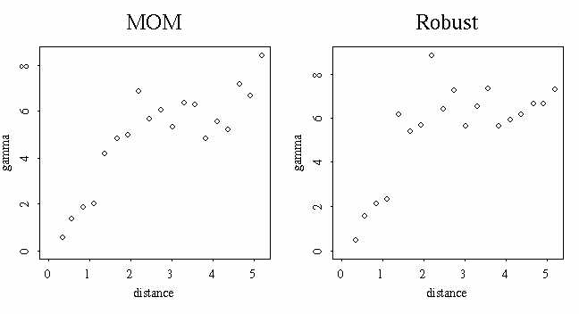
Quadratic model did a good job: the variograms show an upper boundary.
So, our final predictions are:
par (mfrow = c(1,2))
climatep.predt1 _ interp (x=Easting, y= Northing, z=Yqt)
persp (climatep.predt1, zlab = "temp")
title ("Predicted Temp: Quad. Model")
persp (climate.interp, zlab = "temp")
title ("Original Temp Data")
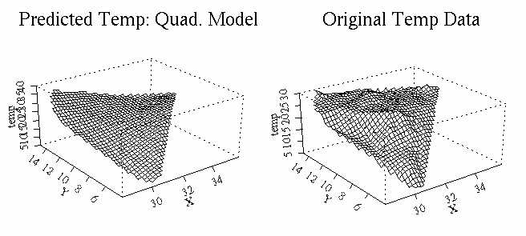
Obviously, predictions are not very good.
Model performance test:
Residual plots:
par (mfrow = c (1,2))
par (pty = "s")
plot (Yqt, temp.res2, pch = 16, ylab = "residuals", xlab = "Modeled Temp", main = "Residuals vs. Fit: MeanTemp")
abline (0, lty =4)
plot (temp.res2, pch = 16, ylab = "residuals", main = "Residuals : MeanTemp")
abline (0, lty =4)
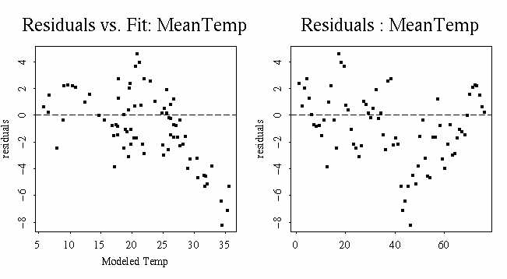
Mean squared error and maximum absolute error:
mean (temp.res2^2)
[1] 7.581058
max (abs (temp.res2))
[1] 8.141688
We proved again that predictions are not good: residual plots do not show uniform distribution and the mean squared error and maximum absolute error values are very high.
As a result of our analysis we obtained trend model for the temperature data set which produced de-trended but spatially depended residuals. The final coefficients of the quadratic surface model are:
bettaqt
[,1]
[1,] -168.37847565
[2,] 3.72322837
[3,] 20.82659253
[4,] 0.05929545
[5,] 0.03517499
[6,] -0.62892299
Spatial Correlation was modeled using Gaussian Variogram.
During this analysis it was also found that loess is a more powerful function for removing trends.

### Precipitation:
As it was shown in the "Exploration of the Data" section there is no obvious linear trend in the data (contour map). It was shown that there is possible zonal anisotropy in all directions but the most obvious is in North-South direction. We checked if that anisotropy was a result of trend:
Function loess was used to model the trend surface:
loess.precip _ loess (Annpreip ~ Easting*Northing, data = climate, normalize = F, span = .25)
Directional variogram based on de-trended data:
precip.res _ climate$Annpreip - predict(loess.precip)
precip.dvar2 _ variogram (precip.res~loc(climate$Easting, climate$Northing), azimuth = c(0, 45, 90, 135), tol.azimuth = 11.25, method = "robust")
plot (precip.dvar2)
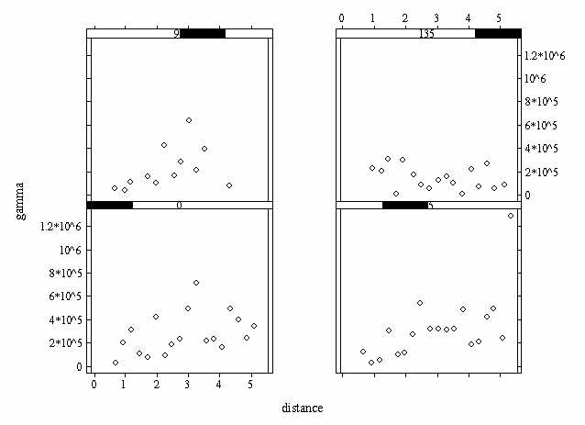
Non of the variograms shows obvious spatial correlation. They all are basically flat, the sills are almost the same and are reduced from the original directional variogram (from 1.5x10^6 to 8x10^5). This is probably the result of removing the trend.
Analysis of directional variograms and obtaining the main parameters for variogram are presented in Appendix A.5, p.38.
The final parameters for Exponential variogram are:
range - 3.5;
sill - 352000;
nugget - 0.
We used the same functions as before. First, Linear Trend Surface (Appendix A.6, p.41). Again, the predictions were not good at all, so we tried Quadratic Trend Surface:
Cp _ covmatexp (76, Easting, Northing, 352000, 3.5, 0)
Xq _ quadxmake (76, Easting, Northing)
bettaqp _ (solve(t(Xq) %*% (solve (Cp)) %*% (Xq))) %*% t(Xq) %*% (solve (Cp)) %*% yp
Yqp _ Xq %*% bettaqp
We studied the residuals:
residual.precq _ climate$Annpreip - Yqp
prec.resq _ matrix (c(Easting, Northing, residual.precq), 76,3)
prec.resq _ data.frame (prec.resq)
dimnames (prec.resq)[[2]] _ name2
finalpq.varmom _ variogram (prec.resq$Residual~loc (Easting, Northing), data = prec.resq)
finalpq.var _ variogram (prec.resq$Residual~loc (Easting, Northing), data = prec.resq, method ="robust")
par (mfrow=c(1,2))
par (pty = "s")
plot (finalpq.varmom)
title ("MOM")
plot (finalpq.var)
title ("Robust")
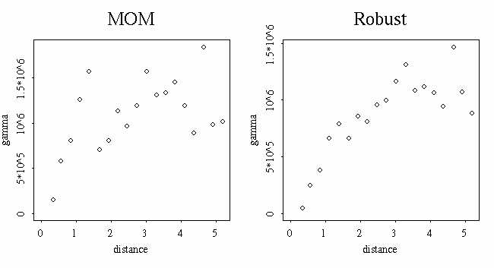
These variograms do not show any trend.
par (mfrow = c(1,2))
climatep.predq _ interp (x=Easting, y= Northing, z=Yqp)
persp (climatep.predq, zlab = "precip")
title ("Predicted Precip: Quad. Model")
persp (climatep.interp, zlab = "precip")
title ("Original Precip Data")
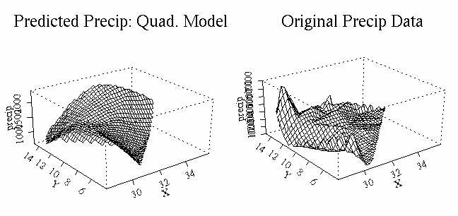
This prediction does not look good either. So, we can conclude that Trend Surface Model is not able to capture variability of spatially variable data.
Residual plots:
par (mfrow = c (1,2))
par (pty = "s")
plot (Yqp, residual.precq, pch = 16, ylab = "residuals", xlab = "Modeled Precip", main = "Residuals vs. Fit: AnnPrecip")
abline (0, lty =4)
plot (residual.precq, pch = 16, ylab = "residuals", main = "Residuals : AnnPrecip")
abline (0, lty =4)
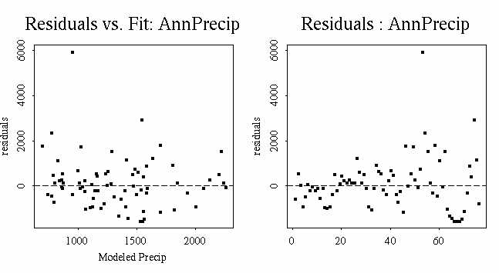

Mean squared error and maximum absolute error:
mean (residual.precq^2)
[1] 1305276
max (abs (residual.precq))
[1] 5951.163
We confirmed that predictions are not good: residual plots show some significant outliers and the mean squared error and maximum absolute error values are extremely high.
Still, we thought, that quadratic surface model produced a better trend surface, so the final coefficients for the trend model are:
bettaqp
[,1]
[1,] 7079.786960
[2,] 590.058389
[3,] -2924.418867
[4,] -26.646334
[5,] -8.538809
[6,] 102.781250
Spatial Correlation was modeled using Exponential Variogram.
ORDINARY KRIGING
### Temperature
For ordinary kriging we first used original, not de-trended data (Appendix B.1, p.43). We did not get good predictions. As a next step we tried to do ordinary kriging on residuals after removing the initial large-scale trend ("Trend Surface Model" section).
Spatial correlation was modeled using Gaussian variogram (Appendix A.3, p.34) with parameters:
range - 1.5;
sill - 0.35;
nugget - 0.25.
temp.krigo1 _ krige (temp.res ~ loc (Easting, Northing, 0, 1.25), data = climate, covfun = gauss.cov, range = 1.5, sill = (0.35-0.25), nugget = 0.25)
Defining the polygon for predictions:
plot (climate$Easting, climate$Northing, pch=16)
temp.poly_locator(type="l")
predict.loc2_poly.grid(temp.poly,size=c(0.4,0.45))
points(predict.loc2,pch="+")
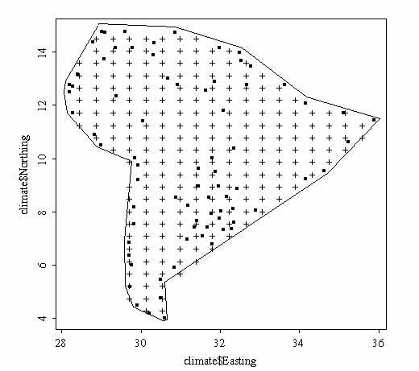
predict.loc2_data.frame(predict.loc2)
name5_c("Easting", "Northing")
dimnames(predict.loc2)[[2]]_name5
Predictions inside user-specified polygon:
temp.opred1 _ predict (temp.krigo1, newdata = predict.loc2)
summary (temp.opred1)
Easting Northing fit se.fit
Min.:28.40 Min.: 4.302 Min.:-0.46520 Min.:0.5205
1st Qu.:30.10 1st Qu.: 8.748 1st Qu.:-0.09671 1st Qu.:0.5435
Median:31.38 Median:10.850 Median:-0.03893 Median:0.5503
Mean:31.41 Mean:10.450 Mean:-0.03699 Mean:0.5523
3rd Qu.:32.66 3rd Qu.:12.260 3rd Qu.: 0.01107 3rd Qu.:0.5602
Max.:35.64 Max.:14.600 Max.: 0.52420 Max.:0.5866
Predicted surface for the data: add predictions from the spatial loess model to the kriged residuals:
temp.lo _ predict(loess.temp, predict.loc2)
temp.opred2_temp.opred1$fit+temp.lo
summary(temp.opred2)
Min. 1st Qu. Median Mean 3rd Qu. Max.
6.933 19.370 24.980 22.420 26.000 28.270
Plotting the contours:
xmat_sort(unique(predict.loc2$Easting))
ymat_sort(unique(predict.loc2$Northing))
temp.predmat_matrix(NA,length(xmat),length(ymat))
temp.predmat[cbind(match(predict.loc2$Easting,xmat),match(predict.loc2$Northing,ymat))]_temp.opred2-1
temp.semat_matrix(NA,length(xmat),length(ymat))
temp.semat[cbind(match(predict.loc2$Easting,xmat),match(predict.loc2$Northing,ymat))]_temp.opred1$se.fit
par(mfrow=c(1,2))
par(pty="s")
plot (Easting, Northing)
contour (xmat, ymat, temp.predmat, levels = c(7, 10, 13, 15, 17, 20, 23, 25, 28, 30), add=T, plotit = T, lty=3)
title ("Contour Map of Predictions")
contour (xmat, ymat, temp.semat)
title ("Contour Map of Standard Errors")
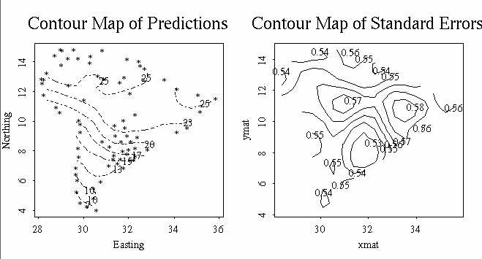
These contours are close to the original data.
Perspective 3-D plots of original, predicted and se.fit surfaces:
par(mfrow=c(1,3))
par(pty="s")
persp (climate.interp, zlab = "temp")
title ("Original Temperature Data")
temp.interpko2 _ interp (x=temp.opred1$Easting, y= temp.opred1$Northing, z=temp.opred2)
persp (temp.interpko2, zlab = "Predicted Temp")
title ("Predicted Temperature ")
temp.interpose2_interp(x=temp.opred1$Easting, y= temp.opred1$Northing, z=temp.opred1$se.fit)
persp (temp.interpose2, zlab = "Se.fit")
title ("SE for Fit ")
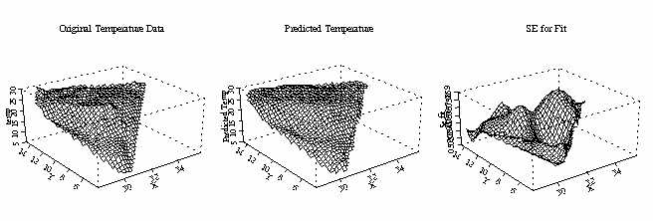
Ordinary Kriging predicted temperature quite well.

Model performance testing:
Predicting temperatures at known locations:
temp.loc _ predict (temp.krigo1, newdata =climate)
temp.loloc _ predict(loess.temp, climate)
temp.oloc _ temp.loc$fit+temp.loloc
Residuals:
res.tempfit _ climate$Meananntemp - temp.oloc
Mean squared error:
mean (res.tempfit^2)
[1] 1.24557e-31
Maximum absolute error:
max (abs (res.tempfit))
[1] 1.776357e-15
par (mfrow = c (1,2))
par (pty = "s")
plot (temp.oloc, res.tempfit, pch = 16, ylab = "residuals", xlab = "Fitted Temp", main = "Res vs. Fit: Ord.Krig on Temp")
abline (0, lty =4)
plot (res.tempfit, pch = 16, ylab = "residuals", main = "Residuals: Ord. Krig on Temp")
abline (0, lty =4)
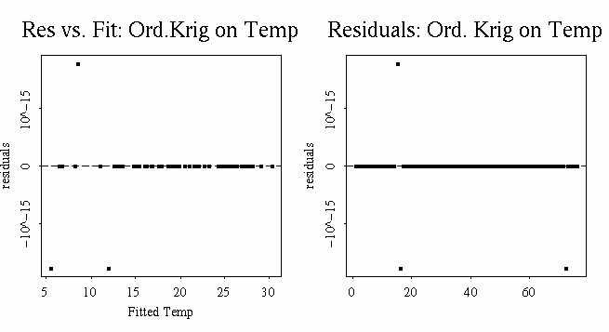
Again, residual plots do not show any non-stationarity and calculated values of mean square error and maximum absolute error are very low. The model works very well.
### Precipitation
In this case we also tried to make predictions using original and de-trended data. Predictions on de-trended data looked a little better so we presented them as a final result. Predictions based on original data are shown in Appendix B.2, p.46.
Spatial correlation was modeled using exponential variogram ("Trend Surface Model" section, Appendix A.5, p.38) with parameters:
range - 3.5;
sill - 352000;
nugget - 0.
prec.krigo1 _ krige (precip.res ~ loc (Easting, Northing, 0, 1.25), data = climate, covfun = exp.cov, range = 3.5, sill = 352000, nugget = 0)
prec.opred1 _ predict (prec.krigo1, newdata = predict.loc2)
Predicted surface for the data: add predictions from the spatial loess model to the kriged residuals:
prec.lo _ predict(loess.precip, predict.loc2)
prec.opred2_prec.opred1$fit+prec.lo
Plotting the contours:
prec.predmat_matrix(NA,length(xmat),length(ymat))
prec.predmat[cbind(match(predict.loc2$Easting,xmat),match(predict.loc2$Northing,ymat))]_prec.opred2-1
prec.semat_matrix(NA,length(xmat),length(ymat))
prec.semat[cbind(match(predict.loc2$Easting,xmat),match(predict.loc2$Northing,ymat))]_prec.opred1$se.fit
par(mfrow=c(1,2))
par(pty="s")
plot (Easting, Northing)
contour (xmat, ymat, prec.predmat, levels = c(1000, 2000, 3000), add=T, plotit = T, lty=3)
title ("Contour Map of Predictions")
contour (xmat, ymat, prec.semat)
title ("Contour Map of Standard Errors")
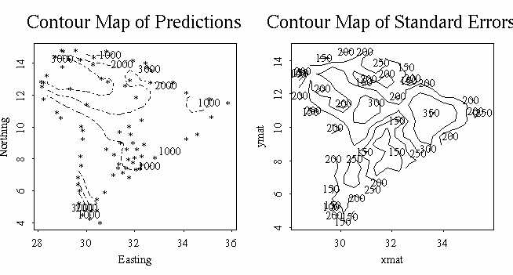

Perspective 3-D plots of original, predicted and se.fit surfaces:
par(mfrow=c(1,3))
par(pty="s")
persp (climatep.interp, zlab = "precip")
title ("Original Precipitation Data")
prec.interpko2 _ interp (x=prec.opred1$Easting, y= prec.opred1$Northing, z=prec.opred2)
persp (prec.interpko2, zlab = "Predicted Prec")
title ("Predicted Precipitation ")
prec.interpose2_interp(x=prec.opred1$Easting, y= prec.opred1$Northing, z=prec.opred1$se.fit)
persp (prec.interpose2, zlab = "Se.fit")
title ("SE for Fit ")
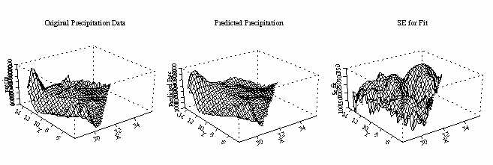
Ordinary Kriging on residuals looks a little better then that on original data, but in general the model predicted precipitation quite well again.
Model performance testing:
Predicting precipitation at known locations:
prec.loc _ predict (prec.krigo1, newdata =climate)
prec.loloc _ predict(loess.precip, climate)
prec.oloc _ prec.loc$fit+prec.loloc
Residuals:
res.precfit _ climate$Annpreip - prec.oloc
mean (res.precfit^2)
[1] 1.133453e-23
max (abs (res.precfit))
[1] 8.6402e-12
par (mfrow = c (1,2))
par (pty = "s")
plot (prec.oloc, res.precfit, pch = 16, ylab = "residuals", xlab = "Fitted Prec", main = "Res vs. Fit: Ord. Krig on Precip")
abline (0, lty =4)
plot (res.precfit, pch = 16, ylab = "residuals", main = "Residuals: Ord. Krig on Precip")
abline (0, lty =4)
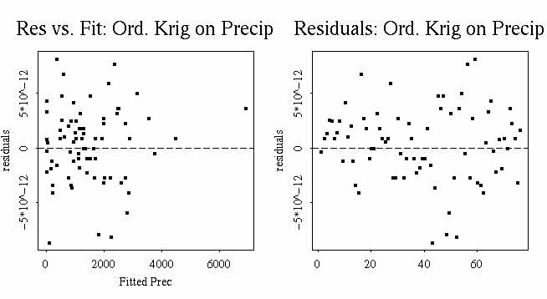
Residual plots do not show any correlation or trend. The mean squared error and maximum absolute error are very small. We can conclude that the model works quite well.
UNIVERSAL KRIGING
### Temperature
Precipitation was modeled using trend model described in "Trend Surface Model" section: Quadratic Trend Surface.
temp.ukrig _ krige (Meananntemp ~ loc(Easting, Northing)+ (-168.378476) + 3.723228*Easting+ 20.826592*Northing+ 0.05929545*Easting^2+ 0.03517499*Northing^2+ (-0.62892299)*Easting*Northing, data = climate, covfun = gauss.cov, range =1.5, sill = 0.35, nugget = 0.25)
temp.upred _ predict (temp.ukrig, newdata = predict.loc2)
Perspective plots of the mean annual temperature original data and predictions:
par(mfrow=c(1,3))
par(pty="s")
persp (climate.interp, zlab = "temp")
title ("Original Temperature Data")
temp.interpuk _ interp (x=temp.upred$Easting, y= temp.upred$Northing, z=temp.upred$fit)
persp (temp.interpuk, zlab = "Predicted Temp")
title ("Predicted Temp: Univ Kriging ")
temp.interpuke_interp(x=temp.upred$Easting, y= temp.upred$Northing, z=temp.upred$se.fit)
persp (temp.interpuke, zlab = "Se.fit")
title ("SE for Fit ")
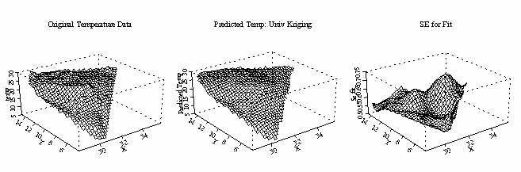
Universal kriging seemed to predict the temperature relatively well.
Making predictions at known locations and analyzing the residuals:
temp.u2pred _ predict (temp.ukrig, newdata = climate)
ures.temp _ climate$Meananntemp - temp.u2pred$fit
mean (ures.temp^2)
[1] 8.148103e-30
max (abs (ures.temp))
[1] 7.105427e-15
par (mfrow = c (1,2))
plot (temp.u2pred$fit, ures.temp, pch = 16, ylab = "residuals", xlab = "Fitted Temp", main = "Res vs. Fit: Univ. Krig on Temp")
abline (0, lty =4)
plot (ures.temp, pch = 16, ylab = "residuals", main = "Residuals: Univ. Krig on Temp")
abline (0, lty =4)
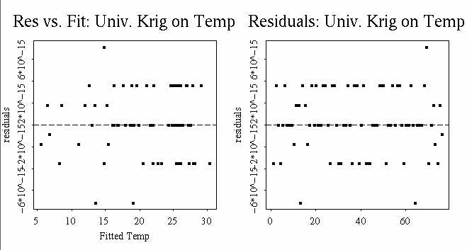

As far as residuals distribution and calculated values for errors (not significant) we conclude that the model is appropriate.
### Precipitation
Precipitation was modeled using Quadratic Trend Surface Model ("Trend Surface Model" section).
precip.ukrig _ krige (Annpreip ~ loc(Easting Northing)+7079.786960+590.058389*Easting+(-2924.418867)*Northing+(-26.646334)*Easting^2+(-8.538809)*Northing^2+102.781250*Easting*Northing, data = climate, covfun = exp.cov, range =3.5, sill = 352000, nugget = 0)
Do the kriging on all new locations within the user-defined polygon
precip.upred _ predict (precip.ukrig, newdata = predict.loc2)
Perspective plots of the mean annual temperature original data and predictions
par (mfrow=c(1,3))
par (pty="s")
persp (climatep.interp, zlab = "precip")
title ("Original Precipitation Data")
precip.interpuk _ interp (x=precip.upred$Easting, y= precip.upred$Northing, z=precip.upred$fit)
persp (precip.interpuk, zlab = "Predicted Precip.")
title ("Predicted Precip: Univ Kriging ")
precip.interpsuke_interp(x=precip.upred$Easting, y= precip.upred$Northing, z=precip.upred$se.fit)
persp (precip.interpsuke, zlab = "Se.fit ")
title ("SE for Fit ")
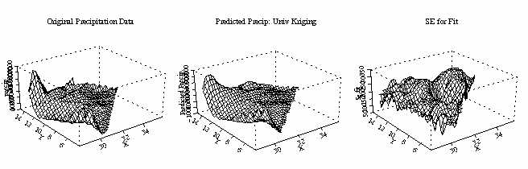
Universal kriging seemed to make not bad predictions for temperature and precipitation.
Making predictions at known locations and analyzing the residuals:
precip.u2pred _ predict (precip.ukrig, newdata = climate)
ures.precip _ climate$Annpreip - precip.u2pred$fit
mean (ures.precip^2)
[1] 2.154805e-23
max (abs (ures.precip))
[1] 1.63709e-11
par (mfrow = c (1,2))
plot (precip.u2pred$fit, ures.precip, pch = 16, ylab = "residuals", xlab = "Fitted Precip", main = "Res vs. Fit: Univ. Krig on Precip")
abline (0, lty =4)
plot (ures.precip, pch = 16, ylab = "residuals", main = "Residuals: Univ. Krig on Precip")
abline (0, lty =4)
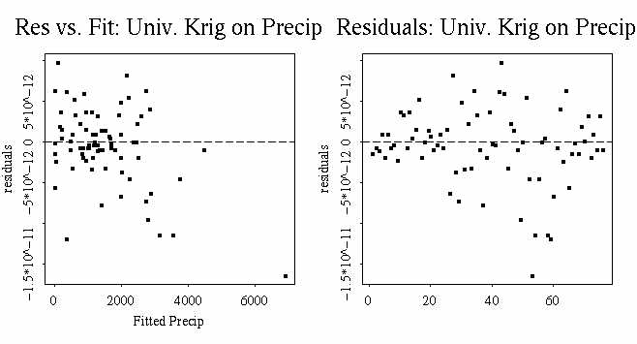
Residual plots and low values of calculated errors confirm that the model is appropriate in this case also.
CONCLUSIONS
### Temperature
Final plots of original and predicted temperature:
par(mfrow=c(1,2))
par(pty="s")
persp (climate.interp, zlab = "temp")
title ("Original Temperature")
persp (climatep.predt1, zlab = "temp")
title ("Predicted Temp: GLS Model")
persp (temp.interpko2, zlab = "Pred Temp")
title ("Predicted Temp: Ordinary Krig")
persp (temp.interpuk, zlab = "Pred Temp")
title ("Predicted Temp: Universal Krig ")
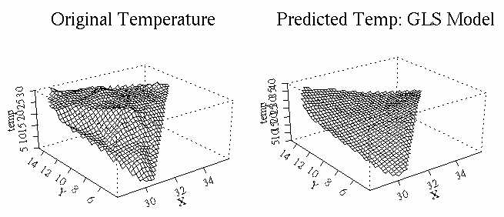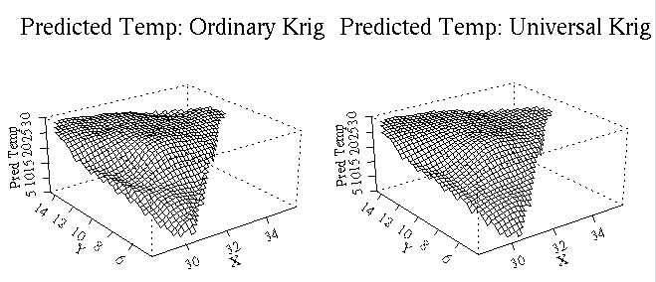
Ordinary and Universal Kriging gave us good predictions with different degree of smoothness: Ordinary Kriging shows a little more variability.
### Precipitation
The final plots for precipitation:
par(mfrow=c(1,2))
par(pty="s")
persp (climatep.interp, zlab = "precip")
title ("Original Precipitation Data")
persp (climatep.predq, zlab = "precip")
title ("Predicted Precip: GLS Model")
persp (prec.interpko2, zlab = "Predicted Prec")
title ("Predicted Precip: Ordinary Krig")
persp (precip.interpuk, zlab = "Predicted Precip.")
title ("Predicted Precip: Universal Krig ")
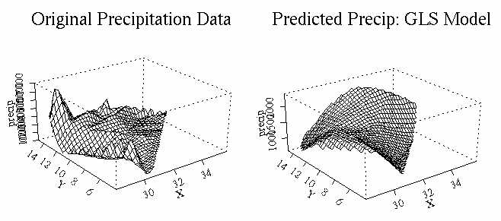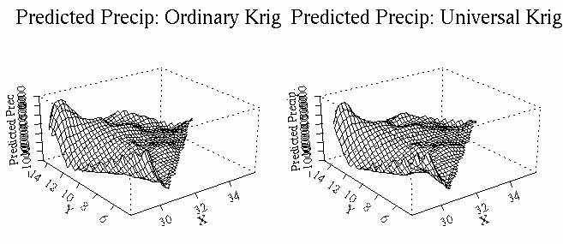
Universal Kriging seemed to have done better predictions in case of precipitation.

References:
- T. C. Bailey, A. C. Gatrell (1995): Interactive Spatial Data Analysis, Longman/Wiley, New York.
- S. P . Kaluzny, S. C. Vega (1997): S+SpatialStats, Springer, New York.

The modeling part of the project can be found at http://www.gis.usu.edu/~ssa1/project2.html
APPENDIX A.0

Using S-Plus to explore the data

1) Import data into S-plus
climateall_matrix(scan("/home/ssa6/project2/samclimate.txt"),76,22,byrow=T)
#include only 4 columns x,y, MeanAnnTemp, AnnPrecip in "samclim"
samclim_matrix(c(climateall[,1],climateall[,2],climateall[,3],climateall[,10]),76,4)
# names for the four columns in samclim
names2_c("x","y","MeanAnnTemp","AnnPrecip")
#the next two commands is used to convert matrix into a data frame
samclim_data.frame(samclim)
dimnames(samclim)[[2]]_names2

2) Simple Plots: sampling locations, histograms of the mean annual temperature, annual precipitation
par(mfrow=c(1,3))
par(pty="s")
plot(samclim$x,samclim$y,xlab="Easting",ylab="Northing")
title("Sampling locations")
hist(samclim$MeanAnnTemp,xlab="Mean Annual Temp")
title("Hist of MeanAnnTemp")
hist(samclim$AnnPrecip,xlab="Annual Precipitation")
title("Hist of AnnPrecip")
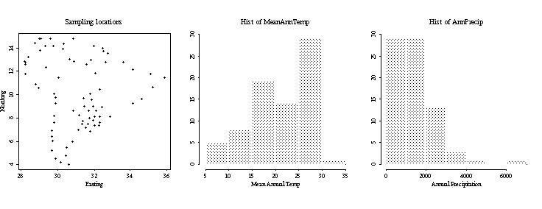
3) Explore spatial dependence using variogram and variogram cloud plots
The variogram plots provide a measure of spatial correlation by describing how sample data are related with distance and direction (anisotropy: directional variograms).
#plot the variograms for MeanAnnTemp and AnnPrecip using ordinary and robust methods
par(mfrow=c(2,2))
par(pty="s")
temp.var1_variogram(MeanAnnTemp~loc(x,y),data=samclim)
plot(temp.var1)
title(main="MeanAnnTemp Variogram Plot")
temp.var2_variogram(MeanAnnTemp~loc(x,y),data=samclim,method="robust")
plot(temp.var2)
title(main="MeanAnnTemp Variogram-Robust")
precip.var1_variogram(AnnPrecip~loc(x,y),data=samclim)
plot(precip.var1)
title(main="Annual Precip Variogram Plot")
precip.var2_variogram(AnnPrecip~loc(x,y),data=samclim,method="robust")
plot(precip.var2)
title(main="Annual Precip Variogram-Robust")
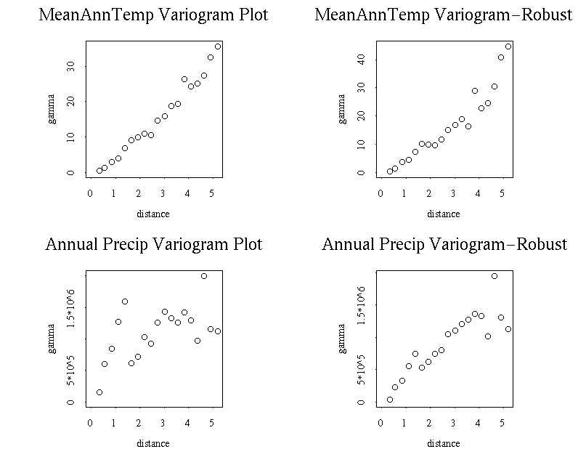
The variograms for both variables show significant increasing of gamma with distance. For the mean annual temperature, there is not an upper bound of the gamma, this indicates non-stationarity in the process. For the precipitation data it is not that obvious: it may or may not have a boundary. Both processes show very good spatial continuity.
The variogram clouds can be used in conjunction with box plots to detect the potential outliers or trends, and to access the variability with increasing distance. Anomalies and nonhomogeneous areas can be detected by looking at short distances that yield high dissimilarities (large values of gamma). Here we use the square-root differences variogram cloud, it is easier to detect outliers in box plots
#variogram cloud plots and boxplots. (Normal variogram cloud plots can be found at the project website)
par(mfrow=c(2,2))
par(pty="s")
temp.vcloud2_variogram.cloud(MeanAnnTemp~loc(x,y),data=samclim,fun=function(zi,zj) sqrt(abs(zi-zj))/2)
plot(temp.vcloud2)
title(main="Temp SqaredRT Variogram cloud")
boxplot(temp.vcloud2,mean=T,pch="o")
title(main="Temp SqaredRT VarioCloud Boxplot")
precip.vcloud2_variogram.cloud(AnnPrecip~loc(x,y),data=samclim,fun=function(zi,zj) sqrt(abs(zi-zj))/2)
plot(precip.vcloud2)
title(main="PercipSqaredRTVariogram cloud")
boxplot(precip.vcloud2,mean=T,pch="o")
title(main="PRecip SqaredRTVarioCloud Boxplot")
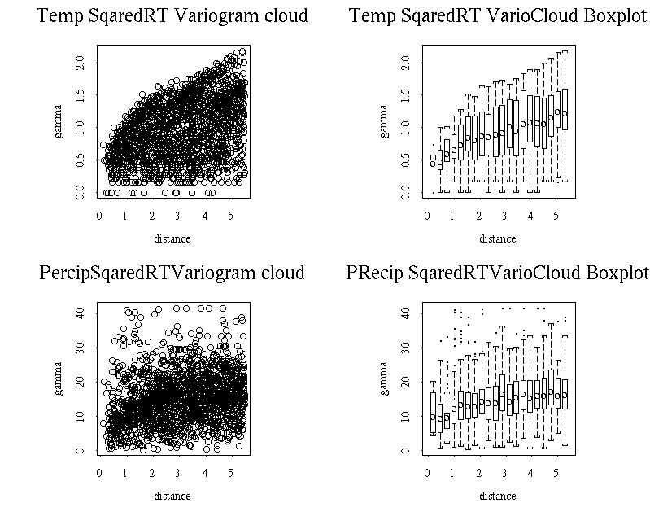
There are fewer points outside the whiskers in the box plots for this squared-root variogram cloud plots. Those points at shorter distances are potential outliers. Based on the plots, we decided to keep all the data for analysis. There seems only slight spatial dependence of the annual precipitation.

APPENDIX A.1.
Removing Trend using Linear Trend Surface Model: Temperature
Data Reading
climate_matrix(scan("/home/ssa6/project2/samclimate.txt"), 76, 22, byrow=T)
climate_data.frame(climate)
name_c("Easting", "Northing", "Meananntemp", "Avgjantemp", "Maxjantemp", "Minjantemp", "Avjulytemp", "Maxjulytemp" ,"Minjulytemp", "Annpreip", "janprecip", "Julyprecip", "Days>1m", "Daysjan>1m", "Daysjuly>1", "Temprange", "Preciprati", "Raindaysra", "Pcascore1", "Pcascore2", "Pcascore3", "Pcascore4")
dimnames(climate)[[2]]_name
Linear Trend Surface analysis.
climate.lmt1 _ lm(Meananntemp ~ Easting + Northing, data = climate, x=T, y =T)
climate.lmt1
Call:
lm(formula = Meananntemp ~ Easting + Northing, data = climate, x = T, y = T)
Coefficients:
(Intercept) Easting Northing
-22.40376 0.7797146 1.902292
Degrees of freedom: 76 total; 73 residual
Residual standard error: 1.978855
And trying another relationship:
climate.lmt _ lm(Meananntemp ~ Easting*Northing, data = climate, x=T, y =T)
climate.lmt
Call:
lm(formula = Meananntemp ~ Easting * Northing, data = climate, x = T, y = T)
Coefficients:
(Intercept) Easting Northing Easting:Northing
-124.9826 4.123178 11.02336 -0.2982033
Degrees of freedom: 76 total; 72 residual
Residual standard error: 1.688946
par (mfrow = c (2, 3))
plot (climate.lmt1)
title ("Temperature: formula = Meananntemp ~ Easting + Northing")
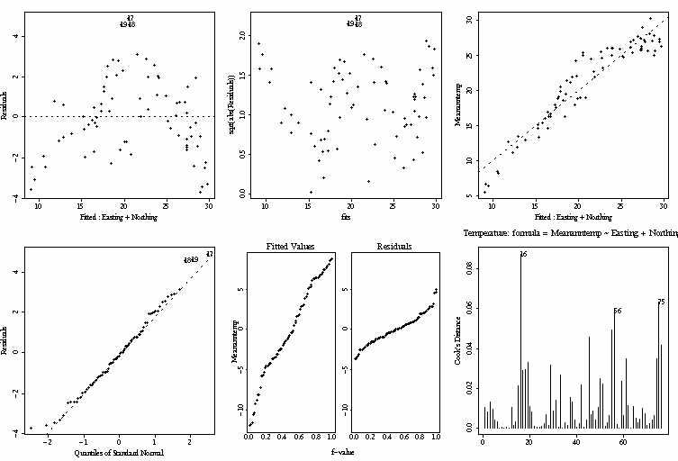
plot (climate.lmt)
title ("Temperature: formula = Meananntemp ~ Easting * Northing")
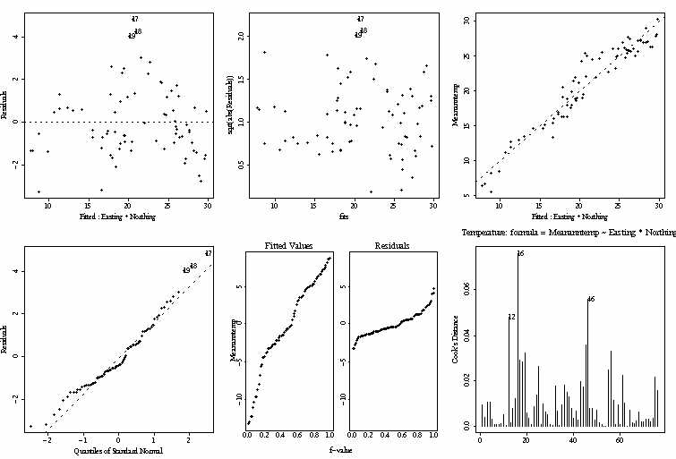
It seems that the first formula (Meananntemp ~ Easting + Northing) works a little better,
so we used it for the further analysis.
b0 _ coefficients(climate.lmt1)[1]
b1 _ coefficients(climate.lmt1)[2]
b2 _ coefficients(climate.lmt1)[3]
climate.pred _ b0 + b1 * climate$Easting + b2 * climate$Northing
par (mfrow = c(1,2))
climate.interppred _ interp (x=climate$Easting, y= climate$Northing, z=climate.pred)
persp (climate.interppred, zlab = "temp")
title ("Modeled Temperature")
climate.interp _ interp (x=climate$Easting, y= climate$Northing, z=climate$Meananntemp)
persp (climate.interp, zlab = "temp")
title ("Original Temperature Data")
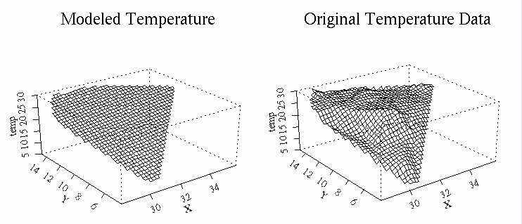

Generalized Least Squares Method.
We removed the trend and found the residuals which we used to calculate predicted temperatures using the following formulas:
Y(s) = X(s) * betta
betta = ( t(X) * C^-1 * X) ^-1 * t(X) * C^-1 * y
where X(s) - (p x 1) vector of p functions of the spatial coordinates;
C - (n x n) matrix of covariances;
y - vector of observed values at the sample sites s;
U(s) - zero mean errors;
betta - (p x 1) vector of parameters to be estimated when the model fitted to the observed data.
residual _ climate$Meananntemp-climate.pred
Easting _ climate [,1]
Northing _ climate [,2]
final _ matrix (c(Easting, Northing, residual), 76,3)
final _ data.frame (final)
name2 _ c ("Easting", "Northing", "Residual")
dimnames(final)[[2]]_name2
par (mfrow = c(1,1))
plot (residual)
title ("Residuals")
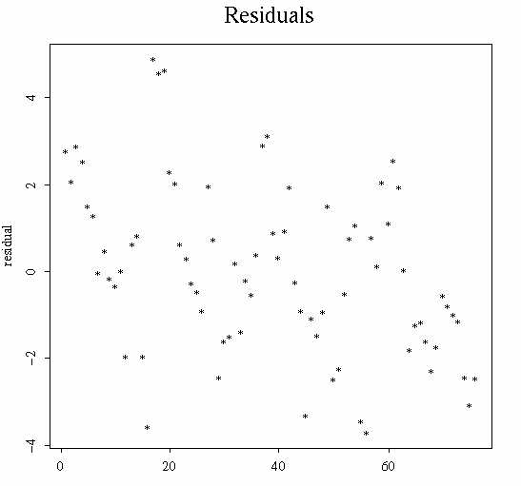
Fitting theoretical variogram:
final.varmom _ variogram (final$Residual~loc (Easting, Northing), data = final)
final.var _ variogram (final$Residual~loc (Easting, Northing), data = final, method ="robust")
par (mfrow=c(1,2))
par (pty = "s")
plot (final.varmom)
title ("MOM")
plot (final.var)
title ("Robust")
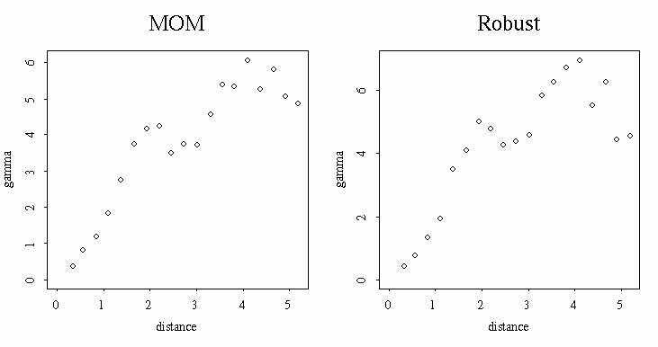
Variograms for residuals look better than initial data, still if we do not look at the last two points, variogram climes up without establishing an upper bound, so there is still can be some trend present. We modeled covariance structure first, then calculated predicted temperatures using Generalised Least Squares and looked at the data again.
The first step in modeling covariance structure is to model variogram. We chose MOM variogram and tried to fit theoretical variogram:
par (mfrow = c (2, 2))
vdist _ 1:10
vrange _ 4.5
vsill _ 6
plot (vdist, exp.vgram(distance = vdist, range = vrange, sill = vsill), type = "l")
plot (vdist, spher.vgram(distance = vdist, range = vrange, sill = vsill), type = "l")
plot (vdist, gauss.vgram(distance = vdist, range = vrange, sill = vsill), type = "l")
plot (final.varmom, main = "Variogram (MOM)")
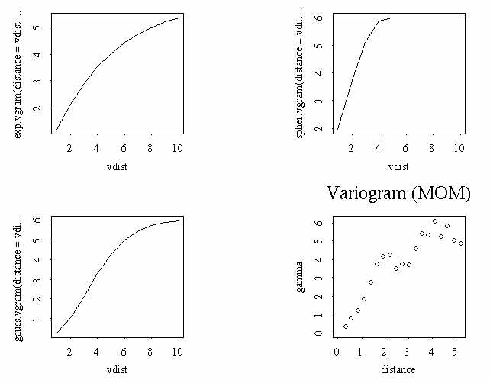
The Gauss variogram looked the best so we used it:
model.variogram(final.varmom, fun = gauss.vgram, range = vrange / 2, sill = vsill)
Select a number to change a parameter (or 0 to exit):
Current objective = 19.7665
1: range - current value: 2.25
2: sill - current value: 6
3: nugget - current value: 0
Selection: 1
New range : 1.6
Select a number to change a parameter (or 0 to exit):
Current objective = 14.1609
1: range - current value: 1.6.
2: sill - current value: 6
3: nugget - current value: 0
Selection: 3
New nugget : 0.1
Select a number to change a parameter (or 0 to exit):
Current objective = 15.2206
1: range - current value: 1.6.
2: sill - current value: 6
3: nugget - current value: 0.1
Selection: 2
New nugget : 5.1
Select a number to change a parameter (or 0 to exit):
Current objective = 13.4448
1: range - current value: 1.6.
2: sill - current value: 5.1
3: nugget - current value: 0.1
Selection: 0
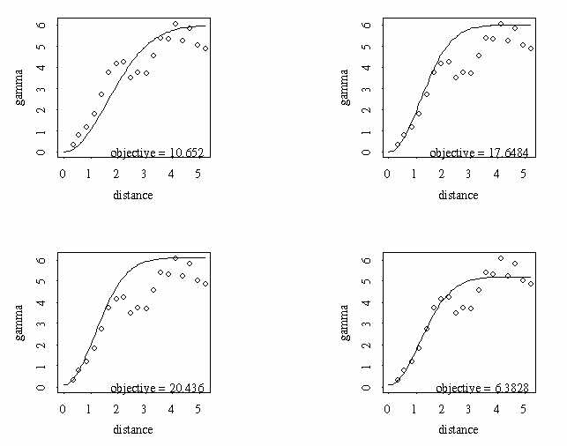
So, the final parameters for Gaussian variogram are:
range - 1.6;
sill - 5.1;
nugget - 0.1
We wrote functions to construct Covariance matrix (Gaussian and Exponential models) and X matrices for linear and quadratic trend surfaces (Appendix A.2, p.32).
Linear Trend Surface for modeling the trend:
Xl _ xmake (76, Easting, Northing)
C _ covmat (76, Easting, Northing, 5.1, 1.6, 0.1)
y _ climate [,3]
betta _ (solve(t(Xl) %*% (solve (C)) %*% Xl)) %*% t(Xl) %*% (solve (C)) %*% y
Y _ Xl %*% betta

Having calculated predicted temperature using Generalised Least Squares we then studied the data again:
residual2 _ climate$Meananntemp - Y
final2 _ matrix (c(Easting, Northing, residual2), 76,3)
final2 _ data.frame (final2)
dimnames (final2)[[2]] _ name2
final2.varmom _ variogram (final2$Residual~loc (Easting, Northing), data = final2)
final2.var _ variogram (final2$Residual~loc (Easting, Northing), data = final2, method ="robust")
par (mfrow=c(1,2))
par (pty = "s")
plot (final2.varmom)
title ("MOM")
plot (final2.var)
title ("Robust")
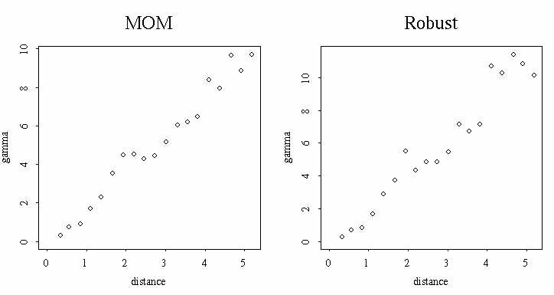
These variograms on residuals obviously do not exhibit an upper boundary confirming that there is still a trend and that the trend is not linear.
As the next step, we tried to use Quadratic Trend Surface Model for removing the trend:
climate.q _ lm(residual2 ~ Easting + Northing + Easting^2 + Northing^2 + Northing*Easting, data = final2, x=T, y =T)
climate.q
Call:
lm(formula = Meananntemp ~ Easting + Northing + Easting^2 + Northing^2 +
Northing * Easting, data = climate, x = T, y = T)
Coefficients:
(Intercept) Easting Northing I(Easting^2) I(Northing^2) Northing:Easting
-172.033 7.293411 11.43174 -0.06372903 -0.109158 -0.2398959
Degrees of freedom: 76 total; 70 residual
Residual standard error: 1.455142
b0 _ coefficients(climate.q)[1]
b1 _ coefficients(climate.q)[2]
b2 _ coefficients(climate.q)[3]
b3 _ coefficients(climate.q)[4]
b4 _ coefficients(climate.q)[5]
b5 _ coefficients(climate.q)[6]
climate.predq _ b0 + b1 * Easting + b2 * Northing + b3 * Easting^2 + b4 * Northing^2 + b5 * Easting * Northing

Found new residuals:
residualq _ residual2-climate.predq
finalq _ matrix (c(Easting, Northing, residualq), 76,3)
finalq _ data.frame (finalq)
dimnames(finalq)[[2]]_name2
We then tried to fit theoretical variogram:
finalq.varmom _ variogram (finalq$Residual~loc (Easting, Northing), data = finalq)
finalq.var _ variogram (finalq$Residual~loc (Easting, Northing), data = finalq, method ="robust")
par (mfrow=c(1,2))
par (pty = "s")
plot (finalq.varmom)
title ("MOM")
plot (finalq.var)
title ("Robust")
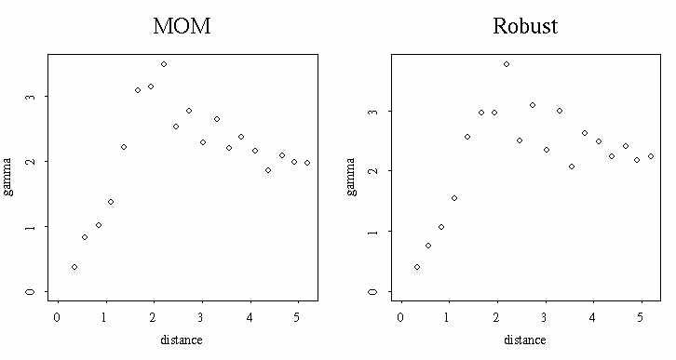
It looks as variograms finally came to a defined upper boundary, besides, the sill is significantly smaller then it was originally (2 comparing to 6), which is consistent with removing a trend. We chose Robust variogram and tried to fit theoretical variogram:
par (mfrow = c (2, 2))
vdist _ 1:10
vrange3 _ 2
vsill3 _ 2
plot (vdist, exp.vgram(distance = vdist, range = vrange3, sill = vsill3), type = "l")
plot (vdist, spher.vgram(distance = vdist, range = vrange3, sill = vsill3), type = "l")
plot (vdist, gauss.vgram(distance = vdist, range = vrange3, sill = vsill3), type = "l")
plot (finalq.var, main = "Variogram (Robust)")
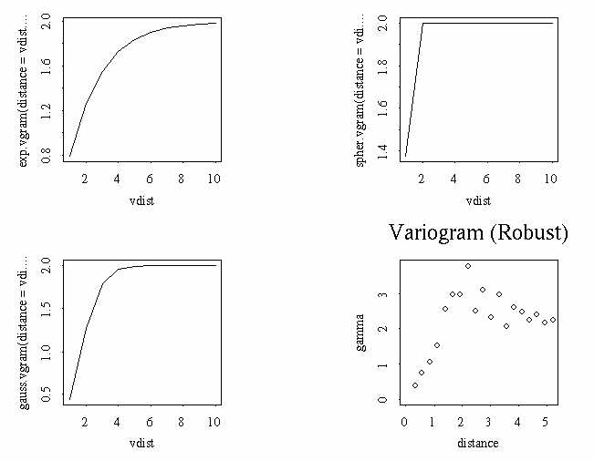
The Gauss variogram looked the best so we used it:
model.variogram(finalq.var, fun = gauss.vgram, range = vrange3 / 2, sill = vsill3)
Select a number to change a parameter (or 0 to exit):
Current objective = 19.7665
1: range - current value: 1
2: sill - current value: 2
3: nugget - current value: 0
Selection: 1
New range : 1.1
Select a number to change a parameter (or 0 to exit):
Current objective = 14.1609
1: range - current value: 1.1.
2: sill - current value: 2
3: nugget - current value: 0
Selection: 3
New nugget : 0.2
Select a number to change a parameter (or 0 to exit):
Current objective = 15.2206
1: range - current value: 1.1.
2: sill - current value: 2
3: nugget - current value: 0.2
Selection: 2
New nugget : 2.1
Select a number to change a parameter (or 0 to exit):
Current objective = 13.4448
1: range - current value: 1.1.
2: sill - current value: 2.1
3: nugget - current value: 0.2
Selection: 0
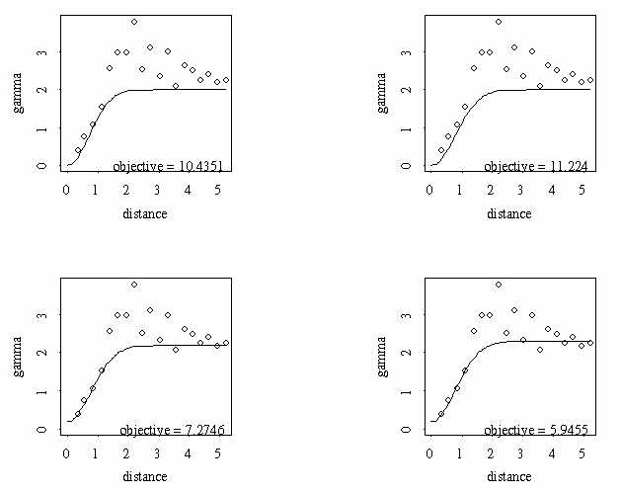
So, the final parameters for Gaussian variogram are:
range - 1.1;
sill - 2.1;
nugget - 0.2
Predictions using Linear Trend Surface:
Cq _ covmat (76, Easting, Northing, 2.1, 1.1, 0.2)
bettaq2 _ (solve(t(Xl) %*% (solve (Cq)) %*% (Xl))) %*% t(Xl) %*% (solve (Cq)) %*% y
Yq2 _ Xl %*% bettaq2
We removed the calculated trend and looked at the residuals:
residual3 _ climate$Meananntemp - Yq2
final3 _ matrix (c(Easting, Northing, residual3), 76,3)
final3 _ data.frame (final3)
dimnames(final3)[[2]]_name2
final3.varmom _ variogram (final3$Residual~loc (Easting, Northing), data = final3)
final3.var _ variogram (final3$Residual~loc (Easting, Northing), data = final3, method ="robust")
par (mfrow=c(1,2))
par (pty = "s")
plot (final3.varmom)
title ("MOM")
plot (final3.var)
title ("Robust")
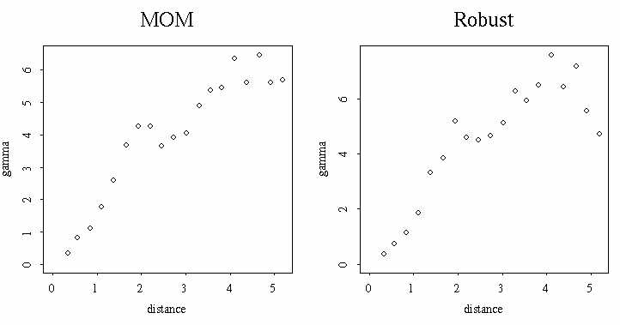
The variograms do not establish an upper boundary showing that the trend has not been removed. It is possible that the trend surfaces we used were not the right ones for the data.
Predictions using Quadratic Trend Surface:
Xq _ quadxmake (76, Easting, Northing)
bettaq _ (solve(t(Xq) %*% (solve (Cq)) %*% (Xq))) %*% t(Xq) %*% (solve (Cq)) %*% y
Yq _ Xq %*% bettaq
Unfortunately, we were not able to calculate bettaq matrix (calculation problems) and further proceed with our analysis: calculating, plotting and analyzing predicted temperatures.
APPENDIX A.2
S-PLUS Codes Used in the Analysis

Gaussian model is described by the formula:
gamma (h) = VAR (1-exp (-3*h^2/r^2))
gamma (h) = VAR - C (h)
C (h) = VAR - gamma (h)
where VAR = sill = 6;
r = range = 2;
h = distance between 2 points, h = SQRT ((e1-e2)^2 + (n1-n2)^2)

Construction of Gaussian Covariance Matrix:
covmat _ function (m, easting, northing, sill, range, nugget)
{
e _ c (easting)
n _ c (northing)
Cmat _ matrix (0,m,m)
for (i in 1:m)
{
j_1
repeat
{
if (i!=j)
{
h _ sqrt ((e[i] - e[j])^2 + (n[i] - n[j])^2)
Cmat[i,j] _ (sill - nugget) * exp (-3*(h^2)/(range^2))
Cmat[j,i] _ Cmat[i,j]
}
else
{
Cmat[i,j] _ sill
}
j_j+1
if (j>i) break
}
}
return (Cmat)
}

Construction of Exponential Covariance Matrix:
covmatexp _ function (m, easting, northing, sill, range, nugget)
{
e _ c (easting)
n _ c (northing)
Cmat _ matrix (0,m,m)
for (i in 1:m)
{
j_1
repeat
{
if (i!=j)
{
h _ sqrt ((e[i] - e[j])^2 + (n[i] - n[j])^2)
Cmat[i,j] _ (sill - nugget) * exp (-3*h/range)
Cmat[j,i ] _ Cmat[i,j]
}
else
{
Cmat[i,j] _ sill
}
j_j+1
if (j>i) break
}
}
return (Cmat)
}
============================================================================
Construction of X Matrix for the Linear Surface:
xmake _ function (m, easting, northing)
{
X <- matrix (0, m, 3)
X [, 1] <- c (1)
X [, 2] <- c (easting)
X [, 3] <- c (northing)
return (X)
}
============================================================================
Construction of X Matrix for the Quadratic Surface:
Quadxmake _ function (m, easting, northing)
{
X1 <- matrix (0, m, 6)
X1 [, 1] <- c (1)
X1 [, 2] <- c (easting)
X1 [, 3] <- c (northing)
X1 [, 4] <- c (easting^2)
X1 [, 5] <- c (northing^2)
X1 [, 6] <- c (easting * northing)
return (X1)
}
APPENDIX A.3
Correction for spatial anisotropy and analyzing the residuals: Temperature
temp.aniso _ temp.dvar2 [(temp.dvar2$distance < 4 & temp.dvar2$azimuth == 90) | (temp.dvar2$distance < 4 & temp.dvar2$azimuth == 45) |
(temp.dvar2$distance < 4 & temp.dvar2$azimuth == 135) |
precip.dvar2$azimuth == 0,]
xyplot (gamma~distance|azimuth, data= temp.aniso, panel = panel.gamma0, gamma0 = 0.45)
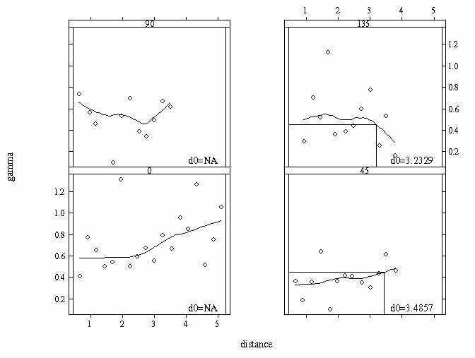
anisotropy.plot (temp.res ~ loc (climate$Easting, climate$Northing), angle = 0, ratio = c(0.75, 1.0, 1.25, 1.5, 1.75, 2.0), method = "robust", layout = c(2,3))
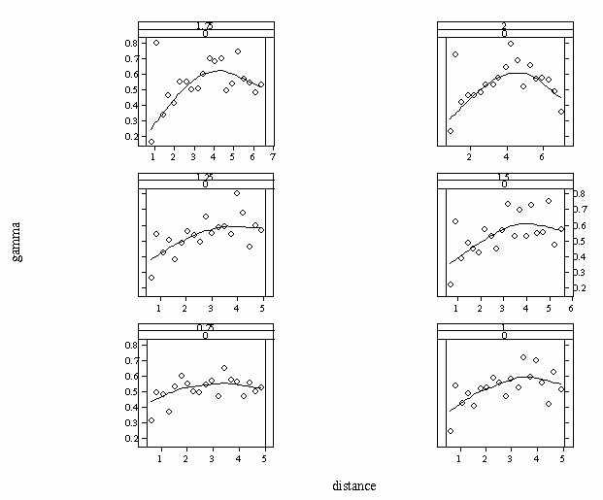
Ratio = 1.25 was chosen.
temp.finalvarmom _ variogram (temp.res ~ loc(climate$Easting, climate$Northing, angle = 0, ratio = 1.25))
temp.finalvar _ variogram (temp.res ~ loc(climate$Easting, climate$Northing, angle = 0, ratio = 1.25), method = "robust")
par (mfrow=c(1,2))
par (pty = "s")
plot (temp.finalvarmom)
title ("Temperature: MOM")
plot (temp.finalvar)
title ("Temperature: Robust")
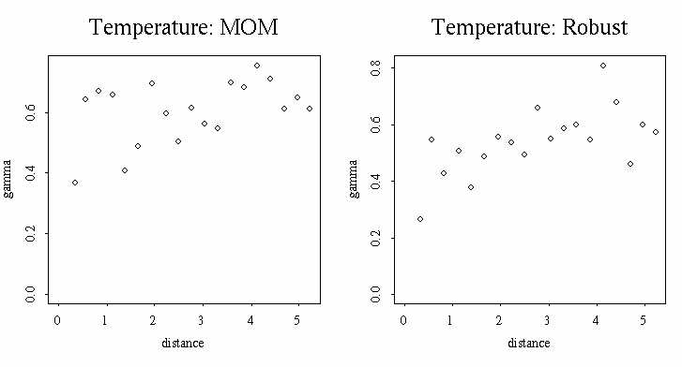
Robust variogram was chosen.
Fitting the theoretical variogram:
par (mfrow = c (2, 2))
vdistt _ 1:10
vranget _ 3
vsillt _ 0.5
plot (vdist, exp.vgram(distance = vdistt, range = vranget, sill = vsillt), type = "l")
plot (vdist, spher.vgram(distance = vdistt, range = vranget, sill = vsillt), type = "l")
plot (vdist, gauss.vgram(distance = vdistt, range = vranget, sill = vsillt), type = "l")
plot (temp.finalvar, main = "Variogram (Robust)")
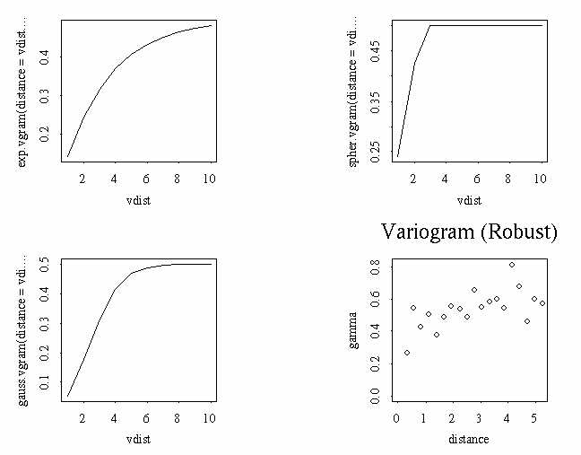
Two variograms: Spherical and Gauss look close, so we tried both:
model.variogram (temp.finalvar, fun = spher.vgram, range = vranget / 2, sill = vsillt)
Select a number to change a parameter (or 0 to exit):
Current objective = 0.1632
1: range - current value: 2.
2: sill - current value: 0.38
3: nugget - current value: 0.2
Selection: 0
model.variogram (temp.finalvar, fun = gauss.vgram, range = vranget / 2, sill = vsillt)
Select a number to change a parameter (or 0 to exit):
Current objective = 0.1787
1: range - current value: 1.5
2: sill - current value: 0.35
3: nugget - current value: 0.25
Selection: 0
par (mfrow = c(1,2))
model.variogram (temp.finalvar, fun = spher.vgram, range = 2, sill = 0.38, nugget = 0.2)
title ("Spherical Variogram")
model.variogram (temp.finalvar, fun = gauss.vgram, range = 1.5, sill = 0.35, nugget=0.25)
title ("Gauss Variogram")
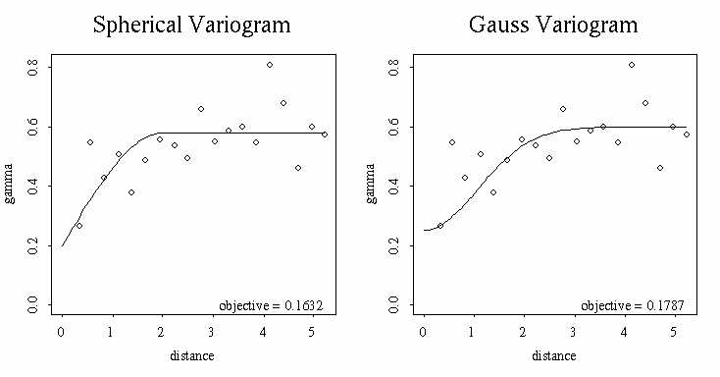
Gauss variogram was chosen. The final parameters are:
range - 1.5;
sill - 0.35;
nugget - 0.25.

APPENDIX A.4
Predictions using Linear Model: Temperature

Ct _ covmat (76, Easting, Northing, 0.35, 1.5, 0.25)
bettat _ (solve(t(Xl) %*% (solve (Ct)) %*% Xl)) %*% t(Xl) %*% (solve (Ct)) %*% y
Yt _ Xl %*% bettat
temp.res1 _ climate$Meananntemp - Yt
temp1 _ matrix (c(Easting, Northing, temp.res1), 76,3)
temp1 _ data.frame (temp1)
dimnames (temp1)[[2]] _ name2
temp1.varmom _ variogram (temp1$Residual~loc (Easting, Northing), data = temp1)
temp1.var _ variogram (temp1$Residual~loc (Easting, Northing), data = temp1, method ="robust")
par (mfrow=c(1,2))
par (pty = "s")
plot (temp1.varmom)
title ("MOM")
plot (temp1.var)
title ("Robust")
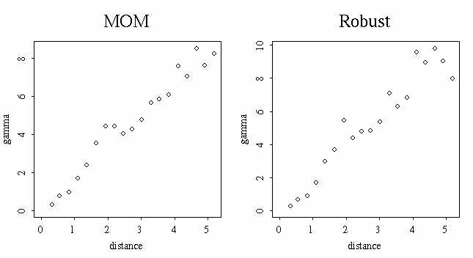
Variograms climb up and do not establish any upper boundary. The method is probably not appropriate for the data set.

APPENDIX A.5
Analysis of Variograms: Precipitation
We looked at how the range in different directions changes. For 90 degree variogram we included distances less than 4 only:
precip.aniso _ precip.dvar2 [(precip.dvar2$distance < 4 & precip.dvar2$azimuth == 90) | precip.dvar2$azimuth == 0 | precip.dvar2$azimuth == 45 | precip.dvar2$azimuth == 135,]
xyplot (gamma~distance|azimuth, data= precip.aniso, panel = panel.gamma0, gamma0 = 200000)
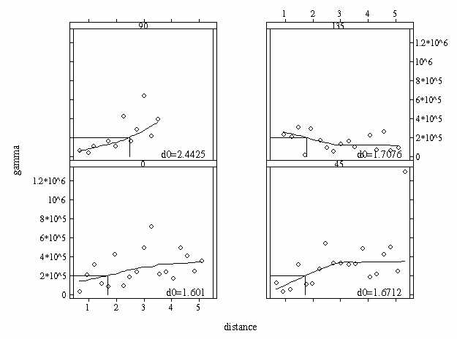
90 degree variogram has quite different interpolated distance h.
We corrected for the geometric anisotropy:
anisotropy.plot (precip.res ~ loc (climate$Easting, climate$Northing), angle = 90, ratio = c(2, 2.25, 2.5, 2.75, 3, 3.25), method = "robust", layout = c(2,3))
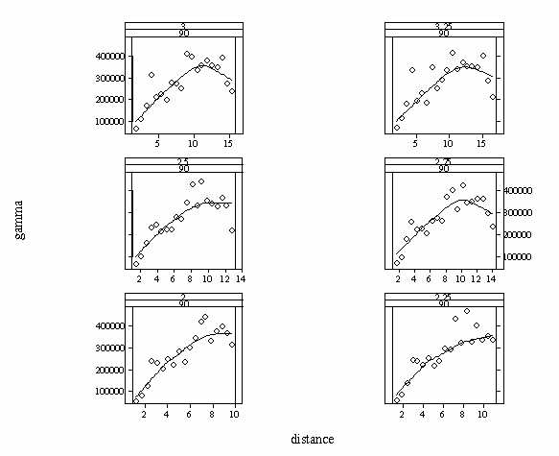
ratio = 2.25 was chosen.
precip.finalvarmom _ variogram (precip.res ~ loc(climate$Easting, climate$Northing, angle = 90, ratio = 2.25))
precip.finalvar _ variogram (precip.res ~ loc(climate$Easting, climate$Northing, angle = 90, ratio = 2.25), method = "robust")
par (mfrow=c(1,2))
par (pty = "s")
plot (precip.finalvarmom)
title ("Precipitation: MOM")
plot (precip.finalvar)
title ("Precipitation: Robust")
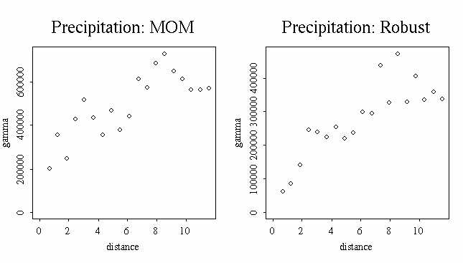
We used robust variogram.
par (mfrow = c (2, 2))
vdistp _ 1:10
vrangep _ 6
vsillp _ 320000
plot (vdist, exp.vgram(distance = vdistp, range = vrangep, sill = vsillp), type = "l")
plot (vdist, spher.vgram(distance = vdistp, range = vrangep, sill = vsillp), type = "l")
plot (vdist, gauss.vgram(distance = vdistp, range = vrangep, sill = vsillp), type = "l")
plot (precip.finalvar, main = "Variogram (Robust)")
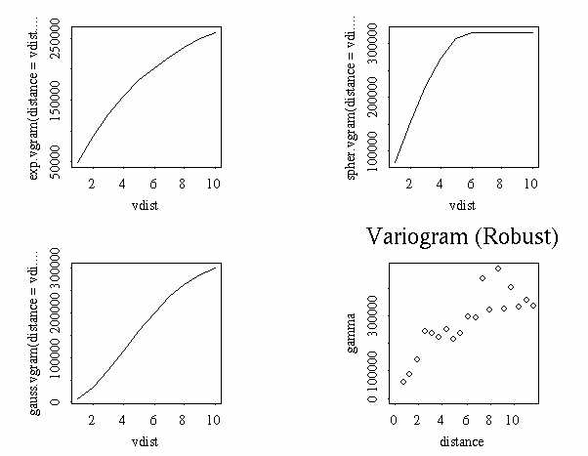
The Gauss and Exponential variograms looked the best so we tried both:
model.variogram (precip.finalvar, fun = gauss.vgram, range = vrangep / 2, sill = vsillp)
Select a number to change a parameter (or 0 to exit):
Current objective = 69575197598
1: range - current value: 4.5
2: sill - current value: 290000.
3: nugget - current value: 50000.
Selection: 0
model.variogram (precip.finalvar, fun = exp.vgram, range = vrangep / 2, sill = vsillp)
Select a number to change a parameter (or 0 to exit):
Current objective = 44851547220
1: range - current value: 3.5
2: sill - current value: 352000.
3: nugget - current value: 0
Selection: 0
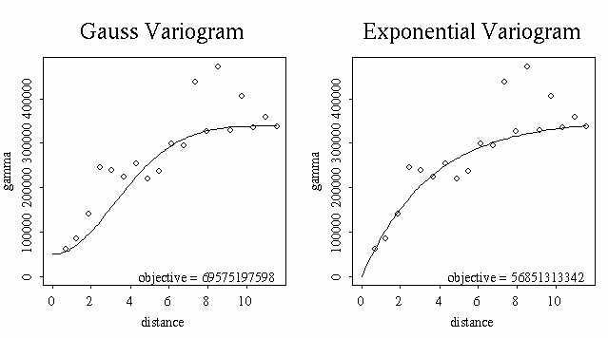
Exponential Variogram looks a little better. So, the final parameters for Exponential variogram are:
range - 3.5;
sill - 352000;
nugget - 0.

APPENDIX A.6
Linear Trend Surface for Prediction of Precipitation

Cp _ covmatexp (76, Easting, Northing, 352000, 3.5, 0)
yp _ climate [,10]
bettap _ (solve(t(Xl) %*% (solve (Cp)) %*% Xl)) %*% t(Xl) %*% (solve (Cp)) %*% yp
Yp _ Xl %*% bettap
We explored the residuals:
residual.prec _ climate$Annpreip - Yp
prec.res _ matrix (c(Easting, Northing, residual.prec), 76,3)
prec.res _ data.frame (prec.res)
dimnames (prec.res)[[2]] _ name2
finalp.varmom _ variogram (prec.res$Residual~loc (Easting, Northing), data = prec.res)
finalp.var _ variogram (prec.res$Residual~loc (Easting, Northing), data = prec.res, method ="robust")
par (mfrow=c(1,2))
par (pty = "s")
plot (finalp.varmom)
title ("MOM")
plot (finalp.var)
title ("Robust")
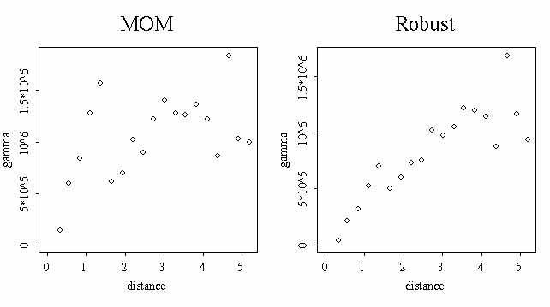
These variograms did not show any obvious non-stationarity or trend. So, we proceeded with our predictions.
par (mfrow = c(1,2))
climatep.pred _ interp (x=Easting, y= Northing, z=Yp)
persp (climatep.pred, zlab = "precip")
title ("Predicted Precip: Linear Model")
climate.interpp _ interp (x=climate$Easting, y= climate$Northing, z=climate$Annpreip)
persp (climatep.interp, zlab = "precip")
title ("Original Precip Data")
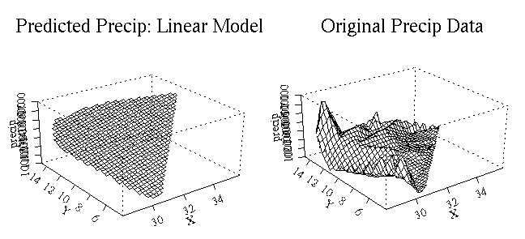
Obviously, Linear Trend Surface Model did not do a good job at all.

APPENDIX B.1
Ordinary Kriging on the Original Data: Temperature

Spatial correlation was modeled using gaussian variogram ("Trend Surface Model" section) with parameters:
range - 1.5;
sill - 0.35;
nugget - 0.25.
temp.krigo _ krige (Meananntemp ~ loc (Easting, Northing, 0, 1.25), data = climate, covfun = gauss.cov, range = 1.5, sill = (0.35-0.25), nugget = 0.25)
temp.krigo
Call:
krige(formula = Meananntemp ~ loc(Easting, Northing, 0, 1.25), data = climate,
covfun = gauss.cov, range = 1.5, sill = (0.35 - 0.25), nugget = 0.25)
Coefficients:
constant
21.31392
Number of observations: 76
Defining the polygon for predictions:
plot (climate$Easting, climate$Northing, pch=16)
temp.poly_locator(type="l")
predict.loc2_poly.grid(temp.poly,size=c(0.4,0.45))
points(predict.loc2,pch="+")
predict.loc2_data.frame(predict.loc2)
name5_c("Easting", "Northing")
dimnames(predict.loc2)[[2]]_name5
Predictions inside user-defined polygon:
temp.opred _ predict (temp.krigo, newdata = predict.loc2)
summary (temp.opred)
Easting Northing fit se.fit
Min.:28.40 Min.: 4.302 Min.:11.31 Min.:0.5205
1st Qu.:30.10 1st Qu.: 8.748 1st Qu.:19.85 1st Qu.:0.5435
Median:31.38 Median:10.850 Median:22.89 Median:0.5503
Mean:31.41 Mean:10.450 Mean:21.72 Mean:0.5523
3rd Qu.:32.66 3rd Qu.:12.260 3rd Qu.:24.10 3rd Qu.:0.5602
Max.:35.64 Max.:14.600 Max.:26.68 Max.:0.5866
Plotting the contours:
xmat_sort(unique(predict.loc2$Easting))
ymat_sort(unique(predict.loc2$Northing))
temp.predmat1_matrix(NA,length(xmat),length(ymat))
temp.predmat1[cbind(match(predict.loc2$Easting,xmat),match(predict.loc2$Northing,ymat))]_temp.opred$fit-1
temp.semat1_matrix(NA,length(xmat),length(ymat))
temp.semat1[cbind(match(predict.loc2$Easting,xmat),match(predict.loc2$Northing,ymat))]_temp.opred$se.fit
par(mfrow=c(1,2))
par(pty="s")
plot (climate$Easting, climate$Northing)
contour (xmat, ymat, temp.predmat1, levels=c(8,10,13,15,17,20,23,25,28,30), add=T, lty=3)
title ("Contour Map of Predictions")
contour (xmat, ymat, temp.semat1)
title ("Contour Map of Standard Error")
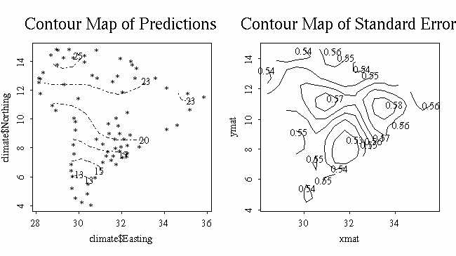
If we compare these predictions with the contour map of the original data ("Exploration of the data" section) we can see that predicted temperatures are quite different from those observed, especially in Northern part of the continent: predicted temperatures are much lower.

Perspective 3-D plots of original, predicted and se.fit surfaces:
par(mfrow=c(1,3))
par(pty="s")
persp (climate.interp, zlab = "temp")
title ("Original Temperature Data")
temp.interpko _ interp (x=temp.opred$Easting, y= temp.opred$Northing, z=temp.opred$fit)
persp (temp.interpko, zlab = "Predicted Temp")
title ("Predicted Temperature ")
temp.interpose_interp(x=temp.opred$Easting, y= temp.opred$Northing, z=temp.opred$se.fit)
persp (temp.interpose, zlab = "Se.fit")
title ("SE for Fit ")
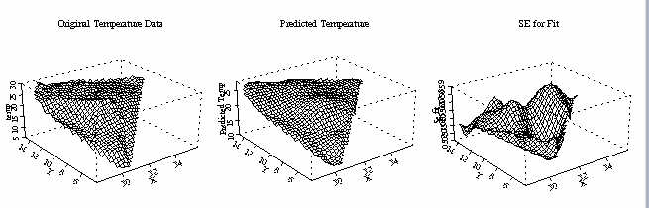
3-d plots confirmed that predictions based on original data do not look very good. This can happen when there is a large-scale trend in the data, and we already know that such trend exists.

APPENDIX B.2
Ordinary Kriging on the Original Data: Precipitation

Spatial correlation was modeled using exponential variogram ("Trend Surface Model" section) with parameters:
range - 3.5;
sill - 352000;
nugget - 0.
prec.krigo _ krige (Annpreip ~ loc (Easting, Northing, 90, 2.25), data = climate, covfun = exp.cov, range = 3.5, sill = 352000, nugget = 0)
prec.krigo
Call:
krige(formula = Annpreip ~ loc(Easting, Northing, 90, 2.25), data = climate,
covfun = exp.cov, range = 3.5, sill = 352000, nugget = 0)
Coefficients:
constant
1216.437
Number of observations: 76
Predictions inside user-defined polygon:
prec.opred _ predict (prec.krigo, newdata = predict.loc2)
summary (prec.opred)
Easting Northing fit se.fit
Min.:28.40 Min.: 4.302 Min.: -61.47 Min.: 88.48
1st Qu.:30.10 1st Qu.: 8.748 1st Qu.: 989.40 1st Qu.:223.20
Median:31.38 Median:10.850 Median: 1475.00 Median:268.40
Mean:31.41 Mean:10.450 Mean: 1629.00 Mean:262.70
3rd Qu.:32.66 3rd Qu.:12.260 3rd Qu.: 2157.00 3rd Qu.:307.80
Max.:35.64 Max.:14.600 Max.: 5934.00 Max.:383.70
Plotting the contours:
prec.predmat1_matrix(NA,length(xmat),length(ymat))
prec.predmat1[cbind(match(predict.loc2$Easting,xmat),match(predict.loc2$Northing,ymat))]_prec.opred$fit-1
prec.semat1_matrix(NA,length(xmat),length(ymat))
prec.semat1[cbind(match(predict.loc2$Easting,xmat),match(predict.loc2$Northing,ymat))]_prec.opred$se.fit
par(mfrow=c(1,2))
par(pty="s")
plot (climate$Easting, climate$Northing)
contour (xmat, ymat, prec.predmat1, levels=c(1000, 2000, 3000), add=T, lty=3)
title ("Contour Map of Predictions")
contour (xmat, ymat, temp.semat1)
title ("Contour Map of Standard Error")
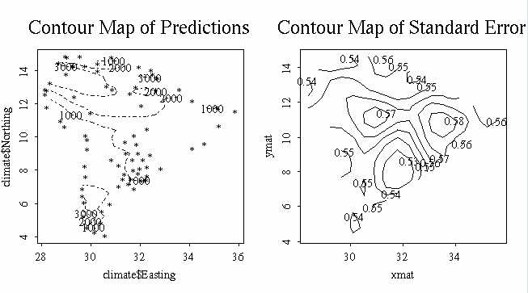
Perspective 3-D plots of original, predicted and se.fit surfaces:
par(mfrow=c(1,3))
par(pty="s")
persp (climatep.interp, zlab = "precip")
title ("Original Precipitation Data")
prec.interpko _ interp (x=prec.opred$Easting, y= prec.opred$Northing, z=prec.opred$fit)
persp (prec.interpko, zlab = "Predicted Precip")
title ("Predicted Precipitation ")
prec.interpose_interp(x=prec.opred$Easting, y= prec.opred$Northing, z=prec.opred$se.fit)
persp (prec.interpose, zlab = "Se.fit")
title ("SE for Fit ")
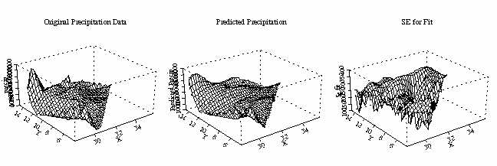
These predictions look good.

