Ann Kitchen
Homework 9 Part II:

Evaluation of presentations of web-based statistical programs.

- Presentation on Statlets
Roxanne and Glen
  - Overall, I found the presentation good; it was well-prepared and taught.
  - There was a very good introduction to the site, and what was available (e.g. revisions, instructors information etc.)
  - I found that I did understand how to use the package, and that an appropriate amount of material was presented for the class to work through to understand the package.
  - The homework was designed well; I was able to complete it quite easily with the information that I obtained during the class.
  - The one downfall of the presentation, I thought, was the technical difficulties that took up some time during the lecture, but these were things that the presenters had little control over and thus they were not their fault.

- Presentation on XploRe
Weiping and Jingjing
  - The presentation overall was of a high quality, but I found that the overview of the site left me somewhat lost. I felt that the features of the site were not explained fully (e.g. what language the program works in). I think it would have been better to discuss the ‘basic features of XploRe’ at the beginning of the lecture, and not at the end.
  - The presentation of the actual execution of the package I thought was handled very well considering that this package was more complex than the others and involved using a language. I obtained a good introduction on how the package works during this section of the presentation.
- The presentation was timed well, with not too much or too little information being discussed.
- I felt that the exercises and the homework were a little too easy to teach us very much about the package or how it runs.

Part III: Homework from the statistical packages

1) R

I carried out the analysis in both the point-and-click modules version of R and the code driven version of Rweb, and found the results to be the same.

Exercise 3: Statistics for height and weight

a) Summary statistics:

Height Weight
Median :69.00 Median :155.0
Std Dev: 3.98 Std Dev: 28.9

b) Correlation between height and weight:

0.5379353

c) Scatterplot:

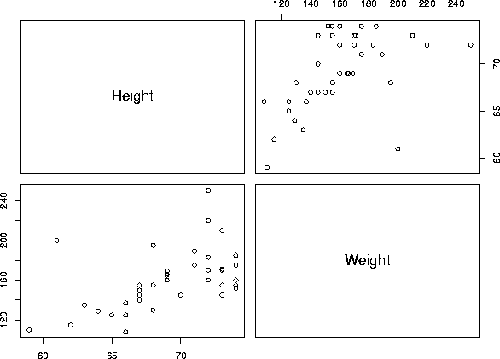

Excercise 4: Regression of weight and age

Coefficients:
Estimate Std. Error t value Pr(>|t|)
(Intercept) 15.231 38.134 0.399 0.691668
Age 6.269 1.645 3.812 0.000455

Residual standard error: 25.09 on 41 degrees of freedom
Multiple R-Squared: 0.2617, Adjusted R-squared: 0.2437
F-statistic: 14.53 on 1 and 41 degrees of freedom, p-value: 0.0004551

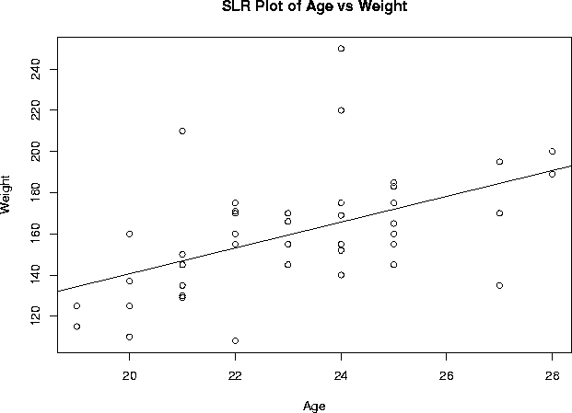

2) Rice virtual lab in statistics:

I performed the exercise 2 as the homework for this package, however none of the output windows let you copy their contents so I report only briefly the results:

a) Weight- mean 159.86, median 155.00, sd 28.85
Height- mean 69.116, median 69.00, sd 3.983

b) The predictor variable is age and the dependent variable is weight. R equals 0.5115
c) Eyecolor does not have a significant influence on weight (F= 1.00994, df=42, p= 0.3733)

3) Master solution to Webstats homework

To complete the homework, it was necessary to use the data set on Labor force available as a sample data set in the site under ‘data’, ‘sample data sets’, ‘labor force’.

To provide a brief statement on what the data set is measuring, we need to look at the file describing the data set on the help/documentation page. We would then find that the data set measures the labor force participation rate of women for 19 cities and two years: 1968 and 1972.

To analyze for differences between 1968 and 1972 in the measured variable we could use a paired t-test. This can be done by clicking ‘stat’, ‘t-test’, ‘paired’. We would generate the following results, and conclude that there was a significant difference (at alpha = 0.05) in the labor force participation rate of women living in the 19 cities between 1968 and 1972 (p=0.0244). The participation rate was higher in 1972 (mean 0.53) than in 1968 (mean 0.49).

Difference Delta0 Estimate Std. Err. DF
1968 - 1972 0 -0.03368421 0.013705561 18

Difference Tstat Pval
1968 - 1972 -2.4577038 0.0244

The summary statistics of interest can be generated by clicking ‘stat’, ‘summary statistics’:

Variable n Mean Variance Std. Dev. Median
1968 19 0.4931579 0.004622807 0.06799123 0.5
1972 19 0.5268421 0.005011696 0.07079333 0.53

Variable Range Min Max Q1 Q3
1968 0.29 0.34 0.63 0.45 0.54
1972 0.29 0.35 0.64 0.49 0.57

I decided a means plot demonstrated nicely the difference in the participation rate of women in the labor force between the two years, but many graphics could have been used here.

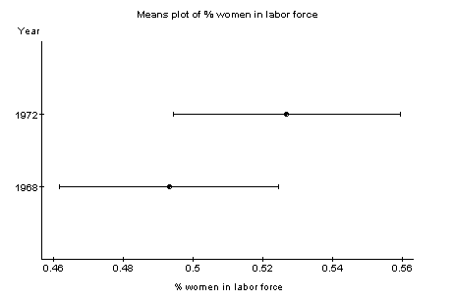

4) Statlets:

The 95% confidence interval is 68.2648, 70.7575.
We reject the null hypothesis at 5% as p=0.0186.
We know this to be the case as 68 does not fall within our confidence interval.
A value of μ between 68.2648 and 70.7575 would lead us to not reject at 5%.

5) XploRe:

1) Histogram and Boxplot:

Sibling:

library("XploRe")
x = readm("user")
z = x.double[ , 3]
library ("plot")
plothist(z)
plotbox(z)

Weight:

library("XploRe")
x = readm("user")
z = x.double[ , 5]
library ("plot")
plothist(z)
plotbox(z)

2) Regression:

library("XploRe")
x = readm("user")
y = x.double[ , 4|5]
y1 = y[ , 1]
y2 = y[ , 2]
library("stats")
{b, bse, bstan, bpval} = linreg(y1, y2)
library("plot")
plot(y)
regy=grlinreg(y)
plot(y, regy)

Output of regression:

[ 2,] "A N O V A SS df MSS F-test P-value"
[ 4,] "Regression 10118.023 1 10118.023 16.696 0.0002"
[ 5,] "Residuals 24847.140 41 606.028"
[ 6,] "Total Variation 34965.163 42 832.504"
[ 8,] "Multiple R = 0.53794"
[ 9,] "R^2 = 0.28937"
[10,] "Adjusted R^2 = 0.27204"
[11,] "Standard Error = 24.61763"

