Preliminary Component Architecture
Development of a Web Application for Enhancing Digital Skills of Older Adults
Astana IT University
Prepared by: Gulnaz Nurseit and Symbat Zhuman
24 October 2026
Status: Proposed design for team review; no claim that the components are already implemented.

1. Purpose and Scope
This document describes the initial component-level architecture of the proposed learning website. It follows the DSOA-7 Software Requirements Specification (SRS): learner registration and authentication; initial digital skills assessment; deterministic rule-based recommendations; lessons and exercises; progress tracking and dashboard; and limited administration. A responsive browser application is in scope. Native mobile apps, AI-generated recommendations, live tutoring and separate caregiver accounts are excluded from the first release.

2. Proposed Technology Stack
Layer | Technology | Purpose
Frontend | Angular + TypeScript | Responsive pages, accessible UI, form handling and API client
Backend | Node.js + Express | REST endpoints, validation, authorization and business logic
Database | PostgreSQL | Persistent accounts, assessments, lessons and progress
Communication | HTTPS + JSON over REST | Browser-to-server communication (planned deployment)
Testing (planned) | Unit, API integration, browser E2E tests | Validate components against SRS acceptance criteria

3. Component Diagram
Figure 1 presents a preliminary logical decomposition. Arrows represent direct API calls, service dependencies and database access; the diagram does not imply independent microservices.
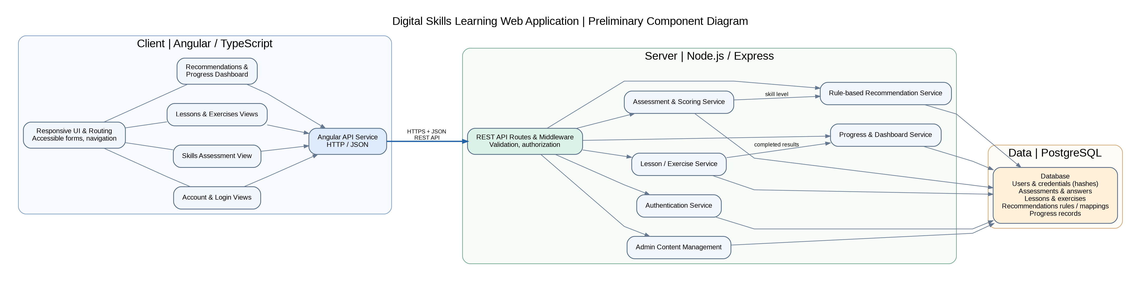
Figure 1. Main frontend, backend and data components (editable Graphviz .dot source supplied separately).

4. Component Responsibilities
Component | Responsibility
Angular UI & Routing | Render responsive accessible pages, validation feedback and learner navigation (NFR-01–04, NFR-11).
Angular API Service | Send HTTP/JSON requests to Express and handle success/error states.
REST Routes & Middleware | Receive requests, validate payloads, check signed-in status and authorize protected operations.
Authentication Service | Register learner, securely store password hashes, sign in/out and protect user records (FR-01–02).
Assessment & Scoring Service | Store submitted answers, compute repeatable skill level and handle retakes where implemented (FR-03–04, FR-13).
Rule-based Recommendation Service | Map the calculated level to published lessons using predefined consistent rules (FR-05).
Lesson / Exercise Service | Provide published catalogue, ordered lesson steps, exercises and result feedback (FR-06–08, FR-14 if included).
Progress & Dashboard Service | Persist completion data; calculate completed totals, next lesson and optional summaries (FR-09–10, FR-12, FR-15 if included).
Admin Content Management | Allow authorized administrators to manage publishing and editing (FR-11, Should Have).
PostgreSQL Database | Store user records, assessments, content and progress reliably (NFR-05–08).

5. Primary Interactions

5.1 Registration and authentication
Angular account form → REST API → authentication service → PostgreSQL. The server validates input and enforces user authorization; the browser does not access PostgreSQL directly.

5.2 Assessment and recommendations
Angular assessment page → assessment service → saved answers and scoring → resulting skill level → recommendation service → predefined level-to-lesson mapping → suggested published lessons.

5.3 Learning and progress
Learner opens a published lesson through the content service; submits exercises; results and lesson completion are stored by the progress service and reflected in dashboard counts across sessions.

5.4 Administrator
Authorized administrator → REST routes with role/permission check → content management → PostgreSQL; unpublished lessons are hidden from learners.

5.5 Error and security handling
Express validates requests and rejects unauthorized access. Angular displays plain-language errors. Passwords are hashed; HTTPS is required in deployment; database changes should avoid partially saved assessment and progress records.

6. Architecture Decisions and Rationale
- A modular three-layer architecture is proposed rather than microservices to keep the two-person student project manageable.
- Angular and TypeScript support component-oriented implementation and reusable accessibility patterns; Node/Express provides a single REST API; PostgreSQL gives structured relational persistence.
- Personalization is deterministic and rule-based (not AI). Fixed answers and mapping fixtures allow repeatable verification.
- Backend services own scoring, access control and persistence; frontend components focus on interaction and presentation.
- The arrangement is preliminary: exact API paths, authentication mechanism, schema and deployment details must be confirmed during implementation.

7. Requirements Consistency Check
FR-01–02 → authentication; FR-03–05 and FR-13 → assessment/scoring/recommendations; FR-06–08 and FR-14 → content; FR-09–10, FR-12 and FR-15 → progress/dashboard; FR-11 → admin. NFR-01–04 and NFR-11 influence frontend design; NFR-05–09 influence validation, secure transport, reliability and errors; NFR-10 requires browser testing; NFR-12 is an optional backup/recovery consideration.

8. Team Review and GitHub Deliverables
Review checklist: (1) both team members verify components against DSOA-7; (2) frontend owner confirms UI/API boundaries and accessibility; (3) backend owner confirms server-side scoring, security and schema responsibilities; (4) unresolved decisions are documented in the PR; (5) revisions are merged after approval. This document records the proposed review process, not a completed approval.
Deliverables to commit: Component_Diagram.dot (editable source), Component_Diagram.png (exported image), Component_Diagram.svg (scalable export), and Preliminary_Component_Architecture.docx (description). Use the exact YouTrack task ID in the branch, commit and PR; request the teammate as reviewer.

9. Open Decisions
To confirm before implementation: API endpoint naming; authentication/session approach; initial scoring thresholds; recommendation mapping format; whether Admin/Should Have features will ship in the first release; concrete database schema and deployment environment.

