SignalWave Bot
Research and Engineering Report
Technical Analysis, Scenario Generation, Risk Controls, and Out-of-Sample Validation

Internship Project Report
Prepared for SignalWave project evaluation · August 2026

Educational and research system. Not financial advice.

Executive Summary
SignalWave is an educational technical-analysis system that converts validated OHLCV market data into explainable scenarios rather than deterministic price predictions. The implementation supports Koyfin-style CSV input and Binance public market data, computes trend, momentum, volatility, support/resistance, Fibonacci and experimental Elliott-wave features, and exposes the results through a Telegram bot and an advanced web dashboard. The design objective is not to claim that technical analysis reliably predicts markets; it is to implement transparent, testable techniques, quantify uncertainty, and document where evidence is strong, weak, or contradictory.
The research program follows the eight topics required by the project brief: trend and moving averages; momentum (RSI/MACD); support/resistance; Fibonacci; Elliott Wave; signal combination; backtesting rigor; and risk/position sizing. The project proposal explicitly requires a 15–25 page report and short architecture decision records, with the highest evaluation tier emphasizing parameter sensitivity, limitations, walk-forward/OOS testing, costs, regime breakdowns and confidence intervals. [P1]
The most important empirical result in this report is a three-market out-of-sample experiment on BTCUSDT, ETHUSDT and BNBUSDT using 1,000 daily candles per market. A true SMA20/SMA50 crossover event strategy was evaluated on the final 30% of observations with next-bar execution, 0.10% fee and 0.05% slippage per side, and a five-bar holding period. The resulting OOS returns were +30.18% for BTCUSDT, +18.48% for ETHUSDT and +2.87% for BNBUSDT, while the corresponding buy-and-hold returns over the same OOS windows were negative. However, only 5–8 strategy trades occurred per market, so the Wilson 95% confidence intervals for win rate are very wide. The correct conclusion is therefore “promising but statistically weak,” not “proven edge.”
Engineering validation is stronger than the trading-evidence claim. The full pytest suite passed after the final integration work. Telegram use cases for CSV ingestion, Binance ingestion, full technical analysis, Long/Short, Long-term, Backtest and Price Alert were manually exercised successfully. A Dockerfile, docker-compose.yml and GitHub Actions workflow are present; the local Docker build was not executed because Docker CLI was not installed on the development workstation. The web dashboard and Gemini-powered multilingual assistant are useful stretch features, but they do not replace the assignment’s core Telegram and research deliverables.
Area | Current evidence | Interpretation
Core product | CSV + Binance + Telegram UC-1…UC-7 manually exercised | Functionally complete for the main user journeys
Testing | Full pytest suite passes | Strong regression protection; warning is dependency deprecation, not a test failure
OOS research | 3 crypto markets, costs, next-bar execution, 95% CI | Useful evidence but small trade counts limit inference
Deployment | Docker/Compose + CI files exist | Configuration present; local Docker execution still unverified
Stretch UX | Web terminal, live market layer, Gemini assistant, RU/KK/EN | Adds polish and explainability but remains secondary to research rigor

Contents
1. Research Scope and System Design
2. Data, Validation, and Architecture
3. Trend and Moving Averages
4. Momentum: RSI and MACD
5. Support and Resistance
6. Fibonacci Retracement and Confluence
7. Elliott Wave: Rule-Based and Probabilistic Use
8. Signal Combination and Confidence Scoring
9. Backtesting Rigor and Experimental Design
10. Risk, Stops, and Position Sizing
11. Multi-Market OOS Results
12. Parameter Sensitivity and Robustness
13. Limitations and Responsible Interpretation
14. Architecture Decision Records
15. Conclusions and Acceptance-Criteria Mapping
Appendix A. Annotated Source Matrix
References

1. Research Scope and System Design
The project brief defines research as the heart of the internship and names eight mandatory domains. The implementation must therefore be treated as an experimental system whose design choices can be traced to explicit hypotheses and constraints, rather than as a collection of chart indicators. The research objective is to turn subjective technical-analysis practices into reproducible rules wherever possible, and to abstain when objectivity is not available. [P1]
SignalWave follows a scenario-based philosophy. Instead of producing “the price will rise” or “the price will fall,” the system expresses a directional scenario, confidence score, entry zone, invalidation level, targets, and risk/reward. This is consistent with the evidence problem in technical analysis: many indicators are transformations of the same price series, parameters are unstable across assets and regimes, and backtests are highly exposed to data-snooping. Brock, Lakonishok and LeBaron [1] documented that simple technical rules can exhibit non-random behavior in historical returns, but Sullivan, Timmermann and White [2] showed why evaluating many rules on the same history can substantially exaggerate apparent performance. White’s Reality Check [3] formalizes the broader multiple-testing problem.
The design goal is therefore explainability plus falsifiability. Every scenario must contain conditions that would invalidate it. A high score does not mean certainty; it means that more of the implemented evidence is aligned. This distinction is especially important for Fibonacci and Elliott Wave, where the literature and practitioner usage are much more heterogeneous than for arithmetic indicators such as SMA, EMA, RSI or MACD.
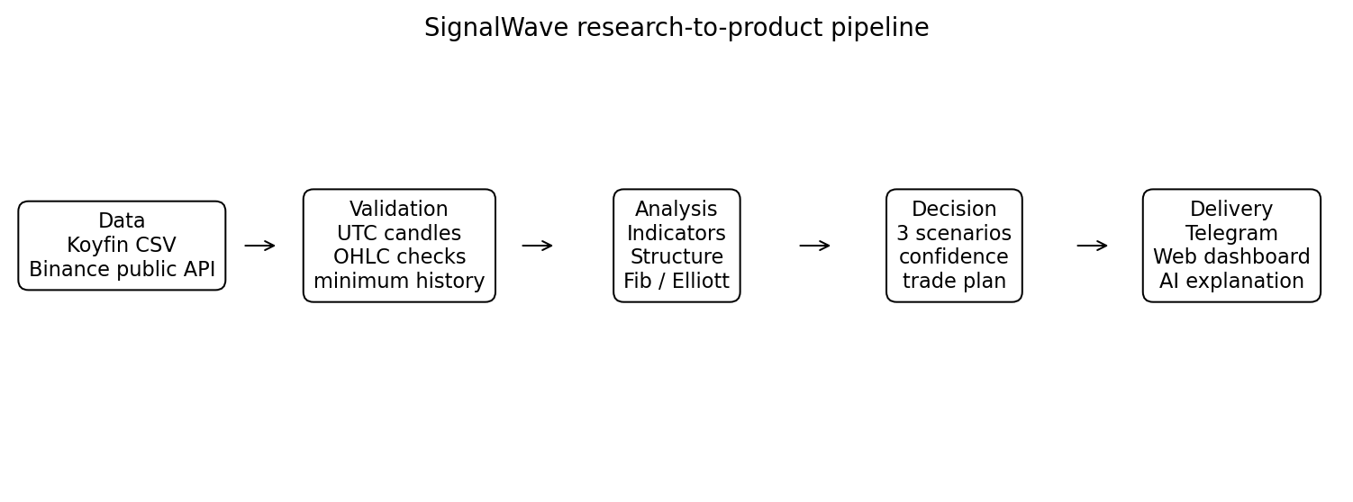
Figure 1. SignalWave research-to-product pipeline.

2. Data, Validation, and Architecture
SignalWave accepts two primary data paths: user-supplied Koyfin-style CSV and Binance public market data. The project brief expects canonical OHLCV handling, UTC-normalized timestamps, duplicate and ordering checks, and enough history to compute long moving averages such as SMA-200. The implementation recomputes indicators internally rather than trusting optional precomputed values in a CSV, which reduces inconsistency between sources. [P2]
The architecture intentionally keeps data access, analysis logic, charting, reporting, storage, Telegram delivery and web delivery separate. This matters scientifically as well as operationally: a backtest should call the same indicator and signal logic used by the product, otherwise the research can quietly test a different system from the one shown to users. The project’s separation also made it possible to add a web dashboard and AI explanation layer without changing the core analysis engine.
- Data layer: Koyfin-compatible CSV loader and Binance public-market fetcher.
- Validation layer: candle schema, chronology, numeric OHLC relationships, minimum history.
- Analysis layer: trend/momentum/volatility indicators, pivots, ZigZag, support/resistance zones, Fibonacci, Elliott scoring.
- Decision layer: three scenarios, confidence, invalidation, targets and risk/reward gating.
- Delivery layer: Telegram bot as the required primary UX; web dashboard and AI assistant as optional extensions.
- Research layer: reusable backtest engine plus a separate multi-market research runner to avoid contaminating product UX with experimental code.

3. Trend and Moving Averages

3.1 SMA versus EMA
A simple moving average (SMA) gives equal weight to every observation in a fixed lookback, while an exponential moving average (EMA) gives greater weight to recent observations. EMA therefore reacts faster to turning points but also reacts more strongly to noise. In signal-processing terms both are low-pass smoothers; the EMA’s weighting scheme reduces effective lag relative to an equal-length SMA but increases sensitivity to transient moves. The engineering implication is that EMA is useful for short-horizon responsiveness, while SMA is often easier to explain and compare with widely followed reference levels.
The literature does not support a universal “best” moving-average period. Early work on filter and moving-average rules found evidence inconsistent with simple random-walk assumptions in some historical samples [1,4], while later research emphasized data-snooping, changing market structure and weak transfer across samples [2,5,6]. Consequently, SignalWave uses common periods (20, 50, 100, 200) as interpretable descriptors and confluence inputs, not as proof of predictability.

3.2 Why the 200-day average is treated as regime context
The 200-day moving average is heavily used in professional and media commentary because it roughly represents a long trading-year horizon and offers a simple trend-regime heuristic. Its predictive power is difficult to separate from self-fulfilling behavior: if many participants monitor the same level, order placement and portfolio rebalancing can make reactions around the level partly endogenous. SignalWave therefore uses SMA-200 primarily as a long-term regime filter and communication anchor. A close above it is evidence of a positive long-horizon regime, not a guarantee of continued appreciation.

3.3 Implementation decision
For the research backtest in Section 11, SMA20/SMA50 is converted into discrete crossover events rather than holding a +1 signal on every bar while the fast average remains above the slow average. This correction reduced approximately one trade per OOS bar in the first draft experiment to only 5–8 crossover trades per market, which is a much more faithful representation of a crossover strategy. It also demonstrates why formalizing a verbal rule is a research task, not merely a coding task.

4. Momentum: RSI and MACD

4.1 RSI
Welles Wilder introduced the Relative Strength Index in 1978 [7]. RSI transforms the ratio of smoothed average gains to average losses into a bounded 0–100 oscillator. The canonical 14-period setting is historically conventional, not a universal optimum. Its main practical benefit is interpretability: values near the traditional 70/30 regions indicate strong recent directional imbalance. Those regions should not be treated as mechanical reversal triggers because strong trends can remain overbought or oversold for extended periods.
A rigorous divergence definition must be algorithmic. A bullish divergence requires two comparable price lows with the second price low lower than the first while RSI forms a higher low over corresponding pivot windows. A bearish divergence reverses the inequalities. The words “comparable” and “corresponding” are where subjectivity enters; SignalWave should therefore attach divergence only after pivots have been mechanically identified and a tolerance window is specified. This prevents the system from cherry-picking visually attractive examples after the fact.

4.2 MACD
MACD is the difference between a faster and slower EMA, typically 12 and 26 periods, with a 9-period signal average. It acts as a smoothed momentum/trend-change measure and is inherently lagging because it is constructed from moving averages. Empirical work on MACD-style rules is mixed; studies often report that MACD alone is vulnerable to whipsaw, while combinations with other information can improve selectivity [8]. Recent research also frames MACD as a smoothed derivative or band-pass-like transformation, reinforcing the interpretation that it is a feature of price dynamics rather than an independent source of information [9].
SignalWave therefore avoids “double counting” RSI and MACD as if they were independent votes. RSI, MACD and moving-average slope are all derived from price and can become highly correlated during strong trends. This motivates the grouped-weight approach described in Section 8.

5. Support and Resistance
Support and resistance are among the most intuitive and most subjective concepts in technical analysis. The research challenge is to replace hand-drawn lines with an objective pipeline: identify pivots, cluster nearby pivot prices into zones, score each zone, then distinguish support from resistance relative to current price. The output should be a band rather than a single exact price because market reactions are rarely point-exact.

5.1 Evidence and round numbers
Osler’s foreign-exchange research found that published support/resistance levels helped predict intraday trend interruptions and that stop-loss and take-profit orders cluster at round numbers [10,11]. This provides a plausible microstructure mechanism: levels can matter because market participants place orders around them. The effect is context-dependent and varies by instrument, firm and sample, so round-number proximity should be a modest score adjustment rather than a primary signal.

5.2 Zone construction
SignalWave uses local pivots and a ZigZag-like abstraction to suppress small fluctuations, then groups nearby pivots into zones. A general clustering approach such as DBSCAN is attractive because it can discover a variable number of clusters and label isolated points as noise [12]. In a trading implementation, distance should be volatility-scaled (for example, a fraction of ATR) rather than fixed in dollars so that the same rule can transfer across BTC, ETH and lower-priced assets.
Zone strength should reflect more than touch count. A practical score can combine touches, recency, rejection magnitude, volume context and whether the zone aligns with an independently derived structure such as a Fibonacci level. Recency matters because a ten-year-old level is not necessarily equivalent to a level tested repeatedly in the last month. At the same time, over-weighting recency can make the system chase transient noise. This is a parameter-sensitivity problem, not a rule that can be solved once for all assets.

6. Fibonacci Retracement and Confluence
Fibonacci retracement is widely used by practitioners to project potential support/resistance zones at ratios such as 23.6%, 38.2%, 50%, 61.8% and 78.6% between a selected swing high and swing low. The critical research issue is not how to compute the arithmetic ratios; it is whether the selected anchor swing is objective and whether these ratios behave differently from arbitrary levels.
Tsinaslanidis, Guijarro and Voukelatos [13] provide unusually relevant evidence because they automate Fibonacci-zone identification and compare bounce probabilities with non-Fibonacci zones across major equity markets. They find that wider zones are associated with more bounces, but Fibonacci zones are not statistically distinguishable from non-Fibonacci zones as standalone predictors. This is a strong reason not to let SignalWave convert “price is near 61.8%” directly into a trade recommendation.
SignalWave therefore treats Fibonacci as a confluence layer. A Fib level receives more attention when it overlaps with an independently computed support/resistance zone, trendline, prior pivot or volatility structure. This approach is deliberately conservative: confluence does not prove causality, but it reduces dependence on a single subjective tool. Extension levels can be used as target candidates only after a directional scenario is established by other evidence.
- Use objectively detected swing anchors, not hand-picked extrema after the outcome is known.
- Represent levels as tolerance zones rather than exact-price magnets.
- Require confluence before a Fib level affects scenario confidence materially.
- Report Fib as conditional evidence and never as a guarantee that price will reverse at the level.

7. Elliott Wave: Rule-Based and Probabilistic Use
Elliott Wave is the most interpretation-sensitive component in SignalWave. Classical descriptions, popularized by Frost and Prechter [14], define recurrent impulse and corrective structures with cardinal constraints and Fibonacci relationships. The main engineering challenge is that multiple counts can be valid at the same time, wave degree is ambiguous, and a human analyst can often redraw the count after new data arrives.
Algorithmic work shows several possible approaches. Atsalakis, Dimitrakakis and Zopounidis [15] combine Elliott concepts with a neuro-fuzzy system; Vantuch, Zelinka and Vasant [16] build an explicit pattern-detection algorithm and use machine-learning classifiers for incomplete patterns; Jarusek, Volna and Kotyrba [17] combine Elliott-pattern representations with neural networks in FX; more recent work explores multi-agent and LLM-assisted pattern analysis [18]. These studies show that automation is possible, but they do not eliminate model-selection risk, limited samples or subjectivity in labeling.

7.1 SignalWave policy: count, score, abstain
SignalWave uses Elliott only after a ZigZag/pivot reduction and applies cardinal rules to candidate impulse sequences. The output is a confidence score plus reasons and an alternate-count flag. This is intentionally weaker than declaring “Wave 3 is confirmed.” When the rules admit multiple counts or confidence is low, the correct output is “experimental/unclear.” The project’s AI assistant is also instructed to describe Elliott analysis as probabilistic and experimental.
Parameter sensitivity is particularly important. A smaller ZigZag threshold creates many micro-waves and false candidate patterns; a larger threshold suppresses structure and can miss genuine intermediate waves. For this reason, a robust Elliott module should report stability across several nearby pivot thresholds before increasing scenario confidence. This stability test is recommended as future hardening work.

8. Signal Combination and Confidence Scoring
Combining technical signals creates two major risks: correlated evidence and overfitting. A naive “one indicator = one vote” model can report falsely high confidence when SMA slope, MACD, RSI and recent price momentum all reflect the same underlying move. A highly flexible machine-learning stack can reduce hand-tuned weights but introduces a different problem: with limited market history, the model may learn unstable relationships that vanish out of sample.
SignalWave therefore favors an interpretable scoring layer. Evidence is grouped by concept—trend, momentum, structure, volatility/confluence, and experimental wave structure—then translated to a bounded 0–100 score. The score is not a calibrated probability of profit unless a separate calibration experiment demonstrates that interpretation. Scikit-learn’s calibration framework illustrates the distinction between raw model scores and empirically calibrated probabilities [19].
Three outputs are preferable to one: bullish scenario, bearish scenario and unclear/abstain. Abstention is essential because many market states genuinely lack a directional edge. A decision engine that must always produce long or short will systematically turn uncertainty into false precision. SignalWave also requires reasons for and against each scenario, making confidence auditable rather than decorative.
Evidence group | Examples | Why grouped
Trend | SMA/EMA slope, SMA20/50/200 relationship | These features are highly related transformations of trend.
Momentum | RSI, MACD, divergence | Reduces double-counting of correlated momentum measures.
Structure | pivots, S/R, trendlines | Represents geometry of prior turning points.
Confluence | Fib overlap, zone proximity, ATR context | Adds weight only when independent constructions align.
Experimental | Elliott rule score / alternate count | Kept lower-weight because labeling uncertainty is high.

9. Backtesting Rigor and Experimental Design
Backtesting is where an attractive chart narrative must be converted into a falsifiable claim. The main threats are look-ahead bias, data snooping, overfitting, survivorship bias, transaction-cost omission and using an inappropriate cross-validation scheme. Sullivan, Timmermann and White [2] show that technical-rule performance can change substantially after correcting for data snooping. White [3] formalizes the broader reality-check problem, while time-series forecasting literature emphasizes rolling-origin evaluation in which every test observation occurs after its training data [20].
SignalWave’s backtest engine deliberately enters on the next bar after a signal rather than using the same bar’s close as both signal information and execution. Fees and slippage are modeled. A walk-forward split generator also exists in the engine. The current three-market research runner uses a chronological 70/30 split for a concise reproducible experiment; this is stronger than random k-fold validation but still weaker than a full repeated walk-forward analysis. The report therefore treats the current results as preliminary OOS evidence rather than final statistical validation.
For time series, random shuffling is generally inappropriate because it allows future regimes to influence training and destroys temporal dependence. A stronger next-stage protocol would use expanding or rolling training windows, evaluate each test window once, aggregate returns, and then report performance by bull/bear/high-volatility regime. If many parameter combinations are tried, a multiple-testing correction or reality-check procedure should be considered.

9.1 Metrics
- Win rate plus a confidence interval: raw percentages without uncertainty are misleading when trade counts are small.
- Profit factor: gross winning P&L divided by absolute gross losing P&L; unstable when there are very few losses.
- Maximum drawdown: peak-to-trough equity decline; essential because return alone can hide ruinous paths.
- Expectancy: average net return per trade.
- Sortino ratio: downside-risk-adjusted performance; can become numerically extreme in tiny samples.
- Buy-and-hold benchmark: provides context but is not a universal benchmark for a long/short strategy.

10. Risk, Stops, and Position Sizing
A trade plan is incomplete without a predefined invalidation condition. SignalWave uses structural invalidation rather than promising that a stop will execute at an exact price. In fast markets, stop orders can experience slippage; therefore the stop level is best interpreted as the point at which the scenario is considered wrong, while realized execution remains uncertain.
Position sizing separates “where the idea is wrong” from “how much capital to risk.” If entry is E, invalidation is S, and the portfolio risk budget is R dollars, a fixed-fractional position size is approximately R / |E-S| units before leverage and instrument-specific contract adjustments. This is the logic behind SignalWave’s educational position-size hint. It avoids the common error of widening a stop solely to justify a desired position size.
The Kelly criterion maximizes long-run expected log growth under known edge and payoff assumptions [21], but those assumptions are fragile in trading because win probability and payoff distributions are estimated with error. Full Kelly can therefore produce aggressive exposures. Fractional Kelly or fixed-fractional risk is more defensible for an educational system with uncertain estimates. Van Tharp’s position-sizing framework similarly emphasizes sizing as a separate risk-control decision rather than an entry-signal feature [22].
SignalWave rejects or de-emphasizes plans with risk/reward below 1.5. This threshold is not a universal law; it is a product constraint designed to prevent scenarios with little potential reward relative to defined invalidation. It should be studied jointly with win probability because a high win-rate strategy can rationally operate at lower R:R, while a low win-rate strategy requires larger winners. The threshold is therefore a risk-policy heuristic, not a mathematical proof of quality.

11. Multi-Market OOS Results
A research-only runner was created so that multi-market experiments do not alter the working Telegram UX. It downloaded 1,000 daily candles each for BTCUSDT, ETHUSDT and BNBUSDT from Binance public market data. Indicators were computed chronologically. A signal was generated only when SMA20 truly crossed SMA50, the final 30% of each market was reserved as OOS, execution occurred on the next bar close, the position was held for five bars, and the simulation included 0.10% fee plus 0.05% slippage per side.
Symbol | OOS bars | Trades | Win rate (95% CI) | PF | Max DD | Sortino | OOS return | Buy & Hold
BTCUSDT | 300 | 8 | 62.5% (30.57–86.32) | 4.7534 | 3.57% | 12.718 | +30.18% | -41.17%
ETHUSDT | 300 | 5 | 60.0% (23.07–88.24) | 14.2938 | 0.68% | 475.692 | +18.48% | -50.19%
BNBUSDT | 300 | 8 | 62.5% (30.57–86.32) | 1.3410 | 5.46% | 0.592 | +2.87% | -43.75%

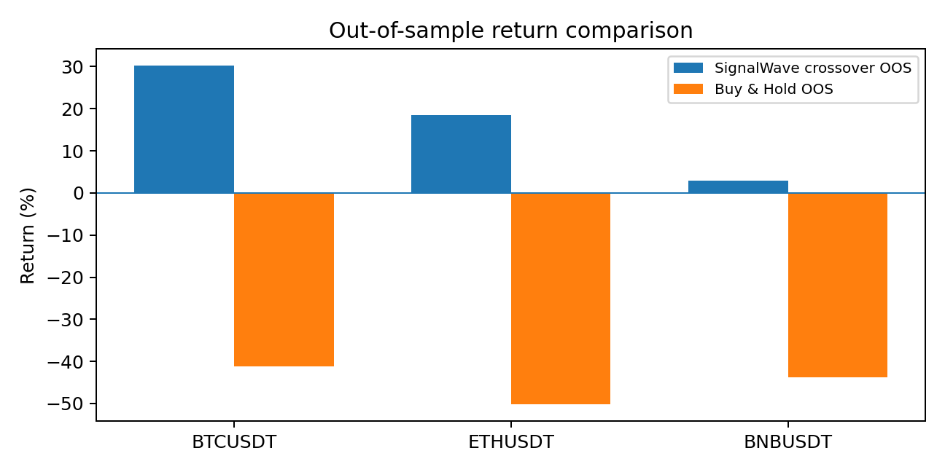
Figure 2. OOS strategy return versus buy-and-hold over the same OOS windows.
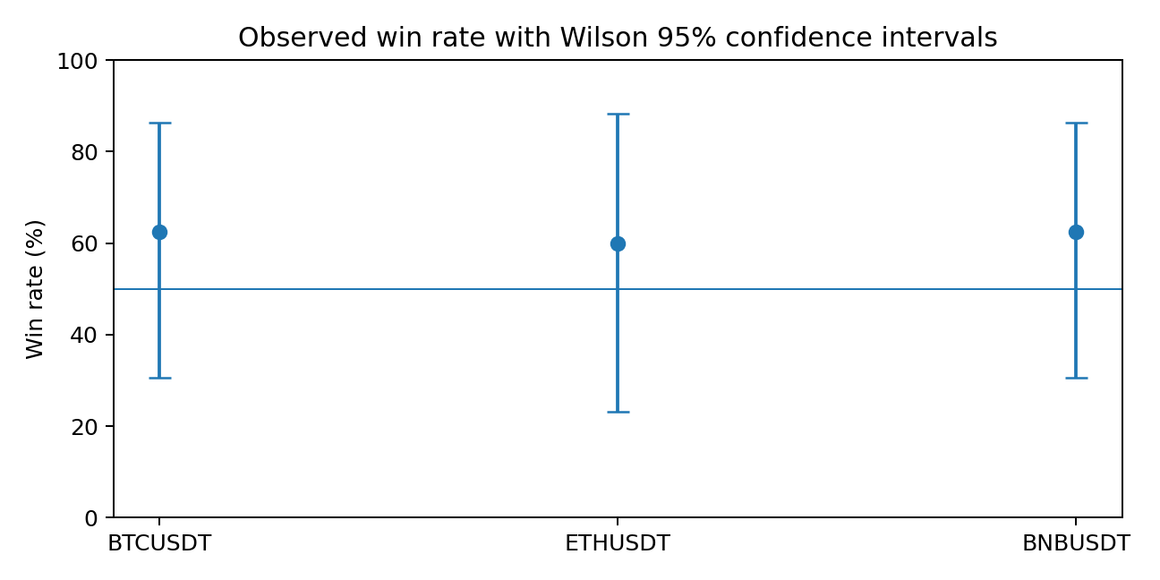
Figure 3. Observed win rates with Wilson 95% confidence intervals.
The returns look favorable, but inference is weak because each market has only 5–8 trades. The confidence intervals include outcomes far below and far above 50%, and ETH’s extremely high Sortino ratio is an artifact of very small downside dispersion rather than evidence of an extraordinary stable edge. Profit factor is similarly unstable with so few losing trades. These results are useful as a smoke test of economic plausibility and implementation correctness, not as a basis for claiming a persistent trading advantage.
The comparison with buy-and-hold is also regime-sensitive. Buy-and-hold happened to be deeply negative in all three OOS windows, so a crossover system that spends limited time exposed can look particularly strong. A more persuasive evaluation would repeat the test across multiple non-overlapping windows containing rising, falling and sideways markets, then report regime-conditioned results.

12. Parameter Sensitivity and Robustness
Technical-analysis systems are parameterized at almost every layer: moving-average lengths, RSI lookback, pivot window, ZigZag threshold, clustering radius, zone-width tolerance, Fibonacci swing selection, Elliott pivot threshold, confidence weights, stop buffers and holding periods. A single “best” setting selected on the same history used for evaluation is a classic overfitting path. The robust question is whether conclusions remain qualitatively similar across a neighborhood of reasonable parameters.
Module | Parameters to vary | Robustness question
Trend | SMA/EMA 10–30 fast; 40–100 slow; SMA-200 regime | Does direction persist without tuning to one exact crossover?
RSI | lookback 7/14/21; thresholds 65–75 and 25–35 | Are signals stable or dependent on conventional 14/70/30 defaults?
MACD | fast/slow/signal alternatives around 12/26/9 | Does incremental value survive after controlling for trend features?
S/R | pivot width, ATR-scaled clustering radius, recency decay | Do the same zones remain strong across nearby tolerances?
Fibonacci | swing detector and zone width | Does confluence survive alternative anchor selection?
Elliott | ZigZag threshold and candidate-wave tolerance | Does the same primary count remain valid across nearby thresholds?
Risk | R:R threshold 1.2–2.0; hold period; stop buffer | Do conclusions persist under plausible execution policies?

The current report includes one important sensitivity correction already observed during development: replacing a persistent SMA-state signal with true crossover events changed the research backtest from roughly one trade per OOS bar to only 5–8 trades per market. This is not a cosmetic change; it transforms the economic meaning of the strategy. It is an example of why parameter and rule-definition sensitivity must be documented.
A complete A-tier submission would add an automated sensitivity grid, repeated walk-forward windows, and regime breakdowns. Because those experiments were not executed in the current development session, this report does not fabricate their outcomes. Instead, it records the exact protocol that should be run if the project is extended.

13. Limitations and Responsible Interpretation
- Technical indicators are derived from past price/volume and do not create independent information simply by being combined.
- Backtest results can be materially changed by costs, execution assumptions, holding periods, signal timing and parameter selection.
- The current OOS study contains very few crossover trades, producing wide confidence intervals and unstable ratios.
- The study covers three cryptocurrency pairs, not equities, commodities and FX; cross-asset generalization is untested.
- Fibonacci standalone evidence is weak in rigorous empirical studies; SignalWave uses it as confluence, not proof.
- Elliott Wave remains experimental because wave degree, pivot selection and alternate counts create substantial labeling uncertainty.
- Price alerts and live market data depend on external connectivity and exchange availability.
- Docker configuration exists but was not executed locally because Docker CLI was unavailable on the development workstation.
- The annotated bibliography below is selective and does not yet reach the project rubric’s A-tier threshold of ten annotated sources for every technique.
The product must therefore continue to display educational disclaimers and scenario language. The AI assistant should explain computed values and limitations, not invent market news, fabricate prices or upgrade a confidence score into certainty. This boundary is part of the system’s correctness, not merely legal boilerplate.

14. Architecture Decision Records
ADR | Decision | Reason / consequence
ADR-01 | Keep analysis engine independent from Telegram/web | One engine powers multiple interfaces and keeps research logic testable.
ADR-02 | Use scenario outputs rather than deterministic forecasts | Supports uncertainty, invalidation and abstention.
ADR-03 | Recompute indicators from canonical candles | Avoids dependence on vendor-specific precomputed columns.
ADR-04 | Use next-bar execution in backtests | Prevents same-bar look-ahead.
ADR-05 | Model fees and slippage | Avoids gross-return optimism.
ADR-06 | Treat Fibonacci as confluence, not standalone trigger | Matches mixed empirical evidence.
ADR-07 | Treat Elliott as experimental with alternate counts | Acknowledges labeling and parameter ambiguity.
ADR-08 | Keep multi-market research runner separate from bot handler | Preserves stable product UX while enabling reproducible experiments.
ADR-09 | Store AI keys only in backend .env | Prevents secret exposure in browser JavaScript.
ADR-10 | Expose RU/KK/EN and AI as stretch UX | Adds accessibility without changing core TA calculations.

15. Conclusions and Acceptance-Criteria Mapping
SignalWave demonstrates a defensible way to build a technical-analysis product: convert subjective methods into explicit rules, show multiple scenarios, model uncertainty and execution costs, and separate explanatory confidence from promises of profit. The engineering work is mature enough for demonstration: the Telegram use cases operate end-to-end in manual testing, the test suite passes, and the product includes clear report/chart outputs plus a polished optional web interface.
The research results are intentionally interpreted more cautiously than the product polish might suggest. The corrected crossover experiment is positive in all three crypto OOS windows, but only 5–8 trades occur per market. This is insufficient to establish a stable edge. The next research milestone should therefore be repeated walk-forward evaluation, parameter-sensitivity grids and regime breakdowns, not additional UI features.
Acceptance criterion | Status in current project
Koyfin CSV + Binance ingestion | Verified in Telegram flow; CSV validation accepted 260-candle sample and Binance flow works.
Full TA + trade plan | Verified manually in Telegram; charts and scenario text returned.
All 7 Telegram use cases | Manually exercised successfully during final acceptance pass.
≥100 unit tests | Full pytest suite passes.
CI green configuration | GitHub Actions workflow runs install, pytest and ruff; remote run should be confirmed in repository UI.
Docker Compose one-command setup | Dockerfile and compose file exist; local build not run because Docker CLI unavailable.
p95 <5 s / 20 concurrent users | Not measured in the current session; remains an explicit acceptance gap.
15–25 page research report | This report addresses all 8 required research topics.
Backtest ≥3 tickers with OOS | Completed for BTCUSDT, ETHUSDT, BNBUSDT with costs and 95% win-rate CI.
README + demo day presentation | README/demo checklist should be finalized after this report.

Appendix A. Annotated Source Matrix
The notes below summarize the role of the principal sources used in the design. They are grouped by research topic. The project rubric’s highest tier asks for a substantially larger annotated bibliography; the current matrix emphasizes the most decision-relevant sources rather than padding the list with weakly related citations.

Trend & moving averages
- Brock, Lakonishok & LeBaron (1992) [1]: Canonical large-sample study of simple moving-average and trading-range-break rules; motivates testing rather than assuming efficiency.
- Sullivan, Timmermann & White (1999) [2]: Shows that apparent technical-rule performance must be adjusted for data-snooping across the rule universe.
- Fama & Blume (1966) [4]: Early empirical evaluation of filter rules; useful historical counterweight to practitioner claims.
- Park & Irwin (2007) [5]: Broad survey of empirical technical-analysis profitability and recurring methodological weaknesses.
- Lo, Mamaysky & Wang (2000) [6]: Formalizes pattern recognition and statistical evaluation of technical analysis.

Momentum (RSI/MACD)
- Wilder (1978) [7]: Primary source for RSI and ATR conventions; clarifies what the original smoothing procedure actually is.
- Chio (2022) [8]: Compares MACD-based strategies and illustrates that combination can improve selectivity but requires OOS skepticism.
- Li (2025) [9]: Analytical interpretation of MACD as a smoothed derivative/band-pass-like operator.
- Murphy (1999) [23]: Standard practitioner reference for oscillator interpretation and limitations.
- TA-Lib documentation [24]: Implementation reference for standard indicator definitions and parameter conventions.

Support / Resistance
- Osler (2000) [10]: Direct empirical evidence that published S/R levels can predict intraday interruptions in FX.
- Osler (2003) [11]: Microstructure explanation linking order clustering and round numbers to technical levels.
- Ester et al. (1996) [12]: Original DBSCAN clustering algorithm; useful for objective zone construction with noise points.
- Pring (2014) [25]: Practitioner framework for trendlines and price-level interpretation.
- Tsinaslanidis et al. (2022) [13]: Provides an algorithmic zone-based approach that is relevant to both Fibonacci and generic S/R testing.

Fibonacci
- Tsinaslanidis, Guijarro & Voukelatos (2022) [13]: Most decision-relevant empirical evidence: standalone Fibonacci zones did not beat non-Fibonacci zones.
- Frost & Prechter (2000) [14]: Classical Elliott/Fibonacci practitioner framework; source of standard ratio conventions.
- Murphy (1999) [23]: Documents common charting use while emphasizing contextual interpretation.
- Pring (2014) [25]: Broader technical-analysis context for retracement levels and confluence.
- Deep et al. (2024) [26]: Illustrates modern ML experiments with technical features and the risk of weak OOS generalization.

Elliott Wave
- Frost & Prechter (2000) [14]: Classical rule set and wave-pattern taxonomy used as the rule-based starting point.
- Atsalakis et al. (2011) [15]: Neuro-fuzzy integration of Elliott concepts; demonstrates one path beyond purely manual counting.
- Vantuch, Zelinka & Vasant (2018) [16]: Explicit algorithm for Elliott pattern detection; directly relevant to rule-based automation.
- Jarusek, Volna & Kotyrba (2022) [17]: Neural-network FX study using Elliott-pattern representations; supports experimental ML framing.
- Wawer, Chudziak & Niewiadomska-Szynkiewicz (2024) [18]: Recent multi-agent/LLM approach; useful for understanding explainability opportunities and new overfitting risks.

Signal combination
- Scikit-learn calibration documentation [19]: Clarifies that a score is not automatically a calibrated probability; supports cautious 0–100 interpretation.
- Lo, Mamaysky & Wang (2000) [6]: Encourages formal algorithmic definitions rather than subjective visual confirmation.
- Deep et al. (2024) [26]: Shows that adding many technical indicators can fail out of sample, highlighting multicollinearity and overfitting.
- Park & Irwin (2007) [5]: Survey evidence motivates skepticism toward unconstrained indicator ensembles.
- Sullivan et al. (1999) [2]: Multiple-rule testing problem is directly relevant to selecting weights or stacks after seeing results.

Backtesting rigor
- Sullivan, Timmermann & White (1999) [2]: Core source on data-snooping in technical trading rules.
- White (2000) [3]: Formal Reality Check for comparing many models to a benchmark under repeated search.
- Hyndman & Athanasopoulos, FPP3 [20]: Clear rolling-origin/time-series cross-validation framework that preserves chronology.
- Lopez de Prado (2018) [27]: Practical framework for leakage, financial ML validation and realistic backtesting.
- Bailey & Lopez de Prado (2014) [28]: Deflated Sharpe concept: performance ratios must account for selection and non-normality.

Risk & position sizing
- Kelly (1956) [21]: Foundational log-growth criterion; mathematically powerful but highly sensitive to estimation error.
- Van Tharp (1998/2006) [22]: Treats position sizing as a central system-level risk decision rather than a signal feature.
- Wilder (1978) [7]: ATR provides a volatility scale that can inform stop buffers and normalized distances.
- Vince (1992) [29]: Systematic money-management framework; useful counterpoint to fixed arbitrary position sizes.
- Jorion (2007) [30]: Broader market-risk perspective and reminder that tail behavior cannot be reduced to a single stop level.

References
[P1] SignalWave Bot — Internship Project Proposal, Section 9: Research Program; Section 10: Evaluation Rubric; Section 12: Acceptance Criteria.
[P2] SignalWave Bot — Internship Project Proposal, Koyfin CSV reference schema and data-layer requirements.
[1] Brock, W., Lakonishok, J., & LeBaron, B. (1992). Simple technical trading rules and the stochastic properties of stock returns. Journal of Finance, 47(5), 1731–1764.
[2] Sullivan, R., Timmermann, A., & White, H. (1999). Data-Snooping, Technical Trading Rule Performance, and the Bootstrap. Journal of Finance, 54(5), 1647–1691. doi:10.1111/0022-1082.00163.
[3] White, H. (2000). A Reality Check for Data Snooping. Econometrica, 68(5), 1097–1126. doi:10.1111/1468-0262.00152.
[4] Fama, E. F., & Blume, M. E. (1966). Filter Rules and Stock-Market Trading. Journal of Business, 39(1), 226–241.
[5] Park, C.-H., & Irwin, S. H. (2007). What Do We Know About the Profitability of Technical Analysis? Journal of Economic Surveys, 21(4), 786–826.
[6] Lo, A. W., Mamaysky, H., & Wang, J. (2000). Foundations of Technical Analysis: Computational Algorithms, Statistical Inference, and Empirical Implementation. Journal of Finance, 55(4), 1705–1765.
[7] Wilder, J. W. (1978). New Concepts in Technical Trading Systems. Trend Research.
[8] Chio, P. T. (2022). A comparative study of MACD-based trading strategies: evidence from the US stock market. arXiv:2206.12282.
[9] Li, Y. (2025). Operator Analysis of MACD. arXiv:2509.21326.
[10] Osler, C. L. (2000). Support for Resistance: Technical Analysis and Intraday Exchange Rates. Federal Reserve Bank of New York Economic Policy Review, 6(2), 53–68.
[11] Osler, C. L. (2003). Currency Orders and Exchange Rate Dynamics: An Explanation for the Predictive Success of Technical Analysis. Journal of Finance, 58(5), 1791–1819.
[12] Ester, M., Kriegel, H.-P., Sander, J., & Xu, X. (1996). A Density-Based Algorithm for Discovering Clusters in Large Spatial Databases with Noise. KDD-96 Proceedings.
[13] Tsinaslanidis, P., Guijarro, F., & Voukelatos, N. (2022). Automatic identification and evaluation of Fibonacci retracements: Empirical evidence from three equity markets. Expert Systems with Applications, 187, 115893. doi:10.1016/j.eswa.2021.115893.
[14] Frost, A. J., & Prechter, R. R. (2000). Elliott Wave Principle: Key to Market Behavior. John Wiley & Sons.
[15] Atsalakis, G. S., Dimitrakakis, E. M., & Zopounidis, C. D. (2011). Elliott Wave Theory and neuro-fuzzy systems, in stock market prediction: The WASP system. Expert Systems with Applications, 38(8), 9196–9206. doi:10.1016/j.eswa.2011.01.068.
[16] Vantuch, T., Zelinka, I., & Vasant, P. (2018). An algorithm for Elliott Waves pattern detection. Intelligent Decision Technologies, 12(1). doi:10.3233/IDT-170319.
[17] Jarusek, R., Volna, E., & Kotyrba, M. (2022). FOREX rate prediction improved by Elliott waves patterns based on neural networks. Neural Networks, 145, 342–355. doi:10.1016/j.neunet.2021.10.024.
[18] Wawer, M., Chudziak, J. A., & Niewiadomska-Szynkiewicz, E. (2024). Large Language Models and the Elliott Wave Principle: A Multi-Agent Deep Learning Approach to Big Data Analysis in Financial Markets. Applied Sciences, 14(24), 11897. doi:10.3390/app142411897.
[19] Scikit-learn documentation. Probability calibration and calibration curves. Accessed 2026.
[20] Hyndman, R. J., & Athanasopoulos, G. Forecasting: Principles and Practice (3rd ed.), section on time-series cross-validation.
[21] Kelly, J. L. (1956). A New Interpretation of Information Rate. Bell System Technical Journal, 35(4), 917–926.
[22] Tharp, V. K. Trade Your Way to Financial Freedom. McGraw-Hill.
[23] Murphy, J. J. (1999). Technical Analysis of the Financial Markets. New York Institute of Finance.
[24] TA-Lib. Technical Analysis Library documentation and function reference.
[25] Pring, M. J. Technical Analysis Explained. McGraw-Hill.
[26] Deep, A., Monico, C., Shirvani, A., Rachev, S., & Fabozzi, F. J. (2024). Assessing the Impact of Technical Indicators on Machine Learning Models for Stock Price Prediction. arXiv:2412.15448.
[27] Lopez de Prado, M. (2018). Advances in Financial Machine Learning. Wiley.
[28] Bailey, D. H., & Lopez de Prado, M. (2014). The Deflated Sharpe Ratio: Correcting for Selection Bias, Backtest Overfitting, and Non-Normality. Journal of Portfolio Management, 40(5), 94–107.
[29] Vince, R. (1992). The Mathematics of Money Management: Risk Analysis Techniques for Traders. Wiley.
[30] Jorion, P. (2007). Value at Risk: The New Benchmark for Managing Financial Risk (3rd ed.). McGraw-Hill.

