|  |
| --- |
| Team G.I. Joe |
| Art and Sound |
| Design Document |

|  |
| --- |
| Phillip Conte, Yan-Simon Martel, Kosta Andreou and Theo Raymond  2-3-2015 |

Theme

# Art and Sound

Project Game & Watch harks back to the first popular handheld devices of the 80’s: Game&Watch and Tiger Electronics handhelds.

Using the same type of visuals with detailed and static images as backgrounds and combining this with the LCD images in foreground for the character, platforms and other iteractable objects, Project Game & Watch aims to recreate that aesthetic.

Audio design also shares the same type of aesthetic but with an updated version of the sound effects and new chiptune music adapted for each level.

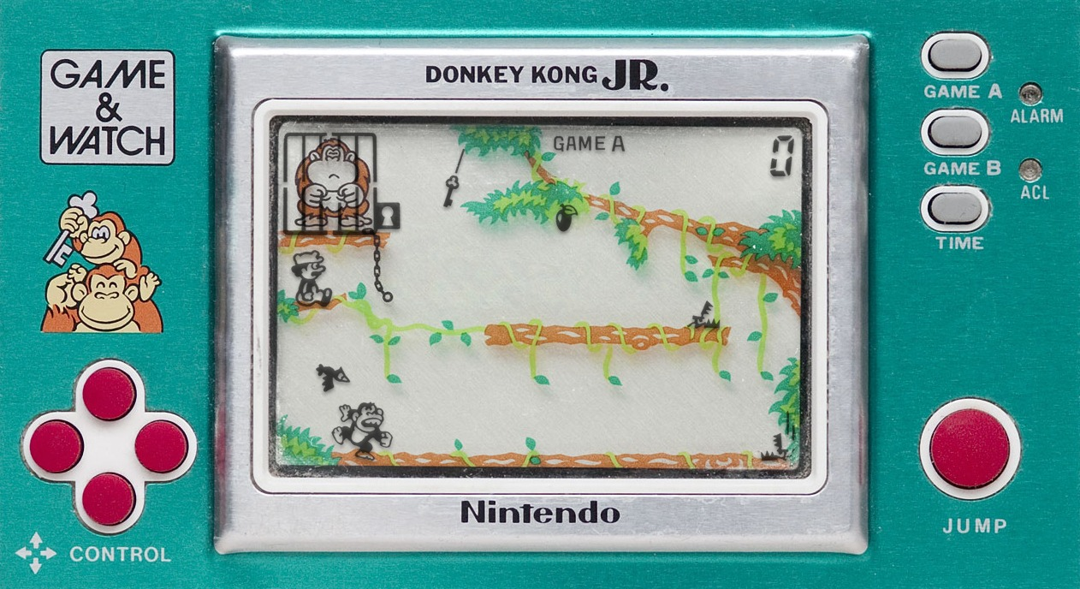

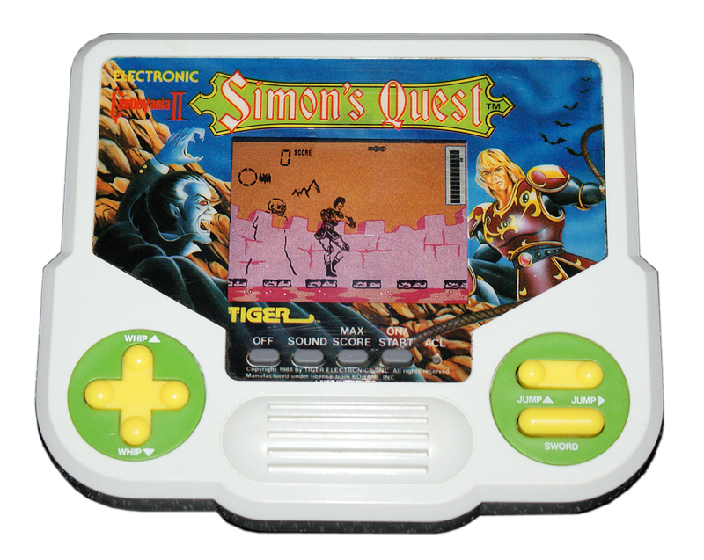

Art

# Main Character

The main character is a simple black LCD style character with minimalist and jerky looking animation.



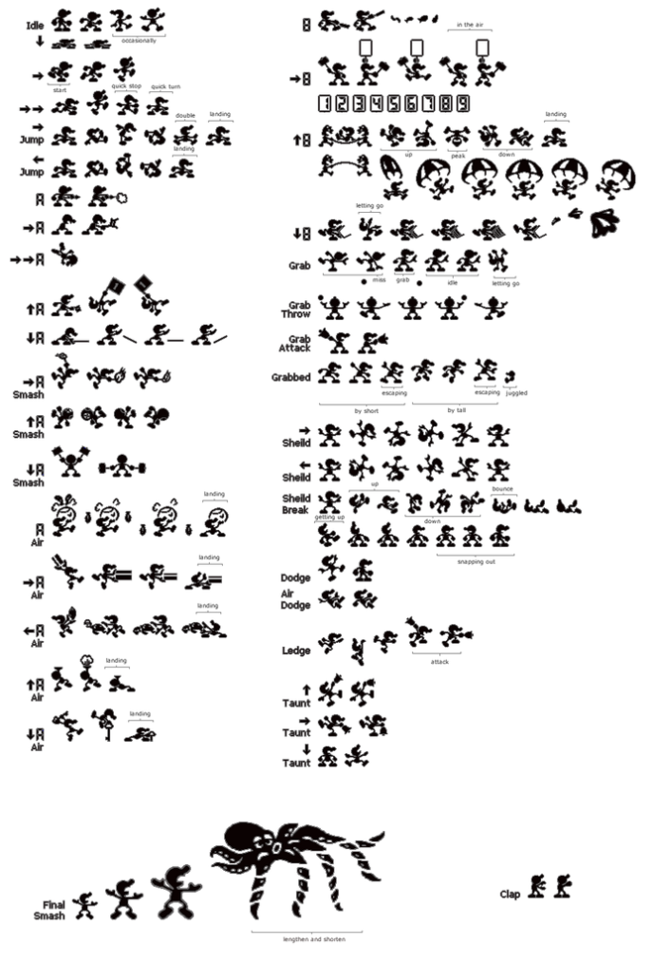

# Enemies

The few enemies in the game will follow the same style and have low animation counts.

* Fixed: Remains immobile.
* Timed: Moves back into position after a set time.
* Pathing: Follows a set path.

# Other Objects

The other objects in the foreground use the same type of LCD, low animation effect, as the main character.

* Static platform: Doesn’t move.
* Movable platform:
  + Horizontal: Moves horizontally.
  + Vertical: Moves vertically.
  + Fixed: Once moved does not automatically move back. Needs to be interacted with again.
  + Timed: Moves back into position after a set time.
  + Eternal: Can be used an infinite number of times.
  + Usage: Can be used only a certain number of times.
  + Disappearing: Disappears periodically.
* Bouncers: Bounces the character up at different arcs, needs to be pre-activated.
* Spikes: Kills character on touching.
  + Eternal: Remain open.
  + Closable: Can be closed when interacted.
    - Timed: Reopens after a timed period.
    - Fixed: Remains closed.
* Gates: Blocks path until opened.
  + Eternal: Remain open.
  + Closable: Can be closed when interacted.
    - Timed: Reopens after a timed period.
    - Fixed: Remains closed.
* Fans: Push in the direction they face.
  + Vertical: Push up or down.
  + Horizontal: In the back makes the character go faster, in front prevents movement.
* Falling objects: Timed falling objects that kill the character. Example coconuts.
* Switches: Not interactable by player, only character. Triggers other objects.
* End goal: Not interactable by player, only character. Triggers the end of the puzzle.

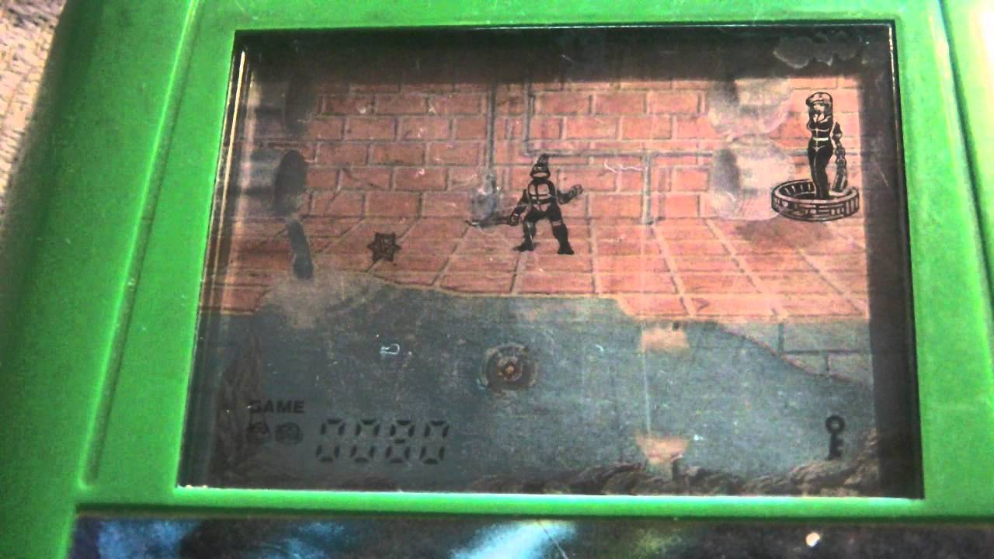

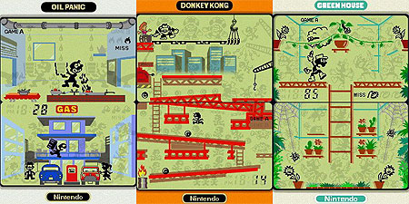

# Backgrounds

The background images are larger static images using a neon and pastel palette with a pixel art style. Each will be themed with a different 80’s centric theme or idea.

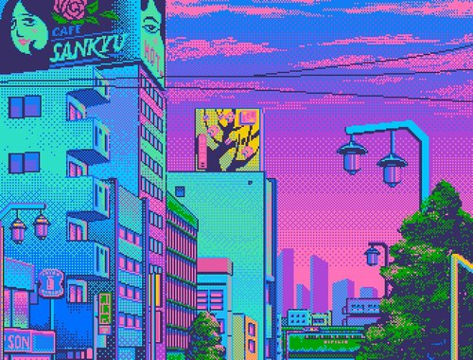



# Tools

Photoshop is used to create the backgrounds and sprite sheets for the character, enemies and objects.

Unity is used to create the animations of the character, enemies and objects.

Sound

# Music

The background music will be small soft repetitive chiptune music; updated versions of classic 80’s NES games to go with the themes of each level.

Mega man Snake man: <http://youtu.be/qPmA8UnCh-Q>

Mega man Fire man: <http://youtu.be/aTVBaLxzgcM>

Game Theory Opening: <http://youtu.be/wnos_7GrC9E>

Final Fantasy 6 airship: <http://youtu.be/qpphUZ5ekb0>

Final Fantasy 6 Espers: <http://youtu.be/aV3AmV1fdpw>

Chrono Trigger 600AD: <http://youtu.be/CdefDwLGJg4>

T.M.N.T.: <http://youtu.be/7UB6aauY-40>

IKARI Warriors: <http://youtu.be/9WgAitWll_g>

# Sound Effects

The sound effect will follow the bleep and bloops of the original Game & Watch’s and Tiger Electronics handheld games, but with an updated flare.

<http://youtu.be/HfKoEWN65Qo>

<http://youtu.be/vw59_SvHLzQ>

<http://youtu.be/pc4qEsdWqpE>

<http://youtu.be/YRlOiF6TYUk>

# Tools

For sound effects: SFXR <http://www.drpetter.se/project_sfxr.html>

For music: Beatwave <http://beatwave.co/>

Moodboard

# Inspiration

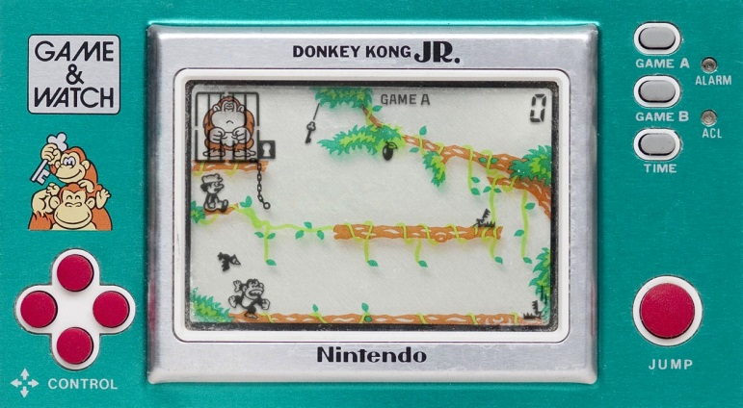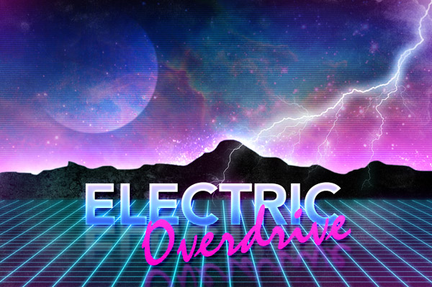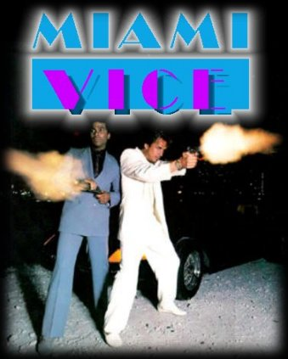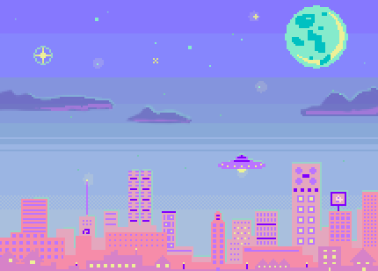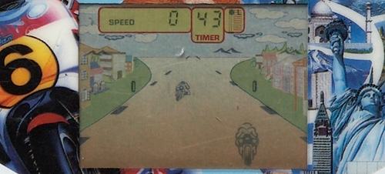

# Mockup

