Rhythm Exercise
1st part :
- Find sequences based on the different possibilities
2nd part :
- On quad paper, build a complete level using at least 15 sequences (based on sequences found in the first part, you can repeat them).
Building rules :

Player: Pacman Object
Jump: 3LX2H (Max), can jump without moving (2 units high), player can run over 1 unit gaps
NO WALL JUMPS!!!
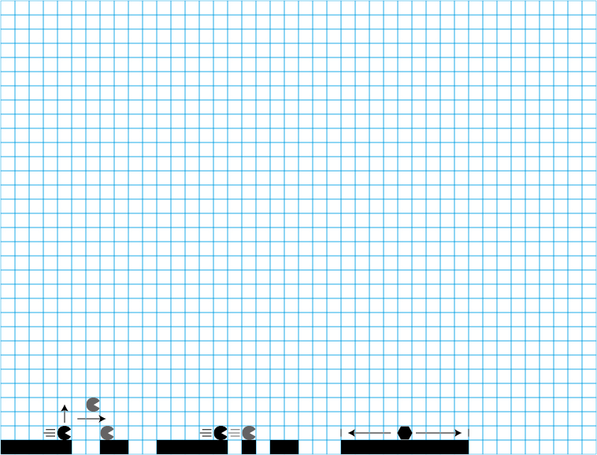
Enemies : 1X1 Polygon moves between edges
Lethal object : 1 X 1 triangle, can be placed on either the floor or the ceiling.
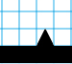
Platforms: 1 unit thick

