Edit config:
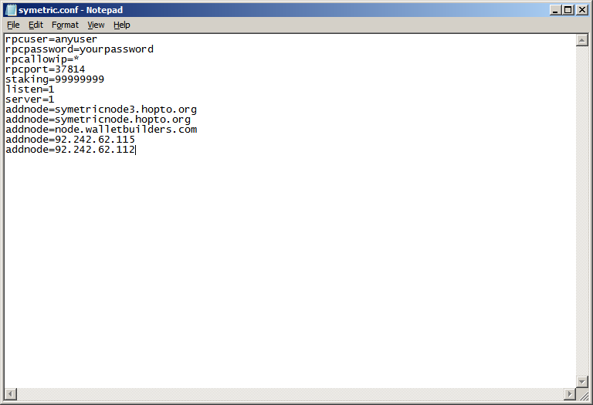

SYMETRIC MANUAL

1. DOWNLOAD & INSTALL

Download GitHub :

Windows Wallet: https://github.com/symetric-token/code/blob/master/symetric-qt.exe
Linux daemon:https://github.com/symetric-token/SymetricGIT/blob/master/symetric-daemon-linux/symetricd
Linux QT: https://github.com/symetric-token/SymetricGIT/blob/master/symetric-qt-linux/symetric-qt
Source: https://github.com/symetric-token/SymetricGIT/tree/master/symetric-source

1.1 INSTALL WINDOWS

Double click in symetric-qt.exe and sync your wallet
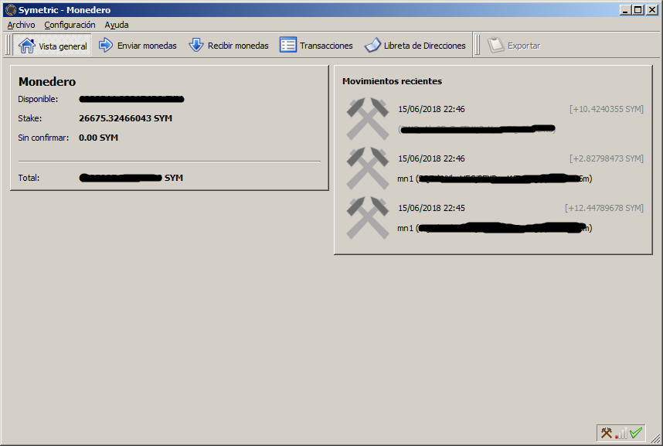

2.2 Edit config
Open In browser %AppData%/roaming/Symetric/

rpcuser=anyuser
rpcpassword=yourpassword
rpcallowip=*
rpcport=37814
staking=99999999
listen=1
server=1
addnode=symetricnode3.hopto.org
addnode=symetricnode.hopto.org
addnode=node.walletbuilders.com
addnode=symetricnode2.hopto.org
addnode=92.242.62.115
addnode=92.242.62.112

*Reboot your wallet

1.2 INSTALL LINUX VPS

apt-get update && upgrade
apt-get install git
git clone https://github.com/symetric-token/SymetricGIT/blob/master/symetric-daemon-linux/symetricd
./symetricd
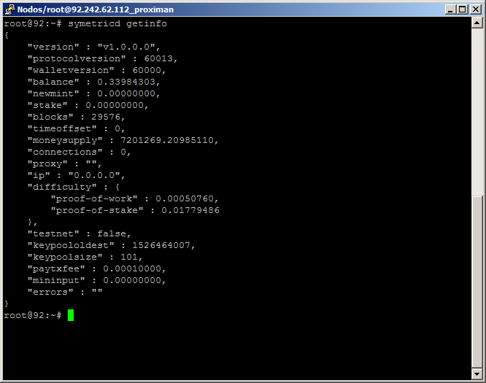

*More info: https://github.com/symetric-token/SymetricGIT/blob/master/symetric-source/doc/build-unix.txt

