CREDIT CONTRACT PORTFOLIO & RISK ANALYTICS
Power BI / SQL Server / DAX Portfolio Project Documentation
End-to-end credit analytics across disbursement, outstanding balance, repayment, overdue exposure, concentration, and portfolio risk.

Project Name | Credit Contract Portfolio & Risk Analytics
Domain | Banking / Credit Analytics / Credit Risk Analytics
Tools | SQL Server, Power BI, DAX, Excel
Role | Data Analyst
Status | Completed
Reporting Period | 2024 Q4
Latest Data Date | 27/12/2024
Credit lifecycle covered: Disbursement → Outstanding Balance → Repayment → Overdue Exposure → Portfolio Risk

1. Project Overview
This project analyzes the performance and risk profile of a banking credit contract portfolio. The dashboard is designed around the full credit lifecycle, from loan disbursement and outstanding balance formation to scheduled repayment obligations, actual collection, overdue exposure, concentration risk, and contract-level monitoring.
The solution uses Power BI, SQL Server, and DAX to handle multiple date roles, repayment schedules, actual repayment transactions, branch disbursement plans, historical snapshots, and portfolio-level risk indicators.
The final report contains four analytical pages:
- Page 01 – Credit Portfolio Overview
- Page 02 – Disbursement KPI
- Page 03 – Repayment & Collection Efficiency
- Page 04 – Portfolio Quality & Risk

2. Business Context
Credit portfolio management requires more than monitoring total loan disbursement. A bank needs to evaluate outstanding exposure, branch KPI execution, principal and interest collection, overdue obligations, maturity pressure, and concentration by customer, industry, and branch.
When these areas are analyzed separately, it becomes difficult to understand whether portfolio growth is being achieved efficiently and whether that growth is accompanied by increasing risk. This project connects credit contracts, repayment schedules, actual repayments, customers, branches, industries, and KPI planning data into a unified analytical model.

3. Business Questions
- How is the credit portfolio changing during the reporting period?
- Which branches hold the largest outstanding balances?
- How does actual disbursement compare with quarterly targets?
- Which branches contribute most to the disbursement KPI shortfall?
- How much principal and interest is due, and how much has actually been collected?
- What are the current principal and interest collection rates?
- How much principal remains overdue and how long has it been overdue?
- Which branches contribute most to total overdue principal?
- How concentrated is outstanding exposure by customer and industry?
- How much outstanding balance is maturing within 30 days?
- Is portfolio growth accompanied by increasing overdue risk?
- Which credit contracts should be prioritized for monitoring?

4. Dataset Overview
The Power BI model combines transactional data, master data, business planning data, repayment schedules, and analytical helper tables. The dashboard focuses primarily on credit-related tables; deposit tables remain in the broader banking database but are outside the main analytical scope of this project.

4.1. Core Credit Tables
Table | Role in the Project
HOPDONG_TINDUNG | Credit contract master table containing contract ID, customer, disbursement date, maturity date, term, loan amount, interest rate, credit type, and lending purpose.
KE_HOACH_TRA_NO | Scheduled repayment obligations by installment, including SO_KY, NGAY_CUOIKY, GOC_PHAITRA, LAI_PHAITRA, opening balance, and interest rate.
KHACHHANG_TRANO | Actual repayment transactions by contract, including NGAYTRA, TRAGOC, TRALAI, TONGTIEN, and KY when an installment identifier is available.
KEHOACH_GIAINGAN | Planned disbursement targets by branch, year, and quarter.
THUNO | Supporting collection/repayment table in the banking model.
TAISAN_BAODAM | Collateral information linked to credit exposure.

4.2. Main Dimension Tables
Table | Role
KHACHHANG | Customer information.
CHINHANH | Branch master data.
KHUVUC | Regional classification.
THANHPHO | City information.
NGANHNGHE_KINHTE_CAP01/02/03 | Hierarchical economic industry classification.
LOAIHINH_DOANHNGHIEP | Business type classification.
HINHTHUC_CAPTINDUNG | Credit granting type.
PHUONGTHUC_CHOVAY | Lending method.
MUCDICH_CAPTINDUNG | Credit purpose classification.
SANPHAM_TINDUNG | Credit product classification.
LOAIHINH_TSBD | Collateral type classification.
RUIRO | Supporting risk classification data.

4.3. Analytical Helper Tables
Table | Analytical Role
DateTable | Central calendar table for daily, monthly, quarterly, and yearly analysis.
Dim_Thoigian_KPI | Defines KPI reporting periods, start dates, and end dates.
Dim_Aging | Disconnected table defining overdue aging buckets: 1–30, 31–60, 61–90, and >90 days.
Dim_QuaHan | Supporting overdue grouping / analytical rules.
Dim_chi_tieu_danh_muc | Helper dimension for portfolio indicators.
Forecast_Bridge | Disconnected helper table used to build the KPI forecast waterfall.
Dư nợ | Measure table used to organize outstanding-balance calculations.
KPI | Measure table used to organize KPI calculations.

5. Data Model
The analytical model is centered on HOPDONG_TINDUNG as the main credit-contract entity connecting customer, branch, industry, and transactional/planning tables. The two most important fact-like tables for collection analysis are KE_HOACH_TRA_NO and KHACHHANG_TRANO.
CUSTOMER / BRANCH / INDUSTRY → HOPDONG_TINDUNG → KE_HOACH_TRA_NO / KHACHHANG_TRANO

5.1. Important Date Roles
Date Field | Business Meaning
HOPDONG_TINDUNG[NGAY_GIAINGAN] | Disbursement date; used for disbursement analysis.
KE_HOACH_TRA_NO[NGAY_CUOIKY] | Repayment due date; used to determine scheduled obligations and overdue exposure.
KHACHHANG_TRANO[NGAYTRA] | Actual repayment date; used to measure collected cash flows.
HOPDONG_TINDUNG[NGAY_DAOHAN] | Final contract maturity date; used for maturity analysis.
To avoid incorrect filter context when a reporting period interacts with multiple date roles, the project uses DAX techniques such as CALCULATE, FILTER, REMOVEFILTERS, USERELATIONSHIP, CROSSFILTER, TREATAS, SUMX, RANKX, and TOPN.

6. Reporting Date Logic (As-of Date)
Historical reporting is handled using an as-of reporting date instead of a fixed current date. The effective reporting date is the earlier of the latest available data date and the selected KPI period end date.
REPORT_DATE = MIN(Latest_Data_Date, Selected_KPI_Period_End_Date)
Selected Period | Period End | Latest Data Date | Effective Reporting Date
2020Q4 | 31/12/2020 | 27/12/2024 | 31/12/2020
2024Q4 | 31/12/2024 | 27/12/2024 | 27/12/2024

7. Page 01 – Credit Portfolio Overview
Objective: provide a portfolio-level view of credit scale, outstanding-balance growth, portfolio structure by region and term, and branch-level exposure.
- 426 credit contracts were disbursed during the period.
- Total disbursement reached approximately 396.53 billion VND.
- Outstanding principal increased from approximately 3.23 trillion VND to 3.45 trillion VND.
- Portfolio growth was approximately 6.69%.
- Principal collected during the period was approximately 180.16 billion VND, while interest collected was approximately 67.72 billion VND.
Main visuals include outstanding balance by region, portfolio structure by contract term, disbursement and collection trends, Top 10 branches by ending outstanding principal, and a portfolio summary table.
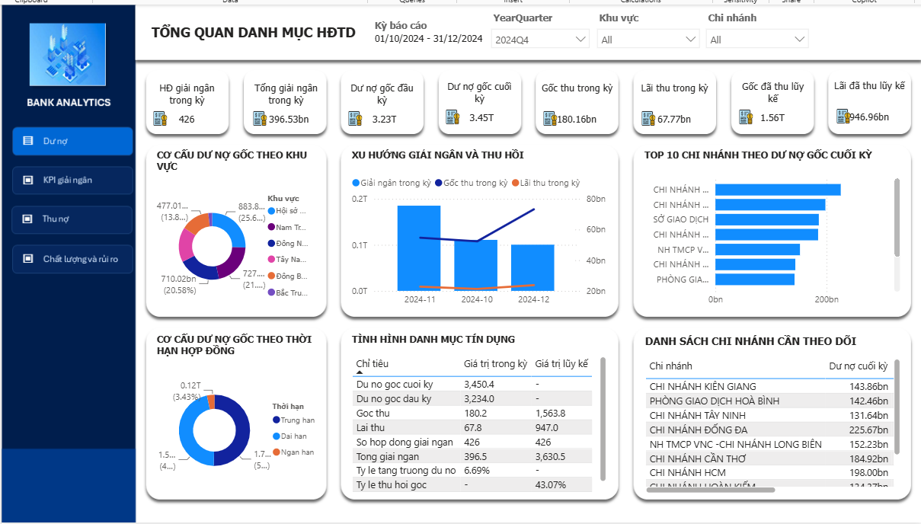

8. Page 02 – Disbursement KPI
Objective: compare planned disbursement with actual performance, estimate the probability of meeting the target by period end, and identify branches contributing most to the KPI shortfall.
KPI | 2024 Q4 Value
Planned Disbursement | ≈ 2.15 trillion VND
Actual Disbursement | ≈ 396.53 billion VND
Completion Rate | 18.48%
KPI Variance | ≈ -1.75 trillion VND
Forecast at Period End | ≈ 476.80 billion VND
Forecast Shortfall | ≈ 1.67 trillion VND
Required Daily Disbursement Rate | ≈ 4.74 billion VND
Branches Below KPI | 31
Main visuals include KPI completion by branch, a branch scale vs. performance scatter plot, a forecast waterfall, Pareto analysis of KPI shortfall, and a branch-level KPI action table.
Key insight: the portfolio continued to expand, but actual disbursement remained significantly below plan. The shortfall is concentrated in a subset of branches, suggesting that management should prioritize high-plan, low-performance branches rather than distribute intervention evenly across the network.
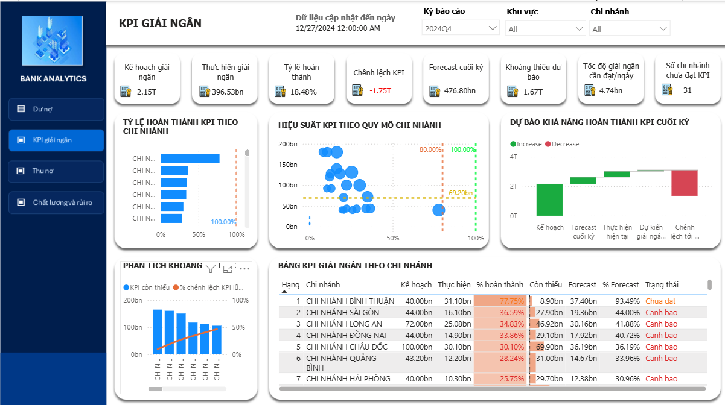

9. Page 03 – Repayment & Collection Efficiency
Objective: compare scheduled repayment obligations with actual collection, evaluate principal and interest collection rates, and identify remaining overdue exposure.
KPI | 2024 Q4 Value
Principal Due | ≈ 1.50 trillion VND
Interest Due | ≈ 881.48 billion VND
Principal Collected | ≈ 1.49 trillion VND
Interest Collected | ≈ 876.88 billion VND
Principal Collection Rate | 99.31%
Interest Collection Rate | 99.48%
Overdue Principal | ≈ 10.39 billion VND
Overdue Contracts | 19

9.1. Overdue Aging Analysis
Aging Bucket | Overdue Principal | Interpretation
>90 days | ≈ 5.98 billion VND | Largest overdue bucket, indicating persistent collection risk.
1–30 days | ≈ 1.56 billion VND | Recently overdue exposure with greater opportunity for early intervention.
31–60 days | ≈ 1.53 billion VND | Increasing warning level.
61–90 days | ≈ 1.33 billion VND | Exposure approaching the most severe aging bucket.
The branch overdue-principal Pareto analysis identifies the small number of branches contributing the majority of total overdue exposure. The cumulative percentage answers a management question: how many branches must be prioritized to address most of the overdue problem?
Key insight: portfolio-wide collection performance is very strong (>99%), but the remaining overdue principal is materially concentrated in the >90-day bucket. This represents a tail-risk problem that requires targeted intervention rather than broad portfolio-wide action.
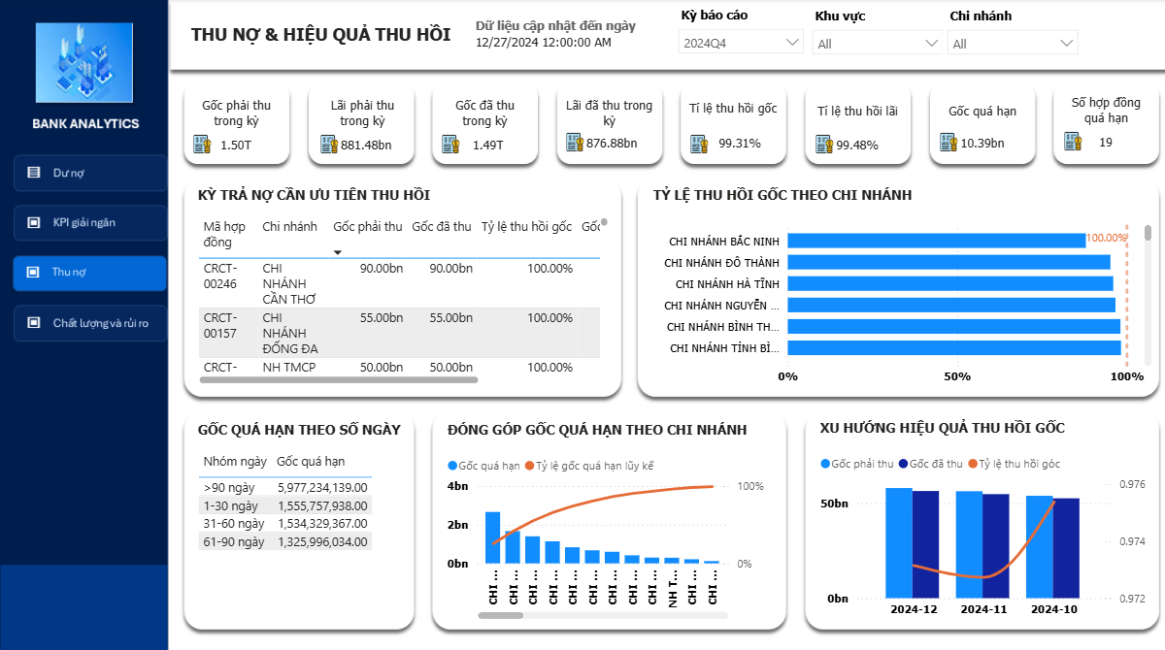

10. Page 04 – Portfolio Quality & Risk
Objective: evaluate portfolio quality at the portfolio level, including exposure associated with overdue contracts, customer and industry concentration, maturity pressure, branch-level risk, and high-risk contract monitoring.
KPI | 2024 Q4 Value
Total Outstanding Balance | ≈ 2.07 trillion VND
Overdue Principal | ≈ 10.39 billion VND
Outstanding Balance of Overdue Contracts | ≈ 45.44 billion VND
Overdue Contract Exposure Ratio | 2.20%
Overdue Contracts | 19
Top 10 Customer Concentration | 26.37%
Top 3 Industry Concentration | 47.08%
Outstanding Balance Maturing ≤30 Days | ≈ 318.33 million VND

Branch Risk Matrix
Compares outstanding balance, overdue-exposure ratio, and overdue principal. Branches with both large exposure and high overdue ratios receive the highest monitoring priority.

Industry Concentration
The treemap shows that the Top 3 industries account for approximately 47.08% of outstanding exposure, highlighting sector concentration risk.

Maturity Structure
Outstanding balances are grouped into ≤30, 31–90, 91–180, 181–365, and >365 day maturity buckets to evaluate near-term maturity pressure.

Outstanding Balance & Risk Trend
AS-OF measures are used for each month to evaluate whether portfolio growth is accompanied by increasing overdue exposure.

High-Risk Contract Watchlist
Moves from portfolio-level monitoring to contract-level action by identifying contracts requiring closer review.
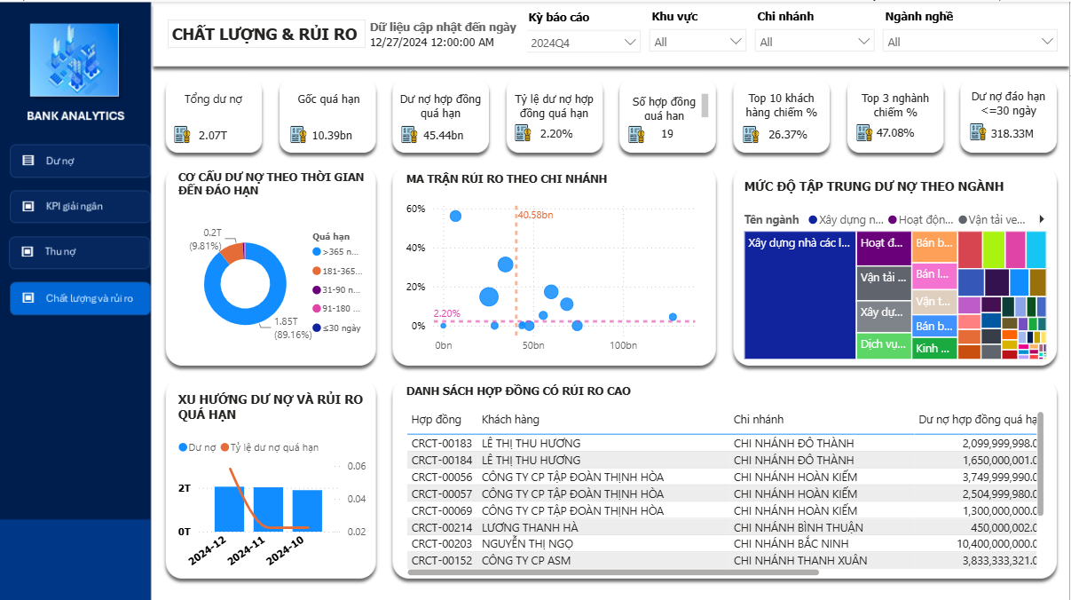

11. Key DAX & Analytical Techniques
Technique | Application in the Project
Filter Context Management | CALCULATE, FILTER, REMOVEFILTERS, CROSSFILTER, USERELATIONSHIP, and TREATAS were used to manage multiple date roles and interactions across fact tables.
Iterator Functions | SUMX, MAXX, and AVERAGEX were used to calculate values at contract/installment grain before aggregation to portfolio level.
Ranking & Pareto | RANKX, TOPN, and ALLSELECTED were used for KPI-shortfall Pareto analysis and overdue-principal Pareto analysis.
AS-OF Reporting | Historical outstanding balance and risk were reconstructed at each snapshot date instead of relying on current-state contract status.
Forecasting | Forecast measures and waterfall analysis were used to estimate period-end KPI completion and remaining shortfall.

12. Key Analytical Challenges

12.1. Multiple Date Roles
A credit contract simultaneously contains a disbursement date, repayment due dates, actual repayment dates, and a final maturity date. Using the wrong date field changes the business meaning of a metric, so each analytical question is mapped to the appropriate date role.

12.2. Repayment Schedule vs. Actual Repayment
KE_HOACH_TRA_NO represents scheduled obligations, while KHACHHANG_TRANO represents actual repayments. Some repayment records do not contain an installment identifier (KY), therefore installment-level allocation must be interpreted cautiously. Contract-level and portfolio-level KPIs are prioritized for final management conclusions.

12.3. Historical Snapshots
Current contract status cannot be used to reconstruct historical portfolio conditions. The project therefore applies AS-OF logic and includes only transactions that occurred on or before each snapshot date.

13. Key Insights
Insight | Interpretation
Portfolio Growth | Outstanding principal increased during the reporting period, indicating continued credit portfolio expansion.
Disbursement KPI Underperformance | Completion reached only 18.48%, and the forecast remained well below target, indicating execution pressure on the business side.
Strong Overall Collection | Principal and interest collection rates both exceeded 99%.
Persistent Tail Risk | Approximately 10.39 billion VND of principal remained overdue, with the >90-day bucket contributing the largest share.
Concentration Risk | Top 10 customers represented 26.37% of outstanding exposure and Top 3 industries represented 47.08%, highlighting the need for concentration monitoring.

14. Business Recommendations
- Prioritize branches with the largest KPI shortfalls instead of applying the same intervention across the entire network.
- Focus collection resources on >90-day overdue exposure because it represents the most persistent risk segment.
- Closely monitor branches with both large outstanding exposure and elevated overdue ratios on the branch risk matrix.
- Control concentration by major customers and industries.
- Monitor contracts approaching maturity to reduce near-term maturity pressure.
- Maintain a contract watchlist to move from descriptive analytics to targeted management action.

15. Skills & Learning Outcomes
- Translated banking business requirements into clearly defined analytical KPIs.
- Designed a Power BI model involving multiple fact tables and multiple date roles.
- Managed complex filter context using DAX.
- Built AS-OF measures for historical portfolio analysis.
- Implemented forecasting, Pareto analysis, and concentration analysis.
- Analyzed overdue exposure, maturity pressure, and portfolio risk.
- Designed dashboard storytelling from overview → performance → collection → risk → action.

16. Suggested Portfolio / Notion Summary
Project card title: Credit Contract Portfolio & Risk Analytics
Short description: A Power BI credit analytics dashboard covering the full credit lifecycle, including disbursement KPI, outstanding balance, repayment efficiency, overdue exposure, portfolio concentration, maturity analysis, and contract risk monitoring.
Tags: Power BI · SQL Server · DAX · Banking Analytics · Credit Risk
Language note: The Power BI dashboard interface is presented in Vietnamese because the project reflects a Vietnamese banking business context. This English documentation is intended for a broader portfolio and recruitment audience.
English Portfolio Documentation – Credit Contract Portfolio & Risk Analytics

