SQ26 Part 2 — QDArchive Classification Report

Executive Overview
2 | 619 | 3850 | 284/619 | 1226/3850
Repositories | Total projects | Total files | Projects classified | Files classified

Project-Type Composition (all repositories)
Project Type | Count
QDA_PROJECT | 0
QD_PROJECT | 380
OTHER_PROJECT | 225
NOT_A_PROJECT | 14
Scope: this delivery covers the two assigned repositories -- 11 (Finnish Social Science Data Archive) and 20 (Sikt). No peer/shared databases from other students were imported into this scope; every number below comes directly from what this pipeline itself discovered and downloaded.

Repository 11
Project Type | Count
QDA_PROJECT | 0
QD_PROJECT | 101
OTHER_PROJECT | 0
NOT_A_PROJECT | 2

QD_PROJECT — by project
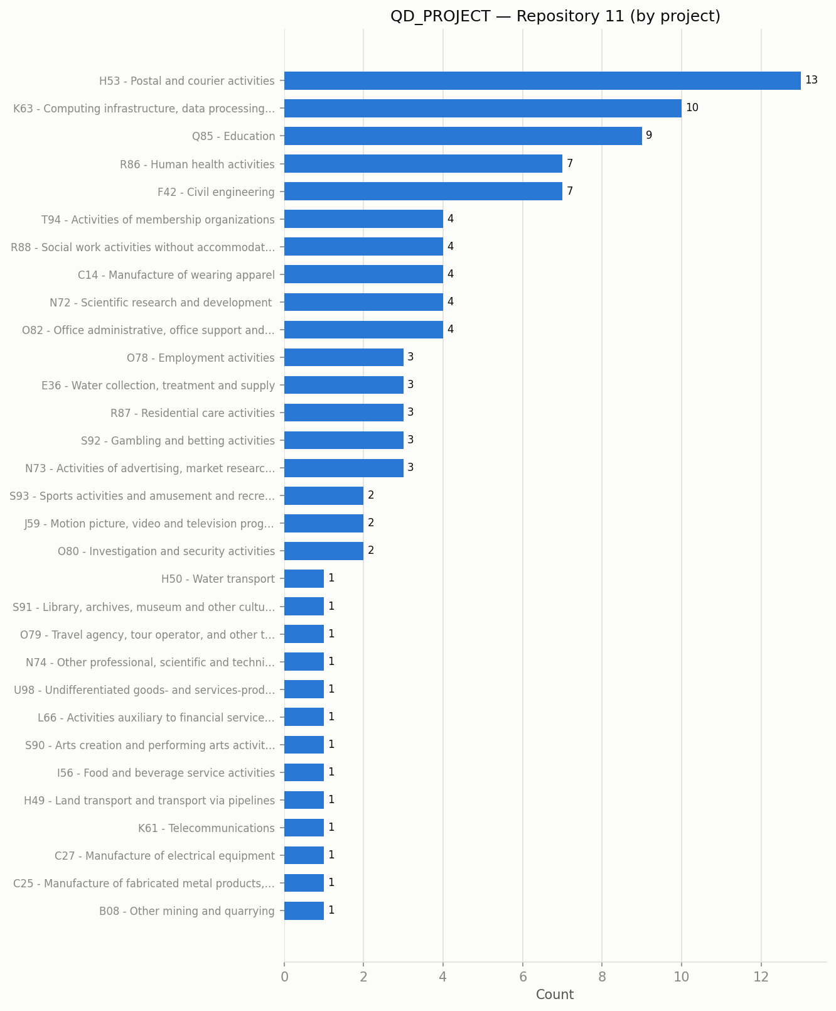

Top 20 classes (by project)
Rank | ISIC Class | Count
1 | H53 - Postal and courier activities | 13
2 | K63 - Computing infrastructure, data processing, hosting, and other informati… | 10
3 | Q85 - Education | 9
4 | R86 - Human health activities | 7
5 | F42 - Civil engineering | 7
6 | T94 - Activities of membership organizations | 4
7 | R88 - Social work activities without accommodation | 4
8 | C14 - Manufacture of wearing apparel | 4
9 | N72 - Scientific research and development | 4
10 | O82 - Office administrative, office support and other business support activi… | 4
11 | O78 - Employment activities | 3
12 | E36 - Water collection, treatment and supply | 3
13 | R87 - Residential care activities | 3
14 | S92 - Gambling and betting activities | 3
15 | N73 - Activities of advertising, market research and public relations | 3
16 | S93 - Sports activities and amusement and recreation activities | 2
17 | J59 - Motion picture, video and television programme production, sound record… | 2
18 | O80 - Investigation and security activities | 2
19 | H50 - Water transport | 1
20 | S91 - Library, archives, museum and other cultural activities | 1

QD_PROJECT — by primary file
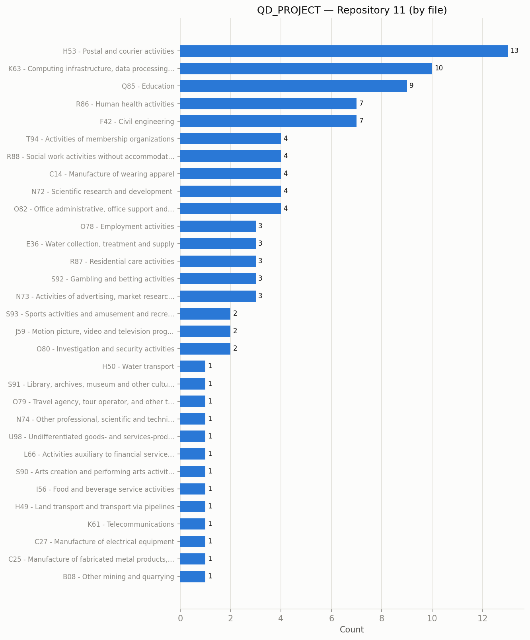
Findings (draft — replace with your own interpretation): 101 QD_PROJECT project(s) analyzed. Dominant class: H53 - Postal and courier activities (13/101, 13%). 31 distinct primary classes at the project level, 31 distinct classes at the file level.

Repository 20
Project Type | Count
QDA_PROJECT | 0
QD_PROJECT | 279
OTHER_PROJECT | 225
NOT_A_PROJECT | 12

QD_PROJECT — by project
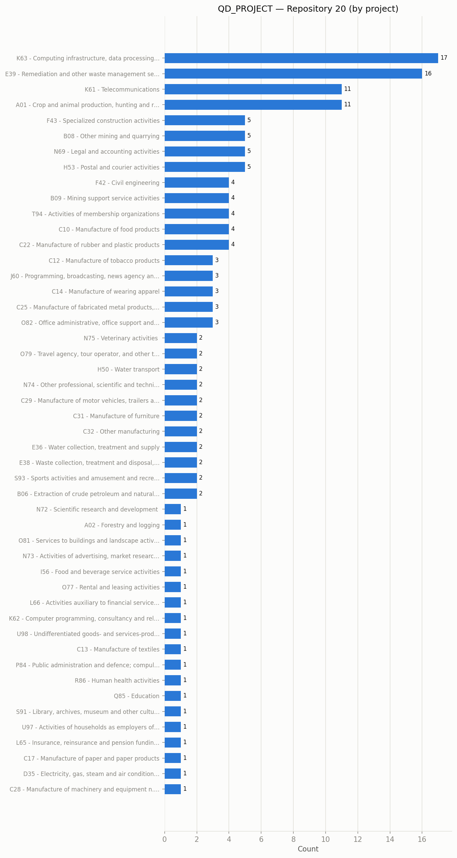

Top 20 classes (by project)
Rank | ISIC Class | Count
1 | K63 - Computing infrastructure, data processing, hosting, and other informati… | 17
2 | E39 - Remediation and other waste management service activities | 16
3 | K61 - Telecommunications | 11
4 | A01 - Crop and animal production, hunting and related service activities | 11
5 | F43 - Specialized construction activities | 5
6 | B08 - Other mining and quarrying | 5
7 | N69 - Legal and accounting activities | 5
8 | H53 - Postal and courier activities | 5
9 | F42 - Civil engineering | 4
10 | B09 - Mining support service activities | 4
11 | T94 - Activities of membership organizations | 4
12 | C10 - Manufacture of food products | 4
13 | C22 - Manufacture of rubber and plastic products | 4
14 | C12 - Manufacture of tobacco products | 3
15 | J60 - Programming, broadcasting, news agency and other content distribution a… | 3
16 | C14 - Manufacture of wearing apparel | 3
17 | C25 - Manufacture of fabricated metal products, except machinery and equipment | 3
18 | O82 - Office administrative, office support and other business support activi… | 3
19 | N75 - Veterinary activities | 2
20 | O79 - Travel agency, tour operator, and other travel related activities | 2

QD_PROJECT — by primary file
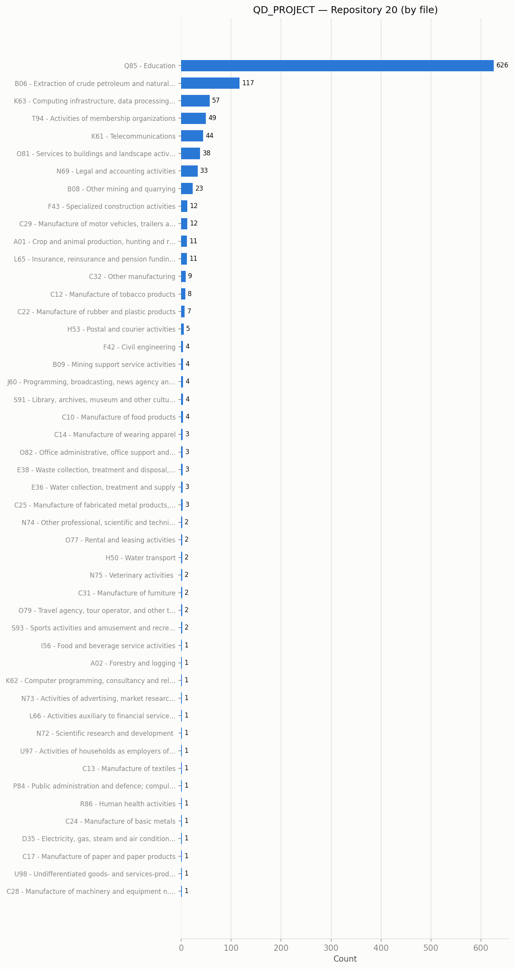
Findings (draft — replace with your own interpretation): 279 QD_PROJECT project(s) analyzed. Dominant class: K63 - Computing infrastructure, data processing, hosting, and other information service activities (17/279, 6%). 48 distinct primary classes at the project level, 48 distinct classes at the file level.

Technical Data Challenges and Limitations
Data-availability and data-quality findings encountered while acquiring and classifying this dataset -- documented as data handling considerations, not code defects.
- No downloadable QDA analysis files (0 QDA_PROJECT) — Every file on disk was checked against the full REFI-QDA/MaxQDA/NVivo/ATLAS.ti/QDA Miner/Quirkos/f4analyse extension list -- zero matches. The one real .qdpx file found on Sikt/Dataverse.no (a Nacey metaphor-analysis dataset) returns HTTP 403: its depositor restricted that specific file while leaving sibling files in the same study open. FSD's QDA-bearing datasets are Condition B -- released only after a human submits a real "purpose of use" application (project title, research description) per dataset. A login is necessary but not sufficient, and that application step was deliberately not automated.
- Non-qualitative content mixed into the Sikt results — The most common file extensions downloaded are .hsat-out, .hsat, .class, and .java -- software/tooling artifacts, not qualitative research data. At least one Sikt hit ("navajo") is a Java/Maven software repository, not a research dataset.
- Some Sikt "projects" are individual loose files, not grouped studies — Sikt/Dataverse.no's file-level search returns one hit per file rather than one hit per dataset. Files sharing no common filename prefix each became their own single-file "project" (e.g. fields-05600.dat). Their titles carry no identifiable topical content, so they correctly receive no ISIC classification rather than a forced, meaningless one.
- Archive contents were initially invisible to classification — Zip/tar archives were first recorded as one opaque file each. The primary data files bundled inside weren't individually indexed until archives were extracted in place and re-scanned.
- Generic academic boilerplate initially skewed classification — Words like "research", "study", and "data" are near-universal in project titles on this archive but rare across the 87 ISIC division reference texts, giving them inflated discriminating weight and pulling results toward division N72 (Scientific research and development) regardless of actual subject matter. Domain-specific stopwords were added to correct this.

Conclusion
Across the two assigned repositories, 619 project records were reviewed; 284 received a primary ISIC class and 1226 individual primary/QDA files were classified at the file level. No QDA_PROJECT was identified in either repository under the current search queries and access constraints -- the Technical Data Challenges section above documents why, with direct evidence (HTTP status codes, extension scans) rather than assumption.

