- Basic info (Panyu)
  - Referring to DiversityOne, College experience dataset
- Validation - EDA (Panyu, Otabek)
  - Data quality checking

    - https://docs.google.com/presentation/d/1SXr6SX6cQuvxe0ptfwk8-uBs_DaMfmFZG1FzEhSc6vM/edit?usp=sharing
    - Label checking (15 times per days)
      - Adherence rate
    - Missing data ratio per sensor
    - Data frequency
    - Duration of study
      - Dropout rate
    - Fitbit
      - Check if they are always wearing the device
  - Data explanation
    - Visualization (referring to DiversityOne)
      - Label distribution
      - # participants throughout the study
      - Adherence rate
  - Model
    - Basic model (refer to the TableShift paper)
      - Baseline model
        - XGboost, MLP, tabPFN
    - Evaluation
      - Group 5 fold, LOSO, timeseries k fold
    - Target
      - Valence, arousal, stress, attention
- Comparing different affective labels (Otabek)
  - Model
    - XGboost, MLP, tabPFN
  - Evaluation
    - Group 5 fold, LOSO, timeseries k fold
  - D-3
    - Happy, relaxed, cheerful, content, sad, anxious, depressed, angry
    - Valence, arousal, stress, attention
- Cross-dataset (Azizbek, Tomiris, Minseo)
  - Target
    - Valence, arousal, stress, attention (more label)
  - Model
    - Using models already implemented in GLOBEM, TableShift
      - Generalization models
        - DRO, GroupDRO…
      - We also need to think about how to set the best parameter for our model size to learning rate etc…
        - Premade frameworks (similar to nnUnet)
  - Evaluation
    - Leave-one-dataset-out evaluation (we can train on two datasets/single dataset)
    - Metric
      - AUROC
  - This idea stems from College Experience Study (IMWUT) paper
    - Model pretraining and transfer learning (listed as one of the open research questions)
  - Cross Dataset setting: Pretrain on two datasets and fine-tune & test on target dataset
    - Train on combined D-1, 3 and test on target dataset D-2
    - Unified feature setting: D1, D2, D3 have different feature number
      - Leave one dataset out evaluation (train on two datasets)
        - D-1, 3 -> D-2
        - D-1, 2 -> D-3
        - D-2, 3 -> D-1
      - Leave one dataset out (train on single dataset)
        - D-1/ D-/3 -> D-2
        - D-1/ D-2 -> D-3
        - D-2/ D-3 -> D-1
  - Model implementation
    - Baseline (XGboost, MLP, tabPFN)
    - Tomiris
      - Tableshift
    - Azizbek
      - Globem
    - Optuna -> layer size, num_layers, Adamw, BCEloss
- Trying possible generalization models for tabular data to handle the cross-user shifts (Tomiris, Azizbek)
  - Target
    - Valence, arousal, stress, attention
    - Train baseline model with each labels with D#1,D#2,D#3
      - XGBoost, MLP, tabPFN
    - 5 random seed
    - Train/test split: 80% / 20% (Globem)
  - Evaluation
    - LOSO, stratified group 5 fold
  - Packages to replicate
    - GLOBEM packages
    - TabBenchmark
      - Domain Robustness Models
      - Label Shift Robustness Models
      - Domain Generalization Models
    - Need to check the overlapping models
- Benchmark
  - Settings
    - Within-dataset (primary)
      - Temporal split (60/20/20 or 70/10/20 lets decide on label number),
        - Concatenate all users’ train slices into the global train set, same for val/test
        - Check If a user has too few samples or label ratio to satisfy all three splits, drop that user - check the number of user who only have one labels
      - Normalize per user
        - Computing the mean and standard deviation separately for each user
        - Normalizing that user’s samples with those statistics.
          - Removes each person’s baseline and makes the model focus on deviations relative to that person, not absolute levels.
          - If we use raw values, the model can learn personal differences instead of stress pattern
          - Reduces individual bias and improves generalization
      - First with Tabular pkl
      - D-1, D-2, D-3 evaluated independently
      - Generalization ability of each dataset
      - Temporal
      - ML/DL
        - XGB, lightGBM, Random Forest,MLP, ResNet for tabular, TabTransformer, SAINT, TabNet, NODE, DCN‑v2
      - Generalization (without target data) (backbone change)
        - IRM: 불변(invariant) predictor 학습의 대표 DG 방법. (arxiv.org)
        - REx / V‑REx: 도메인 간 risk 분산을 줄여 OOD 일반화 강화. (arxiv.org)
        - GroupDRO: 최악 그룹 위험 최소화로 group shift에 강한 baseline. (arxiv.org)
        - MLDG: meta‑learning 기반 DG의 대표적 baseline. (arxiv.org)
        - MASF: meta‑learning + semantic feature regularization DG. (arxiv.org)
        - CrossGrad: domain‑guided perturbation으로 DG 성능 강화. (arxiv.org)
        - MetaReg: meta‑regularization으로 domain‑invariant regularizer 학습. (pure.johnshopkins.edu)
        - SagNet: style bias 제거로 도메인 차이를 줄이는 DG 방법. (arxiv.org)
        - MixStyle: feature statistics mixing으로 새로운 도메인 합성. (arxiv.org)
        - Pruning (Ubicomp)
        - M3BAT (Ubicomp)
      - Adaptation (with target data) (backbone change)
        - DANN: adversarial feature alignment의 대표적 UDA 기준선. (jmlr.org)
        - CDAN: class‑conditional adversarial alignment로 DANN보다 강한 DA 기준선. (arxiv.org)
        - ADDA: 분리된 인코더 + GAN loss로 DA를 수행하는 대표적 방법. (arxiv.org)
        - Deep CORAL: feature covariance 정렬 기반의 간단하고 강한 비‑adversarial DA. (arxiv.org)
        - DAN (MMD): multi‑kernel MMD로 분포 정렬하는 고전적 DA baseline. (arxiv.org)
        - JAN: 여러 층의 joint distribution 정렬, MMD 기반 강한 DA. (arxiv.org)
        - MCD: 두 분류기 discrepancy로 decision boundary 정렬. (openaccess.thecvf.com)
        - SHOT: source‑free UDA 대표 baseline (source data 없이 적응). (proceedings.mlr.press)
        - MCC: class confusion 최소화로 다양한 DA 시나리오를 커버. (ecva.net)
        - DDC: domain confusion loss로 feature를 domain‑invariant하게 학습. (arxiv.org)
        - TENT
        - Weighted MMD
        - BDA / W‑BDA
        - CCDA
        - Self‑adaptive Re‑weighted Adversarial DA
        - TIToK
        - Gradient‑based Class Weighting
      - Generalization + Adaptation
        - Since shift inside the each dataset is strong we can see combining the methodologies helps
        - Foundation model
          - TabPFN
      - Cross-user setting
        - LOSO
        - Training with one user → transfer to other
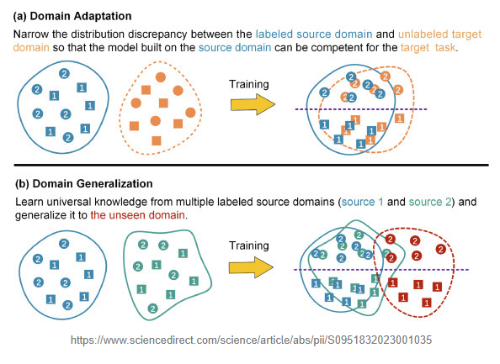
    - Cross-dataset setting (generalizing with different datasets, later work)
      - Feature name normalization to resolve aliases
      - Feature alignment, intersection only, so D‑1/2/3 share identical feature space. (missing sensors, different versions of logger, degree of missing data)
        - First find out ratio of intersection of features
      - Leave one dataset out evaluation (train on two datasets)
        - D-1, 3 -> D-2
        - D-1, 2 -> D-3
        - D-2, 3 -> D-1
      - Leave one dataset out (train on single dataset)
        - D-1/ D-/3 -> D-2
        - D-1/ D-2 -> D-3
        - D-2/ D-3 -> D-1
    - Domain adaptation / Generalization , ML models, DL models
      - Collect replicate the algorithms
      - Globem, Tabshift
    - Handcrafted features & Raw data experiment (too much experiment)
    - Labels to check
      - Four labels (Stress, Valence…)
      - D#4 10 labels

